QUANTUM CORRELATIONS FOR ACHIEVING QUANTUM ADVANTAGE
IN MACHINE LEARNING
A Dissertation Proposal
Submitted to the
Department of Electrical and Computer Engineering
In Partial Fulfillment of the Requirements for
the Degree of Doctor of Philosophy
in Electrical Engineering
by
Sadia Afrin Purba
April 2026
Examining Committee Members:
Dr. Joseph Picone, Advisory Committee Chair, Department of Electrical and Computer Engineering, College of Engineering, Temple University
Dr. Iyad Obeid, Committee Member, Department of Electrical and Computer Engineering, College of Engineering, Temple University
Dr. Chang-Hee Won, Committee Member, Department of Electrical and Computer Engineering, College of Engineering, Temple University
Dr. Andrew Spence, Committee Member, Department of Bioengineering, College of Engineering, Temple University

©
Copyright
2026

By
Sadia Afrin Purba
–––––––––––––––––––
All Rights Reserved

ABSTRACT
Quantum Machine Learning promises profound computational advantages over classical architectures, particularly in mapping highly complex, non-linear data distributions. However, empirical evaluations frequently demonstrate that highly parameterized quantum models, such as Quantum Support Vector Machines, often fail to outperform optimized classical baselines on standard datasets. This limitation primarily stems from heuristic quantum feature maps that fail to generate task-relevant, non-local entanglement, resulting in geometrically redundant spaces or untrainable barren plateaus.
To address this foundational deficit, this dissertation proposal introduces the Entangled Information Capacity ($C_{EI}$) framework. $C_{EI}$ serves as a mathematically rigorous, information-theoretic bound that unifies geometric Centered Kernel Target Alignment (CKTA) with physical quantum non-locality, quantified via CHSH violations and Rényi-2 entanglement entropy. We formally prove that a structural quantum advantage is strictly bounded by the condition $C_{EI} > τ$, where $τ$ is the capacity threshold of the optimal classical Gaussian kernel.
To operationalize this theorem, we transition $C_{EI}$ from a passive diagnostic tool to a differentiable objective function. We propose the $C_{EI}$-driven Quantum Kernel Optimization (CQKO) algorithm, which dynamically trains quantum circuits to simultaneously maximize class separation and global entanglement. Empirical evaluations demonstrate that this algorithm yields statistically significant accuracy advantages over both classical and static quantum baselines, particularly under severe data scarcity. Furthermore, we introduce Anchor-Based Entanglement-Driven Classification (AB-EDC), an approach that natively utilizes this optimized quantum entanglement for continuous similarity mapping to fundamentally reduce the algorithmic inference complexity of exact quantum kernels from an intractable $O\left(N^{2}\right)$ to a highly scalable $O(n⋅M)$ bound, where $M$ represents a small, fixed number of representative class anchors.
Finally, this research transitions these theoretically grounded quantum algorithms to critical, high-dimensional biomedical domains. We propose the $C_{EI}$ framework to address the severe generalization limits of classical deep learning models in healthcare, specifically targeting the reduction of false alarm rates in continuous scalp EEG seizure detection using the TUH EEG Corpus, and enhancing the precise microsegmentation of breast cancer morphologies in digital pathology whole slide images using the TUH Breast Tissue (TUBR) and Fox Chase Cancer Center Breast Tissue (FCBR) corpora. By bridging quantum information theory with applied clinical machine learning, this work establishes a rigorous, empirically validated pathway for achieving structural quantum advantage in real-world diagnostic systems.
Dedication
… to be completed later …

ACKNOWLEDGMENTS
… to be completed later …

Table of Contents
ABSTRACT 2
ACKNOWLEDGMENTS 5
CHAPTER 1 10
1.1 Quantum Entanglement and Non-Classical Correlation 10
1.2 The Landscape of Quantum Machine Learning 11
1.3 Original Contributions 15
CHAPTER 2 17
INFORMATION-THEORETIC BOUND FOR QUANTUM ADVANTAGE 17
2.1 Preliminaries and Definitions 17
2.2 Main Theorem 24
CHAPTER 3 30
Empirical Validation 30
3.1 Experimental Setup and Dataset Selection 30
3.2 Result Analysis 32
CHAPTER 4 38
IMpact and limitations of $CEI$ FRAMEWORK 38
4.1 Impact of the $CEI$ Framework 38
4.2 Limitations of $CEI$-Framework 39
CHAPTER 5 41
AlgorithmS for the trainable Quantum Kernel 41
5.1 Algorithm I: $CEI$-Driven Quantum Kernel Optimization (CQKO) 41
5.1.1 Methodology 42
5.1.2 Result Analysis 43
5.2 Algorithm II: Anchor-Based Entanglement-Driven Classification (AB-EDC) 45
5.2.1 Methodology 46
5.2.2 Result Analysis 49
CHAPTER 6 51
pROJECT TIMELINE AND dELIVERABLES 51
6.1 Problem Statement 52
6.2 Related Work 52
6.3 Proposed Approach 53
CHAPTER 7 55
Research plan 55
REFERENCES 56

CHAPTER 1

INTRODUCTION
The arrival of quantum computing represents a fundamental departure from the von Neumann architecture that has strictly governed classical computation for the past century. By leveraging the physical laws of quantum mechanics, quantum processors possess the theoretical capability to manipulate information in high-dimensional spaces that are exponentially out of reach for classical hardware [1]. Within this broader computational paradigm shift, Quantum Machine Learning (QML) has emerged as a premier candidate for demonstrating near-term quantum advantage. The central promise of QML is profound: quantum feature spaces could natively map and separate highly complex, non-linear data distributions far more efficiently than state-of-the-art classical models like deep neural networks or classical Support Vector Machines (SVMs) [2].
However, the realization of this promise is currently bottlenecked by a critical theoretical deficit. As the field rapidly produces novel quantum algorithms, a fundamental question remains largely unanswered: How can we mathematically prove that a quantum model's success is due to genuinely non-classical computation, rather than just being a highly parameterized quantum model that a classical computer could eventually simulate? This thesis proposes the Entangled Information Capacity $(C_{EI})$ framework to definitively answer this question. To understand the necessity and mechanics of this framework, we must first examine the exact physical resource that fundamentally separates quantum computation from classical probability.

Quantum Entanglement and Non-Classical Correlation
At the heart of quantum information science lies a phenomenon that defies the fundamental constraints of classical probability: quantum entanglement [3]. Entanglement is a form of strictly non-classical correlation where the quantum states of two or more objects must be described with reference to each other, even if the individual objects are separated by vast distances [1]. It is termed "non-classical" because the strength of this coordination mathematically exceeds the absolute upper bounds of classical probability—proving the relationship cannot be explained by any pre-existing shared instructions (hidden variables) or local physical forces [4], [5].
To conceptualize this intuitively, consider a macroscopic analogy of two coins placed in entirely isolated rooms. In classical physics, if both coins are flipped, the outcome of the first coin yields absolutely no information about the second; their probabilities are independent. If these were "quantum coins" initialized in a maximally entangled state, measuring the first coin and observing "heads" would instantaneously guarantee that the second coin in the other room also reads "heads."
From a computer science perspective, this behavior superficially resembles a static variable in object-oriented programming. When a static variable is updated by one instance of a class, all other instances immediately reflect the updated value because they share a single, global memory address. However, quantum entanglement is fundamentally more profound: the entangled particles do not share a physical memory address, nor do they possess a hidden communication channel [1]. This shared state without a shared physical medium, often quantified by violations of the Clauser–Horne–Shimony–Holt (CHSH) inequality [5], provides a structural resource that classical systems cannot natively replicate. For QML, this non-local correlation presents a fascinating, high-dimensional feature space that can potentially map complex data structures far more efficiently than classical architectures.

The Landscape of Quantum Machine Learning
The current landscape of QML is defined by a fundamental tension between expressive power and trainability. Schuld et al. [6] established the foundational understanding that parameterized quantum circuits operate natively as multidimensional Fourier series, granting them theoretical expressivity for mapping high-degree correlations. However, Kubler et al. [7] demonstrated that this expressivity is only advantageous if governed by a strict inductive bias; without it, highly entangled quantum feature spaces project data into unlearnable noise that classical kernels can easily simulate or outperform.
To quantify when this quantum expressivity is actually useful, recent literature has focused heavily on geometric capacity bounding. Abbas et al. [8] introduced the Effective Dimension to map the geometric advantages of the quantum loss landscape, while Huang et al. established the Geometric Difference ($g)$ to rigorously bound prediction error based on the spatial separation between quantum and classical Gram matrices [9]. Complementing these geometric approaches, Caro et al. provided formal Rademacher sample complexity bounds proving quantum generalization is possible from limited data if measurement observables are restricted [10].
While these works provide the foundational framework for modern QML theory, they share a fundamental limitation: they rely on geometrically relative baselines. They compare quantum algorithms against classical algorithms, rather than evaluating the dataset against the absolute limits of classical information theory. Furthermore, they evaluate the final kernel matrices agnostic of the physical quantum state, allowing unentangled product states to be misidentified as classically intractable solutions. Finally, attempting to using physical non-locality introduces a severe optimization trap. As Marrero et al. proved, unstructured global multi-qubit entanglement rapidly flattens the gradient landscape, inducing barren plateaus that render the models untrainable [11].
While theoretical literature guarantees the immense expressivity of quantum feature spaces, empirical evaluations on classical datasets often paint a starkly different reality. To systematically investigate the theorized supremacy of Quantum Support Vector Machines (QSVM) [12], [13], [14] over classical SVMs, an extensive suite of empirical tests was conducted across a variety of data distributions (Overlapping Gaussian, Periodic, Toroidal, and Yin-Yang).
The models were evaluated using two primary performance metrics: Error Rate and Balanced Accuracy (bAcc). The Error Rate measures the proportion of incorrect classifications, where a lower value signifies better model performance. Conversely, Balanced Accuracy — the arithmetic mean of sensitivity (true positive rate) and specificity (true negative rate) — requires a higher value for success. This metric is particularly rigorous because it inherently accounts for potential class imbalances, providing a more reliable measure of predictive power than standard accuracy.
The empirical results (Figure 1) reveal a consistent, systemic failure of the QSVM to structurally outperform classical baselines on classical data. In head-to-head evaluations, the classical SVM equipped with a standard Radial Basis Function (RBF) kernel [15] and Local Periodic Kernel (LPC) [16] consistently matches or outperforms the QSVM using a ZZ-FeatureMap [14], typically yielding a lower or equivalent error rate. Furthermore, the computational overhead is highly asymmetrical; the training and evaluation time for the QSVM scales exponentially worse as the number of training points increases in classical hardware, whereas classical time complexity remains trivially low.
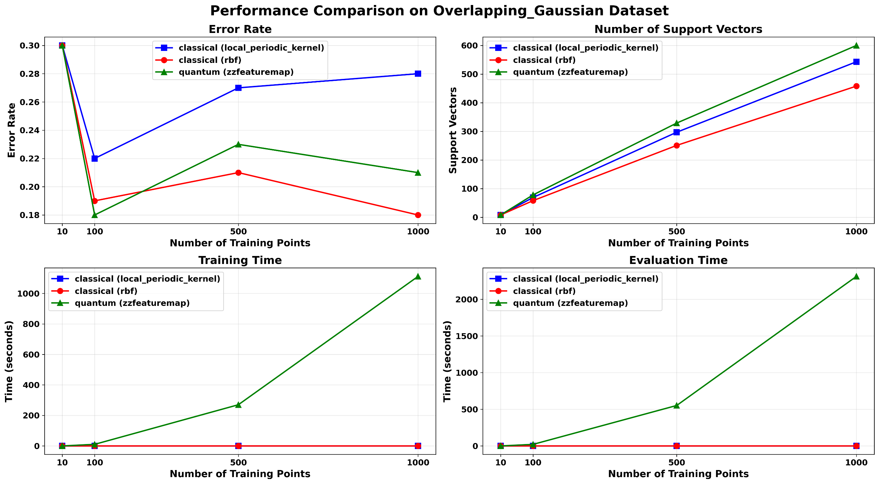
Figure 1. Error Rate of Classical and Quantum Support Vector Machines on an Overlapping Gaussian Dataset
This behavioral plateau is most clearly observed when examining generalization capability across varying sample sizes. In Figure 2, we can observe that when models are trained on a Gaussian distribution and tested across diverse test distributions, a distinct scaling pattern emerges. At extremely low sample sizes (e.g., $N<{10}^{2}$), the QSVM occasionally exhibits high volatility, sometimes registering a higher balanced accuracy than the classical model. However, this advantage is ephemeral. As the sample size scales into statistically significant regimes ($N≥{10}^{3}$), the QSVM universally converges to merely match — or strictly underperform — classical SVM. The quantum model never achieves a sustained improvement in performance.
This empirical reality is strongly corroborated by recent comprehensive studies. Notably, Bowles et al. [17] in their work “Better than classical? The subtle art of evaluating quantum machine learning models” conducted exhaustive empirical evaluations using 160 classical datasets, comparing 12 popular QML algorithms against classical baselines. Their findings align directly with our observations: genuine quantum advantage on standard classical datasets is exceedingly rare. They demonstrated that most perceived quantum advantages in the literature are actually artifacts of suboptimal classical baselines; when classical models are subject to rigorous hyperparameter tuning, the perceived quantum advantage systematically vanishes.
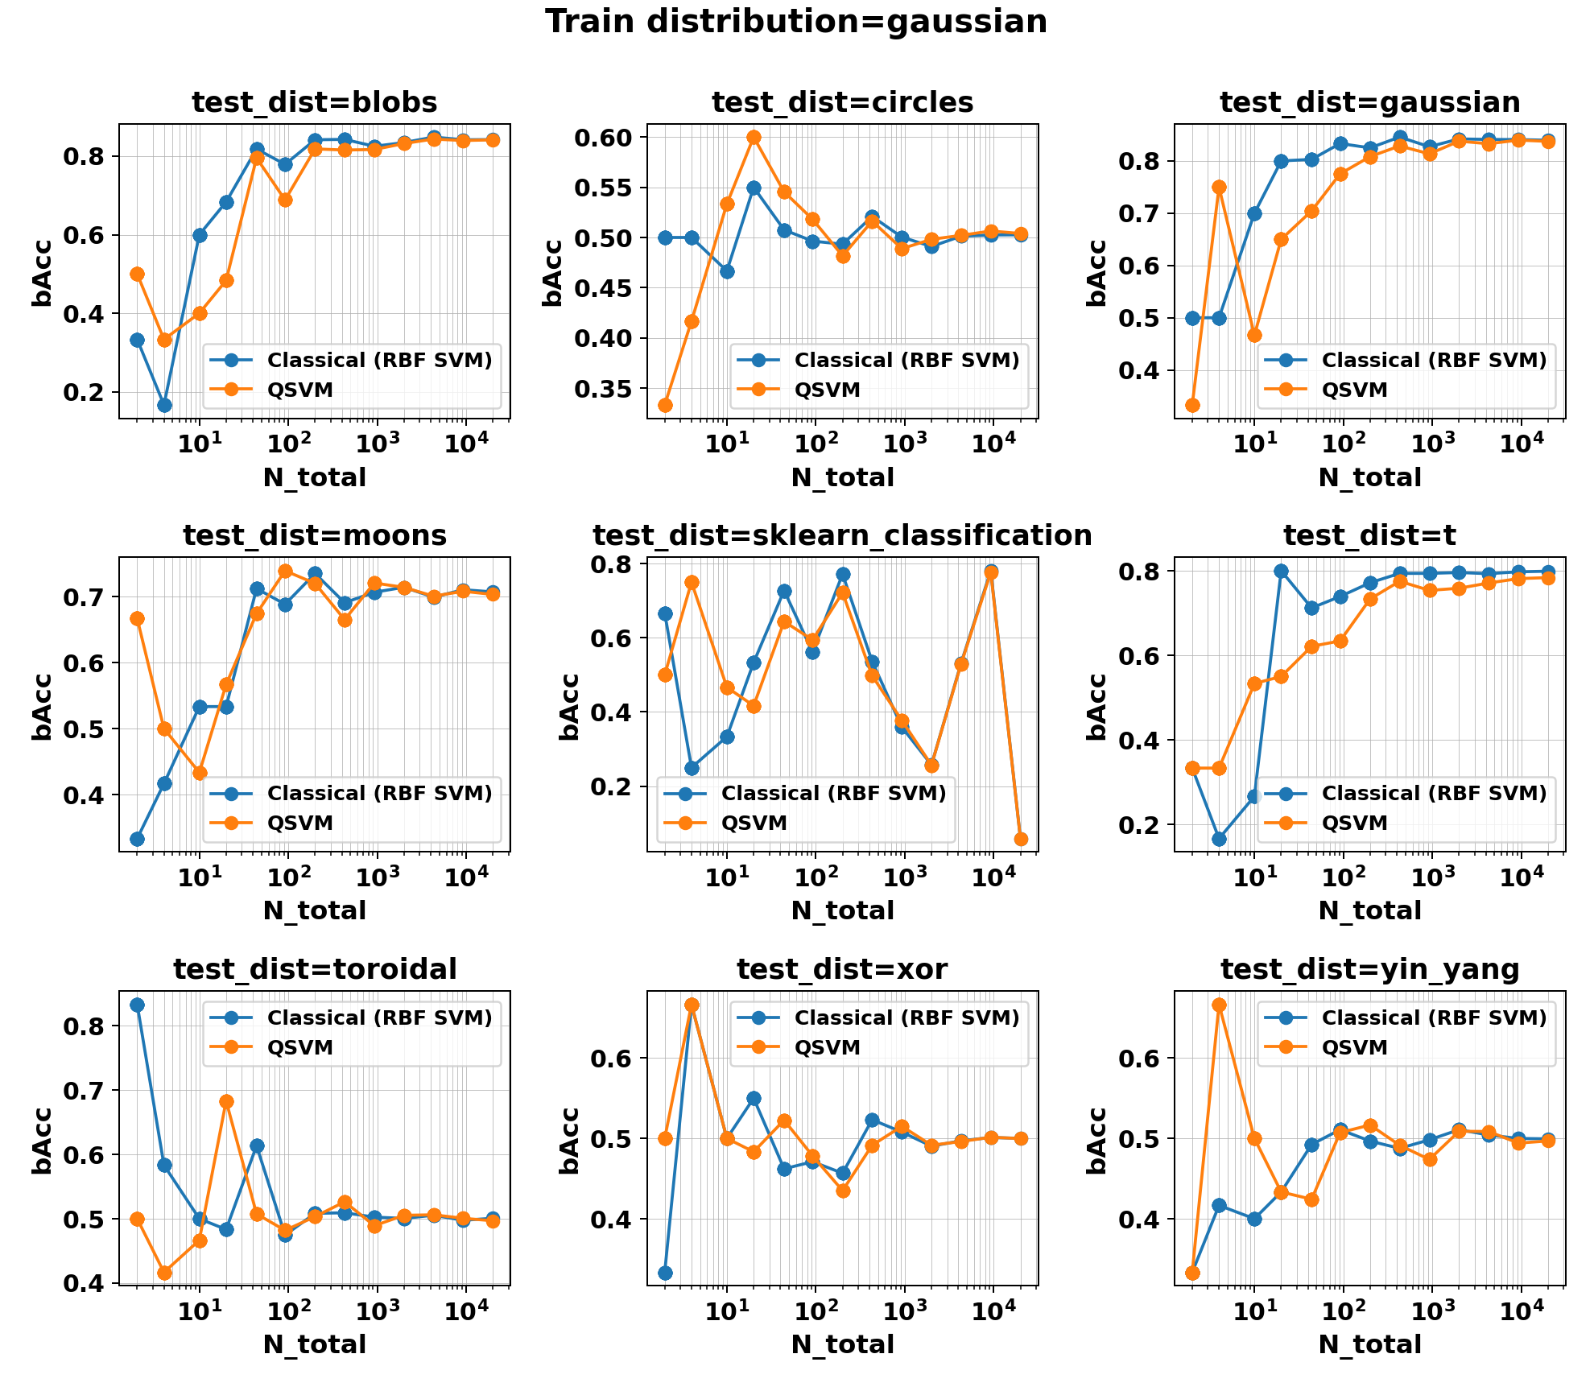

Figure 2. Generalization Performance (bAcc) of Classical vs. Quantum SVMs Across Diverse Test Distributions.
Figure 2. Generalization Performance (bAcc) of Classical vs. Quantum SVMs Across Test Distributions
The observed systemic empirical plateau suggests a deeper theoretical bottleneck linked to the fundamental nature of the dataset. To analyze this, a formal distinction must be made between Classical Data and Quantum Data. Classical data originates from macroscopic measurements or standard coordinate geometry—such as pixel matrices, financial records, or Cartesian coordinates like the Overlapping Gaussian dataset—and inherently lacks superposition or native non-local correlations. In contrast, quantum data arises directly from quantum systems, such as molecular Hamiltonians or entangled photon measurements; this information natively exists within a Hilbert space and possesses inherent non-local physical correlations that distinguish it from its classical counterpart [9].
The empirical failure of QSVM on datasets like the Periodic or Gaussian distributions leads to a critical hypothesis: if classical data fundamentally lacks entangled properties, and the applied quantum feature map fails to manipulate this data into a state that exploits task-relevant, non-local correlations, the quantum model will never outperform an optimal classical algorithm in predictive metrics. A classical feature map mapped onto a quantum circuit is mathematically reducible to classical computation. If the embedding strategy merely utilizes the quantum hardware to calculate a classically simulable distance metric, the exponential overhead of the quantum circuit yields zero structural classification advantage.
Therefore, guessing quantum feature maps and relying on empirical trial-and-error is an unsustainable methodology for achieving quantum advantage. The field requires a mathematically rigorous capacity metric capable of looking at a dataset and a quantum feature map, and definitively proving whether the combination generates non-simulable, task-relevant entanglement.

1.3 Original Contributions
To overcome the limitations of heuristic quantum feature mapping and relative capacity bounding, this dissertation introduces a mathematically rigorous, unified framework. A significant gap currently persists where foundational theories of quantum expressivity and trainability intersect. To successfully bridge this gap, a new metric is required—one that simultaneously demands true global entanglement (transcending local geometric approximations) and enforces task-specific label alignment to incorporate inductive biases while safely bypassing barren plateaus.
Our proposal addresses this exact intersection. By replacing relative geometric baselines with an absolute information-theoretic bound $(τ$), binding Centered Target Kernel Alignment (CTKA) [18], [19] with the physical non-locality of Rényi-2 Entanglement Entropy [1] and CHSH violations [5] to introduce the Entangled Information Capacity ($C_{EI}$) framework. As will be detailed in the subsequent chapters, $C_{EI}$ synthesizes the theoretical efforts and empirical observations into a singular, provable criterion for structural quantum advantage.
We propose a new theorem demonstrating that empirical quantum advantage is strictly bounded by the condition $C_{EI} > τ$. To operationalize this theoretical bound, we will introduce two novel algorithmic implementations: a $C_{EI}$-driven trainable quantum kernel that dynamically maximizes task-relevant entanglement, and Anchor-Based Entanglement-Driven Classification (AB-EDC), which leverages this optimized feature space to execute highly scalable, sub-quadratic inference. Furthermore, we will show that the deployment of these two algorithms to two state-of-the-art, high-dimensional biomedical problems—continuous EEG seizure detection and digital pathology (DPATH) breast cancer microsegmentation—can successfully resolve the generalization limits of classical deep learning models in clinical diagnostics.

CHAPTER 2

INFORMATION-THEORETIC BOUND FOR QUANTUM ADVANTAGE
The central goal in QML is identifying regimes where quantum models offer a provable, structural advantage over classical counterparts. In the context of kernel-based classification, we formalize this pursuit through the Entanglement-Information criterion, denoted as $C_{EI}$.
Before proceeding to the main proofs, we discuss the necessary definition and statistical learning theorems that constrain the behavior of quantum and classical models.

2.1 Preliminaries and Definitions
In this section, we outline the 15 key definitions required to formalize the Entangled Information Capacity ($C_{EI}$) framework of this dissertation proposal. To clearly distinguish foundational concepts from original theoretical contributions, an asterisk (*) denotes a novel definition introduced in this work. Definitions without an asterisk represent established prior knowledge within quantum information science and machine learning.
Definition 1 (Quantum Feature Map). A quantum feature map (QFM) $Φ_{Q}:X→H^{⊗n}$ maps classical data $x∈X⊆R^{d}$ to an $n$-qubit quantum state $\left|ψ\left(x\right)\right\rangle$ via a parameterized unitary circuit $U\left(x\right)\left|0\right\rangle .$ It is also called quantum embedding (QEmed), as it represents the process of embedding classical data manifolds into the high-dimensional geometry of Hilbert space.
Definition 2 (Quantum Kernel). Given a quantum feature map $Φ_{Q}$, the quantum kernel is:
$$\begin{aligned}K_{Q}\left(x_{i},x_{j}\right)={\left|\left\langle ψ\left(x_{i}\right) | ψ\left(x_{j}\right)\right\rangle \right|}^{2}.\#\left(1\right)\end{aligned}$$
Quantum kernel calculates a similarity between two classical data vectors $x_{i}$ and $x_{j}$. To achieve this, the classical data must first be processed through a quantum feature map to encode it into a quantum space. This encoding results in quantum states described using Dirac notation, where the ket $\left|ψ\left(x_{j}\right)\right\rangle$ is a column vector representing the state of the second data point, and the bra $\left\langle ψ\left(x_{i}\right)\right|$ is the complex conjugate transpose (a row vector) of the state for the first data point. Combining these forms the inner product $\left\langle ψ\left(x_{i}\right) | ψ\left(x_{j}\right)\right\rangle$, which evaluates the complex quantum overlap between the two states. Finally, the absolute value squared operation, denoted by $|⋅{\left.​\right|}^{2},$ converts this complex overlap into a real, non-negative value representing the transition probability, or fidelity, between the states. This squaring is important because it ensures the resulting output behaves as a valid Mercer kernel that can be seamlessly integrated into standard machine learning algorithms like SVM [13], [14].
Definition 3 (Radial Basis Function - RBF). The classical RBF kernel is defined as:
$$\begin{aligned}K_{C}\left(x_{i},x_{j}\right)=exp⁡\left(-γ{\left\|x_{i}-x_{j}\right\|}^{2}\right).\#\left(2\right)\end{aligned}$$
Here, $x_{i}$ and $x_{j}$ represent feature vectors within a $d$-dimensional real space $R^{d}$, while ${\left\|x_{i}-x_{j}\right\|}^{2}$ denotes the squared Euclidean distance between two vectors. The behavior of the kernel is governed by the free parameter $γ> 0$, known as the bandwidth or length-scale. This parameter is critical as it dictates the "radius of influence" for training samples; a smaller $γ$ results in a narrower peak, making the kernel sensitive to fine-grained local variations, whereas a larger $γ$smooths the influence over a broader area of the input space [20].
The theoretical power of the RBF kernel is largely derived from a property known as universality [21]. It is proven to be a universal kernel on every compact subset of $R^{d}$ [22]. So, learning algorithms that utilize it (like SVMs) are universally consistent. Given a sufficiently large training dataset and appropriate regularization, an SVM utilizing an RBF kernel can learn any continuous input-output mapping. The universality guarantees that the hypothesis space is rich enough that the approximation error can be driven to zero, making it capable of extracting complex, highly non-linear decision boundaries without requiring explicit feature engineering.
Definition 4 (Centered Kernel Target Alignment - CKTA). For kernel matrix $K$ and target label matrix $Y$, define the centering matrix $H=I_{N}-\frac{1}{N}{11}^{⊤}$. The centered kernel target alignment is:
$$\begin{aligned}CKTA\left(K,Y\right)=\frac{⟨HKH,HYH⟩_{F}}{‖HKH‖_{F}⋅‖HYH‖_{F}}.\#\left(3\right)\end{aligned}$$
Here, $⟨A,B⟩_{F}=\sum_{i,j}{ }\overline{A_{ij}}B_{ij}$ and $‖A‖_{F}=\sqrt{⟨A,A⟩_{F}}=\sqrt{\sum_{i,j}{ }{\left|A_{ij}\right|}^{2}}$ are the Frobenius inner product and Frobenius norm, respectively [23] [24]. Mathematically, this is equivalent to the Pearson correlation coefficient between the entries of the classical feature space covariance matrix and class distributions. It strictly measures how well the spatial variance of the data aligns with the target labels [19]. The bound for CKTA is $0$ to $1$. A score of 1 indicates perfect alignment, meaning the centered kernel matrix perfectly matches the underlying geometry of the target labels. Conversely, a score of 0 signifies no alignment at all, revealing that the kernel matrix provides no useful linear structure for separating those specific target labels.
Evaluating the theoretical advantage of a QSVM requires a metric capable of quantifying how well the quantum feature space separates target classes compared to an optimal classical counterpart. Historically, Target Kernel Alignment (TKA) [18] has been used to measure the similarity between a kernel matrix $K$ and the target label matrix $Y.$
However, raw TKA exhibits a critical structural flaw when comparing quantum kernels to classical RBF kernels. Both approaches are prone to exponential concentration, frequently producing Gram matrices with heavily dominant diagonal elements (where $K_{ii}≈1 and K_{ij}≈0),$ which hinders trainability [25]. When calculating the Frobenius norm for raw TKA, this diagonal magnitude washes out the off-diagonal discriminative structure. Consequently, TKA often yields artificially high, indistinguishable alignment scores that fail to correlate with actual empirical accuracy.
By applying a centering matrix, we remove the uninformative mean component. This forces the metric to evaluate the actual covariance between the feature space geometry and the target labels, making it highly sensitive to true class-separation structure. Also, centered alignment provides tighter generalization bounds than uncentered alignment [19].
Definition 5 (Bell / CHSH Classical Limit). For any local hidden variable (LHV) model, and any pair of observables, the expectation values are bounded by:
$$\begin{aligned}\left|{\left\langle A_{1}B_{1}\right\rangle }_{λ}+{\left\langle A_{1}B_{2}\right\rangle }_{λ}+{\left\langle A_{2}B_{1}\right\rangle }_{λ}-{\left\langle A_{2}B_{2}\right\rangle }_{λ}\right|≤2.\#\left(4\right)\end{aligned}$$
Here, $A_{1}$, $B_{1}$, $A_{2}$ and $B_{2}$ are measurement observables with outcome $±1$, $λ$ represents the shared classical randomness (local hidden variables), and ${\left\langle .\right\rangle }_{λ}$ denotes the statistical expectation value over the classical probabilistic model $λ$ [4].
Definition 6 (Tsirelson Bound). For any quantum state on a bipartite system, the maximum possible CHSH violation is bounded by:
$$\begin{aligned}\left|{\left\langle {\hat{O}}_{CHSH}\right\rangle }_{ψ}\right|≤2\sqrt{2}.\#\left(5\right)\end{aligned}$$
Here, ${\hat{O}}_{CHSH}$ is the CHSH measurement operator, and $ψ$ is the bipartite quantum state [26]. In the context of evaluating systems—such as determining if a quantum feature map genuinely offers an edge over classical methods—these bounds act as an irrefutable lie detector. If a quantum system produces a correlation score of $2$ or lower, it means the system is operating entirely within the boundaries of classical probability. Its behavior could, in theory, be perfectly simulated by a traditional classical algorithm. However, if the system produces a score strictly greater than $2$ (entering the space bounded by $2\sqrt{2}$), it mathematically proves that the system is utilizing non-classical resources (entanglement) that a classical system fundamentally cannot replicate [5].
*Definition 7 (Normalized CHSH Range). To rigorously quantify the presence of non-local quantum correlations, we define the continuous, differentiable CHSH violation metric:
$$\begin{aligned}δ_{CHSH}\left(x\right)=\frac{\text{ softplus }\left({\left\langle {\hat{O}}_{CHSH}\right\rangle }_{ψ}-2\right)}{2\sqrt{2}-2}.\#\left(6\right)\end{aligned}$$
Here, $δ_{CHSH}\left(x\right)$is the normalized violation for a specific data point, $x$ is the classical input data vector, and $softplus\left(z\right)=ln\left(1+e^{z}\right)$ is a smooth approximation of the ReLU function. Averaging this over the dataset yields ${\overline{δ}}_{CHSH}∈\left[0^{+},{\overline{δ}}_{max}\right],$ which approaches $0$ when no states violate the classical limit, and is substantially positive only when a non-negligible fraction of states violate ${|\left\langle {\hat{O}}_{CHSH}\right\rangle }_{ψ}| > 2$.
Definition 8 (Rényi-2 Entanglement Entropy). The entanglement of the states is measured via the Rényi-2 entropy of the reduced density matrices:
$$\begin{aligned}S_{2}\left(ρ_{k}\right)=-\log_{2}{T}r\left(ρ_{k}^{2}\right).\#\left(7\right)\end{aligned}$$
Here, $S_{2}\left(ρ_{k}\right)$ is the Rényi-2 entropy for qubit (unit of information in quantum computing) $k$, bounded in $\left[0,1\right]$, $ρ_{k}$ is the reduced density matrix of the single qubit $k$, and $Tr\left(.\right)$ is the trace operation. The dataset-averaged, qubit-averaged entropy for $N$ size is defined as:
$$\begin{aligned}ε_{H}=\frac{1}{N}\sum_{i=1}^{N}{ }\frac{1}{n}\sum_{k=1}^{n}{ }S_{2}\left(ρ_{k}\left(x_{i}\right)\right)∈\left[0,1\right].\#\left(8\right)\end{aligned}$$
$S_{2}=0$ iff the state is separable (product state), and $S_{2}=1$ (for a qubit) iff maximally entangled.
*Definition 9 (Entanglement Gain - $G$). We define a measure called entanglement gain, which combines the non-locality and entanglement entropy:
$$\begin{aligned}G\left(δ_{CHSH},ε_{H}\right)=tanh\left(κ⋅δ_{CHSH}⋅ε_{H}\right).\#\left(9\right)\end{aligned}$$
Here, $tanh\left(⋅\right)$ is the hyperbolic tangent function, $κ$ is a strictly hyperparameter ($κ> 0$), and $δ_{CHSH},ε_{H}$ represent the respective dataset-average CHSH and entropy metrics which are non-negative values. By the properties of $tanh,G∈[0,1)$. It approaches $1$ only when strong, non-local entanglement is present. Also, $G=0⟺δ_{CHSH},ε_{H}=0$, acting as a continuous logical AND-gate. The hyperparameter $κ$ acts as a scaling factor that controls the steepness or sensitivity of the function; tuning $κ$ determines how rapidly the entanglement gain saturates towards its upper limit of 1 as the underlying metrics increase.
*Definition 10 (Entangled Information Capacity - $C_{EI}$). For quantum kernel $K_{Q}$ with quantum feature map states ${\left\{\left|ψ\left(x_{i}\right)\right\rangle \right\}}_{i=1}^{N}$:
$$\begin{aligned}C_{EI}=G\left(δ_{CHSH},ε_{H}\right)×CKTA\left(K_{Q},Y\right).\#\left(10\right)\end{aligned}$$
Here, $CKTA\left(K_{Q},Y\right)$ describes the alignment between the quantum kernel $K_{Q}$ and the classical labels $Y$, which measures how well the quantum geometry aligns with the classification task. The mathematical bound for the Entangled Information Capacity $C_{EI}$is $[0,1)$. It can be exactly 0 (if there is no entanglement gain or no alignment), but it will always be strictly less than 1.
*Definition 11 (Classical Capacity Threshold - $τ$). The metric $τ$ is defined as the CKTA of the optimal classical RBF kernel:
$$\begin{aligned}τ=\max_{γ∈R^{+}} CKTA\left(K_{RBF}^{\left(γ\right)},Y\right).\#\left(11\right)\end{aligned}$$
Here, $K_{RBF}^{\left(γ\right)}$ represents the classically universal kernel and $γ$ is the bandwidth parameter. To ensure $τ$ is a rigorous ceiling, it is calculated only after$γ$has been optimized via cross-validation to identify the optimal classical mapping for that specific dataset. So, $τ$ can describe how well a classical computer can understand the geometry of the dataset.
Definition 12 (The Rademacher Generalization Bound). For a hypothesis class $H_{K}$ induced by a positive definite symmetric kernel $K$, trained on a sample dataset $S$ of size $N$, the true expected generalization error $R\left(f_{K}\right)$ for any classifier $f_{K}∈H_{K}$ evaluated with a margin $γ>0$, holds with probability at least ($1 - δ)$[27]:
$$\begin{aligned}R\left(f_{K}\right)≤{\hat{R}}_{γ}\left(f_{K}\right)+\frac{2}{γ}{\hat{R}}_{S}\left(H_{K}\right)+3\sqrt{\frac{ln\left(2/δ\right)}{2N}}.\#\left(12\right)\end{aligned}$$
Here, $R\left(f_{K}\right)≡E\left[err\left(f_{K}\right)\right]$ is the true expected generalization error, meaning the probability of misclassifying an unseen point drawn from the underlying distribution, ${\hat{R}}_{γ}\left(f_{K}\right)$ is the empirical margin error (the fraction of training points in sample $S$ classified with a confidence margin less than $γ)$, ${\hat{R}}_{S}\left(H_{K}\right)$ is the empirical Rademacher complexity of the kernel hypothesis class, which bounds the capacity of the model to fit random noise, $δ$ is the confidence parameter (0 < $δ$ < 1), dictating the probability that this bound holds, and $N$ is total number of training samples.
Definition 13 (The Monotonicity Theorem). Cortes et al. [19] established that for a centered kernel matrix $K_{c}=HKH$ and a target label matrix $Y=yy ^{⊤}$, the empirical Rademacher complexity ${\overset{ˆ}{R}}_{S}\left(H_{K}\right)$ is constrained by the trace of the kernel matrix. They proved that optimizing the kernel to maximize the Centered Kernel Target Alignment ($α=CKTA(K,Y)$ ) strictly minimizes the Rademacher complexity, ${\hat{R}}_{S}\left(H_{K}\right)$ which controls the gap between training error and true error. A smaller ${\hat{R}}_{S}\left(H_{K}\right)$ means the empirical performance is a more reliable proxy for true performance [19].
Minimizing Rademacher complexity alone is insufficient, as an overly restricted hypothesis class may reduce the complexity term at the cost of inflating training error. What makes CKTA a principled kernel selection criterion is that maximizing alignment with the target label matrix simultaneously achieves both objectives: a high alignment score indicates that the kernel's feature space is geometrically compatible with the label structure, and driving down training error, while Cortes et al. showed that the associated Rademacher complexity remains controlled along the alignment-maximizing direction. It is the dual effect that underpins the monotonic relationship between alignment and the generalization bound.
*Definition 14 (Generalization Bound Function). Based on Definitions 12-13, for a family of kernels K parameterized such that the trace of the centered kernel matrix is bounded (i.e., $tr\left(HKH\right)≤T$ for a fixed constant $T$), we can define the Generalization Bound Function, $B(α,N,δ)$, as the strict upper ceiling of the expected error. Because Rademacher complexity strictly decreases as alignment increases, $B$ possesses a fundamental property: it is a strictly monotonically decreasing function with respect to alignment $α$. Mathematically:
$$\begin{aligned}Ifα_{1}>α_{2},then B\left(α_{1},N,δ\right)<B\left(α_{2},N,δ\right).\#\left(13\right)\end{aligned}$$
This strict monotonicity establishes that any kernel—quantum or classical—that achieves a superior target alignment is mathematically guaranteed to possess a tighter upper bound on its expected generalization error.
*Definition 15 (Asymptotic Alignment Error Bound). Let $K$ be a symmetric positive definite kernel with effective rank $r(HKH)$, and let $α=CKTA(K,Y)$ be its centered target alignment. By upper-bounding the Rademacher complexity in Definition 14, the expected generalization error can be bounded by the looser, explicitly parameterized inequality:
$$\begin{aligned}E\left[err\left(f_{K}\right)\right]≤1-α+O\left(\sqrt{\frac{r\left(HKH\right)}{N}}\right).\#\left(14\right)\end{aligned}$$
Here, $E\left[err\left(f_{K}\right)\right]$ is the expected generalization error, $1-α$ represents the structural risk baseline, which decreases linearly as target alignment increases, and $O\left(.\right)$ is the asymptotic finite-sample variance, driven by the centered kernel's effective rank $(r)$ and the sample size $(N)$.
This bound is strictly looser than $B(α,N,δ)$. However, it preserves the critical monotonic relationship established in Definition 14. As $N→∞$, the asymptotic variance term vanishes entirely, forcing the expected error to be bounded strictly by the alignment gap, $1-α$.

Main Theorem
Proposition 1. The classical capacity threshold $τ$ (Definition 11) is the tightest achievable centered alignment for the family of classical RBF kernels.
Proof. The RBF kernel family is a universal kernel on a compact subset of $R^{d}$ [21], [22]. This universality guarantees that the Reproducing Kernel Hilbert Space (RKHS) associated with $K_{RBF}^{\left(γ\right)}$ is dense in the space of continuous functions, meaning it can uniformly approximate any continuous target function given sufficient data.
By finding the optimal parameter $γ^{*}=arg{\max_{γ}} CV\text{-Accuracy }\left(K_{RBF}^{\left(γ\right)}\right)$ via cross-validation, we instantiate the most performant model within this universally approximating family for the given dataset. Therefore, $CKTA\left(K_{RBF}^{\left(γ^{*}\right)},Y\right)$ represents a rigorous classical alignment ceiling $τ$); if a quantum kernel exceeds this threshold, it surpasses the alignment of an optimized, universal Euclidean-distance baseline.
Proposition 2. $C_{EI}$ and $τ$ are commensurable — they live in the same metric space, making $C_{EI}>τ$ a meaningful comparison.
Proof. Both $τ$ and the CKTA component of $C_{EI}$ are computed using the same functional CKTA $(⋅,Y)$, with the same centering matrix $H$, the same Frobenius inner product, and the same label matrix $Y$. The entanglement gain $G∈[0,1)$ is a dimensionless multiplier. Therefore $C_{EI}∈\left[0,CKTA\left(K_{Q},Y\right)\right)$ and $τ∈[0, 1]$ share the same units and scale.
Having established $τ$ as the absolute alignment ceiling for universal classical kernels and confirmed its commensurability with our quantum metric, we can now formally define the theoretical threshold for entangled information capacity.
Theorem 1 (Entangled Information Capacity Criterion). Let $D={\left\{\left(x_{i},y_{i}\right)\right\}}_{i=1}^{N}$ be a classification dataset. Let $K_{Q}$ be the quantum kernel induced by a quantum feature map, and $K_{C}^{*}$ be the optimal classical RBF kernel. Define $C_{EI}$ and $τ$ as in Definitions 10 and 11. Then:
$$C_{EI}>τ⟹\text{ the quantum kernel }K_{Q}\text{ has a structural alignment advantage over }K_{C}^{*}$$
Specifically, this requires the simultaneous satisfaction of three necessary conditions:
- local bipartite non-locality ($δ_{CHSH} > 0$),
- global multipartite entanglement ($ε_{H} > 0$),
- superior task-specific centered alignment $\left.CKTA\left(K_{Q},Y\right)>τ\right)$.
Proof by Contradiction (Forward Direction).
Assumption. Suppose $C_{EI}>τ$, but quantum kernel $K_{Q}$ does not have a structural alignment advantage over the optimal RBF kernel, $K_{C}^{*}$. So, QSVM performs worse than SVM in terms of evaluation metrics. One of the two cases must be true:
Case A (Task Failure). Assume the classical SVM geometrically outperforms or ties the QSVM. We defined in Proposition 1 that in the kernel method optimal class separation is bounded by the CKTA. If the classical kernel ($K_{c}$) is superior, then:
$$\begin{aligned}CKTA_{C}>CKTA_{Q}.\#\left(15\right)\end{aligned}$$
We know from Definition 10:
$$\begin{aligned}C_{EI}=G\left(δ_{CHSH},ε_{H}\right)×CKTA_{Q}.\#\left(16\right)\end{aligned}$$

Since the entanglement gain function is bounded such that $G <1$, it must be true that:
$$\begin{aligned}C_{EI}<CKTA_{Q}.\#\left(17\right)\end{aligned}$$
Substituting our assumption ( $CKTA_{C}>CKTA_{Q}$ ) into this inequality yields:
$$\begin{aligned}C_{EI}<CKTA_{C}.\#\left(18\right)\end{aligned}$$
Since $τ=CKTA_{C}$, this leaves us with:
$$\begin{aligned}C_{EI}<τ.\#\left(19\right)\end{aligned}$$
This directly contradicts our initial premise that $C_{EI}>τ$. Therefore, Case A is false. For $C_{EI}>τ$ to hold, the quantum feature space must geometrically align with the target labels better than the best classical RBF space $\left(CKTA_{Q}>τ\right)$.
Case B (Quantum Triviality). Now, assume the quantum kernel achieves high accuracy ( $CKTA_{Q}>τ$ ), but it does so without utilizing genuine quantum resources. This means the feature map could theoretically be simulated on a classical computer without exponential overhead. If the circuit is classically simulatable, it cannot exhibit strong non-local entanglement. Therefore, one of the following must occur:
- The states are separable (no entanglement), meaning the Rényi entropy $ε_{H}≈0$.
- The correlations can be explained by local hidden variables (no non-locality), meaning the normalized CHSH violation $δ_{CHSH}≤0$.
If $ε_{H} = 0 or δ_{CHSH} =0$, then the entanglement gain is:
$$\begin{aligned}G\left(δ_{CHSH},ε_{H}\right)=tanh\left(0\right)=0.\#\left(20\right)\end{aligned}$$
If $G=0$, then regardless of how high the quantum alignment $\left(CKTA_{Q}\right)$ is, the total capacity drops:
$$\begin{aligned}C_{EI}=0×CKTA_{Q}=0.\#\left(21\right)\end{aligned}$$
Assuming a non-trivial classification task, the optimal classical RBF alignment is strictly positive ( $τ>0$ ). Therefore:
$$\begin{aligned}C_{EI}<τ.\#\left(22\right)\end{aligned}$$
Once again, this directly contradicts our initial premise that $C_{EI}>τ$. So, Case B is also false.
Because both cases lead to the contradiction $C_{EI}<τ$, the premise $C_{EI}>τ$ strictly necessitates that:
- $CKTA_{Q}>τ$ : The quantum space isolates the classes better than classical RBF.
- $G≈1$ : The mapping is driven by inseparable ( $ε_{H}>0$ ), non-local ( $δ_{CHSH}>0$).
Therefore, $C_{EI}>τ$ is a sufficient theoretical condition to guarantee that the quantum kernel $K_{Q}$ does have a structural alignment advantage over the optimal RBF kernel, $K_{C}^{*}$. ∎
Proof by Contradiction (Reverse Direction).
Assumption. $C_{EI}<τ$, but $K_{Q}$ exhibits a genuine structural advantage leading to better performance for QSVM than SVM. We evaluate the two exhaustive cases.
Case A (No Entanglement Gain). This implies either $δ_{CHSH}=0$ or $ε_{H}=0$.
If $δ_{CHSH}=0$, the correlations are LHV-compatible (Definitions 6, 7). The kernel can be simulated by RBF Universality, and SVM can match this.
If $ε_{H}=0$, the quantum feature map yields a product state (Definition 8). The kernel decomposes into classical 1D inner products [13], [14]:
$$\begin{aligned}K_{Q}\left(x_{i},x_{j}\right)=\prod_{k=1}^{n}{ }\cos^{2}\left(\frac{θ_{k}\left(x_{i}\right)-θ_{k}\left(x_{j}\right)}{2}\right).\#\left(23\right)\end{aligned}$$
Where $θ_{k}$ is the deterministic rotation angle applied to qubit $k$. This is classically computable in $O(n)$ time. Any advantage is not due to quantum effects. Both sub-cases contradict with the premise that the advantage is quantum.
Case B (Marginal Entanglement Gain). Entanglement exists, but the kernel is misaligned with the classification, $G>0,but CKTA\left(K_{Q},Y\right)<$ $τ$. By Definition 11, $τ$ is equal to $CKTA\left(K_{C},Y\right)$ and by Definition 14, better $CKTA$ leads to lower generalization bound. So, the entanglement hurts classification. The quantum kernel, despite possessing entanglement, does not align with the label structure better than the classical kernel. The entanglement is present but task-irrelevant. It contradicts with the initial assumption. ∎
Lemma 1.1 (Generalization Error Bound Gap). Let $K_{Q}$ denotes a quantum kernel and $K_{C}^{*}$ denotes the optimal classical RBF kernel. If the Entangled Information Capacity satisfies $C_{EI}>τ$, then in the asymptotic limit, the expected generalization error of the QSVM is strictly bounded below the expected generalization error of the optimal classical SVM.
Proof. Let $α_{Q}=CKTA\left(K_{Q},Y\right)$ denote the centered alignment of the quantum kernel, and let $α_{C}=τ=CKTA\left(K_{C}^{*},Y\right)$ denote the centered alignment of the optimal classical kernel.
By hypothesis, $C_{EI}>τ$, and by Definition 10, $C_{EI}=G⋅α_{Q}$. Since the entanglement gain function $G∈[0,1)$, the relation $G⋅α_{Q}>α_{C}$ strictly mandates that $α_{Q}>α_{C}$. We define the strictly positive alignment gap, $Δα∈R^{+}$:
$$\begin{aligned}Δα=α_{Q}-α_{C}>0.\#\left(24\right)\end{aligned}$$By Definition 15, the expected generalization error $E\left[err\left(f_{K}\right)\right]$ for a kernel classifier $f_{K}$ trained on $N$ samples is bounded by its centered alignment and its finite-sample statistical variance. We define the upper generalization error bound for the quantum model (Equation 25a), and a theoretical lower bound for the optimal classical model (Equation 25b). Applying this to both models yields:
$$\begin{aligned}E\left[err\left(f_{K_{Q}}\right)\right]≤1-α_{Q}+O\left(\sqrt{\frac{r_{Q}}{N}}\right).\#\left(25a\right)\end{aligned}$$
$$\begin{aligned}E\left[err\left(f_{K_{C}^{*}}\right)\right]≥1-α_{C}-O\left(\sqrt{\frac{r_{C}}{N}}\right).\#\left(25b\right)\end{aligned}$$
Where $r_{Q}$ and $r_{C}$ are the effective ranks of the centered kernel matrices $HK_{Q}H$ and $HK_{C}^{*}H$, respectively. To determine the comparative advantage, we subtract the theoretical bound of the classical model from the quantum model:
$$\begin{aligned}E\left[err\left(f_{K_{Q}}\right)\right]-E\left[err\left(f_{K_{C}^{*}}\right)\right]≤\left(1-α_{Q}\right)-\left(1-α_{C}\right)+O\left(\sqrt{\frac{r_{Q}}{N}}\right)+O\left(\sqrt{\frac{r_{C}}{N}}\right).\#\left(26\right)\end{aligned}$$
Simplifying the scalar constants:
$$\begin{aligned}E\left[err\left(f_{K_{Q}}\right)\right]-E\left[err\left(f_{K_{C}^{*}}\right)\right]≤-\left(α_{Q}-α_{C}\right)+O\left(\sqrt{\frac{r_{Q}}{N}}\right)+O\left(\sqrt{\frac{r_{C}}{N}}\right).\#\left(27\right)\end{aligned}$$
The variance terms $O(\sqrt{r/N})$ govern the statistical noise inherent to finite sampling. We evaluate the inequality in the asymptotic limit where the training sample size approaches infinity ($N→∞$).
Since the effective ranks $r_{Q}$ and $r_{C}$ are bounded by the dataset dimensionality and do not scale infinitely with $N$, the finite-sample complexity terms vanish:
$$\begin{aligned}\lim_{N→∞} O\left(\sqrt{\frac{r_{Q}}{N}}\right)=0\text{ and }\lim_{N→∞} O\left(\sqrt{\frac{r_{C}}{N}}\right)=0.\#\left(28\right)\end{aligned}$$
Therefore, as $N→∞$, the error difference inequality reduces to:
$$\begin{aligned}E\left[err\left(f_{K_{Q}}\right)\right]-E\left[err\left(f_{K_{C}^{*}}\right)\right]≤-Δα.\#\left(29\right)\end{aligned}$$
From Step 1, we established that $Δα>0$. Therefore, $-Δα<0$. This mandates that the difference in expected errors is strictly negative:
$$\begin{aligned}E\left[err\left(f_{K_{Q}}\right)\right]-E\left[err\left(f_{K_{C}^{*}}\right)\right]<0.\#\left(30\right)\end{aligned}$$
Adding the expected classical error to both sides yields the final bound:
$$\begin{aligned}E\left[err\left(f_{K_{Q}}\right)\right]<E\left[err\left(f_{K_{C}^{*}}\right)\right].\#\left(31\right)\end{aligned}$$
Thus, when $C_{EI}>τ$, the quantum model possesses a strictly tighter expected generalization error bound than any classical equivalent, guaranteeing a structural learning advantage. ∎

CHAPTER 3

Empirical Validation
To validate the Entangled Information Capacity ($C_{EI}$) as a reliable predictor of quantum advantage, we conduct an extensive empirical study across 14 distinct synthetic datasets. These datasets are strategically selected to span a spectrum of complexity, from linearly separable distributions to those possessing deep, non-local correlations that are traditionally difficult for classical kernels to resolve. By comparing the performance of a QSVM against a cross-validated, optimal RBF-SVM, we evaluate whether $C_{EI}$ accurately identifies the transition point where quantum feature maps offer a structural edge.

3.1 Experimental Setup and Dataset Selection
The benchmark suite is partitioned into three distinct structural regimes:
Classical Geometric Benchmarks. Standard non-linear challenges include Two Moons, XOR, Parity, Toroidal, Yin-Yang, UCI Breast Cancer dataset [28], MNIST [29], Set-10 [30], and Set-13 [31]. These datasets test the "Reverse Direction" of Theorem 1, identifying regimes where classical universality ($τ$) should exceed $C_{EI}$.
Statistical and Density Distributions. 3-class Blobs, 2D Overlapping, and 2D non-overlapping. These evaluate the metric's sensitivity to class noise and the "radius of influence" ($γ$) of the RBF baseline.
Figure 3. Visualization of Classical Geometric Datasets
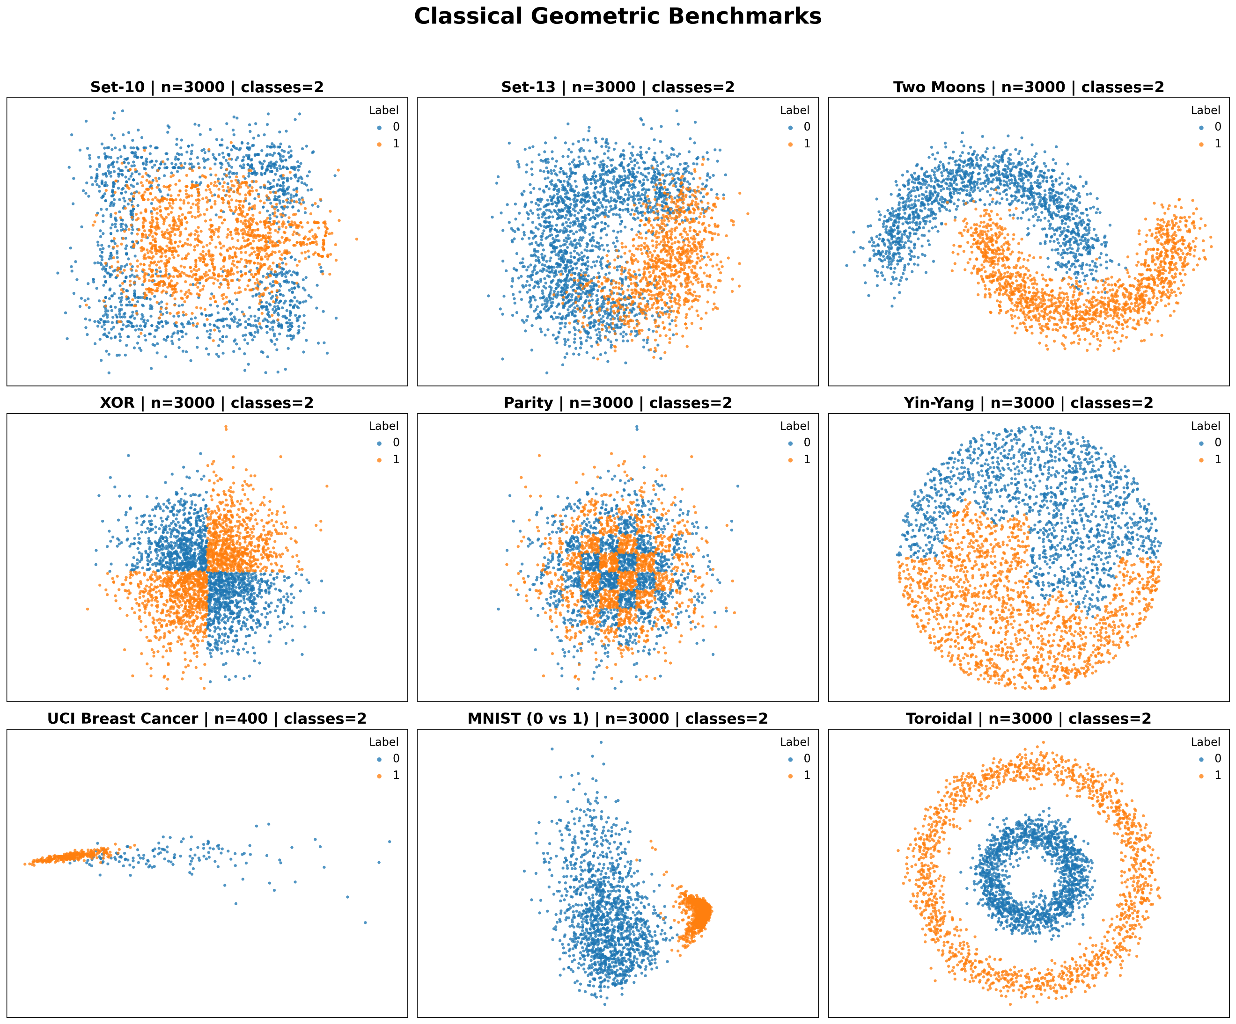

Quantum-Hardened Manifolds. This critical category includes the IBM Ad Hoc dataset [14] and a Custom Entangled Dataset generated via a non-linear quantum feature map. These datasets are specifically "hardened" to resist classical simulation; the IBM Ad Hoc dataset, in particular, uses a high-depth circuit to create feature space correlations that an RBF kernel cannot efficiently resolve.
Figure 4. Visualization of Statistical and Density Distribution
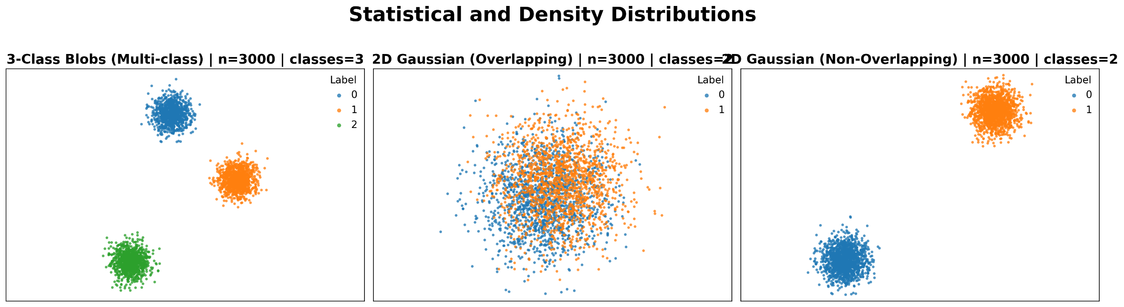

For each of the 14 datasets, we determine the classical capacity threshold by performing a grid search with 5-fold cross-validation over the RBF bandwidth $γ∈\left[{10}^{-3},{10}^{3}\right]$. The peak CKTA achieved by the optimized SVM defines the rigorous classical ceiling $τ$.
Figure 5. Visualization of Quantum Hardened Dataset
We execute seven quantum feature maps to compute the quantum kernel matrix $K_{Q}$. The feature maps are: ZZFeaturemap, ZFeaturemap, PauliFeaturemap, EfficientSU2, Angle-Embedding, Data Reuploading Circuit [32], [33] and a custom feature map that was used to generate entangled quantum data. Simultaneously, we extract the bipartite CHSH violation ($δ_{CHSH}$) and the average Rényi-2 entropy ($ε_{H}$) to calculate the Entanglement Gain ($G$).
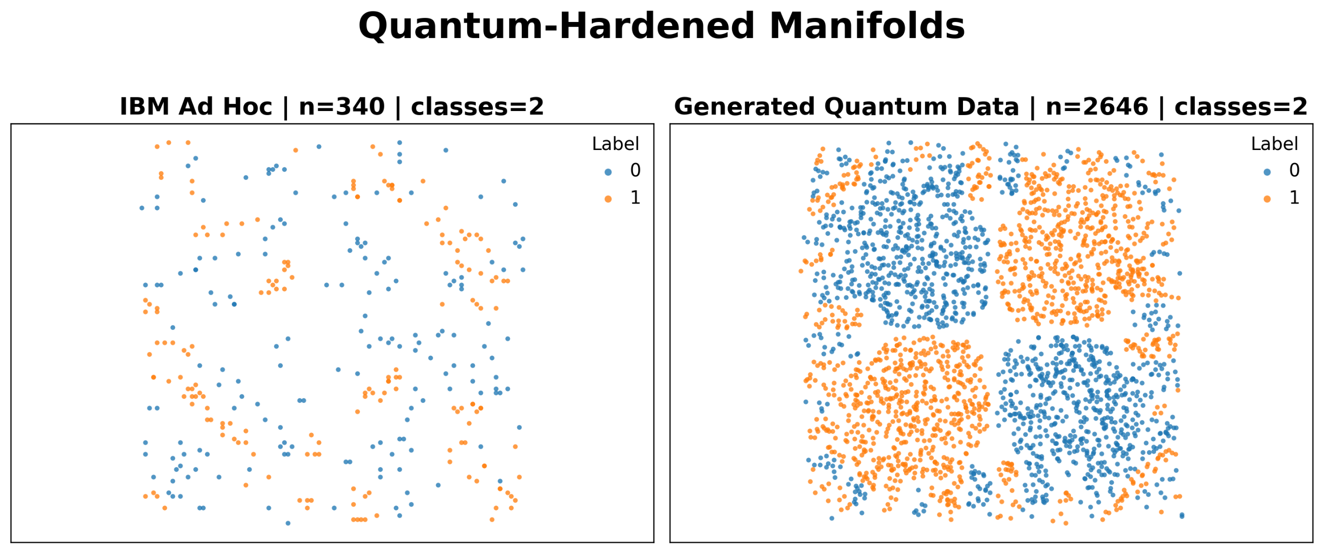

3.2 Result Analysis
To evaluate the predictive power of the QSVM on the basis of Theorem 1, we perform a comparative analysis across various datasets and quantum feature maps. We focus on the relationship between the classical kernel-target alignment $CKTA_{C}$, also known as $τ$), the quantum kernel-target alignment ($CKTA_{Q}$), and the Enatngled Information Category, $C_{EI}$. The experimental results can be categorized into three distinct patterns based on the relationship between these metrics and the resulting classification accuracy.
Empirical Quantum Advantage ($C_{EI} > τ$). In datasets where the $C_{EI}$ value exceeds the classical alignment $τ$, and we observe a clear empirical advantage for the QSVM over the classical SVM in terms of the accuracy metric.
Generated Quantum Data was specifically generated using a custom quantum feature map. For this map, we observe that $C_{EI}≈0.06$ while $τ≈0.055$. This alignment advantage corresponds to the red asterisk in Figure 6(a), marking where QSVM accuracy (95.85%) significantly outperforms SVM (79.90%). We also use another popular quantum dataset named IBM Ad Hoc [14] and observe a similar trend for Pauli-Feature map [32]. In Figure 6(b), the $C_{EI}$ reaches its peak ($≈0.24$) here, surpassing the classical baseline $τ (≈0.12)$.
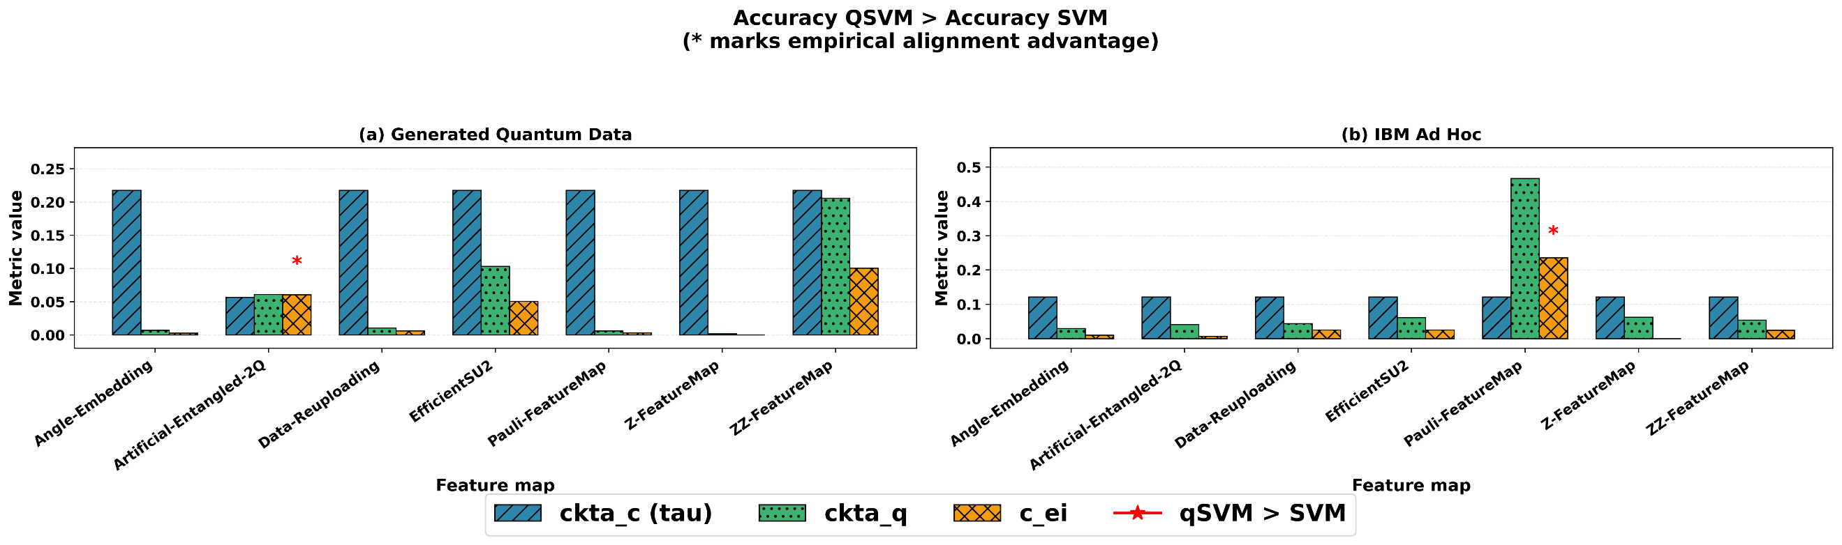
Figure 6. Comparative analysis for (a) Generated Quantum Data and (b) IBM Ad Hoc datasets. Red asterisks indicate instances where the QSVM accuracy outperforms the classical SVM

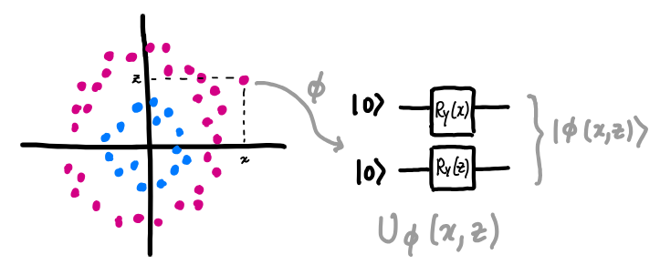

Figure 3. Encoding Classical Data into Quantum States using Quantum Feature Map.
This indicates that the quantum feature map successfully captures complex structures in the data that are inaccessible to classical kernels. For both datasets, the improvements in QSVM accuracy are statistically significant at the 99% confidence interval.
Model Saturation and High Symmetry. In specific cases such as XOR, Toroidal, and Set-10, we observe instances where $CKTA_{Q}$ is higher than $τ$, yet $C_{EI}$ remains lower than the classical baseline (Figure 7). In these scenarios (e.g., EfficientSU2 on Toroidal data), both QSVM and SVM achieve 100.00% accuracy. This suggests that while the quantum kernel provides a high-quality representation, the dataset is "too easy" or sufficiently linearly separable in classical space. In these cases, no quantum resource is strictly required, as the classical SVM provides an optimal solution. The lower $C_{EI}$ correctly reflects that the quantum feature map is not providing a necessary informational gain over classical methods.
Classical Dominance ($C_{EI} < τ$). For the remainder of the datasets—including 2D Overlapping Gaussian, set-13 and UCI Breast Cancer—we consistently find that $C_{EI} < τ$. In Figure 8, the blue bars ($τ$) consistently tower over the orange bars ($C_{EI}$). In all such cases, the QSVM fails to outperform the SVM. This confirms our hypothesis based on Theorem 1: if the entanglement gain-weighted alignment of the quantum kernel cannot surpass the inherent alignment of the classical target, no quantum advantage is expected.
Figure 7. Kernel-target alignment and $C_{EI}$ metrics for (c) XOR, (d) Toroidal, and (e) Set-10 datasets. While the quantum alignment (green) often exceeds the classical baseline ($τ$, blue), the $C_{EI}$ value remains lower than $τ$.
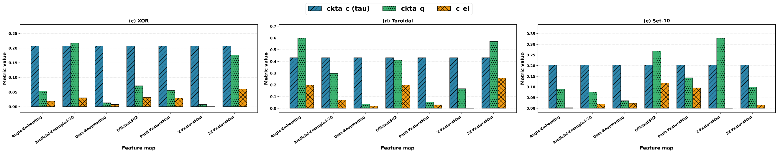

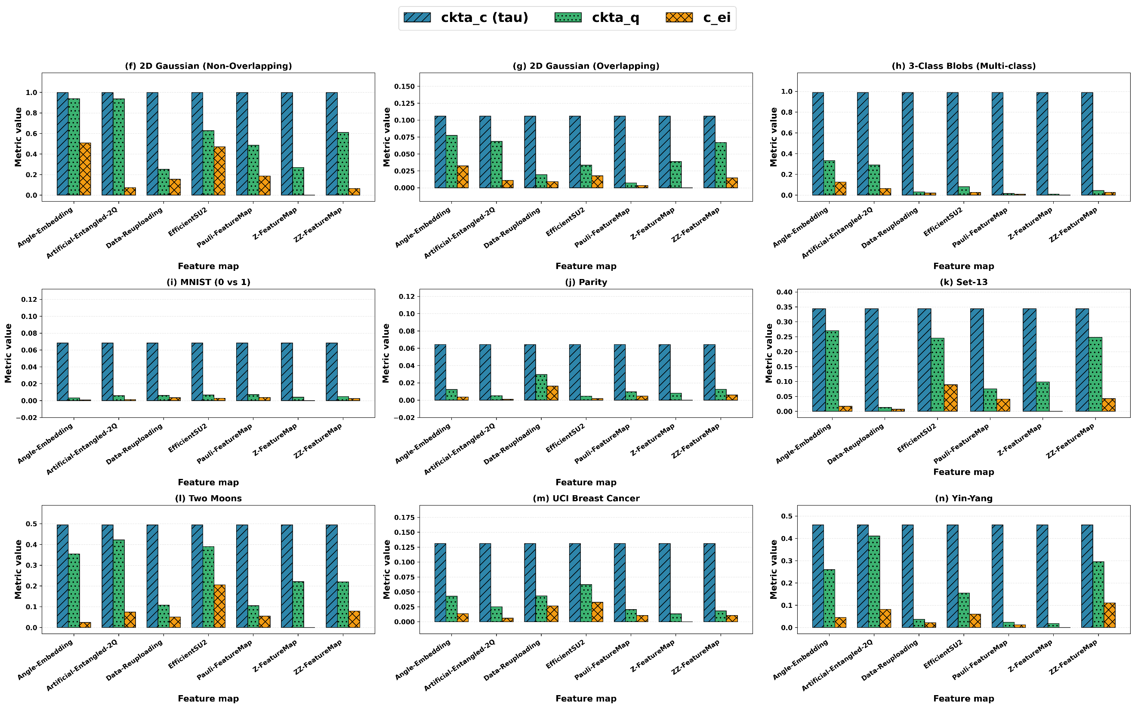

Figure 8. Summary of Classical Dominance
While the previous sections established the predictive power of QSVM on fixed datasets, we now examine its stability across varying sample sizes. Theorem 1 relies on the convergence of kernel-target alignment, which is inherently sensitive to the number of samples $N$. To investigate this, we perform scaling experiments across six representative datasets, ranging from $N =40$ to $N = 10, 000$ (Tables 1-4). We use ZZFeature map (ZZ), Pauli-Feature map (PM), and Data Uploading Feature map (DP) as QFMs. The table details the entangled information capacity $C_{EI}$, and the classical alignment ($τ$), alongside the empirical classification accuracies for the quantum (ACC_{Q}) and classical (ACC_{C}) models in percentages. The Result (RES) column denotes the validity of Theorem 1, where a PASS indicates the consistency of the theory, while the TIME column records the computational execution in seconds. As shown in the scaling tables for 2D Overlapping Gaussian (Table 1) and Two Moons (Table 2), the theory occasionally "misses" at low sample sizes ($N=40$ or $N=100$).These discrepancies support our Lemma 1.1, which states that $C_{EI}$ requires a statistically significant sample size to reach a stable state. As $N$ increases toward $500$and above, we observe consistent results with Theorem 1. This indicates that once the empirical distribution is sufficiently
Table 1. Comparative scaling analysis for the 2D Overlapping Gaussian dataset
N | QFM | $$C_{EI}$$ | $$τ$$ | ACC_{Q} | ACC_{C} | RES | TIME
40 | ZZ | 0.0535 | 0.3106 | 66.70 | 66.70 | PASS | 0.30
40 | PM | 0.0647 | 0.3106 | 58.30 | 66.70 | PASS | 0.30
40 | DP | 0.1080 | 0.3106 | 66.70 | 66.70 | PASS | 0.30
100 | ZZ | 0.0208 | 0.1783 | 63.30 | 60.00 | MISS | 0.40
100 | PM | 0.0688 | 0.1783 | 43.30 | 60.00 | PASS | 0.50
100 | DP | 0.0314 | 0.1783 | 60.00 | 60.00 | PASS | 0.70
500 | ZZ | 0.0247 | 0.1721 | 71.30 | 72.00 | PASS | 1.50
500 | PM | 0.0179 | 0.1721 | 56.70 | 72.00 | PASS | 2.00
500 | DP | 0.0243 | 0.1721 | 61.30 | 72.00 | PASS | 2.90
1000 | ZZ | 0.0228 | 0.1532 | 67.70 | 69.00 | PASS | 3.10
1000 | PM | 0.0060 | 0.1532 | 57.70 | 69.00 | PASS | 4.10
1000 | DP | 0.0134 | 0.1532 | 55.30 | 69.00 | PASS | 5.70
2000 | ZZ | 0.0146 | 0.1059 | 62.50 | 64.30 | PASS | 7.60
2000 | PM | 0.0035 | 0.1059 | 51.20 | 64.30 | PASS | 9.50
2000 | DP | 0.0090 | 0.1059 | 57.20 | 64.30 | PASS | 12.70
5000 | ZZ | 0.0210 | 0.1354 | 67.40 | 69.30 | PASS | 30.30
5000 | PM | 0.0031 | 0.1354 | 53.80 | 69.30 | PASS | 35.60
5000 | DP | 0.0031 | 0.1354 | 53.80 | 69.30 | PASS | 43.40
10000 | ZZ | 0.0178 | 0.1125 | 64.40 | 66.00 | PASS | 122.50
10000 | PM | 0.0021 | 0.1125 | 53.90 | 66.00 | PASS | 132.70
10000 | DP | 0.0044 | 0.1125 | 56.90 | 66.00 | PASS | 148.50

Table 2. Comparative scaling analysis for the Two Moons dataset
N | QFM | $$C_{EI}$$ | $$τ$$ | ACC_{Q} | ACC_{C} | RES | TIME
40 | ZZ | 0.0687 | 0.3889 | 83.30 | 75.00 | MISS | 0.40
40 | PM | 0.2199 | 0.3889 | 58.30 | 75.00 | PASS | 0.40
40 | DP | 0.1080 | 0.3889 | 66.70 | 75.00 | PASS | 0.40
100 | ZZ | 0.1098 | 0.4528 | 80.00 | 93.30 | PASS | 0.50
100 | PM | 0.0688 | 0.4528 | 60.00 | 93.30 | PASS | 0.70
100 | DP | 0.0661 | 0.4528 | 70.00 | 93.30 | PASS | 0.80
500 | ZZ | 0.0835 | 0.4690 | 97.30 | 99.30 | PASS | 1.90
500 | PM | 0.0179 | 0.4690 | 56.70 | 99.30 | PASS | 2.40
500 | DP | 0.0243 | 0.4690 | 61.30 | 99.30 | PASS | 3.20
1000 | ZZ | 0.0821 | 0.4800 | 96.70 | 99.07 | PASS | 3.10
1000 | PM | 0.0824 | 0.4800 | 75.30 | 99.07 | PASS | 4.10
1000 | DP | 0.0671 | 0.4800 | 85.70 | 99.07 | PASS | 5.70
2000 | ZZ | 0.0795 | 0.4939 | 97.50 | 98.80 | PASS | 7.30
2000 | PM | 0.0555 | 0.4939 | 77.30 | 98.80 | PASS | 9.70
2000 | DP | 0.0507 | 0.4939 | 86.20 | 98.80 | PASS | 12.60
5000 | ZZ | 0.0766 | 0.4783 | 98.70 | 99.40 | PASS | 27.00
5000 | PM | 0.0683 | 0.4783 | 78.10 | 99.40 | PASS | 32.80
5000 | DP | 0.0475 | 0.4783 | 86.30 | 99.40 | PASS | 41.40
10000 | ZZ | 0.0717 | 0.4673 | 99.00 | 99.20 | PASS | 113.30
10000 | PM | 0.0645 | 0.4673 | 79.50 | 99.20 | PASS | 121.10
10000 | DP | 0.0449 | 0.4673 | 84.20 | 99.20 | PASS | 147.10

Table 3. Comparative scaling analysis for the Yin-Yang dataset
N | QFM | $$C_{EI}$$ | $$τ$$ | ACC_{Q} | ACC_{C} | RES | TIME
40 | ZZ | 0.1328 | 0.3965 | 75.00 | 91.70 | PASS | 0.30
40 | PM | 0.0598 | 0.3965 | 58.30 | 91.70 | PASS | 0.30
40 | DP | 0.0584 | 0.3965 | 41.70 | 91.70 | PASS | 0.40
100 | ZZ | 0.0977 | 0.4176 | 80.00 | 96.70 | PASS | 0.40
100 | PM | 0.0796 | 0.4176 | 50.00 | 96.70 | PASS | 0.60
100 | DP | 0.0900 | 0.4176 | 66.07 | 96.70 | PASS | 0.70
500 | ZZ | 0.1205 | 0.4052 | 90.00 | 97.30 | PASS | 1.50
500 | PM | 0.0134 | 0.4052 | 66.00 | 97.30 | PASS | 2.00
500 | DP | 0.0208 | 0.4052 | 58.00 | 97.30 | PASS | 2.80
1000 | ZZ | 0.0986 | 0.4172 | 89.30 | 98.00 | PASS | 2.90
1000 | PM | 0.0140 | 0.4172 | 61.70 | 98.00 | PASS | 4.00
1000 | DP | 0.0112 | 0.4172 | 59.70 | 98.00 | PASS | 5.60
2000 | ZZ | 0.1108 | 0.4602 | 91.70 | 97.80 | PASS | 7.60
2000 | PM | 0.0120 | 0.4602 | 64.20 | 97.80 | PASS | 9.50
2000 | DP | 0.0211 | 0.4602 | 65.30 | 97.80 | PASS | 12.70
5000 | ZZ | 0.1005 | 0.4300 | 92.60 | 99.50 | PASS | 27.30
5000 | PM | 0.0116 | 0.4300 | 64.20 | 99.50 | PASS | 32.00
5000 | DP | 0.0107 | 0.4300 | 58.90 | 99.50 | PASS | 40.40
10000 | ZZ | 0.0990 | 0.4279 | 64.40 | 99.00 | PASS | 102.30
10000 | PM | 0.0131 | 0.4279 | 53.90 | 99.00 | PASS | 114.30
10000 | DP | 0.0116 | 0.4279 | 56.90 | 99.00 | PASS | 137.90

approximates the true data distribution, the relationship between $C_{EI}$ and $τ$ becomes a rigorous predictor of performance.
Table 4. Comparative scaling analysis for the Toroidal dataset
N | QFM | $$C_{EI}$$ | $$τ$$ | ACC_{Q} | ACC_{C} | RES | TIME
40 | ZZ | 0.2460 | 0.5956 | 91.70 | 100.00 | PASS | 0.40
40 | PM | 0.0753 | 0.5956 | 66.70 | 100.00 | PASS | 0.30
40 | DP | 0.1389 | 0.5956 | 41.70 | 100.00 | PASS | 0.40
100 | ZZ | 0.1777 | 0.4470 | 100.00 | 100.00 | MISS | 0.40
100 | PM | 0.1148 | 0.4470 | 80.00 | 100.00 | PASS | 0.60
100 | DP | 0.0288 | 0.4470 | 53.30 | 100.00 | PASS | 0.70
500 | ZZ | 0.2334 | 0.4427 | 98.00 | 100.00 | PASS | 1.60
500 | PM | 0.0394 | 0.4427 | 73.30 | 100.00 | PASS | 2.00
500 | DP | 0.0190 | 0.4427 | 64.00 | 100.00 | PASS | 2.80
1000 | ZZ | 0.2399 | 0.4514 | 100.00 | 100.00 | MISS | 3.00
1000 | PM | 0.0304 | 0.4514 | 72.00 | 100.00 | PASS | 4.00
1000 | DP | 0.0240 | 0.4514 | 59.70 | 100.00 | PASS | 5.60
2000 | ZZ | 0.2582 | 0.4316 | 99.80 | 100.00 | PASS | 6.90
2000 | PM | 0.0300 | 0.4316 | 73.30 | 100.00 | PASS | 9.00
2000 | DP | 0.0189 | 0.4316 | 60.50 | 100.00 | PASS | 12.30
5000 | ZZ | 0.2517 | 0.4401 | 99.70 | 100.00 | PASS | 27.80
5000 | PM | 0.0286 | 0.4401 | 71.20 | 100.00 | PASS | 32.90
5000 | DP | 0.0119 | 0.4401 | 63.60 | 100.00 | PASS | 41.00
10000 | ZZ | 0.2410 | 0.4395 | 99.50 | 100.00 | PASS | 115.70
10000 | PM | 0.0279 | 0.4395 | 70.50 | 100.00 | PASS | 125.10
10000 | DP | 0.0179 | 0.4395 | 63.90 | 100.00 | PASS | 141.90

In more structured datasets like Yin-Yang and Toroidal, the $C_{EI}$ metric remains a robust predictor even at lower scales. Despite the QSVM and SVM both achieving near-perfect scores, the $C_{EI}$ consistently remains below $τ$ across the entire scaling range. This suggests that for datasets with high geometric symmetry, the "Entanglement Gain" offered by the quantum feature map is correctly identified as redundant relative to classical methods, regardless of $N$.
Finally, the scaling results highlight the efficiency of the $C_{EI}$ as a pre-screening tool. While the time to train the QSVM grows cubically with $N$ (exceeding 140s for $N=10,000$), calculating the $C_{EI}$ and $τ$ alignment remains significantly faster. This reinforces $C_{EI}$ as a computationally efficient "gatekeeper" that can prevent the deployment of expensive quantum resources on classically dominant datasets.

CHAPTER 4

IMPACT AND LIMITATIONS OF $C_{EI}$ FRAMEWORK

4.1 Impact of the $C_{EI}$ Framework
The introduction of the Entangled Information Capacity framework yields three immediate, paradigm-shifting impacts on the design and deployment of quantum algorithms:
An Objective Measure for Feature Map Optimization. Historically, the design QFMs have been highly heuristic, relying on trial-and-error combinations of parameterized rotation and entanglement gates. Theorem 1 transforms QFM design into an objective optimization problem. Because the components of $C_{EI}$ are defined mathematically, $C_{EI}$ can act as a differentiable quality metric or loss function. As will be detailed in Chapter 3, this framework has been successfully operationalized: we introduce trainable quantum kernel algorithms utilizing $C_{EI}$ as its objective function, which achieves statistically significant performance improvements over classical kernel SVMs.
A Dataset-Specific Quality Baseline. As established in the empirical evaluations, entanglement is not universally advantageous; its utility is entirely dependent on the topology of the input data (Table 4). The $C_{EI}$ criterion explicitly couples the physical properties of the quantum state to the target labels via the CKTA. Therefore, it serves as a highly tailored quality measure, proving definitively whether a specific feature map is "good" for a specific dataset, rather than relying on generalized claims of quantum expressivity.
An A Priori Diagnostic Tool for Classical Data. The $C_{EI}$ framework acts as a diagnostic gatekeeper. Before investing significant computational resources into training, a large-scale quantum model on physical hardware, researchers can evaluate a subset of the dataset using the $C_{EI}$ metric. If the maximally achievable $C_{EI}$ for a given data distribution fails to exceed the optimal classical threshold, it mathematically proves that deploying a quantum algorithm will yield no structural advantage. This allows the industry to rapidly screen classical datasets and identify the rare distributions where QML is genuinely warranted.

4.2 Limitations of $C_{EI}$-Framework
While the condition $C_{EI} > τ$ provides an absolute theoretical guarantee of the structural alignment advantage, the practical application of this theorem is currently constrained by the following limitations:
The Bipartite Constraint of the CHSH Inequality. The current mathematical formulation of the non-locality gate relies on $δ_{CHSH}\left(x\right),$which inherently quantifies two-qubit correlations. Consequently, the initial empirical validations establishing this theorem were conducted within 2-qubit architectural constraints. While this perfectly bounds the foundational theory, scaling the framework to capture true multi-partite entanglement (such as GHZ-state entanglement [34]) requires integrating broader non-locality metrics . Validating how $C_{EI}$ behaves when utilizing these multi-qubit quantification techniques remains a necessary vector for future empirical experimentation.
Heuristic Bounding of the Gating Parameter ($κ$). The entanglement gain utilizes a scaling hyperparameter, $κ$ which was heuristically set $κ=10.00$ during empirical evaluation. Currently, this parameter is not bound by a formal theoretical upper limit or a data-dependent derivation rule. The exact sensitivity of the $C_{EI}$ threshold to fluctuations in $κ$, and how this parameter alters the bounding behavior of the metric across different dataset complexities, requires theoretical tightening to fully formalize the model's structural guarantees.
The Assumption of Fault-Tolerant Coherence. The theorem is fundamentally an information-theoretic bound; it evaluates the capacity of the quantum states exactly as defined by the underlying mathematics, without inherently penalizing for the hardware noise native to Noisy Intermediate-Scale Quantum (NISQ) devices. In a physical deployment, gate errors and decoherence will rapidly degrade both the entanglement magnitude and the non-local correlations. A quantum feature map might theoretically satisfy $C_{EI}$ > $τ$, but fail to demonstrate an advantage in reality because hardware noise suppresses the physical execution below the required threshold.

CHAPTER 5

ALGORITHMS FOR THE TRAINABLE QUANTUM KERNEL
The Entangled Information Capacity ($C_{EI}$) framework, formalized in CHAPTER 2, definitively bounds empirical quantum advantage in terms of performance metric. However, discovering a static quantum feature map that organically satisfies the required threshold of $C_{EI}$ > $τ$ relies largely on mathematical serendipity. For quantum machine learning models to be practically viable, the generation of task-relevant entanglement cannot be left to chance—it must be explicitly engineered. This chapter transitions the $C_{EI}$ metric from a theoretical benchmark to an operational objective function. We introduce two algorithms that natively exploit this framework. The first is a generalized optimization algorithm designed to actively train parameterized quantum circuits by maximizing $C_{EI}$. The second is Anchor-Based Entanglement-Driven Classification (EDC), a novel semi-supervised approach that discards the classical SVM classification head in favor of utilizing the explicitly optimized quantum entanglement as a direct, structural measure of inter-class similarity.

5.1 Algorithm I: $C_{EI}$-Driven Quantum Kernel Optimization
To operationalize the Entangled Information Capacity ($C_{EI}$ ) framework, we introduce a dynamic optimization algorithm. Instead of relying on static, heuristically designed quantum feature maps, this algorithm actively trains parameterized quantum circuits using $C_{EI}$ as a differentiable objective function. This forces the quantum embedding to simultaneously maximize geometric class separation and non-local entanglement.
Input. Classical dataset $D={\left\{\left(x_{i},y_{i}\right)\right\}}_{i=1}^{N}$, where $x_{i}∈R^{d}$ and $y_{i}∈\{0,1\}$.
- A parameterized QFM $U(θ,x)$ with trainable parameters $θ$ (e.g., utilizing $R_{X},R_{Y},R_{Z}$ and CNOT gates).
- A trainable hyperparameter $κ$ controlling the steepness of the entanglement gain function.
Output. Optimized quantum circuit parameters $θ^{*}$ and classification predictions.

5.1.1 Methodology
Initially, the classical features undergo a strict preprocessing phase where they are standardized and min-max scaled to project the data entirely into the angular domain of $0$ to $π$. This angular projection ensures mathematical compatibility with the Pauli rotation gates utilized in the parameterized quantum feature map (Figure 9). For a given epoch, the classical data is embedded into the quantum device using the current state of the trainable circuit parameters. The quantum algorithm prepares the corresponding quantum states and computes their pairwise inner product overlaps, thereby constructing the quantum Gram matrix. By applying a centering matrix to both this quantum Gram matrix and the classical target label matrix, the algorithm computes the Frobenius inner product to extract the geometric CKTA.
Simultaneously, the algorithm measures the structural, non-local properties of the generated quantum states to compute the entanglement penalties. First, the bipartite non-locality is quantified by measuring Pauli tensor observables across the states. These values are normalized via a smooth softplus function against the Tsirelson bound to capture the degree to which the states violate classical local hidden variable limits. Next, the algorithm calculates the Rényi-2 entropy by applying a partial trace to extract the reduced density matrices of the individual qubits, measuring their purity to quantify global entanglement. These two metrics are combined through a hyperbolic tangent function, governed by a trainable steepness parameter $κ$, to compute the overall Entanglement Gain. The final loss function is defined as the negative product of this Entanglement Gain and the CKTA_{Q}. Using automatic differentiation, the classical optimizer calculates the gradients of this loss landscape and updates the quantum feature map circuit parameters. Upon convergence, the optimized parameters are extracted to generate the final training and testing kernel matrices, which are seamlessly passed to a classical SVM for precomputed downstream inference.
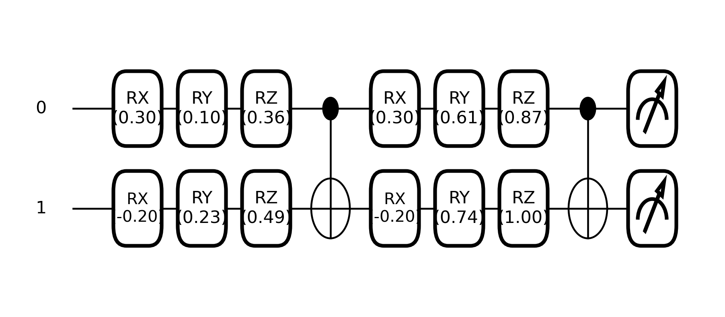

Figure 3. Encoding Classical Data into Quantum States using Quantum Feature Map.
Figure 9. Two-qubit data re-uploading circuit with parameterized RX, RY, RZ gates, repeated layers, CNOT entanglement, and measurement
From a computational perspective, the complexity of this optimization routine is fundamentally governed by the training sample budget. Preparing the quantum states requires time proportional to the product of the sample size and the circuit depth. However, constructing the Gram matrix scales quadratically with the number of training samples, requiring $O\left(N^{2}\right)$ pairwise inner product calculations. While extracting the reduced density matrices for the entropy calculations scales exponentially with the number of qubits, this acts as a manageable constant factor for shallow, few-qubit topologies. Consequently, the per-epoch time complexity is strictly dominated by the quadratic scaling of the Gram matrix construction. Because the $C_{EI}$ formulation provides a highly constrained, physically grounded inductive bias, the training sample size can be kept intentionally small. This allows the optimization loop to execute rapidly, offloading the heavier computational burden to the validation phase where the optimized circuit evaluates the broader testing distribution.

5.1.2 Result Analysis
To rigorously validate whether the resulting optimized quantum model offers a genuine structural advantage over an optimal classical RBF baseline, empirical accuracy alone is insufficient. We employ McNemar's statistical test [35], a non-parametric method specifically designed for paired nominal data. Because the quantum and classical models are evaluated on the exact same test instances, their predictions are inherently paired. McNemar's test isolates the specific instances of discordant predictions—scenarios where the quantum model classifies a point correctly while the classical model fails, and vice versa. By computing the $χ^{2}$ statistic across these disagreements, the test yields a $p$-value that mathematically confirms whether an observed performance advantage is a fundamental algorithmic superiority ($p < 0.05$) or merely a random artifact of the sampling distribution.
In Table 5, we show empirical evaluations across diverse structural distributions strictly validate the predictive power of the $C_{EI}$ objective. A "Yes" value in the S.S column confirms that the algorithmic advantage of the $C_{EI}$-optimized kernel reaches statistical significance at the 95% confidence level. Additionally, the $κ$ column denotes the final converged value of the trainable hyperparameter that dynamically scales the steepness of the entanglement gain.
Table 5. Comparative performance analysis of the $C_{EI}$-driven optimized QSVM (ACC_{Q}) against a static QFM (ACC_{Z}) and an optimal classical RBF SVM (ACC_{C})
DS | N_{TRN} | N_{TEST} | $$C_{EI*}$$ | $$τ$$ | ACC_{Q} | ACC_{Z} | ACC_{C} | $$κ$$ | S. S
OVLP | 50 | 99950 | 0.1171 | 0.1023 | 64.13 | 56.25 | 61.84 | 3.76 | YES
OVLP | 50 | 10K | 0.2344 | 0.1279 | 66.82 | 59.98 | 66.08 | 6.71 | YES
OVLP | 10K | 10K | 0.1266 | 0.1042 | 66.79 | 65.27 | 66.67 | 3.84 | NO
S-10 | 10K | 10K | 0.2949 | 0.2817 | 67.97 | 67.70 | 67.48 | 3.83 | YES
S-13 | 10K | 10K | 0.3750 | 0.3208 | 79.45 | 71.90 | 78.64 | 3.92 | YES

To establish a comprehensive baseline, the dynamically optimized quantum kernel was evaluated not only against classical RBF models but also against a standard QSVM utilizing a static, heuristically chosen ZZFeatureMap. For complex, non-linear manifolds like the Set-10 dataset, the optimization successfully shaped the quantum embedding to capture deep correlations, yielding a robust $C_{EI}$ score of $0.2949$. This allowed the optimized algorithm to strictly outperform both the classical RBF model and the static ZZFeatureMap QSVM, securing a statistically significant accuracy advantage confirmed by a McNemar $p$-value of $0.0303$. This structural advantage was even more pronounced in the Set-13 distribution, where the optimized circuit achieved a $C_{EI}$ alignment of $0.3750$, outperforming the classical baseline with statistical certainty ($p≈2.18×{10}^{-10}$).
Conversely, the algorithm correctly identifies regimes of classical dominance. In the overlap_gaussian dataset, which consists of linearly separable clusters lacking complex geometry, the classical RBF kernel optimally resolves the distribution. Forcing this data into an entangled quantum space yields no structural benefit over classical methods, as reflected by a lack of statistical significance ($p≈$ $0.3560$). However, a critical resource advantage emerges under strict data scarcity. When the classical model is artificially restricted to an ultra-low budget of just $50$ training points, it suffers from severe small-sample variance and fails to construct a reliable decision boundary. Under these exact constraints, the $C_{EI}$ optimization acts as a rigid regularizer. Because the algorithm must satisfy the heavy entanglement penalties, the quantum circuit bypasses the classical overfitting trap. This unique dynamic allows the trainable quantum kernel to produce statistically significant performance edges in heavily constrained environments, cementing its value over both static quantum embeddings and standard classical methods for sparse-data applications.
As detailed in Table 5, the empirical data explicitly confirms Theorem 1 from Chapter 2; whenever the optimized QSVM achieves a structural performance gain, the condition $C_{EI} > τ$ is strictly met, proving the underlying theory holds for this dynamic algorithm.

5.2 Algorithm II: Anchor-Based Entanglement-Driven Classification (AB-EDC)
While the $C_{EI}$-driven optimization framework presented in Algorithm I represents the theoretical standard for quantum kernel methods—strictly satisfying the alignment bounds of Theorem 1 and maximizing absolute classification accuracy—it remains fundamentally constrained by its $O\left(N^{2}\right)$ scaling. For datasets of trivial size, the exact QSVM provides unparalleled geometric precision. However, as dataset sizes scale into the tens of thousands or millions, evaluating the full $N×N$ Gram matrix becomes computationally intractable, requiring exponential quantum circuit executions and prohibitive memory storage.
Anchor-Based Entanglement-Driven Classification (AB-EDC) is introduced not to strictly maximize marginal accuracy, but as a pragmatic, highly scalable compromise. By reducing both training and inference complexity to a sub-quadratic $O(n⋅M)$ scale, AB-EDC sacrifices strict, global adherence to the capacity thresholds of Theorem 1 in exchange for deployability. In real-world environments requiring streaming online inference or operation under severe memory constraints, AB-EDC proves to be a vastly superior algorithmic choice. It preserves the core non-local advantages of the optimized quantum feature space while reducing the per-query classification cost by orders of magnitude, enabling quantum machine learning to operate on previously prohibitive big-data corpora.
Input. Classical dataset $D_{L}={\left\{\left(x_{i},y_{i}\right)\right\}}_{i=1}^{N}$, where $x_{i}∈R^{d}$ and $y_{i}∈\{0, 1\}$.
- Unlabeled dataset $D_{U}={\left\{x_{u}\right\}}_{u=1}^{N_{U}}$.
- A parameterized QFM $U(θ,x)$ with trainable parameters $θ$ (e.g., utilizing $R_{X},R_{Y},R_{Z}$ and CNOT gates).
- Expectation-Maximization (EM) rounds $R,$ margin threshold $σ$.
- Number of anchors per class, $M$.
Output. Optimized quantum circuit parameters $θ^{*}$ and classification predictions.

5.2.1 Methodology
To achieve this sub-quadratic scaling, AB-EDC discards the traditional global hyperplane in favor of localized entanglement measurements against a defined set of class prototypes. Specifically, the algorithm replaces the massive, square Gram matrix with a highly condensed, rectangular cross-kernel matrix, denoted as $K_{\text{cross }}∈R^{N×M}$. Here, $N$ represents the full dataset and $M$ represents a small, fixed number of anchor states ($M≪N$) derived via K-Means clustering in the input space.
The quantum fidelity between the quantum states of training data and the anchors defines the elements of this cross-kernel matrix:
$$\begin{aligned}K_{\text{cross }}\left[i,j\right]={\left|\left\langle ψ_{θ}\left(x_{i}\right)∣ψ_{θ}\left(a_{j}\right)\right\rangle \right|}^{2}.\#\left(32\right)\end{aligned}$$
Here, $x_{i}$ is a training point and $a_{j}$ is an anchor state.
The theoretical validity of replacing the exact kernel with this cross-kernel rests on the formulation of the Cross-CKTA objective. Standard CKTA requires a square matrix to compute the Frobenius inner product between the feature space geometry and the target labels. To adapt this, EDC applies rectangular centering matrices to independently center the training and anchor dimensions:
$$\begin{aligned}\begin{aligned}H_{N}&=I_{N}-\frac{1}{N}1_{N}1_{N}^{T}∈R^{N×N}. \\ H_{M}&=I_{M}-\frac{1}{M}1_{M}1_{M}^{T}∈R^{M×M}.\end{aligned}\#\left(33\right)\end{aligned}$$
By centering the rectangular cross-matrices along both dimensions, the algorithm computes the Cross-CKTA alignment score as:
$$\begin{aligned}CKTA_{\text{cross }}=\frac{{\left\langle H_{N}K_{\text{cross }}H_{M},H_{N}Y_{\text{cross }}H_{M}\right\rangle }_{F}}{{\left\|H_{N}K_{\text{cross }}H_{M}\right\|}_{F}⋅{\left\|H_{N}Y_{\text{cross }}H_{M}\right\|}_{F}}.\#\left(34\right)\end{aligned}$$
Where, $Y_{\text{cross }}∈R^{N×M}$ is the cross-label matrix defined such that $Y_{\text{cross }}\left[i,j\right]=+1$ if the label $y_{i}$ matches the anchor class $c_{j}$, and $-1$ otherwise.
If the K-Means centroids adequately approximate the true class means in the RKHS, the geometric distance between a data point and an anchor inherently proxies the point's distance to the broader class distribution. So, this rectangular alignment serves as a robust proxy for the full dataset geometry because the selected anchors function as sufficient statistics for their classes. While this approximation introduces a slight relaxation of the rigorous $C_{EI}$ bounds established in Chapter 2, it provides a mathematically sound, differentiable pathway that compresses the computational footprint of quantum classification.
Beyond its geometric efficiency, AB-EDC natively supports a semi-supervised Expectation-Maximization (EM) refinement loop, allowing the model to leverage massive unannotated corpora. During the E-step, the algorithm scores unlabeled data points using the current anchor set, assigning high-confidence pseudo-labels to inputs that exceed a strict margin threshold. In the M-step, the K-Means anchor selection is re-run on the augmented pool of ground-truth and pseudo-labelled data to refine the anchor positions. Crucially, because the quantum feature map parameters $θ$ remain fixed during this loop, the computationally expensive quantum circuit optimization does not need to be re-evaluated.
At inference time, AB-EDC discards the traditional SVM decision boundary entirely. Instead, each incoming test point is classified by computing its quantum fidelity against the refined class anchors. Their influence is strictly weighted by their quantum entanglement. The algorithm computes the Rényi-2 entropy and CHSH violation, for each anchor state to quantify its entanglement purity, applying the softmax function within each class to derive an entanglement weight, $w_{j}$. The final classification is determined by an entanglement-weighted anchor similarity score:
$$\begin{aligned}\hat{y}=arg{\max_{c}} \left(\sum_{j∈A_{c}}{ }w_{j}⋅{\left|\left\langle ψ\left(x\right)∣ψ\left(a_{j}\right)\right\rangle \right|}^{2}\right).\#\left(35\right)\end{aligned}$$
This weighting mechanism is driven by the physical intuition that a highly entangled anchor state encodes richer, non-local correlations regarding its class distribution. To maximize these theoretical advantages in simulation, EDC utilizes a highly optimized fast-evaluation pipeline. By collecting the $N$ statevectors in a single batched pass, the algorithm computes the fidelity cross-kernels, Pauli expectation values, and CHSH violations analytically using vectorized matrix multiplications, dropping the requirement for additional quantum circuit calls to zero and enabling the deployment of quantum kernels on datasets previously deemed computationally intractable.

5.2.2 Result Analysis
To validate the Anchor-Based Entanglement-Driven Classification (EDC) algorithm, we must measure the precise trade-off between computational scalability and geometric exactness. In Table 6, we benchmark $C_{EI}$-driven optimized QSVM against static quantum circuits and full-rank classical RBF-SVM models and demonstrate that EDC strictly outperforms standard quantum baselines while successfully preserving the non-local alignment advantages of the $C_{EI}$objective at a fraction of the traditional computational cost.
Table 6. Comparative performance analysis of the EDC-driven QSVM (ACC_{Q}) against a static QFM (ACC_{Z}) and an optimal classical RBF SVM (ACC_{C})
DS | N_{TRN} | N_{TEST} | $$C_{EI*}$$ | $$τ$$ | ACC_{Q} | ACC_{Z} | ACC_{C} | CKA_{Q} | CHSH
OVLP | 10K | 10K | 0.2923 | 0.0789 | 66.63 | 65.27 | 66.67 | 0.1438 | 0.7561
S-10 | 10K | 10K | 0.2510 | 0.1714 | 66.64 | 67.77 | 67.38 | 0.1289 | 0.8424
S-13 | 10K | 10K | 0.3750 | 0.3208 | 78.18 | 71.13 | 78.28 | 0.6357 | 0.6582

The empirical results immediately validate the core premise of the $C_{EI}$ objective: actively optimizing for task-relevant, non-local entanglement structurally outperforms heuristic, static quantum circuits. In the linearly separable overlapping Gaussian distribution, the $C_{EI}$-driven EDC algorithm achieved an accuracy of 66.63%, cleanly exceeding the static quantum baseline (65.27%). This performance gap widened dramatically in highly complex, non-linear distributions. On the Set-13 manifold, the static quantum embedding struggled to map the geometric complexity, yielding an accuracy of 71.13%. In stark contrast, the EDC algorithm successfully navigated this topology to achieve 78.18% accuracy. By enforcing the simultaneous maximization of geometric alignment (CKTA_{Q}) and Bell violation ($δ_{CHSH} = 0.6580$) EDC ensures that the generated quantum correlations are actively discriminative, preventing the model from collapsing into geometrically redundant Hilbert spaces.
The true success of the AB-EDC algorithm lies not just in its raw comparable accuracy, but in the structural characteristics of its learned feature space. Even while operating under severe computational approximations, the algorithm successfully forces the quantum geometry to align with the target labels far better than classical methods. In the Set-13 dataset, while the test accuracies of EDC and the RBF-SVM were virtually identical (78.18% vs. 78.28%), the optimized quantum kernel achieved a CKTA_{Q} of 0.6357—outperforming the classical capacity limit ($τ$ or CKTA_{C}) of 0.308. It confirms that the underlying theoretical bounds established in Chapter 2 hold even under approximation. The $C_{EI}$ optimization natively constructs a feature space with vastly superior label alignment, but the final translation to absolute classification accuracy is slightly bottlenecked by the localized anchor evaluation. Ultimately, the AB-EDC algorithm successfully achieves its pragmatic design goal: it trades a fraction of a percent in marginal accuracy to collapse an intractable $O\left(N^{2}\right)$ computational problem, delivering a deployable, highly competitive quantum diagnostic model capable of processing massive biomedical datasets.

CHAPTER 6

PROJECT TIMELINE AND DELIVERABLES
In previous chapters, we introduced the theoretical bounds of the Entangled Information Capacity ${(C}_{EI}$) framework and operationalized it through the $C_{EI}$ Driven Quantum Kernel Optimization and Anchor-Based Entanglement-Driven Classification (AB-EDC) algorithms. We demonstrated that explicitly optimizing for quantum entanglement yields strict structural advantages over classical SVMs on synthetic manifolds. To complete this dissertation work, we must transition these algorithms from synthetic benchmarks to critical healthcare applications. We need to address three central questions:
How can the $C_{EI}$ framework improve the classification of real-world, high-dimensional biomedical data? Classical machine learning architectures struggle with the low fidelity and complex noise profiles of clinical datasets. We will investigate how the optimized quantum feature space can extract task-relevant, non-local correlations for continuous EEG seizure detection and breast cancer detection from digital pathology slides.
How can the $C_{EI}$-optimized QSVM enhance frame-level classification? Both EEG signals and digital pathology whole slide images (WSIs) require processing vast sequences of localized "frames" or "patches." We will explore how quantum kernels, parameterized by $C_{EI}$, can increase sensitivity and reduce false alarms at the granular frame level.
How can entanglement-driven features improve the localization and microsegmentation of target events? Beyond binary classification, clinical utility requires precise spatiotemporal localization. We will investigate how anchor-based entanglement measurements can accurately map the boundaries of EEG seizure onsets and the spatial morphology of breast cancer tumors.
In the following sections, we will present our detailed plans for these tasks, review the foundational work in these respective domains, and outline our proposed quantum-enhanced solutions.

6.1 Problem Statement
Classification performance, generalization, and precise localization are critical bottlenecks in automated medical diagnostics. In domains such as continuous EEG interpretation and digital pathology, standard deep learning architectures often act as "black boxes" that struggle to separate rare, pathological events from complex background noise. In EEG analysis, this results in unacceptably high false alarm rates. In digital pathology, this manifests as difficulty in accurately microsegmenting premalignant or invasive cellular structures.
While our earlier chapters proved the algorithmic superiority of the $C_{EI}$ framework in maximizing geometric class separation, our understanding of how these quantum models will scale to ultra-high-dimensional, real-world data requires extensive empirical exploration. In this phase of the research, we aim to apply our $C_{EI}$ -optimized algorithms to these acute biomedical challenges, mapping high-dimensional spatial and temporal data into quantum feature spaces to achieve levels of clinical accuracy previously out of reach for classical models.

6.2 Related Work
The application of artificial intelligence to diagnostic histopathology and electroencephalography hinges on the availability of extensive, richly annotated data corpora and the development of architectures capable of exploiting spatial and temporal context.
In the domain of continuous biomedical signals, Golmohammadi et al. [36] explored a variety of deep learning architectures—including Convolutional Neural Networks (CNNs), Long Short-Term Memory networks (LSTMs), and hybrid recurrent-convolutional systems—for automated seizure detection. Utilizing the Temple University Hospital (TUH) EEG Corpus [37], supplemented with data from Duke University, their work demonstrated that exploiting spatial and temporal context is critical for disambiguating seizures from artifacts. However, a primary limitation of these state-of-the-art classical systems is their susceptibility to false alarms. These models frequently misclassify brief delta range slowing patterns—such as intermittent rhythmic delta activity observed during inter-ictal stages—as active seizure events.
Similarly, in the domain of high-dimensional spatial arrays, traditional microscopy workflows are constrained by inter-observer variability and manual subjectivity. Hackel et al. [38] highlighted the necessity of digital whole slide imaging and deep learning to enable reliable microsegmentation and morphology analysis. Their work introduced the Temple University Hospital Digital Pathology Breast Tissue Subset (TUBR) [39] and the Fox Chase Cancer Center Digital Pathology Breast Tissue Subset (FCBR) [40], which collectively provide thousands of extensively annotated images ranging from normal tissue to invasive carcinomas. Baseline classical models, such as EfficientNet, achieved weighted DICE scores ranging from 46.02% to 51.10% on these corpora, underscoring the immense difficulty classical convolutional architectures face when attempting to establish highly accurate microsegmentation boundaries across highly variable histological sections

6.3 Proposed Approach
Classical deep learning models—whether LSTMs processing EEG sequences or CNNs evaluating DPATH slides—face severe generalization limitations when mapping complex biomedical noise profiles. The $C_{EI}$ framework offers a theoretical and operational mechanism to project these structures into a highly expressive, non-local quantum feature space.
Improving Frame-Level Classification. To address the high false alarm rates in the TUH EEG Corpus and the low DICE scores in the DPATH breast cancer corpora, we will adapt the $C_{EI}$-Driven Quantum Kernel Optimization algorithm to process segmented frames. Instead of feeding raw temporal windows or spatial image patches into classical classifiers, these segments will be mapped to quantum states. By forcing the quantum feature map to maximize the Entangled Information Capacity across training crops, the resulting kernel will rely strictly on deep, non-local correlational structures. We hypothesize that artifacts resembling seizures (e.g., rhythmic delta activity) or benign anomalies resembling tumors will fail to generate the threshold entanglement gain ($G$) required by our objective function, structurally suppressing false positive classifications at the frame level.
Enhancing Tumor and Seizure Localization. Precise localization—whether temporal bounding of a seizure event or spatial microsegmentation of a breast cancer tumor—can be framed as a continuous similarity search. We will deploy the Anchor-Based Entanglement-Driven Classification (EDC) algorithm to map these boundaries. During training, the algorithm will identify highly entangled "anchor" states corresponding to definitively malignant tissues (from TUBR/FCBR) or established ictal phases (from TUEG). During inference, a sliding window will traverse the continuous EEG signal or the gigapixel digital pathology slide. Each frame will be quantumly entangled with the predefined anchor states. By measuring the resultant CHSH violation and Rényi-2 entropy, the algorithm will generate an "Entanglement Heatmap." Frames yielding high bipartite non-locality with the anchors will be classified as target events, inherently generating precise, high-resolution bounding boxes and microsegmentation masks that bypass the spatial saturation problems of classical convolutional pooling layers.

CHAPTER 7

Research plan
May 15 - June 30:
- Complete data preparation and standardization for the frame-level extraction of the TUEG Seizure Corpus and the DPATH (TUBR) breast cancer subsets.
- Establish classical capacity threshold for both datasets.
- Draft the journal publication detailing the proposed $C_{EI}$ framework.
July 01 - August 30:
- Execute the $C_{EI}$-Driven Quantum Kernel Optimization on the TUEG and DPATH datasets.
- Tune the steepness hyperparameter ($κ$) to balance entanglement gain.
- Ensure that the theoretical $C_{EI}$ against quantum hardware noise simulation profiles.
September 01 - October 31:
- Evaluate the optimized QSVM on the test sets for frame-level classification.
- Analyze false positive reduction rates, specifically tracking model behavior against delta range slowing patterns in EEGs and benign tissue noise in pathology slides.
- Draft the journal publication detailing the proposed $C_{EI}$ driven kernel optimization algorithms.
November 01 - December 31:
- Implement the Anchor-Based EDC algorithm for localization tasks.
- Generate spatial Entanglement Heatmaps for the TUEG.
- Diagnose and debug problems related to the TUEG experiments.
January 01 - January 31:
- Implement the Anchor-Based EDC algorithm for localization tasks.
- Generate spatial Entanglement Heatmaps for the TUBR.
- Diagnose and debug problems related to the TUBR experiments.
February 01 - February 28:
- Start analysis of different trials using visualization experiments.
- Write down the results of training on TUSZ and TUBR.
- Write down the results of training on both datasets.
March 01 -March 15:
- Wrap up visualization experiments.
- Finalize comparative analysis between the $C_{EI}$-optimized quantum architectures and state-of-the-art deep learning models.
- Synthesize visualization data to interpret the behavior of the quantum feature maps.
March 15 - March 31:
- Finalize the draft of the dissertation.
April 15:
- Defense and submission of dissertation to the dissertation examiner.

REFERENCES
[1] M. A. Nielsen and I. L. Chuang, Quantum Computation and Quantum Information: 10th Anniversary Edition. Cambridge University Press, 2010.
[2] C. Cortes and V. Vapnik, “Support-vector networks,” Machine Learning, vol. 20, no. 3, pp. 273–297, 1995, doi: 10.1007/BF00994018.
[3] Č. Brukner, M. Żukowski, and A. Zeilinger, “The Essence of Entanglement,” in Quantum Arrangements: Contributions in Honor of Michael Horne, G. Jaeger, D. Simon, A. V. Sergienko, D. Greenberger, and A. Zeilinger, Eds., Cham: Springer International Publishing, 2021, pp. 117–138. doi: 10.1007/978-3-030-77367-0_6.
[4] J. S. Bell, “On the Einstein Podolsky Rosen paradox,” Physics Physique Fizika, vol. 1, no. 3, pp. 195–200, Nov. 1964, doi: 10.1103/PhysicsPhysiqueFizika.1.195.
[5] J. F. Clauser, M. A. Horne, A. Shimony, and R. A. Holt, “Proposed Experiment to Test Local Hidden-Variable Theories,” Phys. Rev. Lett., vol. 23, no. 15, pp. 880–884, Oct. 1969, doi: 10.1103/PhysRevLett.23.880.
[6] M. Schuld, R. Sweke, and J. J. Meyer, “Effect of data encoding on the expressive power of variational quantum-machine-learning models,” Phys. Rev. A, vol. 103, no. 3, p. 032430, Mar. 2021, doi: 10.1103/PhysRevA.103.032430.
[7] J. Kübler, S. Buchholz, and B. Schölkopf, “The Inductive Bias of Quantum Kernels,” in Advances in Neural Information Processing Systems, Curran Associates, Inc., 2021, pp. 12661–12673. Accessed: Mar. 30, 2026. [Online]. Available: https://proceedings.neurips.cc/paper/2021/hash/69adc1e107f7f7d035d7baf04342e1ca-Abstract.html
[8] A. Abbas, D. Sutter, C. Zoufal, A. Lucchi, A. Figalli, and S. Woerner, “The power of quantum neural networks,” Nat Comput Sci, vol. 1, no. 6, pp. 403–409, Jun. 2021, doi: 10.1038/s43588-021-00084-1.
[9] H.-Y. Huang et al., “Power of data in quantum machine learning,” Nat Commun, vol. 12, no. 1, p. 2631, May 2021, doi: 10.1038/s41467-021-22539-9.
[10] M. C. Caro et al., “Generalization in quantum machine learning from few training data,” Nat Commun, vol. 13, no. 1, p. 4919, Aug. 2022, doi: 10.1038/s41467-022-32550-3.
[11] C. Ortiz Marrero, M. Kieferová, and N. Wiebe, “Entanglement-Induced Barren Plateaus,” PRX Quantum, vol. 2, no. 4, p. 040316, Oct. 2021, doi: 10.1103/PRXQuantum.2.040316.
[12] P. Rebentrost, M. Mohseni, and S. Lloyd, “Quantum Support Vector Machine for Big Data Classification,” Phys. Rev. Lett., vol. 113, no. 13, p. 130503, Sep. 2014, doi: 10.1103/PhysRevLett.113.130503.
[13] M. Schuld and N. Killoran, “Quantum Machine Learning in Feature Hilbert Spaces,” Phys. Rev. Lett., vol. 122, no. 4, p. 040504, Feb. 2019, doi: 10.1103/PhysRevLett.122.040504.
[14] V. Havlíček et al., “Supervised learning with quantum-enhanced feature spaces,” Nature, vol. 567, no. 7747, pp. 209–212, Mar. 2019, doi: 10.1038/s41586-019-0980-2.
[15] C. E. Rasmussen and C. K. I. Williams, Gaussian Processes for Machine Learning. Accessed: Mar. 30, 2026. [Online]. Available: https://direct.mit.edu/books/oa-monograph/2320/Gaussian-Processes-for-Machine-Learning
[16] D. Duvenaud, “Kernel Cookbook,” The Kernel Cookbook: Advice on Covariance functions. Accessed: Mar. 30, 2026. [Online]. Available: https://www.cs.toronto.edu/~duvenaud/cookbook/
[17] J. Bowles, S. Ahmed, and M. Schuld, “Better than classical? The subtle art of benchmarking quantum machine learning models,” Mar. 14, 2024, arXiv: arXiv:2403.07059. doi: 10.48550/arXiv.2403.07059.
[18] N. Cristianini, J. Shawe-Taylor, A. Elisseeff, and J. Kandola, “On Kernel-Target Alignment,” in Advances in Neural Information Processing Systems, MIT Press, 2001. Accessed: Mar. 15, 2026. [Online]. Available: https://proceedings.neurips.cc/paper_files/paper/2001/hash/1f71e393b3809197ed66df836fe833e5-Abstract.html
[19] C. Cortes, M. Mohri, and A. Rostamizadeh, “Algorithms for learning kernels based on centered alignment,” J. Mach. Learn. Res., vol. 13, no. 1, pp. 795–828, Mar. 2012.
[20] B. Schölkopf and A. J. Smola, Learning with Kernels: Support Vector Machines, Regularization, Optimization, and Beyond. Accessed: Mar. 31, 2026. [Online]. Available: https://direct.mit.edu/books/monograph/1821/Learning-with-KernelsSupport-Vector-Machines
[21] I. Steinwart, “On the influence of the kernel on the consistency of support vector machines,” J. Mach. Learn. Res., vol. 2, pp. 67–93, Mar. 2002, doi: 10.1162/153244302760185252.
[22] C. A. Micchelli, Y. Xu, and H. Zhang, “Universal Kernels,” J. Mach. Learn. Res., vol. 7, pp. 2651–2667, Dec. 2006.
[23] “Frobenius Norm - an overview | ScienceDirect Topics,” Studies in Mathematics and Its Applications. Accessed: Mar. 31, 2026. [Online]. Available: https://www.sciencedirect.com/topics/mathematics/frobenius-norm
[24] “Frobenius inner product,” Wikipedia. Feb. 17, 2026. Accessed: Apr. 01, 2026. [Online]. Available: https://en.wikipedia.org/w/index.php?title=Frobenius_inner_product&oldid=1338834001
[25] M. John, J. Schuhmacher, P. Barkoutsos, I. Tavernelli, and F. Tacchino, “Optimizing Quantum Classification Algorithms on Classical Benchmark Datasets,” Entropy (Basel), vol. 25, no. 6, p. 860, May 2023, doi: 10.3390/e25060860.
[26] B. S. Cirel’son, “Quantum generalizations of Bell’s inequality,” Lett Math Phys, vol. 4, no. 2, pp. 93–100, Mar. 1980, doi: 10.1007/BF00417500.
[27] C. Cortes, M. Mohri, and A. Rostamizadeh, “Generalization bounds for learning kernels,” in Proceedings of the 27th International Conference on International Conference on Machine Learning, in ICML’10. Madison, WI, USA: Omnipress, 2010, pp. 247–254.
[28] O. M. William Wolberg, “Breast Cancer Wisconsin (Diagnostic).” UCI Machine Learning Repository, 1993. doi: 10.24432/C5DW2B.
[29] Y. LeCun, C. Cortes, and Burges, “MNIST Database of Handwritten Digits.” UCI Machine Learning Repository, 1998. doi: 10.24432/C53K8Q.
[30] J. Picone, “set-10.” Accessed: Feb. 20, 2023. [Online]. Available: https://portal.gdc.cancer.gov/
[31] J. Picone, “set-13.” Accessed: Apr. 03, 2026. [Online]. Available: https://isip.piconepress.com/courses/temple/ece_8527/resources/data/set_13/
[32] “Data encoding,” IBM Quantum Learning. Accessed: Apr. 01, 2026. [Online]. Available: https://quantum.cloud.ibm.com/learning/en/courses/quantum-machine-learning/quantum.cloud.ibm.com/learning/en/courses/quantum-machine-learning/data-encoding
[33] A. Pérez-Salinas, A. Cervera-Lierta, E. Gil-Fuster, and J. I. Latorre, “Data re-uploading for a universal quantum classifier,” Quantum, vol. 4, p. 226, Feb. 2020, doi: 10.22331/q-2020-02-06-226.
[34] D. M. Greenberger, M. A. Horne, and A. Zeilinger, “Going Beyond Bell’s Theorem,” in Bell’s Theorem, Quantum Theory and Conceptions of the Universe, M. Kafatos, Ed., Dordrecht: Springer Netherlands, 1989, pp. 69–72. doi: 10.1007/978-94-017-0849-4_10.
[35] “McNemar’s test,” Wikipedia. Oct. 25, 2025. Accessed: Apr. 02, 2026. [Online]. Available: https://en.wikipedia.org/w/index.php?title=McNemar%27s_test&oldid=1318721869
[36] M. Golmohammadi, A. H. Harati Nejad Torbati, S. de Diego, I. Obeid, and J. Picone, “Automatic Analysis of EEGs Using Big Data and Hybrid Deep Learning Architectures,” Frontiers in Human Neuroscience, vol. 13, p. 76, 2019, doi: 10.3389/fnhum.2019.00076.
[37] I. Obeid and J. Picone, “The Temple University Hospital EEG Data Corpus,” in Augmentation of Brain Function: Facts, Fiction and Controversy. Volume I: Brain-Machine Interfaces, 1st ed., vol. 10, M. A. Lebedev, Ed., Lausanne, Switzerland: Frontiers Media S.A., 2016, pp. 394–398. doi: 10.3389/fnins.2016.00196.
[38] D. Hackel et al., “Enabling Microsegmentation: Digital Pathology Corpora for Advanced Model Development,” in Signal Processing in Medicine and Biology: Applications of Artificial Intelligence in Medicine and Biology, vol. 1, New York City, New York, USA: Springer, 2026, p. 50. [Online]. Available: https://isip.piconepress.com/publications/book_sections/2026/springer/dpath/
[39] M. Bagritsevich and D. Hackel, “Special Cases in the Temple University Hospital Digital Pathology Corpus: Breast Tissue Subset,” in NEDC Special Seminar, Temple University, Philadelphia, Pennsylvania, USA, Sep. 2024, pp. 1–15. url: https://isip.piconepress.com/publications/presentations_misc/2024/nedc/dpath/.
[40] M. Bagritsevich, D. Hackel, I. Obeid, and J. Picone, “Annotation of the Fox Chase Cancer Center Digital Pathology Corpus,” in Proceedings of the IEEE Signal Processing in Medicine and Biology Symposium, Philadelphia, Pennsylvania, USA: IEEE, Dec. 2024, pp. 1–4. doi: 10.1109/SPMB62441.2024.10842255.

