January 21, 2018
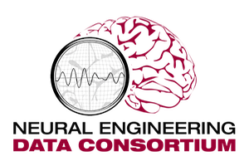
Temple University
ENGR Room 703A
1947 North 12th Street
Philadelphia, PA 19122
Tel: 215-204-4841 (office) / 662-312-4209 (cell)
Fax: 215-204-5960
Email: joseph.picone@gmail.com
URL: http://www.nedcdata.org
Frontiers in Neurology
EPFL – Innovation Square, Building 1
CH - 1015 Lausanne
Switzerland
To Whom It May Concern:
This manuscript, titled “The Temple University Hospital Seizure Detection Corpus”, is being submitted as a data report. The manuscript is not a part of a research topic and has not been submitted for publication elsewhere. We agree to notify the journal in the event we attempt to publish this work in any other journal.
The significance of this manuscript lies in the size and diversity of seizure morphologies in this database. The database is primarily designed for machine learning and AI researchers. This database is the largest publically available source of annotated seizure data in the world and more than 800 subscribers. This work is related to the “Epilepsy” specialty in that the development of an automatic seizure detection system is dependent upon the availability of a large set of high quality seizure data.
Please note this paper was originally submitted to the journal Frontiers in Neuroscience, where we published a paper describing the overall corpus, The TUH EEG Corpus, from which this data was selected:
Obeid, I., & Picone, J. (2016). The Temple University Hospital EEG Data Corpus. Frontiers in Neuroscience, Section Neural Technology, 10, 196.
The Editor of that journal, in a correspondence dated January 11, 2018, recommended this paper be resubmitted to Frontiers in Neurology.
We were asked to identify the Associate Editors from the Editorial Board that are most closely aligned with this work. We recommend Yuping Wang and Gregory Worrell.
We confirm that we agree with a change, if any, in the fees.
Best regards,

Dr. Joseph Picone
Professor, Department of Electrical and Computer Engineering
Temple University

