A Virtual Teaching Assistant
for an Open Circuits Laboratory
Abstract
Background Students prefer an open laboratory experience in which experiments can be conducted at any time. Engineering departments, however, cannot afford to provide continuous teaching assistance to support such a laboratory experience. We designed and implemented a virtual teaching assistant called Virtual Open Laboratory Teaching Assistant (VOLTA) that includes laboratory instructions, equipment usage videos, circuit simulation assistance, and hardware guides.
Purpose We conducted a series of studies over three semesters that compared students using VOLTA to a control group. The effectiveness of VOLTA was evaluated using pre-test/post-test design methods and ANOVA on test scores.
Design/Method Each semester, sophomore-level electrical engineering students were partitioned into two groups: (1) a control group taught in a traditional manner that met once per week at a pre-arranged time with a human teaching assistant, and (2) an experimental group taught once per week at pre-arranged time by a human teaching assistant that also had 24-hour access to VOLTA. In the third semester, the human teaching assistant skipped the introductory lecture to the experimental group, but was available for assistance.
Results For the first two semesters, the experimental group taught by VOLTA performed better compared to the control group, where p-value from ANOVA was 0.1714 and less than 0.001. For the third semester, the student learning was similar in the control and experimental groups.
Conclusions A well-designed virtual teaching assistant can support students in an open laboratory environment as effectively as a human teaching assistant.
Keywords Virtual teaching assistant; open laboratory; electronic circuits

Introduction
In undergraduate engineering, laboratories play an important role. The objectives of these laboratories are to reinforce classroom learning with a hands-on experience, to enhance students’ understanding of real world engineering problems, and to demonstrate how to approach those problems systematically (Ernst, 1983; Feisel & Rosa, 2005). Traditionally, students perform experiments in the laboratory on a fixed schedule under supervision of a teaching assistant. Such a format is often referred to a “closed laboratory” (Palais & Javurek, 1996). Closed laboratories have space and time constraints. As a result, students do not have much flexibility. Students often work in groups because expensive laboratory equipment is in short supply. Due to the limited availability of teaching assistants, not all students receive adequate instruction during a laboratory. Students can meet with the teaching assistants during office hours, but many students find it difficult to meet during the office hours due to scheduling constraints. Therefore, closed laboratories are not an effective use of resources (Knight & DeWeerth, 1996).
An open laboratory model can mitigate scheduling and resource utilization related issues (Kuhn, Hummels, & Dyer, 2000; Oswald & Sloan, 1971; Palais & Javurek, 1996). In an open laboratory, students can perform their experiments at any time. If necessary, they can repeat the experiments to gain a better understanding. However, providing teaching assistants around the clock for open laboratories is challenging. Virtual teaching assistants are a viable option.
In order to fill this gap, we developed a virtual teaching assistant for offering on-demand help to the students in an open laboratory. The system is called Virtual Open Laboratory Teaching Assistant (VOLTA). This web-based system is equipped with pre-laboratory instructions, topic based explanations, equipment usage videos, and assistance for performing circuit simulation and hardware experiment.
The idea of an open laboratory is not new. In 1971, Oswald and Sloan (1971) published a study on an open laboratory where students could schedule their laboratory time in two-hour blocks and perform experiments without direct supervision. Their open laboratory approach received favorable feedback from students in three different courses. In their opinion, although the instructor time did not increase, the effectiveness of instructor time increased. However, they could not reduce the time required to grade laboratory reports. Their approach eliminated the problem of a group being dominated by a single student and provided slower students the opportunity to acquire necessary experience.
Another study of an electrical engineering undergraduate open laboratory was conducted by Palais & Javurek (1996). Eleven different courses were taught over sixteen weeks in a format that allowed each lab to be available for 74 hours weekly. This study explored the effect of this format on student attendance. They also adjusted teaching assistant duty hours based on their observations of attendance. They found out that this approach reduced scheduling conflicts and made more efficient use of laboratory space. The overall feedback from students, faculty and administrators was positive.
Kuhn et al. (2000) designed a small-scale open laboratory for a senior-level RF design course. The open laboratory format provided students with the facilities and test equipment which were expensive to duplicate in multiple lab stations They found that a studio-like setting in their open laboratory enhanced the educational experience through improved interaction among students. Kuhn et al. did not provide any quantitative assessment of their approach
Our approach to an open laboratory includes a virtual tutor in addition to providing students with the ability to conduct experiments anywhere/anytime. The rest of the paper is organized as follows. In Section II we present an introduction to our approach. Section III describes technical aspects of the VOLTA design and discusses implementation issues. Section IV provides evaluation results. We conclude the paper with a discussion of future work in Section V.

A Virtual Tutor
Our approach of open laboratory provides a laboratory space, and facilitates performing the experiments outside the laboratory room as well. Previous open laboratory approaches put lower weight on the teaching assistance aspect. They surmised that the open laboratory approach would encourage students to solve their own problems, and eventually would lead to increase their self-confidence and learning (Palais & Javurek, 1996). In our approach, students were provided with a portable circuit board equipped with power supply and USB oscilloscope. Students were able to carry out their experiments outside the fixed laboratory hours. However, it is difficult to arrange human teaching assistance beyond laboratory and office hours. In this scenario, virtual teaching assistance can be effective. VOLTA is designed to provide teaching assistance in virtual format, which reduces the dependency on human teaching assistants. Previous studies (Kuhn et al., 2000; Oswald & Sloan, 1971; Palais & Javurek, 1996) did not evaluate the impact of their approaches on student learning. We evaluated the impact of our approach on student learning, and used our findings to improve VOLTA in each iteration.
VOLTA was first introduced during the fall of 2014 with basic features (Authors, 2015). Students could query the system with questions about definitions, instrument usage, and experimental procedure. The system responded with answers to the queries, which in some cases include video demonstrations. Based on the initial experience, VOLTA was redesigned in the spring of 2015, and revamped to include more hardware circuit connection assistance and more example questions collected from Fall 2014 participants. Finally, in the fall of 2015, the third version of VOLTA has been released with a Circuit Comparator, inspired by the Circuit Recognizer (CR) feature in universal virtual laboratory developed by Butz et al. (2006; 2008; 2004). The circuit recognizer and comparator can work with AC/DC voltage sources, resistors, capacitors, and inductors. The Circuit Comparator even works with diodes.
We assessed the effectiveness of VOLTA using pre-test and post-test design methods on two groups of students: control and experimental groups. In the first assessment in the fall of 2014, the control group was traditionally taught by a human teaching assistant, whereas the experimental group was taught with VOLTA and by a human teaching assistant. Since the first version of VOLTA was not equipped with all the modules that were planned, we decided to keep a human teaching assistant for the experimental group. We found comparable performance between the control and experimental groups (Authors, 2015). The second version of VOLTA was equipped with more features, and the design of experiment was kept unchanged. We found that the VOLTA taught experimental group performed much better compared to the traditionally taught control group (Authors, 2016). The third version of VOLTA was equipped with all the modules that were planned. This time, we reduced the availability and assistance of a human teaching assistant for the experimental group. Our analysis showed that the VOLTA taught experimental group did not show any difference in learning compared to the traditionally taught control group. This paper focuses the addition of the Circuit Comparator design and implementation, the effectiveness and usability analysis for the latest version of VOLTA, and the comparative study of effectiveness of VOLTA on three cohorts of students in three semesters.

Design and Implementation
In this section, we discuss the VOLTA architecture, user interface, and laboratory assistant features.

VOLTA Architecture and Software Modules
VOLTA guides a student to perform hardware electrical engineering circuits laboratory experiments similar to a human teaching assistant, except that VOLTA is available 24/7 hours. Figure 1 shows the physical architecture of VOLTA. The different modules of VOLTA, hosted in a server, are accessible via internet for the instructors, developers, and students. The students perform laboratory experiments on portable and compact circuit hardware. Since VOLTA is preloaded with instructional videos, definitions, and explanations, it supports on-demand learning and provides immediate feedback on laboratory exercises and quizzes. VOLTA also provides an administration panel for instructors for the management of the laboratory content.
Currently, VOLTA software consists of four modules and one database. The modules are (1) Instructor module, (2) Student module, (3) Help module, and (4) Circuit Checker module.

Figure 1: VOLTA architecture

Instructor module
The Instructor module provides a flexible environment for an instructor or teaching assistant to perform his/her tasks. It authorizes the students for access to VOLTA through the student module. The instructor can update the lab contents via an administration panel. It also helps upload the supporting materials into the database for the Help module.

Student module
The Student module is the part of VOLTA that interacts with the students. It guides the students step-by-step for completing an experiment. It helps the student to understand the subject clearly through tests. It evaluates the student before and after the labwork.

Help module
The Help module provides the students with teaching assistance in virtual format. The students can seek help from this module at any point of a VOLTA session. This module provides multiple sub-modules consisting of definitions of circuit terminology, questions and answers about basic circuit and the related lab. A search algorithm was deployed in VOLTA for finding the appropriate answers to the students' query.

Circuit Comparator and Circuit Tracer module
The Circuit Checker module has two sub-modules: Circuit Comparator and Circuit Tracer. The objective of the Circuit Comparator is to verify the students’ simulated circuits. The Circuit Tracer helps students verify the hardware circuit connections.

Implementation and User Interface
VOLTA is implemented using Python (version 2.7.1) and Django (version 1.6.5). Django is a high-level Python web framework for rapid and scalable web development (“Meet Django,” 2016). This framework consists of model, view, and template layers. It generates a dynamic webpage for each user. VOLTA provides a user-friendly administration panel which gives access in VOLTA database. The lab course materials can be loaded into VOLTA in two ways: via python scripts and via the administration panel. Before making the website live, it is more convenient to load the content using scripts. After making the website live, the administration panel is used for maintaining and updating content. In this way, one can easily avoid overwriting the current user information.
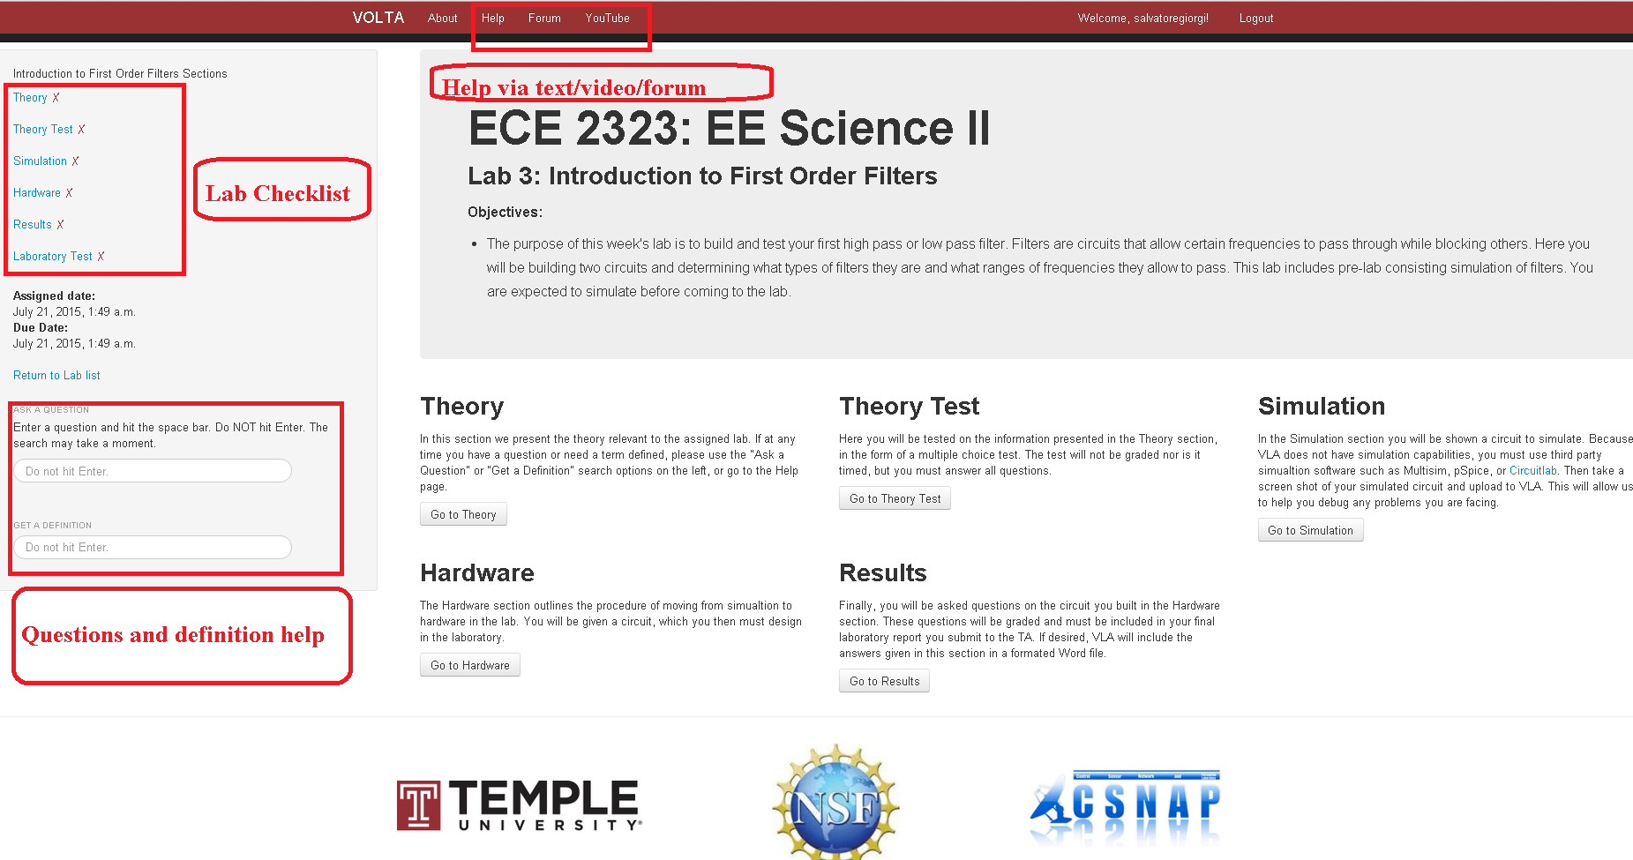
Figure 2: VOLTA web interface
As shown Figure 2, VOLTA’s user interface guides students through an experiment step-by-step. The students take part in pre-tests and post-tests that consist of multiple choice questions. The same set of questions are asked in pre- and post-tests. In post-tests, the multiple choice options are not in the same order as in pre-tests. After the pre-test, the students are directed to the simulation section. In this section, the students are instructed to simulate their circuits before constructing the hardware circuit.
The hardware section provides instructions for building a circuit on a breadboard. The student uses the Electronics Explorer (EE) board (Digilent Inc., Pullman, Washington, USA) for the hardware implementation (“Electronics Explorer: Integrated Analog and Digital Circuit Design Station,” 2016). The EE board is built around a solderless breadboard, which also includes oscilloscopes, waveform generators, power supplies, voltmeters, reference voltage generators, and thirty-two digital signals that can be configured as a logic analyzer, pattern generator, or any one of several static digital I/O devices. All of these instruments can be connected to circuits built on solderless breadboards using simple jumper wires. For data acquisition and analysis, PC based software named “WaveForms” is used. A high-speed USB 2.0 connection ensures near real time data acquisition. The EE boards were provided to the students by the ECE Department and the boards were returned by the students at the end of the semester.

Virtual Laboratory Assistant
In this section, we discuss the virtual laboratory assistant features of VOLTA. VOLTA helps the students with the queries about the laboratory assignments, explains topics with video tutorials, verifies the simulated circuits provided by the students, and guides the students for connecting hardware circuits properly.

Questions and Answers and Video Tutorial
Students can look for answers to their questions about basic electrical concepts, definitions, and laboratory assignments at any point during lab work. The help page of VOLTA contains a summary of the most viewed questions and definitions. Also, there are instructional videos on how to use breadboards, DC power supplies, multimeters, Digilent boards etc. Figure 3 shows a few video instructions in VOLTA help page.
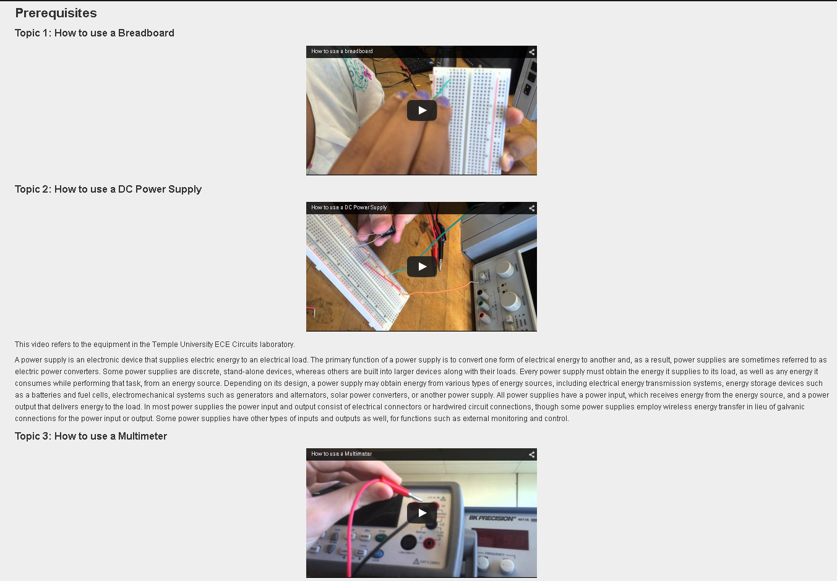
Figure 3: Instructional videos in VOLTA help page.

Circuit Comparator
The objective of Circuit Comparator is to verify whether the students’ simulated circuits are equivalent to the reference circuits stored in VOLTA. In order to help a student with the simulated circuits, the teaching assistants perform the following steps: i) examine whether the circuit contains all the required components, and ii) check if all the components are properly connected according to the lab instructions. Likewise, the Circuit Comparator performs the circuit verification following these steps: i) match elements between the elements of netlists provided by students and VOLTA, and ii) checks topological connections according to node connections from netlists. Figure 4 shows the flowchart of the functions of Circuit Comparator. The teaching assistants load VOLTA with the correct netlist of the circuits (solution netlist) before the labs. Students upload their simulated circuit netlist in VOLTA. These netlists can be of different formats, if generated from different circuit simulation software, such as Multisim, CiruitLab etc. To avoid such situation, both netlists are fed into VOLTA netlist translator, which translate the netlists into a simple format without any extra information (as shown in Figure 5). Then, the circuit components and the topology are cross-checked to output ‘Equivalent circuit’ or ‘Mismatched circuit’. Figure 6 shows the examples of the circuit comparator input and output. On the top of Figure 5, the student provides a correct circuit equivalent to the solution circuit, although the circuit elements are not connected in the same order. Different orders of elements in two circuits do not affect the decision process of the circuit comparator. On the other hand, the bottom of Figure 6 shows an incorrect circuit provided by the student. In the student’s circuit, all the elements are connected properly, although the voltage source has incorrect frequency. Therefore, the circuit comparator outputs “the student’s circuit is incorrect”.
Figure 4: Circuit Comparator flowchart

Figure 5: An example of Multisim generated and VOLTA translated netlists

Figure 6: An example of a correct circuit determined by circuit comparator (top), an example of an incorrect circuit determined by circuit comparator (bottom)

Circuit Tracer
The Circuit Tracer helps students verify the hardware circuit by tracing circuit connections. Figure 7 shows the circuit tracer page for a lab experiment. The troubleshooting starts with the component integrity test. Firstly, a video instruction shows how to check for the damaged components. Secondly, another video instruction shows how to do the continuity test to check whether there are any loose connections. Finally, a brief description of circuit node and component connections is provided for the desired circuit. This description is generated from a previously-loaded netlist of the circuit.
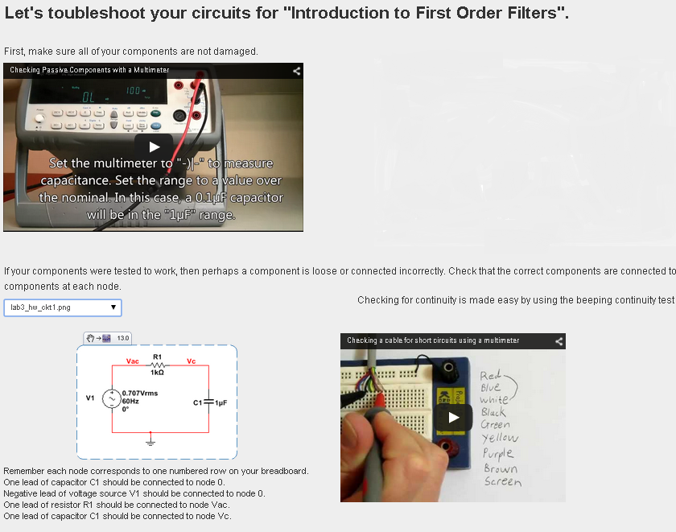
Figure 7: Circuit Tracer page of VOLTA

Benefits

Student Benefits
- With the implementation of VOLTA, laboratory scheduling becomes flexible. Students can perform their experiments in or outside the laboratory space, whenever it is convenient for them.
- Students can pursue the experiments at their own pace. Teaming is not mandatory while using VOLTA. Therefore, the faster students do not have to wait for their lab partners. On the other hand, the slower students do not feel any pressure from their faster lab partners, and complete the experiment at their own pace.
- Help is available for the students in virtual teaching assistance form. VOLTA can answer queries about basic concepts about the particular experiment with video tutorial. VOLTA can help verify simulated circuits, and guide the students in connecting circuit components properly.

Faculty Benefits
- The faculty can adjust loading easily by setting up a fixed due date for report submission. It is not necessary for them to set up fixed laboratory schedules.
- The faculty can have more time to develop new laboratory experiments and to improve existing laboratory experiments using help from the teaching assistant. VOLTA facilitates easy integration of new laboratory experiments.
- VOLTA saves the faculty time that would be spent on routine laboratory matters.

General Benefits
- With introduction of VOLTA, the space-time product is increased. Space-time product can be treated as a metric for resource utilization. In previous open laboratory approaches, only time is increased to improve space-time product. In our approaches, students can use portable boards anywhere. However, the space should be equipped with power outlets, computers, and internet connectivity.
- Scaling is possible with this approach. VOLTA can facilitate small to large programs with its features.

Evaluation
VOLTA was evaluated from two perspectives: effectiveness and usability. The effectiveness study of VOLTA provides insights about its usefulness compared to traditionally taught classes. Usability evaluation data provides knowledge about a program’s functional effectiveness, efficiency, ease of learning, ease of use, motivational influence, and quality assurance.

Methodology

Pre-test and Post-test Design for Effectiveness Analysis
The effectiveness of VOLTA is assessed using gain score analysis of pre-test/post-test design (Brogan & Kutner, 1980; Dimitrov & Rumrill, 2003; Dugard & Todman, 1995). Eleven lab assignments were developed for use with VOLTA. With each lab assignment, there were one pre-test and one post-test.

Likert scale for Usability Evaluation
Likert scale was used for the usability evaluation. The Likert scale is the most widely used technique to measure attitude. It evaluates the attitude toward a topic by presenting a set of statements about topic to the respondents (Ary, Jacobs, Razavieh, & Sorensen, 2009). The respondents are asked to indicate whether they strongly agree, agree, disagree, strongly disagree, or hold no opinion about the statements. Their responses are assigned numeric values, e.g. strongly disagree = 1, disagree= 2, no opinion = 3, agree = 4 and strongly agree = 5. The mean attitude score can be calculated then by averaging the response scores according to the Likert scale (Ary et al., 2009). A mean score below 3 shows a negative attitude and one above 3 shows a positive attitude.

Samples
The study involved students enrolled in a Circuits course “Electrical Engineering Science II” in one institution over three semesters: Fall 2014, Spring 2015, and Fall 2015. Each semester, there were two sections; the intervention was randomly assigned to one section. In this paper, each semester, consisting of an experimental and control group, is referred to as a ‘Cohort’. In Fall 2014, students in the experimental group of Cohort 1 received a curriculum in which the instructor integrated VOLTA with the traditional curriculum. The students were taught with the introduction of the assignment topics in each class. The students were encouraged to use VOLTA for asking questions regarding the laboratory topics. The control group of Cohort 1 received the traditional course curriculum. The students were given an introductory lecture on the day’s topic. Then the students carried out the assignments. The students received help if any troubleshooting is required in the assignment. In Spring 2015, VOLTA was upgraded with hardware circuit tracer module and more questions and answers were added. For Cohort 2, we repeated the experiment of Fall 2014. In Fall 2015, VOLTA was again upgraded with circuit simulation checker. The experimental group of Cohort 3 did not receive any introductory lecture from the teaching assistant. Also, for troubleshooting the circuits, the students received minimal assistance. The control group of Cohort 3 was taught in the same way as Cohort 1 and Cohort 2.

Table 1: Student Enrollment Data
Period | Cohort | Experiment type | Control group | Expt. group | Total
Fall 2014 | 1 | TA vs. (VOLTA v1+TA) | 18 | 16 | 34
Spring 2015 | 2 | TA vs. (VOLTA v2+TA) | 18 | 10 | 28
Fall 2015 | 3 | TA vs. (VOLTA v3+ decreased TA involvement) | 9 | 8 | 17

Laboratory Assignment Topics
VOLTA covers eleven topics in Engineering Science II course: i) Introduction to Multisim using RC circuit, ii) Introduction to Digilent board using RC circuit, iii) Introduction to first order filters, iv) Step response of a second order filter, v) Frequency response of a second order filter, vi) Design of second order circuit based on step response, vii) Impedance measurement of AC circuit, viii) Bass booster implementation using active filters, ix) Gain bandwidth product and slew rate of op-amp, x) Introduction to boost converter, and xi) Introduction to amplitude modulation.

Results and Discussions

Exploratory Data Analysis
The boxplots in Figure 8 show the pre-test and post-test score distribution of the control and experimental groups of students for eleven lab assignments in the fall of 2014. In the pre-tests, the control group has similar median scores of 60 for labs 1, 3, 4, 5, 6, 7, 9, and 10 with larger variation in 1, 3, and 5. In the post-tests, for most of the labs the median scores went upward compared to the pre-tests. There is larger variability in scores for labs 3, 5, 6, and 7. The experimental group has median scores of 60 in labs 1, 3, 4, and 10 in the pre-test scores. The post-test score has larger variation for the experimental group. From the boxplots of pre-test scores, the control group and the experimental group do not have similar distributions of scores.
Figure 8: Box plot pre-test and post-test for Fall 2014 (Cohort 1). The top two figures (in red) are for the traditionally taught students, and the bottom two figures (in blue) are for the students taught with VOLTA.

Figure 9: Box plot for Spring 2015 (Cohort 2). The top two figures (in red) are for the traditionally taught students, and the bottom two figures (in blue) are for the students taught with VOLTA.

The boxplots in Figure 9 show the pre-test and post-test score distribution of Cohort 2. In the pre-tests, the control group has median of 80 in labs 1, 3, 6, 8, and 9, and median of 60 in labs 4, 7, 10, and 11. Lab 6 showed larger variation. In the pre-test, the experimental group has median of 80 in labs 4 and 6, the median of 60 in labs 1, 2, 3, 6, 7, and 10. The experimental group has larger variation in labs 8 and 10. In the pre-tests, in terms of variation the control group appears to do better than the experimental group. In the post-tests, the experimental group median scores increased and the variation becomes smaller compared to their pre-test performance. On the other hand, the control group did not show any significant changes in the post-tests compared to the pre-tests. It appears that the experimental group performed better than the control group, which can be confirmed by analysis of variance test results described later.
Figure 10: Box plot for Fall 2015 (Cohort 3). The top two figures (in red) are for the traditionally taught students, and the bottom two figures (in blue) are for the students taught with VOLTA.
The boxplots in Figure 10 show the pre-test and post-test score distribution of Cohort 3. In the pre-tests, the control group has median of 80 in labs 3, 5, 9, and 11, and median of 60 in labs 2, 4, 7, 8, and 10. Lab 1, 6, 7, 9, and 10 showed larger variation. In the pre-test, the experimental group has median of 80 in labs 4 and 6, the median of 60 in labs 2, 4, and 6. The experimental group has larger variation in labs 5 and 6. In the pre-tests and post-tests, the experimental group has less variation than the control group.
Figure 11: Average gain for Cohort 1, 2 (top two figures), and 3 (bottom)
From the average gain plot in Figure 11, we observe that the experimental performed better in lab assignments 1, 7, 9, and 11, whereas the control group did better in lab assignments 2 and 6 for Cohort 1. The rest of lab assignments showed a little difference. In terms of average gain, the experimental group performed better than the control group for Cohort 2. In terms of average gain, the difference between the control and experimental group is not noticeable for Cohort 3.

Analysis of Variance and Effect Size
A two-group pre-test/post-test design approach was used to evaluate the effectiveness of VOLTA. The major question guiding the evaluation of VOLTA's effectiveness on learning: Did the students who used VOLTA (experimental group) learn more (e.g. score higher on gain measures) than their counterparts in the control group? The gain score analysis approach was used to analyze data from the two-group pre-test/post-test research design. The gain score is defined as the difference between the post-test and pre-test score. The null hypothesis is that there is no difference among the mean gains of the experimental and control groups for eleven assignments.
For Cohort 1, the ANOVA test (Montgomery, 2007) was performed on the gain scores of 28 students in 11 lab assignments. The ANOVA test was performed using R (version 3.1.2). The ANOVA test gave a p-value of 0.1714 indicated that the null hypothesis cannot be rejected. In other words, there is not sufficient evidence that the students taught with VOLTA performed better than their counterparts in the traditional labs. The differences are statistically significant at a confidence level of 80%. For Cohort 2, the ANOVA was performed on the gain scores of 34 students in 11 lab assignments. The p-value less than 0.001 indicated that the null hypothesis can be rejected. In other words, there is sufficient evidence that the students taught with VOLTA performed better than their counterparts in the traditional labs. The differences are statistically significant at a confidence level of 95%. For Cohort 3, the ANOVA test was performed on the gain scores of 17 students in 11 lab assignments. The p-value of 0.768 indicated that the null hypothesis cannot be rejected. In other words, there is sufficient evidence that there is no difference between the students taught traditionally and taught with VOLTA.
In order to find the strength of the statistical significance of our study, we estimated the effect size qualitatively based on Cohen’s d value (Cohen, 2013). We calculated Cohen’s d using the following formula (Thalheimer & Cook, 2002):
where, d is the Cohen’s d effect size, F is the F statistic or F ratio, n_{t} is number of students in experimental group, and n_{c} is number of students in the control group. Cohen suggested that Cohen’s d values of 0.2, 0.5, and 0.8 indicate small, medium, and large effects, respectively (Cohen, 1992). For Cohort 1, Cohen’s d value was found to be 0.49 for F(1,33) = 1.878. The effect size (Cohen’s d = 0.49) indicates that VOLTA had a medium effect during the fall of 2014. For Cohort 2, Cohen’s d value was found to be 2.13 for F(1,27) = 27.145. The effect size (Cohen’s d = 2.13) indicates that this is a large effect during the spring of 2015. For Cohort 3, Cohen’s d value was found to be 0.15 for F(1,16) = 0.087. The effect size (Cohen’s d = 0.15) indicates that this is a small effect during the fall of 2015.

Usability Survey Response Analysis
The usability evaluation is based on the survey response of six students (out of eight participants) taught with VOLTA during the fall of 2015. In this study, twenty questions were asked covering seven broad categories:
a. Did the students think VOLTA was useful for their learning? (Learning environment)
b. Did the students find the software motivating? (Motivational value)
c. Did the students find VOLTA easy to use? (Ease of use)
d. Did the students perceive the usefulness of VOLTA features? (Perception of usefulness)
e. Did the students trust the virtual laboratory environment? (Authenticity of virtual learning)
f. What was the perceived quality of VOLTA? (Quality assurance)
g. What additional features the students would like to see in VOLTA? (Expectations)
The purpose of VOLTA is to improve student learning. Therefore, the questions in this category “a” are important. In this category, five Likert-type questions were asked to understand how successful VOLTA was as a learning environment:
a1. VOLTA helped me to learn electrical circuits’ concepts.
a2. I felt I could trust the VOLTA to properly inform me.
a3. The longer I spent using the VOLTA, the more information I felt I retained.
a4. I needed to respond quickly to the assignment questions.
a5. The simulation tests helped me understanding the concepts.
Figure 12: Learning environment questions response
Figure 12 shows that for questions “a1” and “a5”, 50% of the students rated VOLTA as useful learning tool, regarding to acquisition of concepts. The response for the question “a4” shows that 50% of the students thought they did not have to hasten for completing their assignments. The responses for the other two questions “a2” and “a3” indicate that VOLTA needs to improve its information accuracy.
Several characteristics such as, attention-getting features, relevancy, and confidence-building activities are required for making any learning product motivational. VOLTA includes some of these features such as, circuit comparator, circuit tracer etc. In category “b”, two questions were asked to assess the motivational value of VOLTA:
b1. I enjoyed using VOLTA.
b2. I lost track of time while using VOLTA.
Figure 13:Motivational value questions response
Figure 13 indicates that students are not likely agree that they enjoyed VOLTA. For understanding the level of engagement with VOLTA, the question “b2” was asked. The responses showed a low-level of engagement.
An educational tool must be user-friendly, which brings the category “c” questions in the usability study. In this category, three questions were asked regarding the ease of use of VOLTA:
c1. VOLTA was easy to use.
c2. The use of VOLTA was intuitive.
c3. I was able to navigate within the sections of labs easily.
Figure 14: Ease of use questions response
Figure 14 shows that 83% of the students found VOLTA easy to use and easy to navigate. 50% of the students also felt that the use of VOLTA was intuitive (83%).
In category “d”, four questions were asked regarding to what degree VOLTA’s features were helpful:
d1. The ‘HELP’ module of VOLTA was helpful.
d2. The ‘Youtube channel’ of VOLTA showed helpful demonstrations.
d3. I used ‘Forum’ for interacting with students and instructors for solving my problem.
d4. VOLTA helped me verify the lab results.
Figure 15: Perception of usefulness questions response
Overall, the students endorsed various features of VOLTA not highly (Figure 15). At least one-third of the students gave “no opinion” responses in all the questions in the category. 16% of the students thought the VOLTA Youtube channel was useful.
In category “e”, two questions were asked regarding the authenticity of virtual learning:
e1. The interaction with the VOLTA was personal and I felt as though the teaching assistant was helping me directly.
e2. The lab seemed or "felt" like a real lab.
Figure 16: Authenticity of virtual learning
The responses for question “e1” shows that the most of the students did not think VOLTA as a replacement of a human teaching assistant. However, 50% of the students felt that the labs seemed like a real lab.
In category “f”, two questions were asked to assess the quality of the videos and VOLTA overall:
f1. The videos were of good quality.
f2. VOLTA ran trouble-free.
Figure 17: Quality of insurance questions response
For both questions, 33% of the students agreed the videos were of good quality and VOLTA was trouble-free (Figure 17).
In category “g”, two questions were asked about the expectations from VOLTA:
g1. Would a virtual troubleshooter for the circuit in VOLTA be useful?
g2. Would you like to be able to ask the teaching assistant questions from within the VOLTA and have him/her respond?
Figure 18:Expectations questions response
Most of the students indicated that they would like to have a troubleshooter in VOLTA and a way of communicating with a human TA through VOLTA (Figure 18).

Figure 19: Attitude score of students taught with VOLTA from Cohort 3 in terms of individuals (left) and category of questions (right)

The histogram on the left of Figure 19 shows the mean attitude scores of six individuals. Three of them showed positive attitude (mean attitude score>3) towards VOLTA. The histogram on the right of Figure 19 shows category-wise mean attitude score. Except for category “c” and “g,” the mean attitude score of the student fell below 3. During the spring of 2015, VOLTA was rated highly by the most of the participating students (Authors, 2016).

Conclusions
VOLTA is an intelligent system with virtual teaching assistance feature for students in an open laboratory environment. Traditional laboratory environment needs a fixed laboratory space for experiments, whereas VOLTA breaks this constraint. VOLTA provides on-demand help with a self-paced environment and increasing levels of engagement. Overall, comments from students on this approach were positive. The students found instructional videos, safety videos, and short topic explanations to perform the experiments. In the fall of 2014 and the spring of 2015, the VOLTA taught students performed better compared to their traditionally-taught counterparts in terms of p-values of 0.1714 and less than 0.001. In the fall of 2015, the VOLTA-taught students’ performance was similar to their traditionally-taught counterparts. These results reveal that VOLTA can provide teaching assistance as good as human teaching assistants for undergraduate electrical engineering students. A flexible laboratory like VOLTA can be a critical part of an effective distance learning strategy and will address the needs of modern, nontraditional students.

Acknowledgement
This work was supported by a grant from the National Science Foundation.

Appendix A

Pre-test and post-test scores of the students
Table 2: Control Group’s (n=18) Pre-test and Post-test Score of Fall 2014
Lab Assignment no. | Pre-test |  |  | Post-test |  |  | Average  gain
 | Mean | Standard Deviation |  | Mean | Standard Deviation
1 | 64.44 | 15.71 |  | 66.67 | 20.00 |  | 2.23
2 | 36.67 | 17.95 |  | 47.78 | 19.02 |  | 11.11
3 | 64.21 | 27.97 |  | 62.22 | 33.26 |  | −1.99
4 | 51.76 | 13.82 |  | 48.24 | 22.81 |  | −3.52
5 | 83.33 | 24.27 |  | 90.00 | 15.28 |  | 6.67
6 | 68.75 | 27.36 |  | 82.67 | 17.69 |  | 13.92
7 | 76.67 | 24.27 |  | 72.94 | 28.24 |  | −3.73
8 | 76.00 | 23.32 |  | 82.67 | 17.69 |  | 6.67
9 | 71.11 | 20.25 |  | 76.47 | 12.34 |  | 5.36
10 | 52.50 | 26.34 |  | 65.00 | 27.84 |  | 12.50
11 | 68.57 | 23.56 |  | 70.59 | 21.82 |  | 2.02

Table 3: Experimental Group’s (n=16) Pre-test and Post-test Score of Fall 2014
Lab Assignment no. | Pre-test |  |  | Post-test |  |  | Average  gain
 | Mean | Standard Deviation |  | Mean | Standard Deviation
1 | 58.89 | 22.58 |  | 71.11 | 23.31 |  | 12.22
2 | 47.14 | 17.90 |  | 40.01 | 18.52 |  | −7.13
3 | 58.75 | 23.95 |  | 57.50 | 21.70 |  | −1.25
4 | 68.57 | 26.95 |  | 65.00 | 24.66 |  | −3.57
5 | 68.57 | 26.95 |  | 74.29 | 23.21 |  | 5.72
6 | 61.54 | 27.69 |  | 64.62 | 28.45 |  | 3.08
7 | 66.67 | 18.9 |  | 68.00 | 20.40 |  | 1.33
8 | 86.67 | 13.98 |  | 93.33 | 11.93 |  | 6.66
9 | 63.08 | 15.38 |  | 84.62 | 11.51 |  | 21.54
10 | 65.45 | 21.05 |  | 76.36 | 20.57 |  | 10.91
11 | 74.29 | 26.65 |  | 87.14 | 17.90 |  | 12.85

Table 4: Control Group’s (n=18) Pre-test and Post-test Score of Spring 2015
Lab Assignment no. | Pre-test |  |  | Post-test |  |  | Average  gain
 | Mean | Standard Deviation |  | Mean | Standard Deviation
1 | 61.11 | 19.40 |  | 68.89 | 15.23 |  | 7.78
2 | 48.89 | 23.31 |  | 54.44 | 8.96 |  | 5.56
3 | 67.06 | 13.62 |  | 68.24 | 13.82 |  | 1.18
4 | 74.44 | 26.50 |  | 83.33 | 30.73 |  | 8.89
5 | 85.56 | 17.39 |  | 84.44 | 15.71 |  | −1.11
6 | 77.78 | 22.00 |  | 77.78 | 20.96 |  | 0.00
7 | 54.44 | 23.86 |  | 47.78 | 23.23 |  | −6.67
8 | 76.67 | 30.00 |  | 81.11 | 27.06 |  | 4.44
9 | 85.56 | 17.39 |  | 83.33 | 17.95 |  | −2.22
10 | 54.44 | 28.91 |  | 54.44 | 29.67 |  | 0.00
11 | 47.78 | 20.15 |  | 48.89 | 20.25 |  | 1.11

Table 5: Experimental Group’s (n=10) Pre-test and Post-test Score of Spring 2015
Lab Assignment no. | Pre-test |  |  | Post-test |  |  | Average  gain
 | Mean | Standard Deviation |  | Mean | Standard Deviation
1 | 68.00 | 16.00 |  | 76.00 | 8.00 |  | 8.00
2 | 44.00 | 12.00 |  | 56.00 | 12.00 |  | 12.00
3 | 76.00 | 12.00 |  | 88.00 | 9.80 |  | 12.00
4 | 54.00 | 20.10 |  | 66.00 | 26.91 |  | 12.00
5 | 84.00 | 24.98 |  | 90.00 | 18.44 |  | 6.00
6 | 76.00 | 26.53 |  | 90.00 | 18.44 |  | 14.00
7 | 62.00 | 10.77 |  | 68.00 | 9.80 |  | 6.00
8 | 70.00 | 28.64 |  | 84.00 | 14.97 |  | 14.00
9 | 70.00 | 18.44 |  | 96.00 | 8.00 |  | 26.00
10 | 56.00 | 24.98 |  | 74.00 | 20.10 |  | 18.00
11 | 74.00 | 15.62 |  | 76.00 | 14.97 |  | 2.00

Table 6: Control Group’s (n=9) Pre-test and Post-test Score of Fall 2015
Lab Assignment no. | Pre-test |  |  | Post-test |  |  | Average  gain
 | Mean | Standard Deviation |  | Mean | Standard Deviation
1 | 80.00 | 17.54 |  | 81.54 | 16.57 |  | 1.54
2 | 55.00 | 18.48 |  | 51.67 | 15.18 |  | -3.33
3 | 80.00 | 14.77 |  | 81.82 | 15.85 |  | 1.82
4 | 81.82 | 10.29 |  | 82.27 | 12.86 |  | 5.45
5 | 83.64 | 18.72 |  | 78.18 | 19.91 |  | -5.45
6 | 48.00 | 20.40 |  | 72.00 | 22.27 |  | 24
7 | 56.36 | 29.32 |  | 67.27 | 27.33 |  | 10.91
8 | 60.00 | 15.12 |  | 87.50 | 22.22 |  | 27.5
9 | 68.00 | 25.61 |  | 78.00 | 22.01 |  | 10
10 | 72.50 | 25.61 |  | 78.00 | 22.01 |  | 0.83
11 | 74.55 | 12.33 |  | 76.36 | 18.72 |  | 1.82

Table 7: Experimental Group’s (n=8) Pre-test and Post-test Score of Fall 2015
Lab Assignment no. | Pre-test |  |  | Post-test |  |  | Average  gain
 | Mean | Standard Deviation |  | Mean | Standard Deviation
1 | 68.83 | 8.31 |  | 82.22 | 17.50 |  | 13.39
2 | 62.50 | 6.61 |  | 55.00 | 13.23 |  | -7.5
3 | 80.00 | 20.00 |  | 92.00 | 16.00 |  | 12
4 | 80.00 | 10.00 |  | 72.50 | 13.92 |  | -7.5
5 | 77.78 | 23.93 |  | 84.44 | 29.61 |  | 6.67
6 | 50.00 | 27.28 |  | 75.00 | 21.79 |  | 25
7 | 88.89 | 16.63 |  | 93.33 | 13.33 |  | 4.44
8 | 83.88 | 14.88 |  | 92.50 | 9.68 |  | 8.62
9 | 68.89 | 19.12 |  | 72.50 | 13.92 |  | 3.61
10 | 88.89 | 16.63 |  | 91.11 | 16.63 |  | 2.22
11 | 97.50 | 6.61 |  | 95.00 | 8.66 |  | -2.5

ANOVA tables of the students

Table 8: ANOVA table for Fall 2014
Source of Variation | Degrees of freedom | Sum of Squares | Mean Square | F ratio | p-value
Lab assignment no. | 10 | 7,654 | 765.4
Group | 1 | 705 | 705 | 1.878 | 0.1714
Residual | 362 | 135,904 | 266
Total | 373 | 144,266

Table 9: ANOVA table for Spring 2015
Source of Variation | Degrees of freedom | Sum of Squares | Mean Square | F ratio | p-value
Lab assignment no. | 10 | 3,782 | 378.2
Group | 1 | 7,215 | 7,215 | 27.15 | 3.54×10⁻⁷
Residual | 296 | 78,671 | 266
Total | 307 | 89,568

Table 10: ANOVA table for Fall 2015
Source of Variation | Degrees of freedom | Sum of Squares | Mean Square | F ratio | p-value
Lab assignment no. | 10 | 8,766 | 876.6
Group | 1 | 29 | 28.60 | 0.087 | 0.768
Residual | 296 | 78,671 | 266
Total | 307 | 89,568

References

Ary, D., Jacobs, L., Razavieh, A., & Sorensen, C. (2009). Introduction to Research in Education. Cengage Learning.
Brogan, D. R., & Kutner, M. H. (1980). Comparative Analyses of Pretest-Posttest. The American Statistician, 34(4), 229–232.
Butz, B. P., Duarte, M., & Miller, S. M. (2006). An intelligent tutoring system for circuit analysis. Education, IEEE Transactions on, 49(2), 216–223.
Cohen, J. (1992). A Power Primer, 112(1), 155–159.
Cohen, J. (2013). Statistical Power Analysis for the Behavioral Sciences. Elsevier Science. Retrieved from https://books.google.com/books?id=rEe0BQAAQBAJ
Dimitrov, D., & Rumrill, P. (2003). Pretest-posttest designs and measurement of change. Work, 20, 159–165.
Duarte, M., Butz, B. P., Miller, S. M., & Mahalingam, A. (2008). An Intelligent Universal Virtual Laboratory (UVL). Education, IEEE Transactions on, 51(1), 2–9.
Dugard, P., & Todman, J. (1995). Analysis of Pre‐test‐Post‐test Control Group Designs in Educational Research. Educational Psychology: An International Journal of Experimental Educational Psychology, 15(2), 37–41. http://doi.org/10.1080/0144341950150207
Electronics Explorer: Integrated Analog and Digital Circuit Design Station. (2016). Retrieved from https://www.digilentinc.com/data/Products/EEBOARD/Digilent-EEboard-np-07.pdf
Ernst, E. W. (1983). Role for the Undergraduate Engineering Laboratory, (2), 49–51.
Feisel, L. D., & Rosa, A. J. (2005). The role of the laboratory in undergraduate engineering education. Journal of Engineering Education, 94, 121–130.
Knight, C. D., & DeWeerth, S. P. (1996). A shared remote testing environment for engineering education. In Frontiers in Education Conference, 1996. FIE ’96. 26th Annual Conference., Proceedings of (Vol. 3, pp. 1003–1006). Salt Lake City, UT, USA.
Krishnasamy, K., Butz, B. P., & Duarte, M. (2004, January). A rule-based semi-automated approach to building Natural Language Question Answering (NLQA) systems. The 17th International FLAIRS Conference. Jacksonville, FL, USA.
Kuhn, W. B., Hummels, D. R., & Dyer, S. A. (2000). A senior-level RF design course combining traditional lectures with an open laboratory format. In Frontiers in Education Conference, 2000. FIE 2000. 30th Annual (Vol. 1, pp. T1D/19–T1D/23).
Meet Django. (2016). Retrieved from https://www.djangoproject.com/
Montgomery, D. C. (2007). Design and Analysis of Experiments, 6th Edition Set. John Wiley & Sons, Limited.
Oswald, J. A., & Sloan, M. E. (1971). An Economical Self-Supervised Individually Operated Open Electronics Laboratory. Education, IEEE Transactions on, 14(3), 90–94.
Palais, J. C., & Javurek, C. G. (1996). The Arizona State University electrical engineering undergraduate open laboratory. Education, IEEE Transactions on, 39(2), 257–264.
Saleheen, F., Giorgi S., Smith Z., Picone J., & Won, C.-H. (2015). Design and Evaluation of a Web-based Virtual Open Laboratory Teaching Assistant (VOLTA) for Circuits Laboratory. In Proc. {ASEE} Annual Conference (pp. 1–16). Seattle, WA, USA.
Saleheen, F., Wang, Z., Moser, W., Oleksyuk, V., J., P., & Won, C.-H. (2016). Effectiveness of a Virtual Open Laboratory Teaching Assistant for Circuits Laboratory. In Proc. {ASEE} Annual Conference (pp. 1–13). New Orleans, LA, USA (to appear): ASEE.
Thalheimer, W., & Cook, S. (2002). How to calculate effect sizes from published research: A simplified methodology. Work-Learning Research, (August), 1–9. http://doi.org/10.1113/jphysiol.2004.078915

