March 28, 2015

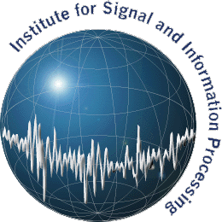

**Temple University**

**ENGR Room 703A**

**1947 North 12th Street**

**Philadelphia, PA 19122**

**Tel: 215-204-4841 (office) / 662-312-4209 (cell)**

**Fax: 215-204-5960**

**Email: amir.harati@gmail.com**

**URL: http://www.isip.piconepress.com**



To Whom It May Concern:

I am a PhD candidate working under supervision of Professor Joseph Picone in the Department of Electrical and Computer Engineering at Temple University in Philadelphia, Pennsylvania. My primary research interests are machine learning and speech recognition. The focus of my dissertation research is application of non-parametric Bayesian models to acoustic modeling in large vocabulary speech recognition.

Please accept the enclosed paper for consideration for publication in the *IEEE Transactions on Pattern Analysis and Machine Intelligence*. This manuscript introduces a new nonparametric Bayesian hidden Markov Model (HMM) that we refer to as a Doubly Hierarchical Dirichlet Process Hidden Markov Model, or DHDPHMM. This model is closely related to a Hierarchical Dirichlet Process Hidden Markov Model (HDPHMM) but has the following additional properties: (1) shares data points between states achieved using two Hierarchical Dirichlet Process, (2) models non-ergodic structures, and (3) models non-emitting states. We show that this model performs better relative to both HDPHMM and HMM models and produces state of the art results. In addition, we have shown that DHDPHMM scales much better than HDPHMM and therefore can be used with large datasets.

The paper includes a mathematical derivation of the model, the introduction of an inference algorithm and an extensive experimental section. Experiments are given for both simulated and real data. Although the experiments focus on a speech recognition application, the model itself can be applied to any signal processing application. For example, we are currently successfully applying this model to an EEG application. Therefore, we believe the topic appeals to a broader audience and would be an excellent candidate for your journal.

Best regards,



Amir Harati

Graduate Research Assistant

Department of Electrical and Computer Engineering

Temple University