Accelerating Generalization: Unveiling the Power of QRBM for Efficient Data Modeling with Limited Training Data
M. Babaei, P. Meng, S. S. Shalamzari and J. Picone
1. Neural Engineering Data Consortium, Temple University, Philadelphia, Pennsylvania, USA
{mahdi.babaei, phuykong.meng, somayeh.seifi.shalamzari, picone}@temple.edu
Abstract— As one of the fastest-growing fields in artificial intelligence, machine learning has revolutionized our ways of analyzing and interpreting data. Quantum computing, on the other hand, offers immense promise to transform the landscape of computation through scientific and technological exploration. At the intersection of quantum computing and machine learning, quantum machine learning has the potential to revolutionize various fields of scientific research and technological advancement. The purpose of this paper is to present experimental results regarding the generalization ability of multiple models with Quantum Restricted Boltzmann Machines. To test the generalization abilities of the models, we used three synthetic balanced datasets of varying difficulty levels. Based on the results of the study, quantum-based model is able to capture the underlying structure of data more efficiently with a small amount of training data. By using only 2000 data points for training, the QRBM model achieved an error rate of 21% on set no. 10, which is about 50% lower than the error rate of competing models. Compared to the alternatives, QRBM shows superior generalization capability.
- Introduction
In recent years, machine learning has gained widespread traction with applications in areas such as computer vision, voice recognition, medical diagnosis, spam filtering, and search engines [1]. Generally, machine learning algorithms create models with adjustable parameters from a large set of examples known as the training set. Following the training of the model, it can make predictions on unseen data, a capability known as generalization. In addition, the system is capable of recognizing objects in images or recognizing commands from voice inputs, for instance.
A common approach to machine learning is probabilistic modeling, where a finite set of samples is used to approximate the probability distribution of the data. Ideally, the learned distribution should closely resemble the actual distribution of the data, which allows accurate predictions in unseen scenarios. There are many algorithms involved in machine learning, including classification, clustering, collaborative filtering, compression, denoising, inpainting, and many others. These algorithms depend on distribution and approximation methods [2].
There has been a considerable amount of research on the use of quantum mechanics in machine learning [3]–[9]. As quantum annealing processors have advanced [10], experimental testing of machine learning concepts can now be conducted using real quantum hardware [11]–[14]. In all the studies mentioned above, the quantum processor has been used primarily to speed up the solution of classical problems. In other words, quantum mechanics is used only as a tool to facilitate the training process, and the models themselves remain classical.
This paper presents an approach to machine learning by introducing a quantum model known as a Quantum Restricted Boltzmann Machine (QRBM). The training process incorporates both the quantum nature of the processor and the model using the Restricted Boltzmann distribution of a quantum Hamiltonian. We propose an approach where quantum principles are incorporated throughout the entire model, as well as during the training process, as opposed to previous approaches where quantum capabilities were limited to training.
A huge amount of progress has been made in the engineering of quantum devices in the last two decades, allowing us to realize quantum technologies that rely on precise control over vast collections of microscopic quantum degrees of freedom [15]–[19]. The development of gate-based quantum computers that employ logical gate operations on qubits (quantum bits) has been notable. This type of device could theoretically execute certain quantum algorithms exponentially faster than classical computers running classical algorithms if scaled up in the ideal case [20]. However, gate-based quantum computers are challenged by scaling up in practice [21]. It is currently estimated that quantum processing units consist of fewer than four hundred qubits, and the assumption of perfect qubits in the statement does not take error correction into account, which introduces a substantial overhead when encoding logical variables in physical ones. These difficulties have led researchers to explore alternative approaches with specific efficiency criteria that may address certain practical problems. An approach aimed at solving classical combinatorial optimization problems is quantum annealing [22], [23]. The method is used to solve computer science problems [24], [25], classification problems [26], [27], machine learning problems [28].
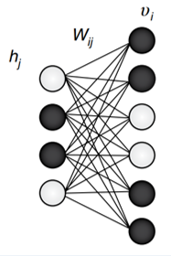
Figure 1. A standard, fully connected RBM

In quantum annealing, Hamiltonians play an important role. Hamiltonians offer a mathematical description of physical systems in terms of their energies. Finding the minimum-energy state for most non-convex Hamiltonians is an NP-hard problem that classical computers cannot solve efficiently. During quantum annealing, the system starts in a state with the lowest energy of an initial Hamiltonian and gradually introduces the problematic Hamiltonian.
A classical Ising Hamiltonian can be reformulated as minimizing a cost function in these optimization problems [29]. There are, however, many practical problems that exhibit many local minima, which resemble classical spin glasses in the corresponding Ising Hamiltonians [30]–[32]. Classical algorithms are challenged by this characteristic when trying to find the global minimum [3]. This problem can be addressed by quantum annealing which transforms the classical Ising Hamiltonian into a collection of interacting qubits.
The primary motivation behind constructing quantum annealing machines like the D-Wave device is to address combinatorial optimization problems. As heuristic approaches are typically employed for such challenging problems, there has been significant interest in leveraging quantum effects to obtain better solutions. In this context, "better solutions" can refer to cost values that are closer to optimality, faster convergence to optimality at a fixed cost, or a more diverse set of solutions (if the problem has multiple minimizing configurations).
Boltzmann machines are generative machine learning models that draw probabilistic distributions from data using unsupervised learning techniques [33]. Data can be generated using BMs via sampling and generating related new data. Although Boltzmann Machines are extremely versatile and potent models for understanding the underlying structure of data, their primary barrier to widespread adoption has been the difficulty in training them. This has resulted in limited use of Boltzmann machines over the years [33]. A special case of this model is the Restricted Boltzmann Machine [34], which disallows interactions between pairs of visible and pairs of hidden units. Restricted Boltzmann Machines combine the structure of a Boltzmann Machine with an additional structure called a "Restricted Neural Graph" to facilitate complex computations. The power and tractability of RBM has led to extensive research in recent years into efficient training methods for the model. An RBM architecture consists of two layers: a visible layer consisting of visible units $v_{j}$ and a hidden layer consisting of hidden units $h_{i}$, both of which are stochastic binary variables that are either 0 or 1. Having a sufficient number of hidden units (H) is essential to enhancing the RBM's representational capacity. The machine parameters define the energy (E) and parametrize the joint probability distribution ($p(v,h)$) as a graphical model. This definition is as:
$E_{λ}\left(v,h\right)= -\sum_{i,j}{W_{ij}h_{i}v_{j}- \sum_{j=1}^{V}{b_{j}v_{j}}- \sum_{i=1}^{H}{c_{i}h_{i}}}$ (1)
The parameters $λ$ of an RBM's energy comprise a set of neural network parameters, including weights ($W$) and biases ($b$, $c$). Restricted Boltzmann Machines are composed of $v$ visible units in the first layer ($v_{1}$, ..., $v_{V}$) and $H$ hidden units in the second layer ($h_{1}$, ..., $h_{H}$). The vectors $v$ (input variables) and $h$ (latent variables) represent these variables. The symmetric connection or interaction between the visible unit ($v_{j}$) and the hidden unit ($h_{j}$) is represented by $W_{ij}$, which acts as an interaction term between variables. By using the Boltzmann distribution of the energy (as shown in equation (2)), RBM assigns a probability score to each joint configuration $(v,h)$.
$P_{λ}\left(v,h\right)=\frac{1}{Z_{λ}}e^{-E_{λ}}$ (2)
where $Z_{λ}$ is the normalizing constant (partition function).
Multiple layers of latent variables constitute a deep belief net, which is a probabilistic generative model. Latent variables, also known as hidden units or feature detectors, are usually binary in nature. Deep belief nets are distinguished by their efficient learning procedure, which is layer-by-layer. It aims to establish relationships between variables in adjacent layers by acquiring top-down, generative weights [34].
A deep belief network can be conceptualized as a collection of simple learning modules, each resembling a restricted Boltzmann machine. Modules include visible and hidden layers, each of which represents input data. The hidden layers are responsible for capturing higher-order correlations within the data. A symmetrically weighted connection matrix known as W establishes the connectivity between these two layers. There is no internal connection between layers within deep belief nets. To construct sophisticated generative models, deep belief networks utilize multiple layers of latent variables. As a result of layer-by-layer learning, these models can capture dependencies among variables and reveal intricate patterns in the data [34].
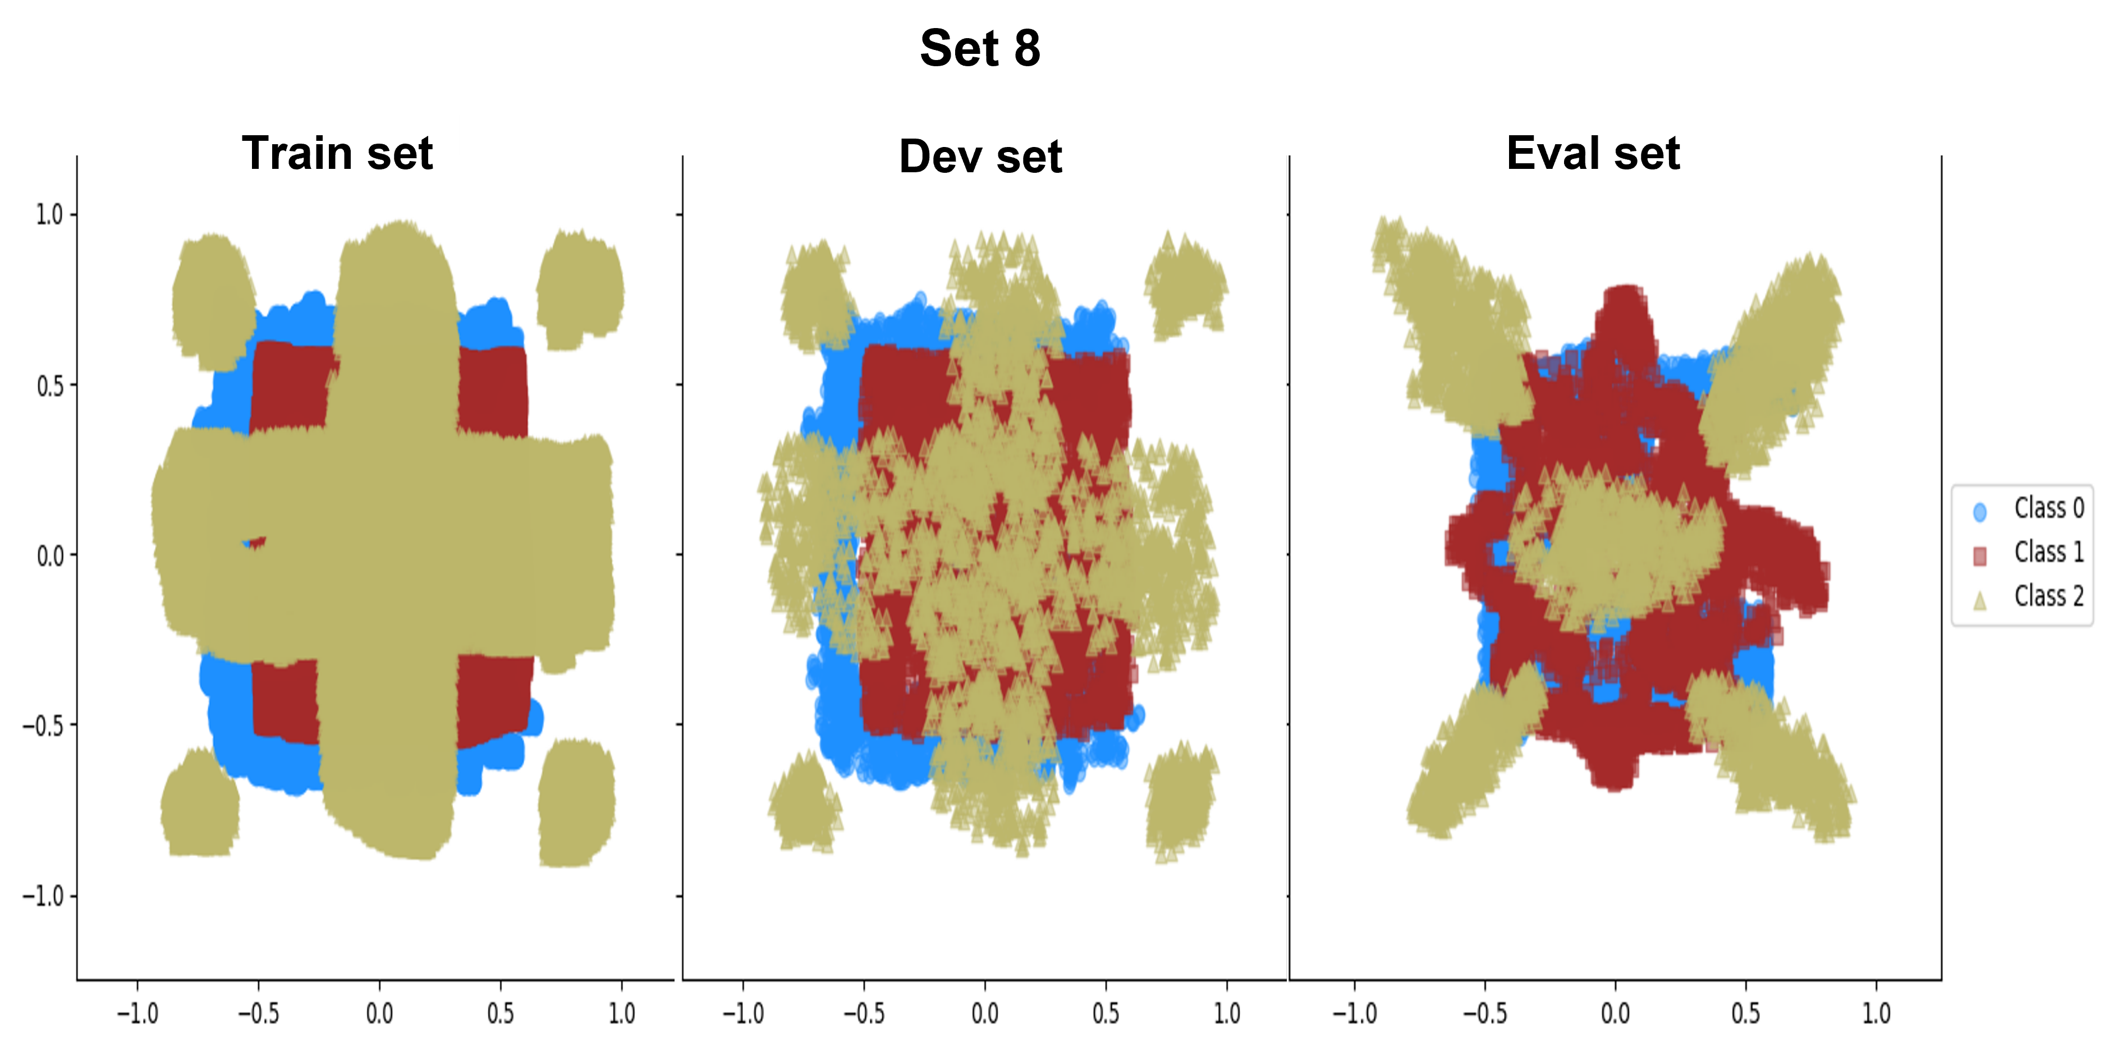
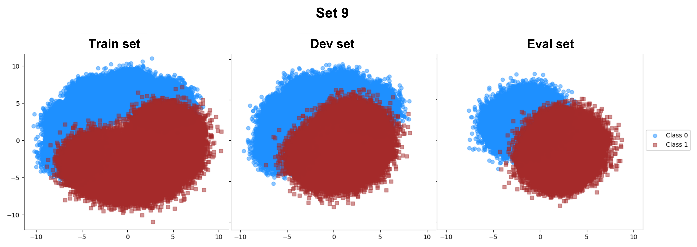
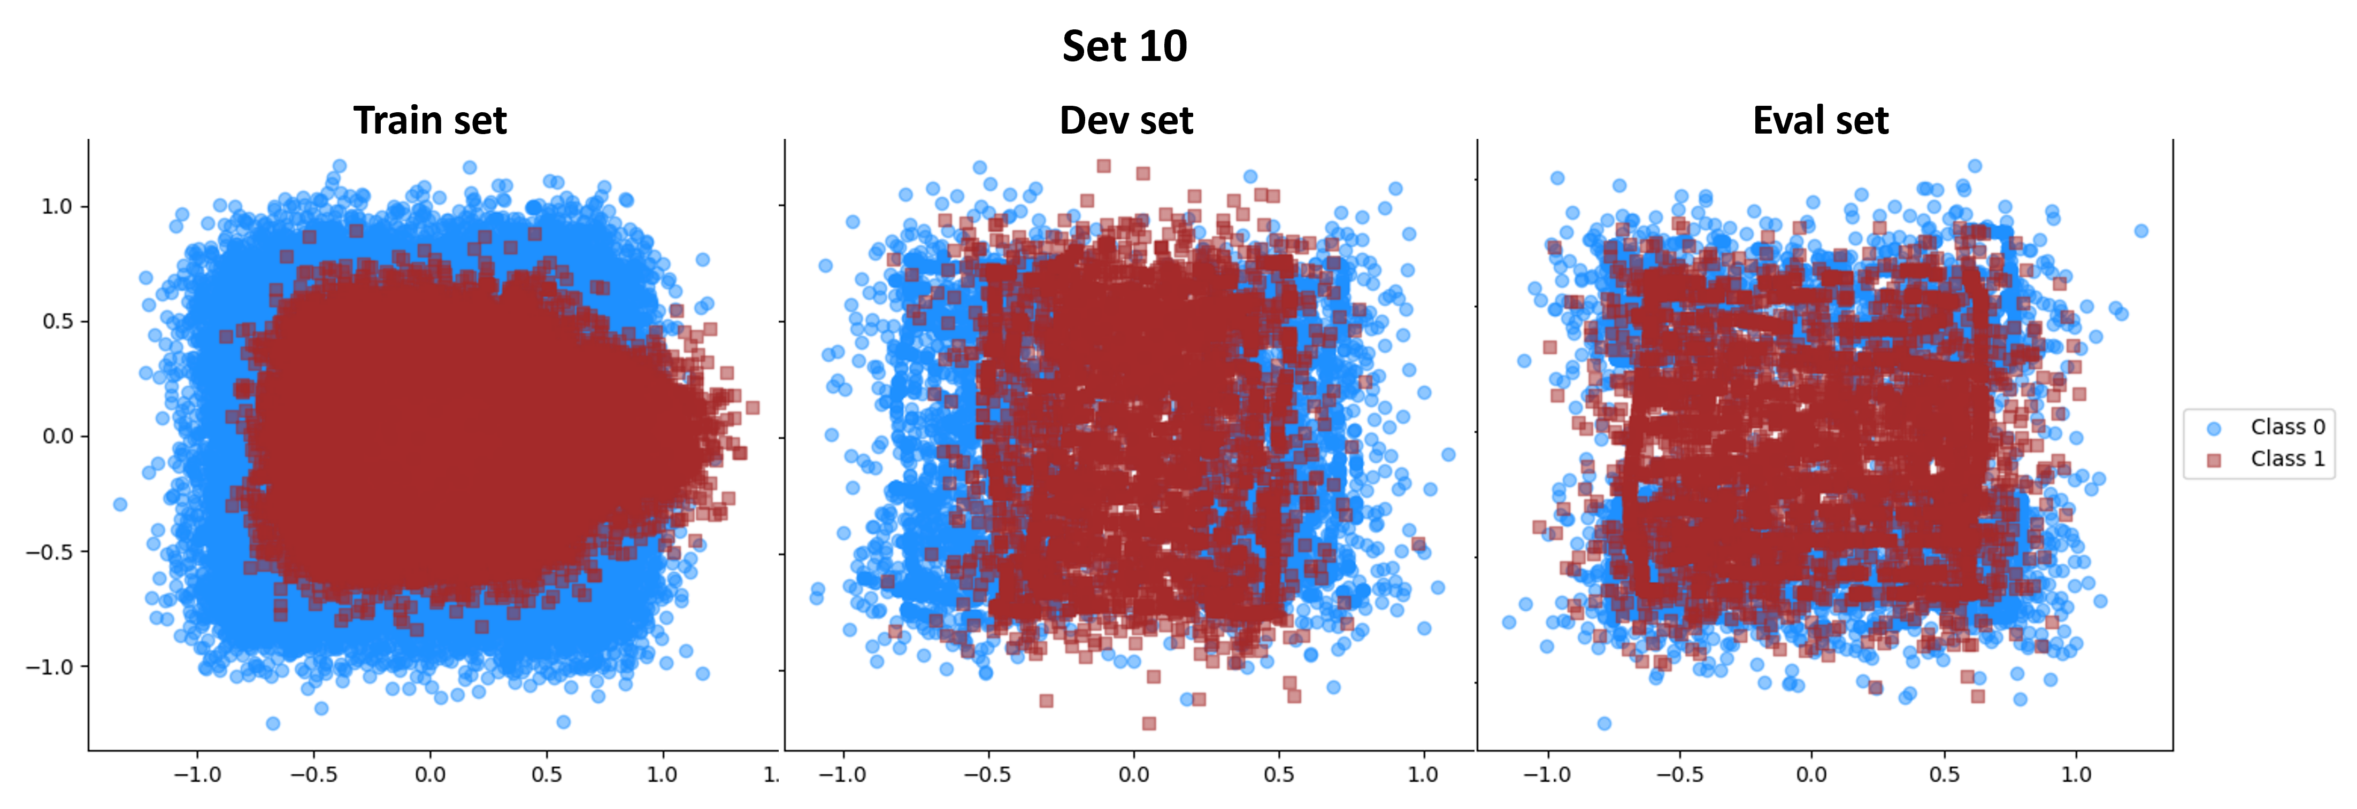
Figure 2. The train, dev, and eval sets for datasets

Experimental Data
Using three balanced datasets of varying difficulty levels, we tested the generalization abilities of the models. A summary of these datasets is presented in Table 1. The three datasets are specifically designed to simulate complex nonlinear decision surfaces. The datasets were divided into three standard subsets: 'train' for training the model, 'dev' for validation and tuning, and 'eval' for blind evaluation. It is public to access these datasets at: https://www.isip.piconepress.com/courses/temple/ece_8527/resources/data/.
In order to test the generalization capabilities of machine learning systems, three synthetic datasets were created using the Python-based open-source tool IMLD that we developed [35]. In dataset number 8, the model is asked to identify an optimal non-linear decision surface based on three classes with complex distributions. Five tight equally spaced Gaussian distributions were used to generate dataset number 9. Gaussian noise was added to dataset #10 after the samples were manually created using IMLD. According to Figure 1, there are a number of overlapping data points and a few duplicates between the two classes in Set 10. As compared to the training set, the development and evaluation sets exhibit more outliers which will affect performance. A visual representation of the distributions for all datasets can be seen in Figure 2. The datasets contain two features (floating numbers). Plotting tools available in Python makes it easy to visualize the data points contained in these datasets.

Experimental Design
Quantum computing operates on quantum bits or qubits, which are the basic units of information in quantum systems. Quantum algorithms exploit this superposition property to compute quantum data using quantum algorithms. The input data for quantum algorithms, however, must be encoded into the quantum states of qubits since classical data cannot be used directly. Classical data is mapped onto quantum states of qubits in order to achieve this encoding. For example, in case of having a classical dataset with multiple variables or features, it is needed to convert each feature into a corresponding set of qubits. Depending on the quantum algorithm and the type of data to be encoded, the encoding process can vary.
Table 1. Description of the datasets
# | No. Classes | Train | Dev | Eval
08 | 3 | 300,000 | 15,000 | 15,000
09 | 2 | 500,000 | 250,000 | 250,000
10 | 2 | 100,000 | 10,000 | 10,000

Furthermore, by applying appropriate transformations, RBMs can also be used on continuous-valued data. Using techniques such as binarization or thresholding, continuous inputs can be discretized into binary values or transformed into binary representations. This method allows RBMs to capture patterns and dependencies in data, even if they are represented in binary form [34].
Hence, we used the 16-bit binary encoding or representation mode for data. Every feature is represented using 16-bit binary data, with each bit representing a binary value (0 or 1).
To obtain data in the linear 16-bit binary mode first need to determine the range of values that you want to encode. For example, all the features in set 10 are in the range of (-1.4, 1.4). This is because we need to ensure that your data falls within this range. The second step is dividing the range into 2^16 (65536) equal intervals. Each interval will represent a unique 16-bit binary value. Then map each feature to the nearest interval value and lastly convert the mapped values to their binary representation using 16 bits.
Table 2. Performance of the models (% error rate)
DS | System | Mode | Train | Dev | Eval
#08 | KNN | Float | 24.29 | 26.37 | 64.32
 | DKNN | Float | 30.78 | 30.81 | 60.00
 | KNN | Lin 16 | 30.03 | 34.36 | 64.07
 | RBM | Lin 16 | 35.48 | 35.88 | 62.88
#09 | KNN | Float | 2.12 | 3.92 | 16.64
 | DKNN | Float | 2.26 | 3.55 | 12.43
 | KNN | Lin 16 | 4.39 | 7.98 | 14.46
 | RBM | Lin 16 | 6.09 | 9.30 | 18.66
#10 | KNN | Float | 7.35 | 38.87 | 33.32
 | DKNN | Float | 8.34 | 38.21 | 32.83
 | KNN | Lin 16 | 13.15 | 42.28 | 40.43
 | RBM | Lin 16 | 13.10 | 41.66 | 34.69

As a non-deep learning baseline, we used KNN, which is known to be quite robust across a wide range of applications [36]. The performance of models is also compared using different models and approaches. We used Deep K-Nearest Neighbors (DKNN) a hybrid classifier that combines the k-nearest neighbors’ algorithm with representations of the data learned by each layer of DNN. In the DKNN model, a test input is compared to its neighboring training points based on their distance [37]. We also implement Quantum Restricted Boltzmann Machine using Python packages. As mentioned before, a quantum annealer, such as the D-Wave system, which is a type of quantum computer specialized for solving optimization problems, can be used to implement QRBMs. By manipulating the quantum state of the system, D-Wave quantum annealers solve problems using a physical process known as quantum annealing. In order to implement QRBM with a D-Wave simulator, the first step is necessary to encode the problem to be solved into Quadratic Unconstrained Binary Optimization (QUBO). The goal of RBMs is to learn the probability distribution of the input data. RBM's energy function is used for this. Afterward, QUBO formulation is then mapped onto the qubits of the D-Wave system. During the D-Wave quantum annealing process, quantum bits are used for computation. The mapping involves assigning variables and constraints of the problem to specific qubits and their interactions. Then quantum annealer is used to perform the computation. The quantum annealing process involves evolving the quantum state of the qubits towards the global minimum of the QUBO cost function. Since the quantum annealer starts at a random point, we may get different sample sets for the same problem. As a final step, samples are obtained from the resulting quantum state following quantum annealing. Based on the RBM, these samples represent the generated data points. In order to improve the model's performance, the generated samples can be used to update the machine parameters.

Results
In general, Restricted Boltzmann Machines are not designed to do classification tasks. Hence, a clamp decoding approach is used for this purpose. In this method, the labels are first replaced with a 0 or 1, then a chain is constructed by decoding a number of times to converge to the correct label. Each time, the generated features of the data are replaced with the actual features, but the predicted label remains intact. For each data point, we capture the predicted labels after a few jumps and vote by the majority on all generated labels. In general, RBMs are used as classifiers in this manner. In addition, all other models, especially the QRBM model, were only given one chance to decode the eval set.
Because all datasets were balanced, we used error rate as our performance comparison metric. Table 2 presents the results of the models trained on the complete training sets. We tuned models' hyperparameters such as learning rate and number of epochs based on the dev sets. Clearly, binary conversion of the features affects the underlying structure of synthetic datasets. With float features, DKNN and KNN perform better than KNN and RBM when presented with linear binary data.
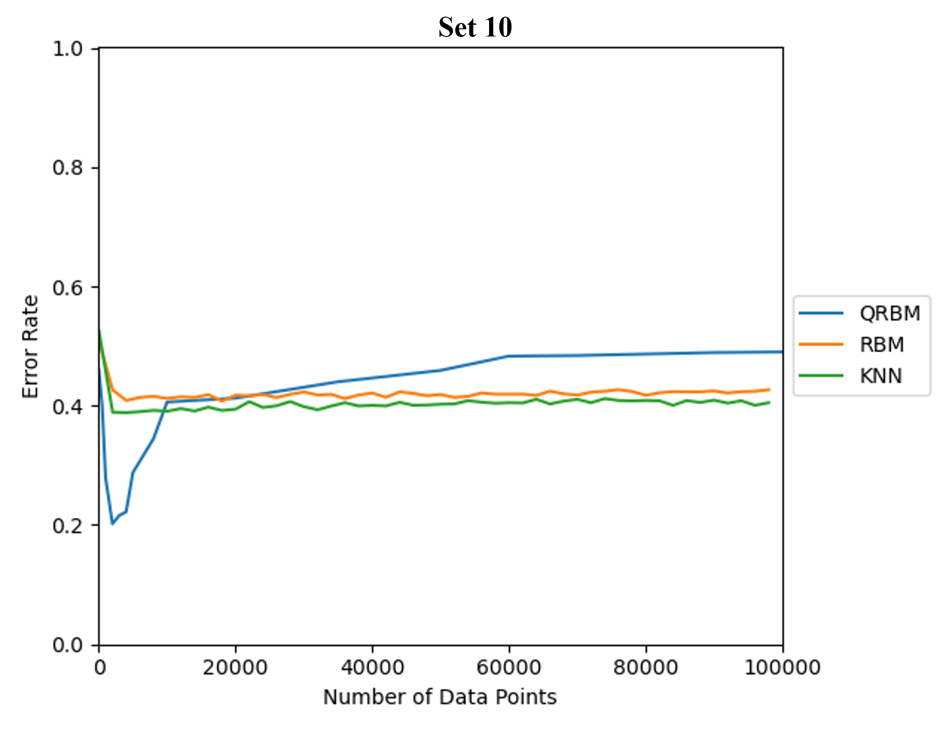
SAME PLOT for SET 8*
SAME PLOT for SET 9*
Figure 3. Performance of the models as a function of number of training points
Figure 2 illustrates the generalization ability of the three models based on the number of data points used during the training process. Each point shows the performance of the models on evaluation set based on a balanced subset of training points. Since the data points are randomly selected and stochastic in nature RBM and QRBM the reported results are the average of multiple runs. Using only a small portion of the training data, QRBM achieves better performance and demonstrates the ability of the model to generalize. The model is more efficient in terms of using less than 10000 data points as compared to the other two models.
Table 3 shows the generalization ability of the models. All of the results in Table 3 are based on 16-bit linear binarization mode of data. The performance of the models is shown as a function of the number of data points used for the training process.

Conclusions
We present a preliminary investigation of the generalization ability of quantum-based Restricted Boltzmann machines. QRBM has demonstrated significant benefits in terms of capturing underlying data structures and achieving superior performance with fewer training data points. It is evident from the study that quantum computing-inspired models have the potential to revolutionize machine learning, particularly in situations where limited data availability poses a challenge. Advancing the field of machine learning and optimizing its applications in real-world situations will be greatly facilitated by further research and exploration in this direction.

Acknowledgments
The material presented here is supported by the National Science Foundation under grants nos. *. The National Science Foundation is not responsible for the views expressed in this material. All opinions, findings, conclusions, and recommendations are those of the author(s).
The IMLD was developed using the following open-source libraries: NumPy v1.15.4, PyQT5 v5.13.1, SkLearn v0.20.0, Scipy v1.1.0, and Matplotlib v3.0.2.
Table 3. Performance of the models (% error rate) using only a portion of datapoints for the training process
DS | Data Points | System | Train | Dev | Eval
#08 | 5000 | KNN | 44.15 | 44.44 | 65.08
 |  | RBM
 |  | QRBM | 25.35 | 25.64 | 26.11
#09 | * | KNN
 |  | RBM
 |  | QRBM
#10 | 2000 | KNN | 19.54 | 41.72 | 39.21
 |  | RBM | 22.91 | 45.14 | 40.00
 |  | QRBM | 20.69 | 21.51 | 21.25

References
[1] M. I. Jordan and T. M. Mitchell, “Machine learning: Trends, perspectives, and prospects,” Science, vol. 349, no. 6245, pp. 255–260, Jul. 2015, doi: 10.1126/science.aaa8415.
[2] C. Bishop, Pattern Recognition and Machine Learning, 2nd ed. New York, New York, USA: Springer, 2011. [Online]. Available: https://www.springer.com/us/book/9780387310732
[3] S. Lloyd, M. Mohseni, and P. Rebentrost, “Quantum algorithms for supervised and unsupervised machine learning,” 2013, doi: 10.48550/ARXIV.1307.0411.
[4] P. Rebentrost, M. Mohseni, and S. Lloyd, “Quantum Support Vector Machine for Big Data Classification,” Phys. Rev. Lett., vol. 113, no. 13, p. 130503, Sep. 2014, doi: 10.1103/PhysRevLett.113.130503.
[5] N. Wiebe, A. Kapoor, and K. M. Svore, “Quantum Deep Learning,” 2014, doi: 10.48550/ARXIV.1412.3489.
[6] H. Neven, G. Rose, and W. G. Macready, “Image recognition with an adiabatic quantum computer I. Mapping to quadratic unconstrained binary optimization,” 2008, doi: 10.48550/ARXIV.0804.4457.
[7] V. Dumoulin, I. Goodfellow, A. Courville, and Y. Bengio, “On the Challenges of Physical Implementations of RBMs,” Proc. AAAI Conf. Artif. Intell., vol. 28, no. 1, Jun. 2014, doi: 10.1609/aaai.v28i1.8924.
[8] R. Babbush, V. Denchev, N. Ding, S. Isakov, and H. Neven, “Construction of non-convex polynomial loss functions for training a binary classifier with quantum annealing,” 2014, doi: 10.48550/ARXIV.1406.4203.
[9] M. Gu, K. Wiesner, E. Rieper, and V. Vedral, “Quantum mechanics can reduce the complexity of classical models,” Nat. Commun., vol. 3, no. 1, p. 762, Mar. 2012, doi: 10.1038/ncomms1761.
[10] M. W. Johnson et al., “Quantum annealing with manufactured spins,” Nature, vol. 473, no. 7346, pp. 194–198, May 2011, doi: 10.1038/nature10012.
[11] S. H. Adachi and M. P. Henderson, “Application of Quantum Annealing to Training of Deep Neural Networks,” 2015, doi: 10.48550/ARXIV.1510.06356.
[12] M. Benedetti, J. Realpe-Gómez, R. Biswas, and A. Perdomo-Ortiz, “Estimation of effective temperatures in quantum annealers for sampling applications: A case study with possible applications in deep learning,” Phys. Rev. A, vol. 94, no. 2, p. 022308, Aug. 2016, doi: 10.1103/PhysRevA.94.022308.
[13] M. Benedetti, J. Realpe-Gómez, R. Biswas, and A. Perdomo-Ortiz, “Quantum-Assisted Learning of Hardware-Embedded Probabilistic Graphical Models,” Phys. Rev. X, vol. 7, no. 4, p. 041052, Nov. 2017, doi: 10.1103/PhysRevX.7.041052.
[14] D. Korenkevych et al., “Benchmarking Quantum Hardware for Training of Fully Visible Boltzmann Machines,” 2016, doi: 10.48550/ARXIV.1611.04528.
[15] D. Kielpinski, C. Monroe, and D. J. Wineland, “Architecture for a large-scale ion-trap quantum computer,” Nature, vol. 417, no. 6890, pp. 709–711, Jun. 2002, doi: 10.1038/nature00784.
[16] A. Blais, R.-S. Huang, A. Wallraff, S. M. Girvin, and R. J. Schoelkopf, “Cavity quantum electrodynamics for superconducting electrical circuits: An architecture for quantum computation,” Phys. Rev. A, vol. 69, no. 6, p. 062320, Jun. 2004, doi: 10.1103/PhysRevA.69.062320.
[17] A. Wallraff et al., “Circuit Quantum Electrodynamics: Coherent Coupling of a Single Photon to a Cooper Pair Box,” 2004, doi: 10.48550/ARXIV.COND-MAT/0407325.
[18] R. J. Schoelkopf and S. M. Girvin, “Wiring up quantum systems,” Nature, vol. 451, no. 7179, pp. 664–669, Feb. 2008, doi: 10.1038/451664a.
[19] M. Hofheinz et al., “Synthesizing arbitrary quantum states in a superconducting resonator,” Nature, vol. 459, no. 7246, pp. 546–549, May 2009, doi: 10.1038/nature08005.
[20] J. Preskill, “Quantum Computing in the NISQ era and beyond,” Quantum, vol. 2, p. 79, Aug. 2018, doi: 10.22331/q-2018-08-06-79.
[21] P. Hauke, F. M. Cucchietti, L. Tagliacozzo, I. Deutsch, and M. Lewenstein, “Can one trust quantum simulators?,” Rep. Prog. Phys., vol. 75, no. 8, p. 082401, Aug. 2012, doi: 10.1088/0034-4885/75/8/082401.
[22] H. Neven, V. S. Denchev, G. Rose, and W. G. Macready, “Training a Large Scale Classifier with the Quantum Adiabatic Algorithm,” 2009, doi: 10.48550/ARXIV.0912.0779.
[23] R. Babbush, P. J. Love, and A. Aspuru-Guzik, “Adiabatic Quantum Simulation of Quantum Chemistry,” Sci. Rep., vol. 4, no. 1, p. 6603, Oct. 2014, doi: 10.1038/srep06603.
[24] S. Garnerone, P. Zanardi, and D. A. Lidar, “Adiabatic Quantum Algorithm for Search Engine Ranking,” Phys. Rev. Lett., vol. 108, no. 23, p. 230506, Jun. 2012, doi: 10.1103/PhysRevLett.108.230506.
[25] A. Perdomo-Ortiz, N. Dickson, M. Drew-Brook, G. Rose, and A. Aspuru-Guzik, “Finding low-energy conformations of lattice protein models by quantum annealing,” Sci. Rep., vol. 2, no. 1, p. 571, Aug. 2012, doi: 10.1038/srep00571.
[26] A. Lucas, “Ising formulations of many NP problems,” Front. Phys., vol. 2, 2014, doi: 10.3389/fphy.2014.00005.
[27] K. Binder and A. P. Young, “Spin glasses: Experimental facts, theoretical concepts, and open questions,” Rev. Mod. Phys., vol. 58, no. 4, pp. 801–976, Oct. 1986, doi: 10.1103/RevModPhys.58.801.
[28] H. Nishimori, Statistical Physics of Spin Glasses and Information Processing. Oxford University Press, 2001. Accessed: Jun. 20, 2023. [Online]. Available: https://academic.oup.com/book/5185
[29] H. G. Katzgraber, F. Hamze, Z. Zhu, A. J. Ochoa, and H. Munoz-Bauza, “Seeking Quantum Speedup Through Spin Glasses: The Good, the Bad, and the Ugly,” Phys. Rev. X, vol. 5, no. 3, p. 031026, Sep. 2015, doi: 10.1103/PhysRevX.5.031026.
[30] A. D. King, T. Lanting, and R. Harris, “Performance of a quantum annealer on range-limited constraint satisfaction problems,” 2015, doi: 10.48550/ARXIV.1502.02098.
[31] S. Mandrà, Z. Zhu, W. Wang, A. Perdomo-Ortiz, and H. G. Katzgraber, “Strengths and weaknesses of weak-strong cluster problems: A detailed overview of state-of-the-art classical heuristics versus quantum approaches,” Phys. Rev. A, vol. 94, no. 2, p. 022337, Aug. 2016, doi: 10.1103/PhysRevA.94.022337.
[32] S. Mandrà and H. G. Katzgraber, “A deceptive step towards quantum speedup detection,” 2017, doi: 10.48550/ARXIV.1711.01368.
[33] D. H. Ackley, G. E. Hinton, and T. J. Sejnowski, “A learning algorithm for boltzmann machines,” Cogn. Sci., vol. 9, no. 1, pp. 147–169, Jan. 1985, doi: 10.1016/S0364-0213(85)80012-4.
[34] G. E. Hinton, S. Osindero, and Y.-W. Teh, “A Fast Learning Algorithm for Deep Belief Nets,” Neural Comput., vol. 18, no. 7, pp. 1527–1554, May 2006, doi: 10.1162/neco.2006.18.7.1527.
[35] T. Cap, A. Kreitzer, M. Miranda, and D. Vadimsky, “IMLD: A Python-Based Interactive Machine Learning Demonstration,” in Senior Design II, College of Engineering, Temple University, Philadelphia, Pennsylvania, USA, 2022, pp. 1–22. doi: https://isip.piconepress.com/publications/presentations_misc/2022/senior_design/imld/.
[36] L. E. Peterson, “K-nearest neighbor,” Scholarpedia, vol. 4, no. 2, p. 1883, Feb. 2009, doi: 10.4249/scholarpedia.1883.
[37] N. Papernot and P. McDaniel, “Deep k-Nearest Neighbors: Towards Confident, Interpretable and Robust Deep Learning,” 2018, doi: 10.48550/ARXIV.1803.04765.

