A major objective of the Biofilm Image Library is the creation of high-quality annotated datasets capable of supporting machine learning methods for automated segmentation of complex three-dimensional biofilm images. Developing an efficient annotation pipeline proved to be one of the most significant technical challenges of the project, requiring substantial optimization to balance annotation quality with scalability.
Our initial workflow relied on exhaustive manual annotation using the open-source visualization tool Napari. Expert annotators manually outlined every visible cell in selected two-dimensional image slices by tracing precise bounding polygons. Restricting the initial effort to single image slices allowed us to refine annotation standards, establish consistent labeling conventions, and evaluate segmentation performance before extending the workflow to full 3D image stacks.
These fully annotated images were then used to train a segmentation model using the open-source StarDist OPP framework. The results are shown in Figure 1. After iterative tuning of model parameters, the resulting segmentation accuracy was encouraging and demonstrated that modern deep learning methods could successfully learn complex cellular morphologies from manually curated examples. Although this validated the overall approach, it also revealed a major practical limitation: complete annotation of every cell in every image required an unsustainable amount of expert effort, making large-scale corpus development impractical.
To overcome this bottleneck, we redesigned the annotation process around partial annotation. Rather than labeling every cell within an image, annotators identify approximately one hundred representative regions of interest that capture the diversity of cell shapes, sizes, densities, and imaging conditions. This dramatically reduces annotation time while preserving the information necessary to train accurate segmentation models. The results are shown in Figure 2.
Implementing this strategy required overcoming a limitation of the StarDist training framework. StarDist assumes that every pixel in each training image has been assigned to either a foreground object or the background. Partially annotated images violate this assumption because large portions of the image remain unlabeled. To address this incompatibility, we developed a preprocessing tool that automatically extracts the annotated regions from each image and assembles them into a single composite training image in which every pixel is assigned a valid label. These collated images satisfy StarDist's labeling requirements while preserving the manually annotated examples.
Experiments demonstrated that models trained using these composite images achieve segmentation performance comparable to models trained on fully annotated images, while reducing manual annotation effort by an order of magnitude. This improvement has transformed the overall workflow by allowing annotated datasets to grow rapidly without sacrificing model quality.
Once an updated segmentation model has been trained, it is applied automatically across every slice of an entire confocal image stack. Since a typical dataset contains approximately 200 slices, automated inference eliminates thousands of manual segmentation operations for every image processed. To further extend the analysis into three dimensions, we have also developed software that tracks segmented cells across adjacent slices and reconstructs them as individual 3D objects. This enables quantitative measurements of cell morphology, volume, and spatial organization throughout the biofilm.
The combination of optimized manual annotation, efficient machine learning training, automated segmentation, and 3D reconstruction provides a scalable pipeline for generating large, high-quality annotated datasets. Using this workflow, we expect to produce approximately 200 fully processed biofilm images as an initial pilot corpus, providing an important community resource for developing and benchmarking future machine learning methods for biofilm image analysis.
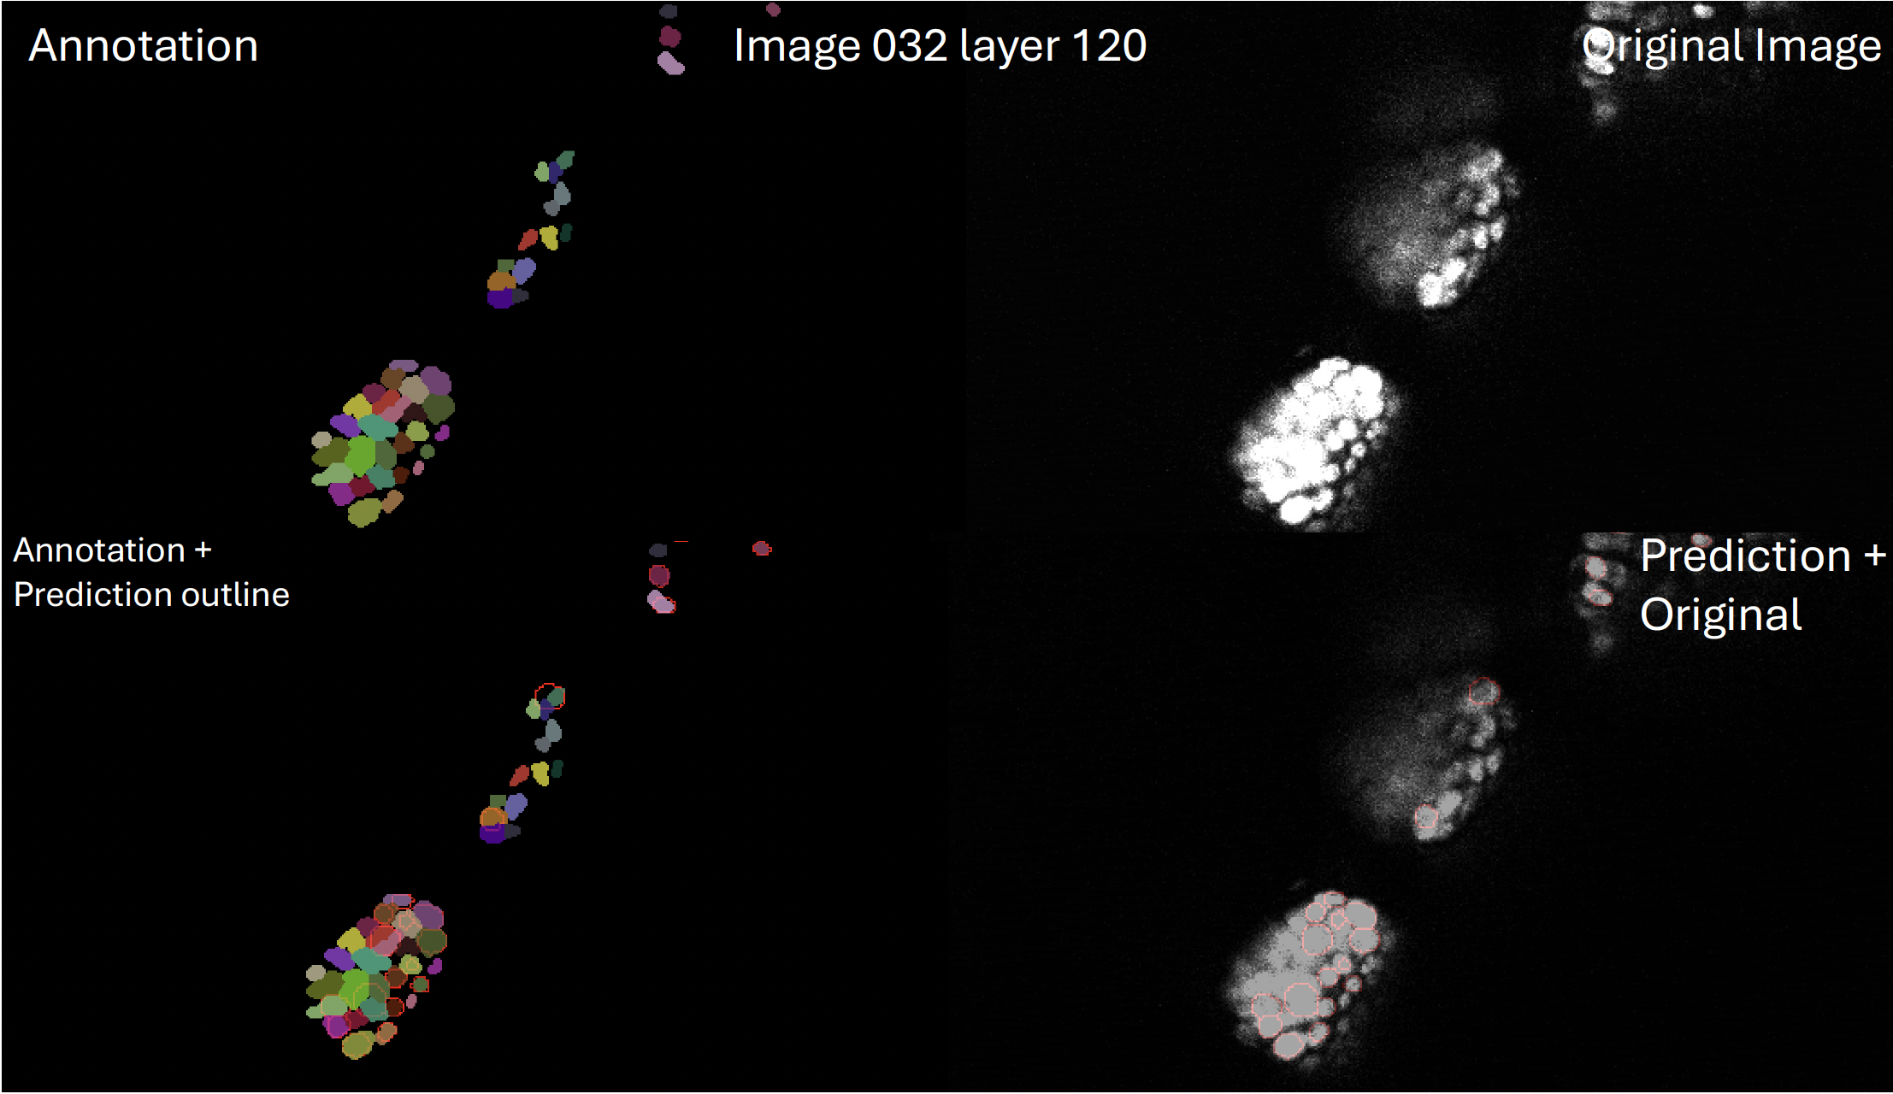
Figure 1. An example of the supervised training process used in machine learning. A manually annotated image is shown in the left. An automatically annotated image is shown on the right. Our optimized StarDist OPP models were used for the automatic annotation

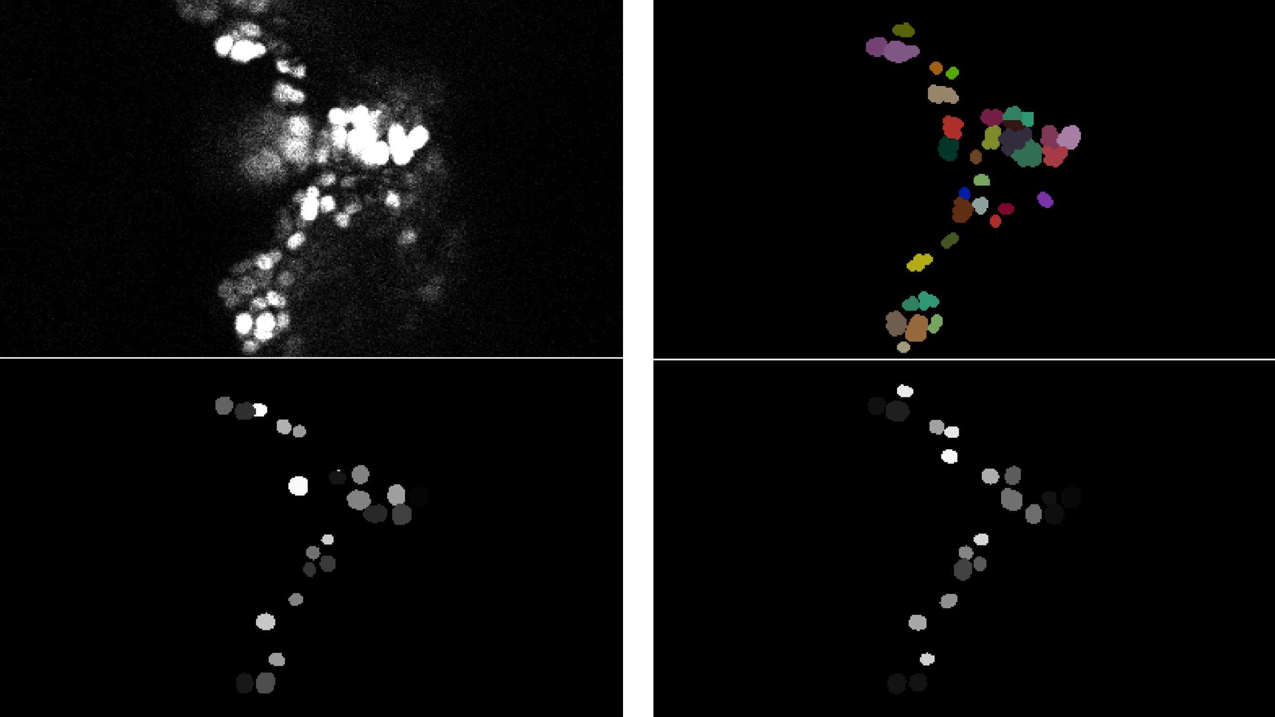
Figure 2. An example of the annotation process. The original image appears on the upper left. A manually annotated image appears on the upper right. An automatically annotated image appears on the lower left that uses a model trained on fully annotated data. A similar automatically annotated image appears on the lower right which is the result of a model trained on partially annotated images.

