Annotation Guidelines for NEDC’s EEG Corpora
May 1, 2026
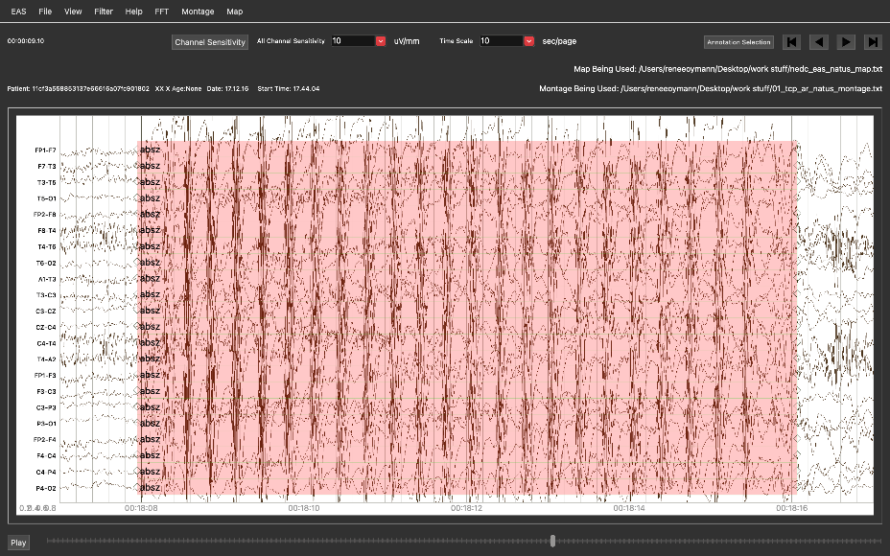
Prepared By:
A. Melles, R. Oymann, I. Obeid and J. Picone
The Neural Engineering Data Consortium
College of Engineering, Temple University
1947 North 12th Street
Philadelphia, Pennsylvania 19122
Tel: 215-204-4841; Fax: 215-204-5960
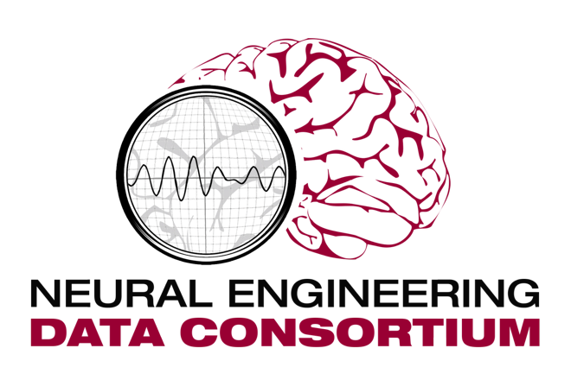
Email: {anne-mai.melles, makeda.paderewski, renee.oymann}@temple.edu, vinit.shahj@gmail.com, {iobeid, picone@temple.edu}
- Introduction
This document describes the annotation guidelines for the Neural Engineering Data Consortium’s EEG Corpora. Readers should begin by studying a companion document (Ferrell et al., 2020) that describes how the data was collected and represented in data files. There are a few important concepts that must be mastered, including the notion of a montage and how channel labels are used. The filenaming schemes for the TUH EEG corpora are also described in this document.
A second document to be studied is the annotation guidelines for the Natus Medical Incorporated Ambulatory EEG Corpus (Melles et al., 2025). This document describes the file organization scheme for this corpus and contains an early version of a description of the annotation process. These guidelines build upon the Temple University Hospital EEG Corpus (TUEG) guidelines (Ochal et al., 2020) and represent a significant advancement in annotation practices, specifically focusing on labeling seizure events, rhythmic periodic patterns, and artifacts. They incorporate updates aligned with the 2021 ACNS guidelines and adopt the latest standardized terminology, ensuring greater accuracy and consistency in ambulatory EEG data labeling (Hirch et al., 2021). Key annotation categories include the seizure types focal, generalized, and absence for the NMAE Corpus and additionally simple partial, complex partial, tonic, clonic, tonic-clonic, atonic, and myoclonic for the TUEG Corpus, rhythmic periodic patterns (e.g., GPD, LPD), and intermittent rhythmic delta activities (e.g., ORIDA, FIRDA, TIRDA). Artifacts and ictal phases are also defined and addressed to avoid misclassification and improve data utility.
It is important to note that when we refer to the TUEG corpora, we are referring to seven versions that have been released over the past 15 years: (1) TUEG: the master corpus from which all subsets have been derived (Obeid & Picone, 2016); (2) TUAB: the normal/abnormal EEG corpus (Lopez, 2017), (3) TUAR: the artifact corpus (Hamid et al., 2020); (4) TUEP: the epilepsy corpus (McHugh, Picone & Obeid, 2017); (5) TUEV: the events corpus, which is now somewhat dated and should be considered somewhat obsolete (Harati et al., 2013); (6) TUSZ: the seizure corpus, which has been our most popular corpus to date (Melles et al., 2024); and (7) TUSL: the slowing corpus (von Weltin et al., 2017). These are available from a central location on our web site: https://isip.piconepress.com/projects/nedc/html/tuh_eeg/. Though only TUSZ and TUEP have been annotated for seizure events, all corpora have been organized in a similar manner and are subsets of the TUEG Corpus.
The main goal of this document is to describe in a single document the annotation process used to annotate both corpora. Once we completed annotation of NMAE, we revisited the TUSZ annotations and updated them based on what we learned from annotating NMAE. Both corpora are now annotated in a similar manner, and experiments using both corpora simultaneously are possible. We begin with a brief description of how annotations are represented in a spreadsheet file we refer to as our EEG annotation file format. We also discuss how the metadata extracted from EEG reports is organized in a spreadsheet.
- File Organization
Though over the years we have used several file formats to store annotations, we currently use a csv format exclusive to store our annotations. This was the preferred approach when we polled our large subscriber base. In this section, we describe the csv format used to store annotations, and the metadata spreadsheet used to store attributes extracted from the anonymized EEG reports. More information on the basic file organization structure for our corpora can be found in the README files that accompany each corpus.
There are three types of files available in each directory containing EEG data for a subject:
*.edf: the EEG sampled data in European Data Format (edf)
*.csv: per-channel or event-based annotations using all available seizure types (multi-class)
*.csv_bi: term-based annotation using only two types of labels (bi-class: seizure/background)
These annotations use one of two formats: (1) event-based (*.csv): annotations of start time, stop time, and seizure type on a specific channel; (2) term-based (*.csv_bi): all channels share the same annotation, which is an aggregation of the per-channel annotations. The former are particularly useful for education, training and basic science research while the latter are extremely useful for ML technology development.
The metadata spreadsheet contains an enumeration of various medical conditions extracted from the EEG reports such as the presence of an electrographic seizure, a clinical seizure, a history of strokes, dementia, and alcohol abuse. These were extracted from the EEG report corresponding to a session, and clustered into the most commonly occurring conditions. The categories were decided based on the needs of the community and our experience with frequently occurring terms in the reports. These were manually reviewed by our annotation team after they completed annotation of TUSZ and TUEP.
  - The EEG Annotation File Format
In Figure 1, we show a csv file containing an annotation of a seizure event. The first five lines are comment fields that contain information about the original file corresponding to this annotation. The next line, which is the first uncommented line, contains the header for the spreadsheet. The following lines contain annotations of actual events.
The montage file is particularly important. It describes how the multichannel signal contained in the EDF file, which are typically absolute voltage levels referenced to some ground point, are preprocessed. The montage files are described in more detail in Ferrell et al. (2020), and available in the /DOCS directory of each corpus release. For example, for TUSZ v2.0.5, the montage files are found at this URL: https://isip.piconepress.com/projects/nedc/data/tuh_eeg/tuh_eeg_seizure/v2.0.5/DOCS.
Each event is described by a n-tuple that contains the channel label, the start and stop time in seconds, the actual label, and a confidence value. For manual annotations, the confidence value is arbitrarily set to $1.0$. For automatically generated hypotheses, it can reflect the system’s confidence in the output as a number in the range $[0,1]$ (often reflecting a probability or likelihood). Figure 1 shows an example of an event-based annotation. Each event is specific to a channel.
# version = csv_v1.0.0
# bname = aaaaanrc_s004_t010
# duration = 578.0000 secs
# montage_file = 01_tcp_ar_montage.txt
#
channel,start_time,stop_time,label,confidence
FP1-F7,191.5421,307.4727,gnsz,1.0000
F7-T3,191.5195,307.4727,gnsz,1.0000
T3-T5,191.5195,307.4727,gnsz,1.0000
FP2-F8,191.5198,307.4727,gnsz,1.0000
F8-T4,191.5195,307.4727,gnsz,1.0000
T4-T6,191.5195,293.1091,gnsz,1.0000
A1-T3,190.2422,307.4727,gnsz,1.0000
T3-C3,190.2422,307.4727,gnsz,1.0000
C3-CZ,190.2422,307.4727,gnsz,1.0000
CZ-C4,190.2422,307.4727,gnsz,1.0000
C4-T4,190.2422,307.4727,gnsz,1.0000
T4-A2,190.2422,307.4727,gnsz,1.0000
FP1-F3,190.2422,307.4727,gnsz,1.0000
F3-C3,190.2422,307.4727,gnsz,1.0000
...
Figure 1. An example of a csv file containing an EEG annotation that includes a seizure event
# version = csv_v1.0.0
# bname = aaaaanrc_s004_t010
# duration = 578.0000 secs
# montage_file = 01_tcp_ar_montage.txt
#
channel,start_time,stop_time,label,confidence
TERM,190.2422,307.4727,seiz,1.0000
Figure 2. An example of a csv_bi file containing a term-based EEG annotation.

In Figure 2, we show this annotation converted to a term-based annotation. We also store this in a csv file that typically has a file extension of “.csv_bi”, which refers to a bi-level annotation. These are convenient for machine learning experiments in which the system attempts to make a seizure/no seizure decision. Instead of specific channel labels, we use the symbol “TERM” as the channel label to indicate this is a term-based annotation.
We convert event-based annotations to term-based annotations using an automated tool (nedc_eeg_convert_events_to_terms) that implements a simple algorithm to collapse a multichannel annotation of an event to a single start and stop time that covers a period of time from the minimum start time to the maximum stop time measured across all annotated channels for that event. We have developed scoring software (Shah, et al., 2020) that uses this format to assess the segmentation accuracy of a machine learning system.
  - The EEG Metadata Format
Starting with v2.0.5, we have released a spreadsheet that identifies key morphologies present in the data. We polled the community and asked for input into what conditions were of most interest to researchers. We augmented this list with our own suggestions based on our experience with the data.
For several years now, we have provided a service to users in which they can provide a Python script to filter reports for certain keywords and return a list of reports matching the constraints programmed into their scripts. The problem with this is that it is extremely difficult to interpret these reports using automated methods. The reports, as explained in our original publications, are unformatted text. The language is often ambiguous and defensive. The presence of a term does not necessarily indicate a positive or negative diagnosis of that condition. Hence, after several years of supporting users in this way, we decided to manually review the reports and cluster them by diagnoses.
The spreadsheet is included in the /DOCS directory with a name metadata_vXXr.xlsx. The identifier “vXX” refers to the version (e.g., “v00”) an “r” refers to “released.” The master copy, which we manage internally contains the name of the annotator who initially processed the session. We keep that for our internal records. The annotation team worked closely as a team, hosting weekly meetings, to ensure that the criteria used to cluster each report were common across annotators. Some amount of manual review of the annotators work was done by the project lead who is the author of this document.
The fields present in the spreadsheet are shown in Table 1. Column A contains a unique identifier for each subject and session. For example, “aaaaaaac_s001” corresponds to subject “aaaaaaac” and session “s001.” Columns B-M are somewhat self-explanatory and contain a value of “Y” if the EEG report indicated the presence of this condition. Otherwise, it is labeled “N.”
Table 1. The categories available in v00 of the metadata spreadsheet
Column | Heading | Column | Heading
A | Subject ID | I | Schizophrenia
B | Electrographic Seizure | J | Dementia
C | Clinical Seizure | K | Alcohol Abuse
D | Stroke | L | Anxiety
E | Epilepsy | M | Depression
F | Parkinson's | N | Other Diagnosis
G | Alzheimer's | O | Major Medications (Comma Separated List)
H | Traumatic Brain Injury (TBI)

Column N is a catch-all that contains information about other significant diagnoses mentioned in the report. For example, for subject “aaaaaaav_s001”, this field contains “focal sclerosis glomerulonephritis.” Extraction of these diagnoses should make it feasible for researchers to select less subjects based on less common attributes using simple keyword searching. These values were often extracted from the report as phrases such as “Reason for visit: anoxic injury, Diagnosis: Refractory status epilepticus” (session aaaaadsz_s002), so some work will be required to parse these values. We recommend doing a unique sort to understand all possible values that can be contained in this field since it is irregular.
Column O is also a bit of a catch-all. Since there are a wide variety of medications mentioned in the reports, we simply provide a comma separated list of medications mentioned in the reports (e.g., “Topiramate, Neurontin, Allegra”). Researchers can easily parse these lists for drugs that are of specific interest. The number of drugs mentioned in the reports is too long to list individually.
- Annotation Labels
We have manually annotated a significant portion of ... have been using v6.0.2 of our open-source annotation tools (nedc_eas) (Capp et al., 2017). (ref: annotation guidelines). To facilitate annotation, we split the data into files no longer than 30 mins. This was necessary to ensure that annotators were not slowed by the inefficiencies of our Python-based tool when handling larger files.
A master list of annotation labels, and their descriptions, are given in Appendix A.
<under development>

The labels used in annotation are shown in Table 1.

There are three different intermittent rhythmic delta activity labels we use: orida, firda and tirda. The first letter indicates what region of the brain the intermittent delta activity is occurring: occipital, frontal or temporal. There are two different rhythmic periodic patterns labels: gpd and lpd. Generalized and lateralized indicate if the periodic discharges are local on focal areas or spread around channels. For seizure annotations, there are three labels in use: fnsz, gnsz and absz. We do not differentiate between the two types of focal seizures, simple or complex, and use one label for both (fnsz). We differentiate absence seizures (absz) from generalized seizures (gnsz). If there is no seizure in the file, we mark the first second in the file on the channels Fp1-F7 as “bckg” so that every edf file has a non-empty annotation file. This makes database curation much easier.
An annotator can typically process approximately 10 files, corresponding to 5 hours of EEG recordings, in a single hour. Annotations are reviewed by a project manager, who selects data for review based on observed patterns and knowledge of each annotator’s behavior. The team also meets weekly to discuss challenging cases encountered in the files and arrive at a committee consensus. We operate in a discussion-based environment, collaboratively researching and determining the best approaches to handle specific activities. To enhance efficiency, we use our real-time seizure detection system (Khalkhali et al., 2021) to triage the data. This has proven to be quite effective.
The annotation tool offers useful features such as adjustable channel sensitivity (µV/mm) and time scale (seconds per page). The default channel sensitivity is 10 µV/mm. Increasing this value can improve visualization when waveform amplitudes are high, which helps in clearly identifying patterns such as the spike and wave morphology.
Table 3. The labels used to annotate TUEG
Index | Label | Description
0 | null | An undefined annotation. Should not be seen in the data.
1 | spsw | Spike and/or slow wave. A short duration epileptiform event involving an electrographic spike in activity and/or a slow wave (low frequency wave). Usually no more than 1 sec. in duration.
2 | gped | Generalized periodic epileptiform discharge. Periodic diffuse spike/sharp wave discharges across multiple regions or hemispheres.
3 | pled | Periodic lateral epileptiform discharge. A regular, periodically occurring spike/sharp wave seen in a certain locality of the scalp.
4 | eybl | Eyeblink. A specific, sharp, high amplitude eye movement artifact corresponding to blinks.
5 | artf | Artifact. Any non-brain activity electrical signal, such as those due to equipment or environmental factors.
6 | bckg | All other non-seizure cerebral signals.
7 | seiz | Seizure. A basic annotation for seizures.
8 | fnsz | Focal nonspecific seizure. A large category of seizures occurring in a specific focality.
9 | gnsz | Generalized seizure. A large category of seizures occurring in most if not all of the brain.
10 | spsz | Simple partial seizure. Brief seizures that start in one location of the brain (and may spread) where the patient is fully aware and able to interact.
11 | cpsz | Complex partial seizure. Same as simple partial seizure but with impaired awareness.
12 | absz | Absence seizure. Brief, sudden seizure involving lapse in attention. Usually lasts no more than 5 seconds and commonly seen in children.
13 | tnsz | Tonic seizure. A seizure involving the stiffening of the muscles. Usually associated with and annotated as tonic-clonic seizures, but not always (rarely there is no clonic phase).
14 | cnsz | Clonic seizure. A seizure involving sustained, rhythmic jerking. Not seen in our datasets, as it is always associated with tonic clonic seizures and is annotated as such.
15 | tcsz | Tonic-clonic seizure. A seizure involving loss of consciousness and violent muscle contractions.
16 | atsz | Atonic seizure. A seizure involving the loss of tone of muscles in the body. Also never seen as it is always associated with an occasionally occurring phase before a tonic clonic seizure.
17 | mysz | Myoclonic seizure. A seizure associated with brief involuntary twitching or myoclonus.
18 | nesz | Non-epileptic seizure. Any non-epileptic seizure observed. Contains no electrographic signs.
19 | intr | Interesting patterns. Any unusual or interesting patterns observed that don't fit into the above classes.
20 | slow | Slowing. A brief decrease in frequency.
21 | eyem | Eye movement. A very common frontal/prefrontal artifact seen when the eyes move.
22 | chew | Chewing. A specific artifact involving multiple channels that corresponds with patient chewing, “bursty”
23 | shiv | Shivers. A specific, sustained sharp artifact that corresponds with patient shivering.
24 | musc | Muscle artifact. A very common, high frequency, sharp artifact that corresponds with agitation/nervousness in a patient.
25 | elpp | Electrode pop. A short artifact characterized by channels using the same electrode “spiking” with perfect symmetry.
26 | elst | Electrostatic artifact. Artifact caused by movement or interference on the electrodes, variety of morphologies.
27 | calb | Artifact caused by calibration of the electrodes. Appears as a flattening of the signal in the beginning of files.
28 | hphs | A brief period of high amplitude slow waves.
29 | trip | Large, three-phase waves frequently caused by an underlying metabolic condition.

The time scale is set by default to 10 seconds per page, but it can be adjusted to show more or less activity depending on the specific needs of the analysis. Neurologists in our experience tend to view waveforms in 10-second intervals. We have used this resolution to inform our research work.
We now discuss the morphology for each label. Note that this is an evolution of standards originally developed in Ochal et al. (2020). Here we focus on aspects of the annotation process that are unique to the Natus data.
  - The Normal EEG
A normal EEG, shown in 1, of an awake adult consists of constant, low amplitude activity in either the alpha or beta ranges. An EEG will show the normal artifacts associated with an awake patient such as eye blinks/movements and muscle artifacts. A major component of the normal EEG is the Posterior Dominant Rhythm (PDR). A PDR is also known as an alpha rhythm, because its fundamental frequency is typically in the range of 8 – 12 Hz. A PDR occurs primarily over the occipital electrodes spreading with a gradual decrease in reflection towards the frontal polar electrodes. The Posterior Dominant Rhythm occurs in awake patients and is normally attenuated by eye opening. A classification of EEG frequency bands is given in Table 3.
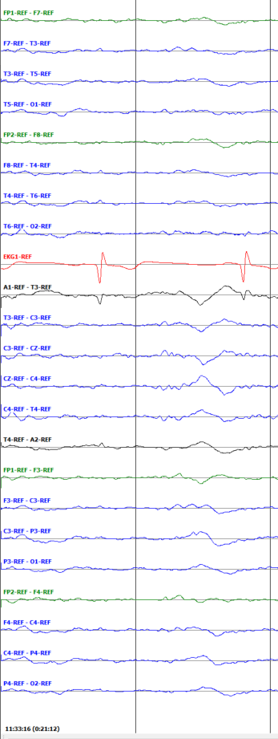
Figure 2. A typical vertex wave
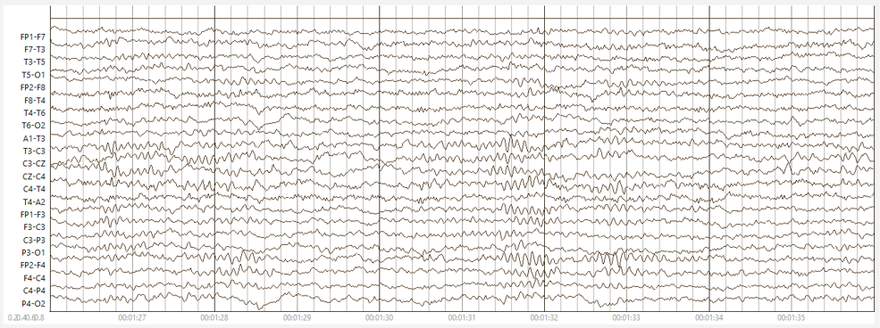
Figure 1. A normal EEG with alpha waves

Table 4. EEG frequency bands
Name | Frequency (Hz)
Delta | 0.5 - 4
Theta | 4 - 8
Alpha | 8 - 12
Beta | 12 - 30
Gamma | 30 - 100

  - Normal Sleep
Sleeping patients show several other normal signals in their EEG records. These signals may be discreet events such as K-complexes and sleep spindles, shown in Figure 3, or the presence of slow waves as the record slips into lower frequency ranges during drowsiness and sleep, as shown in Figure 2 (D. Ochal et al. 2020):
(a) K-complexes: These are individual complexes that occur during the second stage of sleep in normal patients. These events occur approximately every 1 to 2 minutes and are usually followed by sleep spindles. K-complexes consist of a high amplitude (>100 µV), diphasic discharge and occur simultaneously across all or most channels. An example is shown in figure 3.
(b) Sleep Spindles: These are 0.5-2 second events that consist of 11-16 Hz smooth waves of moderate amplitude. Unlike K-complexes, these events generally occur on only one or a few channels at once. An example is shown in Figure 3.
(c) Vertex Wave: These are individual complexes with the appearance of a transient sharp wave, as shown in figure 2. They occur with an amplitude between 50-150 µV during non-REM 1 and non-REM 2 sleep. Vertex waves ae similar in appearance to K-complexes but are more spatially confined and narrower. In children and young adults, it is possible for vertex waves to occur in repetitive tun, giving appearance of ictal activity. However, they are completely normal occurrences.
Figure 3. A K-complex and an associated sleep spindle during normal sleep

  - Seizure Events
A key identifier of an ictal event is its discharge morphology, with typical patterns including spike-and-slow wave or polyspike-and-slow wave complexes. Spikes are characterized by brief amplitude changes lasting a tenth of a second or less, usually occurring within the alpha, theta, or delta frequency ranges, and rarely exceeding 10 Hz or dropping below 2 Hz. For an event to qualify as a generalized or focal seizure, it should last at least 10 seconds, though this duration can be cumulative across channels. In the case of absence seizures, the duration must exceed 3 seconds. If there is gap or suppression longer than 3 seconds, then events are considered two distinct seizures, separated by this interictal period. Surrounding channels often synchronize with the focal seizure, showing an increase in amplitude and a decrease in frequency as the seizure progresses. Postictal slowing, which occurs immediately after the seizure, shows as slow delta waves but is not considered part of the seizure itself.
Focal non-specific seizures (FNSZ) can vary greatly in appearance, duration, and localization. A typical focal seizure is shown in Figure 4. The shaded region represents a portion of the signal that has been annotated as a focal seizure. FNSZ affect only specific channels, often limited to one hemisphere, though they can occasionally evolve into generalized seizures.
General non-specific seizures (GNSZ) are very closely related to focal non-specific seizures. They follow the same morphology, evolution, postictal slowing, and frequency descriptors, but they cover a greater number of channels and area of the skull (see Figure 5.). Synchrony is very important in a general non-specific seizure. The complexes on each channel in a GNSZ seizure are expected to have temporal overlap within 0.2 seconds. This seemingly small point is highlighted on the rare occasion in which a patient has two focal non-specific seizures occurring simultaneously. The only way to effectively determine whether a seizure is generalized or is a combination of two or more seizures is to check for synchrony between the channels. For an event to qualify as a seizure, it should last at least 10 seconds across most of the channels. If there is cap or suppression longer than 3 seconds, then events are considered two distinct seizures.
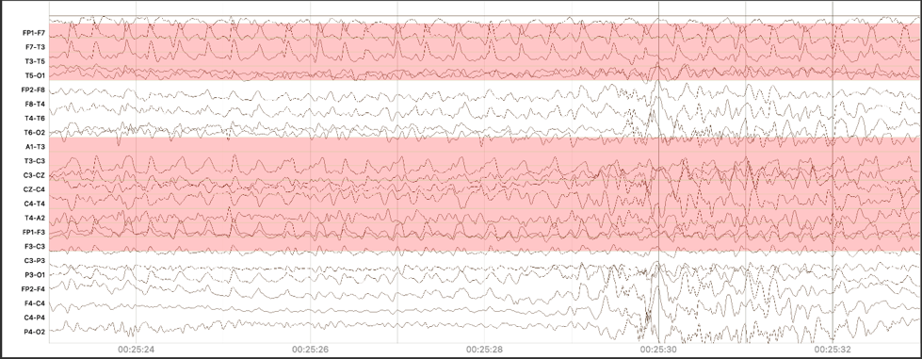
Figure 4. A typical focal seizure
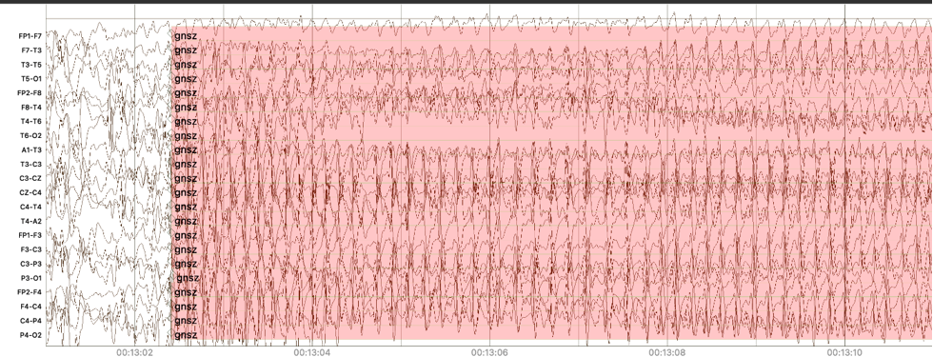
Figure 5. A typical generalized seizure
Absence seizures (ABSZ) are brief seizures that should contain no muscle artifacts. A typical example of an absence seizure is shown in Figure 6. They show a characteristic abrupt onset of spike or polyspike-and-wave discharges at frequency of 3 Hz, lasting a brief period of time, and ending just as abruptly as they began. Absence seizures are frequently high amplitude and very sharp, leaving little room for error. An exception is made for these seizures, as they are so distinct. They do not need to be 10 seconds in duration but must be at least 3 seconds in duration.
We distinguish between typical and atypical absence seizures. Atypical absence seizures can be much longer than 3–10 seconds while following the same typical absence seizure morphology. Absence seizures are particularly important to detect in ambulatory EEG recordings, as they can be difficult to capture in a stationary clinical setting. Absence seizures are one type of generalized seizure that are very easily distinguishable from other generalized seizures without access to clinical reports. This is why we can annotate them.
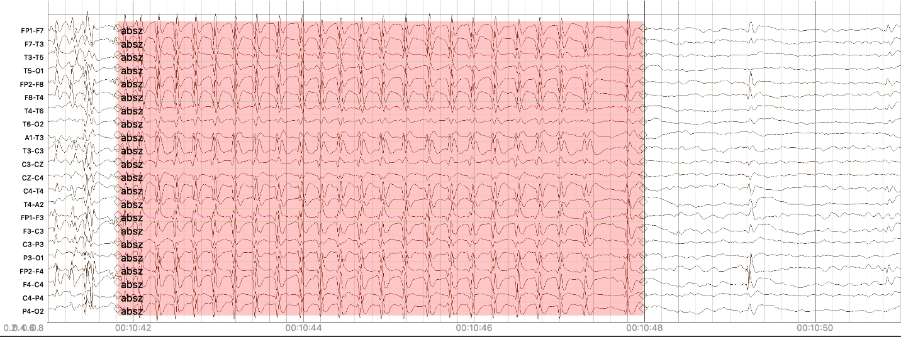
Figure 6. A typical absence seizure (channel sensitivity set to 50 µV/mm)

In addition to these primary labels the TUEG Corpus employs the following specific seizure classifications:
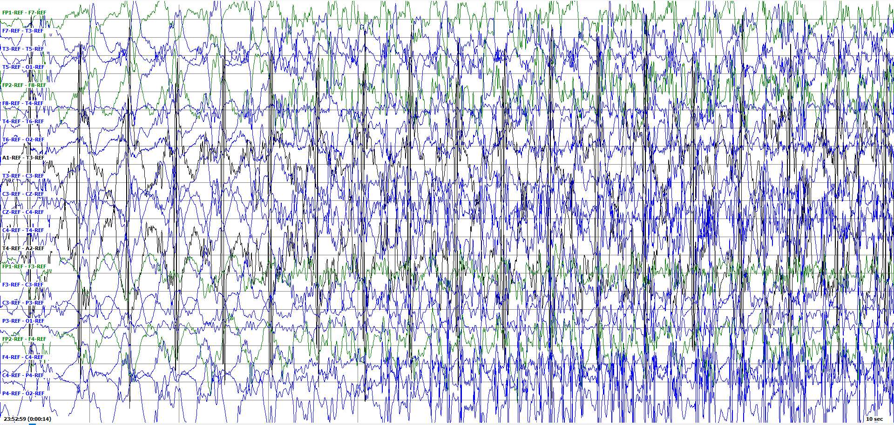
Figure 8. Tonic-clonic seizure becoming completely obscured by muscle artifact
Tonic-Clonic Seizures (TCSZ): Tonic-Clonic seizures are a type of seizure that are characterized by muscle tension and stiffening followed by violent convulsions and jerking. As such, these seizures are characterized by a distinct flattening of the EEG followed by intense muscle artifact. The actual cerebral activity of a tonic-clonic seizure is the same as that of either a focal non-specific or generalized non-specific seizure. The focality may be difficult to determine, as the cerebral activity is generally disguised by intense muscle artifact. As the seizure progresses, it may become impossible to detect the underlying cerebral activity because the muscle artifact will continue to grow in intensity until the seizure comes to an end. This is shown in Figure 8. (D. Ochal et al. 2020)

Myo-Clonic Seizures (MYSZ): Myoclonic seizures are generally very brief – a single jerk can be considered a myoclonic seizure. As such, they are rarely annotated in the EEG corpus, because it is nearly impossible to differentiate an ictal jerk from a non-ictal jerking movement. However, there are some rare instances where the myoclonus may persist for several seconds or where clinical reports indicate the presence of myoclonic seizures. The seizures will show the characteristic spike and wave complexes of a focal or generalized nonspecific seizure, but they will be overlaid with periodic jerks. Figure 7. Shows a focal myoclonic seizure. (D. Ochal et al. 2020)
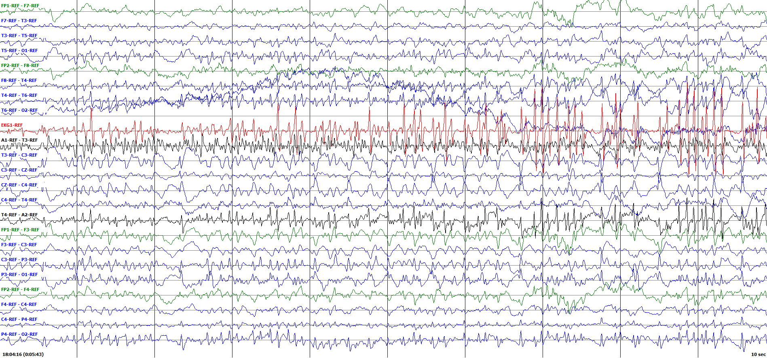
Figure 7. A myoclonic seizure is shown. The temporally locked spikes (arrows) occurring across channels are due to the rhythmic jerking motion of the patient.

Simple Partial Seizures (SPSZ): A simple partial seizure is another name for a focal seizure, as simple partial seizures are always focal. The only way to differentiate a simple partial seizure from a focal non-specific seizure is with clinical data. This is because the “simple” indicates that the patient-maintained awareness throughout the seizure – an unusual clinical finding. TUEG uses the reports to decide whether a seizure is simple partial or focal non-specific. Although this is not currently useful in automated seizure detection, assuring that no data that may be of future importance is lost in the annotation process was a major goal of our work. These seizures follow the same morphology as a focal non-specific seizure: a spike and wave complex, frequently with evolution and postictal slowing. (D. Ochal et al. 2020)
Complex Partial Seizures (CPSZ): A complex partial seizure is the inverse of a simple partial seizure. Complex partial seizures are focal seizures in which the patient does not maintain awareness. Again, this can only be indicated with clinical data captured in the EEG report. Complex partial seizures follow the same morphology of focal non-specific seizures characterized by spike and wave discharges, evolution, and postictal slowing. (D. Ochal et al. 2020)
Note that non-epileptic seizures (NES), also known as pseudo seizures, are a type of seizure that look like epileptic seizures but are not caused by abnormal brain activity. They are not observed in EEG and therefore, our work does not include NES.
  - Ictal phases
Though seizures have well defined parameters, they are often accompanied by activity before and after the primary ictal phase that does not meet these standards. These activities are considered a part of the seizure’s evolution, as activity amplitude and frequency undergo changes. These activities can be named based upon their position in comparison to the primary ictal phase or seizure. Ictal phases are not ictal events and therefore cannot be tagged. These phases serve as terminology for classifying different sectors of ictal event.
Ictal Phase: This phase is the period when the seizure is actively occurring. It encompasses the entirety of a seizure, as defined by the parameters listed within the seizure subsection of the guidelines. An example is shown in Figure 6. Its features include a sudden onset of abnormal, excessive, and synchronous brain activity. Rhythmic spikes, sharp waves, spike-and-wave complexes, or evolving frequency/amplitude patterns can be observed. It may be focal or generalized depending on the seizure type.
Preictal Phase: This phase, shown in Figure 7, occurs immediately before the ictal phase and is often also referred to as the prodromal phase. This phase is considered part of the evolution of a seizure, and discharges will often change in morphology, amplitude and frequency as the ictal activity begins to escalate into the ictal phase. Rhythmic and periodic patterns may occur within this phase but are not necessary to be considered a preictal phase. Not all seizures will be accompanied by a preictal phase (e.g., absence seizures).
Postictal Phase: This phase, shown in Figure 8, is identical to the preictal phase in all regards except that it occurs immediately after the ictal phase. This phase is often referred to as a postdromal phase. This phase is marked by changes in brain activity as the brain recovers from the abnormal electrical activity of the ictal (seizure) event. Key features include generalized slowing, suppression (postictal attenuation), focal slowing, burst suppression, a gradual return to the baseline and absence of epileptiform discharges (Krauss et al., 2011).
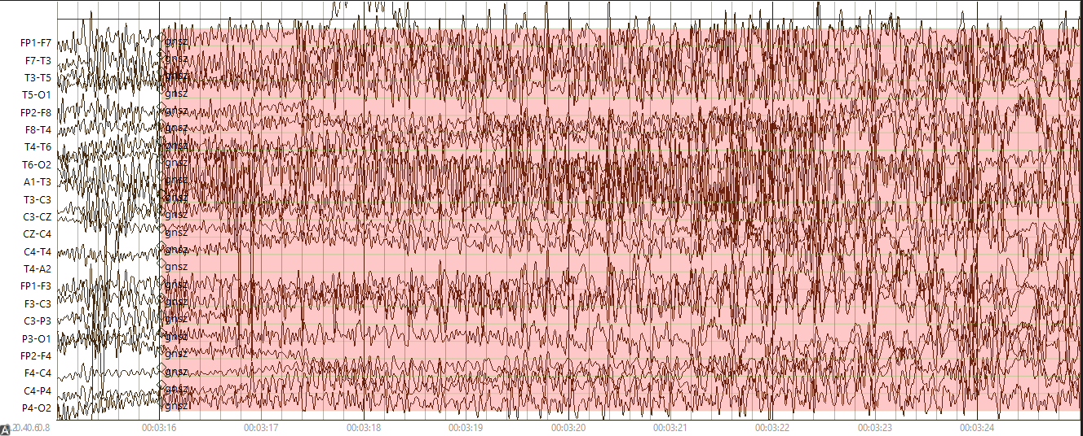
Figure 2. Ictal phase of a generalized seizure
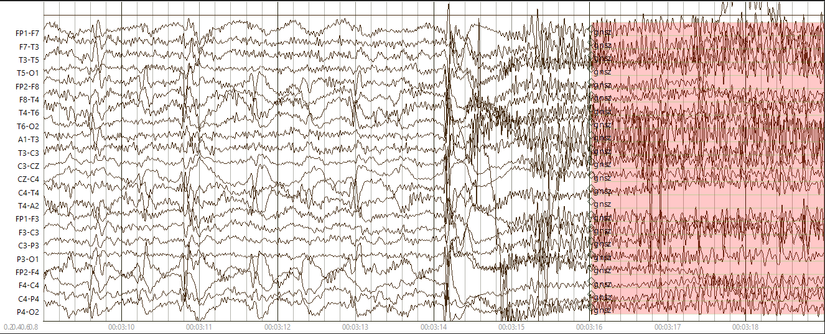
Figure 3. Preictal phase of a generalized seizure

Interictal Phase: This phase is defined as a period between seizures. It will encompass the postictal phase of one seizure, and the preictal phase of the next. Activity often returns to a baseline resting state during this phase. Interictal phase is characterized by interictal epileptiform discharges (IEDs) that occur in brief bursts and disrupts surrounding background activity (Kural et al., 2020).
  - Rhythmic and Periodic Patterns
Many EEG events show rhythmic or periodic behavior. We use the term rhythmic when referring to activity that has no interval between consecutive waveforms. In contrast, periodic activity refers to sequences of relatively uniform waveforms that repeat with a relatively uniform interval between waveforms. This distinction is consistent with the ACNS terminology (Hirsch et al., 2021). Rhythmic and periodic patterns may occur in both ictal and non-ictal events. In general, non-ictal periodic patterns are more common than non-ictal rhythmic patterns. Both types of events are often associated with epileptic or metabolic/toxic encephalopathies. Clinical examples include rhythmic delta activity (RDA) and triphasic waves. Here was discuss three types of activity we label.
Generalized Periodic Discharges (GPD): These are ictal discharges that are highly indicative of neurological dysfunction. The number of GPDs in a record is positively correlated with seizure probability and poor clinical outcomes for patients who have experienced anoxic/hypoxic events, such as drowning or cardiac arrest. In severe cases of anoxic/hypoxic brain damage, the record may consist entirely of GPDs.
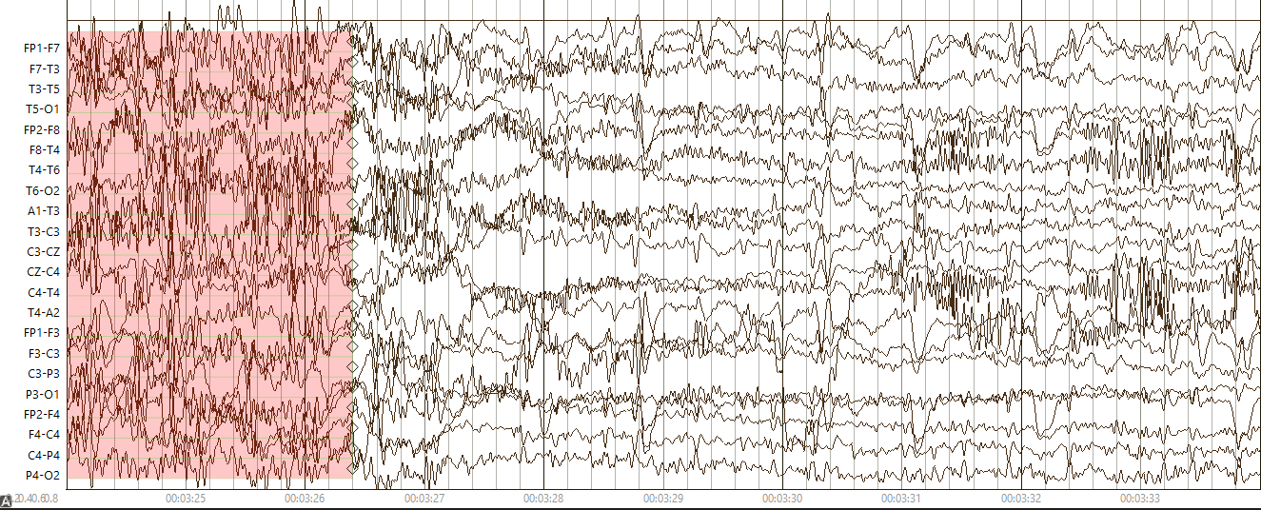
Figure 4. Postictal Phase of a generalized seizure

Although the morphology of GPDs has some variety, a few things are consistent. GPDs do not have to occur on all channels to be considered “generalized.” The phase locked, periodic discharges must simply span both hemispheres of the brain. Discharges are uniform morphology and can range from sharps, spikes, polyspikes, or sharply contoured waves. The nature of a GPD event is the continuous cycle of a discharge followed by a suppression, and each cycle is approximately an equivalent duration to the previous cycle.
This type of event may give the impression of a seizure. However, this event will remain within the lower spectrum of delta frequency and never exceed the directive seizure frequency threshold of 2.5 Hz. GPDs can occur during preictal, postictal, and interictal phases. These events do not have a maximum duration, and in some cases may occur for an entire file. A typical GPD is shown in Figure 9. These events are identical to GPDs, only they occur in one spatially confined hemisphere of the brain. They follow the same morphology of GPDs and are present in the same conditions. More information about these can be found in Gelisse et al. (2021).
Intermittent Rhythmic Delta Activity (IRDA): IRDAs are associated with neurological dysfunction and can occur during both sleeping and waking states. This event may occur during preictal, postictal, and interictal phases as seizure frequency and amplitude devolves into a baseline state. An IRDA is characterized by repetitive and uniform wave morphology without suppressions between each waveform. An IRDA is within the delta range of frequency (1 – 3.5 Hz) and must occur for six or more cycles in order to be counted as an event. An IRDA can have a complex, arciform, or sinusoidal delta wave morphology.
An IRDA may be further differentiated according to which channels the event occurs by appending the name of the prominent channel. This differentiation may have further implications as to what the activity indicates within the patient. For example, frontal intermittent rhythmic delta activity (FIRDA) suggests non-specific and diffuse dysfunction; temporal intermittent rhythmic delta activity (TIRDA) is associated with epileptiform variations; occipital intermittent rhythmic delta activity (OIRDA) is a combination of the two events and is commonly seen in children who experience absence epilepsy (Rayi et al., 2025). These events do not have a maximum duration, and in some cases may occur for the duration of the entire signal.
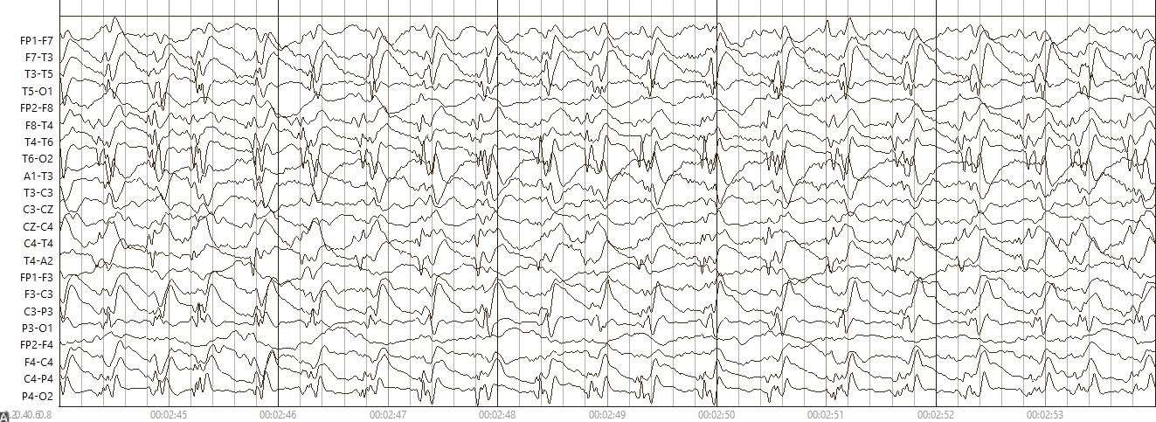
Figure 5. Generalized periodic discharges
A generalized rhythmic delta activity (GRDA) event has the same morphology of IRDA. However, it lacks an identifiable focal point. This diffuse activity must affect the patient across both hemispheres of the brain in order to be considered generalized activity, though it does not have to occur in every single brain region.
Brief Potentially Ictal Rhythmic Discharges (BIRDs): These events are non-specific in localization of a brain region or lateralization of a hemisphere but will often occur in the same regions that a seizure will occur in a patient. BIRDs often indicate the onset of a seizure event. The duration of BIRDs must be at least 0.5 seconds but not exceed 10 seconds. This event occurs within the theta frequency (4 – 7 Hz). Discharge morphology of BIRDs are similar to those of seizures, including spike, spike and wave, sharp, sharp and wave, polyspike, and polyspike and wave. This event will lack suppressions between each discharge (Yoo, 2022). An example is shown in Figure 10.
  - Artifacts
Artifacts in EEG are signals that do not originate from the brain but instead come from external sources or physiological processes unrelated to cerebral activity. Properly identifying and managing artifacts is essential for accurate EEG interpretation, particularly in clinical diagnosis and for ML applications.
The TUEG Corpus includes several subsets in which specific types of events were annotated. One such subset, the TUH Artifact Corpus (TUAR: Hamid et al., 2020), includes annotations of artifact events. This is very useful for building robust background models in machine learning. For NMAE, we have chosen not to annotate artifacts. However, understanding how we classify artifacts remains essential for accurately annotating ictal events. Artifacts are signals that are non-cerebral in origin. The most common causes of artifact are associated with the patient’s movement. Other causes include electrode glitches, sweating, or nearby sources of electromagnetic fields.
    - Muscle Artifacts
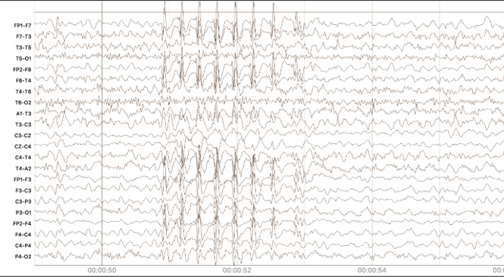
Figure 6. Brief potentially ictal rhythmic discharges
This type of artifact is associated with any type of movement. This class of artifact can be subdivided into many classes of muscle artifact. In this section, we introduce a few of the most commonly occurring types of muscle artifacts. The characteristic feature of this artifact is high frequency content in the signal. Muscle artifacts typically occur in the gamma frequency (30+ Hz) with no discernable pattern. The amplitude ranges from very low to very high. This artifact is also closely associated with tonic-clonic seizures, as the patient begins convulsin g during the clonic portion of the event. An example is shown in Figure 11.
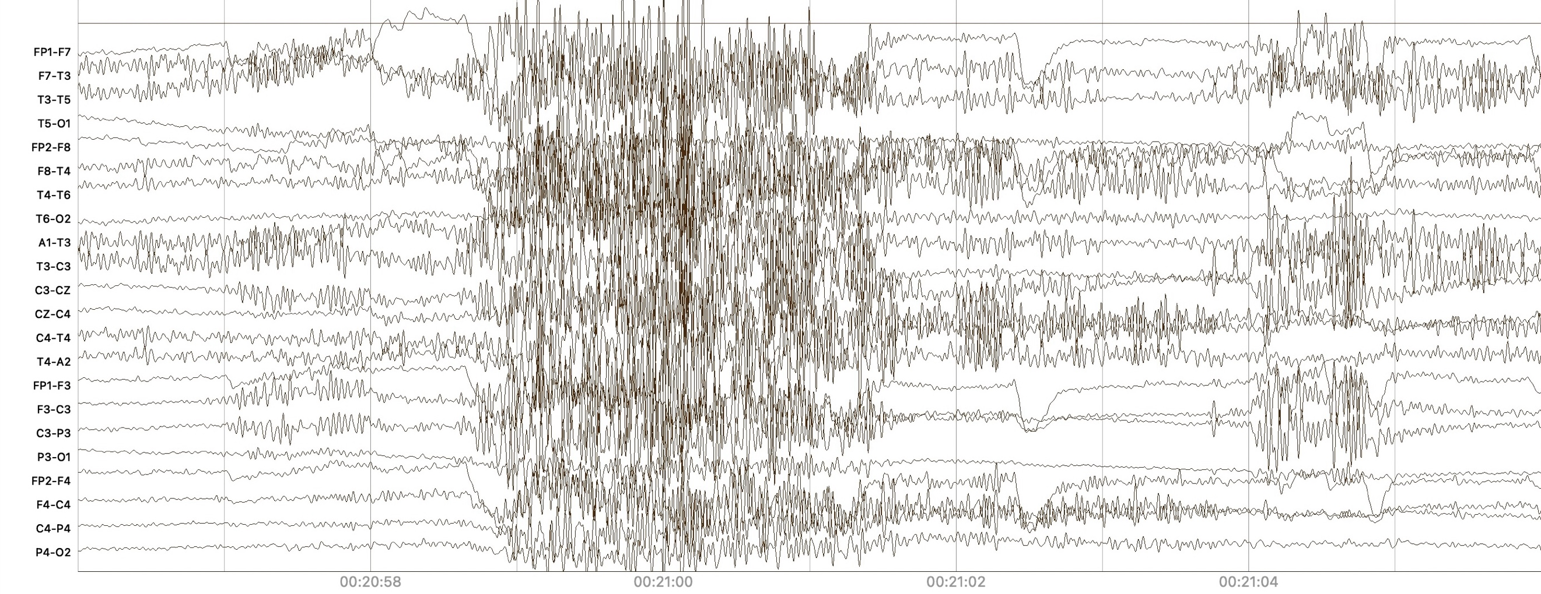
Figure 7. An example of a muscle artifact
Shivering Artifact: Shivering is a subset of a muscle artifact that happens when the patient shivers. A shivering artifact has a characteristic complex that consists of medium to high amplitude sharps or spikes that swoop into a higher amplitude spike before dipping below baseline, followed by the initiation of another complex. These complexes typically occur in the beta frequency range (12 – 30 Hz) and are present on a majority of channels. Although this artifact is rare, it is a significant source of error when it does occur. The morphology in many cases appears analogous to a spike and slow wave seen in typical seizure morphologies, albeit at higher frequency. An example is shown in Figure 12.
Jerk Artifact: A jerk artifact is a form of muscle artifact that occurs from swift movements of the body. This artifact is closely associated with myoclonic seizures and consists of two spikes of opposite polarity coupled together. In some instances, many of these spikes can occur close together and may be indicative of a seizure. In order to properly identify this type of artifact and associate it with a myoclonic seizure or seizure activity, patient clinical reports are necessary. Several examples of jerk artifacts, which are part of a group of artifacts classified as ambiguous paroxysmal events, are provided in Medlink Neurology (2025).
Chewing Artifact: A chewing artifact is a subset of muscle activity that results from tensing and relaxing the temporalis muscles during jaw movement. This artifact is characterized by periodic bursts of high frequency activity of a normal muscle artifact, with approximately 0.5 second periods of baseline activity between each burst. A chewing artifact is typically most prominent on the temporal channels with general spread across all channels and may show greater activity in one hemisphere. A chewing artifact is common in the corpus as normal patients may tense and relax their jaws during sleep. In some instances, chewing can be associated with seizure. In these cases, the brief returns to baseline that occur during chewing will often show some form of spike and slow wave activity characteristic of a seizure event. To classify events of this nature as seizures, clinical reports are necessary. An example is shown in Figure 13.
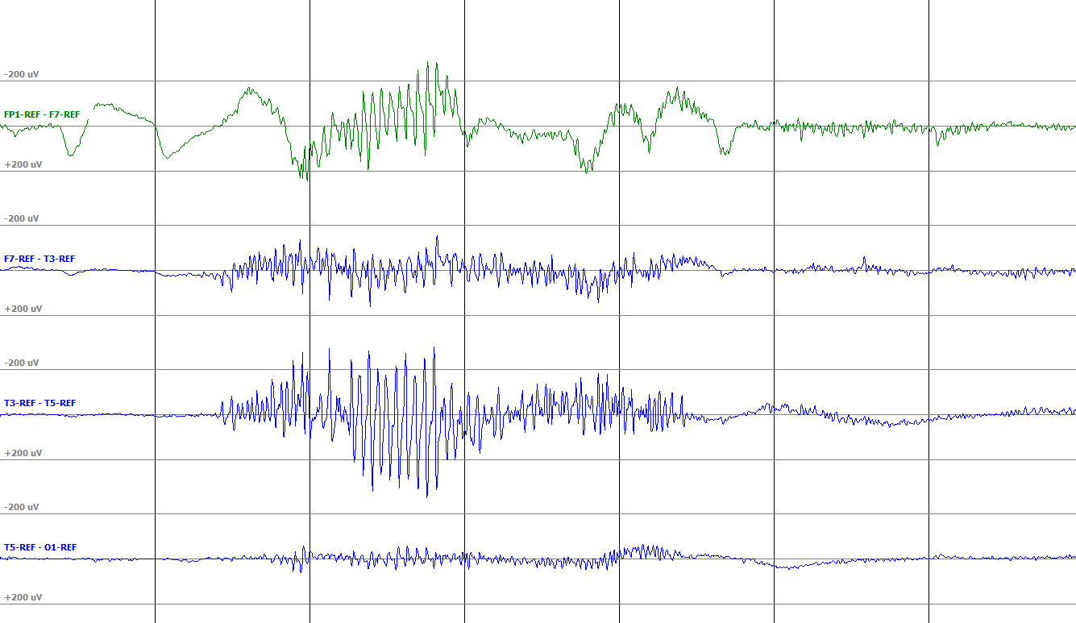
Figure 8. A shivering artifact (channel sensitivity set to 50 µV/mm)
Eye Blink Artifact: An eye blink artifact, shown in Figure 14, is a muscle related artifact caused by the movement of frontal polar electrodes on the forehead. This event shows a single high amplitude sharp wave which can be isolated or followed by a slow wave of opposite polarity. Generally, these eye blink artifacts are single, isolated discharges, rather than repetitive discharges that could be expected from an ictal event. These events occur primarily on the frontal polar electrodes but may echo on the frontal electrodes. Large spans of frequent eye blink artifact may be associated with neurological dysfunction. It is easy for annotators to differentiate eyeblink artifact from seizure events by looking for consistency and the spike and slow wave of seizure events. Moreover, seizure events that occur during spans of rapid eye blinking will be readily recognized by their regularity, spatial confinement, and spike and slow wave morphology.
Eye Movement Artifact: This muscle related artifact is caused by movement of the patient’s eyes. These movements create a wave on the frontal polar electrodes. In neurological dysfunction, it is common for these events to occur in rapid succession. The result is a series of waves which occur largely on the frontal polar electrodes, with some echoing on the frontal electrodes.
Large spans of eye movement artifact contribute to error in automated seizure detection, as the recurrent waves may mimic seizure morphology. Key descriptors that allow annotators to differentiate between eye movement artifacts and seizure are the characteristic spike or polyspike which occurs in seizure as well as the irregularity or discontinuity of eye movement events.
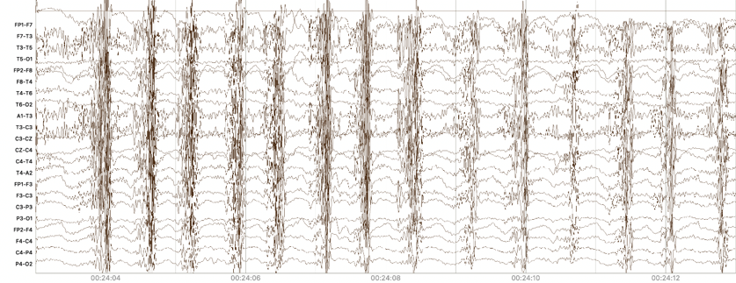
Figure 9. A chewing artifact
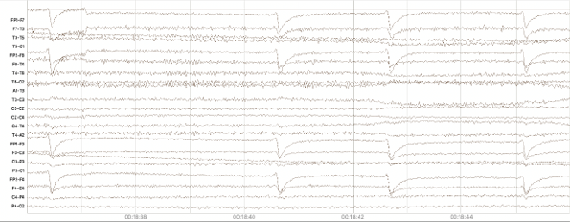
Figure 10. An eyeblink artifact

In the event that continuous eye movement occurs at the same time as a seizure event, the underlying seizure is frequently obvious. The seizure event will typically occur outside of frontal polar channel, where eye movement does not occur, and will be more consistent than the eye movement. The two events will also be out of phase and the seizure should show characteristic spike and slow wave morphology. The two events will also be out of phase and the seizure should show characteristic spike and slow wave morphology. Several examples of eyeblink artifacts can be found in Valentine (2025).
    - Electrical and Electrode Artifacts
An electrode artifact is a catch-all annotation developed for the TUAR database (Hamid et al., 2020). It encompasses three types of artifacts: electrode pop, electrostatic, and lead artifact. These artifacts are grouped together because of their common origin. A more complete discussion of electrode artifacts with examples can be found in Valentine (2025). Here we briefly discuss two common types of artifacts:
Electrode Pop Artifact: An electrode pop artifact results from a glitch at an individual electrode and may be the result of improper adhesion or bubbles in the gel used to fix the electrodes to the scalp. This glitch causes a rapid (on the order of single milliseconds) change in amplitude on a single electrode. This change is very sharp and easily distinguishable from events that are cerebral in origin. In some instances, an electrode will pop repeatedly and continue to pop throughout the record. This is not unusual and may make it difficult or impossible to extract accurate and consistent data from that electrode.
Electrocardiogram (EKG) Artifact: An EKG artifact is not artifact on an EKG channel, but an artifact that occurs in many channels. An EKG artifact results from highly sensitive electrodes on the scalp picking up the changes in voltage associated with a beating heart. This artifact is usually low amplitude, periodic, sharp discharge and is always temporally synced to the EKG channel. It can occur on any channel as a small sharp wave. Due to the lack of an EKG channel on the 01_tcp_ar_natus_montage, this type of artifact cannot be identified with certainty. This type of artifact will fall within the category of electrical artifacts. An example is shown in Figure 15.
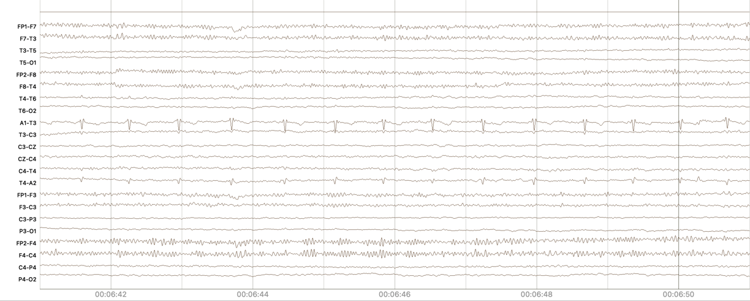
Figure 11. An EKG artifact

- Summary
These annotation guidelines provide a detailed framework for labeling EEG recordings and ensuring standardized and accurate annotation of seizure events and rhythmic periodic patterns. In this document, we define the annotation categories, outlines processes for segmentation and format conversion, and specify criteria for distinguishing between seizure and non-seizure activity. Special focus is placed on key seizure types, artifact differentiation, and ictal phases to enhance data quality. This document is a work in progress, and further revisions and updates are anticipated.
Annotation in general is challenging when we do not have access to clinical reports, patient histories and visual records. This is particularly true for specifying the types of focal and generalized seizures. Additionally, without an EKG channel, annotating RPPs becomes more challenging, as rhythmic patterns could stem from heart rate rather than neural activity. However, our annotations are created collaboratively, reviewed systematically, and refined through weekly discussions to address challenges and ensure reliability. Despite the above limitations, these guidelines facilitate the production of high quality data. As of July 2025, we have had over 12,000 subscribers, many of whom are neurologists or board certified clinicians. We rarely receive bug reports (which we encourage and address quickly), which speaks to the quality of our annotations.
Acknowledgements
The development of this document would not have been possible without the leadership and support of the Natus Research and Advanced Development (RAD) team. Their guidance on annotation standards and technology development was extremely valuable to our development of high-quality annotations.
M. Paderewski, V. Shah,
Many students over the years have contributed to our EEG annotation efforts. The current team of Anne-Mai Melles (project and technical leader), Makeda Paderewski (co-technical lead), Renee Oymann (senior annotator), Nyah Harden, Tara Kehair and Tanaka Manhede was responsible for development of this corpus. Their dedication and hard work are to be commended. Reviewing over 10,000 hours of EEG data with unprecedented accuracy in less than a year is no easy task. Several undergrads including Phuykong Meng and Dyan Heathcote provided valuable software support.
Any opinions, findings, and conclusions or recommendations expressed in this material are those of the author(s) and do not necessarily reflect the views of Temple University or Natus Medical Incorporated.
References
Ferrell, S., Mathew, V., Refford, M., Tchiong, V., Ahsan, T., Obeid, I., & Picone, J. (2020). The Temple University Hospital EEG Corpus: Electrode Location and Channel Labels (pp. 1–9). Temple University. url: https://www.isip.piconepress.com/publications/reports/2020/tuh_eeg/electrodes.
Melles, A.-M., Paderewski, M., Oymann, R., Shah, V., Obeid, I., & Picone, J. (2025). The Natus Medical Incorporated Ambulatory EEG Corpus: Annotation Guidelines (p. 16). Temple University. url: https://isip.piconepress.com/publications/reports/2025/nmae/annotations/.
Ochal, D., Rahman, S., Ferrell, S., Elseify, T., Obeid, I., & Picone, J. (2020). The Temple University Hospital EEG Corpus: Annotation Guidelines (p. 28). Temple University. url: https://www.isip.piconepress.com/publications/reports/2020/tuh_eeg/annotations/.
Obeid, I., & Picone, J. (2016). The Temple University Hospital EEG Data Corpus. In M. A. Lebedev (Ed.), Augmentation of Brain Function: Facts, Fiction and Controversy. Volume I: Brain-Machine Interfaces (1st ed., Vol. 10, pp. 394–398). Frontiers Media S.A. doi: 10.3389/fnins.2016.00196.
Lopez, S. (2017). Automated Identification of Abnormal Adult Electroencephalograms [MS Thesis, Temple University]. url: https://www.isip.piconepress.com/publications/ms_theses/2017/abnormal.
Hamid, A., Gagliano, K., Rahman, S., Tulin, N., Tchiong, V., Obeid, I., & Picone, J. (2020). The Temple University Artifact Corpus: An Annotated Corpus of EEG Artifacts. In I. Obeid, I. Selesnick, & J. Picone (Eds.), Proceedings of the IEEE Signal Processing in Medicine and Biology Symposium (SPMB) (pp. 1–3). IEEE. doi: 10.1109/SPMB50085.2020.9353647.
McHugh, J. R., Picone, J., & Obeid, I. (2017). The TUH EEG Epilepsy Corpus. url: https://isip.piconepress.com/projects/nedc/html/tuh_eeg/#c_tuep.
Harati, A., Choi, S. I., Tabrizi, M., Obeid, I., Jacobson, M., & Picone, J. (2013). The Temple University Hospital EEG Corpus. Proceedings of the IEEE Global Conference on Signal and Information Processing, 29–32. url: http://www.isip.piconepress.com/publications/conference_proceedings/ 2013/ieee_globalsip.
Melles, A.-M., Paderewski, M., Oymann, R., Shah, V., Salazar, J., Obeid, I., & Picone, J. (2024). Annotation of Ambulatory EEGs. Proceedings of the IEEE Signal Processing in Medicine and Biology Symposium (SPMB), 1–4. doi: 10.1109/SPMB62441.2024.10842264.
von Weltin, E., Ahsan, T., Shah, V., Jamshed, D., Golmohammadi, M., Obeid, I., & Picone, J. (2017). Electroencephalographic Slowing: A Primary Source of Error in Automatic Seizure Detection. In I. Obeid, I. Selesnick, & J. Picone (Eds.), Proceedings of the IEEE Signal Processing in Medicine and Biology Symposium (pp. 1–5). IEEE. doi: 10.1109/SPMB.2017.8257018.
Shah, V., Obeid, I., Picone, J., Ekladious, G., Iskander, R., & Roy, Y. (2020). Validation of Temporal Scoring Metrics for Automatic Seizure Detection. In I. Obeid, I. Selesnick, & J. Picone (Eds.), Proceedings of the IEEE Signal Processing in Medicine and Biology Symposium (SPMB) (pp. 1–5). doi: 10.1109/SPMB50085.2020.9353631.

------

Capp, N., Krome, E., Obeid, I., & Picone, J. (2017). Facilitating the Annotation of Seizure Events Through an Extensible Visualization Tool. In I. Obeid, I. Selesnick, & J. Picone (Eds.), Proceedings of the IEEE Signal Processing in Medicine and Biology Symposium (SPMB) (p. 1). IEEE. doi: 10.1109/SPMB.2017.8257043.

Gelisse, P., Crespel, A., Genton, P., Jallon, P., & Kaplan, P. W. (2021). Lateralized Periodic Discharges: Which patterns are interictal, ictal, or peri-ictal? Clinical Neurophysiology, 132(7), 1593–1603. doi: 10.1016/j.clinph.2021.04.003.
Hirsch, L. J., Fong, M. W. K., Leitinger, M., LaRoche, S. M., Beniczky, S., Abend, N. S., Lee, J. W., Wusthoff, C. J., Hahn, C. D., Westover, M. B., Gerard, E. E., Herman, S. T., Haider, H. A., Osman, G., Rodriguez-Ruiz, A., Maciel, C. B., Gilmore, E. J., Fernandez, A., Rosenthal, E. S., … Gaspard, N. (2021). American Clinical Neurophysiology Society’s Standardized Critical Care EEG Terminology: 2021 Version. Journal of Clinical Neurophysiology, 38(1), 1–29. doi: 10.1097/WNP.0000000000000806.
Khalkhali, V., Shawki, N., Shah, V., Golmohammadi, M., Obeid, I., & Picone, J. (2021). Low Latency Real-Time Seizure Detection Using Transfer Deep Learning. In I. Obeid, I. Selesnick, & J. Picone (Eds.), Proceedings of the IEEE Signal Processing in Medicine and Biology Symposium (SPMB) (pp. 1–7). IEEE. doi: 10.1109/SPMB52430.2021.9672285.
Krauss, G. L., & Fisher, R. S. (2011). The Johns Hopkins Atlas of Digital EEG: An Interactive Training Guide (2nd ed.). Johns Hopkins University Press. url: https://www.amazon.com/Johns-Hopkins-Atlas-Digital-EEG/dp/0801897335.
Medlink Neurology. Ambiguous paroxysmal events: Brief isolated jerk. (2025, June 28). url: https://www.medlink.com/media/138255145.
Rayi, A., Asuncion, R. M. D., & Mandalaneni, K. (2025). Encephalopathic EEG Patterns. In StatPearls. StatPearls Publishing. url: https://pubmed.ncbi.nlm.nih.gov/33232041/.
Valentine, D. (2025, June 28). Artifacts: Lateral Eye Movements. Learning EEG. url: https://www.learningeeg.com/artifacts.
Yoo, J. Y. (2022). BIRDs (Brief Potentially Ictal Rhythmic Discharges) watching during EEG monitoring. Frontiers in Neurology, Volume 13-2022, 1–7. doi: 10.3389/fneur.2022.966480.
- . The Annotation Labels Used in our Seizure Corpora
Note that we list all the labels available in our annotation system in this table. A subset of these labels is used in each annotated corpus. In this table, we indicate which specific labels were used in TUSZ and NMAE and provide short descriptions of all the labels.
Index | Label | Corpus |  | Description
Index | Label | TUSZ | NMAE | Description
0 | null |  |  | An undefined annotation. Should not be seen in the data.
1 | spsw |  |  | Occipital Intermittent Rhythmic Delta Activity: spike and/or slow wave. A short duration epileptiform event involving an electrographic spike in activity and/or a slow wave (low frequency wave). Usually no more than 1 sec. in duration.
2 | gped |  |  | Generalized Periodic Epileptiform Discharge: periodic diffuse spike/sharp wave discharges across multiple regions or hemispheres.
3 | pled |  |  | Periodic Lateral Epileptiform Discharge: a regular, periodically occurring spike/sharp wave seen in a certain locality of the scalp.
4 | eybl |  |  | Eyeblink: a specific, sharp, high amplitude eye movement artifact corresponding to blinks.
5 | artf |  |  | Artifact: any non-brain activity electrical signal, such as those due to equipment or environmental factors.
6 | bckg | x | x | Background: all other non-seizure cerebral signals.
7 | seiz |  |  | Seizure: a basic annotation for seizures (typically used in term-based annotations.
8 | fnsz | x | x | Focal Nonspecific Seizure: A large category of seizures occurring in a specific focality.
9 | gnsz | x | x | Generalized Seizure: a large category of seizures occurring in most if not all of the brain.
10 | spsz | x |  | Simple Partial Seizure: brief seizures that start in one location of the brain (and may spread) where the patient is fully aware and able to interact.
11 | cpsz | x |  | Complex Partial Seizure: same as simple partial seizure but with impaired awareness.
12 | absz | x | x | Absence Seizure: brief, sudden seizure involving lapse in attention. Usually lasts no more than 5 seconds and commonly seen in children.
13 | tnsz | x |  | Tonic Seizure: a seizure involving the stiffening of the muscles. Usually associated with and annotated as tonic-clonic seizures, but not always (rarely there is no clonic phase).
14 | cnsz |  |  | Clonic Seizure: a seizure involving sustained, rhythmic jerking. Not seen in our datasets, as it is always associated with tonic clonic seizures and is annotated as such.
15 | tcsz | x |  | Tonic-Clonic Seizure: A seizure involving loss of consciousness and violent muscle contractions.
16 | atsz |  |  | Atonic Seizure: a seizure involving the loss of tone of muscles in the body. Also never seen as it is always associated with an occasionally occurring phase before a tonic clonic seizure.
17 | mysz | x |  | Myoclonic Seizure: a seizure associated with brief involuntary twitching or myoclonus.
18 | nesz |  |  | Non-epileptic Seizure: any non-epileptic seizure observed. Contains no electrographic signs.
19 | intr |  |  | Interesting Patterns: any unusual or interesting patterns observed that don't fit into the above classes.
20 | slow |  |  | Slowing: a brief decrease in frequency.
21 | eyem |  |  | Eye movement: A very common frontal/prefrontal artifact seen when the eyes move.
22 | chew |  |  | Chewing: a specific artifact involving multiple channels that corresponds with patient chewing, “bursty”
23 | shiv |  |  | Shivers: a specific, sustained sharp artifact that corresponds with patient shivering.
24 | musc |  |  | Muscle Artifact: A very common, high frequency, sharp artifact that corresponds with agitation/nervousness in a patient.
25 | elpp |  |  | Electrode Pop: a short artifact characterized by channels using the same electrode “spiking” with perfect symmetry.
26 | elst |  |  | Electrostatic Artifact: artifact caused by movement or interference on the electrodes, variety of morphologies.
27 | calb |  |  | Calibration Artifact: caused by calibration of the electrodes. Appears as a flattening of the signal in the beginning of files.
28 | hphs |  |  | High Amplitude Slowing: a brief period of high amplitude slow waves.
29 | trip |  |  | Triphasic Waves: large, three-phase waves frequently caused by an underlying metabolic condition.
30 | tirda |  |  | Temporal Intermittent Rhythmic Delta Activity: short explanation... followed by a complete sentence.
31 | firda |  |  | Frontal Intermittent Rhythmic Delta Activity: short explanation... followed by a complete sentence.
32 | grda |  |  | General Rhythmic Delta Activity: short explanation... followed by a complete sentence.
33 | lpd |  |  | Lateralized Periodic Discharge: short explanation... followed by a complete sentence.
34 | gpd |  |  | Generalized Periodic Discharge: short explanation... followed by a complete sentence.
35 | bird |  |  | Brief Potentially Ictal Rhythmic Discharges: short explanation... followed by a complete sentence.

