|  |  |  |  |  |  |
| --- | --- | --- | --- | --- | --- |
| **DS** | **System** | **#Train Samples** | **Train** | **Dev** | **Eval** |
| #08 | RBM +KNN | 60,000 | 8.18 | 16.10 | 25.86 |
| QRBM + KNN | 60,000 | 42.89 | 43.07 | 39.19 |
| QRBM | 60,000 | 49.12 | 49.07 | 49.07 |
| #09 | RBM +KNN | 80,000 | 8.17 | 15.76 | 25.17 |
| QRBM + KNN | 80,000 | 31.37 | 30.35 | 13.72 |
| QRBM | 80,000 | 49.82 | 49.84 | 49.84 |
| #10 | RBM +KNN | 100,000 | 7.22 | 25.11 | 30.12 |
| QRBM + KNN | 100,000 | 47.49 | 46.95 | 49.74 |
| QRBM | 100,00 | 45.30 | 46.10 | 46.08 |

**Table 1.** Error rate comparison of classical RBM and Quantum RBM.

|  |  |  |
| --- | --- | --- |
|  |  |  |
|  |  |  |
|  |  |  |

**Figure 1.** Performance of the RBM-based models (RBM+KNN, QRBM+KNN, and standalone QRBM) on set-08 (top row), set-09 (middle row), and set-10 (bottom row) as a function of training samples.

|  |  |
| --- | --- |
| **Figure 2(a).** QSVM on Gaussians | **Figure 2(b).** SVM on Gaussians |
| **Figure 2(c).** QSVM on Yin-Yang | **Figure 2(d).** SVM on Yin-Yang |
| **Figure 2(e).** QSVM on Toroidal | **Figure 2(f).** SVM on Toroidal |

**Figure 2.** A comparison of decision surfaces on some well-known machine learning datasets

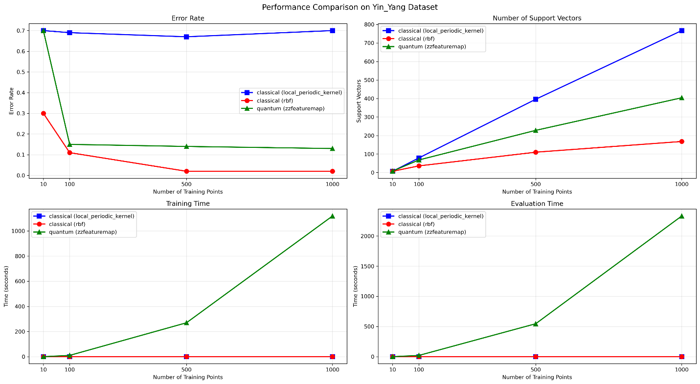

**Figure 3.** Performance comparison of QSVM and SVM on Yin-Yang