Interesting activities
There are numerous activities that might be mistaken for seizures, BIRDs, or RPPs, but they are not. This document is an ongoing effort to compile all the significant activities we need to monitor and approach with caution.

A1 and A2 activities combined with temporal channels. Can be confused as temporal seizure activity.
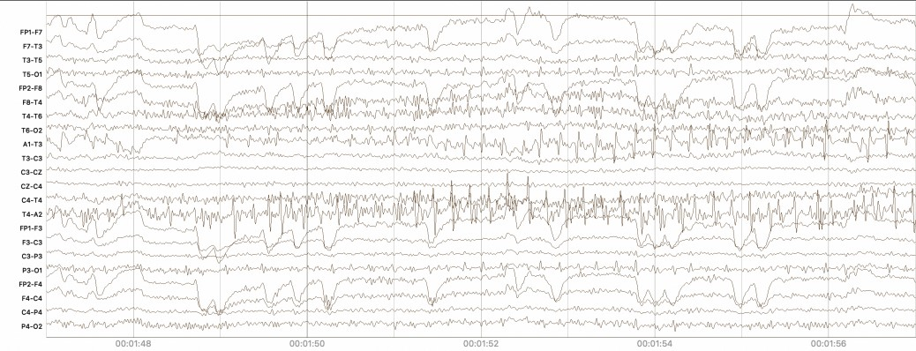
Bipolar montage.
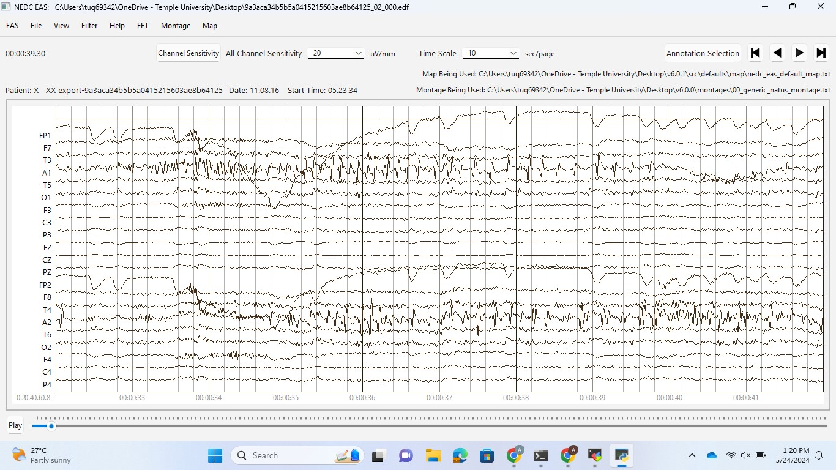
Unipolar montage.
Activities like spike waves can occur. Two things to keep in mind:
- When activity seen on A1-T3 then for temporal seizure, activity has to occur also on T3-C3.
- Look at the activity with unipolar montage. When activity only seen on A1 channel and T3 channel is quiet, then it is an artifact.
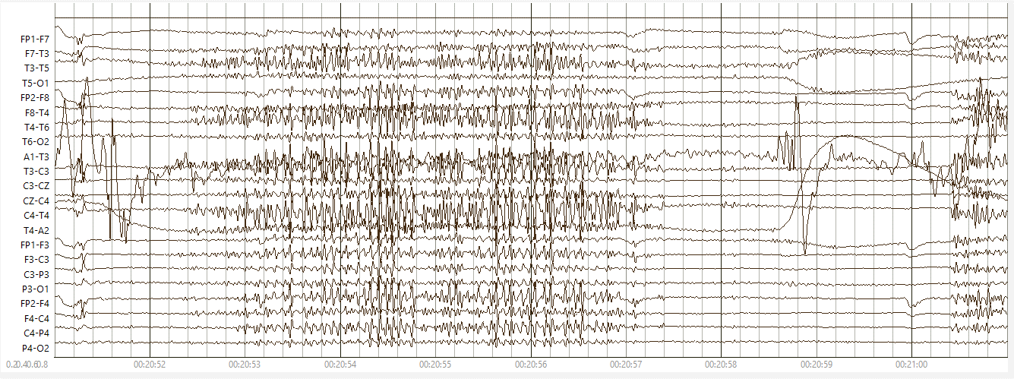
Shivering. Usually comes with seizures. In this case not because no spike wave activity occurs.

Look at the activity more closely:

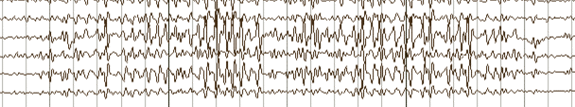

Eyeblinks. May be confused with rhythmic delta activity. However:
- Eyeblinks:
  - High-amplitude spikes that are more prominent in the frontal leads
  - Occur at variable frequencies
  - Do not have rhythmic patterns
- Rhythmic delta activity:
  - rhythmic delta waves (1-3 Hz) that are smooth and repetitive
  - frequency much slower and regular than in eyeblinks
  - does NOT have sharp, vertical appearance of eyeblinks
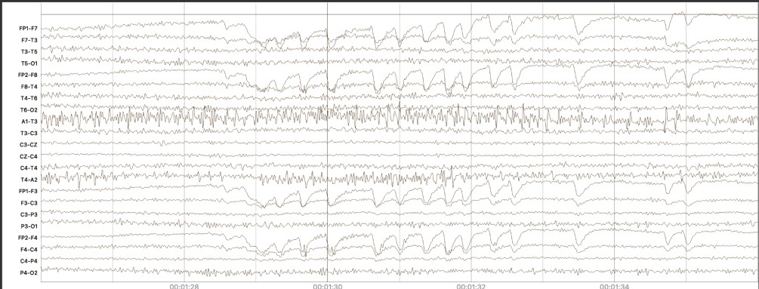

Intermittent spike and wave activity
Intermittent- occurring at irregular intervals; not continuous or steady
It is epileptiform activity that is seen in patients with epilepsy.
However, not a
- seizure because does not last 10 seconds
- BIRD because the frequency is < 4Hz

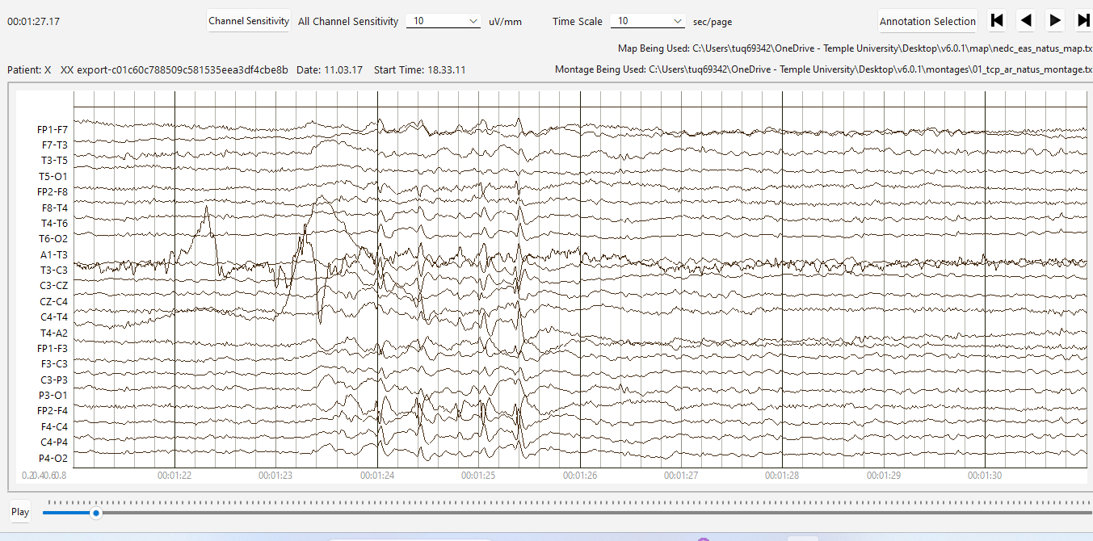
Hypnagogic Hypersynchrony
- Occurs at sleep onset or drowsiness in children
- Dramatic burst of paroxysmal high-amplitude theta-delta frequency slowing of 3- to 5- Hz.
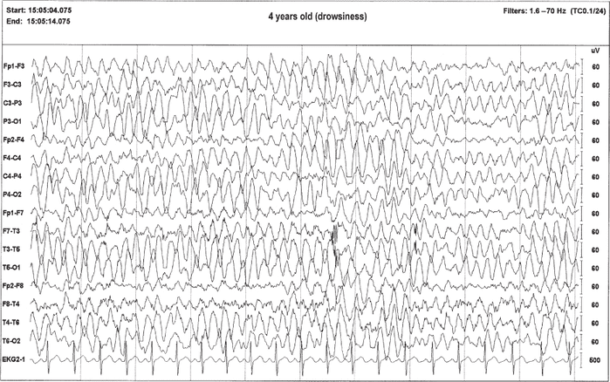

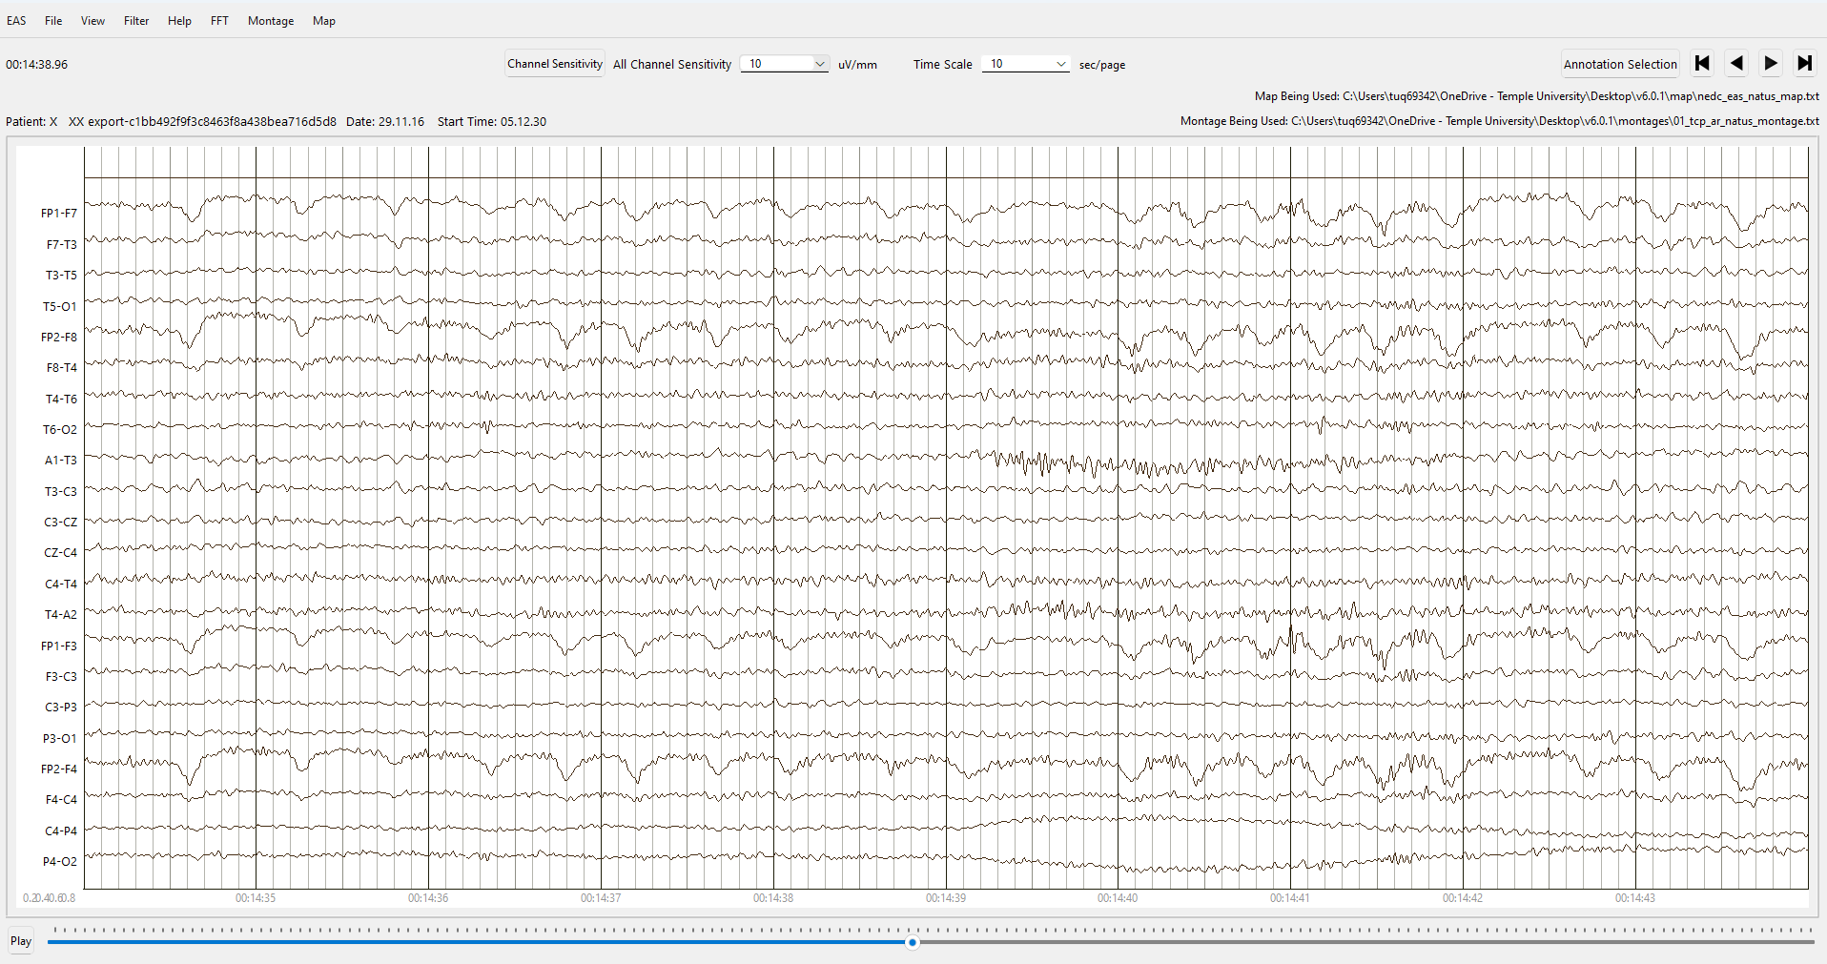
Found at: https://neupsykey.com/artifacts-of-recording/
Activity: slower appearing eye blinks (2.5 to 3 Hz) intermixed with EMG appear similar to 3 Hz spike-and-wave activity. Eye leads show out-of-phase activity, confirming origin from eye movements and distinguishing from epileptiform activity and frontal intermittent rhythmic delta activity.

