Highway Incident Detection Timeline
Work Order (WO) 009
Contract No. 4400011166

Report on Task 1-Deliverable 1.1:
Data Collection

By:
Temple University Research Team

Principal Investigator: Joseph Thomas Coe, Jr., Ph.D.
Assistant Professor
Co- Principal Investigator: Bechara E. Abboud, Ph.D., P.E.
Associate Professor
Co- Principal Investigator: Joseph Picone, Ph.D.
Professor
Graduate Research Assistant: Siavash Mahvelati
Undergraduate Research Assistant: Aaron M. Gross

02/17/2017

Contents
1 Project Objectives 3
2 Task 1: Data Collection 3
2.1 Introduction 3
2.2 Counties of Interest 3
2.3 Data Collection Efforts & Current Status 4
2.3.1 PennDOT RCRS Data 4
2.3.2 911 Call Center Data 4
2.3.3 Project Website & Data Repository (Task 1.2) 8
2.4 Future Data Collection Efforts 8

Project Objectives
The general objective of this project is to characterize the average timeline for when the Pennsylvania Department of Transportation (PennDOT) is notified of incidents requiring highway closures along Primary Interstate Highway I-76, I-80, I-81, and I-95, and Auxiliary Interstate Highway I-78 and I-83 throughout the Commonwealth of Pennsylvania. Specifically, this project will calculate the average time difference between when a highway incident occurs on one of the aforementioned highways based on county emergency dispatch (911) records and the PennDOT Road Condition Reporting System (RCRS). The following notes describe the goals in more details:
- Determine the average delay time between when a highway accident leading to a road closure occurs and when PennDOT is notified of such accident.
- Identify other potential key elements of the Traffic Incident Management timeline
- Determine critical missing data related to the Traffic Incident Management timeline.
- Provide information to PennDOT that will help them to reduce the overall time to clear incidents and reduce the time gap between when a highway closure occurs and when the public is informed.
- Develop an information system that helps PennDOT in their policy and decision making process related to all aspects of traffic incident management, which will improve operation at the statewide, regional, and district traffic management centers.

Task 1: Data Collection

Introduction
The first step to achieve the objectives of this project is to identify and procure the data required to perform the analysis. In order to determine the time delay for a given highway incident, two (2) sources of information must be considered simultaneously; one (1) is the PennDOT Road Condition Reporting System (RCRS) logs, and the other one (1) is based on the time response logs kept at the 911 call center of the county where the incident occurred. Data collection efforts therefore consisted of requesting RCRS logs for the highways of interest from the project technical advisors and contacting county 911 call centers throughout the Commonwealth of Pennsylvania.

Counties of Interest
The research team first identified in collaboration with the PennDOT project team a list of counties containing the pertinent highways for this study (Table 1). These 37 counties represent more than half of the 67 counties that geographically span the Commonwealth of Pennsylvania. Many of the counties contain multiple highways of interest in this study. Successful completion of project objectives will depend on procurement and quality of the data from these counties. It is expected that some of these counties will contain many incidents due to the population density and level of traffic prevalent in their vicinity. However, counties with a smaller number of incidents will still be important to establish any geographical patterns related to the incident management timeline.
Table 1. Counties involved in the project and their corresponding highways
No. | County | Highways | No. | County | Highways | No. | County | Highways
1 | Allegheny | I-76 | 14 | Delaware | I-95 | 27 | Montour | I-80
2 | Beaver | I-76 | 15 | Franklin | I-76; I-81 | 28 | Northampton | I-78
3 | Berks | I-76; I-78 | 16 | Fulton | I-76 | 29 | Northumberland | I-80
4 | Bucks | I-95 | 17 | Jefferson | I-80 | 30 | Philadelphia | I-76; I-95
5 | Carbon | I-80 | 18 | Lackawanna | I-81 | 31 | Schuylkill | I-81
6 | Centre | I-80 | 19 | Lancaster | I-76 | 32 | Somerset | I-76
7 | Chester | I-76 | 20 | Lawrence | I-76 | 33 | Susquehanna | I-81
8 | Clarion | I-80 | 21 | Lebanon | I-76; I-78; I-81 | 34 | Union | I-80
9 | Clearfield | I-80 | 22 | Lehigh | I-78 | 35 | Venango | I-80
10 | Clinton | I-80 | 23 | Luzerne | I-80; I-81 | 36 | Westmoreland | I-76
11 | Columbia | I-80 | 24 | Mercer | I-80 | 37 | York | I-76; I-83
12 | Cumberland | I-76; I-81; I-83 | 25 | Monroe | I-80
13 | Dauphin | I-76; I-81; I-83 | 26 | Montgomery | I-76

Data Collection Efforts & Current Status
The sources of information necessary in this study (i.e., 911 call logs and RCRS logs) are provided by different agencies. The following sections highlight the efforts involved in procuring the data from both PennDOT (RCRS logs) and county emergency dispatch centers (911 logs).

PennDOT RCRS Data
PennDOT RCRS data was provided via email to the Temple research team on Tuesday, November 22, 2016 by the PennDOT project team. The data consisted of a zip file with a Microsoft Excel spreadsheet generated by the PennDOT RCRS software that details all reported incidents along the highways of interest in this study. Therefore, all RCRS data necessary for successful completion of the project objective have been provided as of Tuesday, November 22, 2016.

911 Call Center Data
It was anticipated that the bulk of the data collection efforts in this project would be concentrated in procuring data from the 911 call centers given the large number and spatial distribution of the counties of interested. In anticipation of the project kick-off meeting on Wednesday, October 19th, the research team submitted right-to-know (RTK) requests and procured 911 call data from 10 counties. The purpose of these initial preliminary efforts was to gauge the effectiveness of the RTK request process, the response time for call centers to provide logs, and to examine the quality of the data provided. At the onset of the project during the kick-off meeting, the research team was also informed that the PennDOT technical advisor had initiated contact via email with the counties to request data be provided. This email was submitted to the counties on Tuesday, October 18, 2016. A copy of the email and a list of counties and contact information were provided to the research team after the kick-off meeting. In addition to continued RTK requests, the research team personally contacted the listed person of interest for each county as provided by the PennDOT project team. This contact was initiated via email on Wednesday, November 23, 2016 and continued regularly as various counties responded or failed to respond. In that time, a total of six (6) more counties have provided the research team with their time response logs (most of which did so without submitting an RTK request).
Table 2 shows the current status regarding data collection progress for each county of interest in this project. Counties with “green” status are those that have already provided the information. Please note that having the data provided does not necessarily mean that such data is complete or as detailed as necessary, and some counties may have given less-than-ideal records. For instance, except three (3) green counties, logs from the rest of the counties do not include GPS coordinates. It was expected that counties will have different formats in their response logs (.pdf, .txt, and .xlsx). The difference in format was also observed in how calls are recorded and kept. Figure 1 shows examples of logs provided by three (3) counties. This figure clearly demonstrates how each county creates 911 calls in a different way. Moreover, the information collected so far shows that the Computer-Aided Dispatch (CAD) system of some counties are able to record more details [e.g., multiple time stamps, (latitude, longitude) coordinates] for each incident. On the other hand, some of the datasets are missing critical information (e.g., descriptive address). The research team is currently contacting such counties to determine if more comprehensive logs can be provided. One (1) reason for this discrepancy could be that, as mentioned by a few county 911 call center directors, a number of counties are still using older CAD systems while some others have updated their systems, and a number of them are in the transition period. The team is also reaching out to counties that have already provided their logs to check if GPS coordinates are available for each incident. Having GPS coordinates would significantly facilitate the analysis and reduce the amount of manual work that is needed to pair incidents on county logs with those on PennDOT records. Continuing with Table 2, “yellow” represents responsive counties that are currently processing the team’s request. “Pink” counties are mainly not responsive to the calls and requests. “Blue” counties were responsive, but there are other issues that has slowed down the data collection from such counties (e.g., consulting with legal counselors, delayed follow ups). Finally, “red” counties have referred the Temple team to Pennsylvania State Police (PSP) for further information as their respective counties do not dispatch calls related to highway incidents.

Table 2. Data collection progress with counties
No. | County | Comments
1 | Allegheny | Data Provided; However, no GPS information can be provided.
2 | Beaver | Data Provided.
3 | Berks | Data Provided; However, no GPS information can be provided.
4 | Bucks | Data Provided; Pending a response regarding GPS information
5 | Carbon | Request submitted; Data N/A readily; costs too high; is working on the data
6 | Centre | Call is set up; might be able to assist.
7 | Chester | Data Provided; Logs already have GPS coordinates.
8 | Clarion | Checking legal issues; follow up in two weeks;
9 | Clearfield | Records have to be hand-sorted; Electronic (Y/N); will follow up
10 | Clinton | Called their office several times on multiple days; not picking up.
11 | Columbia | County does not have the data; Referred to PSP; No Fire/EMS can be provided.
12 | Cumberland | Data Provided; Pending a response regarding GPS information.
13 | Dauphin | Data Provided (lacking critical information); No GPS information can be provided.
14 | Delaware | Referred to PSP; "If an accident requires a fire or medical response we will have a record. Otherwise, callers are immediately transferred to the State Police and no record is created here". No Fire/EMS can be provided.
15 | Franklin | County does not have the data; Referred to PSP.
16 | Fulton | County says they do not have a full-time record of accidents;
17 | Jefferson | Contact person is contacted; might be able to provide data.
18 | Lackawanna | Data provided; GPS information included.
19 | Lancaster | Data Provided; Pending a response regarding GPS information
20 | Lawrence | Not in office; left voice message; reminder email sent
21 | Lebanon | Data Provided; Pending a response regarding GPS information
22 | Lehigh | Data Provided; However, no GPS information can be provided.
23 | Luzerne | Data Provided; However, no GPS information can be provided.
24 | Mercer | Waiting to hear back via email; reminder sent
25 | Monroe | County does not have the data; Referred to PSP; No Fire/EMS can be provided.
26 | Montgomery | Data provided; GPS information included.
27 | Montour | No phone no. provided; waiting to hear back via email; reminder sent
28 | Northampton | Data Provided; GPS information are not maintained.
29 | Northumberland | Contact person has forwarded our request to his colleague. We are waiting to hear from the co-worker (his contact info is not given to us).
30 | Philadelphia | Referred to a contact at PSP
31 | Schuylkill | Spreadsheet received, No GPS info., the county manually converts addresses to GPS
32 | Somerset | Not in office; left voice message and online message
33 | Susquehanna | Data Provided; However, no GPS information can be provided.
34 | Union | The County would be able to provide data; only have data since 09/2014; in progress
35 | Venango | Called multiple times; "contact person rarely in office" said the secretary. Left messages and emails.
36 | Westmoreland | Could not reach out to the contact person on phone.
37 | York | County believes it would be extremely time-consuming to pull out the requested record from their not-so-smart CAD system.
Legend:
Data Provided | Data Available (?)/Unresponsive/Not in Progress | Data Available/Responsive/In Progress | Other Issues/Responsive | Data Unavailable (PSP)

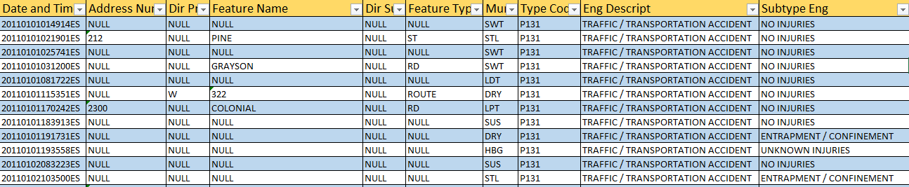

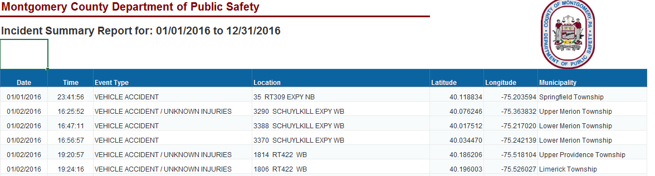

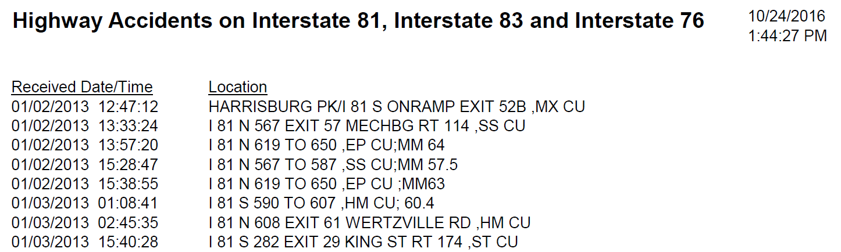

Figure 1. Examples of logs provided by (top) Dauphin County (middle) Montgomery County, and (bottom) Cumberland County
To facilitate continued collection of data and to discuss preliminary analysis efforts, an in-person meeting was scheduled between the Temple research team and the PennDOT project team. This meeting took place at the Central Office in Harrisburg on Friday, February 3rd, 2017. During this meeting, the status of data collection as summarized in Table 2 was shared with the PennDOT project team and a number of items were discussed regarding data collection and preliminary analysis. As pertinent to Task 1 Data Collection, the following discussion points and action items resulted from this meeting:
- The Temple research team requested assistance in contacting a number of counties who have failed to respond to continued requests for data (Clinton, Fulton, Lawrence, Mercer, Montour, Philadelphia, Somerset, Venango, Westmoreland, York, Carbon, Clarion, Clearfield, Northumberland, Susquehanna).
- The meeting demonstrated that the Dauphin County CAD system likely has some GPS data embedded within the call logs. Unfortunately, the Dauphin County data provided to the Temple research team did not have any GPS information. Given the technical advisor’s relationship with Dauphin County, the Temple research team requested that Dauphin County be contacted to ensure whether GPS data would be available for the existing call logs provided to the Temple research team. As suggested by the PennDOT project team, developing an “example” data subset to provide to 911 call centers when requesting data can increase the likelihood that they provide the necessary data in the desired format.
- A number of counties referred the Temple research team to the Pennsylvania State Police (PSP) for records related to highway incidents in their counties. These counties noted that they do not maintain records related to dispatch of PSP officers to highway incidents. Based on the discussions during the in-person meeting between Temple and PennDOT, the Temple research team was advised to request call log information related to dispatch of Fire Department and/or EMS in these counties. When this information requested, no counties were able to provide such data. The Temple research team requested guidance from the PennDOT project team for these counties.

Project Website & Data Repository (Task 1.2)
All the logs have been archived on an online repository server accessible by Temple team. Also, the Temple team has developed an online website with a user friendly interface to upload the same logs so that PennDOT can have access to the information. This website is available via the following hyperlink: https://www.isip.piconepress.com/projects/penndot_response_time/. Most of the website is unprotected, but a username (penndot) and password (penndot_2017_response_time) are required to download the available data. It is anticipated that this website will undergo continual revisions as additional data is provided by the remaining counties and as analysis is performed with the data.

Future Data Collection Efforts
As noted in the previous sections, data collection for this project continues based on the discussions between the Temple research team and PennDOT project team at the in-person February meeting. It is anticipated that the data will continue to evolve throughout the remainder of the project and the Temple research team will provide live updates via the website and email as new data is provided by the 911 call centers and as analysis is performed on the data. Based on initial efforts to analyze a subset of the data contained in the PennDOT RCRS log, very little difference was noted in the response times when different parameters were used. Given this fact and the significant amount of data already procured for the project, it is unlikely that the overall statistics will change drastically over the remaining course of the project once all data has been acquired.
Future efforts will focus on collaborating with PennDOT to ensure that the unresponsive counties (i.e., “pink” counties in Table 2) begin to respond and provide data. Additionally, the Temple research team will continue working with those counties who have responded but have been slower to provide data due to various issues (e.g., manually sorting data). These counties were highlighted in “blue” and “yellow” in Table 2. Finally, the Temple research team plans to attempt to acquire GPS information for all counties as having GPS coordinates would allow matching of the data to be performed in a more automated manner. A number of counties have so far stated their limitations in providing such coordinates (e.g., counties are not keeping GPS records due to older CAD systems, or they manually convert descriptive addressed to GPS coordinates). In some cases though, it is not always clear the reason why GPS data is unavailable (e.g., Dauphin County). It is the intent of the Temple research team to work with PennDOT to collaborate with Dauphin County so that GPS information can be located within their 911 call logs. Based on these efforts, a proof of concept can be established for how to get the GPS coordinates so it can be implemented with the other 911 call centers. This may increase the success rate by which 911 call centers can provide GPS information to the Temple research team.

