SafeStep
An Automatic Hazards Detection Blind Cane
Kevin Bui, Mohamad Charabi, Nathan Pervin, Mikita Piatsevich
Advisor: Dr. Joseph Picone
Table of Contents
Problem and Needs Statement 2
Potential Solutions for Detection Methods 3
Solution 1: Wearable Device 3
Solution 2: Ultrasonic Sensor Blind Cane 5
Solution 3: Camera + Machine Learning and Ultrasonic Blind Cane 6
Next Step 8
Citations 9

Problem and Needs Statement
Blindness and vision impairment are increasing globally [1]. Traditional blind canes can’t detect all hazards. For example, overhanging signs or tree branches which are an obstacles in the path of a person, but with no connection to the ground which a blind cane requires for detection. As a result, falls and collisions can occur. Our project aims to assist blind people with avoiding obstacles and hazards which will reduce the occurrence of injuries.

Potential Solutions for Detection Methods

Solution 1: Wearable Device
There exist wearable devices that can sense the path of travel for obstacles and alert the user. One such example is a device that is worn on the torso of the blind person as shown in the following image:
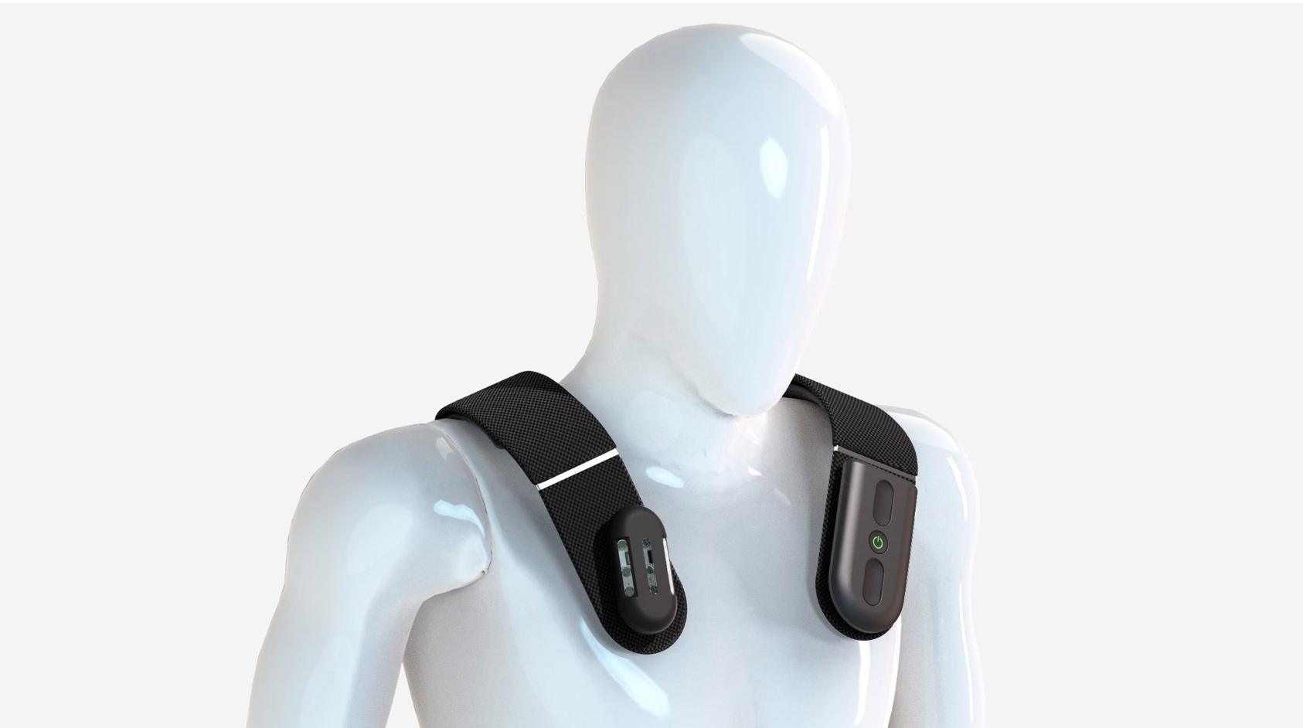
Figure 1: Source: https://www.dezeen.com/2022/01/14/biped-smart-harness-visually-impaired-obstacles-ces-2022/
This design does have advantages:
- A larger battery capacity is permissible due to the wearable nature meaning weight is less of an issue.
- The user doesn’t need to carry around a detected device and can travel similarly to how a sighted person would travel
This design has some disadvantages:
- The height of the user will change the sensing capabilities drastically and would require extensive additional calibration for different height users.
- People move up and down and sway side to side as they walk, and different people do this motion at differing amounts. This means that a robust solution would need to be created to account for the movement variations across many different people.
- The body composition of the user may change the angle the device is sitting at, which would require sensor calibration to account for. Additionally, differing clothing types such as winter jackets could further change the device angle which is unpredictable from a first setup.
- Battery safety considerations are very important because a battery fire could be very dangerous.
Another type of a wearable assistive device is a variety that is worn as glasses:
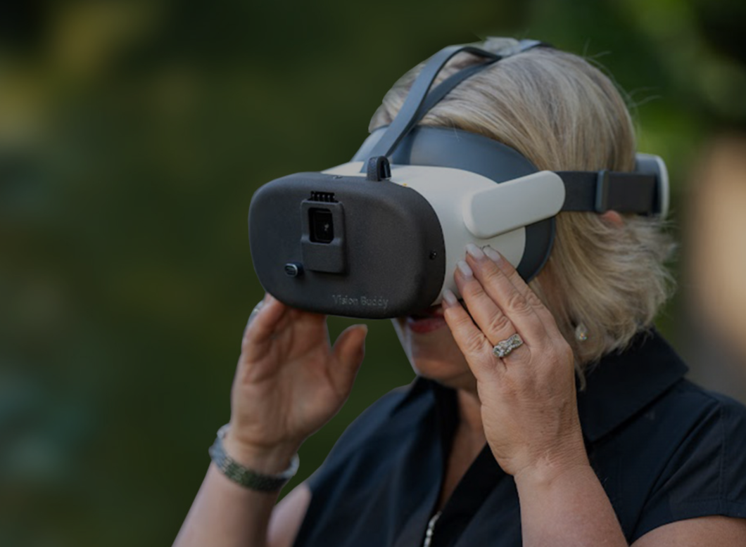
Figure 2: Source: https://visionbuddy.com/electronic-glasses-for-the-blind/

This design also works but has many limitations:
- People may walk straight but with their head at an angle, both up and down and side to side, meaning that the person may not be directly facing in their path of travel. This would need to be accounted for and is a very difficult design challenge as it is needed to know a very precise head orientation as well as the walking direction to properly identify objects that are exclusively in the path of travel and not simply in the direction the user is looking.
- Weight is a major limitation as wearing a heavy device on your head will become tiring very quickly.
- This has the same issue as the torso design, where the user will move in unpredictable ways as they walk, which needs to be accounted for when the sensor data is being analyzed.
- Battery safety considerations are very important because a battery fire could be very dangerous.

Solution 2: Ultrasonic Sensor Blind Cane
This second option is a blind cane that relies exclusively on an ultrasonic sensor for object and hazard detection. There is a similar commercial product to this idea called the WeWALK Smart Cane 2 [2].
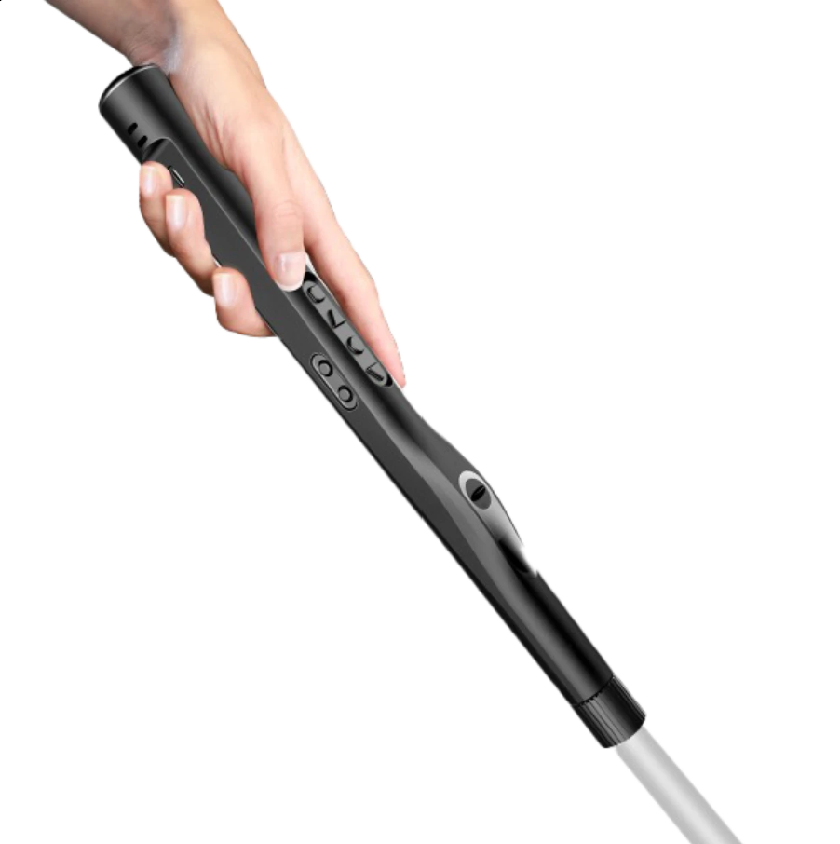
Figure 3: Source:https://lssproducts.com/wewalk-smart-cane-v2/?srsltid=AfmBOoo4zBAt0IdbI-RpqFFK-7z6TxFGSYVc1huRxqgwj15Z7V-Xt5k9#/
A blind cane has several advantages over wearable assistive devices:
- Ultrasonic sensors are reliable and return a simple distance measurement to the detected object, making it a clear signal to the user to avoid the object.
- If the sensing system fails or runs out of battery, the user still has an assistive device available.
- The blind cane serves as a redundancy in case the automated system fails to detect a hazard.
- A battery fire does not pose a significant risk to the user since they can easily and quickly discard the cane.
This ultrasonic sensor-only device has one major disadvantage
- The ultrasonic sensor can only detect the distance that an object is from the sensor, but cannot detect the object’s size, position, or a way to avoid the object.

Solution 3: Camera + Machine Learning and Ultrasonic Blind Cane
This approach involves using a camera, advanced processor, and an ultrasonic sensor to both detect objects with the ultrasonics sensor, but also to process the camera’s image with the processor using a machine learning model. There is a wide range of applications for machine learning including detection of stairs and curbs, which can be hazardous if not avoided properly. A machine learning model can also be expanded at any time over the internet, meaning that the device can improve its functionality with the same hardware.
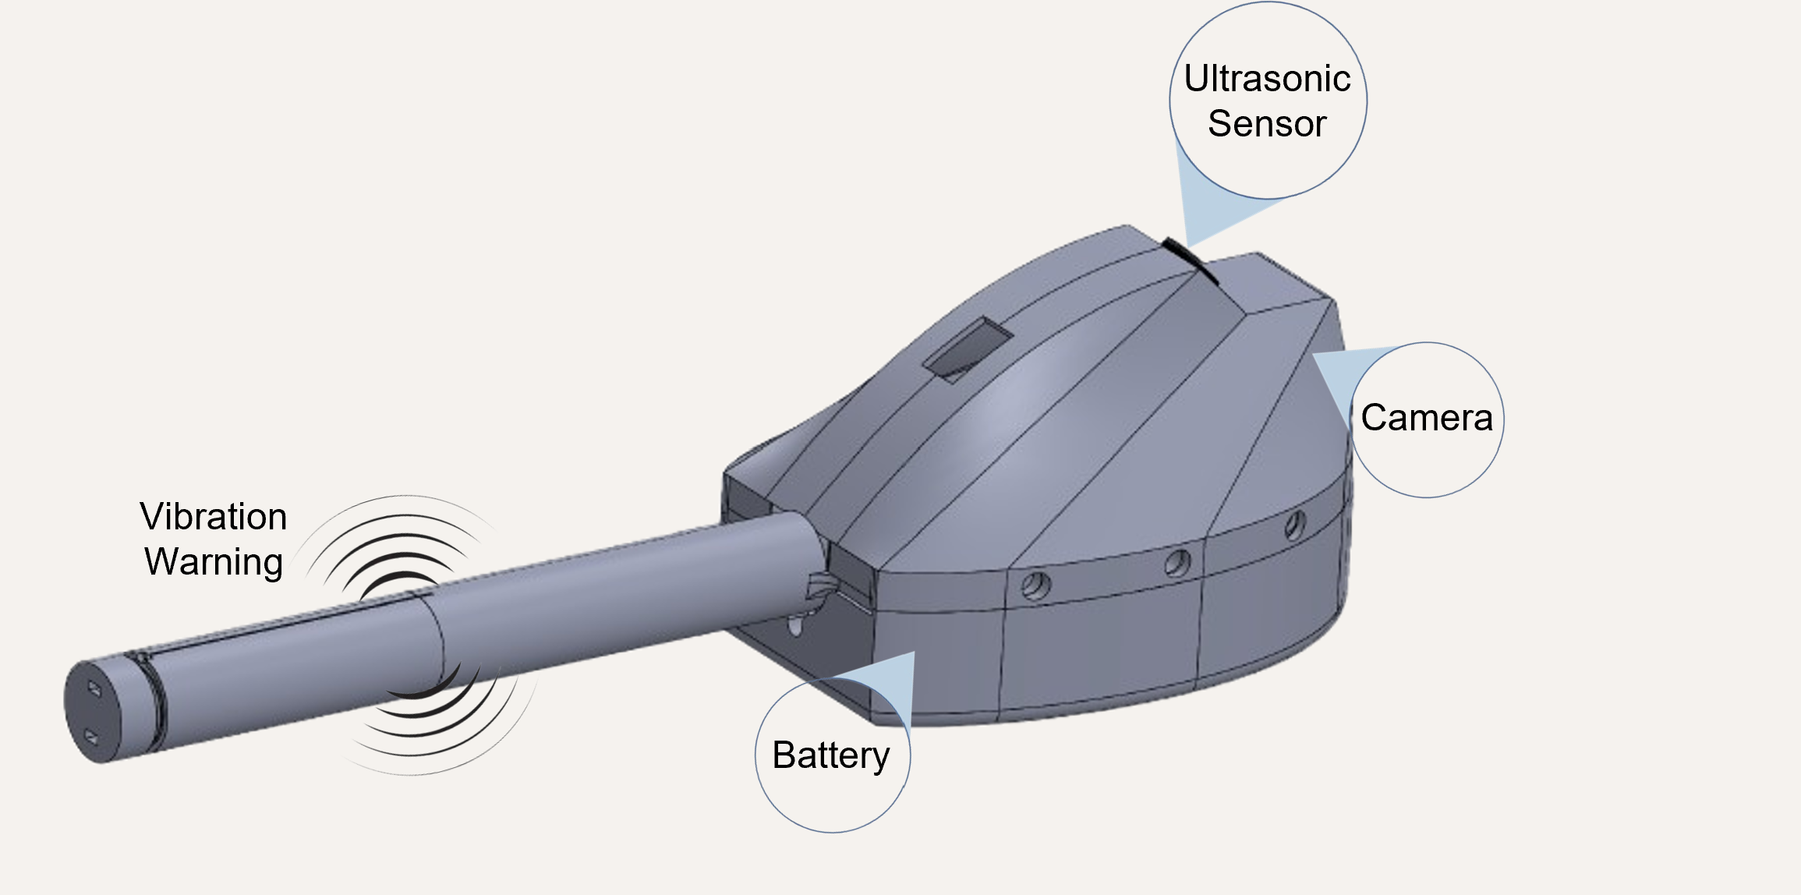
Improved Approach:
The improved design moved the battery, battery charger, boost converter, and vibration motor driver board within the handle instead of in a separate enclosure. This vastly reduces the size of the component enclosure and reduces the weight of the overall design.
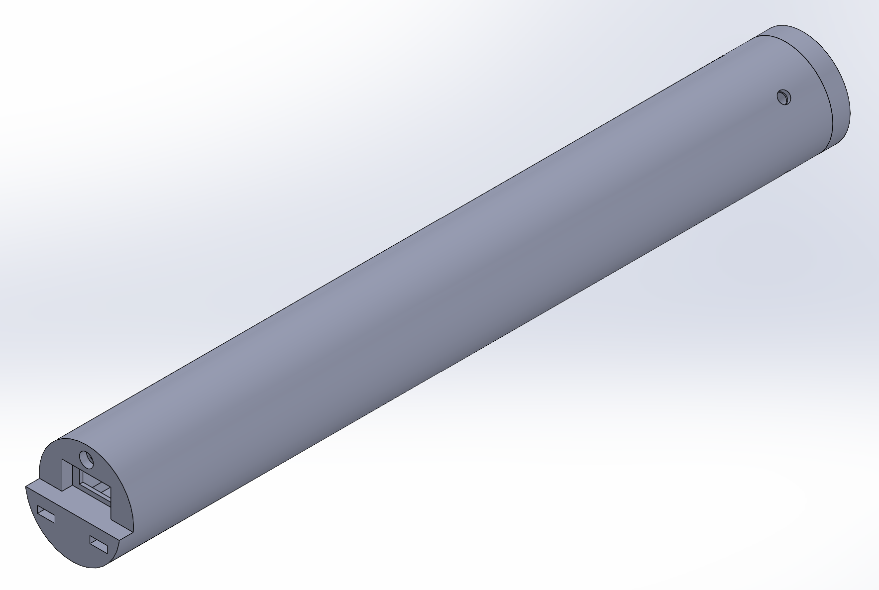
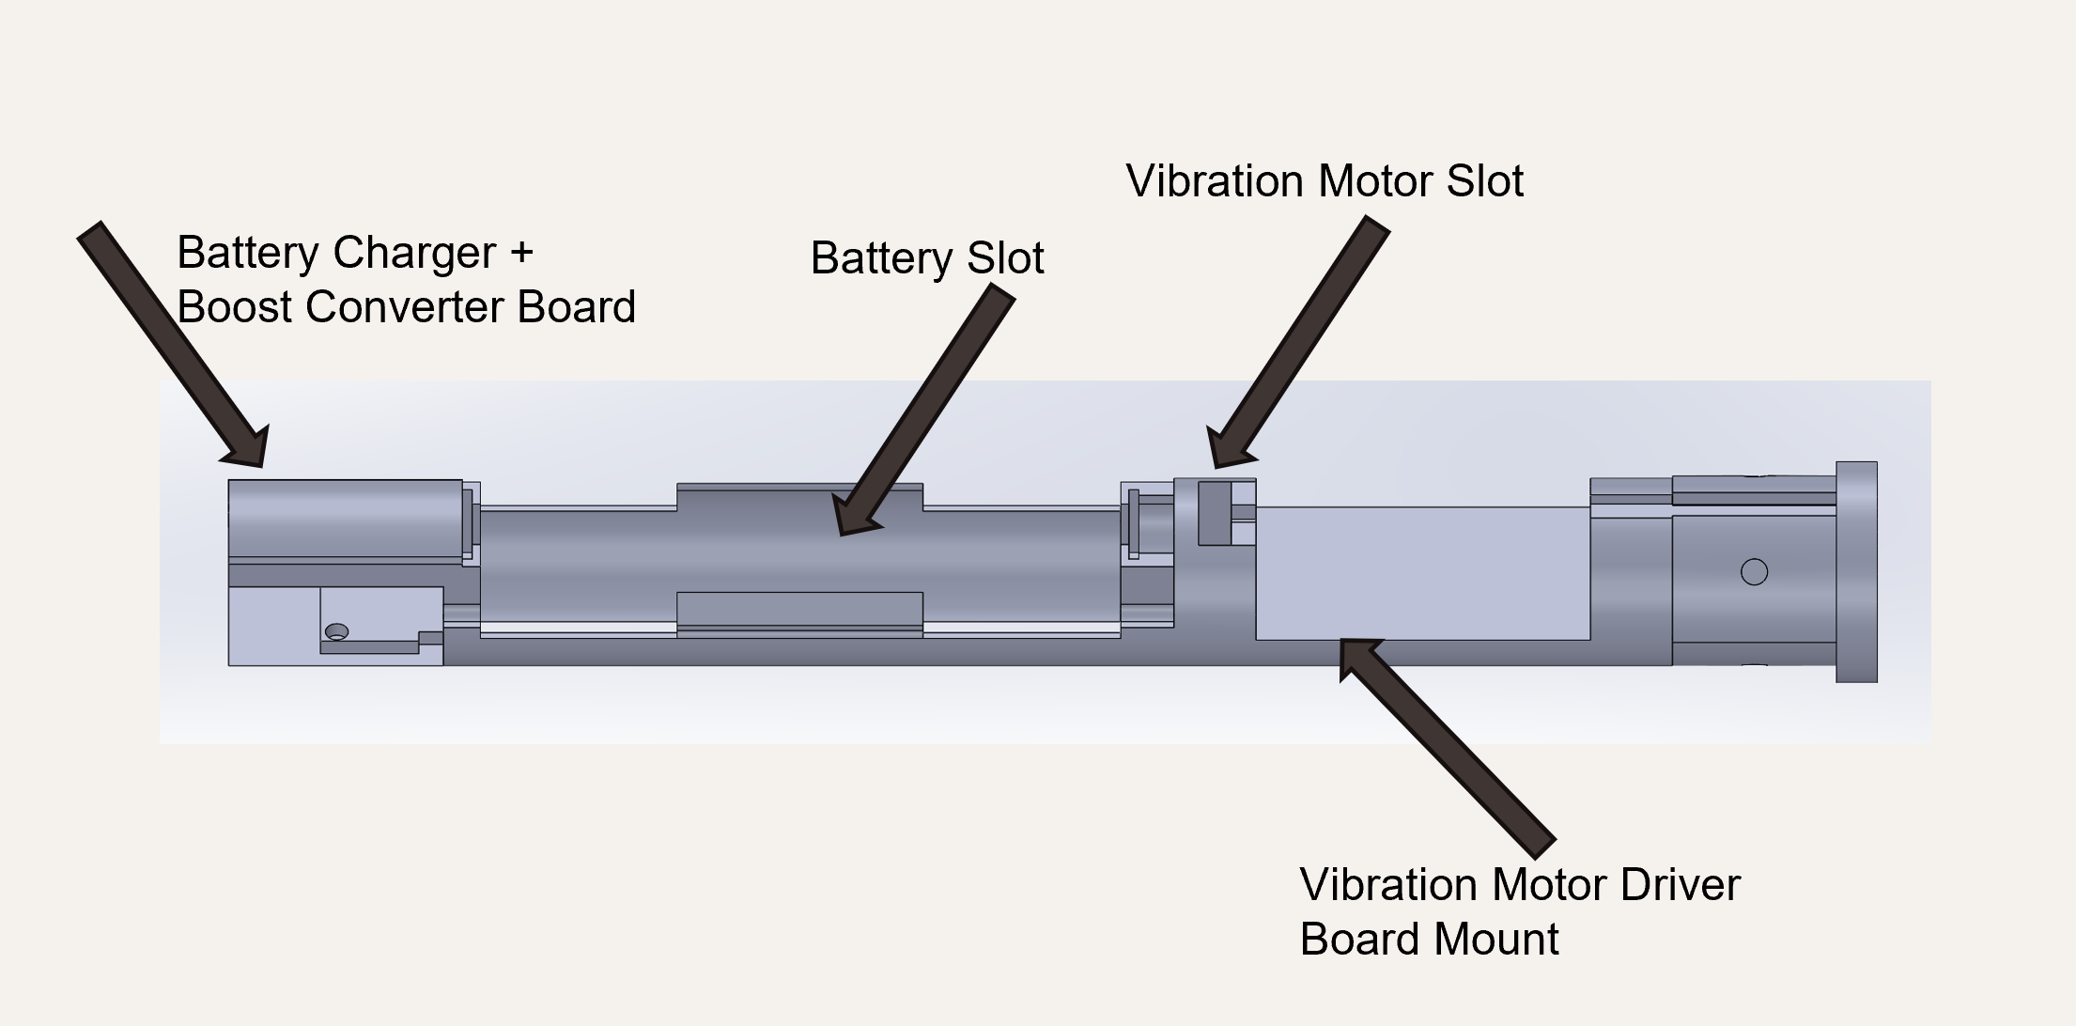
This design has several advantages:
- The 21700 battery has a mass of just 50 to 70 grams [3], this means that the battery is not a significant addition to the weight of a traditional blind cane, which are typically 200-300 grams, varying heavily on material and length. This makes the cane easier to handle for a wider range of users.
- The component enclosure is slimmer because the battery is located within the handle instead of the component enclosure. This makes the cane easier to fold and carry,
- USB-C charging is integrated within handle.

This design has several disadvantages:
- An overall lower battery life, still acceptable for daily use but limited compared to models that use a proprietary battery size.
- Larger diameter handle (28 mm), larger than design constraint of 25 mm. This could be reduced with manufacturing methods such as injection molding as opposed to 3D printing, which is currently used.

Next Step
The wearable device was not chosen due to the difficulty of accounting for the normal variation among different people. A successful wearable device would be able to work with different heights, different body compositions, different clothing, and different walking patterns. Our team does not have the resources to design a functional wearable device. Additionally, the added battery safety concerns would be challenging to design safely given our limited resources.
The ultrasonic sensor-assisted blind cane was not chosen due to its poor resolution and low sophistication. This type of device could only detect if there is an object in front of the user, but not what the object is or how to avoid it.
The ultrasonic sensor-assisted with a camera and machine learning model is the best choice for our team. The ultrasonic sensor provides a reliable indication of an object in the path of travel, which gains all the advantages of the ultrasonic sensor-assisted cane. The design also gains additional sensing capabilities with the camera and machine learning model. This system can be expanded to detect a large variety of objects and can be updated at any time in the future. The current scope of the design detects between stairs, curbs, and normal pavement, but a future model could be expanded to also detect street signs, crosswalks, fire hydrants, trash cans, etc. This additional scope can be downloaded to the device at any time via the internet and means that the device can be significantly improved even with the same hardware. This is in contrast to the ultrasonic sensor-assisted cane which cannot be meaningfully improved because the sensor has a fixed resolution and better software cannot improve the detection significantly. The ability to detect a wider range of hazards, and the future upgrade potential, makes the camera with ultrasonic sensor blind cane the best choice for our team.

Citations

[1] | R. Bourne, J. Steinmetz, S. Flaxman and et al., "Trends in prevalence of blindness and distance and near vision impairment over 30 years: an analysis for the Global Burden of Disease Study," The Lancet Global Health, 2020.
[2] | WeWalk, "Detailed Introduction to the Smart White Cane WeWalk," 10 Novermber 2025. [Online]. Available: https://wewalk.io/en/detailed-introduction-to-the-smart-white-cane-wewalk/. [Accessed 13 September 2026].
[3] | E. Electronics, "21700 Battery: A Complete Guide," 14 February 2025. [Online]. Available: https://www.ersaelectronics.com/blog/21700-battery-a-complete-guide.

