SafeStep
An Automatic Hazards Detection Blind Cane
Kevin Bui, Mohamad Charabi, Nathan Pervin, Mikita Piatsevich
Advisor: Dr. Joseph Picone

Table Of Contents
Overall Objective 2
Final Deliverable 2
Background 3
Scope of the Problem 3
Existing Design 3
Needs Statement 5
Implications of Project Success 5
Citations 6

Overall Objective
Blindness and vision impairment are increasing globally [1]. Traditional blind canes can’t detect all hazards. For example, overhanging signs or tree branches which are an obstacle in the path of a person, but with no connection to the ground which a blind cane requires for detection. As a result, falls and collisions can occur. 76 people with visual impairment were studied over a 12-month period and 74% reported at least 1 fall or injury event in that time, and 63% of falls resulted in an injury [2].

Final Deliverable
A blind cane that is retrofitted with a custom-designed handle that incorporates the sensing technology we design. As this is a continuation of a first-semester senior design project, the deliverable will be an upgraded version of the prototype.
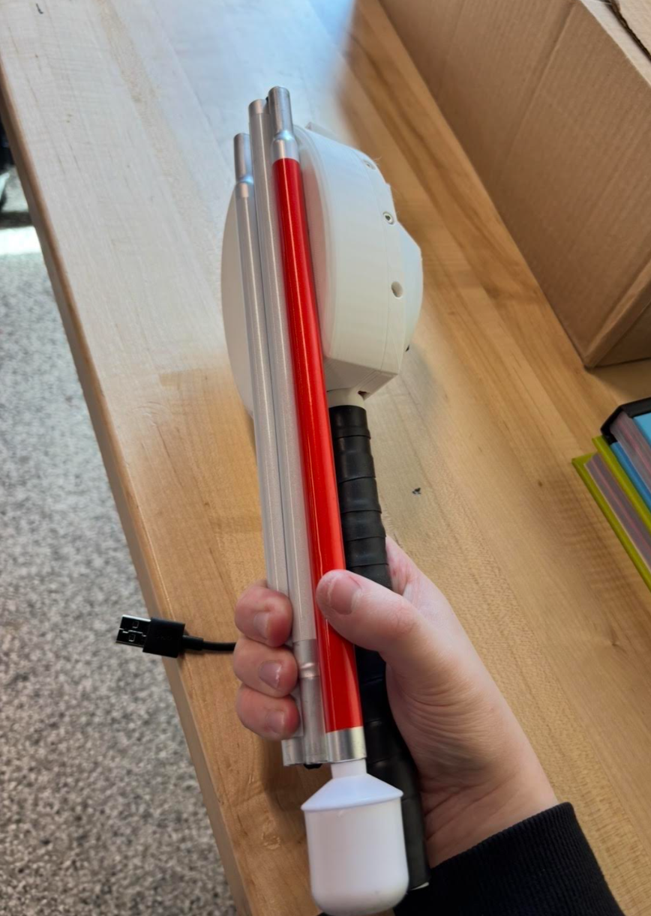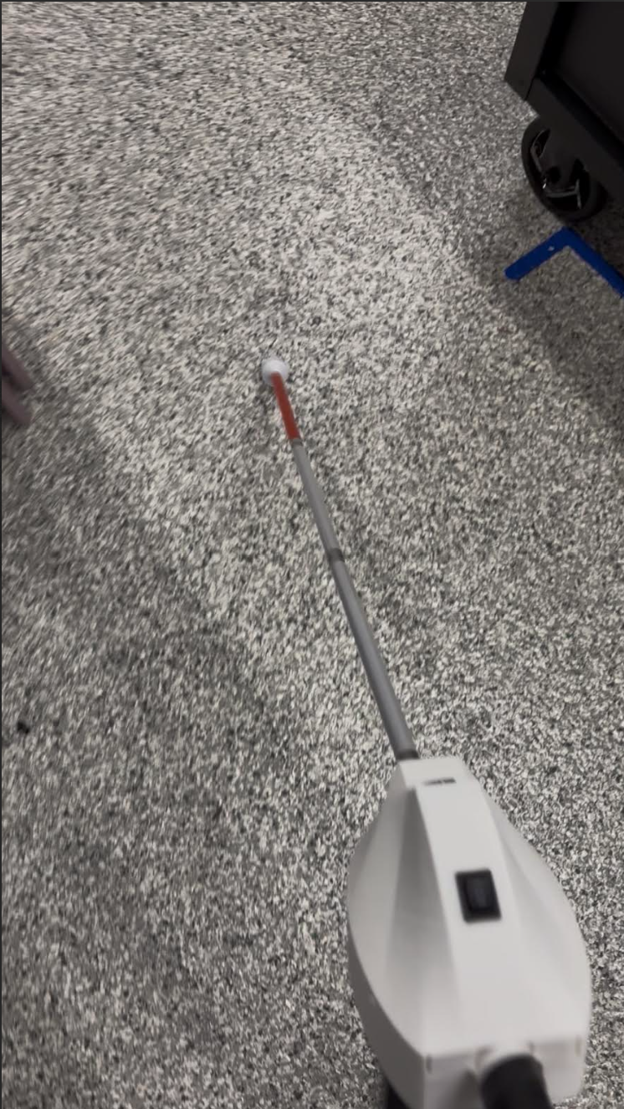
Figure 1: Original SafeStep Prototype
These upgrades will include:
- Slimmer enclosure (improves foldability and reduces weight)
- Reinforced cane segment insert on the handle (avoid layer line fracture seen in prototype)
- More accessible charging port location (in base of handle in redesign)

Background

Scope of the Problem
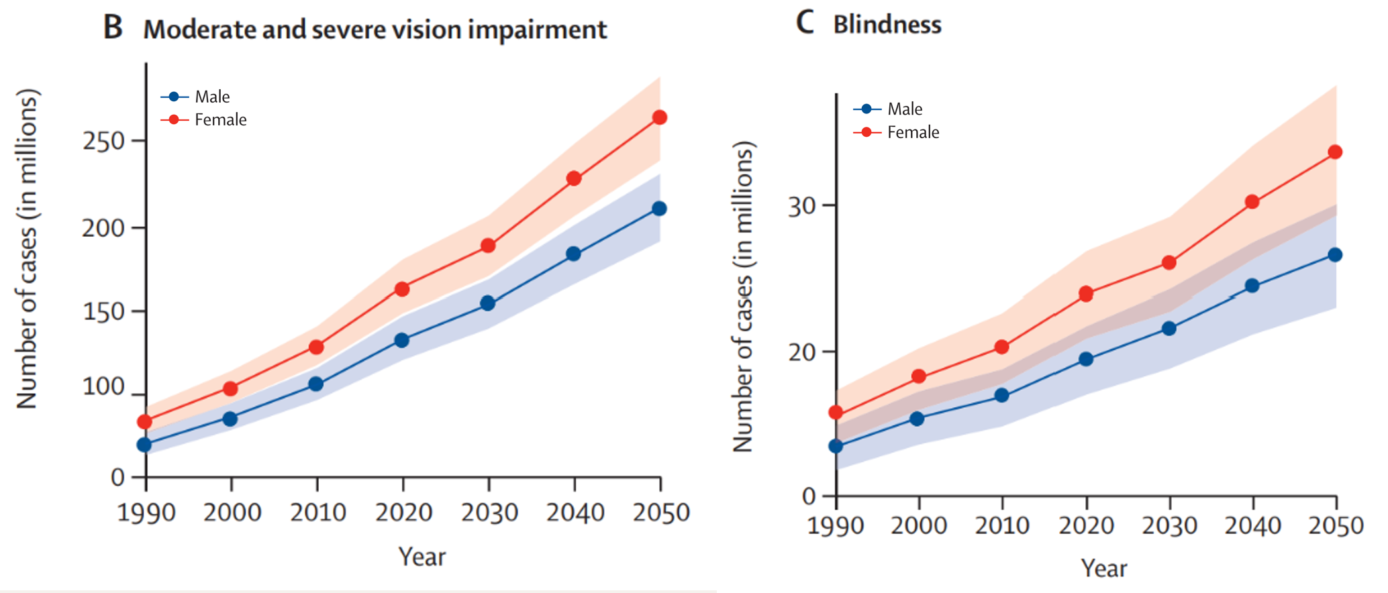
Figure 2: The Projected Increase in the Worldwide Number of Visually Impaired People [1]
As seen in Figure 1, the number of blind people is projected to increase by over 10 million in the next 30 years. The number of moderate and severely visually impaired people is projected to increase over 100 million in the next 30 years.

Existing Design
The most commonly used assistive device is the blind cane, also called a white cane. This is typically a white cane decorated with reflective material that has a variety of tip types which interact with the ground. The blind person swings or taps the cane from side to side as they travel forward, detecting objects in the path of travel as well as ground marking that indicate points of interest such as crosswalks.
There have been companies that have developed blind canes which have additional electronic sensing capabilities. One popular example is the WeWALK Smart Cane 2.
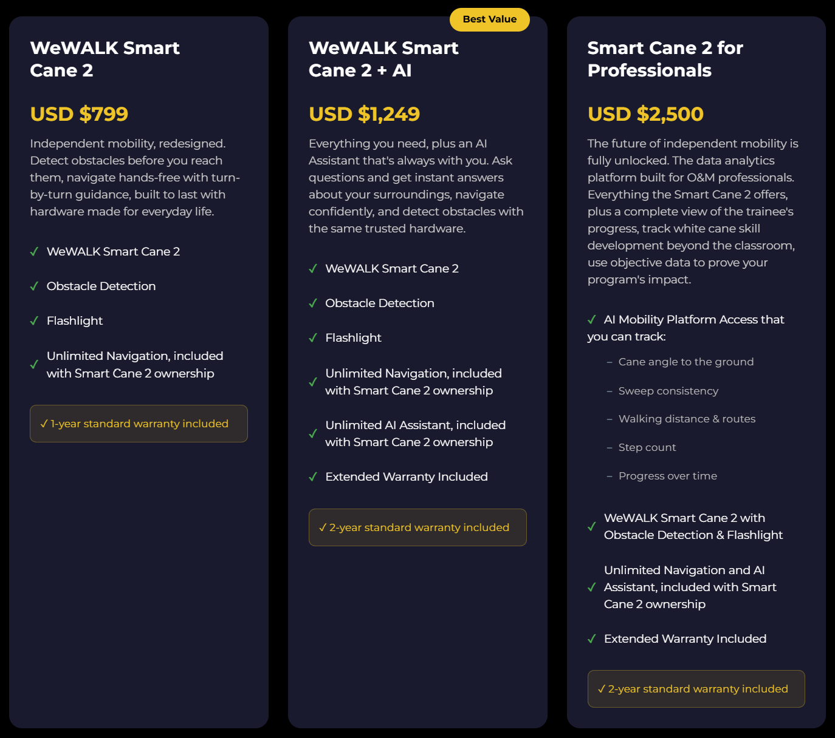
Figure 3: WeWALK Smart Cane 2 Pricing
As seen in Figure 3, the pricing begins at $800, but can cost up to $2,500 for the version with all offered features. Additionally, WeWalk’s design does not use a camera or AI to aid with obstacle detection. WeWALK states, “The smart cane is equipped with an ultrasonic sensor that detects obstacles at chest and head height—areas that a regular cane can’t reach.” [3] Our proposed design includes this feature with the ultrasonic sensor, but also includes a camera which can detect stairs and curbs which is a hazard category WeWALK does not claim to detect.
By having a camera, our design is more adaptable to changing infrastructure since additional hazard detection categories can be added to the camera AI model with an online software update. An ultrasonic sensor alone doesn’t provide enough information to meaningfully be able to detect different types of hazards. This means that our design will be able to be substantially upgraded in the future, whereas the other designs on the market do not have this capability.

Needs Statement
Our project aims to assist blind people with avoiding obstacles and hazards which will reduce the occurrence of injuries.

Implications of Project Success
If our project is successfully developed and adopted, the most immediate impact would be a reduction in fall-related injuries among visually impaired individuals. A smart cane that can detect overhead and ground level hazards could meaningfully reduce the number of falls and injuries. This could improve both safety and independence for low-vision and blind users.
Beyond our original goal of individual safety, a successful SafeStep addresses several UN Sustainable Development Goals (SDGs) [4].
- SDG 3 – Good Health and Well-Being: SafeStep directly contributes to better health outcomes for a vulnerable population by reducing fall-related injuries.
- SDG 9 – Industry, Innovation, and Infrastructure: Our camera-based AI approach creates an innovative platform that can be updated via software as infrastructure changes. Compared to hardware exclusive solutions, new hazards and improved detection models can be pushed to existing devices, meaning the cane grows more capable throughout its lifetime.
- SDG 10 – Reduced Inequalities: Blindness disproportionately affects those on a fixed income such as the elderly, who may not be able to able to afford assistive tools. SafeStep’s design prioritizes affordability compared to existing solutions, making assistive technology more affordable and accessible.
- SDG 11 – Sustainable Cities and Communities: Safer navigation for visually impaired individuals contributes to a more inclusive and safe urban environment.

Citations
[1] | R. Bourne, J. Steinmetz, S. Flaxman and et al., "Trends in prevalence of blindness and distance and near vision impairment over 30 years: an analysis for the Global Burden of Disease Study," The Lancet Global Health, 2020.
[2] | C. Brundle and et al., "The causes of falls: views of older people with visual impairment," Health Expect, 2015.
[3] | "Detailed Introduction to the Smart White Cane WeWALK," [Online]. Available: https://wewalk.io/en/detailed-introduction-to-the-smart-white-cane-wewalk/.
[4] | United Nations, "The 17 Goals," 2015. [Online]. Available: https://sdgs.un.org/goals.

