SafeStep
An Automatic Hazards Detection Blind Cane
Kevin Bui, Mohamad Charabi, Nathan Pervin, Mikita Piatsevich
Advisor: Dr. Joseph Picone
Contents
Chosen Solution 2
Criteria 4
Importance of Criteria 5
Pugh Matrix 5
Engineering Design Plan 7
Overview of Current Progress 7
Planned Improvements 8
Engineering Design Immediate Goals 10
Citations 11

Chosen Solution
The three solutions identified in the previous assignment were a wearable sensing device, an ultrasonic sensor blind cane, and an ultrasonic sensor with camera blind cane.
As seen in Figure 1, there exists a wearable device that rests on the user’s torso. This device uses cameras to detect hazards in the path of the user’s travel [1].
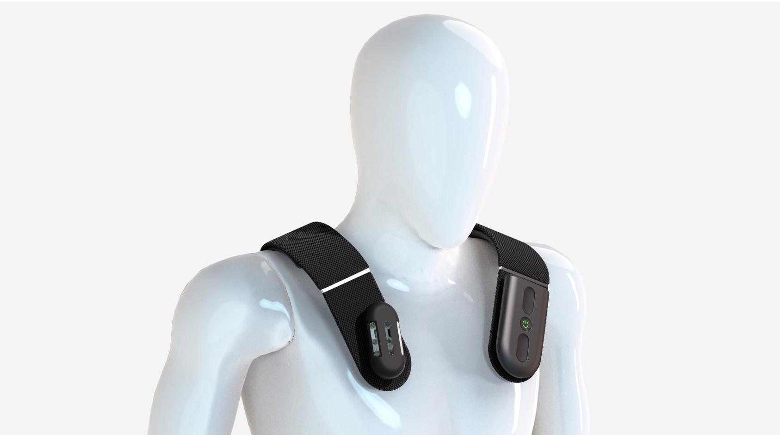
Figure 1: Wearable Device on Torso [1]
Alternatively, as seen in Figure 2, there exists wearable devices worn on the head as goggles or glasses. These devices typically feature a camera to detect hazards in the path of the user’s travel [2].
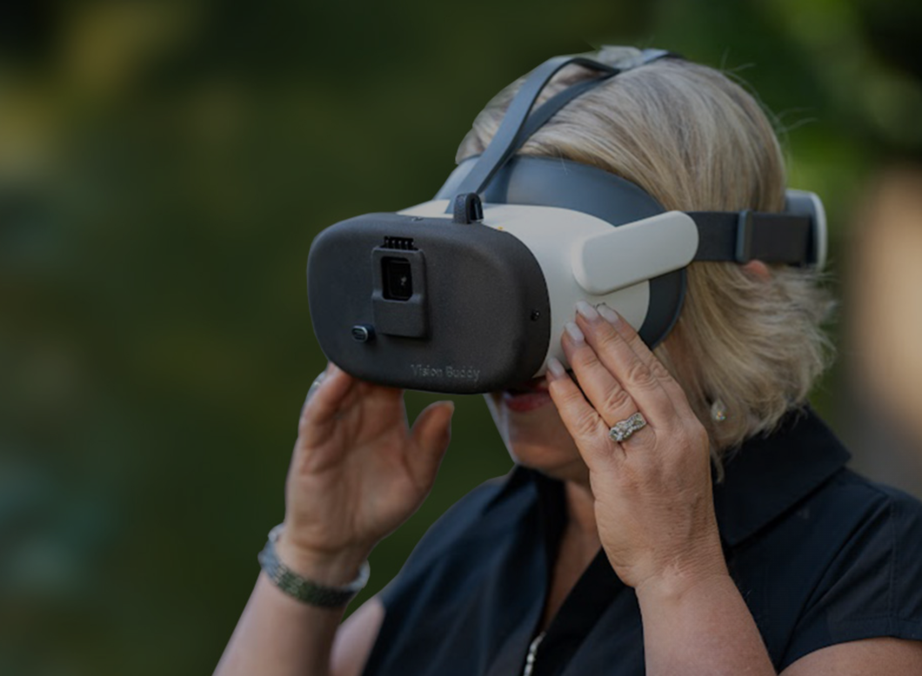
Figure 2: Wearable Device on Head [2]

Another potential solution is a blind cane that uses an ultrasonic sensor to detect objects in the path of the user’s travel [3]. As seen in Figure 3, the user holds this device as a standard blind cane, but this device contains an ultrasonic sensor that can detect objects in advance of when the user would ordinarily collide with them.
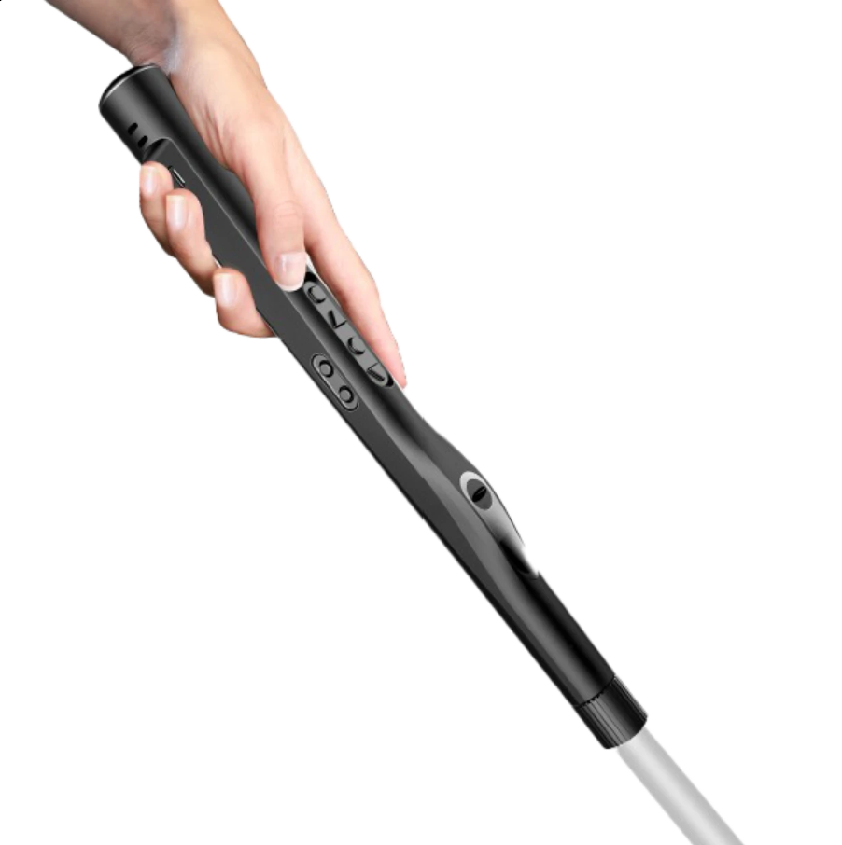
Figure 3: WeWALK Smart Cane 2 [4]
The third potential solution is a blind cane that uses the camera model that the wearable devices use but also uses an ultrasonic sensor like the WeWALK Smart Cane. This combines the advantages of a highly detailed camera image with the simple but reliable detection of an ultrasonic sensor. Figure 4 depicts the preliminary design for this device.
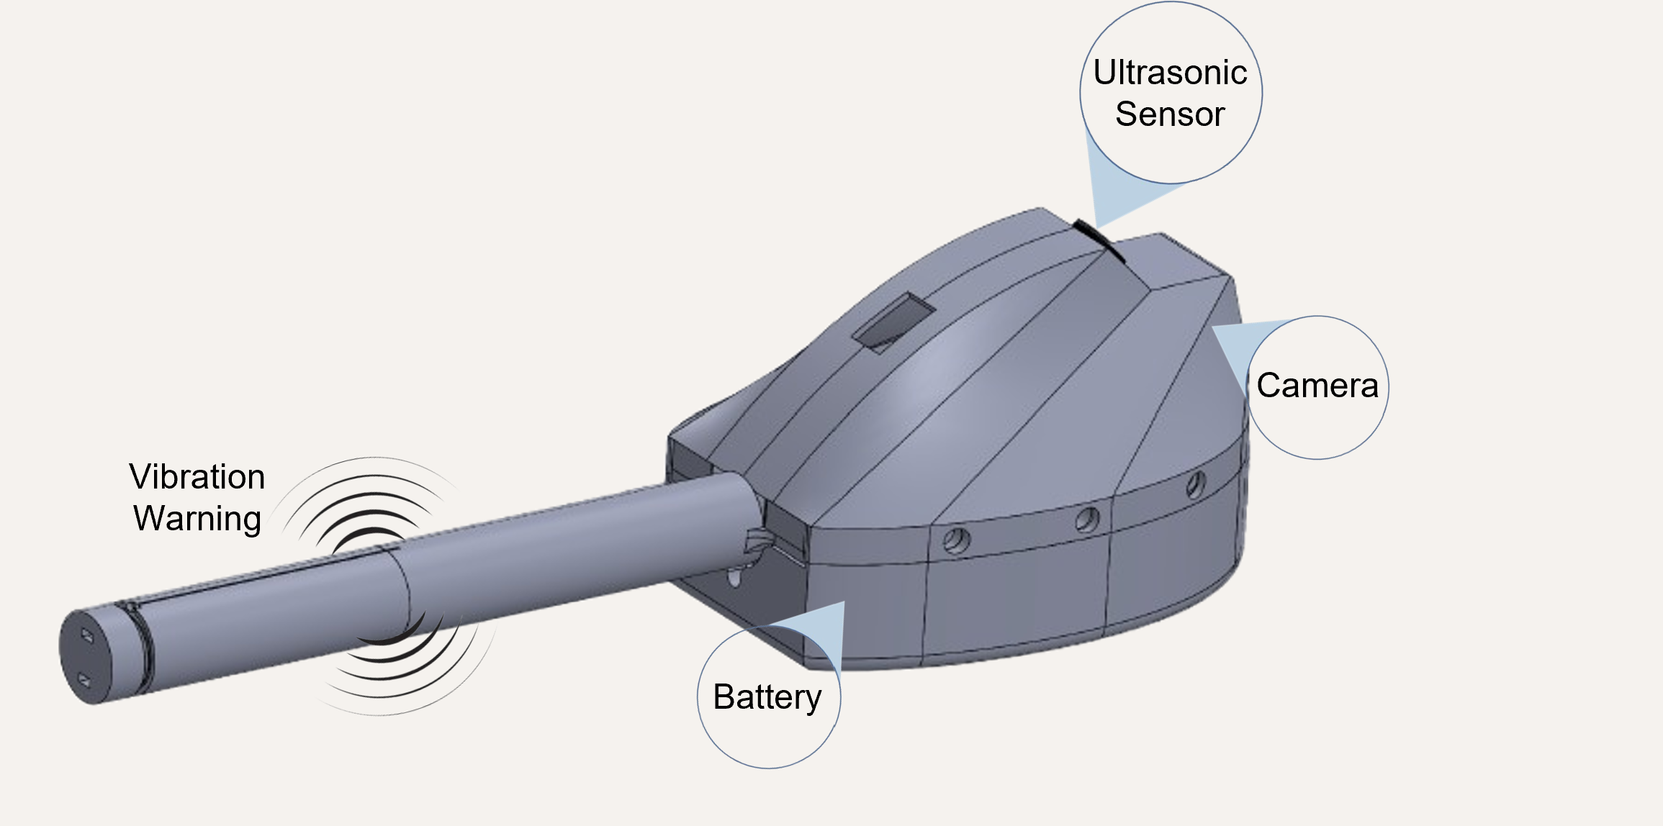
Figure 4: Blind Cane Handle with Ultrasonic Sensor and Camera

Criteria
Criteria | Why is it important
Ease of development | Due to the limited resources and time, a solution that requires a complex design is not feasible. A more complex design may also be prone to more errors. Therefore, the ease of development is very important to ensure that the project is functional within the allotted time.
Comfort | Due to the users possessing the device every day, it is important that the design is comfortable to ensure that the user is not burdened by using the device.
Redundancy | Due to the nature of the device, a device failure could result in injury to the user. It is therefore very important that there is a redundant feature of the design that the user can trust.
Upgradability | The device should be able to be upgraded in the future. This is a major advantage to many modern products such as electric cars. If the device is easily upgradable in the future, such as with an online software update, then the limited timeframe of this project is mitigated, and further development can be conducted even after the product is constructed.

Importance of Criteria
Criteria | Weight (5= very important, 1= somewhat important)
Ease of development | 4 (with limited time and resources, it is very important for the design to be completed within the allotted time)
Comfort | 2 (While this matters for user preference, a compromise on comfort in exchange for great system performance is acceptable)
Redundancy | 5 (In order for the user to trust the system fully, it is best to have redundancy. This also mitigates potential injuries to the user if the device fails)
Upgradability | 5 (an upgradable design accounts for the shortcoming associated with the limited time of development. Additionally the device benefits from advancements in machine learning which has improved substantially in just the last few years, a design that can improve significantly in just the next few years is a major advantage)

Pugh Matrix
Criteria | Weight | Wearable device | Cane w/ Ultrasonic Sensor only | Cane w/ Camera and Ultrasonic Sensor
Ease of development | 4 | 0 | +1 | 0
Comfort | 2 | +1 | +1 | +1
Redundancy | 5 | 0 | +1 | +1
Upgradability | 5 | +1 | 0 | +1

Potential Solution | Score Calculation
Wearable device | $$\left(4*0\right)+\left(2*1\right)+\left(5*0\right)+\left(5*1\right)=7$$
Cane w/ Ultrasonic Sensor only | $$\left(4*1\right)+\left(2*1\right)+\left(5*1\right)+\left(5*0\right)=11$$
Cane w/ Camera and Ultrasonic Sensor | $$\left(4*0\right)+\left(2*1\right)+\left(5*1\right)+\left(5*1\right)=12$$

The wearable device is upgradable and comfortable but would require a very complex design to overcome the differences in the user’s body composition and walking behaviors. The wearable device also fails to have redundancy and the user would need to fully trust in the system, or use an external blind cane for redundancy, diminishing the value of the overall design.
The cane with just the ultrasonic sensor is easier to develop, comfortable, and provides redundancy which would increase the user’s trust in the system. However, an ultrasonic sensor lacks the resolution of data to have upgradability.
The cane with the camera and ultrasonic sensor is more difficult to develop than the ultrasonic sensor only cane, but easier to develop than the wearable device. It passes the other 3 metrics with comfort, redundancy, and upgradability. Upgradability was weighted higher for this project due to the recent advancements in machine learning which may prove very useful if those advancements can be used for this system as they are developed further.
The cane with the camera and ultrasonic sensor had the highest score from the Pugh matrix and for that reason will be the design our team moves forward with.

Engineering Design Plan

Overview of Current Progress
This project is a continuation of the progress made during the first semester of senior design. As seen in Figure 4: Blind Cane Handle with Ultrasonic Sensor and Camera, a prototype has already been developed. This prototype includes a camera, ultrasonic sensor, raspberry pi zero 2 w, vibration motor, and a battery. A 3D printed handle encloses these components and interfaces with the rest of the blind cane to form the complete unit. Figure 5 depicts the prototype developed during the first semester.
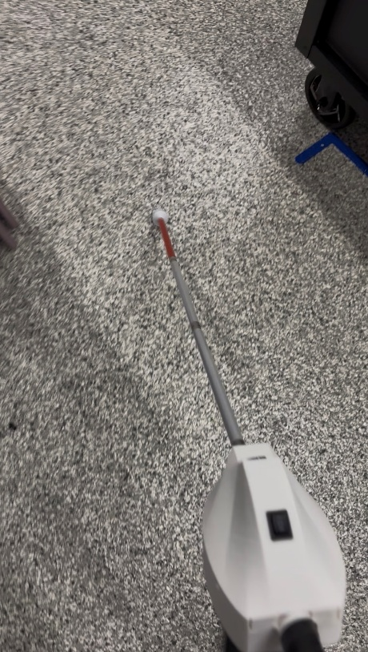
Figure 5: Original Prototype of SafeStep
This design used an ultrasonic sensor mounted at a 45 degree angle above the direction of the length of the cane. This placed the sensor forward and slightly upward in the path of the user’s travel, with the intention for this sensor to detect objects in front of the user but also signage above the sensor, but below the user’s head.
This design used a camera which had its image processed by a machine learning model on the Raspberry Pi Zero 2 W. This machine learning model was designed to detect stairs and curbs in the path of the user’s travel, as opposed to normal pavement.
The device would vibrate in different patterns depending on if the machine learning model detected stairs or curbs, and also had a pattern for the ultrasonic sensor detecting an object.
This design used a 5V, 10000 mAh battery pack which was mounted in the main component enclosure, along with the camera, ultrasonic sensor, and Raspberry Pi Zero 2 W. The vibration motor was located within the handle.

Planned Improvements
This design was bulky and the machine learning model was ineffective at detecting hazards. Several improvements are underway:
- More data will be collected and sorted
- The machine learning model will be fine tuned and retrained on the additional data
- The battery will be moved within the handle instead of in the main enclosure where the camera and ultrasonic sensor are mounted.
- The interface between the handle and rest of the cane will be reinforced with a metal tube to prevent a layer line fracture that occurred in the original prototype
- The vibration motor pulse setting will be modified to be clearer which type of hazard is being detected
- USB-C charging will be added to the base of the handle, this will be an improvement over the micro-USB charging port located under the handle in the main component enclosure.
- The entire device will be slimmer and lighter due to the battery location change and size reduction, and the rest of the components will be designed to fit more compactly in the assembly. This will also reduce the weight of the device.
The objective of these improvements is to create a marketable product, instead of simply a prototype.
As seen in Figure 6, the new design for the handle includes a USB-C charging port in the base, as well as a section for a wrist loop. This is an improvement over the inconveniently placed micro-USB charging port on the original prototype.
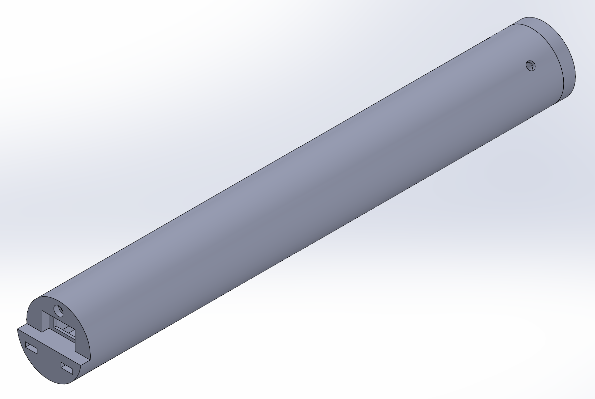
Figure 6: New Handle External Design
As seen in Figure 7, the internal handle contains mounting points for the charger and boost convert board, the 21700 battery, vibration motor, and vibration motor driver board. This handle also features a four-point M3 couple point to connect it to the main component enclosure. The mounting points are rotated at a 45-degree angle with respect to the “up” position of the handle. This allows for wire passthrough channels above and below the internal mounting structure. This design is significantly more compact than the original prototype which reduces the size and weight of the overall design.
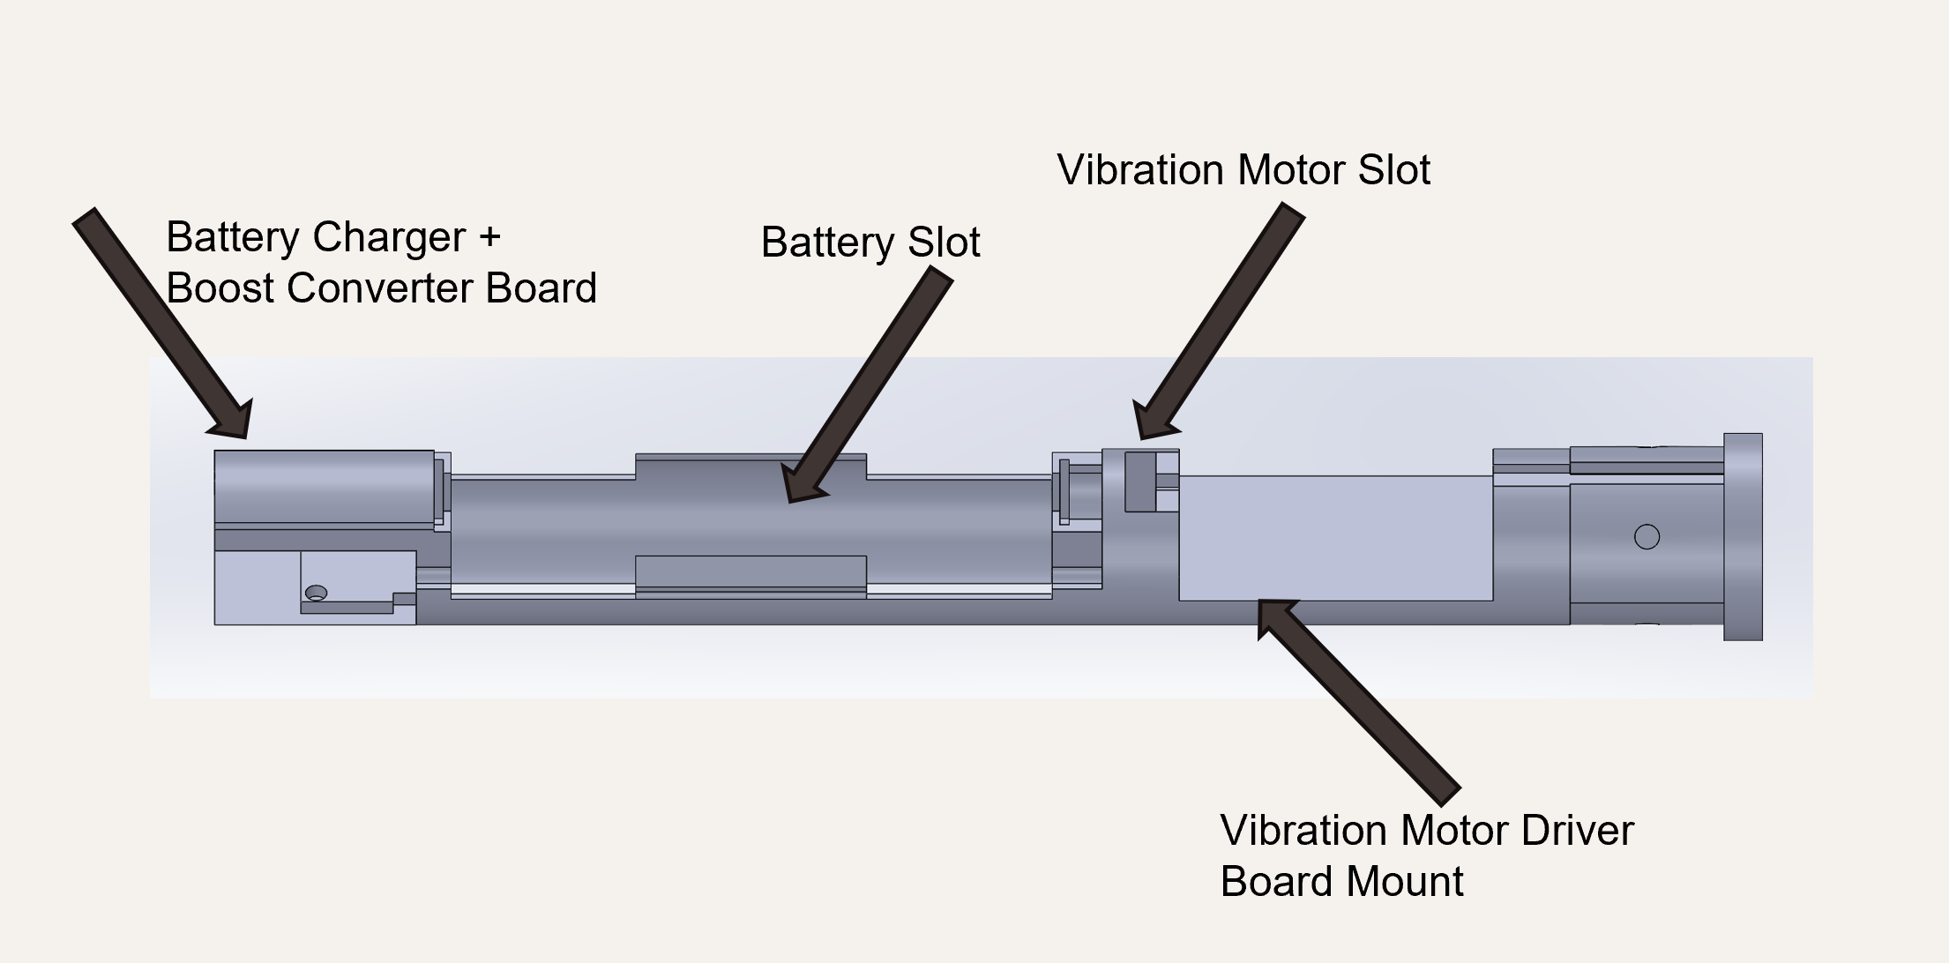
Figure 7: New Handle Internal Design

Engineering Design Immediate Goals
As this is a second-semester continuation of the project, the necessary components have already been ordered and incorporated in the design.
The primary objective over the next two weeks is to collect more data and retrain the model. We will compare the machine learning model’s current performance to its performance on the new data. We will fine tune the model to improve its performance on the expanded dataset. Once a greater model performance has been established, we will benchmark the model’s performance in the field against the benchmarks recorded for the prototype.
The 3D model of the device will continue to be developed. In the next two weeks, the mounting points for the camera, ultrasonic sensor, and Raspberry Pi Zero 2 W will be designed. This design will be an extension to the four-point couple already designed. A preliminary design will be created that will allow the device to function, but without regard to aesthetics. Once functionality has been confirmed, the device’s aesthetics will be designed, however this will occur after two weeks from now.

Citations

[1] | A. Finney, "Biped's smart harness helps visually impaired people avoid obstacles while walking," 14 January 2022. [Online]. Available: https://www.dezeen.com/2022/01/14/biped-smart-harness-visually-impaired-obstacles-ces-2022/.
[2] | J. Hayes, "5 Best Electronic Glasses for the Blind & Visually Impaired," 23 December 2024. [Online]. Available: https://visionbuddy.com/electronic-glasses-for-the-blind/.
[3] | WeWALK, "Detailed Introduction to the Smart White Cane WeWalk," 10 November 2025. [Online]. Available: https://wewalk.io/en/detailed-introduction-to-the-smart-white-cane-wewalk/.
[4] | L. Products. [Online]. Available: https://lssproducts.com/wewalk-smart-cane-v2/?srsltid=AfmBOoo4zBAt0IdbI-RpqFFK-7z6TxFGSYVc1huRxqgwj15Z7V-Xt5k9#/.

