SafeStep
An Automatic Hazards Detection Blind Cane
Kevin Bui, Mohamad Charabi, Nathan Pervin, Mikita Piatsevich
Advisor: Dr. Joseph Picone

Table of Contents
Design Requirements 2
Low Miss Rate for Stairs, Curbs, and Drop-offs 3
Hazard Detection Latency 3
Detection Distance Capability 4
Low False Positive Rate 6
Design Constraints 7
Comfortable Handle Dimensions 8
Citations 9

Design Requirements
Requirement | Metric | Target Value, Range, Pass/Fail | Result | P/F | Quantifications or Definitions | Justification
Low Miss Rate for Stairs, Curbs, and Drop-offs | False negative rate (%) | < 5% | NA | NA | Risers need min of 3in and max of 7in [1]. Treads min of 11in deep. Curbs between 3 in and 9 in. | We want this as low as possible to avoid any falls since they are a leading contributor [2].
Hazard Detection Latency | End-to-End detection and alert time (ms) | < 220 ms | NA | NA | Hazards include stairs, curbs, and drop-offs. Look la Low Miss Rate for Stairs, Curbs, and Drop-offs for quantifications. | The human reaction to simple reactions is around 220 ms [3]. For the user to be able to react in a timely manner, it needs to be equal or faster than the average reaction time.
Detection Distance Capability | Maximum  reliable hazard detection distance (ft) | 6 ft | NA | NA | Reliable hazard detection is when it is consistently detecting hazards at a set distance. | To give a person enough time to react to some type of hazard, we need it to be able to detect from a certain distance and be reliable.
Low False Positive Rate for Non-Hazardous Paths | False positive rate (%) | < 1% | NA | NA | False positives are when the cane alerts the user of a hazard, but none is there. | A very low false positive rate is optimal since, too many false positives might lead to a user ignoring the warnings.

Low Miss Rate for Stairs, Curbs, and Drop-offs
Based on the U.S. Access Board to support ADA compliance, we can define a flight of stairs by uniform climbing distance (riser). Risers need a minimum of 4 inches (100 mm) and a maximum of 7 inches (180 mm) [1]. The part that people step on, the tread, must be 11 inches (280mm) deep at a minimum [1]. Curbs present a similar elevation hazard. The typical height of a curb is usually between 3 inches (75 mm) and 9 inches (230 mm) [1].
The low miss rate measures how often our AI camera and deep learning model fail to detect hazards (such as stairs or curbs). Environmental hazards like these are frequently reported as contributing to falls among individuals who are visually impaired [2]. It is critical that we prioritize this; missing stairs or curbs could result in the user walking forward and potentially falling and injuring themselves. To calculate the miss rate, we would use the formula below:
$$Miss Rate=\frac{False Negatives}{\left(True Positives+False Negatives\right)}$$
False negatives are anytime there is a hazard there and our model FAILS to detect it. True positives are when there is a hazard and our model SUCCEEDS in detecting it. The lower our miss rate also shows how accurate our model is as well.
This requirement is not negotiable, a slightly higher miss rate is acceptable, but a significantly high miss rate means that the product would be ineffective. Therefore, this requirement must be met close to or within the target set in order for the design to be successful.

Hazard Detection Latency
Hazards for the AI camera include stairs, curbs, and drop-offs. Hazard detection latency is the delay from when the AI camera system captures an image of an object to when it decides if it’s a hazard or not. The system performs preprocessing of the captured image, followed by model inference, then classifies the object, and finally decides if it is a hazard. Due to the computational demands of image processing and deep learning, this process will likely create the largest delay in our system. The average human reaction time for simple reactions is around 220 ms. For recognition reaction time, it is about 384 ms [3]. A simple reaction time is one stimulus to one action. action and reaction time involves identifying an unknown stimulus, determining the appropriate action, and then responding. The vibration alert is designed as a direct hazard warning, requiring an immediate reaction (stopping). We assume the user will follow a simple reaction model. Therefore, setting the system latency goal to less than 220 ms can ensure the hazard alert is sent in time for user response.

This requirement is negotiable within reason. Human walking speed is not so high that a detection latency would become a major factor in obstacle avoidance. However, a latency close to or below the target would be more convenient for the user.

Detection Distance Capability
Detection Distance Capability refers to the distance at which the user is located from an object in order to be alerted to the object’s presence. This can be found by using the average walking speed and reaction time to calculate the distance that the cane should detect objects. Casillas et al stated, “The mean walking speed has been reported to be 1.24 m/s in healthy subjects during ambulation” [4]. The average recognition time is 384 ms [3].
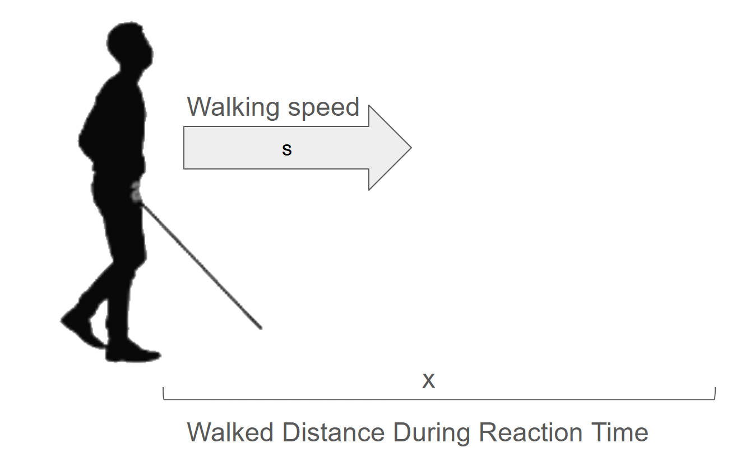
$$x=st$$
Where x is the distance walked during the reaction time, $t$ is the reaction time, and s is the walking speed.
$$x=1.25\frac{m}{s}*0.383=0.47875 m$$
$$x=0.47875 m$$
So, the user will walk 0.47875 meters on average in the time it takes for them to react to SafeStep’s indication of a hazard.
The system should be able to alert the user of an object before they collide with it so the distance of the cane from the user also needs to be calculated.
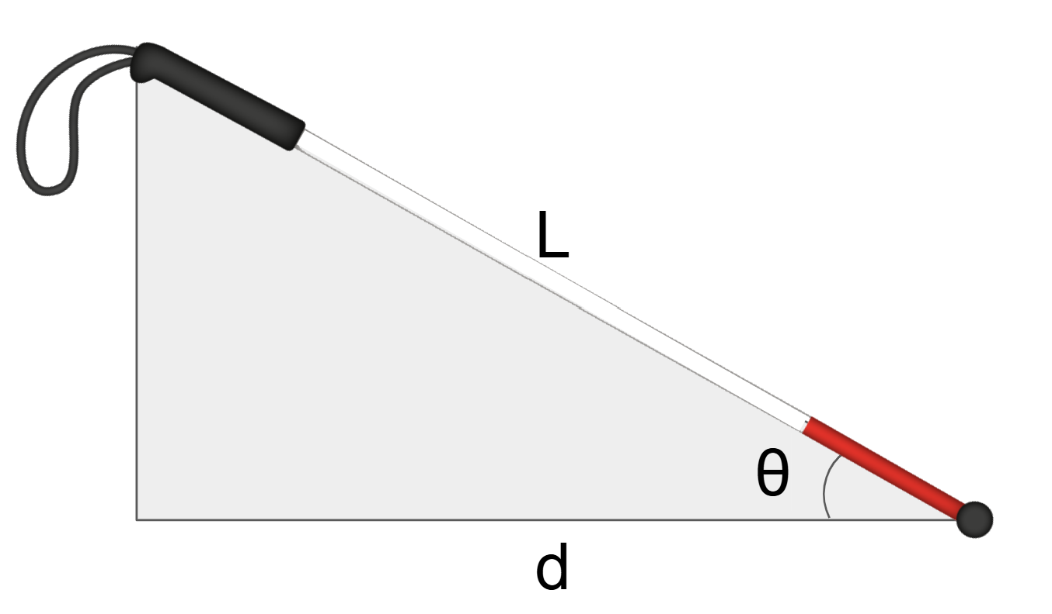
L is the length of the cane and θ is the angle that the cane make with the ground. The ground distance can be calculated with this equation $d=L*cosθ$. The cane has a length of $140 cm=1.4m$ [5]. The angle will depend on the height of the user but $40°$ was found to be an approximate angle during data collection.
$$d=1.4*\cos\left(40\right)=1.072 m$$
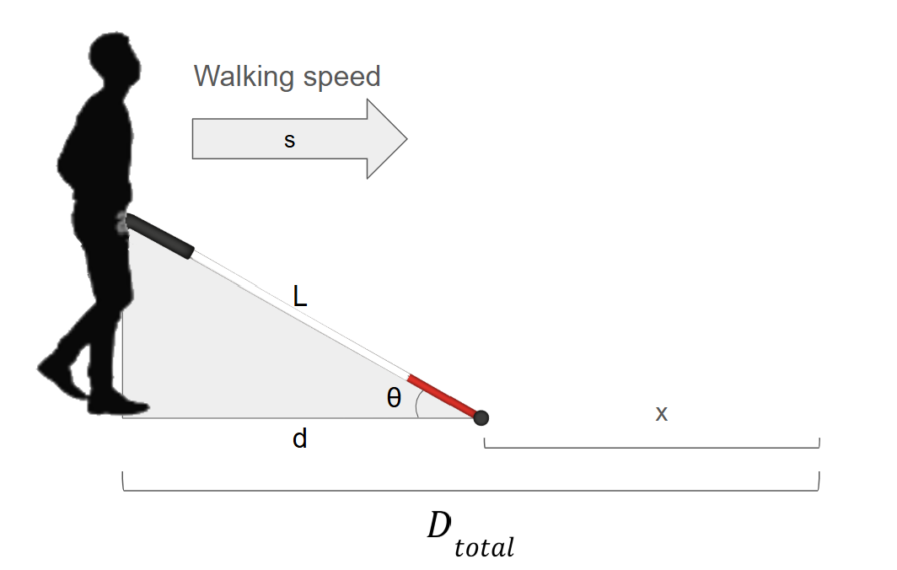
We can add the distance values from the reaction time walked distance (x) and the ground distance of the cane (d) to find the minimum distance we must be able to detect an object ($D_{total})$.
$$D_{total}=d+x$$
$$D_{total}=1.072+0.47875=1.548 m$$
$$D_{total}=1.548 m=5.0787402 ft$$
A value of 6ft is sufficient for the user to be able to stop and pivot away from the obstacle. So, the cane should be able to detect objects at a minimum of 6 ft away from the user.
This requirement is not negotiable since if the detection distance is much shorter than the target, collisions may occur and would thus render the product ineffective. Therefore, the design must be able to detect objects at or beyond the detection distance.

Low False Positive Rate
A false positive refers to the cane incorrectly identifying a hazard where there isn’t one. If the cane is frequently alerting the user to hazards that don’t exist, the user could become desensitized to the haptic feedback. In the worst case, the user could decide to turn the system off due to the perceived unreliability, even if the cane correctly identifies all actual hazards. Therefore, we must ensure that the cane does not have too many false positive alerts. Hsing-Wen Lin et al. wrote, “Our system can reach a true positive rate (tpr) ~96% with a false positive rate (fpr) ~ 1% or tpr ~99% at fpr ~5%.” [6]. Due to the complexity of this data set as evidenced by images such as this:

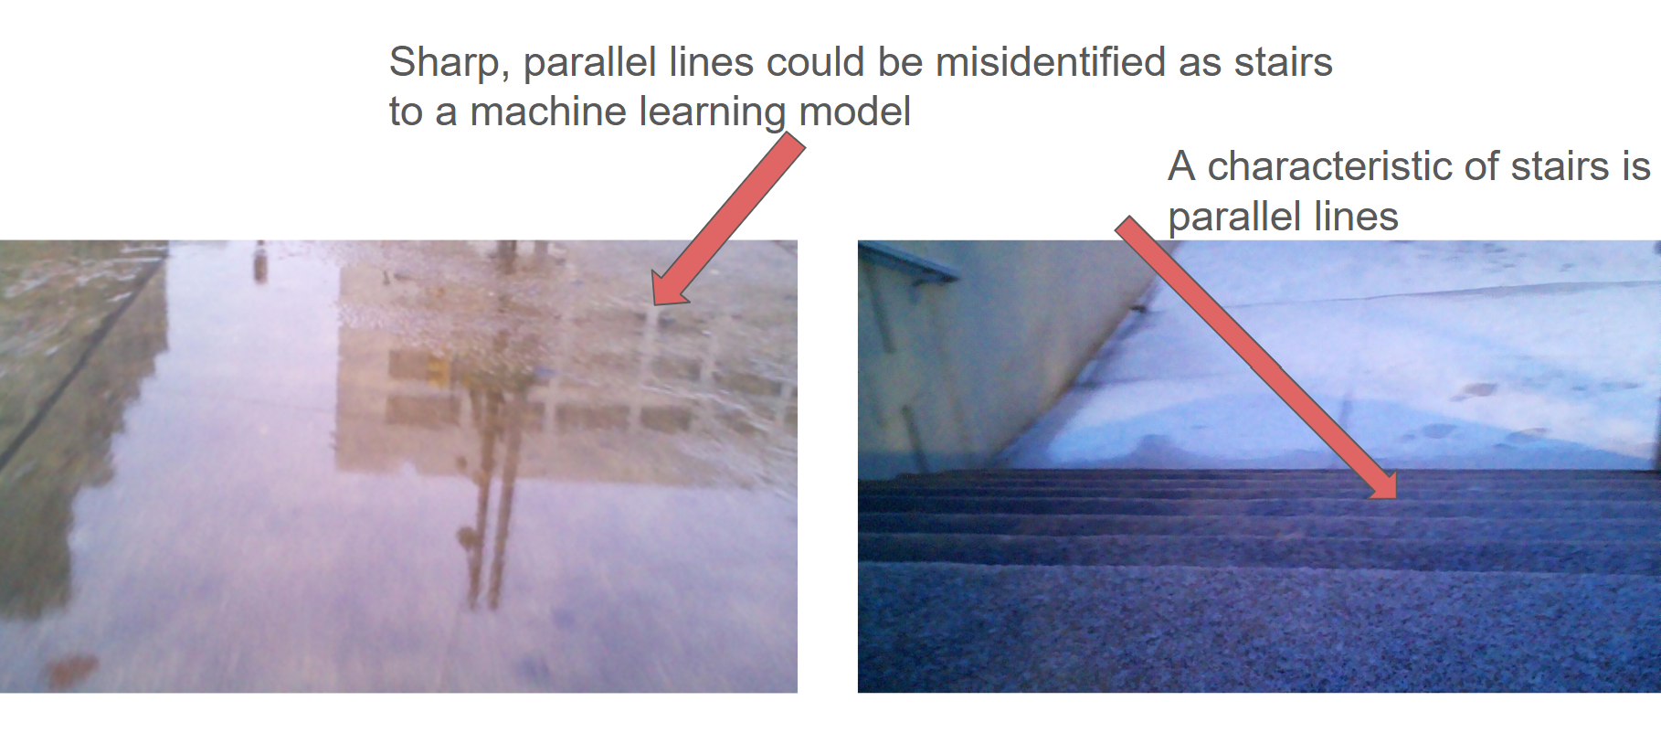
The false positive rate will likely be higher than 1% without an additional heuristic. If we require that, for example, 3 consecutive images must all be positive identifications in order to alert the user, then the experienced false positive rate would be reduced. So, the false positive rate for 3 consecutive images on average should be less than 1%.
This requirement is partially negotiable; a high false positive rate reduces user trust and can encourage them to stop utilizing the product. A greater than 1% false positive rate may still not be high enough to reduce user trust. Still, a low false positive rate is ideal for the convenience and trust of the user.

Design Constraints
Constraints | Metric | Target Value, Range, Pass/Fail | Result | P/F | Justification
Handle has comfortable diameter | Physical dimension (cm) | 2.5 cm | 2.5 cm | Pass | This size allows for a secure and comfortable grip without causing hand strain.
Handle has comfortable length | Physical dimension (cm) | 20 cm | 19.7 cm | Pass | The length gives enough space for a stable grip and proper control while walking.
Handle should contain wrist loop | Operation | Pass/Fail | Contains wrist loop | Pass | The wrist loop prevents accidental drops and improves user safety.
Cane is foldable into 4 segments | Operation | Pass/Fail | Folds into 4 segments | Pass | Folding into four sections makes the cane easy to store and carry when not in use.

Comfortable Handle Dimensions
As per the World Health Organization (WHO), a folding blind cane should include, “Plastic or rubber handgrip of length 20 cm and diameter 2.5 cm and wrist loop” ( [5] , p. 161). Additionally, the WHO states that the cane should have an elastic cord running through it to make it foldable. The WHO also states that the cane should have either 4 or 5 folds. We will abide by these standards to ensure that a user can easily transition from a standard blind cane to SafeStep.
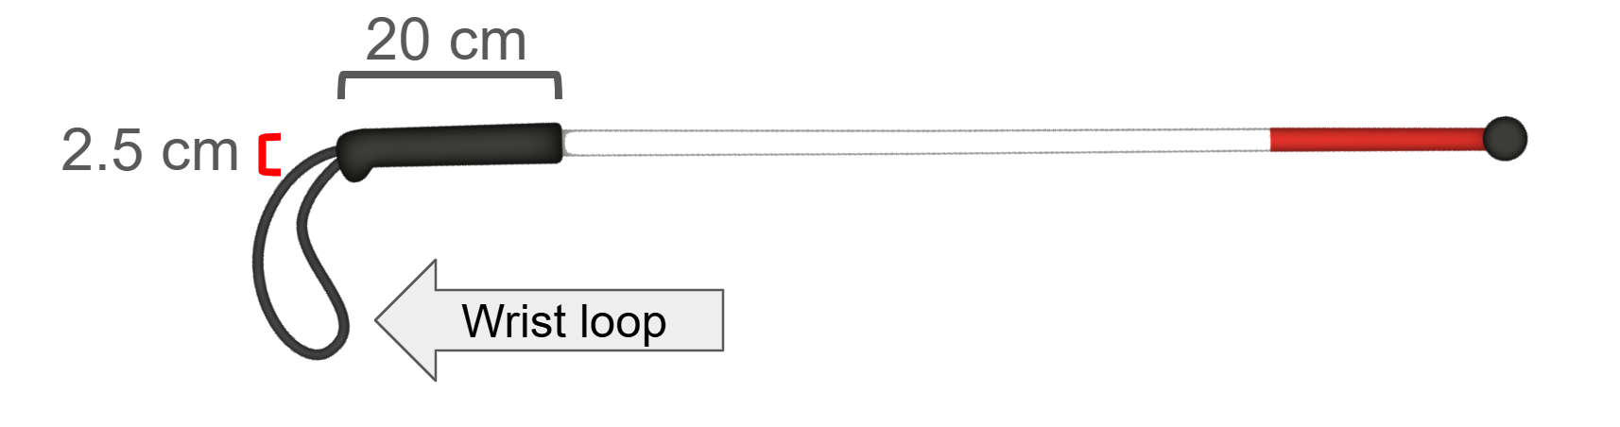
The handle diameter is negotiable within several millimeters. A comfortable diameter will depend on the user’s hand size and personal preferences. Therefore, a variation of several millimeters is acceptable as necessary to fulfill the design requirements or increase the comfort of the product.
The handle length is negotiable as this will depend on the user’s hand size and personal preferences.
The handle including a wrist loop is not negotiable as it improves the portability and safety of the device. This feature is also common among most handheld products and is a standard feature that is highly important to the overall product.
The cane foldability is not negotiable as the product would become too inconvenient to use if it could not be folded for storage. All blind canes on the market are foldable and users expect this feature. Therefore, the product must be foldable into several segments. The number of segments the cane folds into is negotiable as this is not of much importance to the user.

Citations

[1] | U.S. Access Board, "Accessibility Guidelines for Pedestrian Facilites in the Public Right-of-Way," [Online]. Available: https://www.law.cornell.edu/cfr/text/36/appendix-to_part_1190. [Accessed 16 Februrary 2026].
[2] | W. H. Brundle C, Ballinger, O. N. S. DA, S. P and T. C, "The causes of falls: views of older people with visual impairment," Health Expectations, vol. 18, no. 6, pp. 2021-31, December 2015.
[3] | U. M, "Reaction time," Harvard Medical School, [Online]. Available: https://bionumbers.hms.harvard.edu/bionumber.aspx?s=n&v=2&id=110799. [Accessed 5 Februrary 2026].
[4] | A. G. V. G. J. A. D. B. D. L. Jean-Marie Casillas, Assessment tools for personalizing training intensity during cardiac rehabilitation: Literature review and practical proposals, Elsevier Masson, 2015.
[5] | Assistive product specifications and how to use them, World Health Organization, 2021.
[6] | Y.-T. C. J.-H. W. S.-Y. W. F. Y. W.-H. I. S. M. T. T. Hsing-Wen Lin, "Machine Learning Based Real Bogus System for HSC-SSP Moving Object Detecting Pipeline," 2017.

