Main Mounting Plate
- Enable supports, on build plate only
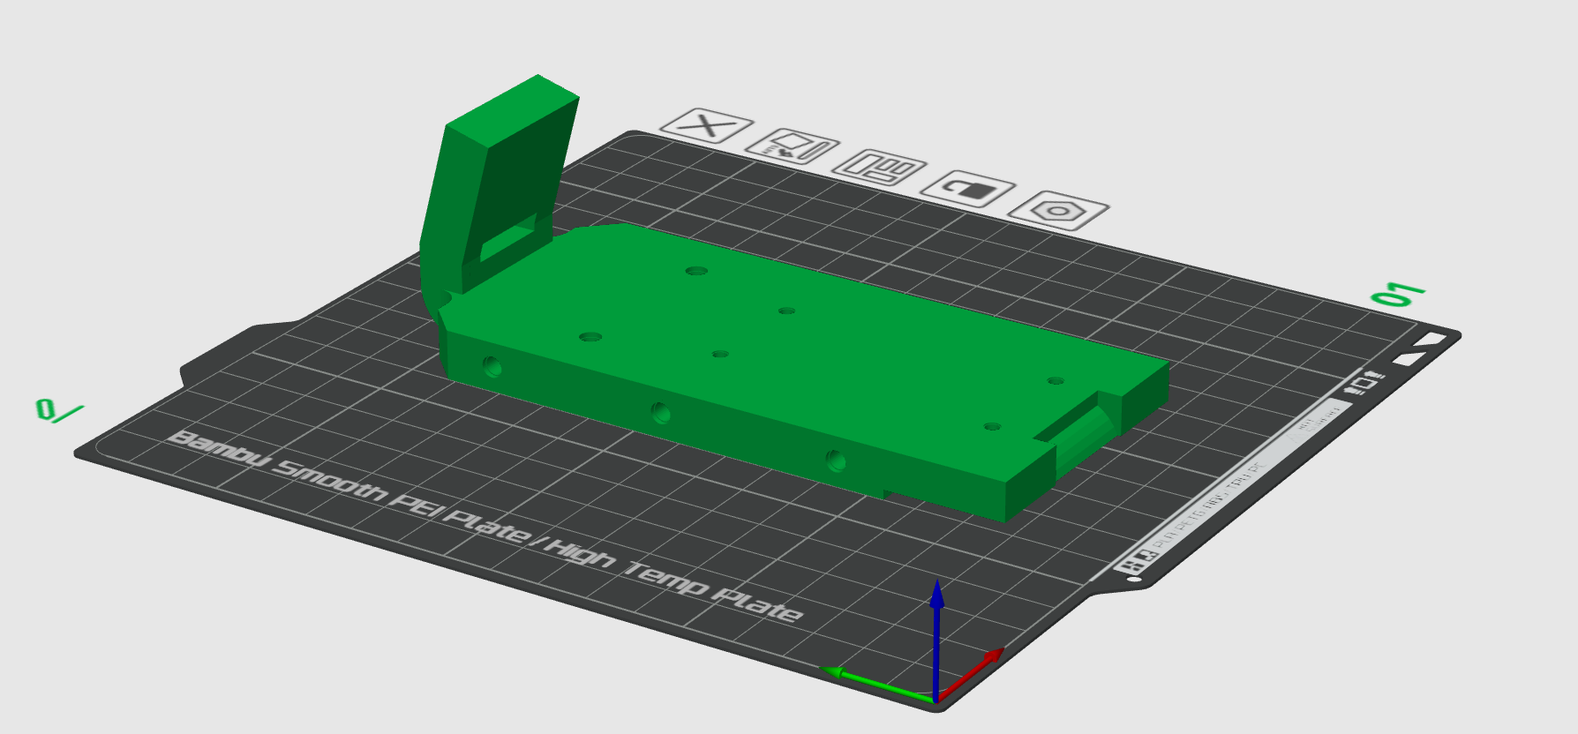
Primary Battery Mount:
- Print in upright position so that layer lines won’t separate on bolt through holes due to battery weight.
- Enable supports
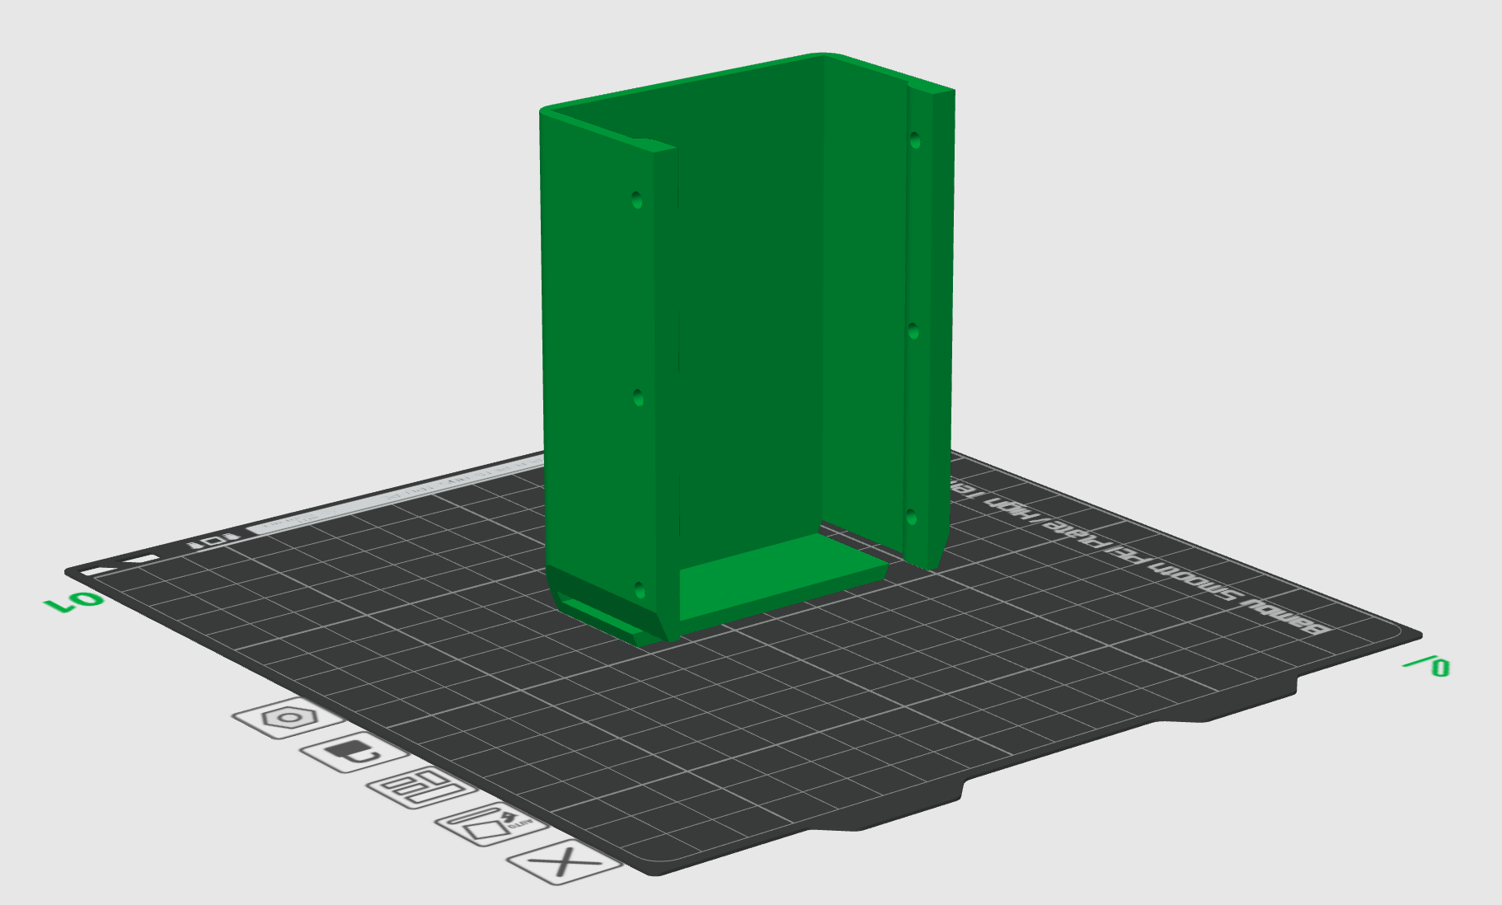

Top Shell
- Print rotated -60 degrees in the x direction
- Enable supports with these settings: type: tree (auto), style: tree strong. Top Interface Layers: 3. Top Interface Spacing: 0.08 mm. Support/object xy distance: 0.15. Branch Distance: 3mm. Branch Angle: 35 degrees/
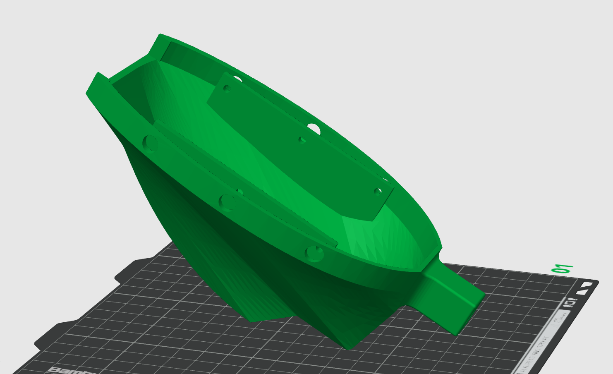
Bottom Shell
- No supports required
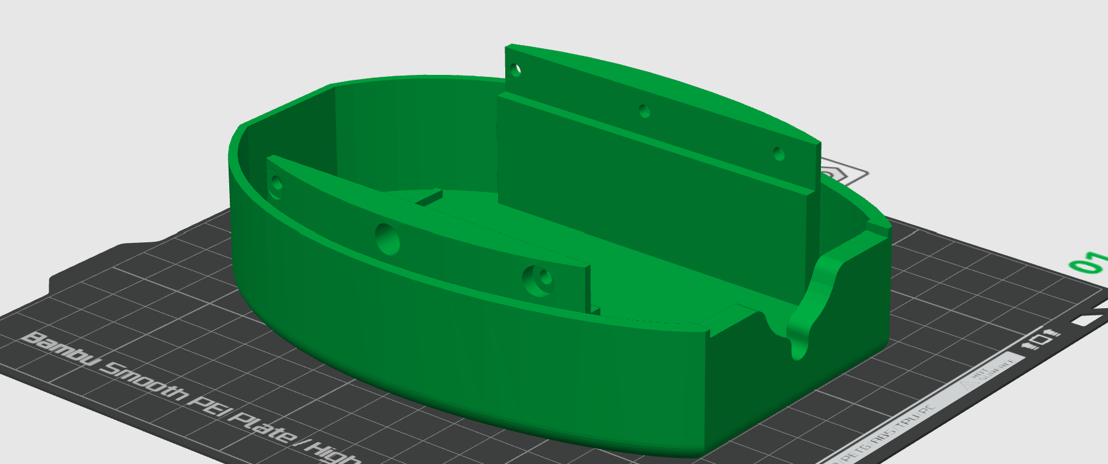

Handle Base
- Rotate 110 degrees in the x direction
- 100% infill (rectilinear)
- Enable supports, type:tree, style:Tree Strong, on build plate only checked (true), remove small overhangs unchecked (false)
- Top interface layers:3, Top interface spacing:0.08mm, Support/object xy distance: 0.15 mm, Branch Distance: 3mm, Branch Angle: 35
