SafeStep
Acronym: PATH: Portable Assistive Travel Helper
Team Members: Mohamad Charabi, Nathan Pervin, Kevin Bui
Deliverables:
A blind cane (also called a white cane) that assists the user with avoiding objects. The cane should provide advance notification of obstacles and should be able to detect obstacles that are above waist height without connection to the ground (see Use Cases section).
Inputs:
One ultrasonic sensor is ideal for object detection in front of the user due to its high reliability. This ultrasonic sensor has a 20 ft maximum range with beam patterns that would work well for this use case. A camera could be used to detect depressions in the ground such as the beginning of a set of stairs. The ultrasonic sensor would face forward in the direction of travel while the camera would face downwards, parallel to the cane similarly to how is shown below:
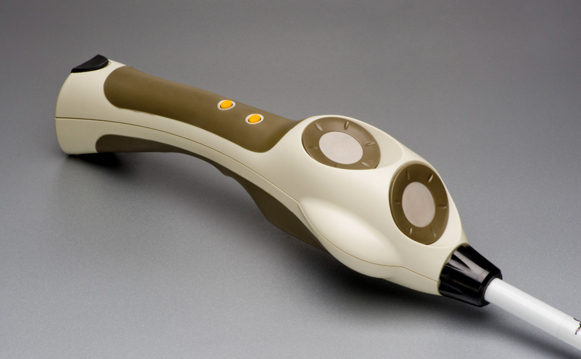
Outputs:
10mm vibration motors can be embedded within the handle to indicate the direction and distance of objects. An auditory signal would also be emitted to the user alerting them of obstacles.
Technology:
A Raspberry Pi Zero 2 W could be used due to its GPIO ports which can be used to interface with the ultrasonic sensor and vibration motors. The Pi Zero also has an inbuilt camera port (CS-2 camera connector). Testing will be required to determine if the Pi Zero has enough RAM and computational power to run a computer vision model. There exist other boards with the same footprint and functionality as the Pi Zero but with improved specifications so we could switch over to one of them without significant disruptions. We could also switch over to a full Raspberry Pi computer if needed.
Methodology
Ultrasonic sensor
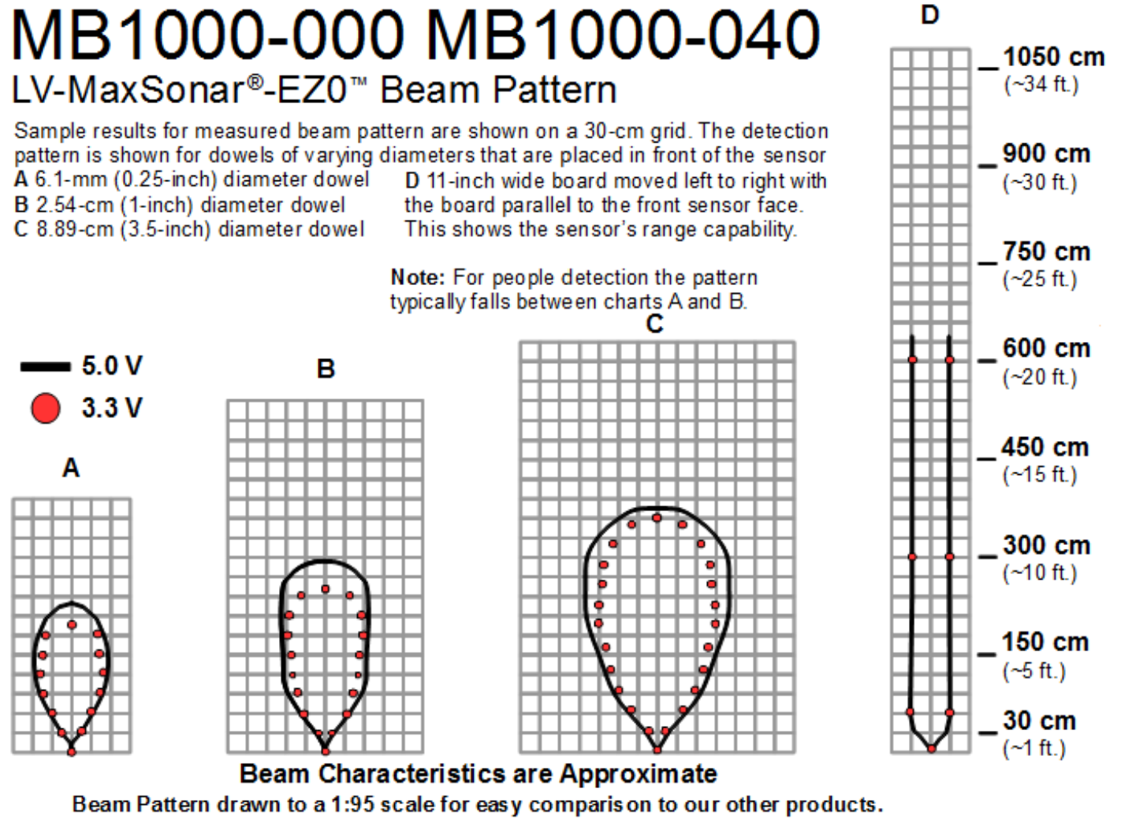
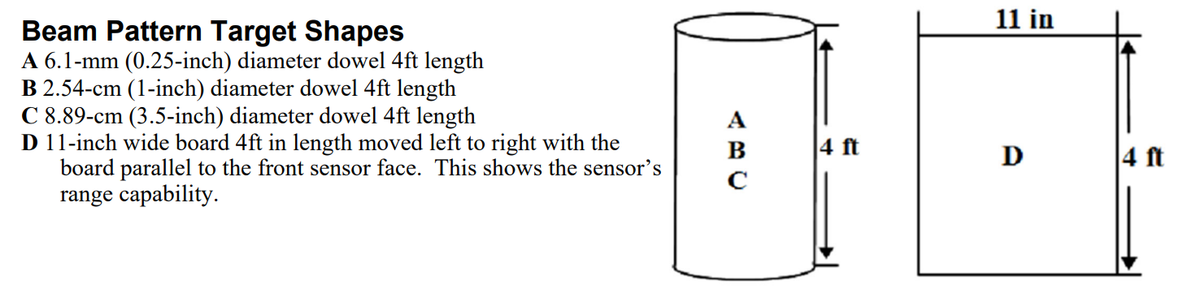
The beam patterns represent the zone that the sensor will reliably detect an object of a specific size. A blind cane typically extends 3-4 ft in front of the user and this ultrasonic sensor would sense about 6-10 ft in front of the user for people and up to 20 ft for larger objects such as walls and other large obstacles. We can use the sensor to find the distance from the user to the object and alert the user of the obstacle.

Camera
The camera would face in the direction 15 degrees above parallel to the cane, approximately a 45-degree angle with respect to the ground. The camera will be used to detect depressions in the ground that are potentially hazardous to the user but wouldn’t be detected by the ultrasonic sensor. The best example of this is a set of stairs or a curb. After preliminary research, a deep learning model is best for this task. A convolutional neural network (CNN) is optimal for this model due to the inputs being images and the geometric nature of stairs meaning that in theory, a CNN would be able to detect sharp, parallel edges, and therefore detect stairs.
Due to the existence of the TensorFlow Python library, the primary focus will be on obtaining the training data rather than programming the CNN from scratch. The model should have three outputs, one for no obstacles detected, one for stairs detected, and one for curb detected, additional obstacles will be added when found during data aquisition.
To collect this data we should build a basic version of the device that has the camera in the same location as would be used in the final version. We can then take a diverse set of images and label them according to the three output categories. The exact number of convolutional layers, pooling layers (if necessary), fully connected layers, activation functions, etc. will be decided when the model is being trained.

Example Use Cases
The E & E Gourmet Express food truck on Montgomery Ave. This food truck has overhangs that block the path of travel but have no connection to the ground. Therefore, a blind cane alone may not detect this obstacle, but an ultrasonic sensor will detect it.
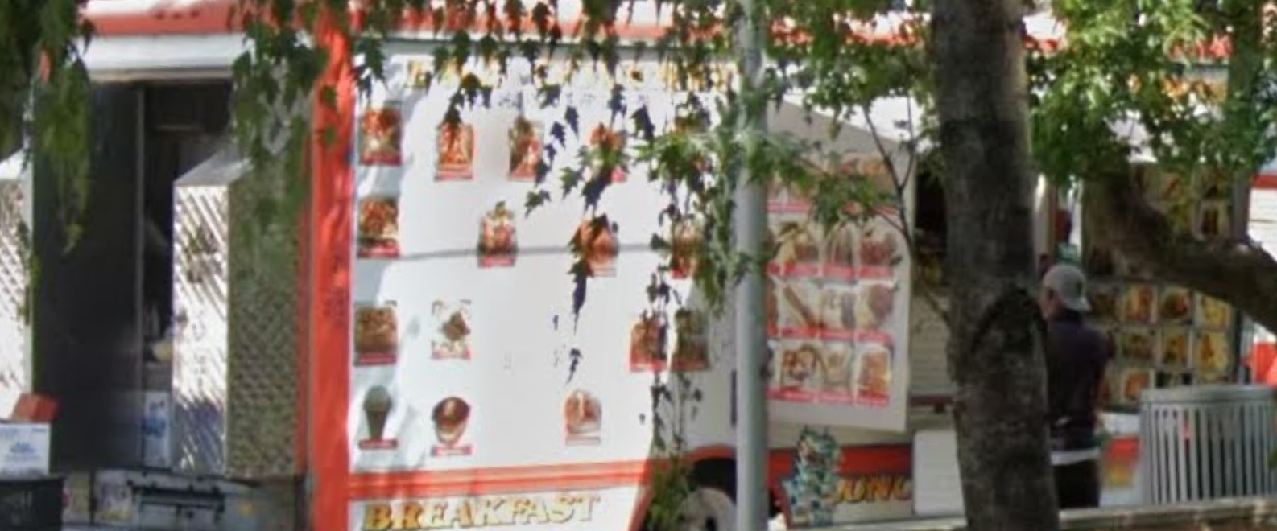

Tree branches overhang onto the sidewalk.
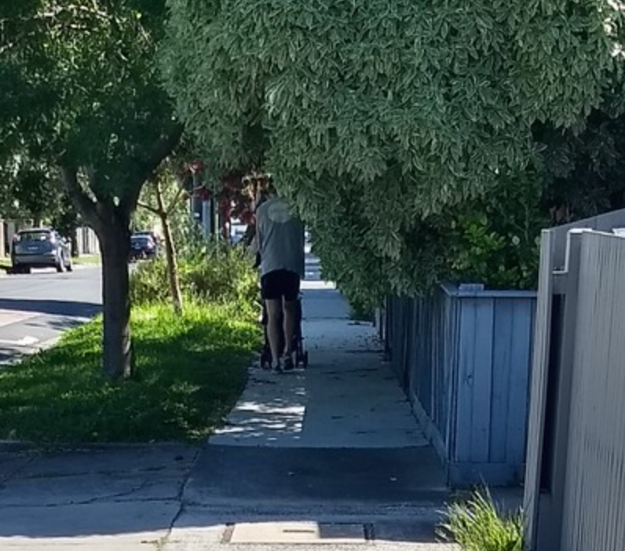

Potential Project Addons
Accelerometer that detects a fall, if a button on the handle isn’t pressed within 10 seconds, emergency services are contacted. This could be done with a Bluetooth connection to a mobile phone which sends out an SMS message.
If SMS feature is put in place then it would be trivial to include a button that would contact emergency services as a silent alarm.

Deliverable Design Specifications
The blind cane handle segment or part of the segment will be replaced entirely with a 3D printed enclosure. This enclosure will house the components and serve as a handle with grip. The enclosure will be printed in parts due to the complex shapes and overhangs. The individual parts will be fixed together using heat-set inserts and bolts.
Any user-interfacing parts such as an on/off switch should have braille to indicate the function and position of the switch.

Battery
A removable battery such as an 18650 battery and boost converter can be used to power the Pi Zero. The battery should be placed in the grip part of the handle. We can use tabs on the base of the handle to open a cover that allows the user to remove the battery and replace it with a new one. There should also be a power delivery port (there exists cheap USB-C BMS breakout boards that would work well for this case). The user should be able to charge the handle and also replace the batteries.

Development Specifications For Camera Mount:
This is for the camera mount that will be used to collect the training images. The end product will be developed concurrently with data collection. So long as the final product has a similar camera location and angle
Blind Cane: link
Handle Grib Length: 17.1 cm = 6.732283 in
Handle Grib Diameter: 2.2 cm = 0.866142 in
Drilled hole diameter: 5 mm $≈$ 0.2 in
M2 Bolt No Taps Passthrough Diameter: 2.3 mm = 0.0905512 in
M2 Bolt Head Depth: 2mm = 0.0787402 in, give 0.08 in
M2 Bold Head Diameter: 3.9 mm = 0.153543 in, give 4.5 mm = 0.177165 in for clearance
Arducam for Raspberry Pi Zero
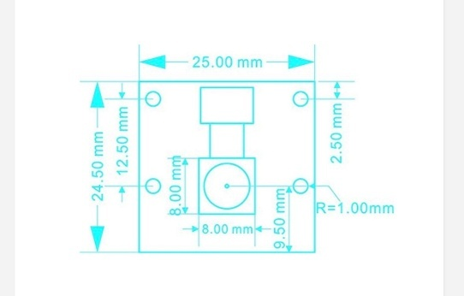
Heat-Set Inserts:
General Suggestions:
Use a Knife Tip for the soldering iron, it works better than a conical tip and adapter
For M2 heat-set inserts use a 2.8 mm = 0.11 in diameter
M2 heat-set inserts depth is 2mm, give 2.2 mm = 0.0866142 in
For the surface to 0.25 mm $≈$ .01 in ,use a diameter of 3.2 mm $≈$ 0.126 in (so that the heat set insert is easier to insert level)
M3x5 heat-set inserts use a 3.8 mm, use 3.9 for bottom to fit = 0.153543 in
For the surface to 1 mm $≈$ .04 in ,use a diameter of 4.3mm $≈$ 0.17 in (so that the heat set insert is easier to insert level)
M3x5 heat-set inserts depth is 5mm, give 5.2mm = 0.204724 in

Camera Mounting Plate uses M2x12 Bolts
Camera Mount is tilted 15 degrees off of parallel with the cane’s length

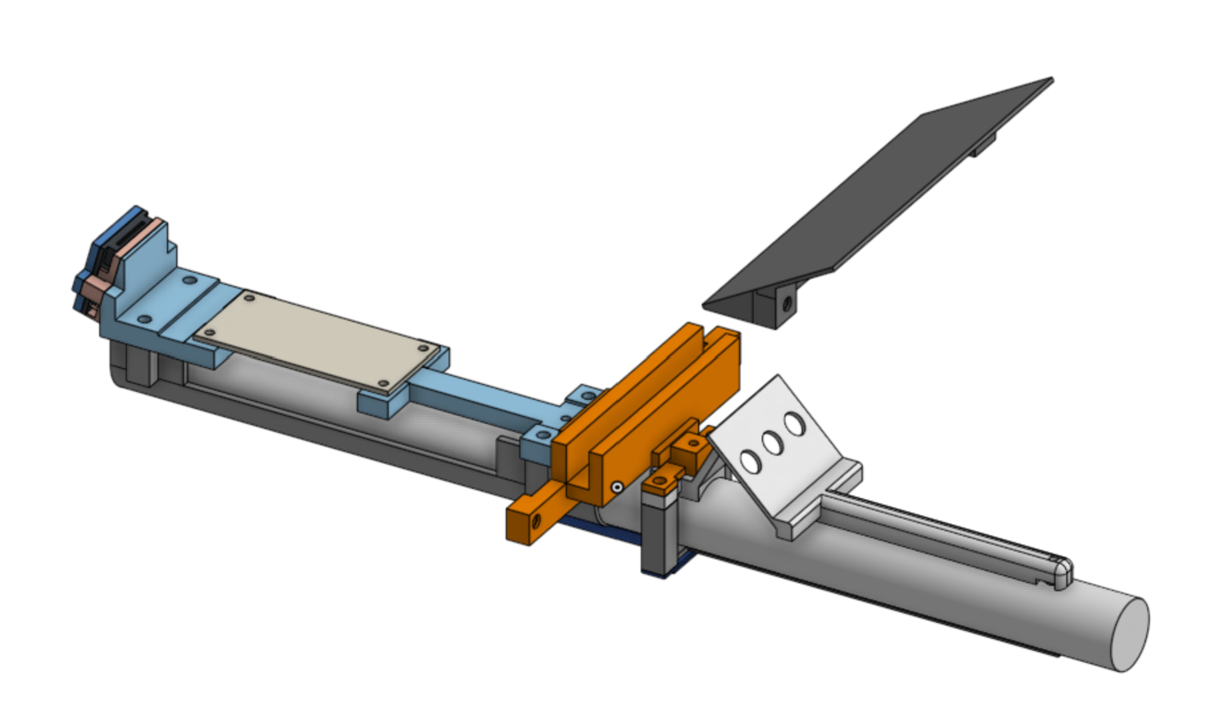
Print the button mounting plate in this orientation with supports (threshold angle $30°$):
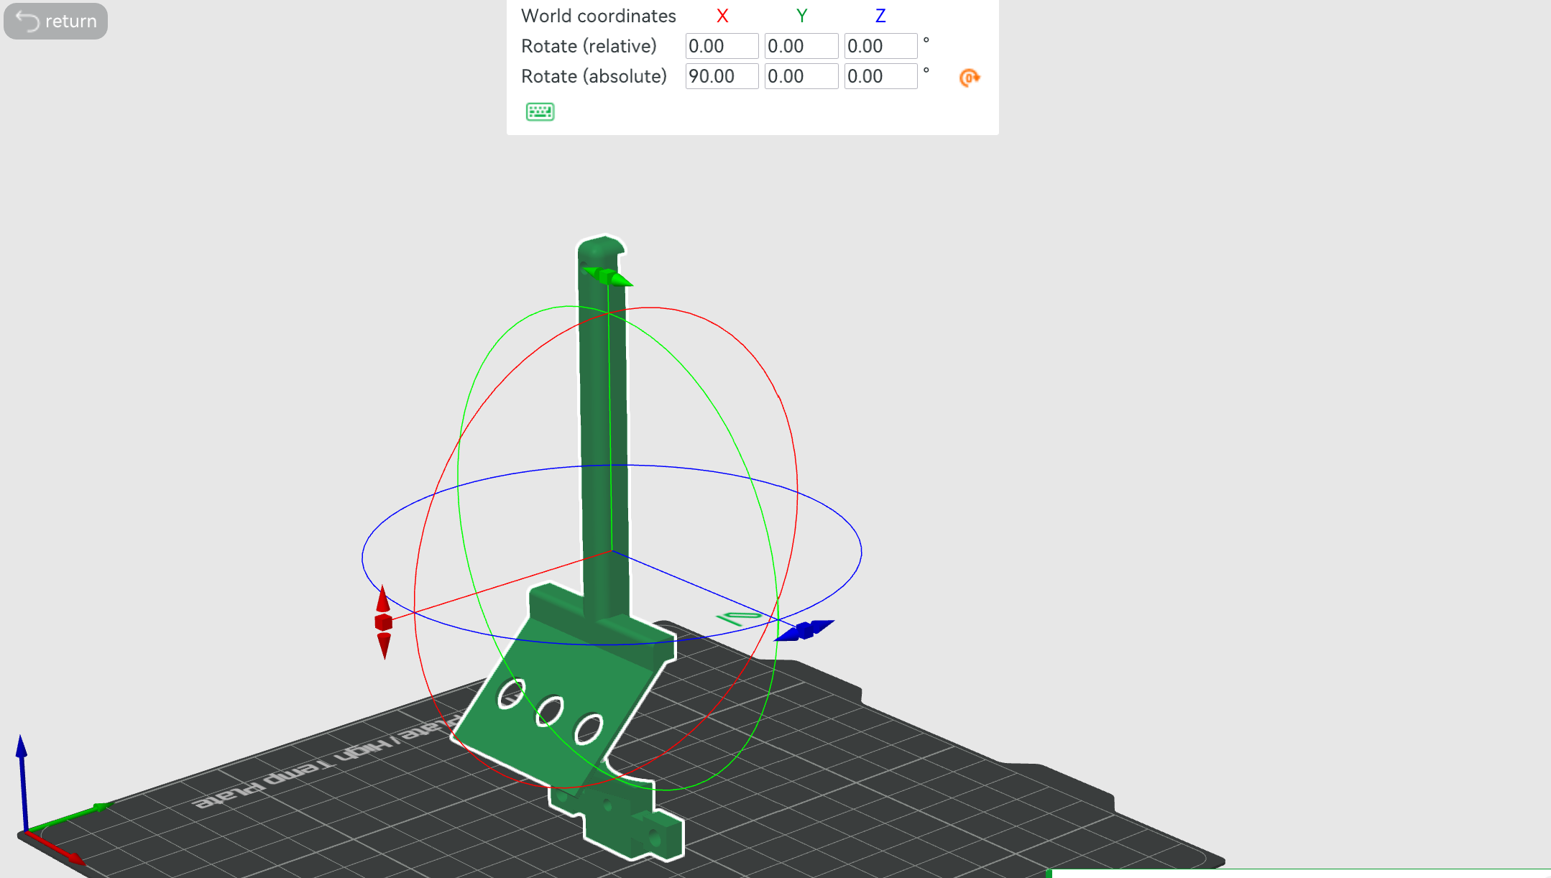
3D Print Slicer Setting:
Wall Loops: 5

Is it likely that the camera mount will be just the handle without the full cane to avoid biasing the model to the data collector’s height and handle. A freehanded handle held at approximately the correct angle and height will provide more variation.

Raspberry Pi Zero 2 W configuration:
Pi OS 64-bit
Hostname: natep

How to Use the Camera Rig:
Step 1) Plug the microusb cable into the Pi Zero and plug the other end into the battery
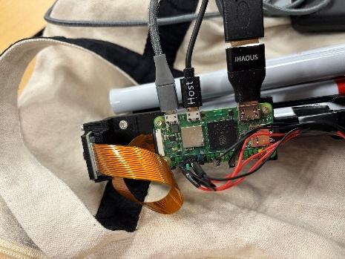
Step 2) Press the button on the battery (wait for it to boot up)
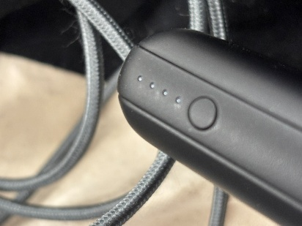
Step 3) Press the terminal button on the screen
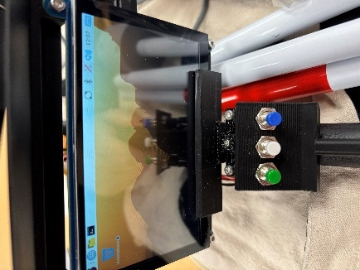
Step 4) Press the up arrow on the keyboard
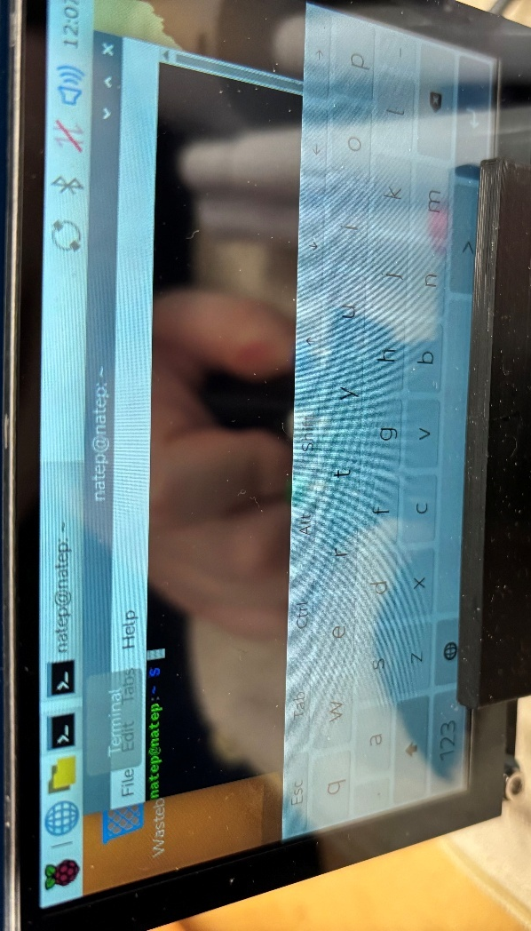
Step 5) You should see “python scripts/data_collection.py”, if not then type this in. Then, press the enter button in the bottom right corner.
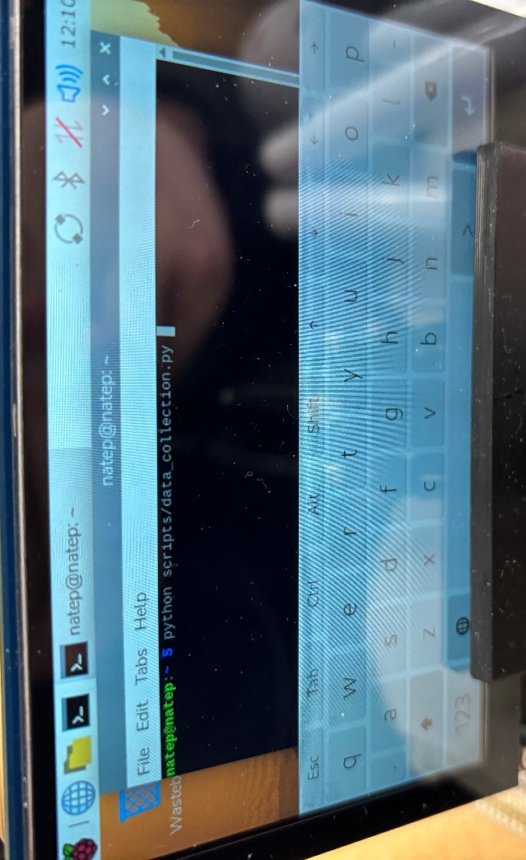

Step 6) Press the up arrow to expand the window
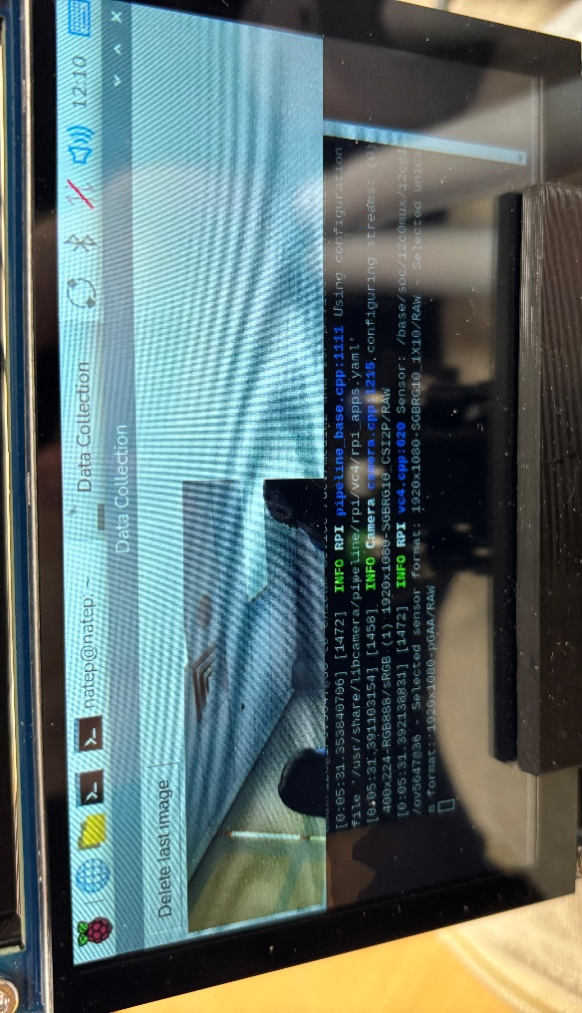
Step 7) Press the buttons to take the pictures you want. The left side of the screen shows the live feed and the right right shows the last taken picture. Press the “Delete last image” button if the picture is not what you intended.
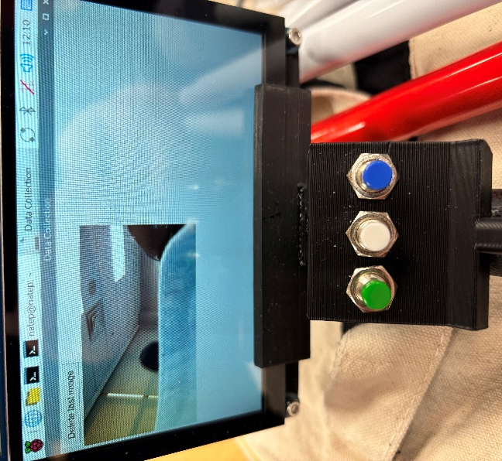

Green button = Curbs (up and down)
White button = normal (sidewalk)
Blue button = stairs (up and down)

Before collecting data:
Ensure that the time is correct, if it is not, then connect it to a wifi network (mobile hotspot is easiest), then it should get the correct time.
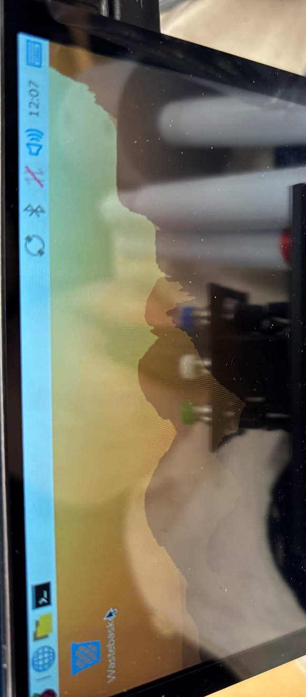

Data Collection:
Try to take a roughly equal number of each image, this doesn’t need to be perfect since we can equalize it later but avoid taking 20 pictures of sidewalks for every 1 picture of curbs/stairs for example. Try to take photos of unique places, avoid taking a bunch of photos of the exact same thing from the same angle, etc. The images should be from different angles, lighting conditions, handle rotations (slight). You can take multiple images in the same area as long as there is a reasonable difference between the images (like background objects, angles, ground slopes, etc.). Take images as they would occur in normal use. Take images at a natural walking position with the blind cane outstretched in front. Take images when the camera should be detecting the obstacle and beyond that point.
For curbs and stairs take images both up and down.
Example Photos:
normal |  | 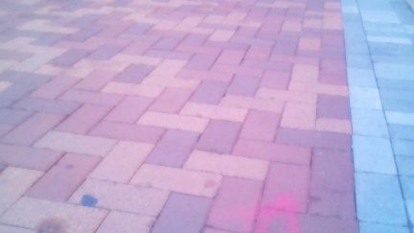 | 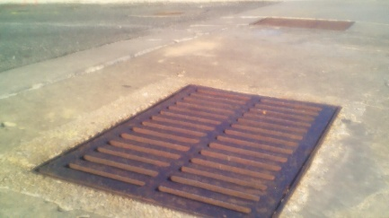
stairs |  | 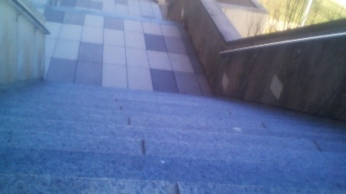 | 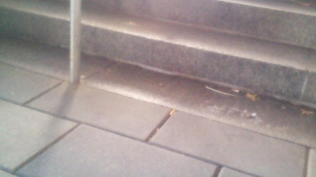
curbs |  | 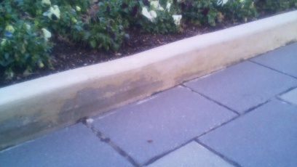 | 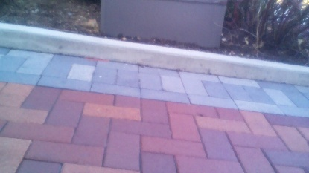

Standards:
World health organization: Assistive product specifications and how to use them (pg.161)
https://iris.who.int/server/api/core/bitstreams/95acb442-ca31-46f0-b1ce-661a92a3c0d1/content
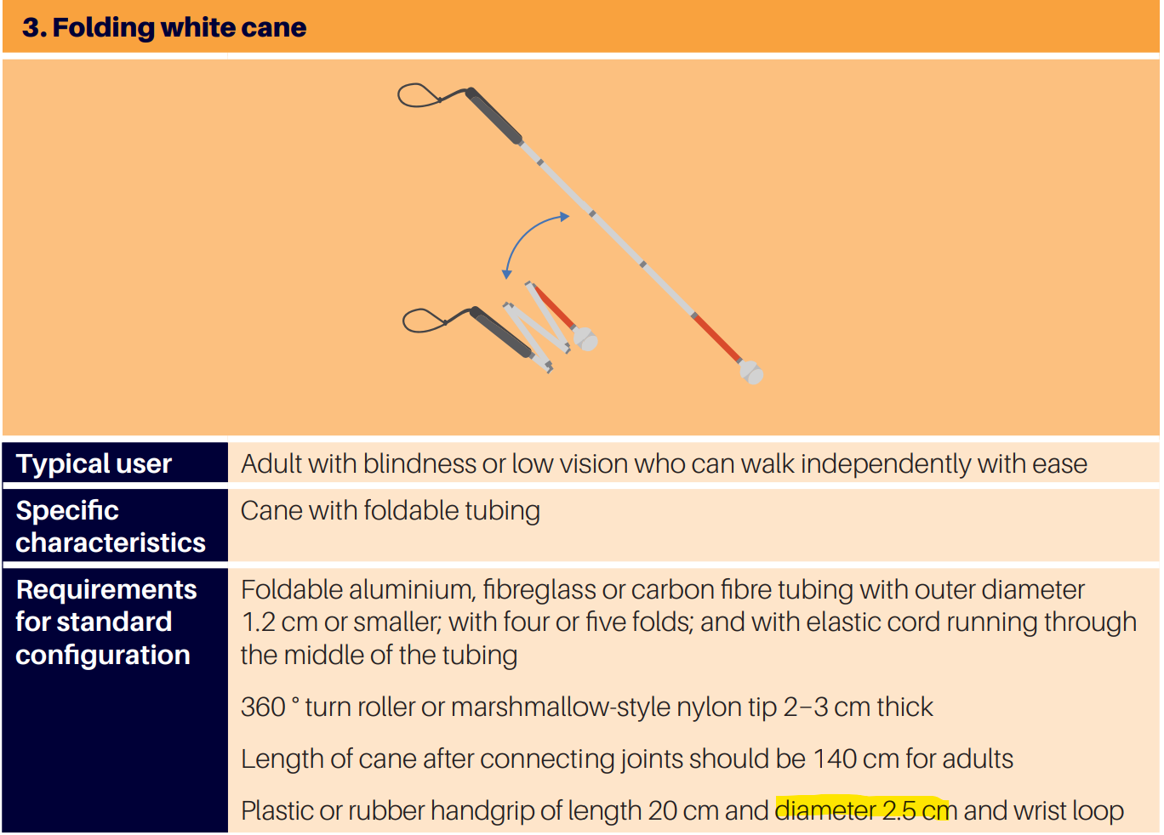
The world health organization describes a blind cane as having a handle diameter of 2.5 cm. So, this is the diameter we will design the handle with. The length of the handle should be 20 cm as well.
Raspberry pi AI camera dimensions
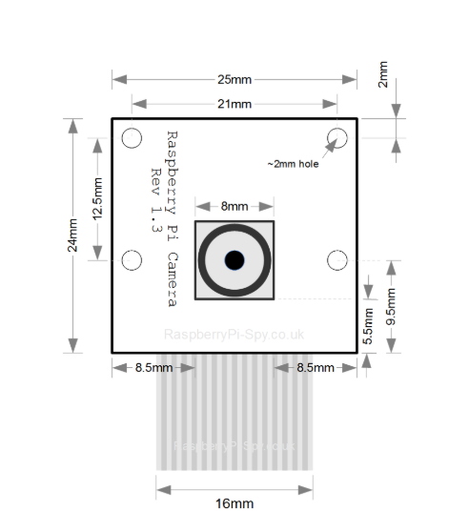

Directory naming conventions:
https://tree.nathanfriend.com/?s=(%27optNs!(%27fancyK~fullPath!fVse~trailingSlashK~ZqDqK)~O(%27O%27tu_safestepIv1.0.0I-MMDDYY_name_locatN5stairX9Q3J6F*3CBJ6U9Q3J6F*3CbuildingsCBJ65curbX9Q376F*37CB6U9Q376F*37CB65normVLeasy*4HAH8HGHE2LR*4HAH8HGHE2LhW*cZssingsH4CpartiVCfullCfoqsteps*sidehazWCcurbsCG*ACweakCmodxateCstZng*BHrampsH8HEHG2I%27)~vxsN!%271%27)*L--%20%202CE3-AC84sediment5I--62CG7CvxticVTs8gZundT9easyHRAreflectNsBlowlightC*-EdefaultF*hWC4GqhxH2*I%5Cn-JCwVlK!trueL5-NionOsource!QC4*RmediumTobjectULdown*ValWardXsLup*Zroqotxer%01xqZXWVUTRQONLKJIHGFECBA98765432-*
The following directory structure ensures that all files have the same directory depth and are specific enough to have less than 100 images. This is subject to change as we collect more data and determine that there are new categories of images we need to sort. There is also some spacers called “default” to ensure a constant directory depth but don’t add any additional specificity.
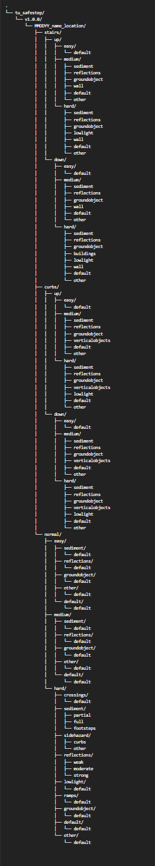

OLD directory structure link | https://tree.nathanfriend.com/?s=(%27opt6s!(%27fancy4~fullPath!false~trailingSlash4~rootDot4)~7(%277%27tu_safestep3v1.0.03*MMDDYY_name_locat68stairC2A28curbC2A28normal-E-9-hB5crossings5sediment5sidehazB5reflect6s5lowlight5ramps5other3%27)~vers6!%271%27)*%20%20-8*2*E595hB3%5Cn*4!true5-*6ion7source!83**9mediumA-down-BardCs-up-Eeasy%01ECBA98765432-*

reflections created during 1-18-26 data sorting, check previous data for sorting required

Username: natep
Command: ssh natep@[IP ADDRESS]
Ssh password: tusafe

New setup:
tusafe123

```bash
sudo apt install -y python3-picamera2 python3-flask
```

```bash
sudo nano /etc/systemd/system/webcam.service
```
Paste:
```txt
[Unit]
Description=Raspberry Pi Camera Flask Server
After=network.target
[Service]
ExecStart=/usr/bin/python3 /home/natep/web.py
WorkingDirectory=/home/natep
StandardOutput=inherit
StandardError=inherit
Restart=always
User=natep
[Install]
WantedBy=multi-user.target
```

```bash
sudo systemctl daemon-reload
sudo systemctl enable webcam.service
sudo systemctl start webcam.service
```

```bash
sudo nmcli connection modify SafeStep connection.autoconnect yes
```
```bash
sudo nano /etc/systemd/system/hotspot.service
```
Paste:
```txt
[Unit]
Description=Bring up Wi-Fi Hotspot
After=network.target

[Service]
Type=oneshot
ExecStart=/usr/bin/nmcli connection up SafeStep
RemainAfterExit=yes

[Install]
WantedBy=multi-user.target
```

```bash
sudo systemctl daemon-reload
sudo systemctl enable hotspot.service
sudo systemctl start hotspot.service
```

```bash
sudo systemctl enable webcam.service
```

```bash
sudo reboot
```

Wifi: SafeStep
Password; tusafe123
Connect to:
http://10.42.0.1:5000

ssh-keygen -R 10.42.0.1
ssh natep@10.42.0.1
password: tusafe

A shunt motor operating at 1200 rev/min has an armature current of 38 A from a 240 V source
when providing 8398 W of mechanical power. If the armature winding resistance is 0.2 Ω,
determine the following:
(a) The loss torque of the motor at the given speed
(b) The required armature current to provide half the mechanical (shaft) power at the same
speed

Consider the shunt motor in Example 8.4 and determine the following:
(a) The developed torque if the load current is 125 A
(b) The developed torque if a 25% increase in full-load current results in a 12% increase in the
¥ux due to the demagnetizing effect of the armature reaction

