Temple University     
College of Engineering     
Department of Mechanical Engineering

  ENGR 4296: Capstone Senior Design

Professor Heravi

Egg Cracker Reverse Engineering

Group 9

Hollie Wolfenden, Sheryl Korah, Britney Lourng, Misa Won

Date: September 21, 2025

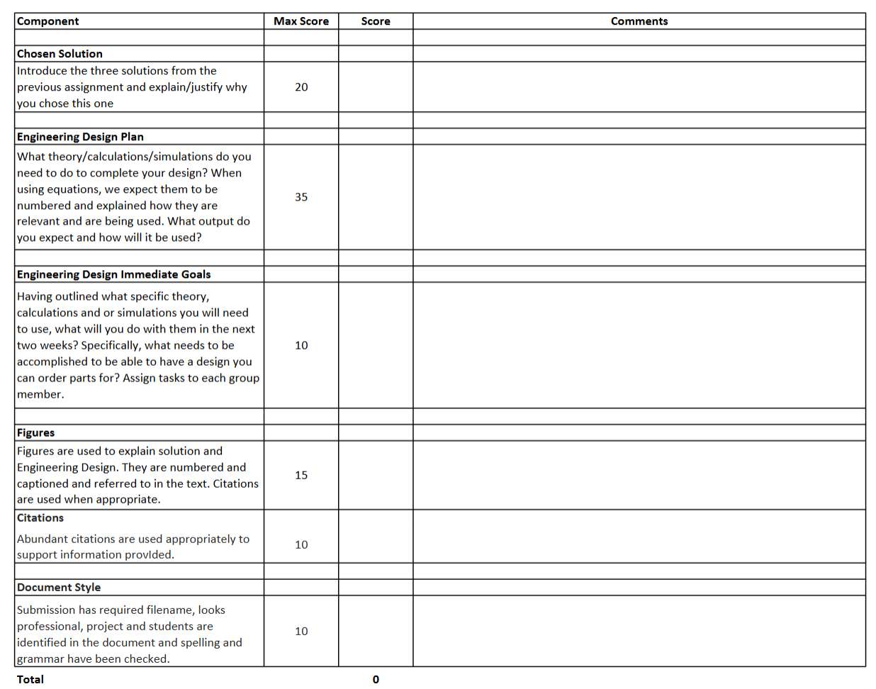

## Chosen Solution

The first solution was recreating the original patent design based solely on the information provided in the patent. The second solution was to reverse engineer the manufacturer’s design which varied from the patent. The third solution was to create a new design based on the previous iteration but with changes believed to be necessary.

The best course of action is to combine solutions two and three. This will base the design off the exact product received but consider changes to improve efficiency. A prototype will be created based solely on the reverse engineering of the device then it will be tested to determine weaknesses.

This solution is the best option for a number of reasons. The original patent doesn’t have enough details or figures to completely reverse engineer a working product from it. The current device is very bulky and seems to be overengineered but functions properly. New changes are necessary, but a complete redesign is not. To make the best use of time, the working device should be used for the majority of the design with only small changes to ensure functionality.

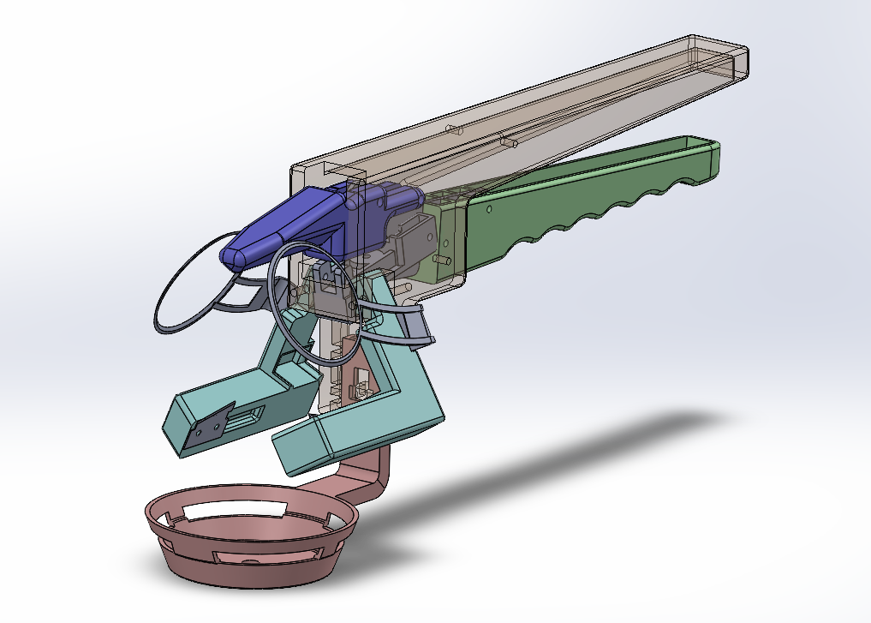

*Figure 1: SolidWorks Assembly of all replicated product parts*

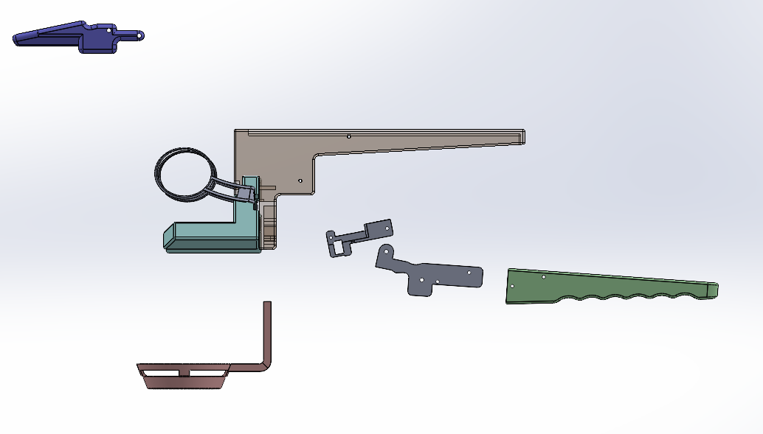

*Figure 2: Exploded view of parts in Assembly*

## Engineering Design Plan

Different forces must be considered when examining the effectiveness of the design. The forces and distance values are represented in Figure 1. The force to press up on the handle ($$F_{in}$$) will be considered in calculations to determine the other unknowns. The spring constants for the compression spring ( $$k_{c}$$) and the extension spring ( $$k_{e}$$) are known as well as the distance the compression spring ($$x_{c}$$) and extension spring ( $$x_{e}$$) can stretch. Hooke’s Law can then be used to find the forces of the compression spring ( $$F_{c}$$) and extension spring ($$F_{e}$$) (Giuliodori 2009).

$$F=kx$$

#### *Equation 1: Hooke’s Law*

Using the moment equation at the fulcrum, the force applied to the egg ($$F_{out}$$) from the bottom handle will be calculated. Using this force, the force of the egg on the center piece ($$F_{center}$$) can be calculated. Figure 2 shows the force diagram as the egg separates. $$F_{center}$$ can be calculated by using the angle ($$θ$$) between the x-axis and the $$F_{out}$$, as well as the distance between the fulcrum and endpoint (s) as well as the distance between the fulcrum and spring (y). Now, the separating force ($$F_{sep}$$) can be first found by dividing $$F_{center}$$ by two and taking the angle into account when it cracks.

$$M=Fd$$

#### *Equation 2: Moment Equation*

With this separating force, a simulation can be made and the effectiveness can be determined. If the force is not effective, the design can be evaluated, and the force can be reevaluated based on the new design. The final separating force and initial force will be used in the final report to assess the success or failure of the final design.

## Engineering Design Immediate Goals

The immediate goal is to develop a working prototype through the combination of SolidWorks and 3D printing. This is the priority currently because changes cannot be explored until the initial prototype is printed. Misa and Britney are currently focused on developing individual CAD models and all group members will meet to create the complete assembly.

Throughout this process, simulations will be run in SolidWorks such as stress analysis and finite element analysis. This will demonstrate possible weaknesses and areas of high stress to consider. Also, this will assist in developing the design equations to understand the motion and forces of the device. This will be completed once the prototype SolidWorks assembly is finalized and all members will contribute heavily.

Furthermore, the spring constants and forces need to be found. This is included in the next steps as it is vital in choosing which spring to utilize. Both the original patent and received device had different sized springs so they must be tested to determine which is more efficient. To understand the spring functions, a force diagram will be created. This step will be completed quickly as it will assist with the other goals. Sheryl and Hollie are focused on creating the necessary figures and finding the design equations to represent the movement of the device. Once all the simulations and equations have been sorted out, printing parts, ordering necessary parts, and testing can occur.

## Figures

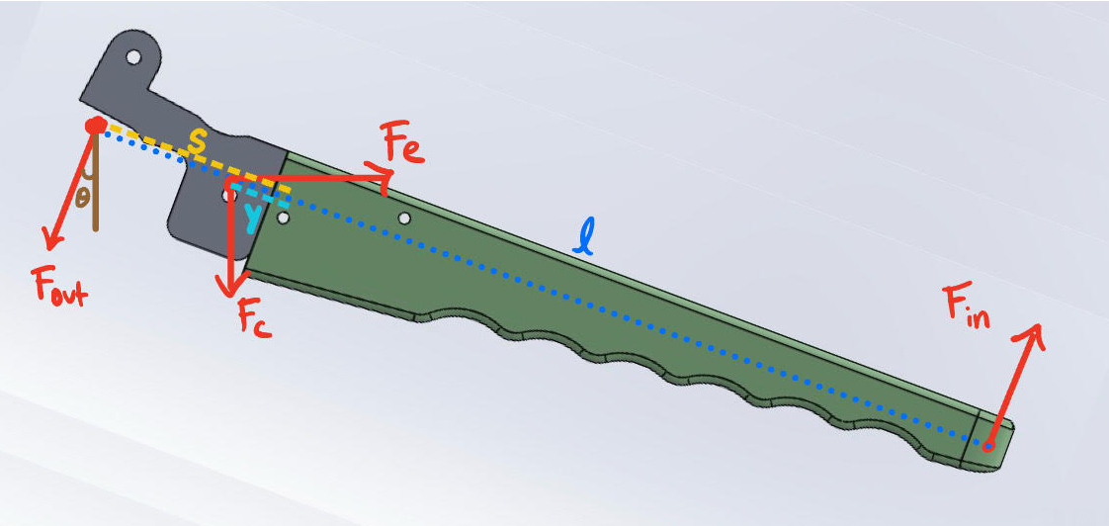

#### *Figure 1: Force Diagram for Bottom Handle*

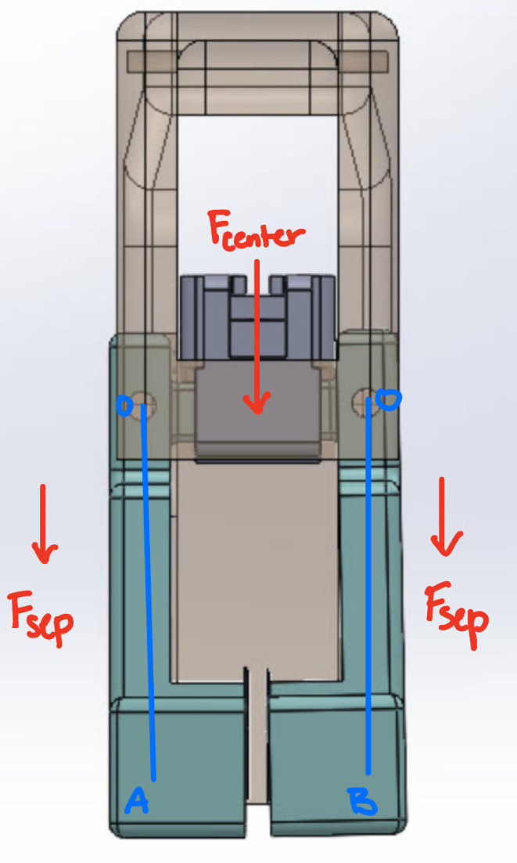

#### *Figure 2: Force Diagram for Egg Separator*

## Citations

Giuliodori, M.J., Lujan, H.L., Briggs, W.M., Palani, A., DiCarlo, S.E. (2009) ‘Hooke’s law: applications of a recurring principle’, Advances in Physiology Education, 33(1), pp. 8‑14. <https://doi.org/10.1152/advan.00045.2009>