Temple University     
College of Engineering     
Department of Mechanical Engineering

  ENGR 4296: Capstone Senior Design

Professor Heravi

Egg Cracker Reverse Engineering

Group 9

Hollie Wolfenden, Sheryl Korah, Britney Lourng, Misa Won

Date: September 14, 2025

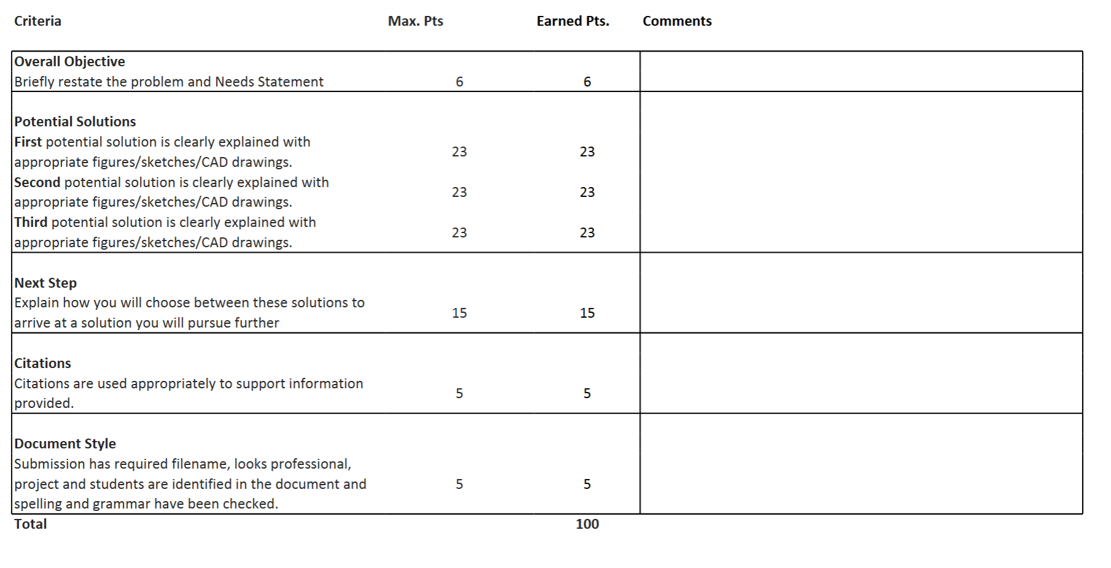

## Objective

Cracking an egg can be difficult for individuals with disabilities such as hand coordination issues and weak muscles. Fine motor disabilities can be seen as a symptom of neurological conditions ranging from adults recovering from a stroke or brain injury to developing diseases including rheumatoid arthritis and dyspraxia (Burr and Choudhury, 2022).

The goal of this project is to reverse engineer a handheld egg cracker. This egg cracker has a smooth movement requiring only the use of the thumb and index finger making it accessible for many people.

An analysis of the device will be developed to create a prototype. Throughout this process, design equations will be created with respect to the motion and force of the egg cracker. The working 3D printed prototype will be based on a SolidWorks simulation. Lastly, a cost analysis will be performed to ensure that the product is affordable to the manufacturer as well as consumers. The deliverables include design equations, a functional simulation, a working final prototype, and a cost analysis.

## Potential Solutions

To complete this objective, three different solutions will be considered. These include following the original patent design, reverse engineering the exact product received, or making changes to improve upon both designs.

### Solution One: Original Patent Design

The first solution is to follow the original patent design 7,363,853 B2. This design seems to be simpler than the current product with only one spring inside the device and one torsion spring on the handle as shown in Figure 1. Further research needs to be done to determine why the manufacturer strayed from this design and now incorporates two helical springs.

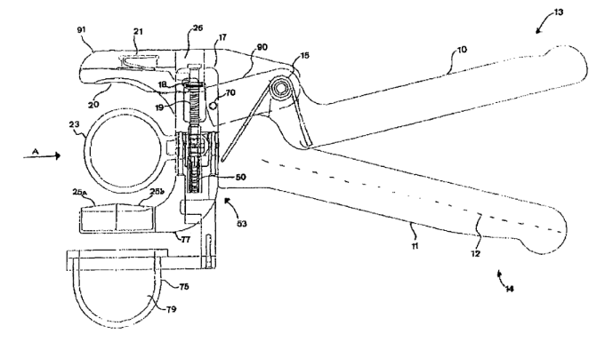

#### Figure 1: Design Shown on Patent

To complete this, all information would be gained from the patent application. If there are any unknowns, they would be determined from the current device as there is no other way to obtain the information. The design will be mainly based off of the patent design and any unknowns will be based off of the manufacturer’s design. When testing the original design, we can test the functionality of the device and see how they measure up with the goals of the project. This solution has the potential to have less parts, making it more cost-effective and more sustainable.

### Solution Two: Exact Reverse Engineer

The next solution to be considered is to reverse engineering the device received from the manufacturer. As previously stated, the egg cracker received is not the same as on the patent. This egg cracker has already been disassembled and measured to determine the dimensions as shown in Figure 2.

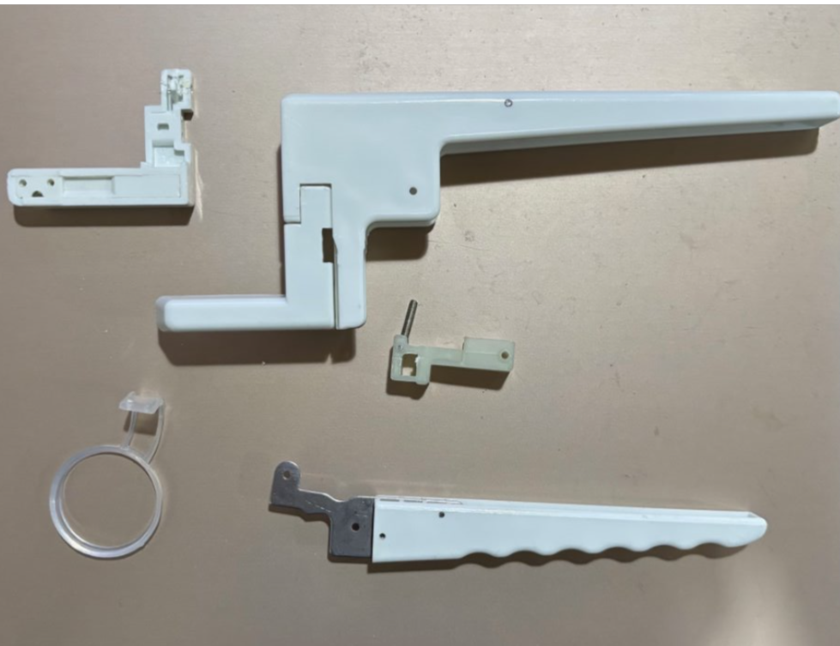

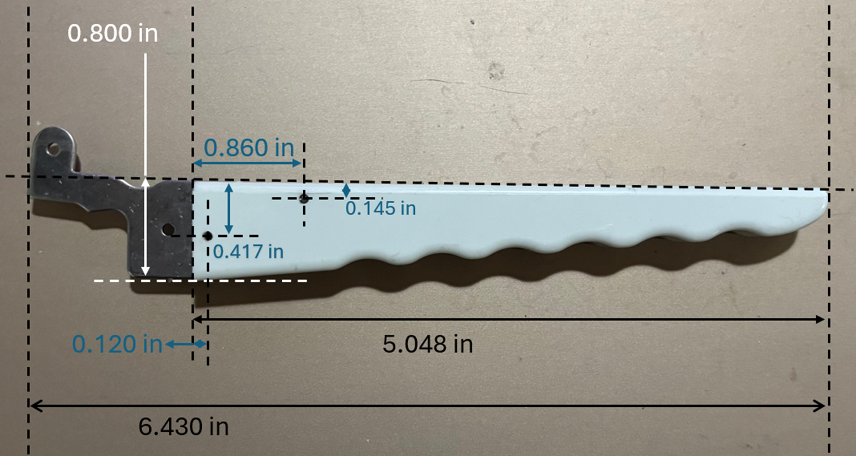

#### Figure 2: Disassembled Device and Measurements example

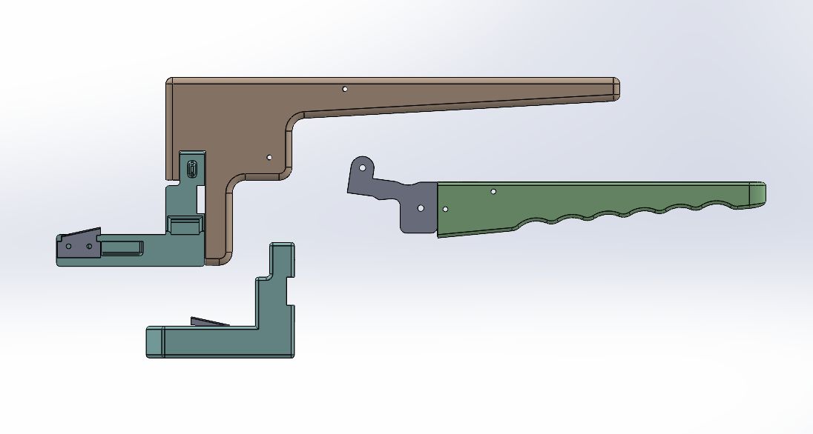

#### Figure 3: Semi-exploded view of SolidWorks Parts

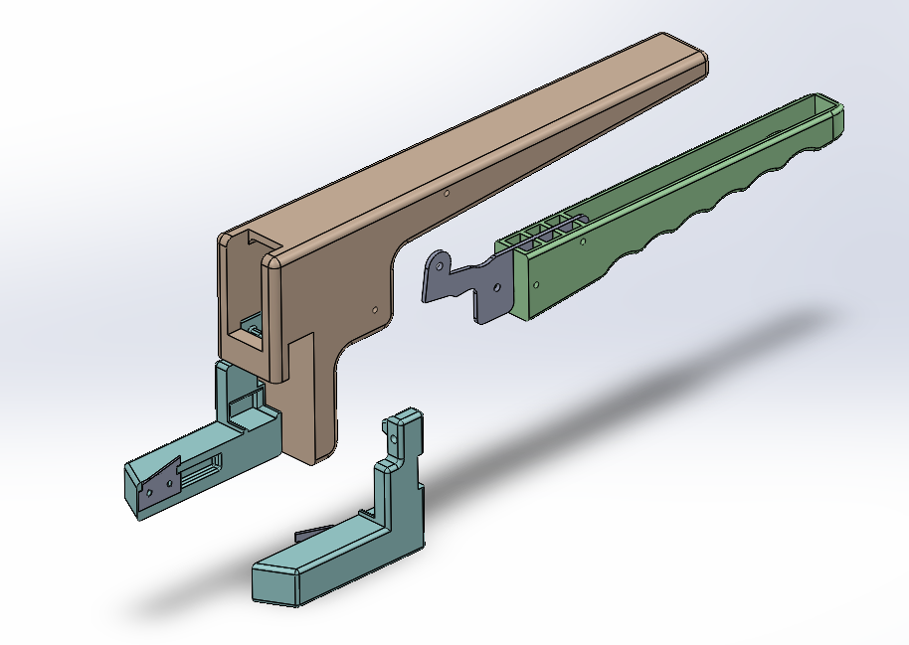

#### Figure 4: Isometric view of SolidWorks Assembly

The SolidWorks assembly can be developed based on these dimensions as all solutions are going to have very slight differences. Through modeling and machine work, a very similar design can be produced. This design will be mostly the same as the original design. However, there will inevitably be slight changes through design and machining. Same or similar materials will be bought to get a similar end product to the manufacturer’s design.

### Solution Three: Potential Changes

Another solution to be considered is making significant changes to the egg cracker that was received. Based off of the effectiveness of the original design and the patent design, a new design can be made with unique differences to both designs. The variable we know at this stage for this third solution will be to make sure there is less plastic in the design. A change in design would be warranted if neither of the designs could perform the basic functions of an egg cracker.

## Next Steps

The final solution will be chosen considering the final goals of the project. The product needs to be able to crack an egg in an efficient way. By modeling and calculating forces on the egg, an optimal solution can be chosen amongst the first two solutions. The first solution has one spring involved in the design, while the second solution has two springs. If they are inadequate or can be improved in any way, the third solution will be taken.

$$F=m×a$$

#### Equation 1: Newton’s Second Law

$$F=k×x$$

#### Equation 2: Hooke’s Law

$$F=\frac{τ}{r}$$

#### Equation 3: Force due to Torque

These equations can be used to determine the forces acting on the egg. Equation 1 can be used to find the force of the device acting on the egg (Subak 2025). Equation 2 refers to the springs inside the device and the subsequent force (Giuliodori 2009). Equation 3 takes into account the torque acting on the egg from the point of squeezing (Bera 2024). This can be a tool to see the effectiveness of the solution in cracking the egg to see if it has enough force for the motion. With this quantifiable data, a solution can be chosen out of the three potential solutions.

## Citations

Bera, P. & Drzewosz, A. (2024) ‘A Novel Formula for Calculating the Dynamic Torque of an Engine Based on Its Geometric Parameters and Static Measurements’, Energies, 17(20), article 5036. <https://doi.org/10.3390/en17205036>

Burr, P. and Choudhury, P. (2022). *Fine Motor Disability*. [online] PubMed. Available at: <https://pubmed.ncbi.nlm.nih.gov/33085413/>.

Giuliodori, M.J., Lujan, H.L., Briggs, W.M., Palani, A., DiCarlo, S.E. (2009) ‘Hooke’s law: applications of a recurring principle’, Advances in Physiology Education, 33(1), pp. 8‑14. <https://doi.org/10.1152/advan.00045.2009>

Subak, G. E. (2025) ‘Newton’s Second Law in Sports Science and Biomechanics: Bridging Physics and Human Performance’, American Journal of Sports Science, 13(2), pp. 32‑38. <https://doi.org/10.11648/j.ajss.20251302.12>