Temple University     
College of Engineering     
Department of Mechanical Engineering

  ENGR 4296: Capstone Senior Design

Professor Heravi

Egg Cracker Reverse Engineering

Group 9

Hollie Wolfenden, Sheryl Korah, Britney Lourng, Misa Won

Advisor Joseph Picone

Date: October 5, 2025

## Chosen Solution

For this project, the chosen solution is to reverse engineer the device received, shown as Figure 1, which happens to be different from the patent, while considering areas of improvement.

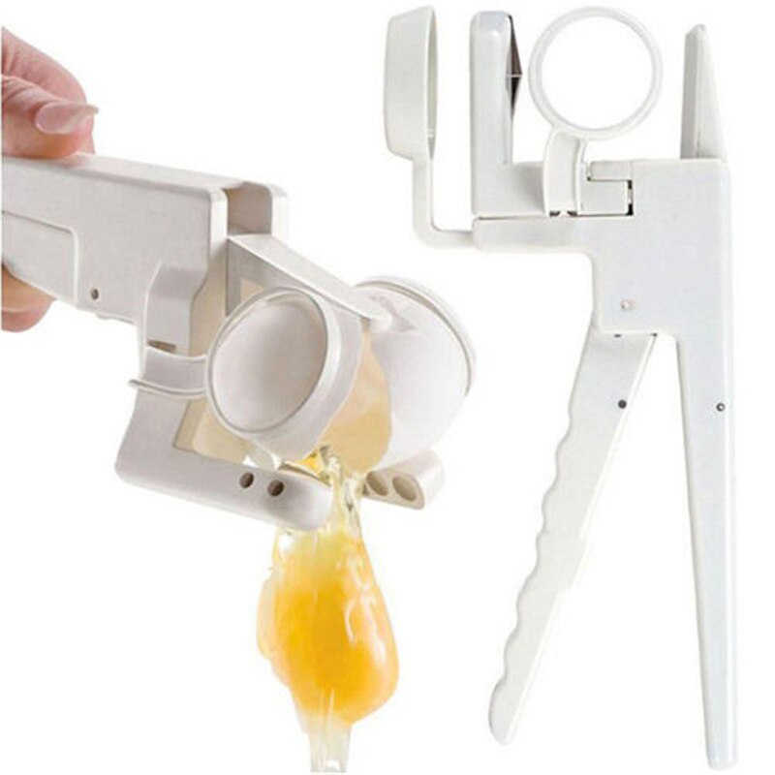

#### Figure 1: Handheld Egg Cracker Ordered from Amazon

Currently the device only meets a few of the design requirements shown in Table 1. It can crack a chicken egg and is accessible for most people. It is undetermined if the current device is safe for food use, but it is reasonable to assume so considering the marketing.

#### Table 1: Design Criteria for Final Prototype

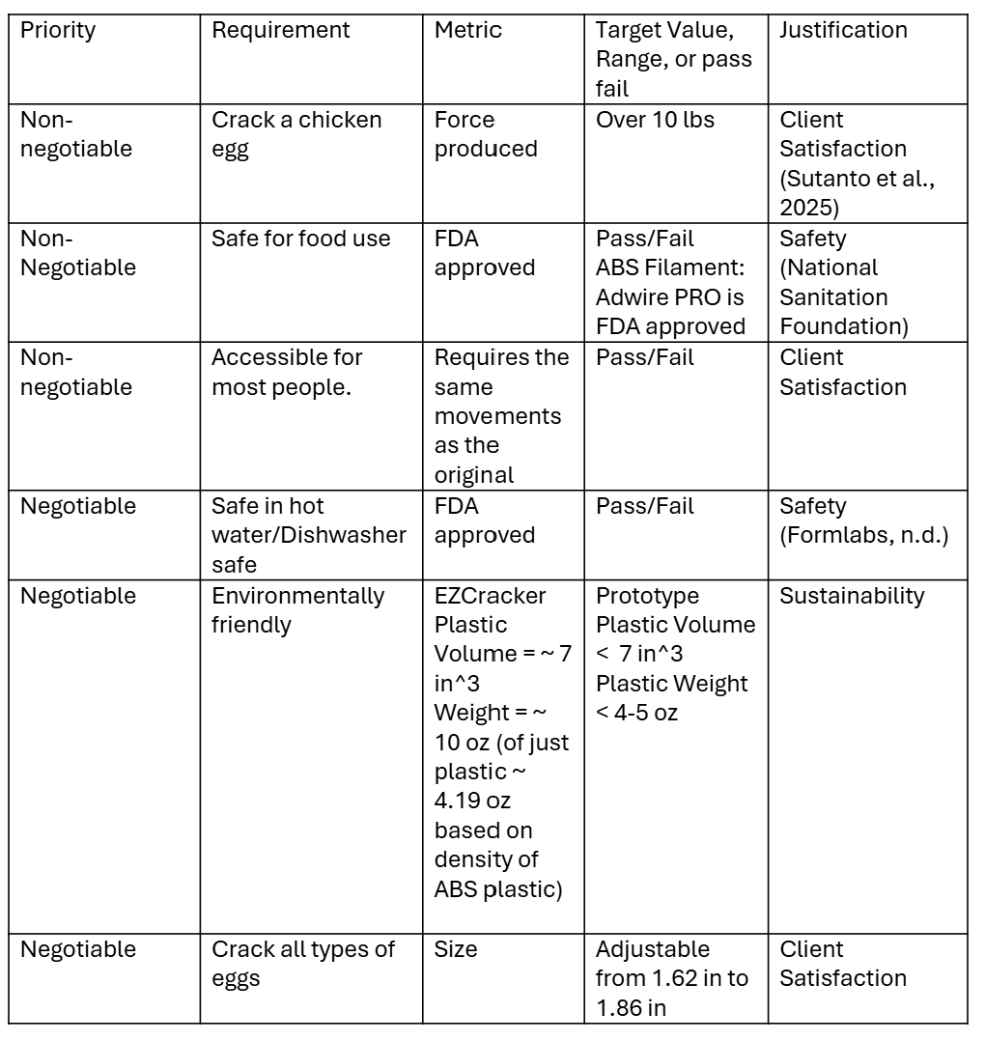

The device was not listed as dishwasher safe and is unable to crack other types of eggs, so these are areas for improvement. By reverse engineering a device that already meets some of the requirements, the focus can be on the remaining criteria and making the prototype as efficient as possible.

## Engineering Design

Different forces must be considered when examining the effectiveness of the design. The forces and distance values are represented in Figure 1. The force to press up on the handle (Fin) will be considered in calculations to determine the other unknowns. The spring constants for the compression spring (kc) and the extension spring (ke) are known as well as the distance the compression spring (xc) and extension spring (xe) can stretch. Hooke’s Law can then be used to find the forces of the compression spring (Fc) and extension spring (Fe) (Giuliodori 2009).

.

*F=kx*

#### Equation 1: Hooke’s Law

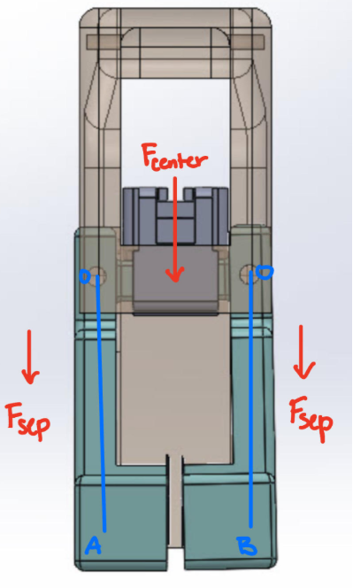

#### Figure 2: Force Diagram for Egg Separator

Using the moment equation at the fulcrum, the force applied to the egg (Fout) from the bottom handle will be calculated. Using this force, the force of the egg on the center piece (Fcenter) can be calculated. Figure 2 shows the force diagram as the egg separates. Fcenter can be calculated by using the angle (θ) between the x-axis and the Fout, as well as the distance between the fulcrum and endpoint (s) as well as the distance between the fulcrum and spring (y). Now, the separating force (Fsep) can be first found by dividing Fcenter by two and taking the angle into account when it cracks.

M=Fd

#### Equation 2: Moment Equation

With this separating force, a simulation can be made and the effectiveness can be determined. If the force is not effective, the design can be evaluated, and the force can be reevaluated based on the new design. The final separating force and initial force will be used in the final report to assess the success or failure of the final design.

The spring constants must be determined using the spring itself and these calculations can be found in Table 2 and Table 3. This was completed for both the compression and tension springs. The compression and tension spring constant can be found with Equation 3 (Budynas).

$$k=\frac{d^{4}G}{8D^{3}N}$$

#### Equation 3: Compression and Tension k Constant

#### Table 2: Compression Spring Calculations

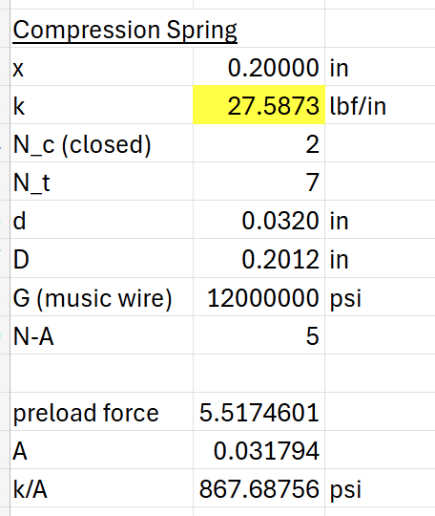

#### Table 3: Tension Spring Calculations

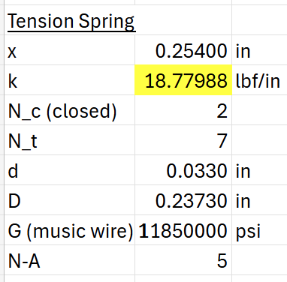

Tables 2 and 3 show the calculations for the spring constants for the compression and tension spring. The values are based off of the springs from the original design. This information is necessary to find the force applied to the handle in order to break the eggshell. Also, the information can be used to determine the necessary parts to order for the design.

## Design

The design being built is based on the device displayed in Figure 1. Once received, this was completely disassembled, and each individual part was measured thoroughly. Figure 2 shows this step. This was done so that each component could be built in SolidWorks.

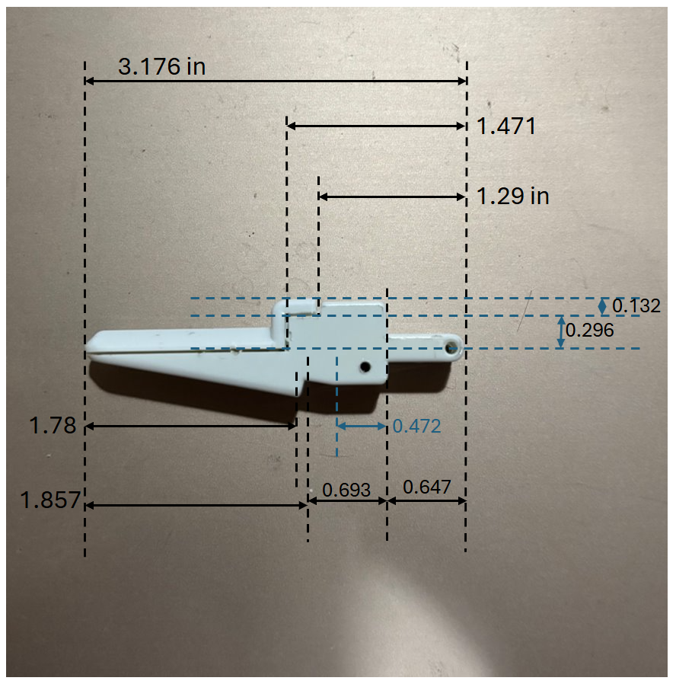

#### Figure 3: Disassembled Device and Sample Measurements

Once measured, different teammates took home different pieces to create individual CAD model. These components have now been compiled into an assembly shown as Figure 3. The mates to allow the assembly to move and function properly are currently in progress and the FEA and stress analysis will be completed as soon as the final assembly is finished.

#### Figure 4: SolidWorks Prototype Assembly

The individual pieces have all been sent to the 3D printer and are in the process of being printed. The current printed pieces are shown below as Figure 4.

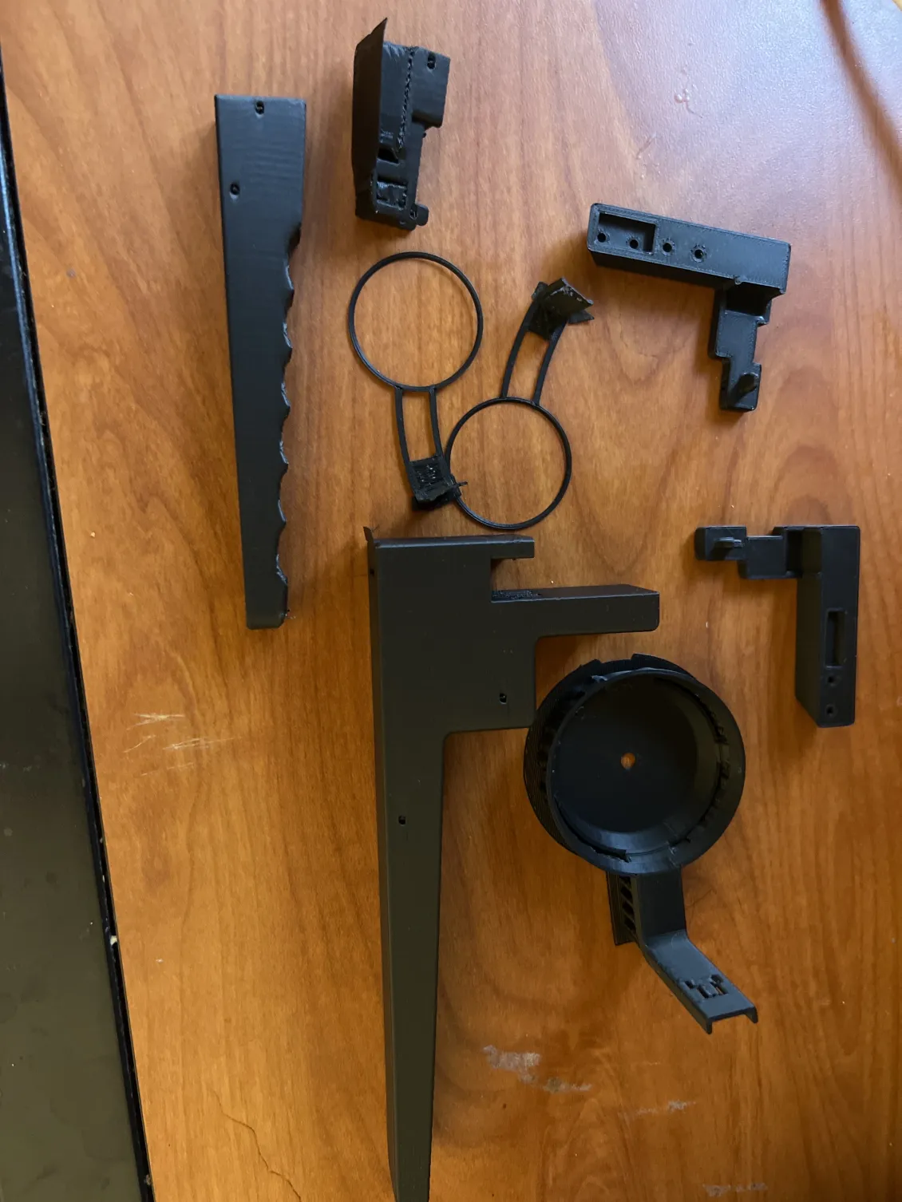

#### Figure 5: Individual 3D Printed Pieces

These components will be assembled in the following week to create the first iteration of the prototype. Once this iteration is complete, it will be evaluated for areas of improvement such as ill-fitting joints and print errors. These changes will then be made to the CAD models and reprinted.

## Citations

Budynas, R.G. and Nisbett, J.K., 2019. Shigley's Mechanical Engineering Design. 11th ed. New York: McGraw-Hill

Giuliodori, M.J., Lujan, H.L., Briggs, W.M., Palani, A., DiCarlo, S.E. (2009) ‘Hooke’s law: applications of a recurring principle’, Advances in Physiology Education, 33(1), pp. 8‑14. <https://doi.org/10.1152/advan.00045.2009>