Temple University
College of Engineering
Department of Mechanical Engineering


ENGR 4296: Capstone Senior Design
Professor Heravi

Egg Cracker Reverse Engineering

Group 9
Hollie Wolfenden, Sheryl Korah, Britney Lourng, Misa Won
Date: September 7, 2025

Abstract
This project is centered on taking an existing product, a handheld egg cracker, and reverse engineering it to study possible areas of improvement for a final prototype. This product needs to have certain qualities for it to be deemed successful. The egg cracker must exhibit a certain force to be able to crack an egg and need to display the same mobility as the EZCracker. This device aims to be more sustainable by containing less plastic than the original model. The material should be food safe as well as dishwasher safe. The last criterion is that the device can crack various types of eggs. After testing, the final prototype is able to fulfil most of the non-negotiable criteria as it was fully functional. However, some of the negotiable criteria could not be fulfilled as the prototype material is not suitable for food use. Overall, the new design was able to function as well as reduce plastic consumption.

Table of Contents
Abstract 1
Table of Contents 2
Problem Statement 3
Design Criteria 4
Table 1: Design Requirements 6
Potential Solutions 6
Solution One: Original Patent Design 7
Figure 1: Design Shown on Patent 7
Solution Two: Exact Reverse Engineer 7
Figure 2: Disassembled Device and Measurements example 8
Solution Three: Potential Changes 8
Chosen Solution 9
Engineering Design 9
Equation 1: Hooke’s Law 9
Equation 2: Moment Equation 10
Figure 4: Force Diagram for Egg Separator 10
Equation 3: Compression and Tension k Constant 11
Table 2: Compression Spring Calculations 11
Table 3: Tension Spring Calculations 11
Design 12
Figure 5: Semi-exploded view of SolidWorks Parts 12
Figure 6: SolidWorks Prototype Assembly 13
Link to Design Criteria 13
Standards and Specifications 14
Statistics/Design of Experiments 14
Table 2: Example of Measurement Device Precision 15
Evaluation: Test Methods & Results 15
Testing Methods 15
Results 16
Figure 7: Egg Holder Iterations 17
Figure 8: Body Iterations 17
Figure 9: Middle Piece Iterations 17
Figure 10: Original part, Hand milled part, and CNC Routed part 18
Figure 11: Cut Pins at Required Lengths 18
Figure 12: First Prototype Attempt 19
Figure 13: Second Prototype Attempt 19
Figure 14: EZCracker Testing 19
Figure 15: Prototype Testing 20
Figure 16: Force Output Results 20
Figure 17: Input EZCracker Force 21
Figure 18: Input Prototype Force 21
Figure 19: ANSYS Simulation 22
Standards and Specifications 22
Cost 22
Summary and Conclusions 23
Reference List 23

Problem Statement
Whether they are disabled or have sensory issues, some people are unable to crack eggs in their daily life. Certain disabilities that affect hand coordination and muscles could inhibit a person from doing a basic task. This fine motor disability is seen as a symptom in neurological conditions ranging from adults recovering from a stroke or brain injury to developing diseases including rheumatoid arthritis and dyspraxia (Burr and Choudhury, 2022). This project is going to take a handheld egg cracker, and reverse engineer it to look for possible areas of improvement.
The focus of this project will analyze the properties of the Emson EZCracker egg cracker and improve upon it by simplifying the mechanics and dynamics of the user’s motion needed and decreasing the material needed for the design. Our new design will be compared to Emson EZCracker to measurably indicate the success of our project (Dolub, 2008). If the project is successful, then the design will be cheaper, more accessible, and more sustainable. By making changes to the egg cracker, we can aid the 17 sustainable goals from the UN. Goal twelve revolves around sustainable consumption and production, which is one of the goals of this project which can be achieved by reducing plastic usage (United Nations, 2015). Goal ten focuses on reduced inequalities, which is another goal of this project as this device makes cooking more accessible for disabled individuals (United Nations, 2015). Overall, if successful, this project can improve the original designs in numerous ways.
Also, a prototype will be fabricated using both 3D printing and ready-to-buy components, therefore, demonstrating that the product can be effectively produced. Lastly, the ability to operate over a range of conditions will be shown. SolidWorks will be used to replicate the system and explore the necessary dimensions and design equations. Throughout all of these design choices, cost-conscious decisions will be considered to allow the product to be affordable to consumers. The deliverables include the design equations, a functional simulation, and a working final prototype.

Design Criteria
This product needs to have certain qualities for it to be deemed successful. The egg cracker must exhibit a certain force to be able to crack an egg to perform the main function of the design. The average force needed to crack an egg is 45 Newtons or 10 lbs (Sutanto et al., 2025). This metric must be met in order for the device to be considered functional. This requirement is non-negotiable and the most important priority as it is the entire purpose of the device.
Another quality it should have is that the material used is FDA approved for being in contact with food. This is a requirement for it to be used in the kitchen and, therefore, is non-negotiable and listed as the second most important priority. This will be measured through the FDA and the material that they approve. Since the prototype will be 3D printed, ABS Filament will be utilized and Adwire PRO is FDA approved (Formlabs, n.d.).
It also should be accessible for most people and our target consumers with fine motor disabilities (recovering stroke patients, etc). This metric will be ensured by following the original design which cracks the egg with one motion of the device. Those with fine motor disabilities mostly rely on assistive products that are functional by simple lateral movement between the thumb and index fingers (Muthu et al., 2023). This criterion will be non-negotiable in our prototype. The current design only has ridges in the handle of the egg cracker, but an added negotiable criterion for our prototype will be a better grip design.
The device must also be safe to clean after each use. This criterion will be based on the type of FDA approved plastic filament we will use. Having dishwasher safe 3D printing filament will be a negotiable criterion and withstanding higher temperatures for hand washing will be a non-negotiable criterion. The metric for this is if the material utilized is FDA approved to be washed in hot water or able to withstand temperatures of 60-70 °C (140-158 °F) without distortion (Formlabs, n.d.). This priority is negotiable because the device could be considered handwash only instead.
To abide by the UN sustainability goals, this device should be environmentally friendly, meaning it contains less plastic than the original model. This will be measured through the volume of the final prototype to ensure that it has less plastic. The original EZCracker has a total volume of about 7 in^3 and 4.19 oz of plastic. Our prototype will aim to use less than this. This priority is negotiable because the overall functionality of the device does not depend on it.
The last criteria is that the device can crack all types of eggs such as quail, goose, and duck. This is measured by the size of the rings that clasp onto the eggshell, and they should be adjustable from 1.62 inches to 1.86 inches (Narushin, 2005). This is the least important priority since the device doesn’t necessarily need to be usable for all types of eggs but could be more marketable if it is.

Table 1: Design Requirements
Priority | Requirement | Metric | Target Value, Range, or pass fail | Justification
Non-negotiable | Crack a chicken egg | Force produced | Over 2 lbs | Client Satisfaction  (Sutanto et al., 2025)
Non-Negotiable | Safe for food use | FDA approved | Pass/Fail  ABS Filament: Adwire PRO is FDA approved | Safety  (National Sanitation Foundation)
Non-negotiable | Accessible for most people. | Requires the same movements as the original | Pass/Fail | Client Satisfaction
Negotiable | Safe in hot water/Dishwasher safe | FDA approved | Pass/Fail | Safety (Formlabs, n.d.)
Negotiable | Environmentally friendly | EZCracker Plastic Volume = ~ 7 in^3  Weight = ~ 10 oz (of just plastic ~ 4.19 oz based on density of ABS plastic) | Prototype  Plastic Volume < 7 in^3  Plastic Weight < 4-5 oz | Sustainability
Negotiable | Crack all types of eggs | Size | Adjustable from 1.62 in to 1.86 in | Client Satisfaction

Potential Solutions
To complete this objective, three different solutions will be considered. These include following the original patent design, reverse engineering the exact product received, or making changes to improve upon both designs.

Solution One: Original Patent Design
The first solution is to follow the original patent design 7,363,853 B2. This design seems to be simpler than the current product with only one spring inside the device and one torsion spring on the handle as shown in Figure 1. Further research needs to be done to determine why the manufacturer strayed from this design and now incorporates two helical springs.
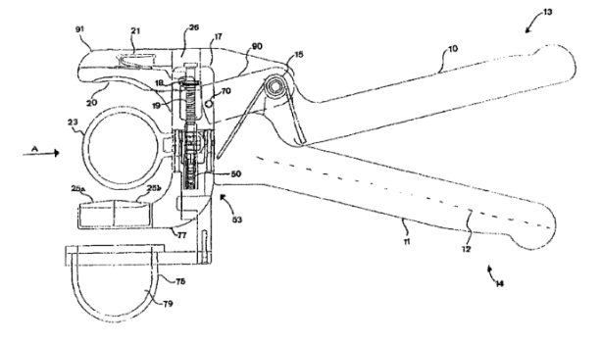

Figure 1: Design Shown on Patent
To complete this, all information would be gained from the patent application. If there are any unknowns, they would be determined from the current device as there is no other way to obtain the information. The design will be mainly based off of the patent design and any unknowns will be based off of the manufacturer’s design. When testing the original design, we can test the functionality of the device and see how they measure up with the goals of the project. This solution has the potential to have less parts, making it more cost-effective and more sustainable.

Solution Two: Exact Reverse Engineer
The next solution to be considered is to reverse engineering the device received from the manufacturer. As previously stated, the egg cracker received is not the same as on the patent. This egg cracker has already been disassembled and measured to determine the dimensions as shown in Figure 2.
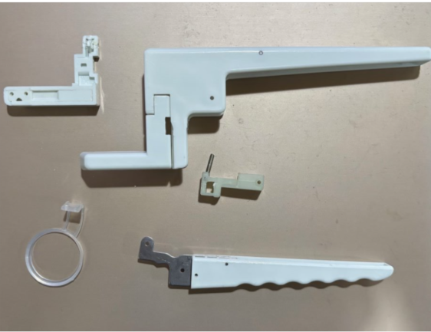
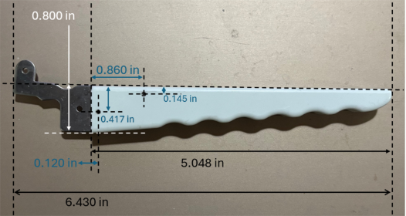

Figure 2: Disassembled Device and Measurements example
The SolidWorks assembly can be developed based on these dimensions as all solutions are going to have very slight differences. Through modeling and machine work, a very similar design can be produced. This design will be mostly the same as the original design. However, there will inevitably be slight changes through design and machining. Same or similar materials will be bought to get a similar end product to the manufacturer’s design.

Solution Three: Potential Changes
Another solution to be considered is making significant changes to the egg cracker that was received. Based on the effectiveness of the original design and the patent design, a new design can be made with unique differences to both designs. The variable we know at this stage for this third solution will be to make sure there is less plastic in the design. A change in design would be warranted if neither of the designs could perform the basic functions of an egg cracker.

Chosen Solution
The first solution was recreating the original patent design based solely on the information provided in the patent. The second solution was to reverse engineer the manufacturer’s design which varied from the patent. The third solution was to create a new design based on the previous iteration but with changes believed to be necessary.
The best course of action is to combine solutions two and three. This will base the design off the exact product received but consider changes to improve efficiency. A prototype will be created based solely on the reverse engineering of the device, then it will be tested to determine weaknesses.
This solution is the best option for a number of reasons. The original patent doesn’t have enough details or figures to completely reverse engineer a working product from it. The current device is very bulky and seems to be overengineered but functions properly. New changes are necessary, but a complete redesign is not required. To make the best use of time, the working device should be used for the majority of the design with only small changes to ensure functionality.

Engineering Design
Different forces must be considered when examining the effectiveness of the design. The forces and distance values are represented in Figure 3. The force to press up on the handle (Fin) will be considered in calculations to determine the other unknowns. The spring constants for the compression spring (kc) and the extension spring (ke) are known as well as the distance the compression spring (xc) and extension spring (xe) can stretch. Hooke’s Law can then be used to find the forces of the compression spring (Fc) and extension spring (Fe) (Giuliodori 2009).
.
F=kx

Equation 1: Hooke’s Law

Using the moment equation at the fulcrum, the force applied to the egg (Fout) from the bottom handle can be calculated. Using this force, the force of the egg on the center piece (Fcenter) can be calculated. Figure 4 shows the force diagram as the egg separates. Fcenter can be calculated by using the angle (θ) between the x-axis and the Fout, as well as the distance between the fulcrum and endpoint (s) as well as the distance between the fulcrum and spring (y). Now, the separating force (Fsep) can be first found by dividing Fcenter by two and taking the angle into account when it cracks.

M=Fd

Equation 2: Moment Equation
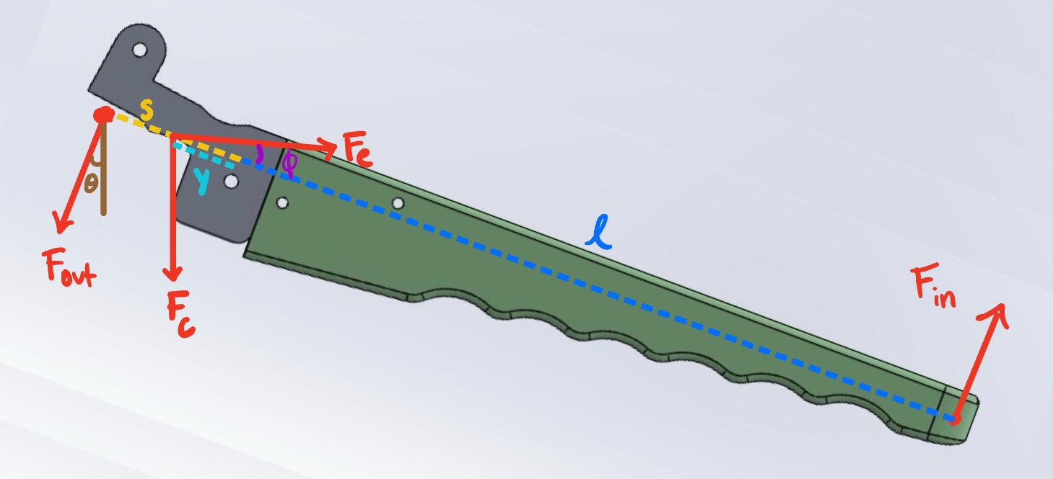
Figure 3: Force Diagram for Bottom Handle
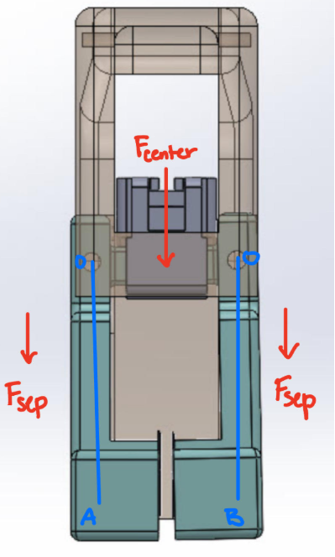

Figure 4: Force Diagram for Egg Separator
With this separating force, a simulation can be made and the effectiveness can be determined. If the force is not effective, the design can be evaluated, and the force can be reevaluated based on the new design. The final separating force and initial force will be used in the final report to assess the success or failure of the final design.

The spring constants must be determined using the spring itself and these calculations can be found in Table 2 and Table 3. This was completed for both the compression and tension springs. The compression and tension spring constant can be found with Equation 3 (Budynas). The d represents the inner diameter, and the D refers to the outer diameter. G refers to modulus of rigidity, which music wire will be used. N is the number of active coils.
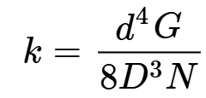

Equation 3: Compression and Tension k Constant

Table 2: Compression Spring Calculations
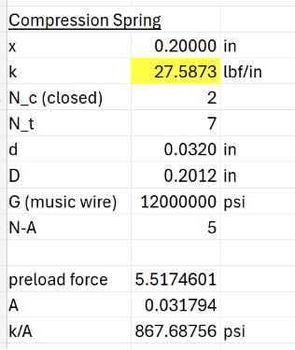

Table 3: Tension Spring Calculations
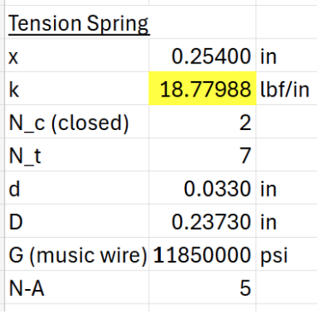
Tables 2 and 3 show the calculations for the spring constants for the compression and tension spring. The values are based off the springs from the original design. This information is necessary to find the force applied to the handle in order to break the eggshell. Also, the information can be used to determine the necessary parts to order for the design.

Design
The design being built is based on the device displayed in Figure 1. Once received, this was completely disassembled, and each individual part was measured thoroughly. Figure 2 shows this step. This was done so that each component could be built in SolidWorks.

Once measured, different teammates took home different pieces to create an individual CAD model. These components have been compiled into an assembly shown in Figure 2. The 3D printed pieces are shown below as Figures 5 and 6.
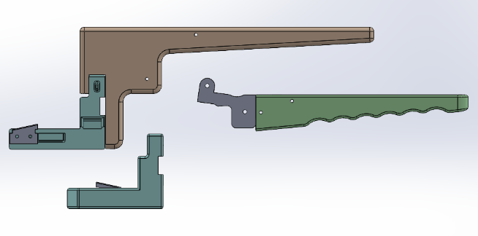

Figure 5: Semi-exploded view of SolidWorks Parts
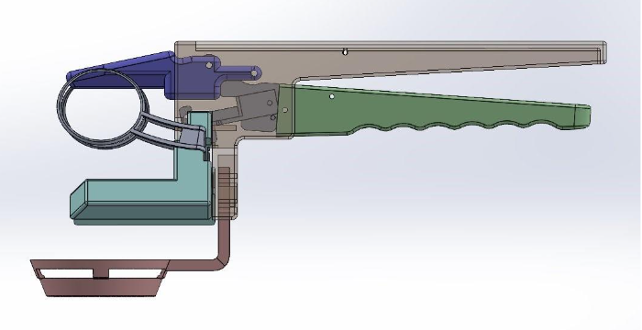

Figure 6: SolidWorks Prototype Assembly

Link to Design Criteria
To test the requirement of cracking a chicken egg, the force of the design must produce a force onto the egg of at least about 2 lbs. This will be experimentally tested using a small pressure sensor (Qinlorgo). Theoretical simulations will also be considered through the completed SolidWorks model.
To test the safety for food use, the FDA requirements for food safe materials will be compared to the final materials that will be in use. The FDA has conducted its own testing to measure the safety of food safe materials. Substances that encounter food must be authorized through a food contact notification (U.S. Food and Drug Administration, 2024). Through this program, the FDA runs a rigorous scientific safety assessment to ensure the substance is safe to the manufacturer. The FDA evaluates the nature of migrating components, the potential consumer cumulative dietary exposure, and the safe levels of dietary exposure (U.S. Food and Drug Administration, 2024). The FDA adds a margin of safety by overestimating dietary exposure. They compare cumulative dietary exposure to toxicological information about the substance. By making sure the material is approved safe, this criteria can be fulfilled. The filament that will be used is YXPOLYER PLA Filament, which is deemed food safe.
For the accessibility criteria, the design must be completely functional and require the same squeezing motion as the original device. These criteria being met coincide with the first criteria, ensuring that there is enough force to crack the egg. This goal requires the motion to be the same, which can be physically monitored. This will not be tested as it is a pass/fail goal but will be observed throughout the process.
To test the dishwashing safety properties, the material must be deemed dishwasher safe. NSF sets the standards for equipment that is in contact with food (NSF International, 2025). Dishwasher safe materials must be able to withstand the high heat and water pressure of a dishwasher. Not many 3D printing filaments are able to withstand the water pressure sustained by a dishwasher (Formlabs, n.d.). The YXPOLYER PLA Filament, which this project is planning to use, is not rated dishwasher safe, like other PLA filaments. PLA filaments have a low glass transition temperature, which will allow them to soften when exposed to high heat. The process of 3D printing leaves microscopic gaps which can trap bacteria and food particles when in the dishwasher. Therefore, this criteria will likely not be fulfilled as the non-negotiable items take precedence. For it to be fulfilled, the 3D printing process would have to be changed as well as the material for the print.
The next criteria is to have the design be environmentally friendly. To complete this, the volume and weight of the plastic will need to be less than the original device. This will be completed through small changes in the design and a low infill value while 3D printing. To test this, the new prototype will be weighed and compared to the weight of the original device, which was about 5 oz. Using SolidWorks, the volume of plastic being utilized can be calculated, and this should be less than the original 7 cubic inches.
The last criteria is that the prototype can crack all types of eggs. This is determined through adjustable egg holders. They must be able to adjust from 1.62 to 1.86 inches. This will be measurable and well as experimentally tested.

Standards and Specifications
ISO 20282-1:2006: This standard is listed as the “ease of operations of everyday products.” It is the main standard for assistive products that is applicable for the design principles of mechanical and/or electrical products (ISO 20282-1:2006).
NSF Protocol P400: This protocol is used for food contact utensils for home use (NSF Protocol P400). NSF P400 establishes food protection and safety requirements for materials and construction of products used on food. It is accredited by ANSI but developed through a public process (NSF International, 2025).

Statistics/Design of Experiments
For the criteria requiring simple measurements only, such as the prototype cracking all eggs and reducing the amount of plastic used, accuracy and precision can be found. This is shown in Table 2 where the precision of the measuring devices utilized is recorded. This information is vital in ensuring the accuracy of comparisons and calculations.

Table 2: Example of Measurement Device Precision
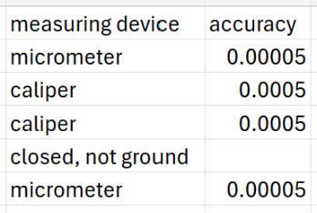
The criteria concerning safety features will not be tested on the final prototype. This will be determined using FDA approved materials. The testing is statistically significant since it was conducted on such a large scale by the FDA.
The force produced will be evaluated with a force sensor. This will be conducted as many times as possible. Statistical tests will then be run on the values to remove outliers and determine averages. This will allow the data to be considered statistically significant.

Evaluation: Test Methods & Results

Testing Methods
To test the ability of the egg cracker, the exertion force of the egg cracker will be tested. This will check the first design criteria for the project. To test the force being applied on the egg, a pressure sensor will be placed under the pressure piece of the egg cracker. The pressure sensor that will be used is the Qinlorgo Pressure Sensors Display Module (Qinlorgo). The pressure sensor will display the force being exerted on the egg from the pressure piece. To get accurate readings, the same person will be conducting the tests to ensure that the test is repeatable. There will be multiple tests to ensure accuracy of the results. There will be at least ten tests to get the most accurate readings. Once the results are finalized, this value will be compared to the value needed in order to crack a chicken egg.
Another study will be conducted to ensure the first and most important design criteria of the project. A chicken egg will be placed in the egg cracker to test if it cracks. The test will be done multiple times and will be done by the same person to ensure repeatability. This experiment also tests accessibility, which is another important criterion.
A simple test can be used to determine the environmental criteria. The original device will be weighed alongside the weight of the final design. They will be weighed on the same scale and will be weighed multiple times.
The last criteria that test the device on different eggs will be tested by measuring the width and adjustability of the egg holders. To do this, a caliper will be used to measure the distance between the egg holders when they are the closest to each other and when they are the farthest from each other. The measurements will be done multiple times to ensure accuracy. These numbers will show the adjustability of the egg holders and the range of diameters for eggs it can hold. This will determine the types of eggs it can crack.
The other criteria are not testable or have been determined by tests done on purchased products. Previous tests have been done on these products and are held up to standards made by the FDA. Therefore, there does not need to be further tests for these criteria.

Results
There was an attempted build with the original SolidWorks models after a standard 3D print. The pins and metal that were ordered were cut down to the correct dimensions. While attempting to assemble the pieces, some of the pieces broke. The 3D printed pieces broke on the layer lines that are present for additive manufacturing. Therefore, in the next attempt, some of the SolidWorks pieces like the handles and middle pieces were modified to add chamfers to corners to lessen strains in those areas. Also, all the pieces were printed in resin as well to compare the durability of each type of print. TPU filaments were also used as it is flexible for the middle pieces as there is the most stress in those areas.
For the second iteration, a combination of standard and resin prints for the new models were used. With the new parts, the assembly did not break down as the resin and chamfers made the parts stronger. However, a few iterations of the egg holders needed to be made to test different designs, as seen in Figure 7. Another set of changes were made to the SolidWorks models. The middle piece was shortened, and the body was modified to make the part longer, as shown in Figures 8 and 9. These changes allow for better fit of the mechanisms inside the egg cracker and decrease the possibility of breaking. Also, for the eye bolt, the threads of the pins were removed to allow for a proper fit.

Figure 7: Egg Holder Iterations

Figure 8: Body Iterations

Figure 9: Middle Piece Iterations
The metal pieces were machined through hand milling and CNC routing, as shown in Figure 10. The pins had to be shortened in the machine shop as well to fit correctly in the body, as shown in Figure 11.

Figure 10: Original part, Hand milled part, and CNC Routed part

Figure 11: Cut Pins at Required Lengths
After the prototypes were completed, the first prototype displayed limited mobility, as shown in Figure 12. The second prototype, as displayed in Figure 13, has greater mobility. Using the testing method described earlier, the Qinlorgo sensor was used to get the force on the egg from the EZCracker and the prototype as shown in Figures 14 and 15.

Figure 12: First Prototype Attempt

Figure 13: Second Prototype Attempt

Figure 14: EZCracker Testing

Figure 15: Prototype Testing
As shown in Figure 16, the EZCracker had a higher range of values for force on the egg than the prototype. The EZCracker also had a higher average force than the prototype, however both were able to crack the eggs. The input force was calculated in Figures 17 and 18, and show that the prototype required less force than the EZCracker. However, these values are significantly lower than the 2 lbs in the design criteria. After consideration, it was realized that the 2 lb value did not account for the additional forces within the egg cracker.

Figure 16: Force Output Results
After the output values were found, the input values were calculated for the EZCracker and the prototype. The prototype required less force to crack the egg, displaying its accessibility.

Figure 17: Input EZCracker Force

Figure 18: Input Prototype Force
For the simulated studies, SolidWorks was used but could not handle the intricacies of the design. Then, ANSYS was used to simulate stress, as seen in Figure 19. The value for the output force of the EZCracker is 1.276 lbf. However, the value for the output force of the prototype was unable to be found as the student licensing had simulation limits.

Figure 19: ANSYS Simulation

Standards and Specifications
ISO 20282-1:2006: This standard is listed as the “ease of operations of everyday products.” It is the main standard for assistive products that is applicable for the design principles of mechanical and/or electrical products (ISO 20282-1:2006).
NSF Protocol P400: This protocol is used for food contact utensils for home use (NSF Protocol P400). NSF P400 establishes food protection and safety requirements for materials and construction of products used on food. It is accredited by ANSI but developed through a public process.

Cost
To create the cost analysis, the cost for the original must be considered. The average cost for the EZCracker was determined to be $19.80 after averaging the cost across six different sources. The average yearly revenue for handheld egg crackers was determined to be $60,000,000 and the units sold yearly were found to be 151,502 (Handheld Electric Egg Beater Market).
For the new design, the costs of each 3D printed part must be calculated, and injection molding will be used for the final design. Protolabs provided an estimate for all the parts, and they were added together. Each individual component was quoted which resulted in the body costing $2.26, the base handle was $1.58, the egg separator was $1.42, the pressure piece was $1.50, the left and right egg holder were $1.26 each, the middle piece was $1.47, and the left and right handles were $1.50 each. This resulted in a unit price of $13.75. Assuming that 150,000 units will be sold yearly, it was calculated that the total profit would be $2,970,250 if only the printed parts were considered.
With further research, overhead and other costs would need to be considered to get a proper estimate. The profit would likely be much less after this. Protolabs is a United States based company and, therefore, production costs are higher so an international supplier should be considered as well.

Summary and Conclusions
In summary, a prototype was created to try to improve the EZCracker design in multiple areas. The EZCracker was replicated in SolidWorks, and revisions were made to the original design, including decreasing the amount of material. Two iterations were made, and the second one was more successful. The final prototype was made using machining and 3D printing. It was successfully able to crack a chicken egg, like the EZCracker.
In conclusion, most of the non-negotiable criteria were met. The criterion of being able to crack a chicken egg was met, and the force produced was sufficient. Although the force did not meet the 2 lb design criteria, that value was deemed inaccurate for an egg cracker device. Since the final design was functional, the criterion of accessibility was met. The only non-negotiable criterion that was not met was the food safety requirement. Many of the negotiable criteria were not met with this prototype. The prototype cannot crack all types of eggs, and the current plastic is not safe in the dishwasher. There were unexpected errors with simulating stresses in SolidWorks and ANSYS that would need to be addressed for future theoretical stress analyses. For future work, there would be a focus on the negotiable criteria, as the primary goal for this semester was functionality.

Reference List
Bera, P. & Drzewosz, A. (2024) ‘A Novel Formula for Calculating the Dynamic Torque of an Engine Based on Its Geometric Parameters and Static Measurements’, Energies, 17(20), article 5036. https://doi.org/10.3390/en17205036
Budynas, R.G. and Nisbett, J.K., 2019. Shigley's Mechanical Engineering Design. 11th ed. New York: McGraw-Hill
Burr, P. and Choudhury, P. (2022). Fine Motor Disability. [online] PubMed. Available at: https://pubmed.ncbi.nlm.nih.gov/33085413/.
Dolub, C.A. (2008). DEVICE FOR CRACKING OPEN AND SEPARATING AN EGG. [online] Available at: https://ppubs.uspto.gov/api/pdf/downloadPdf/7363853?requestToken=eyJzdWIiOiJjNmE0OTIxZi1mMDU2LTQ0MDctYWFiOS02NWM1MjY5OGUwMjciLCJ2ZXIiOiJmOGRlNTNhZS02YzgzLTQ2MzYtOWIwNC00Y2JhMTkzMDRjZmMiLCJleHAiOjB9 [Accessed 29 Aug. 2025].
Formlabs. (n.d.). The Essential Guide to Food Safe 3D Printing. [online] Available at: https://formlabs.com/blog/guide-to-food-safe-3d-printing/.
Giuliodori, M.J., Lujan, H.L., Briggs, W.M., Palani, A., DiCarlo, S.E. (2009) ‘Hooke’s law: applications of a recurring principle’, Advances in Physiology Education, 33(1), pp. 8‑14. https://doi.org/10.1152/advan.00045.2009
Handheld Electric Egg Beater Market. (n.d.-b). https://www.verifiedmarketreports.com/product/handheld-electric-egg-beater-market/
Instructables (2024). Handcrafted Egg Breaker. [online] Instructables. Available at: https://www.instructables.com/Handcrafted-Egg-Breaker/ [Accessed 30 Aug. 2025].
Jung, E. (2021). Egg Crackers. [online] Google.com. Available at: https://patents.google.com/patent/KR20220132221A/en?q=(egg+cracker)&oq=egg+cracker.
Muthu, P., Tan, Y., Latha, S., Dhanalakshmi, S., Lai, K.W. and Wu, X. (2023). Discernment on assistive technology for the care and support requirements of older adults and differently-abled individuals. Frontiers in Public Health, 10(1). doi:https://doi.org/10.3389/fpubh.2022.1030656.
Narushin, V.G. (2005). Egg geometry calculation using the measurements of length and breadth. Poultry Science, [online] 84(3), pp.482–484. doi:https://doi.org/10.1093/ps/84.3.482.
National Sanitation Foundation [NSF] NSF Protocol P400: Food Contact Utensils for Home Use, NSF [Online]. Available at https://www.nsf.org/nsf-standards/standards-portfolio/home-products-protocols-standards (Accessed September 4, 2025).
NSF International (2025) Commercial food equipment testing and certification. Available at: https://www.nsf.org/food-beverage/commercial-food-equipment
Qinlorgo. Pressure Sensor Display Module Model RP-C-MK01-1. [online]. Available at: Qinlorgo Pressure Sensors Display Module, 32x62.6x11mm Copper Clad Laminate Ultra Thin Flexible Pressure Sensitive Film Pressure Sensor + Pressure Display Module: Amazon.com: Industrial & Scientific (Accessed: 14 October 2025).
'Researchers Submit Patent Application, "Automatic Egg Cracker", for Approval (USPTO 20240164585)' (2024) Politics & Government Week, 13 Jun, 8594, available: https://link-gale-com.libproxy.temple.edu/apps/doc/A796980876/GRNR?u=temple_main&sid=summon&xid=59426b1f [accessed 30 Aug 2025].
Riddle, M. et al. (2020) ‘Evaluation of individual finger forces during activities of daily living in healthy individuals and those with hand arthritis’, Journal of Hand Therapy, 33(2), pp. 188–197. doi:10.1016/j.jht.2020.04.002.
Subak, G. E. (2025) ‘Newton’s Second Law in Sports Science and Biomechanics: Bridging Physics and Human Performance’, American Journal of Sports Science, 13(2), pp. 32‑38. https://doi.org/10.11648/j.ajss.20251302.12
‌Sutanto, A., Suhib Abu-Qbeitah, Avishai Jeselsohn, Unikewicz, B.M., Bonavia, J.E., Rudolph, S., Hudson, S. Kiana Naghibzadeh and Cohen, T. (2025). Challenging common notions on how eggs break and the role of strength versus toughness. Communications Physics, 8(1). doi:https://doi.org/10.1038/s42005-025-02087-0.
Taylor, D. et al. (2016) ‘The fracture toughness of eggshell’, Acta Biomaterialia, 37, pp. 21–27. doi:10.1016/j.actbio.2016.04.028.
The International Organization for Standardization [ISO] (2006) ISO 20282-1:2006 Ease of operation of everyday products: Part 1 Design requirements for context of use and user characteristics, ISO [Online]. https://www.iso.org/standard/34122.html (Accessed September 4, 2025)
United Nations (2015). The 17 Sustainable Development Goals. [online] United Nations. Available at: https://sdgs.un.org/goals.
U.S. Food and Drug Administration (2024) Food Packaging & Other Substances that Come in Contact with Food – Information for Consumers. Available at: https://www.fda.gov/food/food‑ingredients‑packaging/food‑packaging‑other‑substances‑come‑contact‑food‑information‑consumers

