Detecting DeepFakes Using Deep Learning

“Meet Team DeepTRUTH” by Team 5, Image created for Senior Design I
Jouri Ghazi, Jahtega Djukpen, Ashton Bryant, Zacary Louis
Capstone Senior Design II
Fall 2025

Abstract
Artificially generated images, such as DeepFakes, have become increasingly easy to create and difficult to detect. DeepFakes pose a serious threat to the credibility of public figures, leading to emotional, financial, and political consequences. Therefore, the development of an accurate and reliable DeepFake detection tool is essential to protect everyone from misuse, including individuals and organizations who may be frequent victims. DeepFakes pose a risk to everyone, making us all stakeholders in their detection.
This project aims to develop an open-source, reliable DeepFake detection tool. Through the implementation and evaluation of multiple machine learning models, our team has achieved high accuracy, demonstrating the feasibility of creating a reliable detection tool. We began with a Random Forest baseline model and progressed to a Convolutional Neural Network that reached up to 90% accuracy. Our design process included data collection, preprocessing, model training and performance evaluation, resulting in a functional detection web tool.

Table of Contents
Abstract 2
Problem Statement 5
Overall Objectives 5
Background & Historical Perspective 6
Needs Statement 7
Major Design and Implementation Challenges 7
Dataset Selection & Management 7
Machine Learning Training 7
Website Development 8
Implications of Project Success 8
Requirements and Constraints 10
Algorithmic Performance Criteria 10
Accuracy 10
Precision 11
Recall 11
F1 Score 11
Solution Efficiency 12
Algorithm Process Time 12
Website Boot Time 12
Resource Usage 12
Dataset Generalizability (Scalability) 12
Demonstration Usability 12
Interpretability 12
Accessibility 13
User Interface 13
Code Maintainability 13
ISIP Guideline Compliance 13
Documentation 14
Ethics & Security Criteria 14
Algorithmic Transparency 14
Website Security 14
Ethical Dataset Development 15
Potential Solutions 16
Face Detection 16
Demonstration 17
Solution 1: Random Forest 17
Discrete Cosine Transform 17
Random Forest Model 18
Solution 2: Convolutional Neural Network (CNN) 19
Parallel Dataset 19
CNN 20
Solution 3: Xception Model 22
Model 22
Next Step 23
Preliminary Design 24
Dataset Selection: 24
Mitigating Dataset Bias 26
Face Detection Algorithm 27
Creation of Parallel Dataset 28
Parallel Dataset Implementation 28
CNN 29
Convolutional Layer 30
Activation Function 31
Pooling Layer 31
Fully Connected Layer 32
Output Layer 33
Algorithm Optimization 33
Forward propagation 33
Loss function 33
Backpropagation 34
Engineering Design Plan 34
Testing Methods 35
Model Performance 35
DeepTRUTH 36
EfficientNet 37
Vision Transformer 38
Performance Metrics 38
Efficiency 39
Algorithm Process time 39
Website boot time 41
Resource Usage 41
Dataset Generalizability 41
Code Maintainability 41
ISIP Guideline Compliance & Documentation 41
Usability 42
Interpretability 42
Accessibility 42
User interface 42
Ethics and security 42
Algorithm Transparency 42
Website Security 43
Preliminary Results 43
Model Performance 43
Accuracy 43
Precision 43
Recall 43
F1 Score 44
Efficiency 44
Algorithm Process Time 44
Website Boot Time 47
Resource Usage 47
Dataset Generalizability 47
Code Maintainability 47
Code Maintainability 47
Website Usability 48
Interpretability 48
Accessibility 49
User Interface 49
Ethics & Security 50
Algorithmic Transparency 50
Website Security 50
Appendix 52
Abbreviations Used 52
Citations 53

Problem Statement

Overall Objectives
With the ongoing rise of AI generated media, detecting such content has become a critical challenge to maintain digital authenticity and prevent fraud. DeepFakes are a form of AI generated content that typically mimics one’s facial features or voice to replace or alter a person’s identity [1]. DeepFakes pose a great risk to the spread of misinformation. Our detection tool would work towards enhancing enterprise security against DeepFake attacks and can be leveraged within an educational scenario to enhance media literacy education [2]. This project aims to develop a web-based DeepFake detection tool, trained on a machine learning (ML) algorithm.
Our tool currently processes all image file forms supported by the Python Image Library, recognizing faces using the Haar Cascade method, determining the authenticity of the image using a random forest algorithm, and producing a Real/Fake result with a probabilistic confidence score. Moving forward, our aim is further improving the accuracy and accessibility of our tool. Among the upgrades we aim to make, we will move our web tool to a publicly hosted server. The next critical upgrade is our algorithm; within this endeavor we aim to reduce overfitting our algorithm to the training data, so our tool is generalizable to a wide variety of image conditions. To achieve this, we aim to implement a deep learning (DL) convolutional neural network (CNN). Additionally, we hope to improve the front-end design and user interface (UI) of the web tool and add additional functionalities, such as the support of audio and video content.

Background & Historical Perspective
DeepFake content can take multiple forms, such as images, audio, and video. DeepFake images can take the form of either generated depictions of nonexistent people or manipulated photographs of real individuals. Modern generative AI (gen-AI) content can instantaneously create photorealistic content that is almost indistinguishable from authentic images, heightening the risk of misuse, deception, and reputational harm [3]. Social media has allowed for the instant spread of generated content, amplifying its harmful effects. Individuals are increasingly vulnerable to targeted DeepFake attacks which may result in psychological and financial distress. To mitigate these risks, a detection tool is required to accurately distinguish between genuine and manipulated content.
DeepFakes emerged as photo editing tools have become widely accessible with the development of generative modeling during the 2010s. The term “DeepFake” was first coined on Reddit in 2017, as availability of open source editing software and large image datasets, enabled by the rise of social media, helped advance gen-AI technology [4].
The development of generative adversarial networks (GAN) made it possible to create photorealistic DeepFake images. GAN are a type of neural network based DL model that works by having two networks, the generator and discriminator, compete with one another in an iterative process for improved results. The generator network forges new data with the goal of making it indistinguishable from real data in attempt to fool the discriminator network. The rapid evolution of GAN models oftentimes outpaces the development of new algorithms, outdating earlier generations of detection methods. Generated DeepFakes increasingly capture natural human attributes, such as small changes in lighting, texture, and facial expressions [5].
Current detection models face a moving target as GAN generated images are continuously evolving to bypass detection, where each generation of forgeries may potentially nullify existing detection methods, requiring a continuous cycle of detection and retraining to stay current with deepfake advances. This cycle is referred to as an “arms race” where detection and generation technology develop along one another, each motivating the other to improve [6].
The United States National Security Agency, Federal Bureau of investigation and the Army Criminal Investigation Command have publicly addressed the threat posed by the emergence of Gen-AI content, stating that “The tools and techniques for manipulating authentic multimedia are not new, but the ease and scale with which cyber actors are using these techniques are. This creates a new set of challenges to national security” [7]. Several laws within the United States have been introduced to mediate the risk posed by DeepFakes. Act 35 passed in Pennsylvania makes it a crime to create or distribute deepfakes for fraudulent purposes or to cause harm. This act was signed on July 7th, 2025, and will be made effective September 5th, 2025 [8]. As Gen-AI continues to improve the development of effective detection tools, it remains a critical research area. These initiatives demonstrate the need for accurate and reliable DeepFake detections method to mitigate the potential harm of Gen-AI content.

Needs Statement
This project highlights the need for the implementation of a reliable easy-to- access AI content detector to distinguish DeepFake content. This tool can mitigate the ongoing risk of fraudulent activity pertaining to identity theft, defamation, and psychological harm potentially caused by the spread of DeepFake content.

Major Design and Implementation Challenges

Dataset Selection & Management
Our DeepFake Detector depends on a machine learning model, whose accuracy is correlated to the quality and quantity of the training dataset [9]. The dataset we choose should contain a diverse selection of high-quality images, capturing variations in lighting, resolution, facial expression and demographics to ensure that the model generalizes well [10]. Although several datasets are available, many lack samples generated with the latest techniques, limiting the generalizability and accuracy of our model [11]. Table 1 in the Appendix presents the DeepFake datasets considered, sourced from a variety of companies and initiatives.
Gen-AI content increasingly mimics natural attributes, such as subtle variations in lighting, texture and facial expressions. Because of this, Gen-AI content is rapidly outpacing the development of new algorithms, outdating earlier generations of detection methods. As the quality of GAN-generated content improves, an artifact based detection approach becomes less effective. This increases the need for a diverse and comprehensive dataset to reliably distinguish between real and fake content [10]. Data diversity and recency pose a design constraint for our detection method.

Machine Learning Training
Another design constraint is the risk of overfitting, which occurs when a model learns the training data too closely, leading it to capture noise and specific patterns, hindering its ability to perform onto new, unseen data. This is caused by diversity and bias found within the data which prevents the model from reliably perform on real-world inputs.
Deep learning (DL) relies on multi-layered neural networks to discover patterns from large datasets. A Convolutional Neural Network (CNN) is a form of DL algorithm that works with grid-like data and learns the spatial hierarchies of features [12]. Although CNNs are an effective in processing images, this method lacks interpretability, making it difficult to understand which patterns and cues the model uses to distinguish real from fake images. This poses a barrier of trust and accountability and hindering potential improvements and parameter tuning.

Website Development
A priority for the website development is to allow users to easily upload images and interact with the UI. The result of the detection should be clearly displayed to encourage user confidence within our tool this can be accomplished through visual cues or confidence scores, allowing users to understand the model’s decision [13]. The website should be accessible and well-designed to provide a straightforward and intuitive experience with uploading and interpreting results.
The site should support real-time processing, as the CNN detection models are computationally intensive and time consuming the tool should deliver fast results to ensure a seamless demonstration and improve the user’s experience [14]. The interface should be easy to use and intuitive, allowing the user to seamlessly engage with the site’s tools.

Implications of Project Success
This project aims to develop an algorithm that accurately differentiates between real and generated images. The final result would be a functional web application where users can upload an image and instantly determine its authenticity.

The success of this project would not only demonstrate the power of machine learning in addressing modern digital challenges but also contribute meaningfully to the global goals of ensuring well-being, reducing inequality, promoting innovation, and protecting the integrity of information.

The broader implications of success extend to several United Nations Sustainable Development Goals (SDGs):
SDG 3: Good Health and Well-Being – By limiting the spread of harmful and exploitative deepfake content, individuals are better protected from psychological distress, harassment, and identity misuse. For instance, 67% of victims of image-based sexual abuse experience negative mental health effects, including anxiety and long-lasting distress [15].
SDG 4: Quality Education – The tool would reduce misinformation and promote digital literacy, helping learners and educators access trustworthy information in an increasingly digital world.
SDG 9: Industry, Innovation, and Infrastructure – Developing an advanced AI system contributes to technological innovation and strengthens the security of digital infrastructures.
SDG 10: Reduced Inequalities – Vulnerable groups, including women and minorities, are disproportionately affected by deepfakes. Women make up 96% of all deepfake pornography victims, and in some regions, as many as 40% of women have experienced online harassment. These statistics show that this project can help safeguard vulnerable groups and reduce digital exploitation and abuse [15].
SDG 12: Responsible Consumption and Production – Encourages ethical use and creation of media by making manipulations easier to identify and discouraging irresponsible content production.
SDG 16: Peace, Justice, and Strong Institutions – By preventing deepfakes from undermining trust in institutions, media, and democratic processes, the project reinforces accountability, justice, and societal trust. Research has shown that exposure to deepfakes significantly increases distrust in government and erodes public confidence in democratic systems and the rule of law [16].

Requirements and Constraints
Our solution consists of a DeepFake Detection model and a demonstration interface that is deployed on the ISIP Cluster and is publicly available. The requirements and constraints criteria include algorithmic performance, which is a measure of our detection model’s ability to reliably detect the generated content. Demonstration usability, which determines the quality of our demonstration website, ensuring its accessibility to all users. Another criteria is the efficiency of our solution, measuring the time and computational resources required to reliably classify the DeepFake. Code maintainability is used to make sure that our code complies with the ISIP standards and is usable in the future. The final criteria is about the ethics and safety of our training and deployment process, ensuring that the results provided by the detection model are explainable, and adheres to privacy restrictions. Table 1 references the requirements and constraints.
Table 1: Requirements & Constrains
 | Criteria | Requirement  /Constraint | Unit | Goal  Value | Negotiable  /Non-Negotiable | Standard
Performance | Accuracy | requirement | % | 95% | Negotiable | N/A
Performance | Precision | requirement | % | 90% | Negotiable | N/A
Performance | Recall | requirement | % | 85% | Negotiable | N/A
Performance | F1 Score | requirement | % | 85% | Negotiable | N/A
Efficiency | Algorithm Process time | requirement | ms/pixel | 1500 | Negotiable | N/A
Efficiency | Website boot time | requirement | Seconds | 5 | Negotiable | N/A
Efficiency | Resource Usage | constraint | gb | <128 | Non-negotiable | ISIP
Efficiency | Dataset Generalizability | requirement | % | 60% | Negotiable | N/A
Code  Maintainability | ISIP Guideline compliance | constraint | Pass/Fail | Pass | Non-negotiable | ISIP
Code  Maintainability | Documentation | requirement | Pass/Fail | Pass | Non-negotiable | ISO 12207
Usability | Interpretability | requirement | Pass/Fail | Pass | Negotiable | WACG
Usability | Accessibility | requirement | Pass/Fail | Pass | Negotiable | WACG
Usability | User Interface | requirement | Pass/Fail | Pass | Negotiable | WACG
Ethics  &  Security | Algorithmic Transparency | constraint | Pass/Fail | Pass | Non-negotiable | IEEE 7003-2024 standard
Ethics  &  Security | Website Security | requirement | Pass/Fail | Pass | Non-negotiable | ISO 27001

Algorithmic Performance Criteria

Accuracy
The accuracy of an AI model measures the correctness, calculated by the percentage of correctly classified instances in relation to the number of total classifications. A model developed by VGG11 reports up to 94.46% accuracy on a gen-AI detection model [17]. Based on these results, our detection model is required to reach at least 95% in performance accuracy. This would prove the feasibility the implementation of a DeepFake detection method [17]. Our previously conducted surveys have resulted in at 60%. We will consider this value as negotiable due to the restricted computational time and resources required for algorithmic training.
Table 2: Confusion Matrix
Actual/Predicted | Predicted Real | Predicted Generated
Actual Real | True Negative (TN)  Correctly classified real images | False Positive (FP)  Real images wrongly classified as fake
Actual Generated | False Negative (FN)  False images wrongly classified as Real | True Positive (TP)  Correctly classified generated images

Precision
Precision is the proportion of all the model’s positive classification to those that are actually positive. Within this project, this metric would measure the fraction of images that are correctly classified as fake to all images classified as fake. A perfect model would have no false positive classifications and result in a precision score of 1.0. Within the scope of this project, we aim for a score of 90% and consider this value as negotiable as it is correlated to our model’s accuracy [18].
$$Precison= \frac{True Positive}{True Positive+False Positives}$$

Recall
Recall measures how often a model correctly classifies positive instances in comparison to all true positives. In this project, this metric measures images classified as fake to all fake images. A perfect model would have a recall of 1.0 meaning all fake images are classified correctly. Based off comparative models, we should be able to achieve a negotiable recall value of 85% [18].
$$Recall= \frac{True Positive}{True Positive+False Negatives}$$

F1 Score
The F1 score is the harmonic mean of precision and recall. It is especially important when working with imbalanced datasets, where one class (e.g. real or fake) contains significantly more data than the other. For our model, a target of at least 85% is required. The F-1 score is calculated from precision and recall. Table 2 presents a confusion matrix, illustrating the categories for our model performance [18].
$$F1=2×\frac{Precison×Recall}{Precison+Recall}$$

Solution Efficiency

Algorithm Process Time
An algorithm with a short execution time would improve its usability and would allow for its integration into software or web services that utilizes real-time user interaction. Achieving a runtime under 1500 ms per 1000×1000 pixels ensures that our model remains competitive in the rapidly evolving field of DeepFake detection, while also leaving room to increase computational complexity. Faster execution additionally allows for a greater number of tests to be conducted, accelerating model refinement and improvement during training. This metric is negotiable [19].

Website Boot Time
Considering that the website speeds is dependent on the internet connection, and we have limited control of our server, a requirement for our demonstration is a short website boot time. This website should load within 5 seconds. As this website serves as a feasibility test, it must support real-time demonstration.

Resource Usage
The demonstration application will be available on the ISIP website and will operate within the constraints of the Neuronix Cluster resources. This application is allocated a limitation 128GB and the processing capacity of the cluster [20]. For the purposes of this project, a single node of CPU should be sufficient for the machine learning system.

Dataset Generalizability (Scalability)
Scalability within this project refers to how a model handles larger, more diverse data sets [21]. Scalability makes sure that the model developed can perform well, keeping up with the increasing scale of the datasets. For our project, scalability isn’t as critical of a concern. Since we are mainly focused on proving the feasibility of developing this type of machine learning powered system, we are not as focused on preparing a system for ultra-large datasets. What is important is that our system can still perform on unseen data and data that is significantly different from the training data. This is what the negotiable requirement under this criterion deals with.
We have one negotiable requirement under this criterion and that is dataset generalizability on unseen data. With this project, we are trying to prove that developing a system of this nature is feasible. To do that, the system we are currently developing needs to be able to perform on unseen data.

Demonstration Usability

Interpretability
Once the classification results are provided, the user must be able to interpret the results and the algorithm that was utilized. To achieve this, our interface will display a clear textual result (“real” or “fake”) for each prediction, with corresponding color allocations to reinforce understanding. To further enhance transparency, a confidence meter will indicate how certain the model is about its decision, based on the internal probability or certainty score for the provided data. These interpretability features help ensure that users can not only see outcomes, but also understand the reasoning behind them, by improving and facilitating informed responses [22].

Accessibility
Accessibility is a negotiable requirement to ensure inclusive use of the system for all users, regardless of disability or device limitations. To meet this requirement, the web application must be compatible with screen readers and support full keyboard navigation for individuals with visual impairments. High-contrast display modes and alternative text descriptions for all non-text content will be implemented to comply with accessibility standards. Wherever possible, the design will follow the Web Content Accessibility Guidelines (WACG) [23], which provide internationally recognized criteria for making web technology more inclusive. Incorporating these practices not only ensures legal and ethical compliance but also improves the overall usability of the platform.

User Interface
By using a responsive design framework, the user interface must be able to adjust to a variety of screen sizes and devices, including desktops, tablets, and smartphones. Relying on legible typography and an easy-to-understand structure, the layout will minimize visual clutter while maintaining a polished yet straightforward appearance. Classification results will be displayed using consistent color coding, making sure that the color selections follow accessibility standards for contrast. The WCAG provides design principles, stating that the website’s content must be perceivable, and the interface components must be operable, the website’s usage instructions must be understandable, and the website content must be robust enough to be widely interpreted. The principles of perceivability, operability, understandability and robustness are defined as POUR [24]. These principles support the professionalism, responsiveness, and clarity of our demonstration, ensuring its ease of use and accessibility for all users.

Code Maintainability

ISIP Guideline Compliance
Our first constraint is compliance with the ISIP standards. This non-negotiable constraint will cover the coding standards that we will follow. We chose to use the ISIP standards because the software we are producing will reside in the ISIP environment. Additionally, our web tool will be hosted on ISIP’s web server. Our non-negotiable requirement is documentation, this includes a user guide, in-line comments in our code, and a project overview page. This documentation will facilitate upgrades and edits we make throughout this semester and will aid future developers who need to understand and/or upgrade our software [20].

Documentation
Code maintainability refers to how easily code can be modified and updated over time [25]. More specifically, maintainable code makes it easier and more efficient for current and future developers to fix bugs, add features, and update the code to keep up with modern technology. Writing and organizing code that is maintainable is crucial to the longevity of the codebase, especially with how rapidly software is evolving nowadays. The ISO 12207 standard defines the software lifecycle process, providing a structured framework to systematically develop software [26]. For this project, writing clean, maintainable code is important for both our current and future progress. As we write our code, making it maintainable will ensure that we can easily make updates as we progress through the semester. Furthermore, this will allow any future students to easily understand how our code works in case they decide to further our project or are simply learning from our work. There are many strategies for writing maintainable code, including following coding standards, writing meaningful comments, using descriptive naming conventions, and maintaining up-to-date documentation [25]. Our requirement and constraint under this criterion reflect some of these strategies.

Ethics & Security Criteria

Algorithmic Transparency
Algorithmic transparency is a non-negotiable constraint of our system to ensure that the processes behind classification remain interpretable and accountable. CNNs and other deep learning models are considered to be "black box" systems, making it hard for stakeholders and users to comprehend the reasoning behind a particular decision [27]. To make it clear which patterns affect classification results, our proposed solution prioritizes explainability, such as feature visualization and additional interpretability methods, to clarify which patterns influence classification outcomes. By prioritizing explainability alongside accuracy, we ensure ethical alignment with the broader AI community’s emphasis on fairness, accountability, and transparency [27]. This requirement reduces the risk of misuse, builds user trust, and provides auditors the ability to assess whether the system behaves as intended.
When developing our algorithm, we need to be aware of unintended bias, where a model may mistakenly classify against a group of individuals based on characteristics such as race or gender. This stems from the underrepresentation of a group within the training dataset. When unmonitored, these biases could result in systematic discrimination. The IEEE 7003-2024 standard provides a framework to address these risks [28]. This standard calls for the establishment of a bias profile, where all the considerations regarding bias are documented.

Website Security
Website security is a non-negotiable requirement, evaluated as pass/fail. Since the trained detection model and user-submitted data are accessible through a web interface, secure handling of inputs and outputs is mandatory. Basic security measures such as input validation and HTTPS encryption must be implemented to protect sensitive interactions [29]. The ISO 27001 is referred to as the international standard for Information Security Management Systems, providing a framework for managing sensitive information securely. In addition, no user information or uploaded data will be retained by the system after classification is complete; all user input is immediately deleted to ensure privacy and prevent data misuse [30]. A breach would compromise both user privacy and model integrity, thereby disqualifying the system for deployment. Successful implementation of these standard security protocols and privacy protections upholds user trust in the platform.

Ethical Dataset Development
When handling our data, we need to maintain ethical dataset practices. This constraint determines where we source our datasets and images from. We are only sourcing images from databases that are open source and pull their images from sources like Google and Facebook which are licensed. ISO 27001 outlines the requirements for the proper classification, handling, and protection of information [31]. Following these guidelines ensures data is handled properly. Following these guidelines and only sourcing our data from the sources name earlier, we ensure that we aren’t collecting and using individual’s private data without their consent or knowledge [32].

Potential Solutions
Machine learning models need large amounts of representative high-quality data. Our model required that we source thousands of real and DeepFake images. To fulfill our needs, we chose the OpenForensics dataset. This open-source dataset contains 45,473 real images and 70,325 fake images taken from Google’s Open Images Dataset. Each image is richly annotated, with segmentation masks describing outlines of faces in pixel values, and bounding boxes referencing rectangular areas around faces. This means that DeepFake pixels are known. This dataset is challenging due to sophisticated GAN models deployed onto high resolution images. Furthermore, most images contain multiple faces, with a mixture of real and fake faces.
Our solution transformed this data for use with NEDC tools. Annotations were reformatted from large “json” files containing all annotations into numerous “csv” files. Each ‘”csv” file contained annotations for a single image. The annotations categorized each row as a separate face with columns specifying classification, bounding box, and segmentation mask data. The original dataset subdivided images into “test-challenge”, “test-dev”, “train”, and “val” directories. Our modifications further subdivided each category into directories containing 50 images. Lastly, 288 images were removed from the dataset for lacking annotations [33].

Face Detection
Face detection is a crucial preprocessing stage in the workflow of our proposed solutions. Precisely identifying and cropping faces guarantees that later models work on the regions of interest, specifically the individual faces, instead of entire images, which frequently have several faces or unrelated background material. This focused approach improves computational efficiency, enhances model accuracy, and minimizes false positives. In particular, the Random Forest method benefits from this step, as it requires well-aligned inputs and explicit feature vectors for optimal classification performance. Deep learning models such as CNNs and Xception can work with uncropped images, but dedicated face detection generally strengthens their robustness and consistency, especially in mixed, high-resolution datasets.
The Haar Cascade classifier was chosen for this preprocessing step. This technique leverages Haar-like features, simple edge and line patterns measured across windows of the image, and applies a boosting approach (AdaBoost) to combine these weak features into a strong classifier [34]. The cascade architecture allows for rapid rejection of non-face regions and efficient focusing of computation on probable faces. Despite advances in deep learning, the Haar Cascade remains a strong choice for real-world, high-resolution images due to its speed and effectiveness.
In our system, the Haar Cascade detector preprocesses each image and outputs annotations containing information about detected faces only. These face-focused annotations are then passed to the classification models, ensuring that the models operate exclusively on relevant facial data.

Demonstration
To demonstrate the feasibility of our DeepFake detector, a website will be developed. This application will be deployed for public use and hosted on the ISIP site. Within this demonstration, the face detection method will be utilized, in addition to all the machine learning models implemented. Figure 1 demonstrates the solution we will be developing, and how our solutions will be integrated within the system.
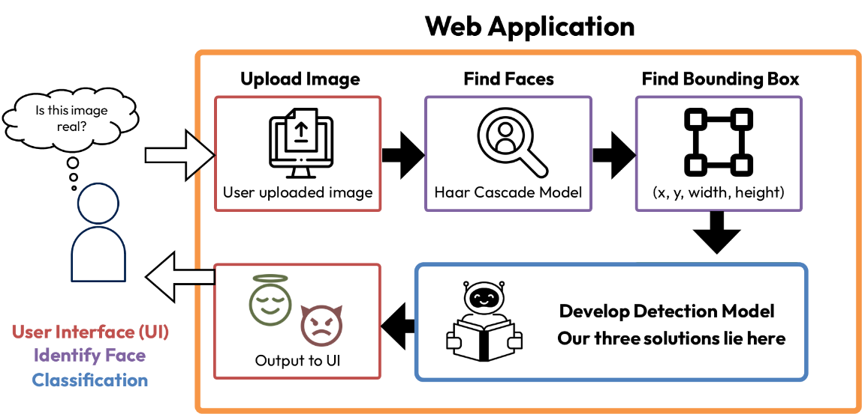
Figure 1: Proposed Solution System

Solution 1: Random Forest

Discrete Cosine Transform
A Discrete Cosine Transform (DCT) is a mathematical transformation similar in concept to the more familiar Fourier transform. A DCT converts a series of data points into a sum of cosine functions, each with different frequencies [35]. While similar in concept to a Fourier transform, a DCT uses only real numbers. DCT has many uses, but it is widely used in image and video compression because of its efficiency in representing data [36]. For this solution, we are making use of the DCT to create our input data for the Random Forest Model. For this solution, we feed the RGB values of a given image through a DCT and store the resulting values (cosine coefficients). Each color channel has its own feature vector, and these vectors are what we use as input for the Random Forest Model.
We chose to use the DCT for this solution so that we could be efficient with our data. Originally, we were extracting the RGB values and storing them into csv files to use as input data. These files were very large and were slow to generate. Thus, with advice from our advisor, we decided to perform a DCT on those RGB values and store the first 100 coefficients instead. This approach allows us to represent the image’s qualities with only 100 values as opposed to three values per pixel in the image, which would be approximately 196,608 values for a 256x256 image. This is for one image, and our dataset partitions contain hundreds of images of varying sizes. Using the DCT allows us to more efficiently represent our data.

Random Forest Model
Our first classification model will utilize the extracted DCT values to train a Random Forest model. The random forest is a machine learning algorithm that classifies by combining the output of multiple decision trees. This is an ensemble learning method, which combines multiple models to achieve higher accuracy, rather than a single model. The main component of a Random Forest model are the decision trees, each tree is built by the splitting of data, based on its structure, leading to the creation of the leaves. Each tree in the forest is trained on a random subset of training data, which is bootstrapped, meaning that some datapoints may appear within multiple trees learning data. Figure 2 visualizes the structure of a Random Forest algorithm [38].
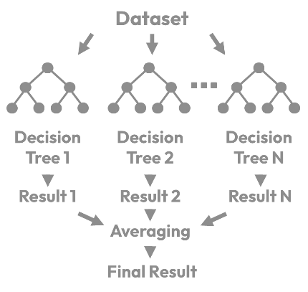
Figure 2: Random Forest Visualization
When designing the Random Forest model, there are several hyperparameters that may be alternated to tune the model’s accuracy and generalization. The number of estimators, or number of trees within the forest. The maximum depth of each tree, the minimum number of samples needed to split a trees node, and the minimum number of samples required within a leaf node. These hyperparameters are summarized in Table 3 [39].
Table 3: Random Forest Hyperparameter Considerations
Hyperparameter | Purpose | Typical Test Values
(Python Variable) | Purpose | Typical Test Values
N estimators | Number of trees in a forest More trees, higher accuracy, increased computational power | 50, 100, 200
(n_esimators) |  | 50, 100, 200
Maximum depth | Maximum depth of each tree, controlling model complexity and preventing overfitting | 5, 10, 20, None
(max_depth) |  | 5, 10, 20, None
Minimum Samples Split | minimum number of samples required to split a node, more values result in simple trees | 2, 5, 10,
(min_samples_split) |  | 2, 5, 10,
Minimum Samples Leaf | Minimum numbers of samples needed for a leaf node to prevent overfitting | 1, 2, 5, 10
(min_samples_leaf) |  | 1, 2, 5, 10
Maximum Features | Number of features to consider when looking for best split | 'sqrt', 'log2', 0.2–1.0 fraction of total features
(max_features) | Number of features to consider when looking for best split | 'sqrt', 'log2', 0.2–1.0 fraction of total features
Bootstrap | Using bootstrap samples | True/False
(bootstrap) | Using bootstrap samples | True/False
Criterion | Function to measure quality of split | ‘gini', 'entropy'
(criterion) | Function to measure quality of split | ‘gini', 'entropy'
Random State | Seed for reproducibility | Any value
(random_state) | Seed for reproducibility | Any value

In addition to alternating the hyperparameters of the model, the DCT values may be alternated as well. As the upper left corner of the DCT quantifies low frequencies, while the lower right corner summarizes the high frequency values. High frequency values describe the sudden change between two textures, and low frequency is used to describe gradients. Certain portions of these values may be selected to train on, as shown in Figure 3. Code 1 demonstrates how the Random Forest models is initiated, trained and evaluated [36].
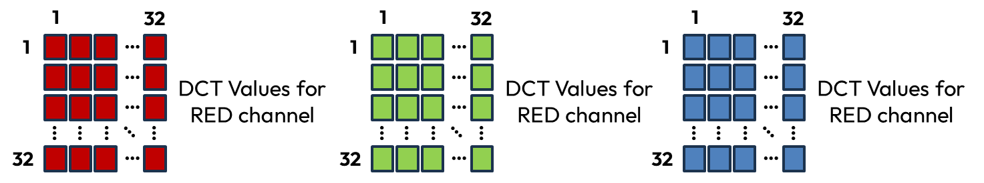

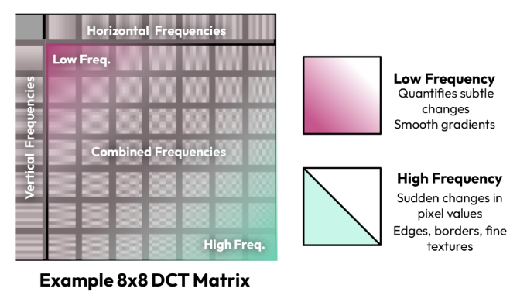

Figure 3: DCT Visualization
rf = RandomForestClassifier( # initialize random forest with hyperparameters
n_estimators=100, # number of trees
max_depth=None, # maximum depth of each tree
min_samples_split=2, # minimum samples required to split a node
min_samples_leaf=1, # minimum samples required at a leaf
max_features='auto', # number of features considered for best split
bootstrap=True, # use bootstrap samples when building trees
criterion='gini', # function to measure quality of split
random_state=42) # random seed for reproducibility
rf.fit(X_train, y_train) # train the model
y_pred = rf.predict(X_test) # predict on test set
Code 1: Example Random Forest Implementation

Solution 2: Convolutional Neural Network (CNN)

Parallel Dataset
This new parallel dataset is essentially the same as the dataset we used for Solution 1. We will be extracting the faces from the images in our original dataset and storing them as their own image. We are making this modification to the dataset so that we can train the CNN on one image at a time in hopes that this will allow the model to learn more effectively.

CNN
Convolutional Neural Networks is a type of deep learning model that processes grid like data, such as images and is commonly used within image classification. CNNs are made up of several layers including the convolutional, pooling and fully connected layers. The convolutional layers apply filters, also known as kernels, to the input image to allow the detection of various features, such as the edges, textures and patterns. These features would then be learned within the training process [40].
The pooling layers would reduce the spatial dimension of the image, helping retain the most important features, reducing computational complexity. The fully connected layers would take in the high level features that were extracted by the previous layers and use them to make a classification. When trained, these layers would learn the patterns differentiated between real and generated content. Figure 4 visualizes the layers of the CNN, and how they are utilized to classify an image.
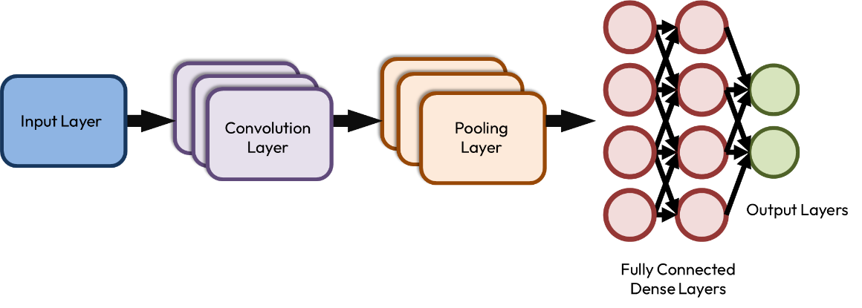
Figure 4: Layers of CNN
As the CNN processes images, not matrix features of vectors, a parallel dataset of just the extracted faces would need to be utilized for training and evaluation. Once a CNN model is initiated, convolutional layers are added, the filter number and the size across the image are defined, and the activation model is defined. These layers learn the low-level features such as the edges of the image. A pooling layer is then introduced which reduces the spatial dimension of the data and the computational cost to process [41]. Table 4 provides a brief explanation of the purpose of each layer and their parameters.
Table 4: CNN Layers
Layer | Description | Parameters
Input Layer | Takes in image information | Input size of image
Convolutional Layer | Feature Extraction using kernels (filters) | Number of filters, Filter size (pixel x pixel), Stride, Padding
Activation Layer | introduces non-linearity | Activation function choice
Pooling Layer | Reduces spatial dimensions | Pooling type (max, average, global), pool size (n×n), stride
Fully Connected Layer | Connects features to output classes | Number of neurons, activation function
Output Layer | Produces final prediction | Number of classes (2: Real/Fale), activation function

The 2-dimentional features are then flattened into a 1-dimenstional vector then passed to the fully connected layers. The output layer is made up of 2 neurons, where they represent 0-real or 1-fake, initiated with an activation function, which would output a probability distribution for each class, allowing the model to classify the image [41]. Code 2 demonstrates an example of how a CNN and its layers are initiated.
X_train=X_train/255 # normalizing the pixel values
X_test=X_test/255 # normalizing the pixel values
model=Sequential() # defining model
model.add(Conv2D(32,(3,3),activation='relu',input_shape=(28,28,1))) # adding convolution layer
model.add(MaxPool2D(2,2)) # adding pooling layer
model.add(Flatten()) # adding fully connected layer
model.add(Dense(100,activation='relu'))
model.add(Dense(10,activation='softmax')) # adding output layer
model.compile(loss='sparse_categorical_crossentropy',optimizer='adam',metrics=['accuracy']) # compiling the model
Code 1: Example CNN Implementation
Once the model is implemented, it would be trained on the data, and the number of Epochs would be varied. Epochs are passthrough on the entire training data, where the model is able to learn and update its internal weights based on the error within tis predictions, allowing the model to gradually improve its accuracy. Table 5 provides a brief explanation of the parameters found in each layer and their purpose [40].
Table 5: CNN Parameter Definition
Layer | Parameter | Definition
Convolutional Layer | Stride | Step size taken by the filter has it moves across the input image.
Convolutional Layer | Padding | Adds extra pixels around the input of the image prior to convolution, helping control the size of output.
Pooling  Layer | Pooling Type | Reduces the spatial size of the feature maps while keeping important information.
Pooling  Layer | Pooling size | Dimension of the pooling region.
Fully connected Layer | Activation function | Adds nonlinearity and allows the network model to form complicated decision boundaries.
Output Layer | Activation Function | Transforms probability calculations to classification.

Solution 3: Xception Model

Model
Xception is a deep learning model used for image classification and stands for Extreme Inception, proposed in 2017. While normal CNNs utilize convolutions to learn image patterns, Xception models look at the spatial patterns within each channel individually and combine the information within the color channels. This process is called depth wise separable convolution and makes the network more efficient due to the usage of less parameters. This process is oftentimes more accurate than a traditional CNN. Xception models have become a benchmark for DeepFake detection, due to their ability to detect subtle artifacts such as blending errors, color mismatches and or texture inconsistencies. This solution will utilize the same parallel dataset developed for Solution 2 for training, development and evaluation [42].
The Xception model is made of three portions, an entry flow, a middle flow, and an exit flow. The entry flow is the first layer that processes the input image, to extract low-level features such as edges, colors and textures. The middle flow is considered the core of the network, where its purpose is to extract deeper and more abstract features. The exit flow is the final layer prior to classification, where the features are compressed. The exit flow considers all the features learned and provides a classification of real or fake. Between each convolutional layer and flow, a residual skip connection is included. This adds the original input to the layers output. This prevents the information from degrading as it is passed through system [44]. Figure 4 demonstrates how the model layers are organized. Table 5 demonstrates the various parameters of the Xception model layers and which portions can be adjusted [43].
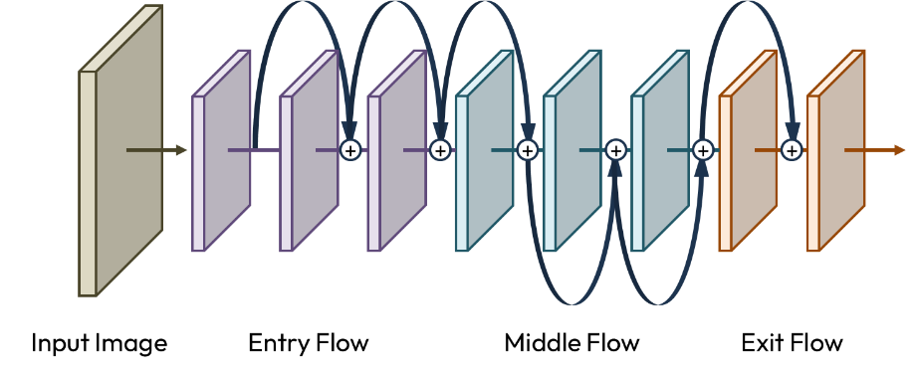
Figure 5: Xception Model Flow
Table 6: Parameters of Xception Model
Layer | Purpose | Parameter
Entry Flow | Extracts low level features | Filter size, Filters, Stride, Padding, Activation
Middle Flow | Learns higher level features | Filter size, Filters, Stride, Padding, Activation
Exit Flow | Produces classification results | Filter size, Filters, Stride, Padding, Activation, Global Average Pooling, Dense Units

Next Step
We plan to begin our evaluation using the Random Forest model because prior research has demonstrated its effectiveness as a baseline for DeepFake detection, particularly when combined with handcrafted feature extraction methods such as Histogram of Oriented Gradients (HOG) and Local Binary Patterns (LBP) [45], [46]. Random Forest is also quick to train, computationally efficient, and relatively easy to interpret compared to deep learning models, making it an ideal first choice for establishing baseline performance. After validating the Random Forest results, we will transition to a Convolutional Neural Network (CNN), which is specifically designed for image analysis tasks and better suited to learning spatial and texture-based features directly from the data. Finally, we will evaluate the Xception model as our third approach due to its demonstrated state-of-the-art performance in DeepFake detection benchmarks [47]. Although our initial focus will be on Random Forest, as optimization continues, we will move on to develop and test the CNN and Xception models. Our long-term objective is to make all three models accessible for users to evaluate and contrast, offering a balance between computational demands, speed, and accuracy.

Preliminary Design
Our three proposed solutions for DeepFake detection included the implementation of a Random Forest model, a Convolutional Neural Network (CNN), and the Xception model. The Random Forest model was previously implemented and thoroughly tested as a baseline, achieving approximately 55% accuracy. We selected the CNN model as our primary solution, since it can directly learn from image data without manual feature extraction, unlike the Random Forest. This model is highly applicable to object recognition tasks and can be optimized effectively. To implement this model, a dataset of images would need to be selected. Figure 6 demonstrates the steps required to implement and train the CNN.
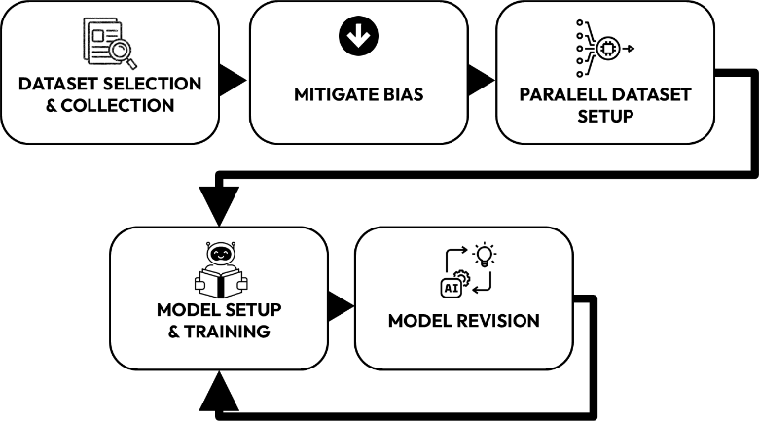
Figure 6: Preliminary Design Process

Dataset Selection:
The scope of this project needs a dataset large enough to train and evaluate full models. However, the Neuronix cluster has limited processing power, constraining dataset scale. To solve this problem, this project focuses on Deepfake images instead of videos. Furthermore, supervised Machine learning algorithms limit this project from using unlabeled data. This means a dataset containing annotated real and Deepfakes images is needed to train our classifier. Lastly, the dataset needs high quality images, representative of modern Deepfake technology, to prove feasibility.
From a limited number of choices, the OpenForensics dataset was chosen. As mentioned previously, this dataset is open-source and contains 45,473 real faces and 70,325 fake faces [33]. This large size gives more than enough data to create high quality CNN models. Fake images were generated with proprietary GAN models, resulting in high resolution 512 by 512-pixel faces [33]. On averages images contain resolutions of greater than 680p, with 2.9 faces per image [33]. These qualities make the dataset an exceptional representation of modern Deepfake technology. The dataset comes prearranged into 4 subdivisions, categorized according to Table 7.
OpenForensics annotations use a “json” file corresponding to each sub-division. These files reference images by two arrays. Array 1, column 1 of Table 8, contains file information for each image. Array 2, column 2 of Table 8, contains annotation data per face in each image. Linking these two arrays is the numerical “Image ID” category.
Facial annotations contain multiple categories, for richly detailed labels. “Face ID” gives each face a numerical identifier. “Iscrowd” is a Boolean value corresponding to whether images have abnormally high number of faces. “Area” is the size of the annotated region. The “category_id” is a Boolean classification of each face as real, 0, or fake, 1. The “bbox” is a sub array of 4 integer values. These values draw a rectangular box around the annotated face. From top to bottom, the values represent “X”, “Y”, width and height. “Segmentation” is another sub array. This sub array contains pixel coordinates which draw an outline around the annotated face. Coordinates start with “X” and alternate between “X” and “Y” values.
Annotations were converted from “json” files for compliance with ISIP formats. The new system separates annotations into “csv” files for each image. Following Table 9, the rows of each value would correspond to a single face in the image. The “json” annotation array data is placed in each column of each row.
Table 7: Dataset Images
Division | Faces
Test-challenge | 45000
Test-dev | 18895
Train | 44097
Val | 7308

Table 8: Dataset Annotation
Images | Annotations
Image ID | Image ID
File Name | Face ID
Width | Iscrowd
Height | Area
 | Category ID
 | BBox
 | Segmentation

Table 9: Annotation CSV
Face ID | IsCrowd | Area | CategoryID | BBox1 | BBox2 | BBox3 | BBox4 | Segmentation
Face 1
…
Face N
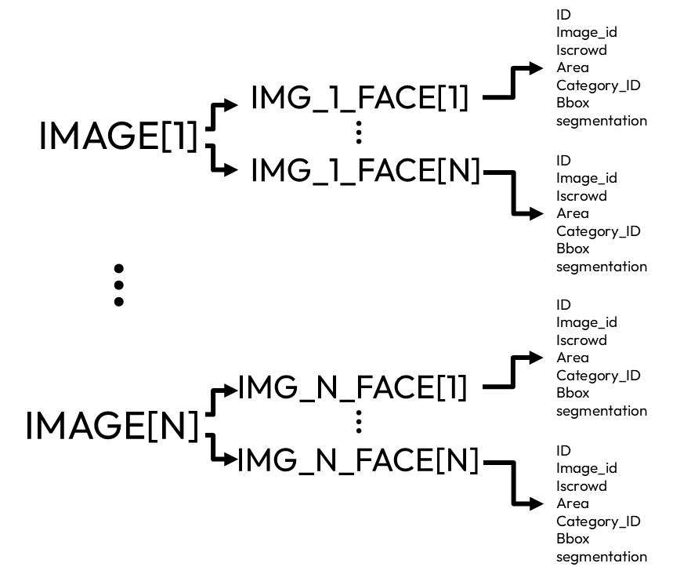
Figure 7: Dataset Annotation
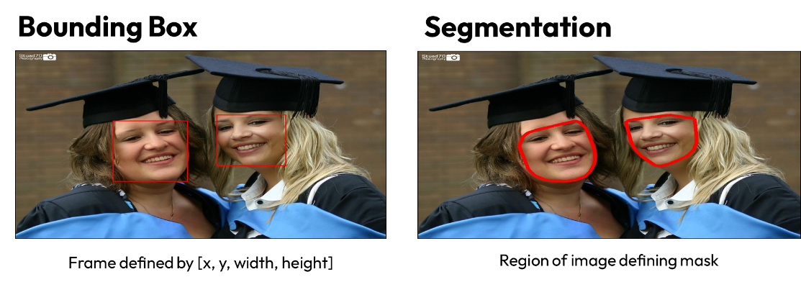
Figure 8: Segmentation & Bounding Box Mapping

Mitigating Dataset Bias
When preparing a training dataset, it is important to have all the classes represented with equal number of samples. Each class, in our case “Real” or “Fake” need to have an equal number of data points. A balanced dataset would prevent model bias, where one model would learn to classify towards the majority class and ignore the minority. For example, a model trained on a dataset of 90% real and 10% fake would consistently predict real. This would produce 90% accuracy but would be useless in detecting fake images [37]. A balanced dataset would effectively learn meaningful patterns from both classes, improving the generalization of the model. Providing a balanced dataset would also improve the stability in training and could result in a faster accuracy convergence [57].
The Open Forensics dataset selected for training demonstrated an imbalanced amount of real to fake faces. This imbalance stems from the image classification. An image containing multiple faces is classified as fake if one face is fake. Rather than training the model based on the features of the entire image, the portion specified by the bounding box was extracted and analyzed for classification. Based on this observation, we will be training our model on the face portion of the dataset. This would require a parallel dataset comprising only the face portion of each image.

Face Detection Algorithm
Face detection is the first stage in our deepfake detection pipeline. It isolates facial regions for later feature extraction and classification. By extracting only faces, the system significantly decreases unnecessary data processing and directly addresses our chosen focused area of manipulation in deepfake forensics. For our design, we chose the Haar Cascade Classifier because of its fast inference speed, minimal computational overhead, and simplicity of implementation in real-time or resource-constrained settings. To ensure that our solution is both practical and scalable for further development, these features are crucial given our objective of real-time or near-real-time detection on standard images.

The Haar Cascade algorithm, introduced by Viola and Jones [34], detects objects using a cascade of simple rectangular features inspired by Haar wavelets. Each feature is calculated as the difference in pixel intensities between adjacent rectangular regions as seen in equation 1. IN Eqn. 1, R₁, R₂ are adjacent rectangular regions, and I(x,y) is the pixel intensity.

$$f_{i}=\sum_{x,y∈R_{1}}{I(x,y)}-\sum_{x,y∈R_{2}}{I(x,y)}$$

Equation 1: Haar Feature Calculation

The use of integral image representation is a fundamental component of the Haar Cascade technique, which makes it possible to quickly calculate feature sums across various scales and locations, significantly increasing face detection efficiency in real-time situations. By creating a powerful classifier as shown in equation 2, the AdaBoost algorithm is crucial to further improving the selection of useful features. In this process, multiple weak classifiers—each specializing in distinguishing certain facial patterns—are combined into one ensemble, weighted according to their accuracy in discriminating face and non-face regions. This ensemble method ensures reliable detection performance while maintaining low computational overhead [48].
$$H\left(x\right)=sign\left(\sum_{t=1}^{T}{∝_{t}h_{t}(x)}\right)$$

Equation 2: AdaBoost Strong Classifier

The algorithm is an ideal starting point for our system because of its simplicity and efficiency. Higher accuracy is possible with deep learning-based techniques like MTCNN or RetinaFace, but they are less appropriate for rapid prototyping because they require a lot more processing power and require longer training periods. The accuracy, computation time, and hardware requirements of the Haar Cascade and other well-known face detection models are contrasted in Table 10.
Table 10: Comparison of Face Detection Models
Model | Accuracy (%) | Computation Speed | Hardware Requirement | Key Strength
Haar Cascade [34] | 85–90 | Fast  (CPU-based, ~15–30 FPS) | Low | Lightweight and easy to deploy
HOG + SVM [49] | 90–93 | Moderate  (CPU-based, ~10–15 FPS) | Moderate | Better under varied lighting conditions
MTCNN [50] | 95–98 | Slow  (GPU recommended) | High | High accuracy and multi-face handling
RetinaFace [51] | 97–99 | Slow  (GPU required) | High | State-of-the-art accuracy

The Haar Cascade offers a practical trade-off between accuracy and performance, suitable for projects where real-time detection and resource efficiency are priorities. Following the detection of a face, the algorithm produces a bounding box that represents the upper-left corner and width/height of the detected region and is defined by the coordinates (x, y, w, h). After that, these bounding boxes are sent to later models for feature extraction or deepfake classification.

Creation of Parallel Dataset
Currently, we are working with two new/parallel datasets for this design. One of these is an evaluation dataset we’re generating ourselves, and the other one is parallel dataset that is a modification of the Open forensics dataset that we used alongside our baseline Random Forest solution.
The new evaluation dataset will be 200 images in total sourced from “Caltech’s 10k Web Faces” dataset [52]. Of these 200 images, 100 are real, and 100 are fake. These new fake images will be face swaps like the OpenForensics dataset. Unlike the OpenForensics dataset, these face swaps will not be created using a GAN method. Instead, 50 images will be created manually using Photoshop, and the other 50 images will be created using a free website called “Deepfake Maker” [52].
The parallel dataset uses all the original data we used from the OpenForensics dataset with some modification. In the OpenForensics dataset, images could contain one or more faces, background elements, and dead space. This parallel dataset will include only the faces, each face will be its own image with minimal dead space.

Parallel Dataset Implementation
The creation of the new evaluation dataset is straightforward. For the 50 Photoshopped images, the face of the target is cut out from the target image and then placed over the face of the source image. The resulting image is smoothed using Photoshop’s Auto-Blend feature, demonstrated in Figure 9.
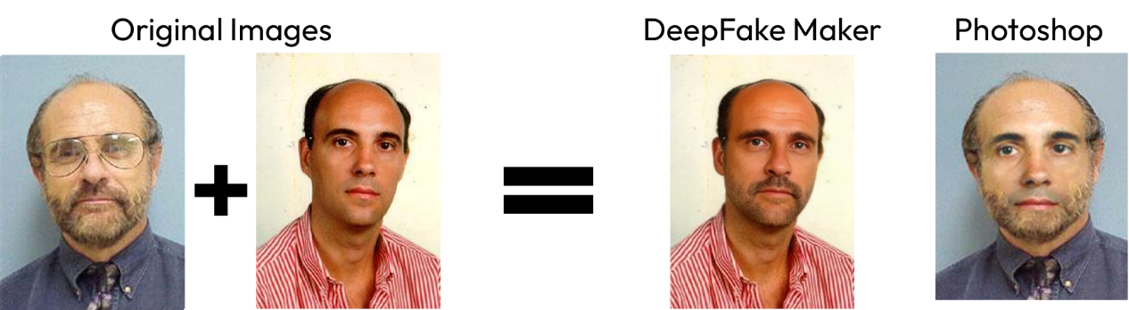
Figure 9: Generated Evaluation Dataset
To create the parallel dataset, we used NEDC (Neural Engineering Data Consortium) software. We used NEDC’s nedc_dpath_gen_images tool to crop the faces. This tool is powerful and offers a variety of functionality. For this application we used the tool to extract the faces from a given image. We provided a list of image files (.jpg images) and a list of corresponding annotation files (.csv files) as inputs and got the new image(s) of the extracted face(s) as output along with corresponding annotation files for each extracted face. Additionally, we specified the parameters used to parse and read the annotation file, the dimension the new image (256x256), the extensions for the new images and annotation files, and the output directory. Figure 10 demonstrates an example of the extracted faces.
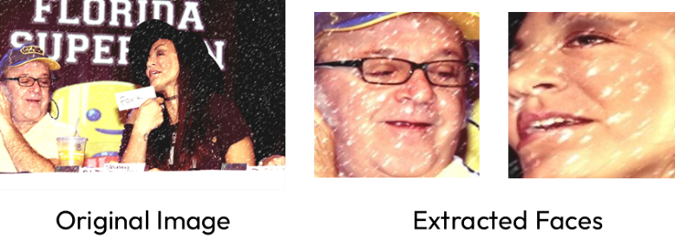
Figure 10: 256 256 image extracted
For our two new datasets, we have two different motivations. In line with our dataset generalizability design requirement, this dataset will allow us to understand whether the model is learning to recognize DeepFakes in general, or if it is learning to recognize GAN face swapped images.
The parallel dataset will be used to facilitate the training of our CNN based solution. Firstly, the images that these models classify have manipulations in the face region due to the common methods of creating these deepfakes. Since it will have to classify images that have manipulations in the facial regions, starting with images that contain only faces makes for a more successful detection workflow.

CNN
CNNs are a form of Deep Learning model that automatically extract and learn spatial features from image data. This model utilizes convolutional operations to preserve the spatial relationship within the image pixels. The model is made up of several layers including the input, convolution, pooling and fully connected layer.

Convolutional Layer
The function of a Convolutional layer is to apply a set of filters, formally known as kernels, to the input of the image to extract important features such as patterns, textures and edges. This operation is expressed within Equation 1.
$$Z=X*W+b$$
Equation 1: Image Convolution
In the equation above, $X$ represents the input image, $W$ represents the kernel, and $b$ Is the bias symbol. The image convolutional operation involves the kernel sliding across the image and computing element wise multiplication and summation at each point.
The convolutional layer is made of three portions, the lower, middle and higher layers. The edges, lines and colors are identified within the lower layers. The middle layers identify patterns, shapes and textures, while the higher layers are able to distinguish faces [40].
Figure 11 demonstrates the Prewitt filter applied to an image, which is a manual example for the lower convolutional layers, deriving the gradient magnitude, X and Y direction derivatives. The Prewitt filter is a form of edge detection filter. It highlights the edge of an image by calculating the gradient of the image intensity function and utilizes two 3$×$3 convolution kernels, one to detect horizontal edges and another for vertical edges.
Equation 2 shows the formulas for the Prewitt operation. $G_{x}$is the Horizontal Prewitt Filter, detecting the vertical edges, or changes along the X-axis. $G_{y}$is the Vertical Prewitt Filter, detecting the horizontal edges, or changes across the y-axis. $\left|G\right|$represents the calculation of the magnitude of the gradient, representing the straight of the edge at each pixel. This process allows for the detection of localized spatial features, while preserving the spatial correlation between pixels, enabling the CNN to learn the visual pattern for image recognition [58].
$$G_{x}=\left[\begin{matrix}-1 & 0 & +1 \\ -1 & 0 & +1 \\ -1 & 0 & +1\end{matrix}\right], G_{y}=\left[\begin{matrix}+1 & +1 & +1 \\ 0 & 0 & 0 \\ -1 & -1 & +1\end{matrix}\right], \left|G\right|=\sqrt{G_{x}^{2}+ G_{y}^{2}}$$
Equation 2: Prewitt Filter
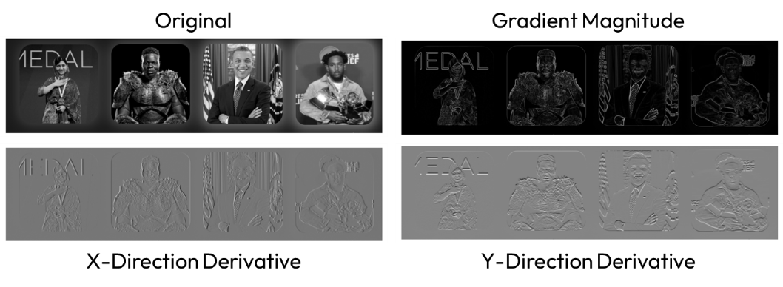
Figure 11: Prewitt Filter

Activation Function
The activation function introduces non-linearity to the CNN, which allows it to learn complicated patters and relationships within the data. Without an activation function, the model would be limited to linear classification, regardless of the number of layers. An activation function allows the model to capture the intricate features within the image. The most common activation function is ReLU which is demonstrated in Equation 3, where $x$ represents the input to the function, which is the weighted sum of inputs and bias ($b$) from the previous layer.
$$f\left(x\right)=\max\left(0,x\right),$$
$$x=\sum_{i}{W_{i}∙}a_{i}+b$$
$$W=\left[\begin{matrix}w_{11} & ⋯ & w_{1n} \\ ⋮ & ⋱ & ⋮ \\ w_{m1} & ⋯ & w_{mn}\end{matrix}\right]$$
Equation 3: ReLU Function
Wi is the weight connecting neuron I from the previous layer and is the weight from the element of the kernel, ai is the output, or activation from the previous layer, and b is the bias term [59].

Pooling Layer
The goal of the pooling layer is to reduce the spatial dimension of the feature map, while maintaining the most important information. This helps decrease computation complexity, mitigate algorithmic overfitting, and increases the networks robustness. By reducing the complexity of the feature map, the representation becomes smaller and summarizes the region of the feature map. The parameters of the pooling layer are summarized in Table 11, while Table 12 summarizes the pooling methods that can be utilized within this layer [60].
Table 11: Parameters of Pooling Layer
Parameter | Definition | Type of Values
Pool Type | Type of pool operation | Max pooling, Average Pooling, Global Max pooling, Global Average Pooling
Kernel Size | Size of sliding window | NxN pixels
Stride | Number of pixels the window moves | 1,2- equal to kernel size to avoid overlap
Padding | Extra pixels around the input | True/False
Ceil Mode | Whether to round up or down | True/False
Return Indices | Whether to return the location of the maximum values | True/False
Dilation | Spacing between the elements within the pooling window | 1
Channel-Wise Application | Whether pooling is applied independently for each channel | True/False

Table 12: Pooling Method
Pooling Method | Definition | Usage
Max Pooling | Selects maximum value in the pooling window | Most common and emphasizes prominent edge features
Average Pooling | Selects the average value in the pooling window | Smooths feature maps and reduces noise
Global Max Pooling | Takes the maximum value in the feature map | Reduces the entire feature map to a single value
Global Average Pooling | Takes the average value in the feature map | Reduces the entire feature map to a single value
Stochastic Pooling | Selects a random value in the window based on probability | Used to improve regularization and prevent overfitting

Fully Connected Layer
The fully connected (FC) layer is a neural network layer where every neuron is connected to the neuron within the previous layer. The FC layer utilizes the features extracted by the convolutional and pooling layer to make its final prediction. This layer converts the 2-dimensional feature maps from the convolutional and pooling layers into a 1-dimensional vector used for classification, learning complication combinations of features. Table 13 summarizes the types of FC layers we may utilize, and Table 14 demonstrates the hyperparameters that may be utilized within the FC layers [55].
Table 13: Types of Fully Connected Layers
FC Layer | Definition | Usage
Standard or Dense Layer | Each neuron is connected to all the neurons in the previous layer | Placed after pooling layer
Dropout Layer | Randomly disables some of the neurons within training | Placed after dense layers
Batch Normalization Layer | Normalizes the input of the layer to have zero mean | Can be places before or after dense layers
Residual /Skip Connections | Adds the input from a previous layer to the output of a dense layer | Used to prevent vanishing gradients

Table 14: FC Hyperparameters
Hyperparameter | Description | Values
Number of Neurons | Number of neurons within the layer | Constant N
Activation function | Function applied to the output of each neuron | ReLU, Signmoid, Tanh, Leaky ReLU
Dropout Rate | Fraction of neurons randomly disabled | 0.2-0.5
Weight Initialization | Method used to initialize the weights prior to training | Xavier, He, Random Normal
Bias Initialization | Initial value of bias | 0
Regularization | Penalizes the large weights to reduce overfitting | 0.0001-0.01

Output Layer
The output layer is the last stage of the CNN and is responsible for creating the models’ predictions based on the features extracted and analyzed within the previous layers. Within this layer, each neuron calculates a weighted sum of its inputs and adds a bias term, as shown in Equation 4, where $a_{i}$ represents the activated outputs from the previous layer ($i)$. This is then passed through an activation function to produce the output classification of the network [44].
$$y=f\left(\sum_{i=1}{W_{i}∙}a_{i}+b\right)$$
Equation 4: Output Layer Calculation

Algorithm Optimization
When optimizing a neural network, the goal is to adjust the weight and bias along all the internal layer to minimize the number of incorrect predictions and improve overall performance. This is achieved by first utilizing forward propagation to pass the input through the network, generating initial predictions. Then the error rate was calculated using a loss function and applying backpropagation to update the weights and biases according to the calculated gradients [61].

Forward propagation
Forward propagation is the initial process where input data is passed through a network to create a prediction. Within a CNN, the input image is passed through all the layers of the network and the weights and biases are applied to produce the network’s output [61].

Loss function
A loss function, also knowns as a const function is a mathematical function that measures how well a CNN model predicted to match the true labels. This is done by calculating the discrepancy between the predicted output $(\dot{y})$and the actual output $(y)$. The goal of this is to quantify the error that needs to be minimized. The smaller the loss the better the performance. Table 15 summarizes the most common types of loss functions.
Table 15: Loss Function
Loss Function | Formula | Usage
Mean Squared Error | $$L=\frac{1}{n}\sum_{i=1}^{n}{{({\dot{y}}_{i}-y_{i})}^{2}}$$ | Regression
Mean Absolute Error | $$L=\frac{1}{n}\sum_{i=1}^{n}{|{\dot{y}}_{i}-y_{i}|}$$ | Measurers the average distance between the predicted output and true label
Binary Cross Entropy | $$L=-[y\log\left(\dot{y}\right)+(1-y)\log\left(\dot{1-y}\right)]$$ | Binary Classification

Backpropagation
Backpropagation is the process utilized to optimize a CNN by updating the internal weights and bias to reduce prediction errors. Once the forward propagation calculates the networks output, the loss function is calculated. The backpropagation procedure then calculates how much weight and bias contributed to that error by calculating the gradients. Table 16 demonstrates how the kinds of gradient to be calculated.
Table 16: Backpropagation Methods
Gradient Type | Definition | Derivative
Weight | Derivative of the loss with respect to weight | $$\frac{∂L}{∂w}$$
Bias | Derivative of the loss with respect to bias | $$\frac{∂L}{∂b}$$
Activation | Derivative of the loss with respect to the output of a neuron | $$\frac{∂L}{∂a}$$
Input | Derivative of the loss with respect to the input of a layer | $$\frac{∂L}{∂x}$$
Layer | Derivative of the loss with respect to the input of a entire layer
Gradient w.r.t Convolutional FILTERS | Derivative of loss with respect to convolutional filters

The gradients determine the direction and magnitude of change required for each parameter to minimize the loss. An optimization algorithm utilizes these gradients to calculate the weights and bias. This process allows the network to learn and improve upon its mistakes by identifying which parameters mostly contributed to its errors. This process is iterated over a specified number of epochs until the network converges [62].

Engineering Design Plan
To implement our CNN model, we first need to develop our parallel dataset of uniform images. Then we would be able to design the input layer of the model; each step needs to be deliberately optimized and debugged to support large scale training and evaluation. The hyperparameters and activation functions within each layer need to be tuned and optimized to better understand how our model is able to extract meaningful features from the data, improving its ability to generalize and classify accurately on unseen images.
The output of our experiments would be results in the form of heatmaps of our accuracies and a comprehensive review of how each parameter affected the training and evaluation process. Within the next two weeks we will be focusing on finalizing the dataset processing pipeline and implementing the initial CNN structure with baseline experiments.

Testing Methods
Model Performance
To determine the algorithmic performance across diffiecent CNN architectures, we will be testing three models: our custom architecture DeepTRUTH, EfficientNet 0, and a Vision Transformer (ViT) model. The experimental framework from the training, development and evaluation architecture has been adopted from the framework developed by the ISIP researchers. We will modify their existing methods to support binary classification of DeepFake images.
All model training and development will be performed on the NEDC SLURM-based GPU cluster. This process was done on the GPU node nedc_012, while model evaluation will be carried out on CPU node nedc_002. These environment used CUDA version 12.8 with the PyTorch deep learning structure.
The parallel OpenForensics dataset was used for the training, validation and evaluation processes. A pre-processing process was implemented for all subsections of data. The images were resized to 256×256 and converted into tensors and were normalized. Within the training dataset, some images were horizontally flipped.
All three models were trained using the same hyperparameters including a batch size of 8, a training process of 20 epochs, and a AdamW optimizer was used with a learning rate of 0.001. After each batch within the training process, the loss rate is printed. This process is shown in Figure 12. The ReduceLROnPlateau scheduler modified the learning rate according to the validation loss every 5 epochs. A checkpoint process was used to save the best performing model. If the validation accuracy improves at the end of each epoch, then the model is saved.
As ISIP research team specializes in image classification within digital pathology, we were able to adopt their architecture for deepfake detection by modifying the classification and data preprocessing portions of the codebase.
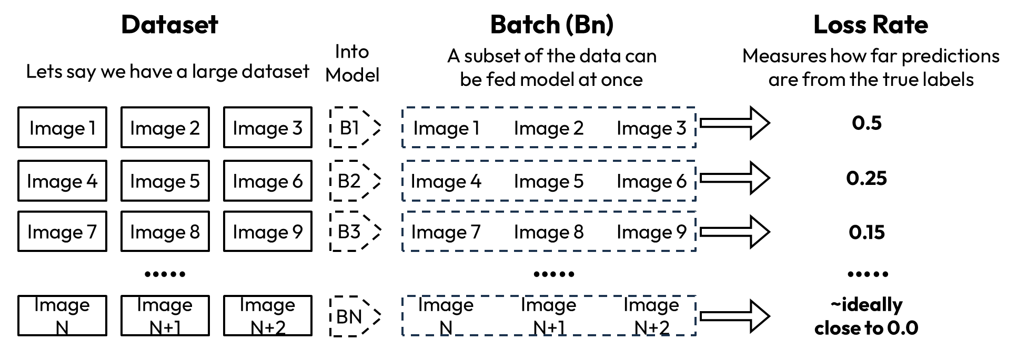
Figure 12: Dataset Processing
A variety of factors would be taken into consideration when comparing the three models, including the loss per epoch, the average time to train per epoch, and the overall model performance when evaluating. During evaluation the model is tested on the train, development and evaluation portion of datasets. This process is shown within Figure 13. A high train and development accuracy with a low evaluation accuracy may indicate some overfitting, by testing on all three sub-categories, we are able to analyze the model’s performance as a whole.
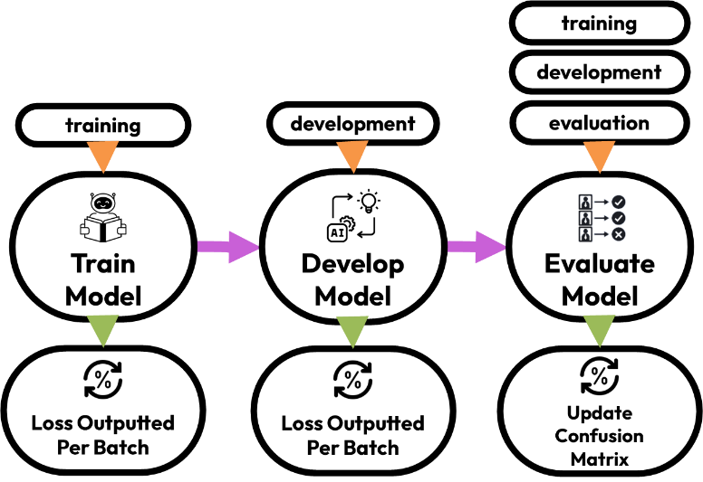
Figure 13: Training to Evaluation Process

DeepTRUTH
The baseline DeepTRUTH is a custom CNN created for binary deepfake classification. This model consists of two components that handle feature extraction and classification. The feature extraction layer includes convolutional blocks that down sample the image from 256 x 256 into 32x32x64 feature maps. The classifier would then flatten the feature map and correlate the output to the fully connected layer. The final layer would then produce a classification score.
Over 20 epochs, the average training loss per epoch decreased from 0.251 to 0.053, Figure 15 shows the decline of training loss per epoch. To test the overall performance of this architecture with various parameters, the number of convolutional layers was iterated from 2 to 8 and the kernel size from 2x2 to 10x10. After each training epoch, the model was evaluated on a test set of 100 real and 100 fake images. The resulting confusion matrices were used to calculate the accuracy, precision, recall, and F1. Figure 14 shows the increase in performance as the epoch value increases.

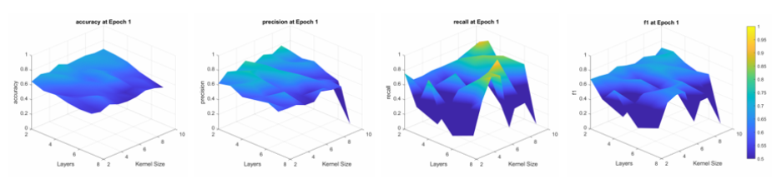
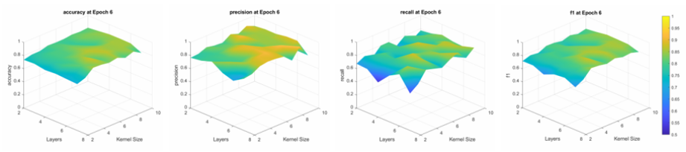
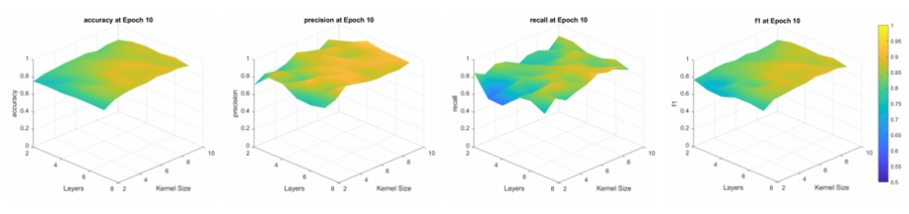
Figure 14: Performance over Epochs
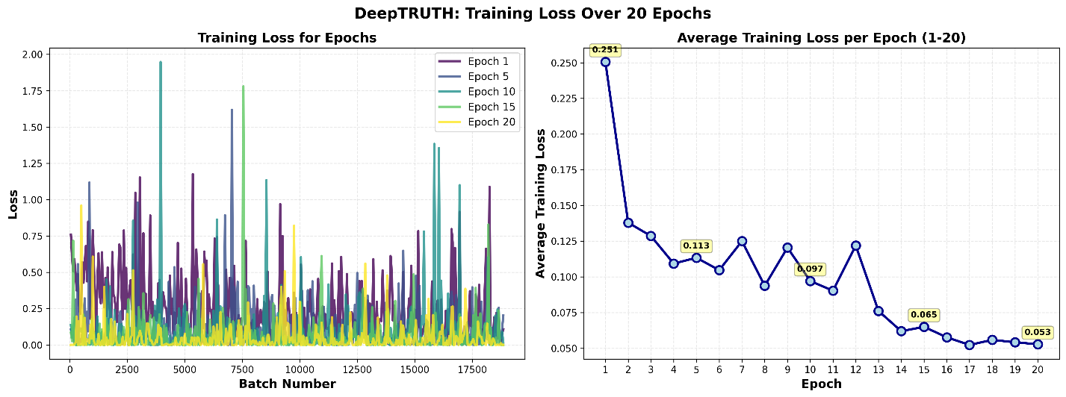
Figure 15: Loss Value Across Epochs

EfficientNet
EfficientNet is a CNN model proportionally scaled in three dimensions at once and consists of seven variations from EB0 to EB7. The model uses a compound coefficient to scale depth, width, and resolution. This balances performance improvement across multiple dimensions without manually tuning each parameter [63]. Figure 16 illustrates the gradual complexity within the models. Through this approach, EfficientNet models use less compute while achieving similar accuracies to other models [63]. For this project, EfficentNet Baseline 0 (EB0), the smallest EfficientNet model, was trained and evaluated for comparison with our proprietary model. Over 20 epochs, the average training loss per epoch reduces from 0.070 to 0.010. Figure 17 shows the decline of training loss per epoch.
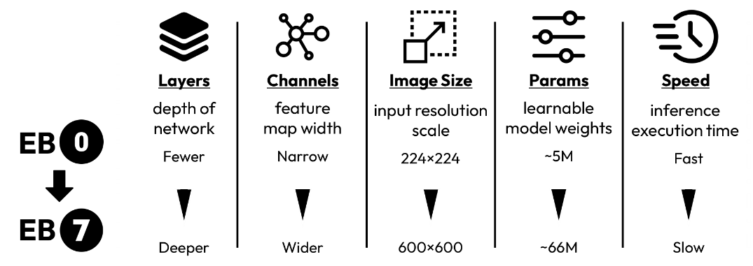
Figure 16: EB0 to EB7
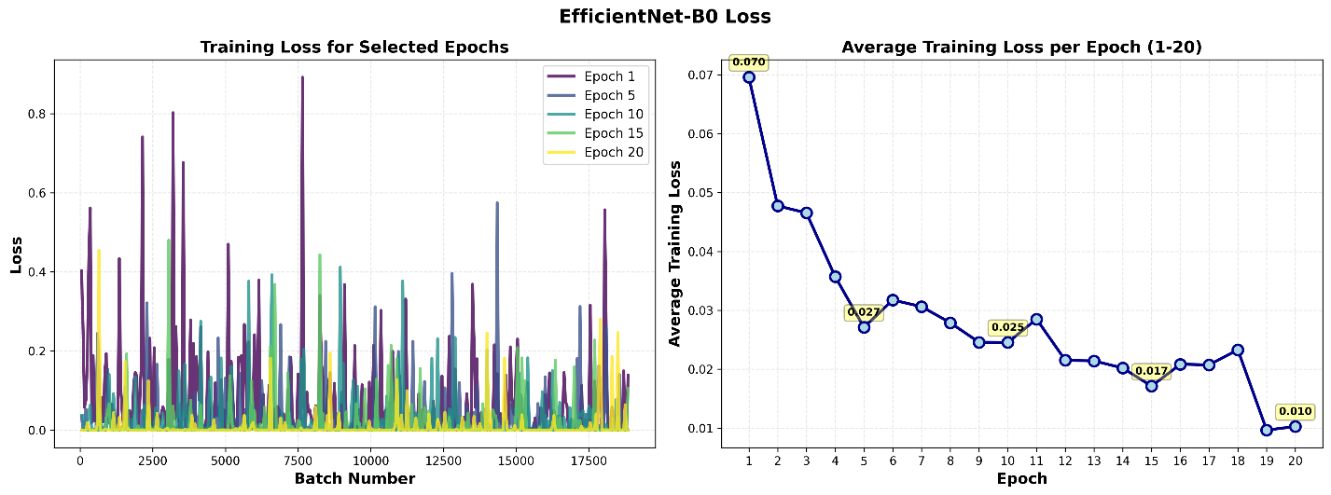
Figure 17: EB0 Loss

Vision Transformer
The Vision Transformer (ViT) model is a deep learning architecture for analyzing images that uses the transformer framework from natural language processing for visual tasks. ViT doesn't process image pixels directly. Instead, it divides each image into fixed-size patches, embeds these patches, and then sends them through transformer encoders in order. This approach allows the ViT to model long-range dependencies more effectively than standard CNN's. This results in better performance in image classification tasks, when a suitable amount of data and computational resources are available [66].

Performance Metrics
Table 17 summarizes the performance of all three CNN models across various classification metrics such as accuracy, precision, recall and F1. The models demonstrated strong classification results, showing its ability to classify generated content within the evaluation dataset with upwards of 90% accuracy. EB0 demonstrated higher overall performance than the DeepTRUTH model, reaching all our specified performance requirements.
Table 17: Performance of Various Models
System | Dataset | Performance Metric |  |  |  | Confusion Matrix
System | Dataset | Accuracy | Precision | Recall | F1 | R (0) | F (1)
DeepTRUTH | Train | 98.54% | 99.46% | 97.97% | 98.71% | 84548 | 458
 |  |  |  |  |  | 1749 | 64111
DeepTRUTH | Development | 96.41% | 95.01% | 96.46% | 95.73% | 19997 | 1051
 |  |  |  |  |  | 733 | 27937
DeepTRUTH | Evaluate | 94.44% | 89.84% | 92.13% | 90.97% | 4296 | 486
 |  |  |  |  |  | 367 | 10196
EB0 | Train | 98.97% | 99.89% | 98.31% | 99.10% | 84914 | 92
 |  |  |  |  |  | 1457 | 64403
EB0 | Development | 99.36% | 99.33% | 99.16% | 99.25% | 20908 | 140
 |  |  |  |  |  | 177 | 28493
EB0 | Evaluate | 98.90% | 98.10% | 98.36% | 98.23% | 4691 | 91
 |  |  |  |  |  | 78 | 10485
ViT  [will be updated] | Train | - | - | - | - | N/A | N/A
 |  |  |  |  |  | N/A | N/A
ViT  [will be updated] | Development | - | - | - | - | N/A | N/A
 |  |  |  |  |  | N/A | N/A
ViT  [will be updated] | Evaluate | - | - | - | - | N/A | N/A
 |  |  |  |  |  | N/A | N/A

Efficiency

Algorithm Process time
Our classification pipeline consists of three stages currently including face detection utilizing the Haar Cascade classifier, the Discrete Cosine Transform (DCT) feature extraction , and the Random Forest Classification. We conducted a scaling experiment to determine the computational efficiency of the system as the image resolution increases. To test this, an image is inputted into the tool, and is incrementally scaled up, by 1.1x, each iteration records the scale, file size and the time to run each process, Figure 18 shows the photo used for this test. Each iteration is repeated 20 times, and the average time is recorded, the results of this experiment are shown in Table 18. Figure 19 shows the total runtime as the image is scaled, while Figure 20 illustrates the runtime of each subprocess within the implemented classification system. Next, we would like to test the process time as we include more faces within the image and the speed of various face detection methods.

Figure 18: Photo Used for Test [67]
Table 18: Runtime Average
Scale | File Size (mb) | Face Detection (s) | DCT (s) | Classification (s) | Total Average Time (s)
1 | 0.029 | 0.1298 | 0.0121 | 0.0433 | 0.1851
1.5 | 0.049 | 0.1507 | 0.0171 | 0.0441 | 0.2119
2 | 0.069 | 0.2169 | 0.0255 | 0.0472 | 0.2895
2.5 | 0.102 | 0.298 | 0.035 | 0.0424 | 0.3754
3 | 0.129 | 0.3701 | 0.0482 | 0.0435 | 0.4617
3.5 | 0.17 | 0.4751 | 0.0614 | 0.0454 | 0.582
4 | 0.203 | 0.5575 | 0.0789 | 0.0433 | 0.6797
4.5 | 0.25 | 0.6831 | 0.0999 | 0.0419 | 0.8248
5 | 0.293 | 0.7693 | 0.1199 | 0.0426 | 0.9318
5.5 | 0.346 | 0.904 | 0.148 | 0.0432 | 1.0953
6 | 0.392 | 1.0181 | 0.1722 | 0.0443 | 1.2346
6.5 | 0.452 | 1.151 | 0.2005 | 0.0427 | 1.3941
7 | 0.509 | 1.2785 | 0.233 | 0.0422 | 1.5537
7.5 | 0.572 | 1.3818 | 0.2567 | 0.0408 | 1.6793
8 | 0.608 | 1.5157 | 0.2953 | 0.0415 | 1.8525
8.5 | 0.704 | 1.6949 | 0.3301 | 0.042 | 2.0671
9 | 0.776 | 1.8562 | 0.3631 | 0.0427 | 2.2619
9.5 | 0.853 | 1.9771 | 0.4041 | 0.0408 | 2.422
10 | 0.929 | 2.2091 | 0.4519 | 0.0457 | 2.7067

Figure 19: Total Runtime as Photo is Scaled

Figure 20: Runtime of Each Subprocess

Website boot time
To assess efficiency, our website is evaluated for boot time after deployment on the ISIP server. Once deployed, the site remains operational continuously, benefiting from the reliability and uptime guarantees of the ISIP server infrastructure. No further boot time delays are expected, ensuring consistent user access.

Resource Usage
Resource usage is measured with system call libraries through Python Flask. The “psutil” Library allows Python programs to pull CPU and RAM usage [64]. Incorporating this into our program allows collection of CPU and RAM metrics. Our expectation is that the metric will be well below the Neuronix server’s capacity. However, loading ML models pose significant challenges to RAM usage. This metric’s importance is that our project runs without interfering with any other processes on the Neuronix Cluster.

Dataset Generalizability
To ensure Dataset Generalizability, all models will be evaluated on the Caltech faces dataset. Because this dataset uses different Deepfake techniques and different image sources than Openforensics, results on this dataset verify that our dataset has Generalized. This is important because it proves our models have learned to recognize Deepfakes, instead underlying patterns in the Openforenics dataset. Evaluation will be handled using the same tools as previous performance metrics.

Code Maintainability

ISIP Guideline Compliance & Documentation
To ensure that we are in compliance with the ISIP guidelines and are developing adequate documentation, we will be using the existing code and documentation as a template and receiving feedback from our advisor. Firstly, as we develop our software for this project, we will use the software released on the ISIP server as a template and style guide. We will use these to make sure our naming conventions, commenting style, and program organization meets the ISIP Guidelines. After this, we will seek feedback from our advisor and make the necessary corrections and tweaks. We will follow a similar process with our documentation. Section 6.3.6.3.2 of ISO 12207 states that a project should maintain documentation and retrieve and distribute the information held within to the appropriate parties [1]. Thus, after writing our documentation using exiting documentation as a style guide, we will receive feedback on it and make necessary corrections. This feedback-corrections process will be repeated until our code and documentation are in full compliance with ISIP guidelines in accordance with the ISO 12207 standard.

Usability

Interpretability
To ensure the interpretability of our website’s visual and textual content, we performed a series of accessibility and readability tests. Using tools such as the WAVE Web Accessibility Evaluation Tool and Contrast Checker, we verified that all text and background color combinations met the minimum contrast ratios outlined in the WCAG 2.1 guidelines. Feedback from users along with our advisor also aided us in making decisions on the visual, as well as what text should be provided to aid in understanding [23].

Accessibility
The website was designed to be accessible via multiple input methods and fully compatible with assistive technology. To verify this, we tested navigation using both mouse and keyboard inputs to ensure that all interface elements were reachable through proper tab order. We also evaluated the site’s compatibility with screen readers to confirm that text and image content were described. These tests ensure that users can navigate and interact with the website without restriction, demonstrating full compliance with WCAG accessibility standards [23].

User interface
The website’s interface was designed to be intuitive, consistent, and responsive across all devices. To ensure this design criterion is met, we conducted usability testing that included both internal evaluations and external user feedback sessions. Multiple device and browser tests covering desktop, and other mobile platforms were performed to view layout consistency and responsiveness. The site was adjusted with clarity, and ease of navigation in mind. Through these tests, we confirmed that all interactive components are clearly labeled, the layout adjusts dynamically across devices, and users can intuitively complete all essential tasks without guidance, meeting our interface usability objectives.

Ethics and security

Algorithm Transparency
Our Algorithmic Transparency follows IEEE7003- 2024 Standard. Following the standard’s guidelines, a bias profile of our final AI model will be made [68]. This profile will contain adequate research into whether our model’s performance for different races or genders. Since all models will be trained on the Openforensics dataset, underlying biases will begin there. Subsections of this data can be evaluated to test performance by race and gender. The generalization requirement also helps verify whether the model has underlying biases. Our expectations are that the model will have a small amount of bias. Our dataset is large and diverse, making it harder for the model to overgeneralize by race or gender.

Website Security
To verify that our website follows cybersecurity and data privacy standards, we re-evaluated our website and focused on security compliance and responsible data management. Since the ISIP server adheres to ISO 27001 information security requirements, our application inherently benefits from this certified infrastructure. We verified this compliance through a review of ISIP’s security policies to confirm that our implementation aligned with best practices for secure web applications. In addition, we held tests to ensure that all uploaded images were processed entirely in-memory and never stored locally or on the server. This approach guarantees that no user data is retained after analysis, maintaining both data confidentiality and ethical integrity as listed within the ISO 27001 standard [30].

Preliminary Results
Model Performance

Accuracy
Table 19 shows the accuracy results of all three models implemented on the website, showing that our EB0 model reaches and exceeds the goal value of a 95% accuracy rate.
Table 19: Accuracy Comparison
 | Accuracy
Model | Train | Development | Evaluation | Goal Value
DeepTRUTH | 98.54% | 96.41% | 94.44% | 95.00%
EB0 | 98.97% | 99.36% | 98.90% | 95.00%

Precision
Table 20 shows the precision results of all three models implemented on the website, showing that our EB0 model reaches and exceeds the goal value of a 90% precision rate.
Table 20: Precision Comparison
 | Precision
Model | Train | Development | Evaluation | Goal Value
DeepTRUTH | 99.46% | 95.01% | 89.84% | 90.00%
EB0 | 99.89% | 99.33% | 98.10% | 90.00%

Recall
Table 21 shows the recall results of all three models implemented on the website, showing that our DeepTRUTH and EB0 model reaches and exceeds the goal value of a 85% recall rate.
Table 21: Recall Comparison
 | Recall
Model | Train | Development | Evaluation | Goal Value
DeepTRUTH | 97.97% | 96.46% | 92.13% | 85.00%
EB0 | 98.31% | 99.16% | 98.36% | 85.00%

F1 Score
Table 22 shows the F1 results of all three models implemented on the website, showing that our DeepTRUTH and EB0 model reaches and exceeds the goal value of a 85% F1 rate.
Table 22: Precision Comparison
 | F1
Model | Train | Development | Evaluation | Goal Value
DeepTRUTH | 98.71% | 95.73% | 90.97% | 85.00%
EB0 | 99.10% | 99.25% | 98.23% | 85.00%

Efficiency

Algorithm Process Time
The webtool was iterated upon to include 2 face detection and 3 Classification methods, the face detection models include the Haar Cascade and MTCNN, and the classification methods include the Random Forest on DCT, our custom DeepTRUTH model and the Efficientnet B0 model. Figure 21 shows the usage of the Haar Cascade compared to the MTCNN Detection methods, while Figure 22 demonstrates the varying runtime using the various face detection and classification methods as the image is iteratively scaled up by 1.1x times. Based on the expected use case of this application and the result of this experiment, we can say that our estimated total run time to detect the faces within the image and classify them is approximately 1-5 seconds. As this experiment was run locally, we can assume that the ISIP supplied GPU’s are able to run and classify faster. Table 23 shows the run time of each section of the pipeline, from the face detection to classification. Using this information, we are able to calculate the average millisecond per pixel rate, as shown in Table 24. The results from this experiment show that we have achieved our requirement of a time to pixel ratio of [].
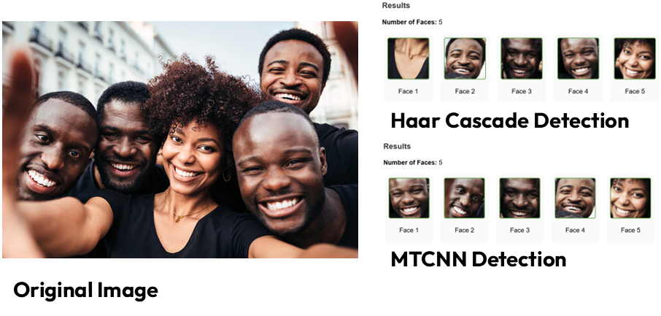

Figure 21: Small Group of People
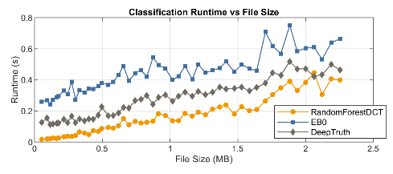
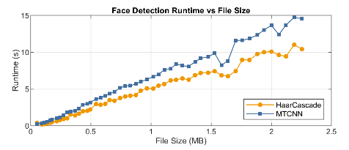
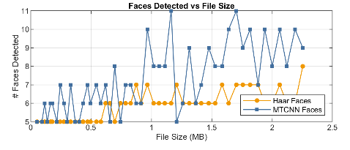
Figure 22: Small Group of People Program Run Time
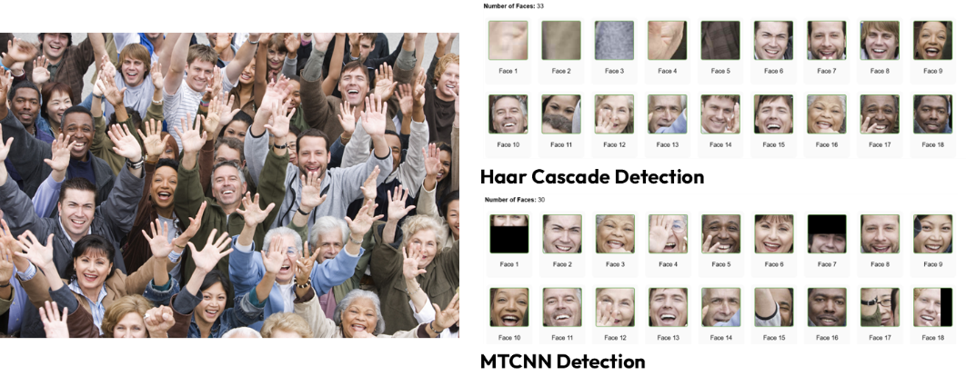
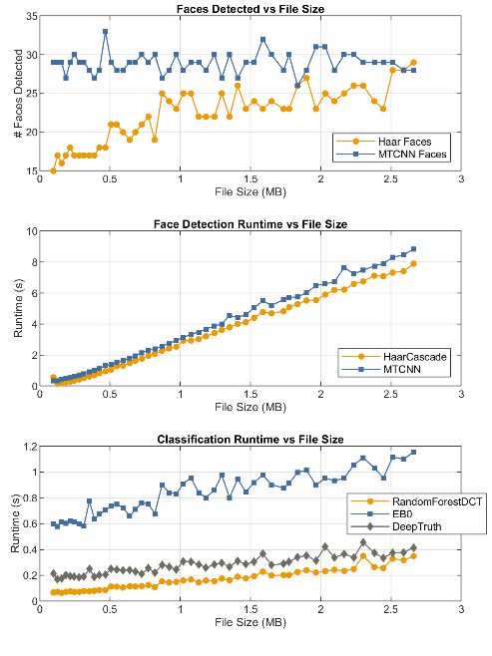
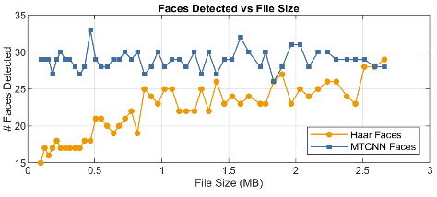
Figure 24: Large Group of People
Figure 23: Program Run Time on Large Group of People

Table 23: Section Run Time
 |  | Run Time (s)
Iteration |  | Face Detection |  | Classification
Scale | Pixel Count | MTCNN | Haar Cascade | Random Forest DCT | DeepTruth | EB0
1 | 166500 | 0.349 | 0.566 | 0.067 | 0.216 | 0.598
2 | 333000 | 0.639 | 0.351 | 0.073 | 0.192 | 0.611
3 | 499500 | 1.137 | 0.841 | 0.086 | 0.202 | 0.674
4 | 666000 | 1.785 | 1.492 | 0.116 | 0.243 | 0.661
5 | 832500 | 2.579 | 2.278 | 0.154 | 0.282 | 0.901
6 | 999000 | 3.483 | 3.03 | 0.146 | 0.284 | 0.842
7 | 1165500 | 4.43 | 4.012 | 0.19 | 0.312 | 0.945
8 | 1332000 | 5.572 | 4.83 | 0.202 | 0.291 | 0.878
9 | 1498500 | 6.594 | 5.903 | 0.233 | 0.422 | 0.953
10 | 1665000 | 7.739 | 7.122 | 0.265 | 0.373 | 1.033

Table 24: Calculating Ms/Pixel Rate
 | Iteration | HAAR+ RNF |  | HAAR+ DT |  |  | HAAR+ EB0
 | Scale | Millisecond | ms/Pixel | Millisecond | ms/Pixel | Millisecond |  | ms/Pixel
 | 1 | 633 | 3.80E-03 | 782 | 4.70E-03 | 1164 |  | 6.99E-03
 | 2 | 424 | 1.27E-03 | 543 | 1.63E-03 | 962 |  | 2.89E-03
 | 3 | 927 | 1.86E-03 | 1043 | 2.09E-03 | 1515 |  | 3.03E-03
 | 4 | 1608 | 2.41E-03 | 1735 | 2.61E-03 | 2153 |  | 3.23E-03
 | 5 | 2432 | 2.92E-03 | 2560 | 3.08E-03 | 3179 |  | 3.82E-03
 | 6 | 3176 | 3.18E-03 | 3314 | 3.32E-03 | 3872 |  | 3.88E-03
 | 7 | 4202 | 3.61E-03 | 4324 | 3.71E-03 | 4957 |  | 4.25E-03
 | 8 | 5032 | 3.78E-03 | 5121 | 3.84E-03 | 5708 |  | 4.29E-03
 | 9 | 6136 | 4.09E-03 | 6325 | 4.22E-03 | 6856 |  | 4.58E-03
 | 10 | 7387 | 4.44E-03 | 7495 | 4.50E-03 | 8155 |  | 4.90E-03
 |  | Average | 3.14E-03 | Average | 3.37E-03 | Average |  | 4.19E-03
 | Iteration | MTCNN+ RNF |  | MTCNN+ DT |  |  | MTCNN+ EB0
 | Scale | Millisecond | ms/Pixel | Millisecond | ms/Pixel | Millisecond |  | ms/Pixel
 | 1 | 416 | 2.50E-03 | 565 | 3.39E-03 | 947 |  | 5.69E-03
 | 2 | 712 | 2.14E-03 | 831 | 2.50E-03 | 1250 |  | 3.75E-03
 | 3 | 1223 | 2.45E-03 | 1339 | 2.68E-03 | 1811 |  | 3.63E-03
 | 4 | 1901 | 2.85E-03 | 2028 | 3.05E-03 | 2446 |  | 3.67E-03
 | 5 | 2733 | 3.28E-03 | 2861 | 3.44E-03 | 3480 |  | 4.18E-03
 | 6 | 3629 | 3.63E-03 | 3767 | 3.77E-03 | 4325 |  | 4.33E-03
 | 7 | 4620 | 3.96E-03 | 4742 | 4.07E-03 | 5375 |  | 4.61E-03
 | 8 | 5774 | 4.33E-03 | 5863 | 4.40E-03 | 6450 |  | 4.84E-03
 | 9 | 6827 | 4.56E-03 | 7016 | 4.68E-03 | 7547 |  | 5.04E-03
 | 10 | 8004 | 4.81E-03 | 8112 | 4.87E-03 | 8772 |  | 5.27E-03
 |  | Average | 3.45E-03 | Average | 3.68E-03 | Average |  | 4.50E-03

 | Average | Unit
HAAR + RNF | 3.14E-03 | ms/Pixel
HAAR + DT | 3.37E-03 | ms/Pixel
HAAR + EB0 | 4.19E-03 | ms/Pixel
MTCNN + RNF | 3.45E-03 | ms/Pixel
MTCNN + DT | 3.68E-03 | ms/Pixel
MTCNN + EB0 | 4.50E-03 | ms/Pixel

Website Boot Time
The website is currently available on: DeepFake Detector. This website is also accessible via Landing Page. Both these websites load instantaneously, and do not require an additional test to quantify its boot time.

Resource Usage
Our application is able to run locally via desktop and produce classifications on a broad range of images up to millions of pixels within seconds. The local development machine used to test the application includes a Intel Core i7-11800H processor with 8 physical cores and 16 logical threads, this system also includes 16 GB of RAM and provides the image classification within seconds. This software runs well below our constrained value and does not require any further computational testing.

Dataset Generalizability
To ensure Dataset Generalizability, all models will be evaluated on the Caltech faces dataset. Because this dataset uses different Deepfake techniques and different image sources than Openforensics, results on this dataset verify that our dataset has Generalized. This is important because it proves our models have learned to recognize Deepfakes, instead of underlying patterns in the Openforenics dataset. Evaluation will be handled using the same tools as previous performance metrics.
Result: As shown by Table 25, both the DeepTRUTH CNN and EB0 models were capable of scoring above 60% accuracy on this dataset. This shows that the models recognize Deepfakes, instead of unseen artifacts in the dataset. This supports the capability of our models to generalize.
Table 25: CalTECH Results
 | CalTech Dataset |  |  |  | Goal Value
Model | Accuracy | Precision | Recall | F1 | Goal Value
DeepTRUTH | 60.64% | 70.07% | 65.61% | 67.76% | 60.00%
EB0 | 60.64% | 96.60% | 60.43% | 74.35% | 60.00%

Code Maintainability

Code Maintainability
Methods: To ensure that we are in compliance with the ISIP guidelines and are developing adequate documentation, we will be using the existing code and documentation as a template and receiving feedback from our advisor. Firstly, as we develop our software for this project, we will use the software released on the ISIP server as a template and style guide. We will use these to make sure our naming conventions, commenting style, and program organization meets the ISIP Guidelines. After this, we will seek feedback from our advisor and make the necessary corrections and tweaks. We will follow a similar process with our documentation. Section 6.3.6.3.2 of ISO 12207 states that a project should maintain documentation and retrieve and distribute the information held within to the appropriate parties [1]. Thus, after writing our documentation using exiting documentation as a style guide, we will receive feedback on it and make necessary corrections. This feedback-corrections process will be repeated until our code and documentation are in full compliance with ISIP guidelines in accordance with the ISO 12207 standard.
Results: Much of our code and other productions still need to be submitted for review by the ISIP team. So far, our tool nedc_dfake_gen_feats has completed this process and now sits on the ISIP server in the python tools library. Additionally, the two databases we’ve use for training reside on the cluster with completed and approved organization and documentation (i.e. AAREADME files).
Next Steps: For this criterion, our next steps involve cleaning up and commenting our code in the dfake experiment directory as well as our code for our web application. After that, it will be submitted for review by the ISIP team and any corrections or modifications will be made.

Website Usability

Interpretability
The user interface was designed to produce a classification that is easily interpreted by the user. The console produces real-time feedback for the user to show the reactivity of the application. In addition to the real/fake classification, the confidence bar appears with green/red clearly communicating the classification of the face, as shown in Figure 25.
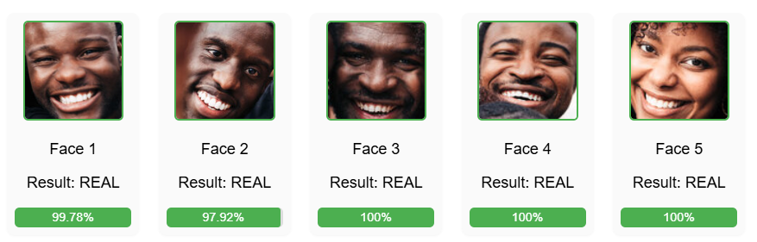
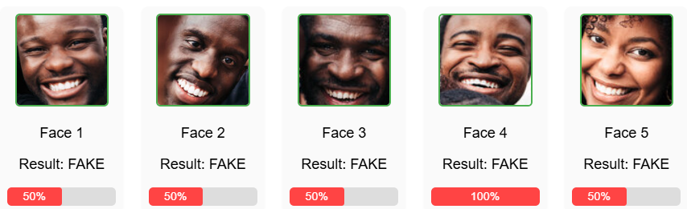
Figure 25: Result Interpretability
The console within the web application is also used to clearly communicate progress feedback from the model, as shown in Figure 26.
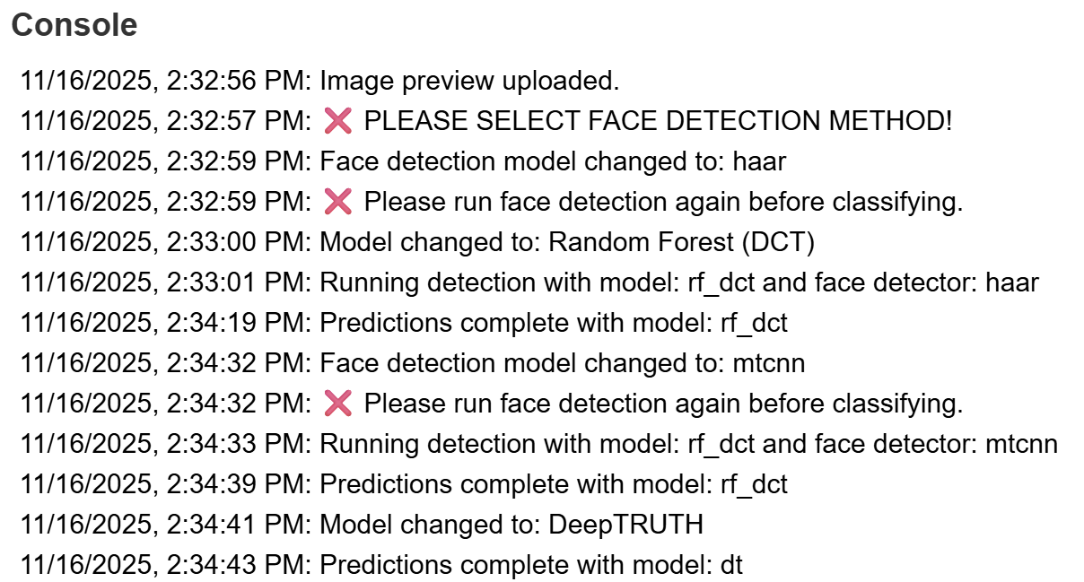
Figure 26: Console User Response
Once the face detector runs, bounding boxes are drawn on the faces of the subjects, clearly indicating the portion of classification, as shown in Figure 27.
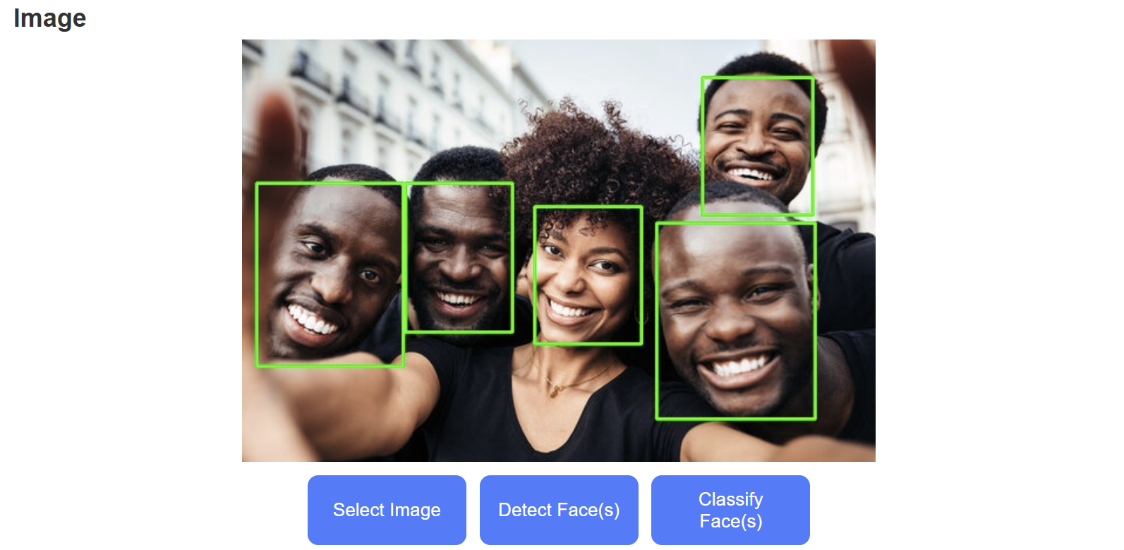
Figure 27: Bounding Boxes on Detected Subjects

Accessibility
The web application was tested for accessibility by ensuring that the content of the tool remains on a single page, and that this website is completely navigable through the usage of only the keyboard. The contents of the website can also be made larger and smaller using “ctrl+” or “ctrl-“, and that the page components of Image Display, Results, Configuration and Console remain the same as the size of the text is adjusted.

User Interface
We simplified the behavior of our web interface; to receive a classification the user is guided through the steps of uploading a photo, detecting the faces and receiving a classification. Dropdown menus are included to show the possible options and the buttons change from grey to blue to walk the user through the usage of the application. Figure 25 shows the behavior of the website.
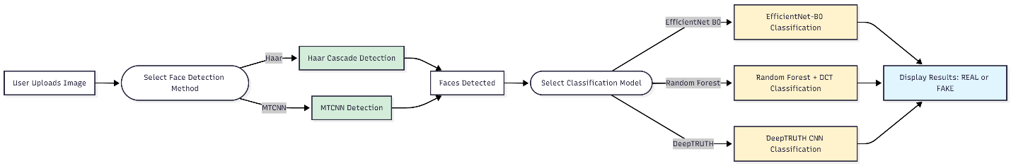
Figure 25: Web Application Behavior Flowchart
Ethics & Security

Algorithmic Transparency
Methods: Our Algorithmic Transparency follows IEEE7003- 2024 Standard. Following the standard’s guidelines, a bias profile of our final AI model will be made [68]. This profile will contain adequate research into whether our model’s performance for different races or genders. Since all models will be trained on the Openforensics dataset, underlying biases will begin there. Subsections of this data can be evaluated to test performance by race and gender. The generalization requirement also helps verify whether the model has underlying biases. Our expectations are that the model will have a small amount of bias. Our dataset is large and diverse, making it harder for the model to overgeneralize by race or gender.
Results: A gender bias profile test was performed on a subset of the evaluation dataset. 50 images from both genders, split evenly between real and fake, were evaluated using the EB0 Model. By Table 26, each test yielded the same results, suggesting that our model does not have gender bias.
This is expected due to the diversity of the Openforensics dataset. The dataset is 49% male and 51% female [69]. Furthermore, it contains a variety of ages between 0 and 90. However, the dataset focuses on ages between 21 and 60 which make up 83% of faces [69].
Table 26: Gender Bias Profile Test
EB0 Model | Metric
Gender | Accuracy | Precision | Recall | F1
Men | 48.00% | 96.00% | 100.00% | 97.96%
Women | 98.00% | 96.00% | 100.00% | 97.96%

Website Security
To ensure user privacy and uphold website security, we removed dependencies on CSV’s to store data between programs. The current version of the application utilizes dictionaries that are passed between programs and are not stored. Figure 25 shows the passage of the dictionary within our application, comparing the CSV dependent approach to our current.
Figure : Dictionary Approach

Cost Analysis
As this project is entirely software based, there are no direct overhead costs associated with the development of our algorithms or the deployment of our application. All computational resources were provided by The Institute for Signal and Information Processing (ISIP). Table 27 summarizes the anticipated costs for this project.
Table 27: Cost Analysis
Category | Item | Purpose | Cost | Source
Dataset acquisition | Open Forensics Dataset | Used to train and develop classification model | $0 | Open source
Dataset acquisition | Caltech Dataset | Used to determine model generalizability | $0 | Open source
Software | Deep learning framework | Used to create classification model | $0 | Open source
Software | Image processing library | Used to process large sets of images | $0 | Open source
Software | Full stack development | Create web tool demonstration | $0 | Open source
Hardware Resources | AWS Graphical Process Unit | Used to speed model training and development | $0.1504/Hour [69] | ISIP Provided
Webtool Development | Web-tool hosting and publishing | Upload our webtool to the web | $15/Year [70] | ISIP Provided
Maintenance | System Administration | Support the deployment of our website | $15/Hour [71] | ISIP Provided

Summary
This project focuses on developing a reliable, safe and accurate DeepFake detection tool. As AI-generated content becomes increasingly realistic and widely accessible, it poses significant risks related to the spread of misinformation and fraud. To mitigate these risks, this project implements three machine learning detection algorithms, a statistical method called Random Forest, and two deep learning convolutional neural networks (CNN), a custom CNN called DeepTRUTH, and Efficientnet-B0 (EB0).
A full-stack web tool was developed as a wrapper for these algorithms, allowing a user to upload an image, select a face detection and classification method, then receive a classification of real or fake for each of the faces within the images.
This project focused on achieving a variety of required values and constraints related to algorithmic performance, computational efficiency, code maintainability, and web app usability. The EB0 model achieved the strongest performance reaching 98% on the blind evaluation data. Overall, the implemented algorithms and web application have met all the specified requirements and constraints and was verified as functional by the ISIP team.

Appendix
Table 7: DeepFake Datasets
Name | Real Photos | Fake Photos | Media Form
DFFD | 58,703 | 240,336 | Images
ForgeryNet | 1,438,201 | 1,457,861 | Images
Generated Photos | Not Available | 10,000 | Images
CelebA | Not Available | 202,599 | Images
FaceForensics | Not Available | 500,000 frames containing faces from 1004 videos | Video Frames
Celeb-DF | 590 original videos | 5639 corresponding DeepFake videos | Videos
OpenForensics: Multi-Face Forgery Detection And Segmentation In-The-Wild Dataset | 45473 | 70325 | Photos
Deepfake Detection Challenge Dataset | Not Available | 100,000 videos | Videos
Flickr-Faces-HQ | 70,000 |  | Photos
Deepfake Synthetic-20K Dataset | Not Available | 20K synthetically generated face images | Photos
Individualized Deepfake Detection Dataset | 23k authentic | 22k deepfake | Photos
UADFV | 49 videos | 49 videos | Videos

Abbreviations Used
  - Machine Learning (ML)
  - Deep Learning (DL)
  - General Adversarial Network (GAN)
  - Convolutional Neural Network (CNN)
  - User interface (UI)

Citations
- F. Juefei-Xu, R. Wang, Y. Huang, Q. Guo, L. Ma, and Y. Liu, “Countering Malicious DeepFakes: Survey, Battleground, and Horizon,” arXiv.org, 2021. https://arxiv.org/abs/2103.00218
- Tenali Anusha and A. Srinagesh, “Deepfake Video Detection: A Comprehensive Survey of Advanced Machine Learning and Deep Learning Techniques to Combat Synthetic Video Manipulation,” IEEE Xplore, pp. 1033–1041, Jan. 2025, doi: https://doi.org/10.1109/icmsci62561.2025.10894187.
- F.-A. Croitoru et al., “Deepfake Media Generation and Detection in the Generative AI Era: A Survey and Outlook,” Arxiv.org, 2024. https://arxiv.org/html/2411.19537 (accessed Aug. 31, 2025).
- D. Gamage, P. Ghasiya, V. Bonagiri, M. Whiting, and K. Sasahara, “Are Deepfakes Concerning? Analyzing Conversations of Deepfakes on Reddit and Exploring Societal Implications,” Are Deepfakes Concerning? Analyzing Conversations of Deepfakes on Reddit and Exploring Societal Implications, 2022, doi: https://doi.org/10.1145/3491102.3517446.
- T. Say, M. Alkan, and A. Kocak, “Advancing GAN Deepfake Detection: Mixed Datasets and Comprehensive Artifact Analysis,” Applied Sciences, vol. 15, no. 2, pp. 923–923, Jan. 2025, doi: https://doi.org/10.3390/app15020923.
- A. Dehghani and H. Saberi, “Generating and Detecting Various Types of Fake Image and Audio Content: A Review of Modern Deep Learning Technologies and Tools,” arXiv.org, 2025. https://arxiv.org/abs/2501.06227
- National Security Agency, “NSA, U.S. Federal Agencies Advise on Deepfake Threats,” National Security Agency/Central Security Service, Sep. 12, 2023. https://www.nsa.gov/Press-Room/Press-Releases-Statements/Press-Release-View/Article/3523329/nsa-us-federal-agencies-advise-on-deepfake-threats/ (accessed Aug. 31, 2025).
- J. SHAPIRO, Act No. 35. 2025. Available: https://www.palegis.us/statutes/unconsolidated/law-information?sessYr=2025&sessInd=0&actNum=35
- H. Song, S. Huang, Y. Dong, and W.-W. Tu, “Robustness and Generalizability of Deepfake Detection: A Study with Diffusion Models,” arXiv.org, 2023. https://arxiv.org/abs/2309.02218
- S. M. Qureshi, A. Saeed, S. H. Almotiri, F. Ahmad, and M. A. Al Ghamdi, “Deepfake forensics: a survey of digital forensic methods for multimodal deepfake identification on social media,” PeerJ Computer Science, vol. 10, p. e2037, May 2024, doi: https://doi.org/10.7717/peerj-cs.2037.
- C. Bhattacharyya, H. Wang, F. Zhang, S. Kim, and X. Zhu, “Diffusion Deepfake,” arXiv.org, 2024. https://arxiv.org/abs/2404.01579 (accessed Aug. 31, 2025).
- U. R. Acharya, Y. Zhang, J. Wang, and W. Ding, “Convolutional Neural Network - an overview | ScienceDirect Topics,” www.sciencedirect.com. https://www.sciencedirect.com/topics/engineering/convolutional-neural-network
- Google PAIR, “People + AI Guidebook,” Withgoogle.com, 2017. https://pair.withgoogle.com/chapter/explainability-trust/
- A. Rajesh, S. Tiwari, Vivek Gotecha, and N. Y. Kapadnis, “Deepfake Detection using CNN,” ResearchGate, Mar. 2024. https://www.researchgate.net/publication/378609583_Deepfake_Detection_using_CNN
- J. Laffier and A. Rehman, “Deepfakes and Harm to Women,” Journal of Digital Life and Learning, vol. 3, no. 1, pp. 1–21, Jun. 2023, doi: https://doi.org/10.51357/jdll.v3i1.218.
- S. Ahmed, M. Masood, A. Wei, and K. Ichikawa, “False failures, real distrust: the impact of an infrastructure failure deepfake on government trust,” Frontiers in Psychology, vol. 16, May 2025, doi: https://doi.org/10.3389/fpsyg.2025.1574840.
- Chai, L., Bau, D., Lim, SN., Isola, P. (2020). What Makes Fake Images Detectable? Understanding Properties that Generalize. In: Vedaldi, A., Bischof, H., Brox, T., Frahm, JM. (eds) Computer Vision – ECCV 2020. ECCV 2020. Lecture Notes in Computer Science(), vol 12371. Springer, Cham. https://doi.org/10.1007/978-3-030-58574-7_7
- Google, “Classification: Accuracy, recall, precision, and related metrics,” Google for Developers, 2024. https://developers.google.com/machine-learning/crash-course/classification/accuracy-precision-recall
- M. S. Saealal, M. Z. Ibrahim, M. I. Shapiai, and N. Fadilah, “In-The-Wild Deepfake Detection using Adaptable CNN Models with Visual Class Activation Mapping for Improved Accuracy,” 2023 5th International Conference on Computer Communication and the Internet (ICCCI), pp. 9–14, Jun. 2023, doi: https://doi.org/10.1109/ICCCI59363.2023.10210096.
- J. Picone, “Neuronix: A Low-Cost High Performance Cluster,” Piconepress.com, 2018. https://isip.piconepress.com/projects/neuronix/html/about.shtml (accessed Sep. 22, 2025).
- "DEEPCHECKS GLOSSARY," [Online]. Available: https://www.deepchecks.com/glossary/ml-scalability/. [Accessed 15 September 2025].
- A. Jha, “ML Model Interpretation Tools - What, Why, and How to Interpret,” neptune.ai, May 08, 2021. https://neptune.ai/blog/ml-model-interpretation-tools
- W3C, “Web Content Accessibility Guidelines (WCAG) 2.1,” W3.org, May 06, 2025. https://www.w3.org/TR/WCAG21/
- W3C, Web Content Accessibility Guidelines (WCAG) 2.1. Jun. 2018. [Online]. Available: https://www.w3.org/TR/WCAG21/
- M. Y. Arif, "LinkedIn," 27 June 2024. [Online]. Available: https://www.linkedin.com/pulse/importance-code-readability-maintainability-software-development-s9ckf/. [Accessed 14 September 2025].
- ISO, “ISO/IEC/IEEE 12207:2017,” ISO, 2017. https://www.iso.org/standard/63712.html
- F. Doshi-Velez and B. Kim, “Towards A Rigorous Science of Interpretable Machine Learning,” arXiv:1702.08608 [cs, stat], vol. 2, no. 2, Mar. 2017, Available: https://arxiv.org/abs/1702.08608
- “IEEE Standard for Algorithmic Bias Considerations,” IEEE, Dec. 2024, doi: https://doi.org/10.1109/ieeestd.2025.10851955.
- OWASP, “OWASP Top 10: 2021,” OWASP, 2021. https://owasp.org/Top10/
- International Organization for Standardization, “ISO/IEC 27001 standard – information security management systems,” ISO, 2022. https://www.iso.org/standard/27001
- S. Baker, "ISO 27001 Information Classification and Handling Policy Beginner’s Guide," 17 July 2025. [Online]. Available: https://hightable.io/information-classification-and-handling-policy/. [Accessed 20 September 2025].
- J. Jayan, "Importance of Ethical Data Collection," PromptCLoud, 1 August 2024. [Online]. Available: https://www.promptcloud.com/blog/importance-of-ethical-data-collection/. [Accessed 15 September 2025].
- T.-N. Le, H. Nguyen, J. Yamagishi, and I. Echizen, “OpenForensics: Large-Scale Challenging Dataset For Multi-Face Forgery Detection And Segmentation In-The-Wild.” Available: https://openaccess.thecvf.com/content/ICCV2021/papers/Le_OpenForensics_Large-Scale_Challenging_Dataset_for_Multi-Face_Forgery_Detection_and_Segmentation_ICCV_2021_paper.pdf
- P. Viola and M. Jones, “Rapid object detection using a boosted cascade of simple features,” in Proc. IEEE Conf. Computer Vision and Pattern Recognition, Kauai, HI, USA, 2001, pp. I-511–I-518. doi:10.1109/CVPR.2001.990517.
- “Discrete Cosine Transform - MATLAB & Simulink,” www.mathworks.com. https://www.mathworks.com/help/images/discrete-cosine-transform.html
- K. R. Vijayanagar, “Discrete Cosine Transform in Video Compression - Explain Like I’m 5 - OTTVerse,” ottverse.com, Aug. 20, 2020. https://ottverse.com/discrete-cosine-transform-dct-video-compression/
- T.-N. Le, H. Nguyen, J. Yamagishi, and I. Echizen, “OpenForensics: Large-Scale Challenging Dataset For Multi-Face Forgery Detection And Segmentation In-The-Wild.” Available: https://openaccess.thecvf.com/content/ICCV2021/papers/Le_OpenForensics_Large-Scale_Challenging_Dataset_for_Multi-Face_Forgery_Detection_and_Segmentation_ICCV_2021_paper.pdf
- IBM, “What is random forest?,” Ibm.com, Oct. 20, 2021. https://www.ibm.com/think/topics/random-forest
- Scikit-Learn, “sklearn.ensemble.RandomForestClassifier — scikit-learn 0.20.3 Documentation,” Scikit-learn.org, 2025. https://scikit-learn.org/stable/modules/generated/sklearn.ensemble.RandomForestClassifier.html
- IBM, “Convolutional Neural Networks,” Ibm.com, Oct. 06, 2021. https://www.ibm.com/think/topics/convolutional-neural-networks
- Jorgecardete, “Convolutional Neural Networks: A Comprehensive Guide,” The Deep Hub, Feb. 17, 2024. https://medium.com/thedeephub/convolutional-neural-networks-a-comprehensive-guide-5cc0b5eae175
- G. Boesch, “Xception Model: Analyzing Depthwise Separable Convolutions - viso.ai,” viso.ai, May 16, 2024. https://viso.ai/deep-learning/xception-model/
- F. Chollet, “Xception: Deep Learning with Depthwise Separable Convolutions,” arXiv.org, 2016. https://arxiv.org/abs/1610.02357
- M. Prokofieva, “Attention in Transformers: residual connection layer, a shortcut that makes it work,” Medium, Oct. 29, 2024. https://medium.com/@mariaprokofieva/attention-in-transformers-residual-connection-layer-a-shortcut-that-makes-it-work-165b52566167
- A. Farid, “Creating and detecting deep fakes,” IEEE Signal Processing Magazine, vol. 36, no. 1, pp. 18–27, Jan. 2019. doi:10.1109/MSP.2018.2877581
- Y. Zhang, X. Luo, and H. Jiang, “Lightweight deepfake detection based on multi-feature fusion and Random Forest,” arXiv preprint arXiv:2502.11763, 2025. [Online]. Available: https://arxiv.org/abs/2502.11763
- F. Chollet, “Xception: Deep learning with depthwise separable convolutions,” in Proc. IEEE Conf. Computer Vision and Pattern Recognition (CVPR), Honolulu, HI, USA, Jul. 2017, pp. 1251–1258. doi:10.1109/CVPR.2017.195.
- G. Bradski, “The OpenCV Library,” Dr. Dobb’s Journal of Software Tools, 2000.
- N. Dalal and B. Triggs, “Histograms of Oriented Gradients for Human Detection,” Proc. IEEE Conf. on Computer Vision and Pattern Recognition, 2005.
- K. Zhang, Z. Zhang, Z. Li, and Y. Qiao, “Joint Face Detection and Alignment using Multi-task Cascaded Convolutional Networks,” IEEE Signal Processing Letters, 2016.
- [4] J. Deng, J. Guo, E. Ververas, I. Kotsia, and S. Zafeiriou, “RetinaFace: Single-stage Dense Face Localisation in the Wild,” Proc. IEEE Conf. on Computer Vision and Pattern Recognition (CVPR), 2020.
- M. Fink and P. Perona, "Caltech 10k Web Faces," CaltechDATA, Online, 2022.
- "Free Face Swap AI Online for Photos & Videos," [Online]. Available: https://deepfakemaker.io/. [Accessed 5 October 2025].
- T.-N. Le, H. H. Nguyen, J. Yamagishi and I. Echizen, "OpenForensics: Large-Scale Challenging Dataset For Multi-Face Forgery Detection And Segmentation In-The-Wild," Zenodo, Online, 2021.
- L. Kroiß and R. Reschke, "Deepfake Detection of Face Images based on a Convolutional Neural Network," arXiv, Online, 2025.
- G. Naska, M. Sk, M. Samir, C. Erik and S. Ram, "Deepfake detection using deep feature stacking and meta-learning.," Heliyon, vol. 10, no. 4, p. e25933, 15 February 2024.
- “Bias in Large Language Models: Origin, Evaluation, and Mitigation,” Arxiv.org, 2019. https://arxiv.org/html/2411.10915v1
- GeeksforGeeks, “Edge detection using Prewitt, Scharr and Sobel Operator,” GeeksforGeeks, Oct. 11, 2021. https://www.geeksforgeeks.org/software-engineering/edge-detection-using-prewitt-scharr-and-sobel-operator/
- L. Nanni, S. Brahnam, M. Paci, and S. Ghidoni, “Comparison of Different Convolutional Neural Network Activation Functions and Methods for Building Ensembles for Small to Midsize Medical Data Sets,” Sensors, vol. 22, no. 16, p. 6129, Aug. 2022, doi: https://doi.org/10.3390/s22166129.
- S. Mukherjee, “A Comprehensive Exploration of Pooling in Neural Networks: A Python demo to Pooling in CNN,” Paperspace by DigitalOcean Blog, Nov. 27, 2023. https://blog.paperspace.com/a-comprehensive-exploration-of-pooling-in-neural-networks/
- A. Kohan, E. A. Rietman, and Siegelmann, Hava T, “Signal Propagation: A Framework for Learning and Inference In a Forward Pass,” arXiv.org, 2022. https://arxiv.org/abs/2204.01723 (accessed Oct. 06, 2025).
- M. Li, “Comprehensive Review of Backpropagation Neural Networks,” Academic journal of science and technology, vol. 9, no. 1, pp. 150–154, Jan. 2024, doi: https://doi.org/10.54097/51y16r47.
- M. Tan and Q. Le, “Efficientnet: Rethinking model scaling for convolutional neural networks,” in International Conference on Machine Learning. PMLR, 2019, pp. 6105–6114.
- “psutil documentation — psutil 5.7.0 documentation,” psutil.readthedocs.io. https://psutil.readthedocs.io/en/latest/
- "IEEE Standard for Algorithmic Bias Considerations," in IEEE Std 7003-2024 , vol., no., pp.1-59, 24 Jan. 2025, doi: 10.1109/IEEESTD.2025.10851955.
- A. Dosovitskiy et al., “An Image is Worth 16 × 16 Words: Transformers for Image Recognition at Scale,” Proc. ICLR, vol. 2021, pp. 1–12, 2021.
- G. Neal, “Bridget Hollitt: The Triple Threat,” All My Friends Are Models, Apr. 28, 2015. https://www.allmyfriendsaremodels.com/bridget-hollitt/ (accessed Nov. 03, 2025).
- "IEEE Standard for Algorithmic Bias Considerations," in IEEE Std 7003-2024 , vol., no., pp.1-59, 24 Jan. 2025, doi: 10.1109/IEEESTD.2025.10851955.
- “Amazon EC2 G4 Instances — Amazon Web Services (AWS),” Amazon Web Services, Inc. https://aws.amazon.com/ec2/instance-types/g4/
- ‌ “How much does it cost to do something on the Web? - Learn web development | MDN,” Mozilla.org, Jul. 18, 2025. https://developer.mozilla.org/en-US/docs/Learn_web_development/Howto/Tools_and_setup/How_much_does_it_cost?utm_source=chatgpt.com (accessed Dec. 13, 2025).
- ‌ “How Much Does Pay per Hour in 2025?,” Glassdoor, 2025. https://www.glassdoor.com/Hourly-Pay/Temple-University-Student-Worker-Hourly-Pay-E23406_D_KO18 (accessed Dec. 13, 2025).

