COLLEGE OF ENGINEERING

Preliminary Exam Report:
Feature-Enriched AI and Quantum Methods in Digital Pathology
Claudia-Anca Dumitrescu
Email: claudia-anca.dumitrescu@temple.edu
Department of Electrical and Computer Engineering
College of Engineering, Temple University
1947 North 12th Street, Philadelphia, Pennsylvania 19122

November 11, 2025
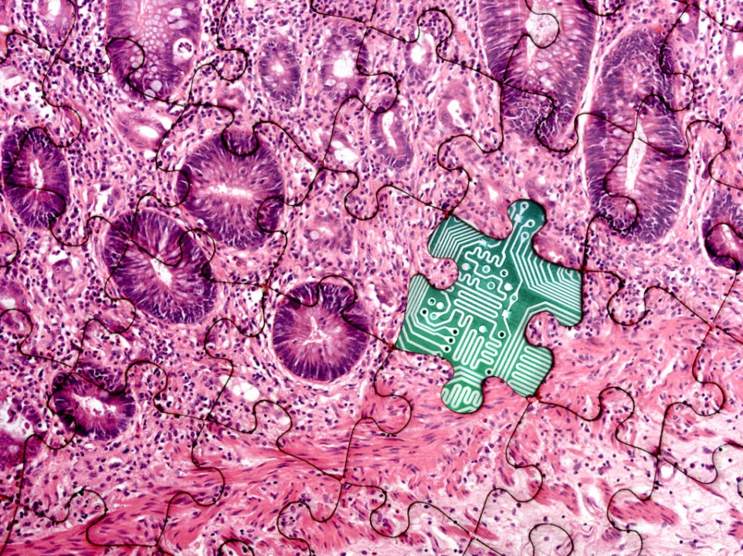
Examining Committee:
Dr. Joseph Picone, Committee Chair, Department of Electrical and Computer Engineering, College of Engineering, Temple University
Dr. Iyad Obeid, Committee Member, Department of Electrical and Computer Engineering, College of Engineering, Temple University
Dr. Fauzia Ahmad, Committee Member, Department of Electrical and Computer Engineering, College of Engineering, Temple University
Dr. Philip Dames, Committee Member, Department of Mechanical Engineering, College of Engineering, Temple University
Dr. Yaroslav Koshka, Committee Member, Department of Electrical and Computer Engineering, Mississippi State University
Executive Summary
The main goal of this document is to advocate the importance of using relevant features in the development of robust computational solutions for digital pathology applications (DPATH). We’ll set up a timeline of the current literature and challenges in developing an Artificial Intelligence (AI) system using whole slide images (WSI), with special attention to data characteristics, leaving aside computational aspects. Feature extraction remains one of the most critical stages in AI development, as the quality and representativeness of extracted features directly determine model performance and generalization. In this context, we will investigate dataset enrichment approaches that involve integrating crystallization data, switching the data distribution from histopathological imagery to structurally informed representations, thereby broadening the feature space available for model learning. Additionally, quantum computing approaches are emerging as a promising paradigm to improve learning efficiency. Techniques such as quantum feature mapping and quantum kernel methods can project classical data into high-dimensional Hilbert spaces, elucidating relationships within pathology data that classical algorithms may overlook. These quantum-enhanced frameworks ultimately lead to more efficient and expressive models for digital pathology.
The first paper, titled Quantitative chemical imaging of breast calcifications in association with neoplastic processes, highlights the potential of crystallography and spectroscopic imaging as tools for model feedback and dataset enrichment. By applying hyperspectral stimulated Raman scattering (SRS) and second harmonic generation (SHG) microscopy, the study demonstrates that the chemical composition and spatial heterogeneity of breast calcifications are strongly associated with local pathological processes. These findings suggest that specific mineralogical features, particularly variations in carbonate content, correlate with the development and progression of neoplastic lesions. This motivates the integration of crystallization-derived data as an alternative annotation distribution for training AI models.
The second paper, titled QDeepColonNet: a quantum-based deep learning network for colorectal cancer classification using attention-driven DenseNet and shuffled dynamic local feature extraction network, introduces a hybrid Deep Learning (DL) and Quantum Machine Learning (QML) framework designed to enhance classification performance and learning efficiency in histopathological image analysis. The proposed QDeepColonNet employs a dual-track architecture that combines DenseNet with an Enhanced Feature Learnable Group Attention (EFLGA) block to capture high- and mid-level features, while the Shuffled Dynamic Local Feature Extraction Network (SDLFEN) integrated with a Lightweight Multi-Kernel Convolution (LMKC) block focuses on modeling fine-grained, short-range dependencies. The outputs from both tracks are concatenated and refined through Efficient Channel Attention (ECA) to strengthen inter-channel interactions without additional computational burden.
The final paper, titled Hybrid quantum-classical graph neural networks for tumor classification in digital pathology, presents a quantum–classical framework that integrates advanced graph neural networks (GNNs) with variational quantum classifiers (VQCs) to address key challenges in spatial biology and disease modeling. Building upon the limitations of conventional machine learning approaches in capturing complex cell-microenvironment interactions, this work leverages quantum computing principles to enhance representational efficiency and scalability.
Collectively, these studies illustrate a conceptual progression from data-centric enrichment to advanced model architecture. The first paper establishes the theoretical importance of incorporating chemically and structurally informed features to enhance feature space representation. The second demonstrates architectural innovation that integrates attention-driven networks with quantum-enhanced classifiers for improved feature extraction and classification. The third extends these principles to spatially resolved tissue modeling, applying quantum–classical GNNs to capture complex cellular interactions within the tumor microenvironment. Together, they exemplify how theoretical insights, novel architectures, and application-driven design converge to advance next-generation digital pathology systems.
Table of Contents

1. Introduction 1
1.1. Enriching Pathology Data with Calcification 2
1.2. Quantum-Enhanced Deep Learning Models 2
1.3. Hybrid Quantum Neural Networks 3
2. State of the Art 4
3. Architectures that Exploit Feature Spaces 5
4. Results and Clinical Trust 9
5. Discussion 12
6. Conclusions 13
7. References 14

Introduction
Computational pathology leverages digital histology images to automate tasks like cancer subtyping, staging, and prognostic prediction. Modern whole-slide images (WSIs) are gigapixel in size, comprising tens of thousands of tiles (Xu, H. et al., 2024), posing major computational challenges. Existing AI models often require vast annotated datasets, but in pathology, annotations are scarce and costly. For example, supervised learning of tumor subtypes or biomarker status typically demands manual labeling of cellular or tissue structures. Feature extraction, the process of converting raw image data into meaningful representations, is therefore critical. High-quality features reduce data complexity and improve model accuracy and generalization.
Current approaches predominantly rely on standard H&E-stained WSIs and conventional deep learning architectures, which may be reaching their performance limits for complex diagnostic tasks. The next evolutionary steps need to take into account current limitations while personalizing them to the nature of the problem. According to (Ajay, A. et al., 2025), current models fail to capture features on multiple scales, mainly relying on high-level features and lacking efficient attention mechanisms that can adequately capture cross-channel interactions, reducing the model’s ability to generalize and classify the images accurately. On top of the model’s abstraction, current studies do not take into account the morphological nature of the problem, which was proven (Shin, K.S. et al., 2019) to be limiting, considering that morphological appearance alone often provides an incomplete picture of the disease state.
First, as demonstrated by studies (Shin, K.S. et al., 2019; Scott, R. et al., 2016), the carbonate content within hydroxyapatite calcifications in breast tissue, a chemical property never considered in conventional histology, shows a strong inverse correlation with malignancy (r = -0.89, p < 0.001). This establishes that underlying tissue chemistry provides critical diagnostic signals that complement morphological assessment. Moreover, X-ray diffraction demonstrates potential clinical application, with measurements of carbonate substitution achieving a sensitivity of 85% and specificity of 88% in distinguishing benign and neoplastic cases using the average carbonate content alone.
Second, to effectively model the complexity of the data, classical AI architectures may be insufficient. The studies (Ajay, A. et al., 2025; Ray, A. et al., 2023) demonstrate that hybrid architectures combining different computational approaches can achieve superior performance. Ajay et al.'s QDeepColonNet integrates classical convolutional networks with quantum-inspired classifiers, while Ray et al. combine graph neural networks with variational quantum circuits. Both approaches outperform their purely classical counterparts, suggesting that hybrid models can better capture the complex, multi-scale nature of pathological data.
Therefore, there is a clear need for a fundamental shift toward systems that can natively integrate heterogeneous data types, leverage novel computational paradigms, and provide transparent, biologically-grounded reasoning. In summary, DPATH systems must overcome (1) data heterogeneity and scale, and (2) limited labeled examples, which motivates both data-centric enrichment and advanced modeling approaches:
- Scale and Annotation: A single WSI can contain over 10,000 image tiles. While deep learning (DL) models have shown promise on specific tasks, they typically demand large labeled datasets. Manual annotation by pathologists is laborious, creating a bottleneck for training powerful AI systems. Recent trends in self-supervised and foundation-model learning aim to exploit abundant unlabeled WSIs, reducing annotation needs.
- Feature Quality Matters: The quality and representativeness of input features directly determine model performance. Feature extraction techniques transform raw image data into compact, informative formats, improving efficiency and accuracy. For instance, convolutional neural networks automatically learn hierarchical features, but they still depend on informative inputs such as stain-normalized tissue patches or domain-specific signals.

Overall, digital pathology benefits from integrating relevant multimodal features and novel learning paradigms. In particular, recent work explores enriching WSIs with additional data modalities (e.g. chemical imaging) and leveraging quantum-enhanced algorithms. These efforts aim to broaden the feature space and improve model expressiveness beyond standard RGB histology. Quantum machine learning (QML) is an emerging field in healthcare (Gupta, R.S. et al., 2025). Classical data can be embedded via quantum feature maps into high-dimensional Hilbert spaces, potentially uncovering complex patterns (Akpinar, E. et al., 2025). However, systematic reviews note that empirical quantum advantage in real health data is still under investigation (Gupta, R.S. et al., 2025). The following works illustrate how data enrichment and hybrid models can advance AI for digital pathology.
  - Enriching Pathology Data with Calcification
One data-centric approach is to augment histology images with biochemical and structural features. Shin et al. demonstrate this by analyzing breast microcalcifications using specialized microscopy (Shin, K.S. et al., 2019). They applied hyperspectral stimulated Raman scattering (SRS) microscopy and second harmonic generation (SHG) imaging to biopsy samples spanning benign to malignant lesions. This label-free chemical imaging revealed that the carbonate content of individual calcifications correlates strongly with local pathology.
SRS microscopy mapped chemical constituents (phosphate, carbonate, phenylalanine) within calcifications at high resolution. By quantifying carbonate percentage in each calcification, the authors found distinct patterns: benign regions had higher carbonate levels than malignant ones.
Using carbonate content alone, they achieved over 85% sensitivity and specificity in distinguishing benign versus neoplastic lesions. This confirms that mineral composition carries diagnostic information beyond the level of importance they’re currently given in computer vision approaches.
SHG microscopy provided collagen-related structural context that improved subtype discrimination, helping to differentiate specific disease categories beyond the carbonate measure.
These findings suggest incorporating crystallographic features into AI pipelines. For example, feeding per-calcification mineral profiles or SHG-derived texture metrics into a classifier could enrich the feature set. As the authors note, this combined SRS+SHG approach “reveals previously unknown large variations of breast microcalcifications in association with local malignancy” (Shin, K.S. et al., 2019), indicating its potential to enrich training data with physiologically meaningful annotations.
In summary, chemical imaging can transform raw pathology data into structure-informed representations. By linking microcalcification chemistry to cancer progression, one can create alternative annotations (e.g. carbonate maps) that complement the other annotations, provide feedback, or sort them in any way. This dataset enrichment expands the effective feature space for learning algorithms, potentially improving the robustness of models trained with DPATH data.
  - Quantum-Enhanced Deep Learning Models
Parallel to data enrichment, novel architectures are being explored. In particular, quantum-inspired algorithms offer new ways to extract and classify features. Quantum feature mapping is a key concept: it encodes classical inputs into quantum states in high-dimensional Hilbert space (Akpinar, E. et al., 2025), where complex correlations may be more easily captured. Quantum kernel methods similarly measure inner products in that space. Although practical quantum advantage remains to be fully demonstrated, integrating quantum elements into deep networks is an active area of research (Gupta, R.S.et al., 2025).
  - Hybrid Quantum Neural Networks
Ajay et al. introduced QDeepColonNet, a hybrid deep learning and quantum machine learning framework for colorectal cancer classification (Ajay, A. et al., 2025). This model illustrates how architectural innovation and quantum classifiers can be combined to improve representational richness and decision-making. QDeepColonNet employs a dual-track feature extraction strategy in which one path is a DenseNet backbone augmented with EFLGA blocks to capture high- and mid-level features across the histology image, while the second path is an SDLFEN with Lightweight Multi-Kernel Convolutions (LMKC) that focuses on fine-grained local patterns and short-range dependencies. The two tracks are concatenated to provide a comprehensive description of both global tissue context and local morphological detail. After concatenation, an ECA module refines the combined feature maps by re-weighting channel-wise information with minimal computational overhead, thereby strengthening inter-channel interactions and improving the representational power of the pooled features. The refined feature vector is then passed into a variational quantum classifier: a parameterized quantum circuit that serves as the model’s final decision layer. The authors argue that the quantum layer can capture intricate, highly non-linear relationships in the learned feature space that may be difficult for classical classifiers to model. On the public EBHI colorectal dataset, QDeepColonNet achieved 98.92% accuracy, outperforming several state-of-the-art classical deep learning models. In effect, QDeepColonNet demonstrates how attention-driven deep learning can extract a rich, multi-scale set of features while a quantum-enhanced classifier provides a novel mechanism for leveraging those features for robust tissue classification.
Modeling spatial cell–tissue interactions with graph-structured representations is another promising direction. Ray et al. proposed a hybrid quantum–classical graph neural network (GNN) for tumor classification (Ray, A. et al., 2024), where data such as single-cell measurements or patch embeddings are organized as a graph that represents the tumor microenvironment. In their approach, each cell or image patch becomes a node and edges encode spatial proximity or phenotypic similarity; a classical GNN processes this graph to produce node- and graph-level embeddings that summarize local neighborhoods and long-range tissue topology. Rather than using a conventional classical readout, the authors employ a small variational quantum classifier (VQC) as the final decision module: the GNN outputs are amplitude-encoded into qubits so the quantum classifier can process a compressed, information-dense representation. By amplitude-encoding GNN features into a quantum state, the model effectively represents high-dimensional information in a logarithmic number of qubits, which the authors show can outperform equivalent classical compression schemes that incur information loss (Ray, A. et al., 2024). Two training variants were explored: one in which the GNN parameters are fixed and only the VQC is trained, and another in which the GNN and VQC are trained end-to-end; results indicate that the hybrid network matches or slightly exceeds the performance of state-of-the-art classical GNN baselines in weighted precision, recall, and F1-score, with the end-to-end training regime producing modest additional gains (Ray, A. et al., 2024). This work exemplifies how quantum–classical hybrids can be applied to spatial pathology problems: leveraging quantum encoding within a GNN framework enables efficient summarization of complex cell interactions, and although current performance is broadly comparable to classical methods, the approach demonstrates feasibility and a clear path toward potentially more powerful spatial models as quantum resources mature.
Together, these studies illustrate a pathway toward next-generation digital pathology AI that is both data-rich and model-innovative. The first paper highlights the value of chemically informed features: extracting crystallographic data reveals new signals correlated with disease states. The second demonstrates advanced network architectures that combine attention and hybrid processing: multi-branch feature extractors plus a quantum classifier significantly boosted colorectal cancer detection accuracy. The third paper extends these ideas to the spatial domain, showing that quantum-enhanced graph models can effectively summarize the tumor characteristics. These multidisciplinary advances suggest that incorporating biochemical imaging and quantum-inspired algorithms will be key to improving diagnostic accuracy and efficiency in DPATH.

State of the art
Machine learning (ML) methods provided a first layer of automated assessment that complements human expertise. Classical algorithms, such as Support Vector Machines (SVM), Decision Trees (DT), Random Forests (RF), Naive Bayes (NB), k-Nearest Neighbours (kNN), gradient boosting, logistic regression (LR), and early neural network models have been applied across tasks ranging from tumor grading to metastasis prediction (Bülbül et al., 2023; Talebi et al., 2024; Rahman and Muniyandi 2018). Empirical studies illustrate the value of carefully chosen engineered features: for example, texture analysis of preoperative CT scans and features derived from local image-feature packages have enabled RF, kNN and gradient-boosting models to distinguish tumor grade (Bülbül et al. 2023). Similarly, feature selection combined with artificial neural networks has been shown to materially improve classification accuracy (Rahman and Muniyandi 2018). Beyond primary diagnosis, ML methods have also been used to assess risk of subsequent primary cancers and to explore non-invasive detection from electronic medical records, with models such as XGBoost and logistic regression emerging as competitive choices depending on the task and available features (Ting et al., 2020; Li et al., 2021). Despite these successes, traditional ML approaches remain constrained by their reliance on manually engineered features and curated input representations, which limit adaptability across variable imaging conditions and large, heterogeneous WSI datasets.
Deep learning (DL) has substantially shifted the landscape by enabling automated, hierarchical feature learning directly from image data and thereby alleviating some of the burdens of hand-crafted representation. Convolutional neural networks (CNNs), vision transformers (ViTs) and hybrid architectures have been widely applied. Object-detection systems built on fine-tuned YOLOv3, coupled with tracking and post-processing, have demonstrated practical performance for integration into computer-aided detection workflows (Nogueira-Rodríguez et al., 2021). Comparative studies that evaluate VGG16, ResNet-50, Inception-V3 and ViT reveal task-dependent tradeoffs. Architectural innovations continue to appear: modifications that fuse transformer and CNN concepts (e.g., ConvMixer variants combining ViT and CNN components), channel attention modules, and multi-scale ConvLSTM blocks have been proposed to capture both local texture and broader spatial context (Mohammed and Omeroglu 2024; Khan et al., 2025). Lightweight and optimized designs, such as MobileNet-based truncations, metaheuristic hyperparameter optimisations (Chain Foraging, Cyclone Ageing), and the Manta Ray Foraging Optimiser (MRFO) for network tuning, have been studied to improve efficiency without sacrificing accuracy across imaging modalities (Khan et al., 2025). At the same time, thorough benchmarking across backbone families (EfficientNet, ResNet, DenseNet, ConvNeXt, EfficientNetV2) and the use of ensemble strategies highlight that combining complementary architectures often yields the best empirical performance (Abhishek et al., 2024; Karthik et al., 2024; Prezja et al., 2024).
More recently, quantum machine learning (QML) has emerged as an exploratory frontier that aims to complement DL by mapping classical data into quantum representations where complex, high-order relationships may be more readily separable. Broad surveys catalogue a growing taxonomy of QML methods for medical imaging: Quantum Distance Classifiers, simplified quantum-kernel SVMs, hybrid quantum–classical CNNs, quantum transfer learning, circuit-centric classifiers, and other circuit-based models, illustrating the diversity of approaches under investigation (Wei et al., 2023). Proposed hybrid architectures combine classical convolutional or graph encoders with parameterized quantum circuits (variational quantum circuits, quantum neural networks) as downstream classifiers or embedding modules; these hybrid systems are explored for a range of tasks including image classification, segmentation and ordinal regression in medical contexts (Senokosov et al., 2024; Prajapati et al., 2023). Examples of such applications include hybrid quantum–classical convolutional networks that incorporate channel attention and self-attention for brain tumor detection in MRI, augmented by parameterised quantum circuits to address class imbalance and multiscale tumor morphology (Wang et al., 2025); comparisons of QNN-based pipelines for breast cancer prediction against classical baselines (Prajapati et al., 2023); and QuantumNet, which leverages quantum transfer learning to improve diabetic retinopathy detection (Bali et al., 2025).
Despite encouraging results, QML methods are at an early stage of maturity. Current studies are heterogeneous in methodology, datasets and evaluation protocols, and reported advantages are often task- and configuration-specific rather than universally observed. Practical considerations such as quantum hardware constraints, encoding overheads, noise, and the need for efficient hybrid optimization remain active research challenges. Nevertheless, the conceptual promise is clear: QML offers alternative mechanisms for feature embedding and classification that may complement, rather than supplant, powerful classical deep architectures.

Architectures that Exploit Feature Spaces
The efficacy of AI systems in DPATH is fundamentally constrained by the representational capacity of the feature space in which they operate. WSIs present a multi-scale, hierarchically structured data domain where the transition from pixel intensities to diagnostically salient representations is non-trivial. While deep learning models, particularly Convolutional Neural Networks (CNNs), have demonstrated proficiency in learning hierarchical features, their classical nature often limits their ability to model the intricate, non-linear relationships and long-range dependencies inherent in histopathological data. This chapter examines two pioneering architectural paradigms that strategically exploit high-dimensional feature spaces to transcend these limitations. The first, QDeepColonNet, employs a dual-track CNN for multi-scale feature extraction, augmented by a QML classifier for enhanced separability. The second, a hybrid quantum-classical GNN, leverages the exponential dimensionality of Hilbert space to enrich graph-based representations of the tumor microenvironment. Together, these architectures exemplify a concerted move towards more expressive and computationally efficient models for computational pathology.
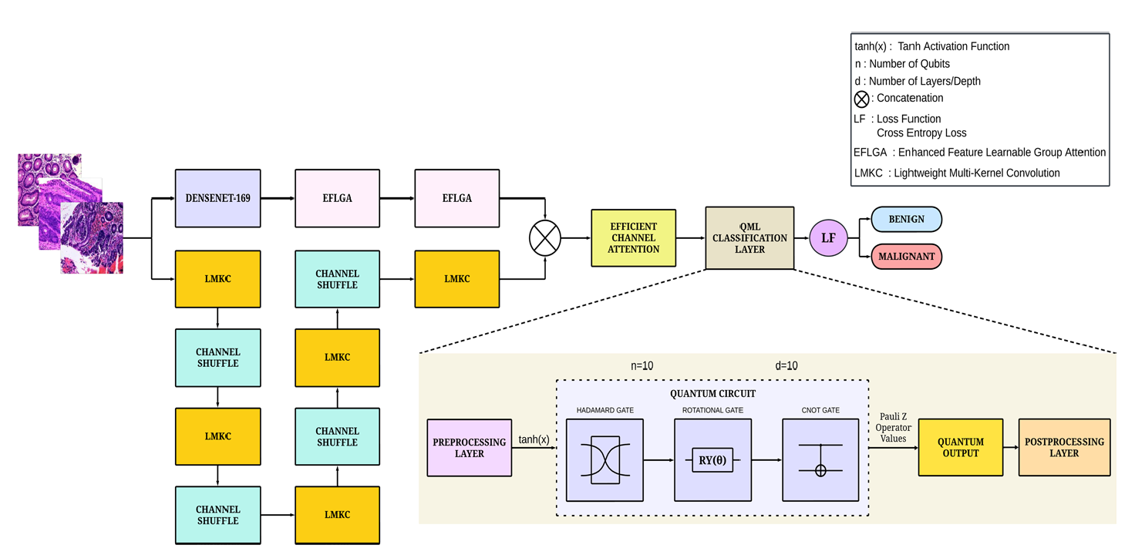
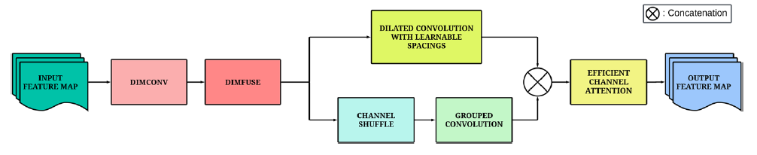
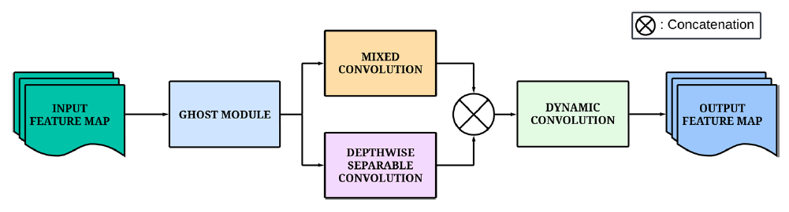
Figure 1. Architectural overview of the QDeepColonNet model, the EFLGA block and the LMKC block
The QDeepColonNet framework, whose overall architecture is depicted in Figure 1, addresses the challenge of colorectal cancer (CRC) classification by implementing a dual-track feature extraction pipeline, whose outputs are refined and subsequently projected into a quantum-enhanced space for final classification.
The model's first track is based on a DenseNet-169 backbone, chosen for its dense connectivity pattern that facilitates feature reuse and mitigates vanishing gradients. Let an input image be represented as a tensor $X∈R^{C_{\text{in}}×H×W}$. The DenseNet processes $X$ through a series of dense blocks and transition layers, producing a high-level feature map $Y_{\text{dense}}∈R^{D×H^{'}×W^{'}}$.
To capture often-neglected mid-level features critical for distinguishing malignant from benign tissues, an EFLGA block is integrated. The detailed structure of this block is illustrated in Figure 1. The EFLGA operates on $Y_{\text{dense}}$. It first applies dimension-wise convolutions (Dim-Conv), performing independent convolutional operations along the depth ($D$), height ($H^{'}$), and width ($W^{'}$) dimensions, yielding three distinct tensors $Y_{D},Y_{H},Y_{W}$. These are subsequently fused via dimension-wise fusion (Dim-Fuse):
$$Y_{\text{Dim}}=\text{Concat}(Y_{D},Y_{H},Y_{W})∈R^{3D×H^{'}×W^{'}}$$
The tensor $Y_{\text{Dim}}$ is then processed through two parallel pathways. The first pathway employs a Dilated Convolution with Learnable Spacing (DCLS), which adaptively adjusts the receptive field to capture spatial relationships without a proportional increase in parameters. The second pathway utilizes a Channel Shuffle (CS) operation followed by a Group Convolution (GC) to promote cross-channel information flow. The outputs of these pathways are concatenated and refined by an ECA module. The ECA module computes a channel-wise descriptor $z∈R^{C}$ via global average pooling:
$$z_{c}=\frac{1}{H^{'}×W^{'}}\sum_{i=1}^{H^{'}}{.}\sum_{j=1}^{W^{'}}{Y_{c,i,j}}$$
A lightweight 1D convolution with an adaptive kernel size $k=φ(C)$ is then applied to capture local cross-channel dependencies, generating an attention vector $α∈R^{C}$ through a sigmoid activation $σ$:
$$α=σ({\text{Conv1D}}_{k}(z))$$
The final output of the first track is the recalibrated feature map $Y_{1}=α⊙Y_{\text{Dim}}$, where $⊙$ denotes channel-wise multiplication.
Concurrently, the second track, the SDLFEN, focuses on fine-grained, short-range dependencies. Its architecture, shown in Figure 1, is built around the iterative application of the Lightweight Multi-Kernel Convolution (LMKC) block. The LMKC, detailed in Figure 1, begins with a Ghost Module (GM), which generates a set of feature maps $\{y_{ij}\}$ from $m$ intrinsic features $\{y_{i}\}$ through a series of linear operations $Φ_{i,j}$:
$$y_{ij}=Φ_{i,j}(y_{i}),∀i=1,…,m, j=1,…,s$$
The resulting feature maps are then processed by two parallel branches: a Mixed Convolution (MixConv) branch that applies heterogeneous kernel sizes to different channel groups, and a Depthwise Separable Convolution (DWSC) branch for efficient spatial filtering. Their outputs are concatenated and passed through a Dynamic Convolution (DC) layer, which employs an attention-weighted combination of multiple convolution kernels to enhance feature adaptability. The output of this track is a feature map $Y_{2}$.
The feature maps from both tracks are concatenated, $Y_{\text{cat}}=\text{Concat}(Y_{1},Y_{2})$, and passed through a final ECA module for cross-channel refinement, yielding $Y_{\text{final}}$.
The refined feature map $Y_{\text{final}}$ is prepared for quantum classification by applying global average pooling and flattening to produce a feature vector $x∈R^{N}$. This classical vector is encoded into a quantum state $∣ψ(x)⟩$ of $n$ qubits, where $N≤2^{n}$. The encoding maps the classical information into the amplitudes of the quantum state:
$$∣ψ(x)⟩=\sum_{i=1}^{N}{\frac{x_{i}}{∥x∥}∣i⟩}$$This state is then processed by a parameterized quantum circuit (PQC), illustrated in Figure 1. The circuit consists of a feature map $U_{ϕ(x)}$ that encodes the input data, followed by a variational ansatz $V(θ)$ with tunable parameters $θ$. The full state preparation is given by:
$$∣ψ(x,θ)⟩=V(θ)U_{ϕ(x)}∣0⟩^{⊗n}$$
The variational ansatz $V(θ)$ is composed of parameterized single-qubit rotations (e.g., $R_{y}(θ)=exp⁡(-iθY/2)$) and entangling gates, such as the controlled-NOT (CNOT) gate. The entanglement generated by CNOT gates is crucial for capturing non-linear dependencies between features that are intractable for classical models.
The classification is performed by measuring the expectation value of a chosen observable, typically a Pauli-Z operator on all qubits, $O=Z^{⊗n}$. The measurement outcome provides a binary outcome whose probability is given by:
$$P(y=+1∣x,θ)=⟨ψ(x,θ)∣O∣ψ(x,θ)⟩$$
The parameters $θ$ are optimized via classical methods to minimize a cross-entropy loss function, thereby training the quantum classifier to separate the quantum-projected features of different CRC classes with high accuracy.
A distinct challenge in DPATH is modeling the spatial interactions within the tumor microenvironment (TME). This architecture, conceptualized in Figure 2, addresses this by combining a classical GNN with a variational quantum classifier (VQC).
The initial step involves constructing a hierarchical graph $G=(V,E)$ from a WSI, where nodes $v_{i}∈V$ represent biological entities (e.g., cells, tissue regions) and edges $e_{ij}∈E$ represent their spatial or functional interactions. A state-of-the-art GNN, such as HACT-NET, processes this graph. The GNN learns node embeddings through a series of message-passing layers. For a node $v_{i}$ at layer $l$, the update function can be summarized as:
$$h_{i}^{(l)}=f_{\text{update}}(h_{i}^{(l-1)},\underset{j∈N(i)}{⨁}f_{\text{message}}(h_{i}^{(l-1)},h_{j}^{(l-1)},e_{ij}))$$
where $h_{i}^{(l)}$ is the feature vector of node $v_{i}$ at layer $l$, $N(i)$ is the set of its neighbors, $⨁$ is a permutation-invariant aggregation function (e.g., sum or mean), and $f_{\text{message}}$ and $f_{\text{update}}$ are learnable functions. A graph-level readout function, such as global average pooling, then produces a fixed-size embedding vector $z=\text{Readout}(\{h_{i}^{(L)}∣v_{i}∈V\})∈R^{d}$ that encapsulates the entire TME.
The classical graph embedding $z$ is subsequently passed to the quantum component. A pivotal innovation in this work is the use of amplitude encoding to map the high-dimensional classical vector into a quantum state. This encoding represents a $d$-dimensional vector using only $n=⌈{log⁡}_{2}d⌉$ qubits:
$$∣ψ(z)⟩=\sum_{k=0}^{d-1}{\frac{z_{k}}{∥z∥}∣k⟩}$$
This logarithmic compression is lossless and stands in contrast to classical dimensionality reduction techniques, which typically incur information loss. The quantum state $∣ψ(z)⟩$ is then fed into a variational quantum circuit $V(θ_{Q})$. The prediction for a binary classification task is derived from the expectation value:
$$p(y∣G;θ_{G},θ_{Q})=⟨ψ(z)∣V^{†}(θ_{Q})OV(θ_{Q})∣ψ(z)⟩$$
where $O$ is a Hermitian observable defining the measurement.
Two training paradigms are explored, as shown in Figure 2a and Figure 2b. The first is a serial approach, where the GNN parameters $θ_{G}$ are fixed after classical pre-training, and only the VQC parameters $θ_{Q}$ are optimized. The second, more powerful paradigm involves end-to-end training, where the loss from the quantum circuit is backpropagated through the entire hybrid system. This allows the GNN to learn graph representations $z$ that are specifically tailored for the quantum feature space, leading to superior performance by jointly optimizing $θ_{G}$ and $θ_{Q}$.
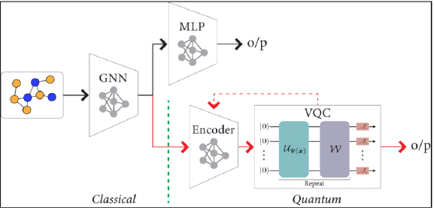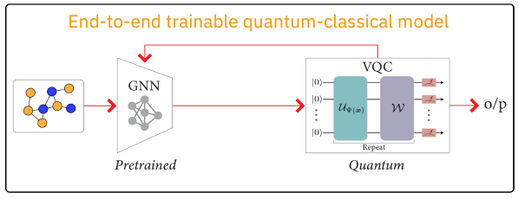
Figure 2. Architectural overview of the GNN-VQC model with serial and end-to-end GNN followed by VQC
The QDeepColonNet and hybrid GNN architectures, though architecturally distinct, are unified by their strategic exploitation of high-dimensional feature spaces to overcome specific limitations in classical DPATH models. QDeepColonNet, with its intricate dual-track design detailed in Figure 1, addresses the problem of multi-scale feature integration within a single image. Its dual-track CNN meticulously synthesizes a comprehensive feature set, which is then projected into a quantum Hilbert space where complex class boundaries become more separable. Its contribution lies in the synergistic combination of advanced CNN modules (EFLGA, LMKC, ECA) with a QML backend.
Conversely, the hybrid GNN framework, conceptualized in Figure 2, tackles the challenge of modeling complex spatial relationships across a tissue graph. It leverages the inherent efficiency of amplitude encoding to handle high-dimensional graph embeddings without informational loss, thereby mitigating issues like over-squashing that plague classical GNNs. Its end-to-end training paradigm demonstrates that quantum-classical co-design can yield representations unattainable by either paradigm in isolation.
The conceptual trajectory evidenced by these works points towards a future where the most robust DPATH AI systems will not merely rely on larger classical models but will strategically employ hybrid architectures. These architectures will be designed to first construct maximally informative classical features, be they multi-scale visual patterns or spatial interaction graphs, and then utilize quantum computational principles to project these features into a space where their inherent complexities can be resolved with greater efficiency and accuracy. This represents a fundamental shift from a scale-centric to a representational-centric approach in the development of AI for digital pathology.

Results and Clinical Trust
The validation of computational pathology systems hinges upon demonstrable performance, interpretable decision-making, and the subsequent cultivation of clinical trust. Transcending abstract architectural innovation, this chapter presents a quantitative analysis of results, deconstructs model efficacy through systematic ablation studies, and articulates the critical nexus between feature relevance, model interpretability, and clinical adoption. The integration of novel data modalities and computational paradigms thus emerges not as a mere technical exercise, but as a necessary evolution towards building robust, trustworthy, and clinically actionable artificial intelligence tools.
Ablation studies serve as a fundamental methodology for deconstructing a model's inner workings, systematically quantifying the contribution of each constituent component to the final performance. The empirical results from the featured studies provide compelling evidence for the value of multi-scale feature extraction and hybrid classical-quantum design. A rigorous ablation analysis of the QDeepColonNet framework on the EBHI dataset for colorectal cancer classification reveals a clear, cumulative benefit from its innovative components (Table 1). The baseline performance, established by the SDLFEN track alone at 95.34% accuracy and the DenseNet-169 backbone at 95.70%, confirms that neither local texture nor global context in isolation is sufficient for state-of-the-art performance. The integration of the EFGLA block, designed to capture often-neglected mid-level features, yielded a modest but consistent improvement to 96.06% accuracy, thereby validating the hypothesis that these intermediate features are critical for differentiating malignant and benign samples.
A significant performance leap occurred with the fusion of both tracks into a dual-track architecture, achieving 97.85% accuracy. This result underscores the profound importance of a synergistic integration of multi-scale features—spanning global tissue context and local textural patterns—for accurate histopathological classification. The subsequent refinement of these concatenated features through the ECA module further elevated performance to 98.57% with a classical classifier, demonstrating the utility of dynamically weighting feature channels to emphasize the most discriminative information. The final substitution of the classical classifier with a QML classifier provided the decisive boost to 98.92% accuracy, suggesting that the quantum circuit is uniquely adept at modeling the complex, non-linear decision boundary within the rich feature space synthesized by the dual-track CNN.
Experiment | Metrics
Experiment | Accuracy (%) | Precision (%) | Recall (%) | F1-Score (%)
SDLFEN Track Only | 95.34 | 95.21 | 95.24 | 95.22
DenseNet-169 Only | 95.70 | 96.42 | 96.40 | 96.41
DenseNet-169 + EFLGA | 96.06 | 96.49 | 96.48 | 96.48
Dual Track (DenseNet+EFLGA + SDLFEN) | 97.85 | 97.77 | 97.79 | 97.76
Dual Track + ECA + Classical Classifier | 98.57 | 98.36 | 98.37 | 98.36
Dual Track + ECA + QML Classifier (Proposed) | 98.92 | 98.94 | 98.94 | 98.93
Table 1. Ablation study of QDeepColonNet on the EBHI dataset (Adapted from Ajay et al., 2025).

Parallel findings from the hybrid Graph Neural Network (GNN) model, evaluated on breast cancer subtyping tasks, further illuminate the interplay between feature dimension, encoding, and performance. For high-dimensional graph embeddings (256, 512, and 1024 dimensions), the hybrid model (classical GNN + Variational Quantum Classifier) achieved performance parity with the state-of-the-art classical GNN. This is a significant result, demonstrating that a quantum classifier can effectively process complex, high-dimensional pathological representations without performance degradation. A pivotal experiment contrasted classical compression—reducing the GNN output to lower dimensions before encoding—against quantum compression via amplitude encoding. The quantum model with amplitude encoding significantly outperformed its classically compressed counterpart, providing empirical proof that amplitude encoding constitutes a lossless compression mechanism, thereby preserving critical information that is typically forfeited in classical dimensionality reduction. Furthermore, the transition from a serial training paradigm, with a fixed pre-trained GNN, to an end-to-end training regime, where the GNN and quantum classifier are co-optimized, resulted in a significant performance improvement. This end-to-end approach even enabled the hybrid model to slightly surpass the classical GNN baseline for a lower-dimensional task, indicating that the classical backbone can learn graph representations specifically tailored for the quantum feature space, unlocking superior representation.
For AI to achieve integration into clinical practice, it must transcend the "black box" paradigm; its decisions must be interpretable and aligned with established pathological knowledge. The featured studies offer distinct yet complementary pathways toward this paramount objective. The work employing chemical imaging provides a paradigm for inherently interpretable feature extraction. When an AI system incorporates quantitative measures such as carbonate content or SHG-derived collagen structure as an input feature, its decision logic becomes immediately grounded in a known and biologically plausible phenomenon. A model predicting malignancy based on low carbonate content at the edges of a microcalcification is making a decision that pathologists can intuitively rationalize, as it directly correlates with the acidic microenvironment of proliferating cancer cells. This represents a more foundational form of interpretability compared to post-hoc explanation methods that generate saliency maps for an otherwise opaque model. Moreover, chemical imaging can serve as a robust validation tool, corroborating the findings of models trained on H&E images and thereby building a foundational trust in the AI's decision-making process.

Architecturally, models like QDeepColonNet bake interpretability directly into their framework through attention mechanisms. The ECA module generates a vector of weights that signifies the relative importance of each feature channel. By analyzing which channels are amplified for a given prediction, researchers can infer the type of morphological or textural patterns—such as glandular formations or nuclear atypia—that the model deems most salient. This provides a channel-wise rationale for the model's output. While the interpretability of the quantum components themselves remains a challenging frontier of research, the hybrid approach offers a pragmatic compromise. The interpretability effort can be focused on the classical feature extractor—the DenseNet or GNN—whose learned representations have a more direct, albeit complex, relationship with histopathological structures. The quantum circuit can thus be viewed as a highly efficient, powerful function for separating these well-defined features in a high-dimensional space, with future research in quantum explainable AI (Q-XAI) being crucial to fully unwrap its decision logic.
The collective evidence from these studies coalesces into a coherent vision for the future of AI in digital pathology, one that systematically addresses the limitations of relying solely on H&E morphology and classical deep learning architectures. The observed progression is both logical and compelling: the process begins with the identification of biologically relevant features beyond standard morphology, as exemplified by the chemical imaging of calcifications. This is followed by the design of advanced architectures, such as dual-track CNNs and hierarchical GNNs, engineered to comprehensively capture these features across multiple scales and spatial hierarchies. The final step leverages novel computational paradigms, namely quantum computing, to classify these enriched feature sets with greater efficacy and efficiency. This trajectory marks a fundamental shift from a model-centric scaling approach to a representational-centric strategy, where the quality and comprehensiveness of the feature space are paramount.
It is, however, imperative to acknowledge current constraints within this discussion. The computational overhead and specialized hardware requirements for executing QML models remain non-trivial, positioning their widespread clinical deployment as a medium-term goal rather than an immediate reality. Furthermore, the generalizability of these sophisticated models across diverse cancer types, tissue staining protocols, and multi-institutional datasets necessitates extensive and rigorous external validation.
The QDeepColonNet framework was rigorously evaluated on the EBHI dataset for colorectal cancer classification. The step-by-step ablation, summarized in Table 1, clearly demonstrates the cumulative benefit of its innovative component.
- Both the SDLFEN track (focused on short-range dependencies) and the DenseNet-169 backbone (focused on high-level features) perform respectably on their own (~95.3-95.7% accuracy), but neither is sufficient for state-of-the-art performance.
- Integrating the EFLGA block with DenseNet specifically to capture mid-level features provided a modest but consistent boost (96.06%). This validates the identified research gap that many models neglect these crucial features for differentiating malignant and benign samples.
- The fusion of both tracks into a dual-track architecture yielded a significant performance jump to 97.85%. This underscores the critical importance of combining features from multiple scales—global context and local texture—for accurate histopathological classification.
- The addition of the ECA module further refined the concatenated features, pushing accuracy to 98.57% with a classical classifier. This highlights the value of dynamically weighting feature channels to emphasize the most discriminative information.
- Replacing the final classical layer with a Quantum Machine Learning (QML) classifier provided the final boost to 98.92%. This suggests that the quantum classifier is more effective at modeling the complex, non-linear decision boundary in the rich feature space created by the dual-track CNN.

The hybrid GNN model was evaluated on breast cancer subtyping tasks from the BRACS dataset. For high-dimensional graph embeddings (256, 512, 1024 dimensions), the hybrid model (classical GNN + VQC) performed on par with the state-of-the-art classical GNN. This is a significant result, demonstrating that a quantum classifier can effectively handle complex, high-dimensional pathological representations without performance degradation.
A crucial experiment compared classical compression (reducing the GNN output to 10 dimensions, then using ZZ-feature-map encoding on 10 qubits) against quantum compression (using 1024-dimensional GNN output with amplitude encoding on only 10 qubits). The quantum model with amplitude encoding significantly outperformed the classically compressed model. This proves that amplitude encoding provides a lossless compression mechanism, preserving critical information that is otherwise lost in classical dimensionality reduction.
When the GNN and VQC were trained end-to-end (as opposed to serially with a fixed GNN), the hybrid model's performance improved significantly and even slightly surpassed the classical GNN baseline for a 10-dimensional task. This indicates that end-to-end training allows the classical backbone to learn feature representations that are specifically optimized for the quantum classifier's unique processing capabilities.

Discussion
In this report, the critical role of feature relevance in building robust computational solutions for digital pathology has been explored, with a specific focus on overcoming the limitations of conventional histomorphological analysis. We have discussed a paradigm that shifts from a purely data-scale driven approach to one that prioritizes the extraction of physiologically and structurally meaningful features, enabled by novel data modalities and computational architectures.
The potential of data enrichment through chemical imaging, as demonstrated by hyperspectral stimulated Raman scattering microscopy, offers a significant advantage. This technique moves beyond traditional H&E morphology to provide a quantitative, label-free assessment of tissue biochemistry. The strong inverse correlation between carbonate content in microcalcifications and local malignancy establishes that underlying tissue chemistry carries critical diagnostic information. This finding inspires the integration of such crystallographic data as an alternative or complementary annotation distribution for training AI models. By enriching whole slide images with these chemically-informed features, we can create a more comprehensive feature space that may lead to models with improved generalization and biological plausibility.
Architecturally, the trend toward hybrid deep learning and quantum machine learning models presents a promising path to handle the complexity of this enriched data. The QDeepColonNet model, with its dual-track design, directly addresses the challenge of multi-scale feature extraction. Its synergy of a DenseNet backbone augmented for mid-level features and a parallel network for local textures underscores that capturing hierarchical tissue organization is key to high accuracy. Furthermore, the integration of a quantum classifier at the final stage suggests that the complex, non-linear relationships within these rich feature sets may be more effectively separable in a quantum-enhanced Hilbert space. This property of quantum systems to model intricate correlations could be pivotal for tasks like differentiating subtle pathological grades.
Concurrently, the hybrid quantum-classical graph neural network framework provides a powerful method for modeling the spatial tumor microenvironment. A key insight from this work is the efficacy of amplitude encoding for lossless data compression. This quantum approach to handling high-dimensional graph embeddings mitigates the information loss typically associated with classical dimensionality reduction techniques. This is particularly relevant for digital pathology, where preserving the nuanced interactions between cells and tissue structures is paramount. The finding that end-to-end training of the hybrid GNN and variational quantum classifier yields performance improvements indicates that the classical network can learn representations specifically optimized for the quantum processing layer, a co-design strategy that merits further investigation.
Finally, the overarching theme that connects these approaches is the move towards inherently more interpretable and trustworthy systems. The use of chemically-grounded features like carbonate content provides a direct biological rationale for a model's decision, bridging the gap between computational output and pathological reasoning. Similarly, attention mechanisms within the deep learning pipelines offer a glimpse into the model's focus, highlighting which feature channels or, potentially, which spatial regions are most influential. While the interpretability of the quantum components themselves remains a challenge, framing them as powerful classifiers operating on well-defined classical features provides a pragmatic path forward for building clinical trust. The convergence of enriched, biologically-relevant data and more expressive, hybrid computational models charts a course toward next-generation digital pathology tools that are not only accurate but also transparent and robust.

Conclusions
The pursuit of robust computational pathology systems necessitates a fundamental paradigm shift: from an obsession with model scale and data quantity to a dedicated focus on feature relevance and representational intelligence. This analysis has substantiated that the performance ceiling of conventional approaches, reliant solely on CNN-capturable morphology and classical deep learning, can only be breached by strategically enriching the feature space and employing more expressive computational paradigms.
The evidence presented affirms three core pillars of this next-generation framework. First, the integration of multi-scale features is not an optional refinement but a architectural imperative, as demonstrated by models that explicitly capture both global tissue context and local textural nuances to achieve superior diagnostic accuracy. Second, data enrichment through biochemical and structural imaging provides a biologically-grounded substrate for model reasoning. By incorporating quantifiable properties like mineral composition or even morphology, we anchor AI decisions in known pathophysiological processes, thereby building a foundational bridge to clinical interpretability and trust. Third, quantum-enhanced learning offers a tangible pathway to manage the complexity of this enriched data. The empirical results show that hybrid quantum-classical models can match or exceed classical performance while introducing the potential for lossless compression and more efficient learning in the high-dimensional spaces that characterize complex tissue ecosystems.
Looking forward, the trajectory of research must evolve to translate these principles into clinical practice. This involves a transition from static, single-modality analysis to dynamic, multi-modal frameworks that natively unify histology, immunohistochemistry, spatial transcriptomics, and chemical imaging. Furthermore, the field must advance from analyzing two-dimensional snapshots to modeling longitudinal disease progression and three-dimensional tissue architectures, offering unprecedented insights into tumor dynamics and treatment response. Parallel to this, the journey of quantum computing in pathology must progress from demonstrating potential on simulators to overcoming the practical challenges of resource-efficient algorithms and noisy intermediate-scale quantum hardware.
In essence, the future of digital pathology AI lies not in building larger models, but in engineering more intelligent systems. The path forward is defined by a deliberate focus on extracting physiologically salient features and leveraging the most advanced computational paradigms to interpret them. By prioritizing representational quality over brute-force scaling, we can develop tools that are not only highly accurate but also transparent, trustworthy, and capable of seamlessly integrating into the clinical workflow to ultimately improve patient outcomes.

References
Abedizadeh, Roya, Fateme Majidi, Hamid Reza Khorasani, Hassan Abedi, and Davood Sabour. “Colorectal Cancer: A Comprehensive Review of Carcinogenesis, Diagnosis, and Novel Strategies for Classified Treatments.” Cancer Metastasis Reviews (Netherlands) 43, no. 2 (2024): 729–53. https://doi.org/10.1007/s10555-023-10158-3.
Ajay, Abhishek, Han Wang, Ali Rezvani, et al. “Assessment of Targets of Antibody Drug Conjugates in SCLC.” NPJ Precision Oncology (England) 9, no. 1 (2025): 1. https://doi.org/10.1038/s41698-024-00784-7.
Ajay, Armaano, R. Karthik, Akshaj Singh Bisht, and Abhay Karan Singh. “QDeepColonNet: A Quantum-Based Deep Learning Network for Colorectal Cancer Classification Using Attention-Driven DenseNet and Shuffled Dynamic Local Feature Extraction Network.” Artificial Intelligence Review 58, no. 10 (2025): 304. https://doi.org/10.1007/s10462-025-11295-7.
Akpinar, Emine, and Murat Oduncuoglu. “Hybrid Classical and Quantum Computing for Enhanced Glioma Tumor Classification Using TCGA Data.” Scientific Reports 15, no. 1 (2025): 25935. https://doi.org/10.1038/s41598-025-97067-3.
Bülbül, Hande Melike, Gülen Burakgazi, and Uğur Kesimal. “Preoperative Assessment of Grade, T Stage, and Lymph Node Involvement: Machine Learning-Based CT Texture Analysis in Colon Cancer.” Japanese Journal of Radiology (Japan) 42, no. 3 (2024): 300–307. https://doi.org/10.1007/s11604-023-01502-2.
Gupta, Riddhi S., Carolyn E. Wood, Teyl Engstrom, Jason D. Pole, and Sally Shrapnel. “A Systematic Review of Quantum Machine Learning for Digital Health.” Npj Digital Medicine 8, no. 1 (2025): 237. https://doi.org/10.1038/s41746-025-01597-z.
H. M. A. Mohammed and A. N. Omeroglu. “A Novel Attention-Based ConvMixer Model for Enteroscope Biopsy Histopathological Images.” 2024 32nd Signal Processing and Communications Applications Conference (SIU), May 15, 2024, 1–4. https://doi.org/10.1109/SIU61531.2024.10600889.
Karthik, R., Vaibhav Thalanki, and Preyash Yadav. “Deep Learning-Based Histopathological Analysis for Colon Cancer Diagnosis: A Comparative Study of CNN and Transformer Models with Image Preprocessing Techniques.” In Intelligent Systems Design and Applications, edited by Ajith Abraham, Anu Bajaj, Thomas Hanne, and Patrick Siarry. Springer Nature Switzerland, 2024.
Khan, Saif Ur Rehman, Sohaib Asif, Ming Zhao, Wei Zou, Yangfan Li, and Xiangmin Li. “Optimized Deep Learning Model for Comprehensive Medical Image Analysis across Multiple Modalities.” Neurocomputing 619 (February 2025): 129182. https://doi.org/10.1016/j.neucom.2024.129182.
Li, Hui, Jianmei Lin, Yanhong Xiao, et al. “Colorectal Cancer Detected by Machine Learning Models Using Conventional Laboratory Test Data.” Technology in Cancer Research & Treatment 20 (2021): 15330338211058352. https://doi.org/10.1177/15330338211058352.
Nogueira-Rodríguez, Alba, Rubén Domínguez-Carbajales, Fernando Campos-Tato, et al. “Real-Time Polyp Detection Model Using Convolutional Neural Networks.” Neural Computing and Applications 34, no. 13 (2022): 10375–96. https://doi.org/10.1007/s00521-021-06496-4.
Prajapati, Jigna B., Himanshu Paliwal, Bhupendra G. Prajapati, Surovi Saikia, and Rajiv Pandey. “Quantum Machine Learning in Prediction of Breast Cancer.” In Quantum Computing: A Shift from Bits to Qubits, edited by Rajiv Pandey, Nidhi Srivastava, Neeraj Kumar Singh, and Kanishka Tyagi. Springer Nature Singapore, 2023. https://doi.org/10.1007/978-981-19-9530-9_19.
Prezja, Fabi, Leevi Annala, Sampsa Kiiskinen, et al. “Improving Performance in Colorectal Cancer Histology Decomposition Using Deep and Ensemble Machine Learning.” Heliyon (England) 10, no. 18 (2024): e37561. https://doi.org/10.1016/j.heliyon.2024.e37561.
Rahman, Md. Akizur, and Ravie Chandren Muniyandi. “Feature Selection from Colon Cancer Dataset for Cancer Classification Using Artificial Neural Network.” Articles. International Journal on Advanced Science, Engineering and Information Technology 8, nos. 4–2 (2018): 1387–93. https://doi.org/10.18517/ijaseit.8.4-2.6790.
Ray, Anupama and others. “Hybrid Quantum-Classical Graph Neural Networks for Tumor Classification in Digital Pathology.” 2024 International Conference on Quantum Computing and Engineering, October 2023. https://doi.org/10.1109/QCE60285.2024.00188.
Scott, Robert, Nicholas Stone, Catherine Kendall, Kalotina Geraki, and Keith Rogers. “Relationships between Pathology and Crystal Structure in Breast Calcifications: An in Situ X-Ray Diffraction Study in Histological Sections.” Npj Breast Cancer 2, no. 1 (2016): 16029. https://doi.org/10.1038/npjbcancer.2016.29.
Senokosov, Arsenii, Alexandr Sedykh, Asel Sagingalieva, Basil Kyriacou, and Alexey Melnikov. “Quantum Machine Learning for Image Classification.” Machine Learning: Science and Technology 5 (March 2024). https://doi.org/10.1088/2632-2153/ad2aef.
Shin, Kseniya S., Mint Laohajaratsang, Shuaiqian Men, Benjamin Figueroa, Suzanne M. Dintzis, and Dan Fu. “Quantitative Chemical Imaging of Breast Calcifications in Association with Neoplastic Processes.” Theranostics (Australia) 10, no. 13 (2020): 5865–78. https://doi.org/10.7150/thno.43325.
Talebi, Raheleh, Carlos A. Celis-Morales, Abolfazl Akbari, Atefeh Talebi, Nasrin Borumandnia, and Mohamad Amin Pourhoseingholi. “Machine Learning-Based Classifiers to Predict Metastasis in Colorectal Cancer Patients.” Frontiers in Artificial Intelligence (Switzerland) 7 (2024): 1285037. https://doi.org/10.3389/frai.2024.1285037.
Wei, Lin, Haowen Liu, Jing Xu, et al. “Quantum Machine Learning in Medical Image Analysis: A Survey.” Neurocomputing 525 (March 2023): 42–53. https://doi.org/10.1016/j.neucom.2023.01.049.
Xu, Hanwen, Naoto Usuyama, Jaspreet Bagga, et al. “A Whole-Slide Foundation Model for Digital Pathology from Real-World Data.” Nature 630, no. 8015 (2024): 181–88. https://doi.org/10.1038/s41586-024-07441-w.

