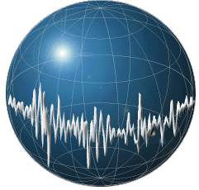
MACHINE LEARNING APPLICATIONS IN DIGITAL PATHOLOGY

Leo Berman
Albert Bulik
Yuan Nghiem

Table of Contents
1 Abstract 6
2 Problem Statement 6
2.1 Background 7
2.2 Needs 8
2.3 Implications of Project Success 8
3 Design Criteria 9
3.1 Functional Requirements 10
3.2 Design Constraints 12
4 Potential Solutions 13
4.1 Digitizing and Storing Biopsy Slides 14
4.2 Slide Segmentation 16
4.3 Feature Extraction 17
4.3.1 Frequency Analysis Overview 18
4.3.2 Feature extraction by frequency analysis 19
4.4 Dimension reduction 23
4.5 Principal Component Analysis (PCA) 25
4.6 Machine/Deep Learning Models 27
4.6.1 Random Forest (RNF) 28
4.6.2 Convolutional Neural Networks 30
5 Engineering Design 36
5.1 Temple University Health Digital Pathology (TUHDP) Corpus 36
5.2 Polygon Fill of Labeled Regions 38
5.3 One to Two-Dimensional DCT 38
5.4 Implementing PCA 39
5.5 Implementing PyTorch CNN 39
5.6 Train, Dev, and Eval Datasets 39
5.7 Application of the Flood-Fill Algorithm and WSI Classification 42
5.8 Prediction Report & Example Use Case 45
5.9 Implementing a Graphical User Interface 46
6 Evaluation 46
6.1 Test Methods 46
6.1.1 Statistical Testing Methods 46
6.1.2 Qualitative Testing Methods 58
6.1.3 Quantitative Non-Statistical Testing Methods 60
6.2 Results 62
6.2.1 Train Set Frame Accuracy and Loss Error! Bookmark not defined.
6.2.2 Confusion Matrix 62
6.2.3 F1 Score 62
6.2.4 Cohen’s Kappa 63
6.2.5 Example Output Images 63
6.2.6 Graphical User Interface (GUI) 64
7 Standards & Specifications 65
7.1.1 Coding Standards 65
8 Cost 66
9 Summary & Conclusion 66
9.1 Successes 66
9.2 Failures 66
10 References 68

Table of Figures
Fig. 1: Example of the Train & Dev Cycle [17] 13
Fig. 2: Digitized biopsy slide with two tissue samples. 14
Fig. 3: Leica Biosystems Aperio AT2 biopsy slide scanner. 15
Fig. 4: Biopsy slide segmented into frames; frames are represented larger than 200x200 pixels to make them easier to see. 16
Fig. 5: Borders of windows overlapping with adjacent windows and frames. 17
Fig. 6: Illustration of f_2N [n] (right) and f[n] as it is applied to a DFT (left) (the DFT is identical to the discrete Fourier series of the periodic extension of the signal). 19
Fig. 7: Plot of test signal $xn=0.9ncos0.1πn, n∈0,31$. [19] 20
Fig. 8: Plot of real (a) and imaginary (b) parts of 32-point DFT of $xn$ (pts 16-31 are mirrored). Plot of 32-point DCT (c). [19] 21
Fig. 9: Example image reconstructed from k frequencies using 1D DCT-II and 2D DCT-II. [20] 23
Fig. 10: Example plot of weight vs. age of a population sample (the dark green line is the line of best fit, included for reference). 24
Fig. 11: PCA demonstration; vertical and horizontal axes represent two features, and each point is a separate input. 26
Fig. 12: Variance (predictive ability of a PC) vs. PC number in a sorted list of PCs. 26
Fig. 13: Random Forest structure [23]. 28
Fig. 14: Bootstrapping example [25]. 29
Fig. 15: Random Forest example [26]. 30
Fig. 16: CNN structure [28]. 31
Fig. 17: Filter over image with depth 'c'. 32
Fig. 18: Usage of multiple filters in the convolutional layer [30]. 32
Fig. 19: Stacking feature maps [30]. 33
Fig. 20: ReLU activation function. 34
Fig. 21: CNN max pooling example [30]. 35
Fig. 22: Image scale at various resolutions [35]. 37
Fig. 23: Example of Outlined Regions [36]. 37
Fig. 24: Example of Train, Dev, Eval Split 40
Fig. 25: Sample model output of Fig. 3; outline of a potentially malignant region. 42
Fig. 26: Flood fill applied to Fig. 25: Sample model output of 43
Fig. 27: Inverted flood-fill of Fig. 26. 44
Fig. 28: Original DCIS predictions with mask (Fig. 27) applied. 44
Fig. 29: Example graphical representation 45
Fig. 30: Example of GUI pipeline 46
Fig. 31: Precision and recall in Venn diagrams. 51
Fig. 32: Reference annotation outline of an artifact (pen mark) on a slide, illustrated by a black border. 54
Fig. 33: Hypothesis annotations of artifact (ARTF) model predictions, represented by two contiguous patches of red frames. 55
Fig. 34: Intersections (bright red) of a reference annotation (black border) and hypothesis annotations (all red). 56
Fig. 35: Area (green) of a reference annotation (black border) not covered by hypothesis annotations (red). 57
Fig. 36: Pixel areas of highlighted intersected (red) and non-intersected (green) regions. 58
Fig. 37: A GUI example demo. 59
Fig. 38: PEP8 Code Example 60
Fig. 39: Unsupervised learning example. 61
Fig. 40: Annotations generated from model predictions. 63
Fig. 41: GUI 'Viewer' page with descriptions of different areas/functions. 64
Figure 42: 'More' window that shows the RNF predictions of the selected image. 65

Abstract
This document contains the summation of a yearlong project in the pursuit of implementing a novel breast cancer diagnosis system that utilizes frame segmentation to pinpoint exact locations of malignancies within breast tissue. We go into detail regarding our pipeline from the initial source of the images to preprocessing, prediction generation, and postprocessing. Furthermore, we discuss both machine learning algorithms, deep learning algorithms, geometric algorithms regarding segment consolidation. We also delve into memory safe parallelization to maximize cluster utilization to reduce training times and increase batch sizes over a large dataset to improve convergence time of deep learning models. Once the infrastructure was in place to prepare for training a model to diagnose breast tissue, we implemented a user-friendly GUI that focuses on ease of use for non-expert users. We detail useful statistics valuable in diagnosis and evaluation of deep learning and machine learning models. Through the creation of these tools, we plan to help plan to help prioritize patients and reduce treatment times.

Problem Statement
Breast cancer is the most frequent cancer diagnosis in women worldwide [1]. According to a literature review published in the journal Nature,
Early breast cancer — that is, cancer that is contained in the breast or that has only spread to the axillary lymph nodes — is considered curable. Improvements in multimodal therapy have led to increasing chances for cure in ~70–80% of patients. By contrast, advanced (metastatic) disease is not considered curable using currently available therapeutic options [1].
Breast cancer’s incidence rate combined with its prospects in early stage and inoperability in late stage place a unique emphasis on early diagnosis. The earlier an accurate diagnosis is made, the greater a patient’s likelihood of survival.
Diagnostic methods are numerous and multivariate. Mammography is a popular screening method in developed countries but its implementation varies widely among developing nations (e.g., sub-Saharan and east African countries) [1]. We choose instead to focus on histological stains – photographic images of cell samples from biopsies. These images may be processed by a machine learning (ML) model and provide additional diagnostic information for breast cancer pathologists.
Our deliverables are entirely software-based. We use biopsy images from Fox Chase Cancer Center to train our ML model; we investigate, document and describe the training algorithm used to produce the model, and evaluate its efficacy (diagnostic accuracy and computational performance) using similarly sampled biopsy images.
The uniqueness of our approach relies on frame-level diagnosis. Instead of classifying a biopsy slide image as a whole, our classifier segments each test image into a uniform grid and assigns grid squares to malignant or non-malignant labels. This will allow pathologists to evaluate biopsies faster by obviating the need for humans to comb through entire slide images.

Background
If breast cancer is not caught and treated within a small time-window, the patient’s prognosis is likely invasive surgery or death. Therefore, the best prophylactic for this disease is early, proactive screening. Currently, pathologists employ a variety of methods to screen and diagnose breast cancer. The first line of defense is population screening via mammograms [1]. Mammograms use low doses of x-rays to detect early biomarkers of malignancy, so it may be treated with non-invasive procedures such as personalized drugs. Unfortunately, mammograms may produce false positive or false negative results due to variations in breast tissue density [2].
Another screening method is Magnetic Resonance Imaging (MRI). MRIs are generally safer for patients requiring frequent imaging, since MRIs (unlike mammograms) do not produce ionizing radiation. MRI technicians are able to create detailed visualizations of tissue. Additionally, while mammograms are insensitive to tumors in dense tissue, MRI images are easier to differentiate between white and gray matter, aiding in accurately detecting benign and malignant lesions. However, MRIs are very expensive and require a lot of time and specialized personnel to use them effectively and efficiently [3]. MRIs and mammograms are part of a class of screening methods known as tomographic imaging. When a patient is screened using tomographic methods, their next step is a needle biopsy [1] [4].
Needle biopsies use needles to extract physical tissue samples from patients’ breasts. Needle biopsies are less invasive as compared to cutting into breast tissue and, as a result, have lower rates of re-excision compared to surgical biopsies. According to oncologist C. H. Weaver of the University of Pennsylvania, “Of the 3481 women who underwent needle biopsy, 23% had to have a breast re-excision compared with 92% of the 2650 women who underwent surgical biopsy” [5]. In this procedure, a needle is inserted into a suspicious region of the breast (e.g., a lump, scar tissue, or foreign object); the tissue is removed, stained with hematoxylin and eosin dyes, inspected under microscope and photographed for reference. The disadvantage of a needle biopsy is that it does not remove significant malignant material as a surgical biopsy would. To prevent metastasis of the tumor, it’s essential when performing a needle biopsy that time-to-diagnosis is short.
Aforementioned tomographic and biopsy images require significant time to be reviewed by breast cancer pathologists. Unfortunately, there is currently more demand than supply for pathologists with the relevant skills and training. One method of minimizing time-to-treatment is to preprocess patient data using machine learning methods. One study of Bangladeshi patients suggests a clear advantage of using the XGBoost training algorithm to model classification of histological data from biopsies, citing the highest precision (0.94), recall (0.95), and F1 scores (0.96) of a survey including decision trees, random forests, logistic regression, and naive Bayes classifiers [6]. The results were promising but the dataset “... was limited in size and diversity, potentially limiting the generalizability of the findings.” We hope to complement its findings by applying a larger and more diverse dataset to a wider selection of models.

Needs
By creating an urgency system using machine learning, we can call attention to biopsy slides with higher malignancy risks. Within each slide, we can direct the reviewing pathologist to an area predicted by the model to contain malignant tissue. Our software cannot replace trained pathologists, as a trained pathologist will be needed to verify model predictions, but it can reduce the time required to review biopsy slides. As a result, it may increase the productivity of pathologists, and by extension, the productivity of pathology labs and hospitals.

Implications of Project Success
Our intent is to investigate unique ways of training and classifying data and thereby contribute some increase in computational performance, diagnostic accuracy or diversity of algorithms to the existing corpus of pathology software. We aim to improve the speed and accuracy of cancer detection in parts of the world where health infrastructure and access to expensive screening methods (such as MRIs) are limited.
If our goal were met, breast cancer patients could receive more accurate diagnoses in shorter time, and receive earlier treatment. As a result, the mortality rate of breast cancer patients would diminish. Future innovations may build on our software framework or model to solve related problems, such as detecting early-stage lung cancer or other tissue types.
These outcomes coincide with the United Nation’s Sustainable Development Goals (SDG). [7] Specific SDG goals include:
(1) No poverty: Economically accessible screening methods reduce financial burden on individuals and nations.
(3) Good health and well-being: If patients receive quicker diagnoses, they may be treated faster, requiring less time and therapy to recover.
(8) Decent work and economic growth: The symptom burden of late-stage treatment is often debilitating.
(9) Industry, innovation, and infrastructure: Our software may be reappropriated for other use-cases, as discussed.
(10) Reduced inequalities: Marginalized peoples are less likely to be financially prepared for expensive screening methods, following from SD goal no. 1.
The symptom, financial and psychosocial burden of cancer affect not only individuals but also the collective material conditions of entire groups of people [UN SDG 1], and the effect is pronounced in developing countries where cancer burden is higher.
Symptoms of therapy greatly inhibit patients’ quality of life [UN SDG 3]. Endocrine therapy causes frequent hot flashes; aromatase inhibitors produce joint pain; chemotherapy causes nausea, fatigue, infertility, cardiotoxicity, neuropathy and cognitive dysfunction [1].
Financial and psychosocial burdens of therapy introduce additional hardships–
Lost employment and cost of care can be economically challenging [UN SDG 8], and dealing with a potentially fatal diagnosis (including relying on friends and family to help with, for example, transportation and home responsibilities) can be emotionally challenging [1].
These burdens collectively and disproportionately affect impoverished nations with poor health infrastructure lacking the capacity for early diagnosis [UN SDG 10].

Design Criteria
The scope of this project can be separated into two categories: functional requirements (3.1) and design constraints (3.2). Functional requirements communicate our objectives while design constraints communicate our self-imposed and natural limitations when conducting research.

Functional Requirements
Functional requirements outline what we intend to achieve and the metrics we use to determine if a goal has been met. Requirements are separated into negotiable and non-negotiable priorities (Tab. 1, Column 1). Non-negotiable priorities are critical to the project’s success as a whole and negotiable priorities are stretch goals we may pursue if other requirements are satisfied. Columns 2-4 (Tab. 1) list the associated requirement and its metric target, and col. 5 is a description or citation of its utility.
Tab. 1: Functional Requirements
Priority | Requirement | Metric | Target Value, Range, Pass/Fail | Justification
Non-negotiable | Inter-Rater Reliability | Cohen’s kappa coefficient [0,1] | 0.6 | [8]
Non-negotiable | Class Dependent Performance | Mean $F_{1}$ score [0,1] | 0.8 | [9]
Non-negotiable | Whole-slide image (WSI) accuracy for each slide | {Pass,Fail} | Pass | [10]  [11]
Non-negotiable | Semi-Supervised Model | Utilization of unlabeled images in final model (Percent) | 100% | [12]  [13]
Non-negotiable | Graphical user interface (GUI) segments slides or tissue area | {Pass,Fail} | Pass | Presentation should communicate salient features to an untrained audience.
Non-negotiable | GUI displays malignancy probability | {Pass,Fail} | Pass
Non-negotiable | GUI displays reference annotations | {Pass,Fail} | Pass
Negotiable | Time to train model | (Days) | < 3 days | The less computer time it takes to train a model, the quicker we can evaluate and improve the algorithm.
To assess the accuracy of our model, we use two distinct statistics: inter-rater reliability, represented by Cohen’s kappa coefficient, and class-dependent performance, represented by an $F_{1}$ score.
Inter-rater reliability (Tab. 1, Row 1) allows us to compare the accuracy of our model to a baseline of human accuracy when classified by a trained pathologist. The pathologist and model in this context are referred to as raters. Our choice of statistic is Cohen’s kappa coefficient, which measures observed agreement between raters beyond the probability of agreement by pure chance. Our target kappa value of 0.6 is extracted from the study by Wetstein et al. [8], which yielded a kappa coefficient of 0.59 from the application of deep-learning methods to whole histopathology slides.
Class-dependent performance (Row 2) implies evaluating the model’s predictive performance by focusing on individual classes. Our choice of statistic is the $F_{1}$ score, which is the harmonic mean of sensitivity and specificity of an individual class. Sensitivity is the proportion of predictions correctly guessed to belong to a specific class, and specificity is the proportion of predictions correctly guessed not to belong to a specific class. We evaluate the $F_{1}$ score for each class and take the mean. Our target value is 0.8, which is derived from a study of deep networks for invasive ductal carcinoma discrimination [14], which yielded an $F_{1}$ score of 0.9. Inter-rater reliability and class-dependent performance statistics are discussed further in §6.1.1 Statistical Testing Methods.
Whole-slide image classification (Row 3) is a de facto standard for researchers using machine-learning models to generate predictions from histopathology slides. Simply put, the slide itself must receive a class label (for example, “ductal carcinoma in situ”), in addition to any tissue samples contained in the slide.
Utilization of a semi-supervised model (Row 4) has become a necessity with Temple University’s acquisition of new data. Not all slide data is annotated, so a semi-supervised model allows us to combine annotated datasets with non-annotated datasets. A greater volume of data allows us to increase our model’s predictive performance by increasing the variance of data used to train the model.
A graphical user interface (“GUI”, Rows 5-7) allows people who lack in-depth knowledge of our program to view results. Specifically, we present our slides in a window with buttons to view and compare pathologist annotations and model predictions, a list box to search and select slide images, and widgets to display statistics and metrics.
The time to train our model (Row 8) must be brief enough for us to be able to iteratively improve our model by adjusting variables and model parameters. We estimated, without rigorous analysis, that 3 days would be a reasonable training time.

Design Constraints
Design constraints (Tab. 2) outline our limitations when conducting research and development. These limitations are partly self-imposed, such as adhering to code formatting standards to aid in readability, and partly naturally occurring as a result of the limited availability of data.
Tab. 2: Design Constraints
Priority | Constraint | Metric | Target/Limit | Justification
Non-negotiable | Programming language must be Python | {Pass,Fail} | Pass | Python is the language the research lab (ISIP) maintains.
Non-negotiable | Data availability | Available training data (Bytes) | 1.2 terabytes | Larger datasets correlate to more robust machine learning models.
Non-Negotiable | Adherence to ISIP standard for Python code formatting | {Pass,Fail} | Pass | [15]See below
Negotiable | Adherence to PEP8 Python standard for code formatting | {Pass,Fail} | Pass | [16]See below

Writing our program using Python (Tab. 2, Row 1) is necessary because our code will be inherited by Dr. Joseph Picone’s research group. Researchers of that group primarily use Python, so if we were to use another programming language (while possibly yielding better short-term results), the software wouldn’t be maintainable.
The amount of data available (Row 2) is a physical limitation. For each piece of annotated data, a trained pathologist has to manually generate the annotations. Since this is an expensive and time-consuming process, there is a limited amount of data (1.2 terabytes) that we currently have access for model training.
The last two rows of Tab. 2 are standards constraints. Row 3 is the lab standard for Temple’s Institute for Signal and Information Processing (ISIP). We use ISIP’s tools for data processing tasks and format our code according to ISIP style guidelines [15] for consistency and interoperability between components. Row 4 mentions the industry standard for Python formatting (PEP8). Where ISIP guidelines don’t take precedence, we defer to PEP8 standards [16] for the sake of maintaining and publishing our code for a wider readership. PEP8 standards contain recommendations on indentation, commenting, and conventions such as consistency among function return types.

Potential Solutions
Training a machine learning model to predict malignancy requires many interlocking components. First, a biopsy slide is digitized by a pathologist at Temple University Health, and the slide image is stored in the TUH Digital Pathology data store (4.1). The slide is then segmented into frames and windows (4.2). An algorithm extracts the features of each window (4.3), and the number of features is reduced using a dimension reduction algorithm (4.4, 4.5). A model is trained on the windows (4.6), and the model output for a test case (a segmented slide image) is postprocessed (5). Finally, the model is tuned and evaluated (Fig. 1).
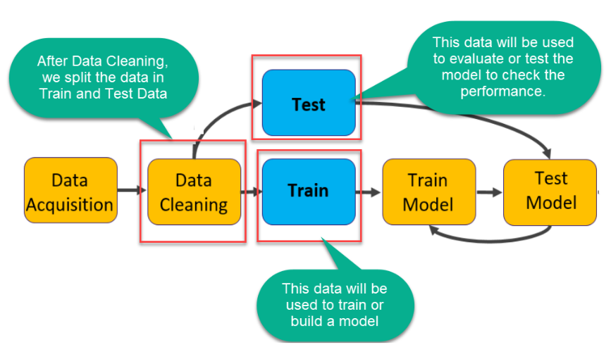
Fig. 1: Example of the Train & Dev Cycle [17]

Digitizing and Storing Biopsy Slides
The first job of any data analyst is to collect data. For the purpose of machine learning, data must have clearly defined input and output. For example, if one were predicting height based on age, height would be the output and age would be the input; we would collect and record the height and age of a random sample of the population, and this dataset would form the basis of our predictions. In our case, we are predicting the presence of malignant tissue in a patient biopsy, so we require annotated photos of biopsy slides. The photos themselves (or some aspect of each photo) will be the input for our model, and the annotations will be the model's output. See for a representative example of a biopsy slide.
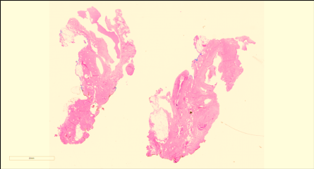
Fig. 2: Digitized biopsy slide with two tissue samples.
What do we mean by annotation? In Fig. 1, several shapes will have been traced over the image by a pathologist. Each shape has a corresponding label with a specific meaning. Each label and its meaning are listed in Tab. 1 by ascending order of urgency. The higher the urgency, the more likely it is that tissue from the sample will develop into malignant tissue (ductal carcinoma in situ, or DCIS).

Tab. 3: Slide labels, their meanings, and order of urgency.
Label | Description | Urgency
Unlab | Unlabeled tissue area; non-annotated area of the biopsy slide. | 0
Bckg | Background stroma tissue surrounding lobules and ducts. | 1
Norm | Normal tissue, including lobules or ducts with empty spaces called lumen (areas of the slide that allow light to shine through). | 2
Null | Indistinguishable tissue, often caused by poor cuts of the sample. | 3
Artf | Artifacts in the slide image, such as pen marks. | 4
Nneo | Non-neoplastic tissue, a non-malignant lesion. Includes fibrosis and hyperplasia. May develop into a malignancy. | 5
Infl | Inflammation, high concentration of small dots typically found around stroma. | 6
Susp | Suspicious tissue, at risk for developing into DCIS. | 7
Indc | Invasive ductal carcinoma in situ, cancer tissue, freeform malignant tissue invading stroma. | 8
Dcis | Ductal carcinoma in situ, dense and tightly enclosed cancer tissue. | 9

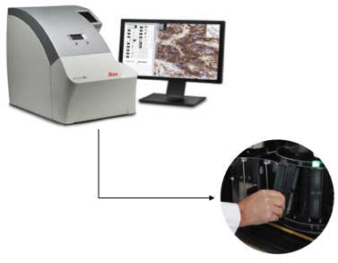
Fig. 3: Leica Biosystems Aperio AT2 biopsy slide scanner.
Biopsy slides are prepared and scanned by the pathology lab at Temple University Health (TUH) using a Leica Biosystems Aperio AT2 (Fig. 3). All identifying patient information is removed and the slides are stored in the TUH Digital Pathology database in Scanscope Virtual Slide (SVS) format. An SVS file contains the labels for each slide annotation and the slide image at multiple resolutions (1:1, 4:1, 16:1, 32:1). The images are compressed using JPEG 2 (Joint Photographic Experts Group) compression with three color values per pixel (red, green, and blue, or, 'RGB'); the full resolution of a biopsy slide is 50,000 x 50,000 pixels.

Slide Segmentation
Unlike machine learning models that focus on whole-slide image classification, our approach is unique in that we segment slide images into smaller areas called frames. Our ML model is trained on frames, and makes predictions on (i.e., assigns labels from Tab. 1 to) frames. The benefit of this approach is that it allows a reviewing pathologist to quickly localize the affected area of a malignancy. For each slide in the training dataset, the slide is divided into a uniform grid of 200 x 200 pixels per frame (Fig. 4).
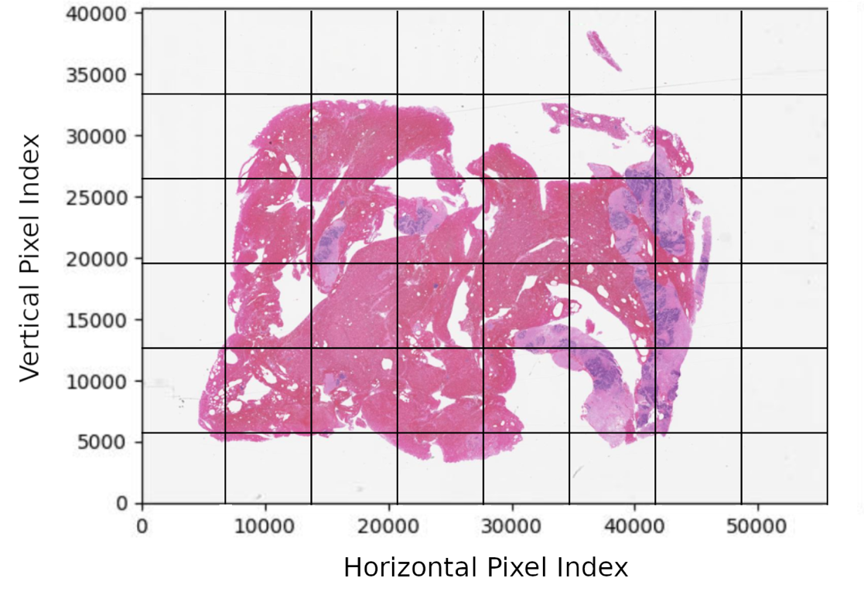
Fig. 4: Biopsy slide segmented into frames; frames are represented larger than 200x200 pixels to make them easier to see.
When we pass frames as input to the training algorithm, we allow some overlap between adjacent frames. Prior to training, frame boundaries are extended by 25 pixels on every side. The extended 250 x 250 area is what we call a window (Fig. 5). The amount of overlap is a non-negative number set by the training engineer, and the reason that we desire overlap is that it encodes context into the training data.
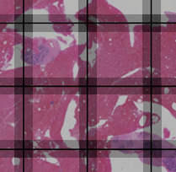
Fig. 5: Borders of windows overlapping with adjacent windows and frames.
Context is a broad subject in machine learning but is, in essence, the surrounding information or environment that may affect a prediction. For instance, in language processing certain letters are more likely to appear in certain positions in a word, and words have different meanings depending on their position in a sentence. While increasing the amount of overlap between adjacent windows may be thought of as a filter, because we are lowering the amount of variance between adjacent window predictions, it’s not a filter in the sense of a convolutional window. Therefore, it’s important not to confuse window size in our segmentation algorithm with, for example, window size of a moving average filter. Window size was not calculated with a specific cutoff frequency in mind.
In our application, context is correlation between adjacent frames. If one frame is classified DCIS, then incorporating context raises the likelihood that adjacent frames are classified DCIS as well. This allows us to keep predictions relatively consistent.

Feature Extraction
In machine learning lingo, features are subsets of an input datum. If we were predicting height based on weight and age, weight and age would be features of the input data. For simple examples like this, features are often readily apparent. For the purpose of predicting label classifiers from bitmap images, the features are not readily apparent. The question of extracting features is analogous to the question of determining what aspects the data yield the most predictive ability and information for our model. Our input datum (the smallest unit of input) to the training algorithm is a bitmap image for a single window, extracted from a biopsy slide. Each bitmap image is separated into 3 layers (one per color) and each layer is a 250 x 250 matrix, encoding color intensity per pixel. How can we organize the color matrices into useful features for our training algorithm?
The most obvious way to extract features for a bitmap image is to consider each pixel value a separate feature. For one window we would have 250x250x3 = 187,500 features. As simple and direct as this method is, it often yields surprising results when training a convolutional neural network (CNN). We discuss CNNs and scoring metrics in later sections, but to put the performance of this method into context, a CNN trained directly on image data yielded 86.64% accuracy and an 89.00% F1 score in a study of 400 slide images; the best results in the same study and dataset were 96.00% accuracy and 96.00% F1 score yielded by a CNN trained on statistics from a contourlet transform and histograms [18].
We don't want to limit ourselves to one method of feature extraction; the best method varies by application. Let's consider other methods of characterizing input data.

Frequency Analysis Overview
Before discussing alternative methods of feature extraction, we’ll briefly introduce the math behind frequency transforms. Any signal $f$ can be decomposed into frequencies $F$. The relationship is one-to-one; if we know $F$, then $f$ can be fully reconstructed. This means that every signal is a superposition of periodic functions, and the frequency spectrum encodes magnitude and phase for every frequency necessary to reconstruct $f$. It's worth noting that each window matrix in our training set is a sequence of discrete values (color intensities per pixel). This allows us to leverage aspects of discrete series that we would otherwise not be able to do for continuous signals.
Consider a simple sequence of bits $f=\{1,0,1,1\}$. We note that the sequence contains $N=4$ bits, so it requires 4 steps to traverse—$N$ is the fundamental period of this bit sequence. Therefore, the fundamental frequency $ω_{0}=2π/4=π/2$ corresponds to a quarter rotation of a circle. It can be shown that only 4 frequencies are required to reconstruct the signal $\left(0,\frac{π}{2},π,\frac{3π}{2}\right)$ when $f$ is applied to a discrete Fourier transform (DFT). The transform pair of a DFT is provided in Eqn. 1.
$$F\left[k\right]=\sum_{n=0}^{N-1}{f\left[n\right]}e^{-j\frac{2π}{N}kn}, f\left[n\right]=\frac{1}{N}\sum_{k=0}^{N-1}{F[k]e^{j\frac{2π}{N}kn}},$$
Equation 1: Discrete Fourier transform analysis (left) and synthesis (right) equations.
where $n$ is the index of $f$, $N$ is the fundamental period of $f$, and $F\left[k\right]$ is the $k^{th}$ harmonic in frequency spectrum $F$. If $r$ is an integer, then substituting $k+rN$ for $k$ yields the same analysis expression (Eqn. 2).
$$F\left[k+rN\right]=\sum_{n=0}^{N-1}{f\left[n\right]}e^{-j\frac{2π}{N}\left(k+rN\right)n}=\sum_{n=0}^{N-1}{f\left[n\right]}e^{-j\frac{2π}{N}kn}e^{-j\frac{2π}{N}\left(rN\right)n}=\sum_{n=0}^{N-1}{f\left[n\right]}e^{-j\frac{2π}{N}kn}$$
Equation 2: Substituting a sum of harmonic k and integer multiple of the fundamental rN.
This implies that harmonics $≥N$ are copies of harmonics in $\left[0,N-1\right]$, because $e^{-j\frac{2π}{N}\left(rN\right)n}$ can only be a multiple of $e^{-j2π}=1$. If the discrete-time signal were sampled from an analog signal, we would say the higher frequencies are aliases of lower frequencies.
The DFT transforms a series of length $N$ to a frequency spectrum of equal length $N$. The DFT of a 2-dimensional matrix is more involved but the result is the same. If we apply a 2D DFT to a 250x250 window matrix of pixels, then we receive a 250x250 matrix of every combination of horizontal and vertical harmonics. This will become important later when discussing dimension reduction.

Feature extraction by frequency analysis
Our choice of frequency transform is the discrete cosine transform II (DCT-II). The DCT-II $F_{c2}$ is related to the DFT of $f$ if $f$ were mirrored on its final value and $2N$-points long (Eqn. 3). The way in which $f$ is mirrored is illustrated in Fig. 6.
$$F_{c2}\left[k\right]=2Re\left\{F_{2N}\left[k\right]e^{-\frac{jπ}{2N}k}\right\}=2\sum_{n=0}^{N-1}{f_{2N}\left[n\right]}\cos\left(\frac{πk\left(2n+1\right)}{2N}\right),$$
Equation 3: Relationship between DCT-II $F_{c2}\left[k\right]$ and DFT $F_{2N}\left[k\right]$ analysis equation.
$$f_{2N}\left[n\right]=\left(\frac{1}{2}F_{c2}\left[0\right]+\sum_{k=1}^{N-1}{F_{c2}\left[k\right]\cos\left(\frac{πk\left(2n+1\right)}{2N}\right)}\right)\frac{2}{N}$$
Equation 4: Synthesis equation of DCT-II.
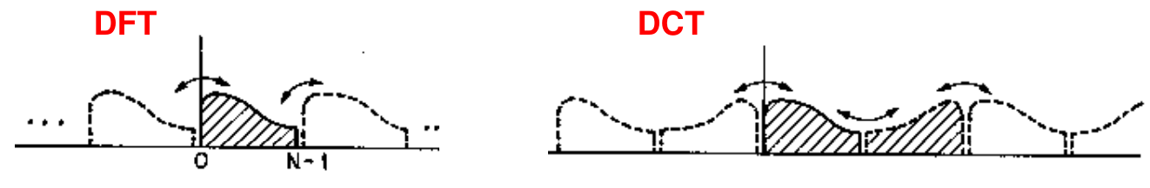
Fig. 6: Illustration of f_2N [n] (right) and f[n] as it is applied to a DFT (left) (the DFT is identical to the discrete Fourier series of the periodic extension of the signal).
Mirroring the signal gives DCT-II an advantage over DFT: the DCT-II frequency spectrum is much more compact than DFT. Fig. 6 compares the DFT and DCT-II spectra for the series in Fig. 7. Note that DCT-II coefficients approach zero much quicker than DFT coefficients.
This spectral compaction of DCT-II is desirable because every frequency is a feature of our model. The more features we can remove without losing information about the signal, the better our model's predictive and computational performance will be.
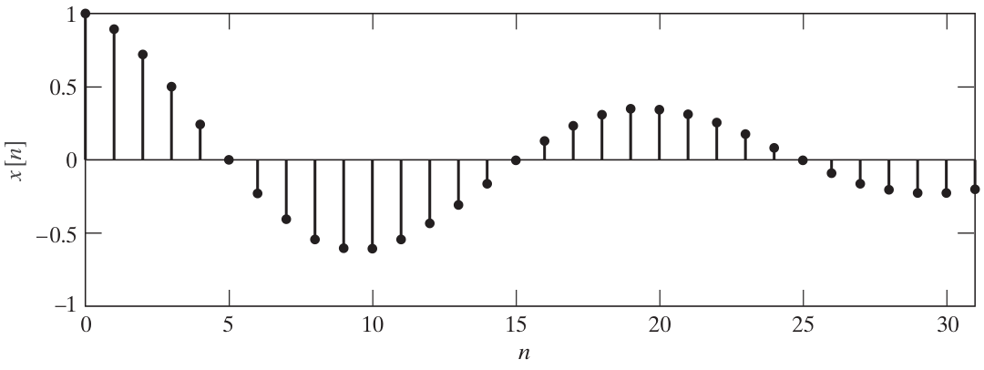
Fig. 7: Plot of test signal $x\left[n\right]={0.9}^{n}\cos\left(0.1πn\right), n∈\left[0,31\right]$. [19]
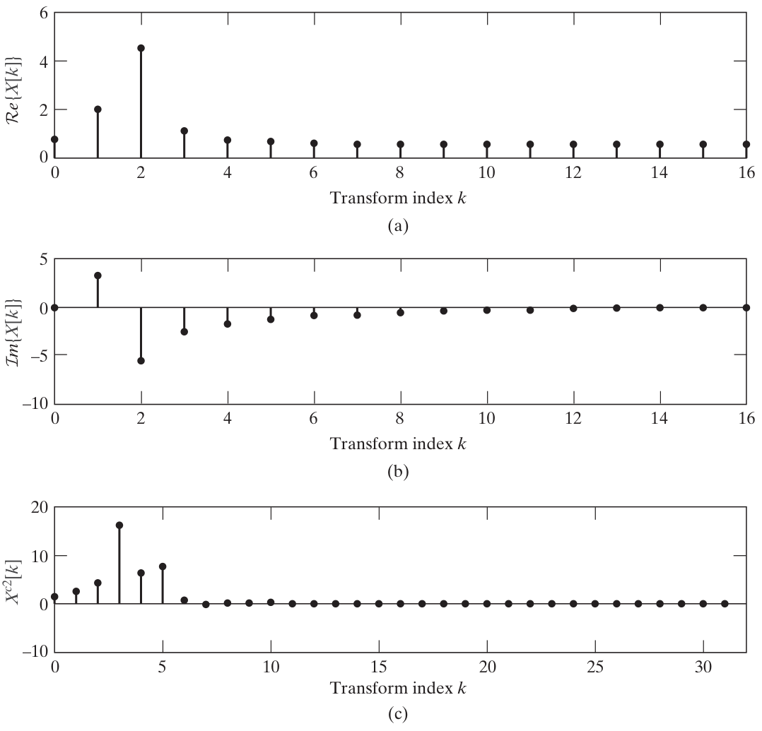
Fig. 8: Plot of real (a) and imaginary (b) parts of 32-point DFT of $x\left[n\right]$ (pts 16-31 are mirrored). Plot of 32-point DCT (c). [19]
Worth noting is that the synthesis equation of DCT-II (Equation 3) is not orthogonal. Orthogonality is a property of matrices that simplifies calculations. The inverse of an orthogonal matrix $C^{-1}$ is its transpose $C^{T}$. If we substitute $\sqrt{\frac{1}{4N}}f_{2N}\left[0\right]$ for $f_{2N}\left[0\right]$ and $\sqrt{\frac{1}{2N}}f_{2N}\left[n\right]$ for $f_{2N}\left[n\right]$, $n≠0$, Eqn. 3 simplifies to Eqn. 5.
$$F_{c2}\left[k\right]=\sqrt{\frac{1}{N}}f_{2N}\left[0\right]+\sum_{n=1}^{N-1}{f_{2N}\left[n\right]\sqrt{\frac{2}{N}}\cos\left(\frac{πk\left(2n+1\right)}{2N}\right)}$$
Equation 5: Orthogonal variant of DCT-II analysis equation.
Equation 5 can be rewritten as the product of an orthogonal matrix $C$ (Eqn. 6) and the signal column vector $f_{2N}\left[n\right]$, $F=Cf$. The signal may be reconstructed by the inverse operation, $f=C^{-1}F=C^{T}F$.
$$C_{k,n}=\left\{\begin{aligned}\begin{matrix}\sqrt{\frac{1}{N}}, & k=0 \\ \sqrt{\frac{2}{N}}\cos\left(\frac{πk\left(2n+1\right)}{2N}\right), & 0<k<N\end{matrix}\end{aligned}\right.$$
Equation 6: Orthogonal matrix representation of DCT-II analysis equation.
In two dimensions, we simply apply the one-dimensional DCT-II along the columns and rows of $C$; $F=C^{T}fC$. And to reconstruct the signal, we repeat the operation in reverse order, $f=CFC^{T}$. (This may also be done via Kronecker product, $vec\left(f\right)=C⊗Cvec\left(F\right)$.)
We may apply either 2D DCT-II or 1D DCT-II to a window matrix. In the one-dimensional case, all rows of a window matrix would concatenate to form a single vector. Changes in columns of pixels would be encoded as harmonics of the larger vector, so why use 2D DCT-II at all?
The advantage of 2D DCT-II is that it has the greatest spectral compaction of all frequency transforms discussed thus far. It encodes greater information in fewer frequencies than either 1D DCT-II or DFT, and we seek to eliminate redundant features. Compare the reconstructed images for 2D DCT-II in Fig. 9 to those of 1D DCT-II in Fig. 8. For $10≤k≤20$ frequencies, the 1D DCT-II reconstruction degrades significantly.
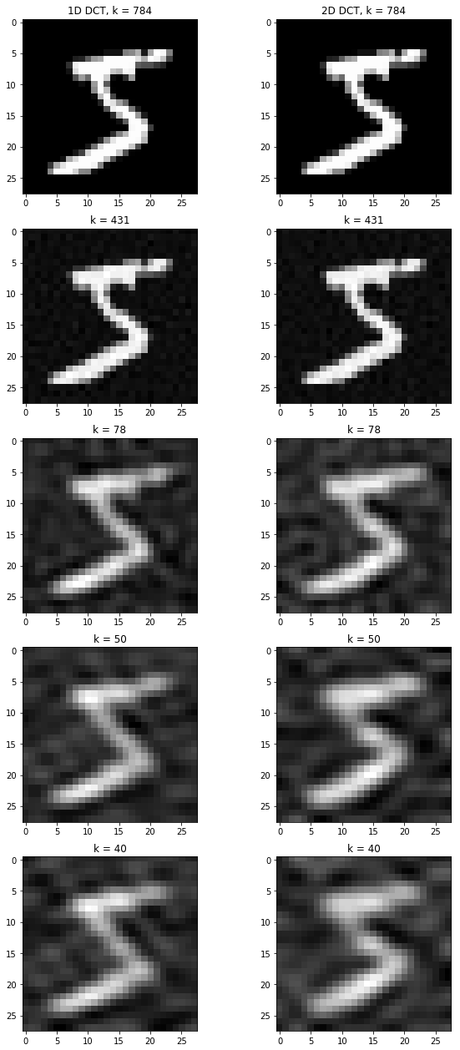 | 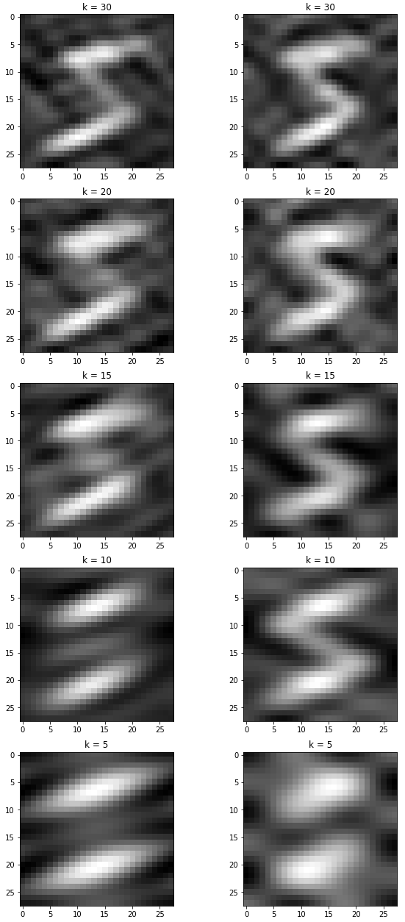

Fig. 9: Example image reconstructed from k frequencies using 1D DCT-II and 2D DCT-II. [20]

Dimension reduction
After extracting the features of each window, we can begin training. However, if we were to apply our features as-is, we would run into a problem in science and mathematics known as the curse of dimensionality. Models used for classification make predictions by dividing the feature space into label-specific regions. For example, if age and weight were used to predict heart disease, then the coordinate plane of age on one axis, and weight on the other axis, would be divided into separate regions of heart disease and not heart disease (Fig. 10). A trained model would predict whether a person has heart disease based on where their age and weight locate a point on the plane.
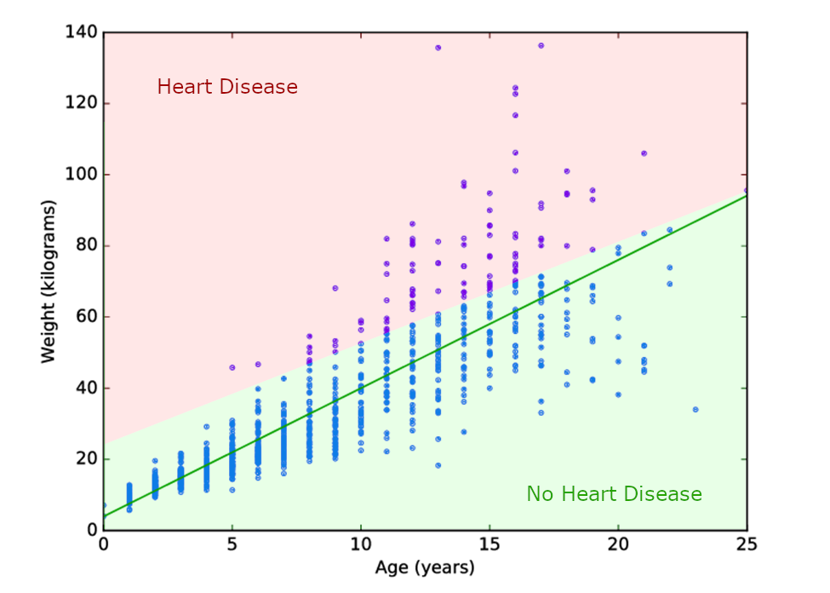
Fig. 10: Example plot of weight vs. age of a population sample
(the dark green line is the line of best fit, included for reference).
The line (or decision surface) that separates the red and green regions in Fig. 10 can be extended to 3 dimensions (for example, if height were a feature), or n dimensions for n features in $R^{n}$. In 3 dimensions the decision surface would be a plane, and for >3 dimensions, the decision surface would be a “hyperplane”.
The curse of dimensionality states that in higher dimensions, every point in a dataset is approximately the same distance to every other point [21]. This is troublesome for training because we prefer each class in the training data to be tightly separated in feature space from every other class. The question then becomes, how many dimensions is too many for the training data?
A good rule of thumb is to use fewer features than the square root of training inputs. Let $p$ be the number of features in a window, and $n$ be the number of windows in our training set; we desire $p<\sqrt{n}$. We have 3,505 tissue images, and each image is 50,000x50,000 pixels. These are segmented into 200x200 frames for classification and enlarged to windows. Therefore, we have $n=\left(3,505\left[slides\right]\right)\left(\frac{{50,000}^{2}}{{200}^{2}}\left[\frac{windows}{slide}\right]\right)=219,062,500$ windows in our training set. We must limit ourselves to $p<\sqrt{219,062,500}$ or $p<14,800$ features.
This poses a problem; we need fewer than 14,800 features, but bitmap images and frequency transformations for each window both yield 250x250x3 = 187,500 features. We need to reduce the number of features from 187,500 to 14,800. We mentioned in passing in section 4.3.2 that we desire frequency-based feature extraction methods with the greatest spectral compaction. We may prune frequencies above a threshold to constrain the number of features, but we may also apply linear or non-linear transforms to reduce that number even further. There is a tradeoff between the number of features pruned and the predictive ability of features lost to pruning. This is a subject of data analysis known as dimension reduction.

Principal Component Analysis (PCA)
The most popular method of dimension reduction is principal component analysis (PCA). The idea behind PCA is relatively simple: we find the line of best fit between every two features, and best-fit lines (eigenvectors) become our new axes in the principal component (PC) space. Each datapoint in feature space is projected onto the eigenvector (Fig. 11). Principal components subsequently replace the original features for training.
While PCA produces the same number of principal components as features, and ostensibly does nothing to reduce dimensionality, it allows the analyst to neatly prune PCs. This is because PCA orders PCs by variance, and half of all principal components have greater variance than the features from which they’re derived. If two features are highly correlated, then one PC axis will have high variance (datapoints far from the mean), and the other PC will have low variance (datapoints concentrated around the mean).
Variance is our metric of predictive ability with respect to features and principal components. Low-variance principal components can be safely removed without losing useful information for training. In practice, PCA leads to substantial dimension reduction as the variance of principal components decays geometrically. Fig. 12 displays the normalized variance of each PC for a high-resolution test image applied to PCA.
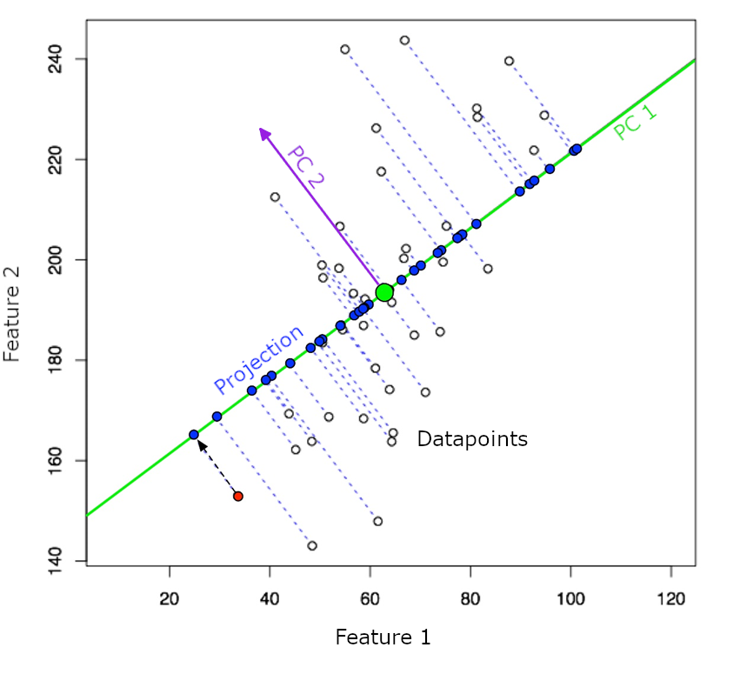
Fig. 11: PCA demonstration; vertical and horizontal axes represent two features, and each point is a separate input.
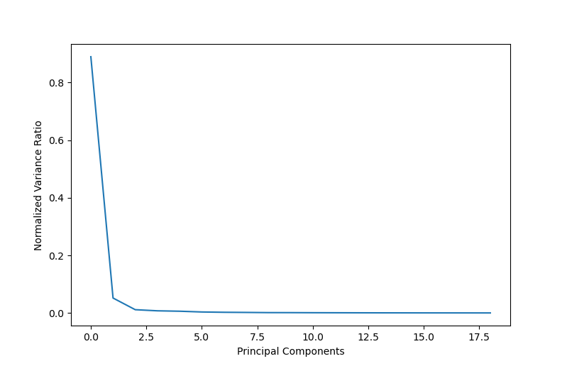
Fig. 12: Variance (predictive ability of a PC) vs. PC number in a sorted list of PCs.
PCA operates by computing the eigenvectors of the covariance matrix of training data. If we have a matrix $W$ for which each row $w$ is a window, and each feature is a column of this matrix, then we average each row to form the mean vector $\overline{w}$. We construct the mean matrix $\overline{W}=\left[\begin{matrix}1 \\ ⋮ \\ 1\end{matrix}\right]\overline{w}$, subtract means to center each feature, $B=W-\overline{W}$, and compute the covariance matrix $C=B^{T}B$. Each eigenvector of the covariance matrix $v_{i}$ is determined by maximizing the eigenvalue respective to $v_{i}^{T}Cv_{i}$, and the eigenvectors $v_{i}∈V$ form the basis of our principal component space. The rows of $W$ are projected onto $V$ to map features to principal components. In practice, more efficient matrix factorization methods are employed.
We also plan to test Uniform Manifold Approximation and Projection (UMAP) or Convolutional Neural Networks (CNNs) as dimension-reduction alternatives. Much as principal components are linear combinations of features, UMAP components are non-linear functions of features. UMAP is shown to provide better class-clustering in feature space and better computational performance on large datasets. CNN models, on the other hand, perform well on higher-dimension data, and do not require dimension reduction to the same degree as other models.

Machine/Deep Learning Models
When we are satisfied with the dimensionality of our features, we begin training on windows of biopsy slides. Machine learning diverges from traditional computer programs in that the computer program is learned from available data. There are three essential components to machine learning: the data, the mathematical model, and the training algorithm [22]. We’ve already talked about data, so let’s clarify what we mean by model and training.
The model is a mathematical representation of different relationships inherent to the training data. Data is fed to the model and variables of the model are continuously adjusted so its output agrees with its input. In a broad sense, the model may be thought of as a control system. When we train a model, we assess the error between input and output. In machine learning, error is evaluated by means of a loss function. A loss function may be as simple as the sum of squared errors, or as involved as cross-entropy.
All machine learning output is, in some sense, an average of training data. Polynomial regression fits a polynomial to data trends, neural networks superimpose activation functions, decision trees divide the feature space into averages of constituent points, and k-nearest-neighbors compute averages directly for points nearest to the input. The model chosen for any particular application should reflect the behavior of training data. For this reason, we survey a number of models and assess their ability to predict trends and converge in reasonable amounts of time.

Random Forest (RNF)
One of the most commonly used models is Random Forest (RNF), also known as Random Decision Trees. This model is a supervised ensemble learning model, made up of many weaker models, or decision trees, that collaboratively create a stronger model. The structure of an RNF can be seen in Fig. 13.
Overall, RNFs resemble a forest with x number of trees. Starting at one point, an RNF splits into multiple tree-like diagrams. Each tree continues to branch out until all branches terminate at unique endpoints. The topmost node of an RNF structure is the sample, or root node. This root node represents the entire training dataset – the set of extracted features, as discussed in §4.3.
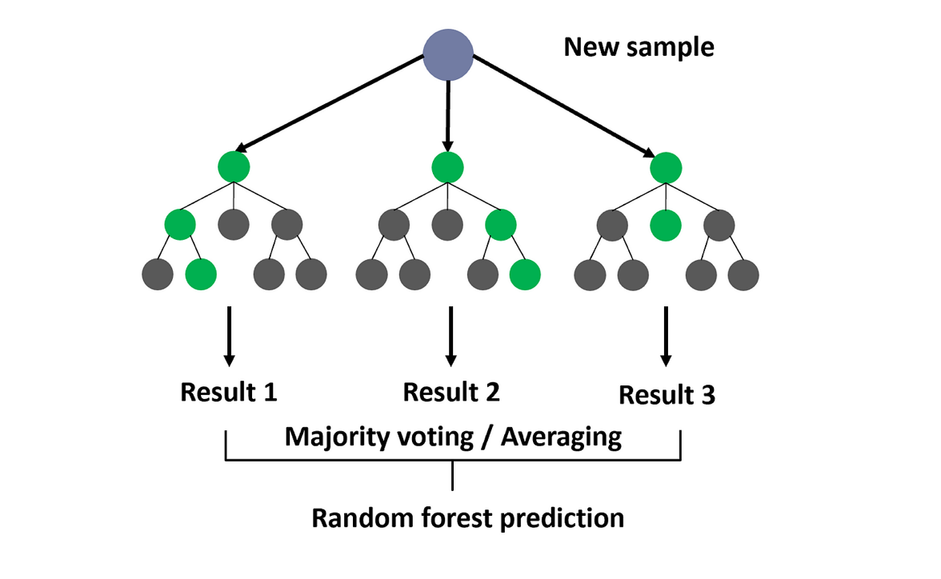
Fig. 13: Random Forest structure [23].

Bootstrapping
Because a sample may be limited in quantity, RNF implements a method called bootstrapping to quantize the sample. Bootstrapping takes the sample and resamples it over and over, producing subsets of the sample. The subsets are random parts of the original data, uniformly distributed and sampled with replacement. In other words, some subsets may contain multiples of the same feature, and each of the features have equal probability of getting selected [24].
Fig. 14 below is an example of bootstrapping, or resampling with replacement. Because the original sample on the left has only a few datapoints, there is a limited number of combinations that can be made when sampling. In this case, there are three blue, two orange, two green, and two yellow data points. However, when resampling with replacement, more combinations can be made since datapoints are reused. Sample 1 reuses a yellow datapoint, and Sample 3 reuses blue datapoints, omitting green datapoints. In summary, bootstrapping provides a model more samples for training.
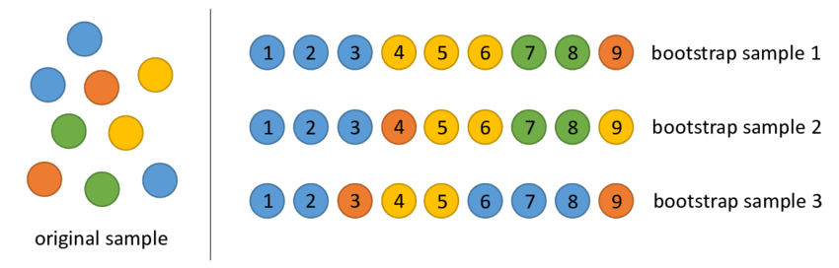
Fig. 14: Bootstrapping example [25].
Each time a sample is split into random subsets, every subset marks the beginning of a decision tree stemming from the root node. Based on the distribution of constituent features, each decision tree branches out to some sort of outcome, also called a decision node, and continues doing so until reaching a terminating point (or “leaf”). This stage is called a prediction. In this way, the model builds decisions off decisions, continuing recursively until all trees reach predictions.

Bagging (Bootstrap Aggregation)
Because each tree is handling random subsets of the overall sample data, there will be multiple different predictions. A quarter of the predictions may want to classify a frame as INFL, while the rest of the predictions think it may be DCIS. RNF deals with different weights of prediction using the bagging method, also called bagging aggregation. Just as the name implies, after the bootstrapping method, all the predictions are aggregated, and the final prediction is chosen based on a majority vote of all the predictions. This final prediction is the classification of the frame.
An example of bagging is shown below in Fig. 15. If our model is trained to classify different fruits, the sample would be features of a specific fruit. The features would undergo the bootstrapping methods, so the model has many different combinations to train on. Eventually, each tree will produce a prediction: Tree 1 and Tree 2 will predict the fruit is an apple, and Tree 3 will predict it is a banana. The bagging method will combine all the predictions. In this case, two out of three predictions are apples, so by majority vote, the fruit in question is classified as an apple.
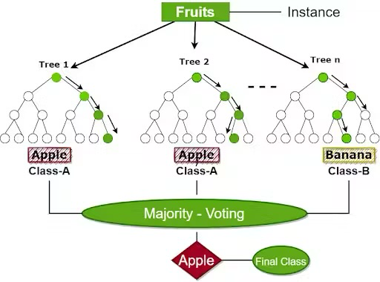
Fig. 15: Random Forest example [26].
RNF models have their own set of benefits that set them apart from other Machine Learning models. If the data were trained only on a decision tree model, the tree would keep branching, with each split eventually becoming too specific to the original training data. This is called overfitting. Since RNF is one big model combined with many decision trees, there would be multiple predictions, resulting in a smaller chance of overfitting and lower variance. However, depending on how large the dataset is, this may lead to a more complex algorithm with a longer runtime, as the data for each decision tree is computed [27].

How was RNF used in our project so far?
There are three main hyperparameters: the node size, number of trees, and the number of features sampled. Using the Python’s SKLearn library, it already has a random forest function built-in. There are many modifiable parameters, however, for our project, we have not set any parameters and hyperparameters. At the moment, we have only input our data into the RNF model to see if it works. By not inserting any parameters, the parameters may have been the default settings. Of course, the results were not what we wanted, but it gave us a baseline to know where we should start and what we should look into tuning.

Convolutional Neural Networks
Unlike Random Forest, Convolutional Neural Networks (CNN) is a deep learning model that is an extended version of the machine learning model Artificial Neural Networks (ANN). ANN is a model that holds units called neurons. These neurons receive an input, does some sort of computation, and provide an output, and those outputs will become inputs to the next outputs. Just like a brain, these neurons are all intertwined, forming a complex structure that provides highly accurate classifications. However, as ANN is used for a wide range of tasks, not specifically dedicated in one area, CNN builds off ANN and specializes in image recognition and classification. CNN has three types of layers: input layer, hidden layer, and output layer.
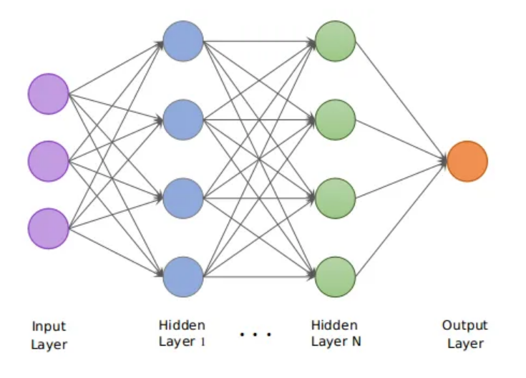
Fig. 16: CNN structure [28].

Input Layer
The input layer takes one image at a time. Usually, images have three channels: red, green, and blue, which is why in Fig.15, the input layer has three dimensions. These refer to the channels. In our case, our training data consists of images in RGBA format, which means there will be four dimensions in the input: red, green, blue, and alpha. In addition, the images are 50k×50k pixels. Since they are quite large, rather than the whole image, the input will be provided with windows of the images containing only the extracted features.

Hidden Layer
The hidden layer has three main types of layers: a convolutional layer, pooling layer, and dense layer. At the end of a convolutional layer, a very important step before moving onto the pooling layer is applying the activation function.

Convolutional Layer
The convolutional layer takes the features from the input layer and performs linear transformations, specifically convolution, using a filter – a matrix with weights. Since the image has three dimensions (the last dimension depth of 3 channels: RGB), the filter must also have three dimensions with a depth of 3. A typical filter would usually have a height and width of three 3 pixels, while the depth is the same as the image. It would resemble Fig. 17, where c is the depth (i.e., number of channels). The height and width of the filter must be significantly smaller compared to the input as there would be too many weights resulting in too many connections if the filter was the same size.
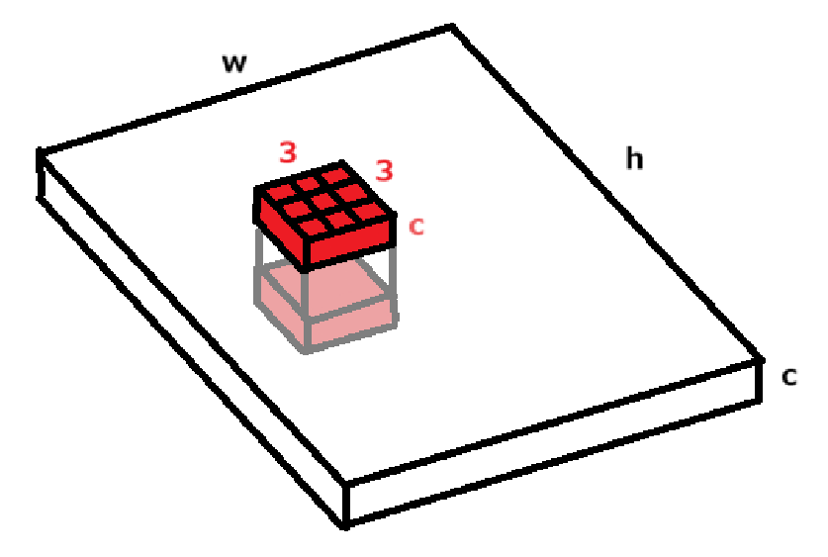
Fig. 17: Filter over image with depth 'c'.
The filter will start by positioning itself to the top-left of the image, and the dot product of the filter and the features laying underneath will be calculated. The filter will move in strides (which can be adjusted) and iterates through each row of the image. Once the whole image is swept through, it will output a feature map, a matrix containing all of the scalars from the dot product computations [29]. There can be multiple filters in a convolutional layer, which will result in multiple feature maps. Multiple filters are used to extract different features (e.g., edges, textures, color), and each of those filters will work on the same input image. In Fig. 18, you can see that the number of feature maps outputted is the same as the number of filters that run through the image. It should be noted that filters and kernels are interchangeable, and feature maps and activation maps are interchangeable.
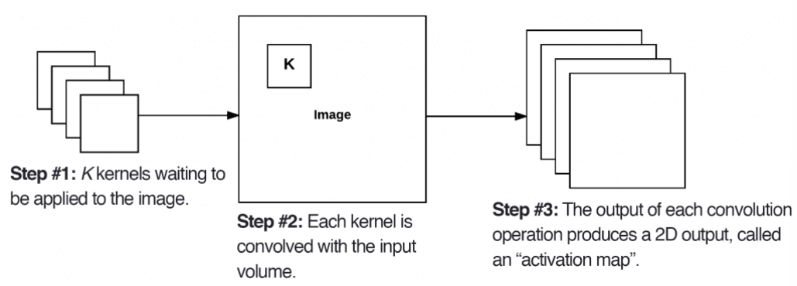
Fig. 18: Usage of multiple filters in the convolutional layer [30].
The feature maps are all 2-dimensional, but when stacked together in the depth axis, it creates a 3-dimensional output, as shown in Fig. 19.
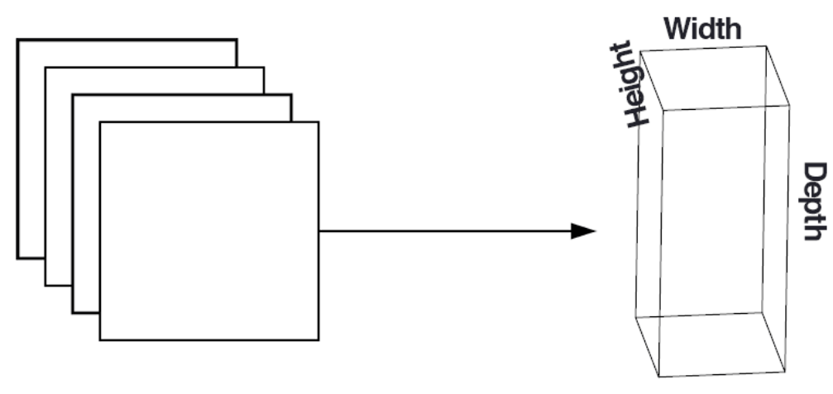
Fig. 19: Stacking feature maps [30].
In addition, there can be multiple convolutional layers, where the next layer takes the feature map of the previous layer as the input. Using multiple layers helps improve efficiency and accuracy since the layers build off one after another, extracting more complex features from the previous features.

Activation Function
The activation function is a nonlinear function that is applied to each feature map of every convolutional layer. The activation function is an important step of the CNN model because it produces only the meaningful parts of the data. One of the most common activation functions is the rectified linear unit (ReLU). Fig. 20 below shows a plot of the ReLU function. As you can see, when x is negative, y is equal to 0, and when x is positive, y is equal to x.
When this function is applied to the input, the negative elements of the matrix are zeroed while the positive elements are kept the same. In other words, It turns off the negative elements, and only keeps the elements that seem important. This allows the model to learn complex relationships with the input and output. Afterwards, the resulting matrix is sent as the input to the next convolutional layer or the pooling layer if there are no more convolutional steps.
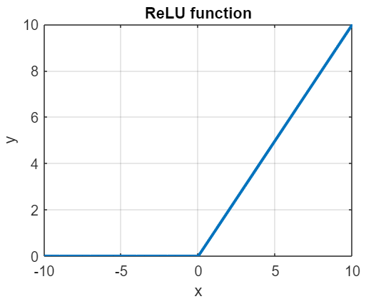
Fig. 20: ReLU activation function.

Pooling Layer
After the last convolutional layer, the pooling layer takes the feature maps and downsamples, or compresses, them using a filter and send it to the output array. When compressing the feature map, it summarizes the features by combining multiple features throughout the image, which removes a lot of the fluctuation between them. This helps the model to not “overreact” and misclassify the frame. The filter must be smaller than the feature maps. If the feature map is 250 × 250 pixels and the filter is 2×2 pixels, for every 2×2 position of the feature map, it would compress those values into a single value using max pooling or average pooling [31].
The size of the pooled feature map depends on the stride. In Fig. 21, it shows an example of max pooling the input matrix with a stride of 1 and 2. Higher strides lead to smaller matrices as it sweeps through the input faster, as well as downsampling more, while lower strides lead to bigger matrices, retaining a bit more information. This is also the same for the filter size too. When picking the filter size and stride, there will be chances of oversampling or undersampling, so a middle ground must be considered.
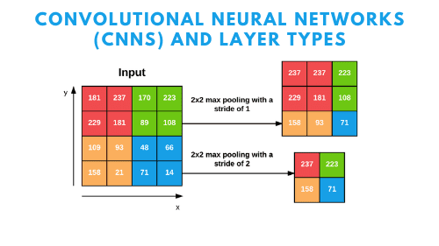
Fig. 21: CNN max pooling example [30].

Dense (Fully-connected) Layer
Before reaching the dense layer, the feature maps received from the pooling layers for each hidden layer must be condensed into one-dimensional vectors and then fed into the dense layer, specifically, each neuron of the dense layer. Each neuron will do computations to the input vector, which helps the neurons connect to each element of all of the feature maps. These computations consist of a weighted sum plus a bias term as Eqn. 7 below.
$$z=w_{1}x_{1}+w_{2}x_{2}+…+w_{n}x_{n}+b$$
Equation 7: Weighted sum plus bias.
This layer also makes use of activation functions as it would be applied to the output of the above equation. Each neuron in the layer would produce a scalar. The scalars would be placed into a vector with size m, where m is the number of neurons in the layer. An activation function would be applied to this vector (Eqn. 8).
$$a=[a_{1},a_{2},a_{3},…,a_{m}]$$
Equation 8: Vector of computed scalars from each dense layer neuron.
Just as there can be multiple convolutional layers, there can also be multiple dense layers. The output vector of the first dense layer would be fed into the second dense layer. Lastly, the outputs of the last dense layer would be sent to the outer layer.

Outer Layer
Just like the hidden layer, the outer layer may also contain a dense layer. However, this dense layer would finalize everything and output a score. Using the same process as above (computing the weighted sum plus a bias), we may use a different type of activation function. There are multiple options but the most common activation functions that produce a score is the sigmoid function and softmax function. If we plan to classify frames by checking for each classification type individually (e.g., “Is this NULL type?”, “No.” “Is this DCIS type?”, “Yes.”), then it’s better to use sigmoid as it classifies only with two symbols: 0 (no) and 1 (yes). The second option is classifying frames by checking all of the classification types in once process. In this case, it would be better to use the softmax function since it can use multiple symbols: 0 to 9 (e.g., 0: Unlab, 1: BCKG, 2: NULL, etc.) If there is a higher probability of a certain class, then the output would produce the score of the probability and the classification.
Using this model over Random Forest would provide many advantages. Since this model specializes in image recognition and classification, this would be more ideal to use as it provides more accurate classifications and is more efficient for what our project is intended to do. It also handles noise and variation much better since the input would go through many pooling layers and activation functions for combining and downsampling. However, CNN models are more difficult to train as they are very complex and require a lot of computational resources. In addition, the outputs of the overall model or individual layers may be difficult to interpret, that it would take some time figuring out how to finetune the model [32].

Engineering Design
To implement our workflow, described in the §4 introduction, we subdivided the workflow into further action items.

Temple University Health Digital Pathology (TUHDP) Corpus
The function of digitizing and scanning biopsy slides is performed by the pathology lab at Fox Chase Cancer Center. Temple University is host to a large, open-source dataset developed with a variety of diverse tissue types in mind. The subset of data we will use for training is a 3,505-image (1.23 terabyte) collection of breast tissue slides. For each image, there is an associated annotations file containing the following information: image scale (microns per pixel), height and width in pixels, and labeled regions [33].
Microns-per-pixel is a measure of image scale analogous to dots-per-inch in computer displays. This figure is calculated by dividing the field of view (the length of what the digital camera can see, in microns) by the camera resolution (the longer of the two dimensions, in pixels). For instance, if a microscope can see 500 microns with a resolution of 1920x1080 pixels², then its image scale is $500/1920=0.26$ microns per pixel. Microns-per-pixel is stored in the SVS file as a floating-point number. We may use microns-per-pixel to normalize image scale across biopsy slides when our model is implemented [34].
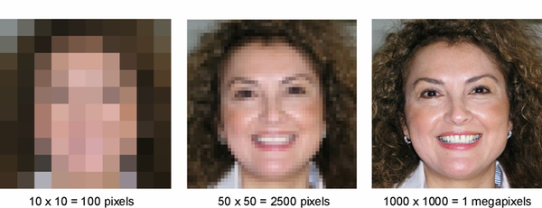
Fig. 22: Image scale at various resolutions [35].
The labeled regions field of an annotation file is list of pixel coordinates corresponding to labels assigned by a pathologist. See Fig. 23 for an example of a region of breast tissue annotated by a pathologist. The two dark textboxes in the figure contain the respective labels.
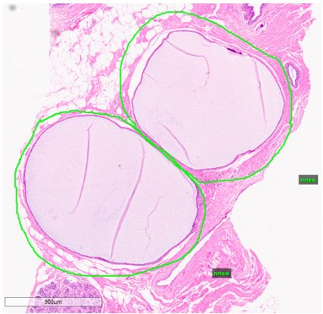
Fig. 23: Example of Outlined Regions [36].
Our task, when presented the data from Fox Chase Cancer Center, is to extract image scale, pixel height and width, and labeled regions from the image’s corresponding annotation file. To do this, we’ll use NEDC’s annotation tools.

Polygon Fill of Labeled Regions
Labeled regions are stored in annotation files as lists of pixel coordinates. We may create polygon objects from coordinates using shapely’s or scikit-geometry’s polygon libraries. However, the coordinates extracted from annotations only outline region borders. To assign a label to the interior of a region, we must retrieve all the pixel coordinates contained in the interior. Because the pixel scale of a slide image is on the order of 50,000x50,000 pixels, using either shapely’s or scikit’s intersect or fill functions may take an excessively long time to process.
To reduce computation time, we first apply frame segmentation to the slide image and use frame indices in place of pixel coordinates. I.e., pixel coordinates may be converted to frame indices by dividing by frame size. Fractional components of frame indices are discarded and coordinates lying in the same frame are discarded, effectively downsampling frame coordinates of labeled regions.
After downsampling frame coordinates, a polygon interior may be filled in less time than filling individual pixels. When the interior is filled, frame indices are reconverted to pixel coordinates by multiplying by frame size (effectively upsampling frame indices). The reconverted frame coordinates represent the top-left pixel coordinate of each frame. We create an association between each frame and its top-left coordinate and label.
To calculate window coordinates for the associated frame, we subtract ½ the amount of overlap between windows from the frame’s top-left coordinate. The other vertices of the window may be inferred from window size, but only the top-left coordinate is needed to NEDC’s image tools. NEDC’s image tools returns the bitmap image for the window as a numpy matrix of red, green, and blue (RGB) color values.

One to Two-Dimensional DCT
When we have RGB values, we may use them directly, as input features, or we may apply further processing. The choice of input features is discussed in §4.3.
Currently, our system extracts RGB values from the image into separate color vectors containing. This essentially leaves us with 3 vectors of length (window height [pixels] * window width [pixels]) containing integers between 0 and 255. On each vector, we perform a one-dimensional DCT and keep an arbitrary number of the most significant frequencies. Moving forward, we want to perform a two-dimensional DCT as mentioned above in section 4.3.2. We will implement this using scikit’s FFTpack library.

Implementing PCA
As mentioned in section 5.3, we are arbitrarily selecting a frequency cutoff. The reason we implement this is due to speed and memory of the machine, as well as the optimization of the algorithm to train the model. By keeping only the most significant frequencies of the color spectrum, we are able to keep a good portion of the information without taking up very much memory and reducing compute time. The drawback of this approach is that the variance of each window is not rigorously enforced. We plan to implement PCA and retain the number of principal components necessary to achieve 95% variance of input windows, as discussed in section 4.5. We will implement this using scikit-learn’s decomposition library.

Implementing PyTorch CNN
Our system is currently utilizing the Python scikit-learn library for establishing a base model, as mentioned in section 4.6.1. This is a machine learning model, but we want to add an option for deep learning to explore the affects it has on making predictions. In order to do this, we are going to be utilizing the PyTorch library, which allows us to more easily create a pipeline for deep learning models such as a CNN.
While the detailed explanation of how to use a CNN with PyTorch is outside the scope of this discussion, the first step for us is to take our processed frames and feed them into something called a DataSet. This allows us to increase the maximum training set size as it allows us to train the model off disk, instead of from memory as was done with the Random Forest implementation.
After we load the data into a DataSet, we explicitly declare some of the parameters talked about in section 4.6.2. Explicitly setting some of these parameters such as the types of layers, number of layers, epochs, etcetera. Allow us to significantly manipulate how the model trains, and as a result the model’s precision and accuracy on general data.

Train, Dev, and Eval Datasets
To train a model, we must first initially train the model on a subset of the data. Afterwards, we refine parameters by utilizing a separate subset of the data. Finally, we take this trained and refined model and evaluate it on a third separate subset of the data. The reason we do this is to reduce overfitting.
Overfitting happens when we put too much weight on attributes of the data that couldn’t be generalized from the size of the available data. For example, if our first subset of the data has a particular feature that is very pronounced in the artifact label, the model is going to attribute that feature to recognizing the artifact labels. However, if this feature doesn’t normally exist within the artifact label, we hope that when we compare with a second subset of the data, the model will pick up that this isn’t a feature that is normally present in the artifact label.
Finally, we utilize a third subset of the data to validate that our model hadn’t overfitted to either of the previous two subsets of the data. A graphical representation of this can be shown below in Fig. 24 . We call the first, second, and third subsets of the data Train, Dev, and Eval respectively [37].
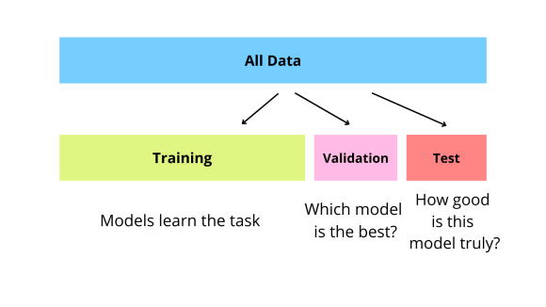
Fig. 24: Example of Train, Dev, Eval Split
To have this method be effective, we need to have both an even distribution of the labels through all the datasets, and a proper ratio of data in the Train, Dev, and Eval set. It’s standard to have 80% of the data in the Train set, 10% in the Dev set, and 10% in the Eval set. However, as seen in Tab. 4 below, we have a slightly different ratio of around 60% for Train, 20% for Dev, and 20% for Eval. The reason this is slightly different from what is standard is due to the imbalance of labels, such as inflammation (INFL), that only make up a small amount of the total labelled regions. It’s possible that if there was an 80:10:10 split followed, there wouldn’t have been an even distribution of such labels.

Tab. 4: Train, Dev, and Eval Label Distribution [33].
Label | Train | Dev | Eval | Total
artf | 17,147 | 6,513 | 6,881 | 30,541
bckg | 329,404 | 110,425 | 110,599 | 550,428
dcis | 5,626 | 1,945 | 1,900 | 9,471
indc | 6,574 | 2,528 | 2,599 | 11,701
infl | 1,144 | 473 | 457 | 2,074
nneo | 15,183 | 5,684 | 5,770 | 26,637
norm | 4,524 | 1,755 | 1,745 | 8,024
susp | 15,445 | 5,768 | 5,607 | 26,820

We have now established well defined Train, Dev, and Eval datasets. We then need to do two things to each image within the data. We need to segment it as shown in Fig. 4 and perform some preprocessing as shown in Fig. 6. However, for some use cases that need the full context of the entire image before performing something like a 2D DCT. What this means is that sometimes the preprocessing will be done before the segmentation, and sometimes it will be done after. The combinations of these are shown in Fig. 11 & Fig. 9.
After the image has been segmented and undergone some pre-processing, we now have our features. However, this means that we could be sending window_size² floats for each window. This is too much for the model to handle and for it to analyze each of those numbers is something that we don’t have time for especially when we can perform feature reduction. Doing something like PCA as seen in Fig. 11 allows us to reduce the amount of information the model has to process, and as a result, the amount of time the model takes to train.
Once we have established a dataset of features, we need to take the train set and fit the model. This involves feeding the data into a CNN as mentioned above. Once we have fit the model to the train set, we are then going to have the model make predictions on the development set. Using these predictions, we can attempt to optimize the model and remove some symptoms of overfitting inherited from the train set. This process can be seen in Fig. 1. Finally, we validate our model on the eval set. Once we are happy with our results, this leaves us with a trained and refined model.
With a finished model, we can effectively generate predictions for individual frames. However, we need to bring these individual predicted frames together to make a predicted region, like the annotations made in Fig. 23. This amounts to an inverse operation of the slide segmentation algorithm described in section 4.2.

Application of the Flood-Fill Algorithm and WSI Classification
Consider Fig. 25 and suppose the frames highlighted in green were predicted by the model to contain ductal carcinoma in situ (DCIS).
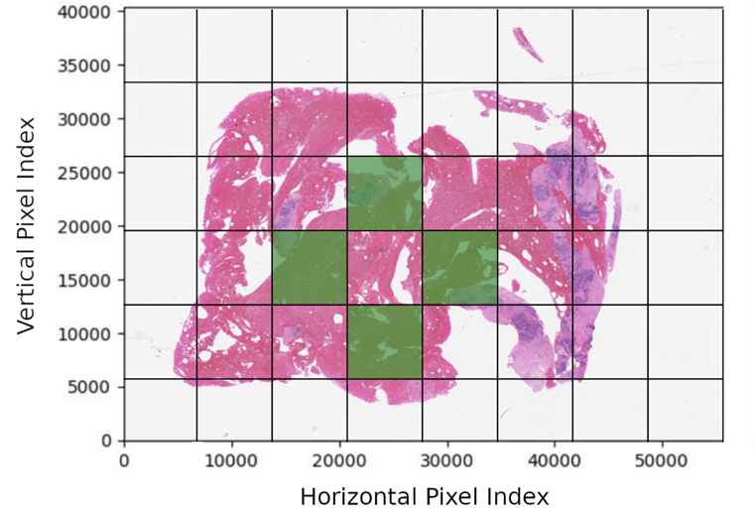
Fig. 25: Sample model output of Fig. 3; outline of a potentially malignant region.
If a tumor has extended to the region in green, then the interior must be malignant as well (we operate under the assumption that tissue containing ductal carcinoma in situ is uniform and tightly packed). We therefore identify and reclassify the interior frame between the green frames in Fig. 25 with the appropriate DCIS class, by means of a flood-fill algorithm.
Flood-fill algorithms are commonly used in graphics editors and more colloquially known as ‘paint-bucket’ tools. The purpose of a flood-fill algorithm is to fill an area of an image or array with some value (be it a color or label) while respecting the boundaries of existing values. Flood fill may be used to identify interior regions of DCIS predictions in the following manner:
First, we apply flood fill to the entire biopsy slide starting at a boundary frame (e.g., the top-left frame in Fig. 26).
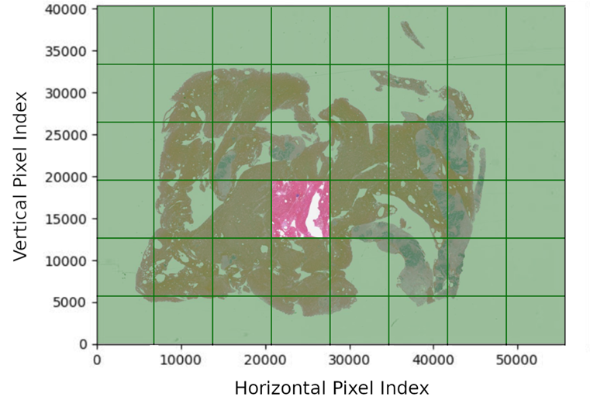
Fig. 26: Flood fill applied to Fig. 25: Sample model output of
We invert DCIS predictions such that non-DCIS frames are classified DCIS and vice versa (Fig. 27). Finally, we apply the inverted array in Fig. 27 as a mask to the generating array in Fig. 21. The result is an array of predictions with interior regions of DCIS classifications consistent with adjacent frames (Fig. 28).
To classify whole-slide images, we note the label with the highest urgency (according to Tab. 1) for the biopsy slide. If a slide image contains DCIS, the entire image is classified as DCIS. However, if only non-neoplastic, inflamed, and normal tissue were identified in a biopsy slides’ frame classifications, then the slide image would be classified with the highest urgency label (INFL, in this example).
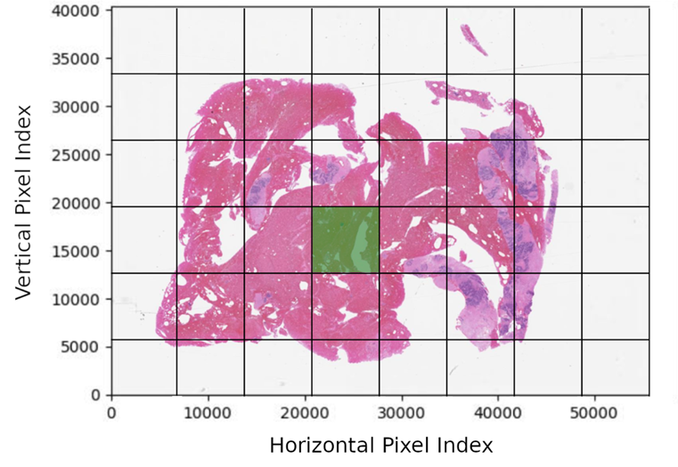
Fig. 27: Inverted flood-fill of Fig. 26.
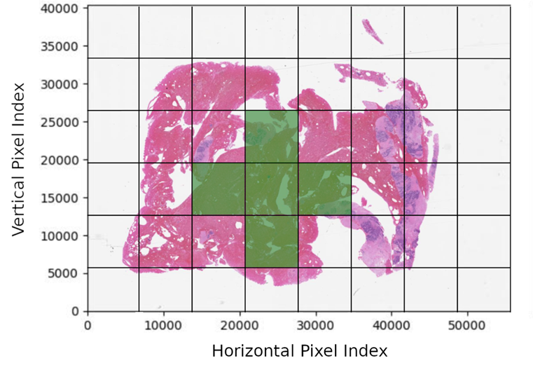
Fig. 28: Original DCIS predictions with mask (Fig. 27) applied.

Prediction Report & Example Use Case
Having a trained, refined, and tested model allows us to start making predictions in a production environment. In order, to make our predictions useful to end users unfamiliar with our system, we must have a Graphical User Interface (GUI). This is essentially a slightly higher-level view of the results. This includes an overlay of the predicted regions over the image of the tissue fed in, the type of tissue of these regions, and an overall report of cancer for the image. This can be seen below in Fig. 29.
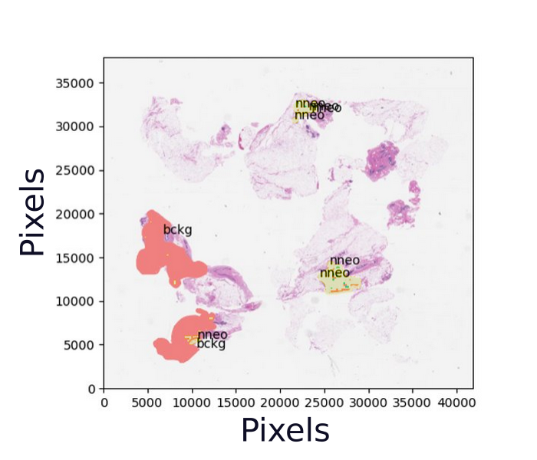
Fig. 29: Example graphical representation
One use case for these reports is to be used in an urgency system. If the volume of biopsied tissue slides that need to be reviewed is greater than the amount of work that pathologists can do, it’s possible for there to be a buildup of these images. A hospital may be able to utilize the predictions to organize the quote of images, so the highest risk patients are evaluated first. Due to the inherent aggressiveness of breast cancer, evaluating these higher risk patients can reduce their time to treatment and therefore their overall risk factor. Once a pathologist gets the chance to evaluate an image processed by the model, the pathologist can utilize the prediction report shown above in Fig. 29 to validate their diagnosis.

Implementing a Graphical User Interface
When we have a functional pipeline that takes from an image to fully formed regions, we want to be able to showcase something like what is shown in Fig. 29. Furthermore, we want a person unfamiliar with our system to be able to enter an image. To do this, we must implement a sort of drag-and-drop image functionality so the user will be able to drop an image in and get the showcased image and some information back as shown below in Fig. 30.

Fig. 30: Example of GUI pipeline

Evaluation
In this section, we will review each criterion and requirement from §3 and describe the testing methodology used to determine whether the criterion or requirement has been satisfied.

Test Methods
Testing methods are organized into three subsections: statistical testing methods (§6.1.1), qualitative testing methods (§6.1.2), and quantitative (non-statistical) testing methods (§6.1.3).

Statistical Testing Methods
For each functional requirement (inter-rater reliability and class-dependent performance), model outputs are compared against the control group of pathologist annotations, observations are aggregated into a single statistic and each statistic is validated against the respective target value.

Inter-Rater Reliability
Inter-rater reliability is a correlation coefficient describing agreement between two raters. Raters are independent parties who sort, or assign numbers or labels, to data. In our case, the two raters are the trained ML model and the human pathologists who annotate biopsy slides at the Fox Chase Cancer Center pathology lab.
Inter-rater reliability is analogous to the population correlation coefficient
(Equation 9).
$$ρ_{xy}=\frac{σ_{xy}}{σ_{x}σ_{y}}∈\left[-1,1\right].$$
Equation 9: Population correlation coefficient, where $σ_{xy}$ is the covariance between populations $x$ and $y$, $σ_{x}$ is the standard deviation of $x$ and $σ_{y}$ is the standard deviation of $y$.
Indeed, if raters were assigning numbers to data, then we would use the Pearson correlation coefficient (Equation 10).
$$r_{xy}=\frac{s_{xy}}{s_{x}s_{y}}∈\left[-1,1\right].$$
Equation 10: Pearson/sample correlation coefficient, for sample covariance $s_{xy}$, and sample standard deviations $s_{x}$ and $s_{y}$.
However, because we are assigning unordered nominal values (i.e., labels) to frames of biopsy slides, which have no immediate numeric interpretation, we use Cohen’s kappa coefficient $κ$ (Equation 11). $ρ,r$ and $κ$ all map to real numbers $∈[-1,1]$, where a value of $1$ indicates perfect agreement between populations/samples/raters, $-1$ indicates perfect disagreement, and $0$ indicates no correlation.
$$κ=\frac{p_{o}-p_{e}}{1-p_{e}}∈\left[-1,1\right]$$
Equation 11: Cohen’s kappa coefficient calculation.
The quantities $p_{o}$ and $p_{e}$ in Equation 11 are, respectively, the probability of observed agreement between raters, and the probability of expected agreement between raters. Both $p_{o}$ and $p_{e}$ are calculated via relative frequency. To illustrate how they’re calculated, we’ll use a simple 2-class example of patients diagnosed as either healthy or sick by two different doctors.
Out of 30 patients, doctor 1 diagnoses 17 as sick and 13 as healthy, and doctor 2 diagnoses 15 as sick and 15 as healthy. Both agree that 13 of the patients are sick and 11 are healthy, but disagree among the remainder of patients. The confusion matrix for their diagnoses is displayed in Table 5.
Table 5: Confusion matrix for 2-class example; green suggests agreement between the raters and red suggests disagreement. Rows correspond to diagnoses made by doctor 1 and columns correspond to diagnoses made by doctor 2.
 | Doctor 2
Doctor 1 |  | Sick | Healthy | Sums across rows  (doctor 1’s diagnoses)
 | Sick | 13 | 4 | 17
 | Healthy | 2 | 11 | 13
 | Sums across columns  (doctor 2’s diagnoses) | 15 | 15 | 30
Note that diagonals in Table 5 indicate instances where both doctors agreed on a diagnosis. The observed probability of agreement between doctors 1 and 2, $p_{o}$, is the relative frequency of the sum along diagonals (Equation 12).
$$p_{o}=\frac{\left(13+11\right) [patients]}{30 \left[total patients\right]}=\frac{24}{30}=0.8.$$
Equation 12: Observed probability of agreement $p_{o}$.
In contrast, if we considered both doctors’ diagnoses to be independent of one other (if, for example, we didn’t know which patients received which diagnosis), then our expected probability of agreement $p_{e}$ is the sum of products in Equation 13.
$$p_{e}=p\left(both doctors agree | sick patient\right)+p\left(both doctors agree | healthy patient\right) \\ =p\left(sick diagnosis | doctor_{1}\right)∙p\left(sick diagnosis | doctor_{2}\right)+p\left(healthy diagnosis | doctor_{1}\right)∙p\left(healthy diagnosis | doctor_{2}\right)=\left(\frac{17}{30}\right)\left(\frac{15}{30}\right)+\left(\frac{13}{30}\right)\left(\frac{15}{30}\right)=0.283+0.217=0.5$$
Equation 13: Expected probability of agreement $p_{e}$.
Therefore, the inter-rater reliability between doctors 1 and 2, according to Cohen’s kappa coefficient, is calculated as follows (Equation 14).
$$κ=\frac{p_{o}-p_{e}}{1-p_{e}}=\frac{0.8-0.5}{1-0.5}=\frac{0.3}{0.5}=0.6=60\%.$$
Equation 14: Inter-rater reliability calculated by Cohen’s kappa coefficient for 2-class example.
This implies there is 60% correlation between diagnoses between doctors 1 and 2 (not to be interpreted that they agree 60% of the time, but that in our observations, they agreed 60% more than random chance; Equation 14 applies min-max normalization to the probability of agreement $p$).
When calculating Cohen’s kappa coefficient for our model, we apply a similar methodology. First, a biopsy slide is input to the trained model; the slide is segmented into frames and the model assigns labels to each frame from the list of cancer classifications (unlabeled, background, normal, null, artifact, non-neoplastic tissue, inflammation, suspicious tissue, ductal carcinoma in situ, and invasive ductal carcinoma; 10 possible labels in all).
Secondly, the model label is compared to the human pathologist’s label for tissue in the frame area. For instance, our model may believe a biopsy slide frame to contain non-neoplastic tissue, but the annotating pathologist may have indicated invasive ductal carcinoma tissue in the same frame area. The confusion matrix is constructed by summing every instance of every permutation of labels between the model and annotating pathologist. That is, a matrix similar to Table 5 is constructed, containing 10 columns and 10 rows for each label, instead of a 2x2 matrix.
$$p_{o}=\frac{1}{N}\sum_{k=0}^{N}{n_{kk}}, p_{e}=\frac{1}{N^{2}}\sum_{k=0}^{N}{\left[\left(\sum_{j=0}^{N}{n_{k,j}}\right)\left(\sum_{i=0}^{N}{n_{i,k}}\right)\right]}$$
Equation 15: General form of probabilities in Cohen’s kappa coefficient (Equation 11), where $n_{i,j}$ is the element $n$ at index $i,j$ of the confusion matrix, and N is the number of labels or classes.
Lastly, we apply the same calculations in Equation 12, Equation 13, and Equation 14 to determine our model’s inter-rater reliability. (The general form of $p_{o}$ and $p_{e}$, for any size confusion matrix, is provided by Equation 15.) Our target value is $κ≥0.6$. This target was extracted from a similar study on whole-slide image classification [8]. The study used deep learning models and whole-slide image data augmented with molecular markers. The experiment’s three trials yielded kappa coefficients of 0.54, 0.61, and 0.58.

Class-Dependent Performance
An F-score is a measure of the predictive ability of a machine learning model. An $F_{1}$ score is the harmonic mean of precision and recall (Equation 16).
$$F_{1}=2\frac{precision∙recall}{precision+recall}$$
Equation 16: $F_{1}$ score calculation.
To understand why an $F_{1}$ score is useful, we need to understand the meaning of precision and recall.
Consider a 2-class example where a model is used to predict whether a patient is healthy or sick. Recall is the ratio of true positives to the sum of true positives + false negatives. In our 2-class example, this would be the ratio
$$Recall=\frac{true positives}{true positives+false negatives}=\frac{true sick cases}{true sick cases+false healthy cases}.$$
Equation 17: Recall in a 2-class example.
Recall indicates the percentage of cases correctly identified as sick, with respect to all sick cases in the dataset.
In contrast, precision is the ratio of true positives to the sum of true positives + false positives. In our 2-class example, this would be the ratio
$$Precision=\frac{true positives}{true positives+false positives}=\frac{true sick cases}{true sick cases+false sick cases}.$$
Equation 18: Precision in a 2-class example.
Precision indicates the percentage of cases correctly identified as sick, with respect to all cases believed by the model to be sick. Precision and recall for the 2-class example are illustrated in Fig. 31.
The two metrics, precision and recall, complement each other. If a model only predicted patients to be sick (i.e., a model that never predicts a patient to be healthy), then the model would have high recall but low precision. Conversely, if a model correctly predicts only one patient to be sick, but makes no other sick diagnoses (i.e., predicts all other patients to be healthy, regardless if they’re healthy or sick), then the model would have low recall but high precision. Recall concerns the span of the model’s ‘true’ predictions over the input dataset, and precision concerns the model’s accuracy within its ‘true’ predictions.
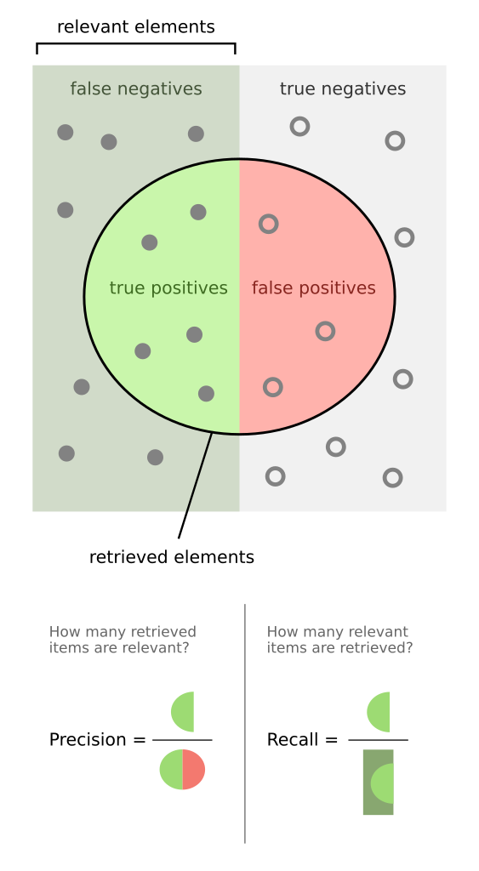
Fig. 31: Precision and recall in Venn diagrams.

An $F_{1}$ score balances precision and recall. Both quantities must be significant for an $F_{1}$ score to be significant. If either precision or recall approaches 0 then the corresponding $F_{1}$ score also approaches 0.
In the prior example, we used two classes (sick and healthy). For multi-class cases, we calculate precision and recall for each class, and subsequently average $F_{1}$ scores over all classes [38]. For example, if we were using the non-neoplastic (NNeo) label as reference, the true positive rate would be the number of correctly classified NNeo frames, and the false negative rate would be the sum of NNeo frames incorrectly classified by another label. These would be used to calculate recall for NNeo, which would in turn be used to calculate the $F_{1}$ score for NNeo, which would be averaged with $F_{1}$ scores for other classes.
We can derive true positive (TP), false positive (FP), false negative (FN), and true negative (TN) statistics for every class from the confusion matrix of all classes (Table 6).
Table 6: Example confusion matrix.
 | Pathologist (True)
Model (Predicted) | Frame Labels | Unlab | Bckg | Norm | Null | Artf | Nneo | Infl | Susp | Indc | Dcis | Sums across rows
 | Unlab | 20 | 1 | 4 | 1 | 7 | 6 | 7 | 0 | 4 | 6 | 56
 | Bckg | 6 | 30 | 1 | 3 | 5 | 2 | 4 | 7 | 3 | 3 | 64
 | Norm | 3 | 2 | 29 | 6 | 0 | 1 | 1 | 3 | 1 | 2 | 48
 | Null | 3 | 0 | 4 | 24 | 3 | 4 | 6 | 3 | 5 | 0 | 52
 | Artf | 5 | 6 | 4 | 7 | 29 | 3 | 6 | 2 | 3 | 3 | 68
 | Nneo | 1 | 6 | 6 | 1 | 3 | 21 | 5 | 3 | 3 | 5 | 54
 | Infl | 6 | 3 | 7 | 4 | 0 | 6 | 26 | 7 | 1 | 2 | 62
 | Susp | 6 | 4 | 6 | 4 | 5 | 3 | 6 | 22 | 0 | 6 | 62
 | Indc | 5 | 5 | 2 | 6 | 0 | 3 | 6 | 0 | 28 | 0 | 55
 | Dcis | 5 | 0 | 6 | 6 | 7 | 7 | 4 | 7 | 5 | 24 | 71
 | Sums across columns | 60 | 57 | 69 | 62 | 59 | 56 | 71 | 54 | 53 | 51 | 592
To illustrate, suppose we were deriving statistics for the NNeo class. The TP rate of NNeo is its position on the diagonal of the confusion matrix, highlighted in green in Table 6; the FN rate of NNeo is the sum of all elements highlighted in orange; the FP rate of NNeo is the sum of all elements highlighted in red; and the TN rate of NNeo is the sum of all elements highlighted in blue. Table 6 simplifies to Table 7.
Table 7: Simplified confusion matrix for nneo case. Green indicates TP; red indicates FP; orange indicates FN; blue indicates TN.
 | Pathologist (True)
Model (Predicted) | Frame Labels | NNeo | Not NNeo | Sums across rows
 | NNeo | 21 | 33 | TP+FP = 54
 | Not NNeo | 35 | 503 | FN+TN = 538
 | Sums across columns | TP+FN = 56 | FP+TN = 536 | 592
The example NNeo $F_{1}$ score for Table 7 is calculated as follows (Equation 19).
$$Precision=\frac{true positives}{true positives+false positives}=\frac{21}{21+33}=0.389$$
$$Recall=\frac{true positives}{true positives+false negatives}=\frac{21}{21+35}=0.375$$
$$F_{1}=2\frac{precision∙recall}{precision+recall}=2\frac{\left(0.389\right)\left(0.375\right)}{0.389+0.375}=0.382$$
Equation 19: NNeo $F_{1}$ score calculation.
Our target $F_{1}$ score is 0.80. This target value was extracted from a similar 2019 study employing deep-learning models to classify whole-slide images [14]. The $F_{1}$ score yielded by the study was 0.90. Although we can adopt the 0.9 target as our own, the fact that we are using 9 classes instead of 2 leads us to believe that $F_{1}=0.9$ is too optimistic. If we do not consider relative frequency then the base accuracy of each class is $1/9$, which means that sensitivity and specificity will be depressed compared to the 2-class case.

Confusion Metrics & Patch Scoring
While §6.1.1.1 and §6.1.1.2 describe how confusion metrics (e.g., true positives & false negatives) are used to derive predictive performance statistics, they do not describe how the confusion metrics are themselves obtained. To obtain confusion metrics we use the following algorithm.
First, provided a list of reference annotations, containing coordinates of biopsy-slide tissue samples outlined by a pathologist, we enumerate each reference annotation. One such reference annotation is displayed in Fig. 32. Likewise, provided a list of annotations for model predictions (‘hypotheses’) of the same biopsy slide, we enumerate each hypothesis annotation. Two such hypothesis annotations are displayed in Fig. 33. (Hereon we’ll refer to annotations simply as ‘reference’ and ‘hypothesis’.)
We bear in mind that each reference annotation is partially annotated (i.e., not every pixel of a biopsy slide receives a label in training data). Therefore, we are careful not to make any assumptions about hypothesis annotations lying in unlabeled areas of reference annotations (for example, the area outside the black border in Fig. 32, respective to the single annotation in Fig. 32), as they may or may not contain the label predicted by the model.
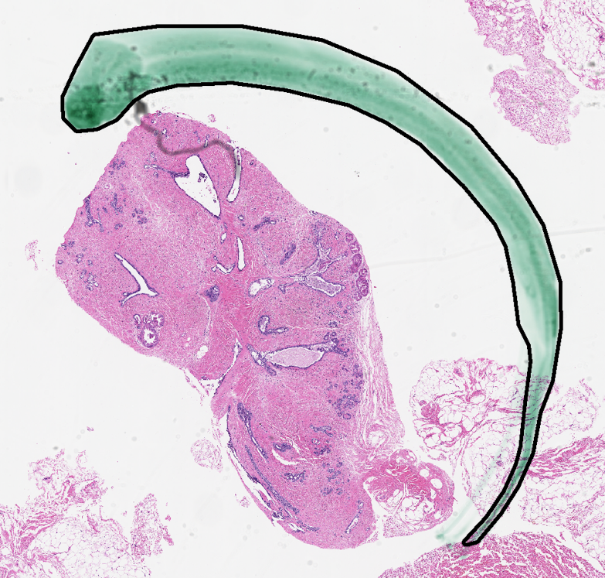
Fig. 32: Reference annotation outline of an artifact (pen mark) on a slide, illustrated by a black border.
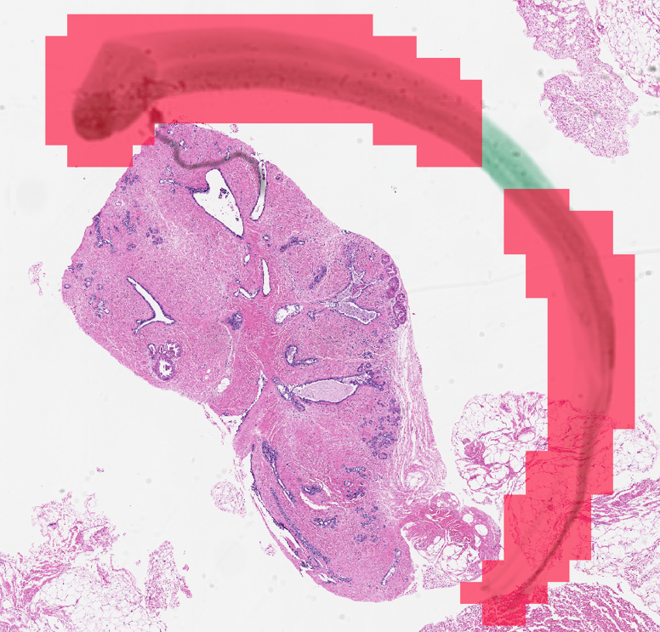
Fig. 33: Hypothesis annotations of artifact (ARTF) model predictions,
represented by two contiguous patches of red frames.
Second, for every reference annotation, we compute the set intersection of the reference annotation and each hypothesis annotation (in total, $r×h$ intersections, for $r$ reference annotations and $h$ hypothesis annotations). Two such intersections are displayed in Fig. 34. Each intersection has a pixel area, and in our example, represents a true positive outcome, as both the model and pathologist agree on the ARTF label for the intersecting area. If we solely consider pixel area as a measure of confusion metrics, then we would add the intersecting areas to the ARTF/ARTF cell of our multiclass confusion matrix.
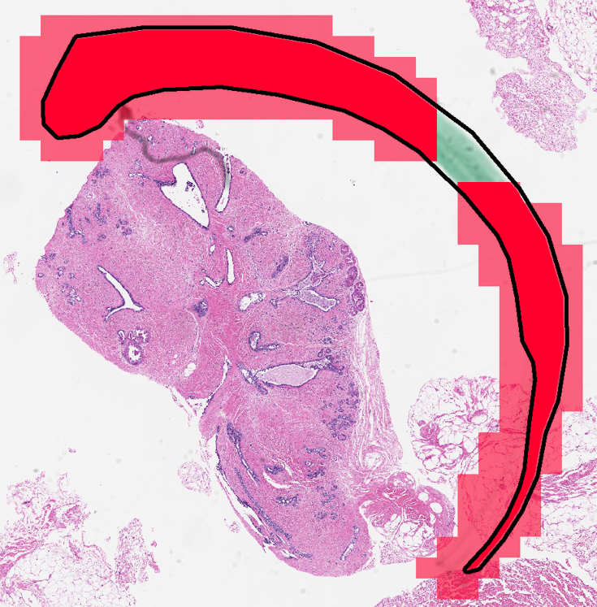
Fig. 34: Intersections (bright red) of a reference annotation (black border) and hypothesis annotations (all red).
Third, for every set intersection, we subtract the intersecting area from the reference annotation. When all hypothesis annotations have been intersected, all that is left of the reference annotation is the area ignored by model predictions. To demonstrate, note that hypothesis annotations in Fig. 34 do not completely cover the reference annotation. If no other model predictions exist for this biopsy slide, then the remaining area would be represented in green in Fig. 35. The green area suggests a false negative outcome, because the model did not successfully classify this area with the ARTF label. We would add the green area to the ARTF/UNLAB cell of the multiclass confusion matrix, where UNLAB (i.e., unlabeled data) is a label unique to hypothesis annotations, used solely for the purpose of adding non-intersected areas to false negative tallies.
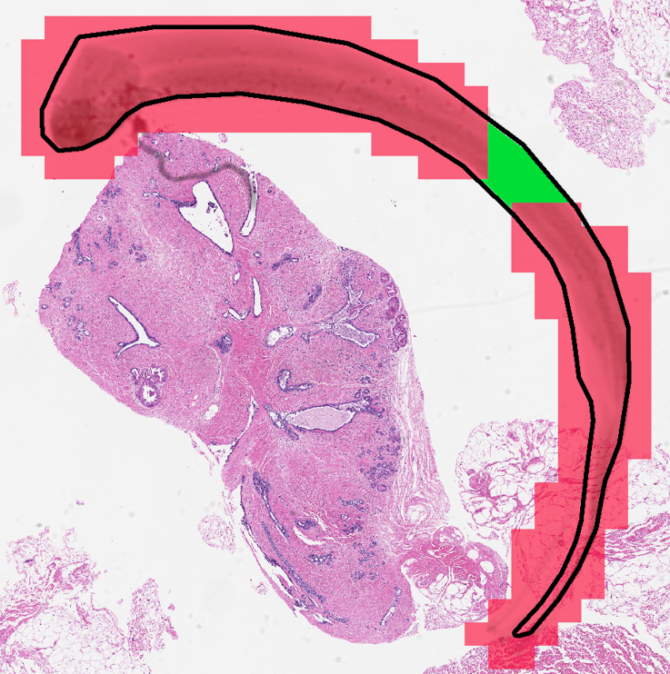
Fig. 35: Area (green) of a reference annotation (black border) not covered by hypothesis annotations (red).
One other problem presents itself when using pixel area to calculate confusion metrics. Suppose background (BCKG) reference annotations were on average much larger in area than invasive ductal carcinoma (INDC) reference annotations. This would in turn lead to larger values in reference BCKG cells than reference INDC cells in the multiclass confusion matrix, biasing confusion metrics in favor of BCKG over INDC. This would result in inconsistent confusion metrics; we desire to know the number of reference patches correctly or incorrectly predicted, not the area of those predictions.
The solution to the preceding problem is to normalize pixel area by the total area of the reference annotation in question. For example, the area contained in the region bounded by the black border in Fig. 36 is 87,695 pixels².
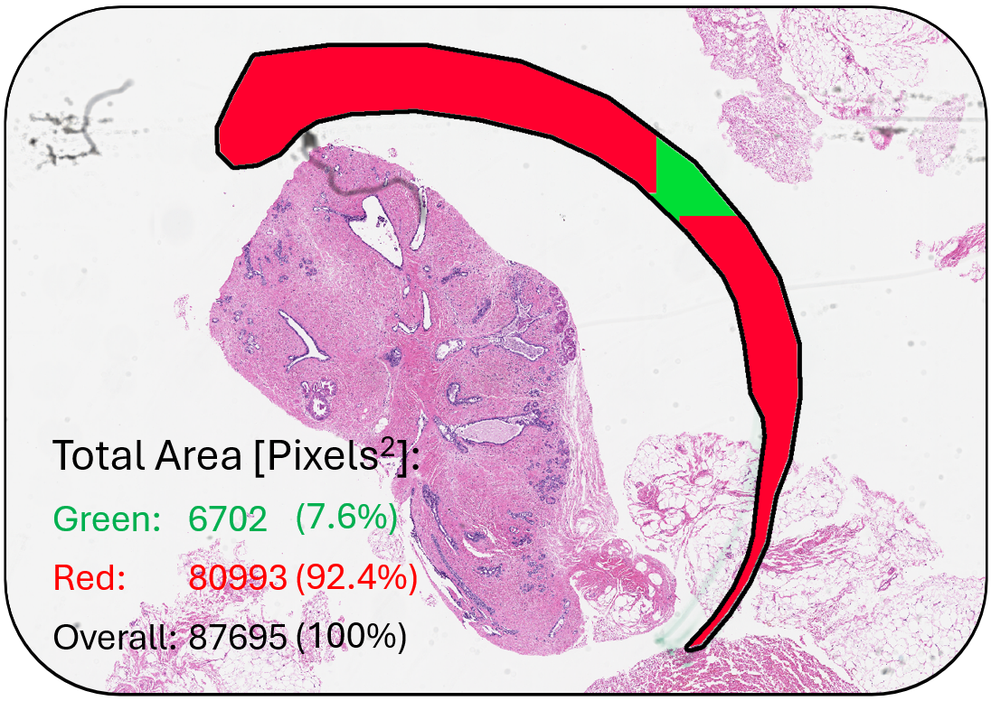
Fig. 36: Pixel areas of highlighted intersected (red) and non-intersected (green) regions.
If we normalize the green and red areas (Fig. 36) by 87,695 pixels², we conclude that the total intersected area represents $80,993/87,695=0.924$ of a hit, and the total non-intersected area represents $6,702/80,993=0.076$ of a hit. Instead of adding an area to a multiclass confusion matrix element, we add to the element the ratio of a hypothesis area to its reference patch.

Qualitative Testing Methods

Reporting Whole-Slide Image Accuracy
The purpose of WSI accuracy is to allow us to compare our model to general machine learning models in industry. Since we are mostly focusing on detecting location and precision of patches of cancer, WSI accuracy isn’t the most important metric, but it is important to establish a baseline in comparison with other systems with different areas of focus.
While the implementation of this feature satisfies the pass/fail requirement, we will be cross-referencing it with industry standards to benchmark our system later in the process which falls outside the scope of this project. The pass/fail metric for this functional requirement will be the ability to generate predictions for whole slides based on patch level classifiers. We will take a series of slides with annotations from our model and by categorizing these annotations graphically we will be able to ascertain whether our system successfully processes WSI predictions.

GUI Requirements
The three GUI requirements will be pass/fail based on their presence on our graphical representation of the report. The reference and hypothesis annotations will be graphically evaluated, and we will compare the confidences to spreadsheets containing our information. Overall, the estimate of our GUIs functionality will be based on the ease of access of our program and the ability of a person unfamiliar with our program to easily parse through and understand the data [39].
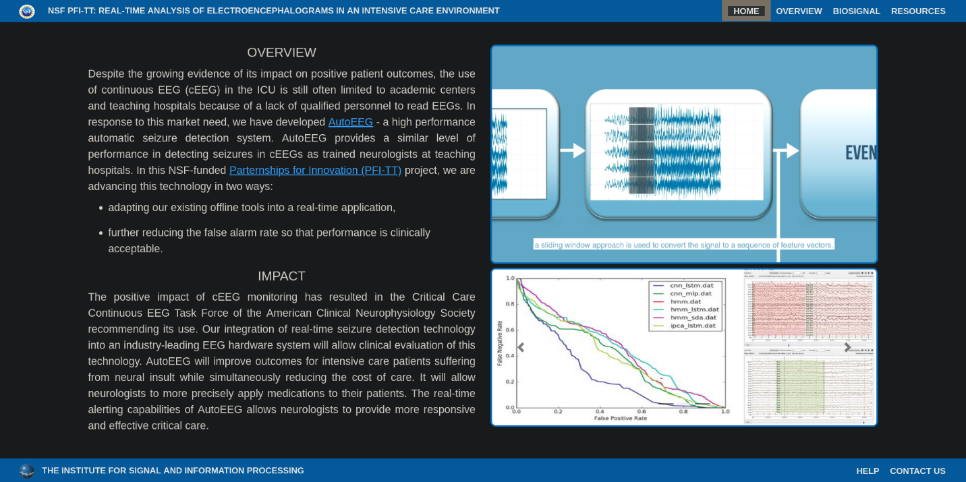
Fig. 37: A GUI example demo.

Code Standards and Language Requirements
The formatting of the code will be evaluated by Dr. Picone in combination with a graduate student, Claudia Dumitrescu. They will be using the ISIP bluebook standard [15] and existing sample code. Alongside this, we will be evaluating naming conventions, commenting style, and overall code style by cross referencing with the most recent PEP8 style guide [16] and other example code (Fig. 38).
# Wrong:  # Arguments on first line forbidden when not using vertical alignment.  foo = long_function_name(var_one, var_two,  var_three, var_four)  # Further indentation required as indentation is not distinguishable.  def long_function_name(  var_one, var_two, var_three,  var_four):  print(var_one) | # Correct:  # Aligned with opening delimiter.  foo = long_function_name(var_one, var_two,  var_three, var_four)  # Add 4 spaces (an extra level of indentation) to distinguish arguments from the rest.  def long_function_name(  var_one, var_two, var_three,  var_four):  print(var_one)  # Hanging indents should add a level.  foo = long_function_name(  var_one, var_two,  var_three, var_four)
Fig. 38: PEP8 Code Example

Quantitative Non-Statistical Testing Methods

Unsupervised Learning
Currently we utilize a supervised learning model which leverages data that has been annotated by a pathologist. This creates a bottleneck where we are limited by the amount of data that has been processed by pathologists. While our model does take time to process training data, the time it takes for a pathologist to annotate these slides is much greater. This is where an unsupervised model comes in. An unsupervised model takes slides that have not been annotated and extracts features that it thinks are important by leveraging techniques based on the variance of the images. Once it’s categorized these features, it will utilize a smaller subset of labeled data to classify the different subsets of these features. This will allow us to utilize all the images we have even if a pathologist has not touched the data.
It’s possible that by using a larger amount of information we can build a more generalized model. While we will be testing these results to see if there is an improvement, it’s likely that extensive testing will fall outside the scope of this project, but we will be testing our ability to utilize this data by measuring the total amount of utilization of the data. We utilize catching exceptions and logs to see which data was used successfully and which failed.
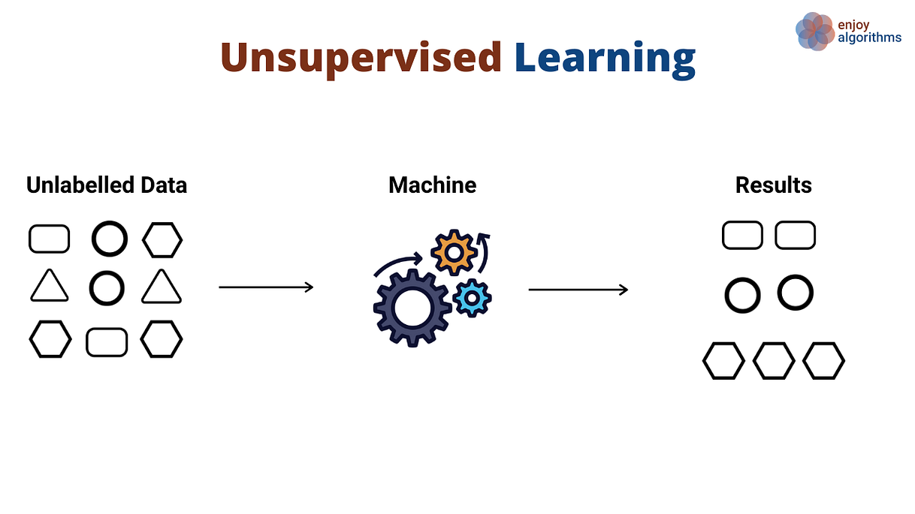
Fig. 39: Unsupervised learning example.

Training Time & Data Limitations
Time to Train is a self-imposed limitation of less than 3 days due to the scope of our project. To run proper testing trials to refine our model we must limit the amount of time our trials take. With our data limitation of 1.2 Terabytes of annotated data [36], we need to limit our trial time to less than 3 days which gives us enough headroom to find a sweet spot where the model is accurate enough that the trials are significant but have a short enough trial time that we can try different parameters out.
While we can run many trials in parallel due to the high-performance compute (HPC) cluster, we will eventually be limited since this compute cluster is being utilized for other classes and other projects. We will, of course, measure this by timing our models by using the output of results from Slurm, a job manager on the cluster that covers metrics like CPU, GPU, and real time [40].

Results
Our final model was a convolutional neural network. Initially, the model had very low accuracy when outputting from a softmax layer to a criterion for backpropagation. We discovered that the criterion we were using applied its own softmax layer to input. We removed preceding softmax layer and achieved accuracy near 90%. However, as we will see from confusion metrics, this accuracy metric was misleading.

Confusion Matrix
The confusion matrix for model predictions is depicted in Tab. 8. Columns in Tab. 8 correspond to hypotheses (model predictions) and rows correspond to references (pathologist annotations). Elements of the matrix are formatted as percentages of total hits.
Tab. 8: Confusion Matrix
Ref/Hyp: | dcis | bckg | artf | infl | nneo | norm | susp | indc | null | unlab
dcis | 0.00% | 44.55% | 0.00% | 0.00% | 0.00% | 0.00% | 0.00% | 55.40% | 0.00% | 0.04%
bckg | 0.00% | 39.97% | 0.00% | 0.00% | 0.00% | 0.00% | 0.00% | 60.03% | 0.00% | 0.00%
artf | 0.00% | 38.09% | 0.00% | 0.00% | 0.00% | 0.00% | 0.00% | 61.90% | 0.00% | 0.02%
infl | 0.00% | 40.41% | 0.00% | 0.00% | 0.00% | 0.00% | 0.00% | 58.74% | 0.00% | 0.85%
nneo | 0.00% | 41.28% | 0.00% | 0.00% | 0.00% | 0.00% | 0.00% | 58.70% | 0.00% | 0.02%
norm | 0.00% | 39.25% | 0.00% | 0.00% | 0.00% | 0.00% | 0.00% | 60.75% | 0.00% | 0.00%
susp | 0.00% | 37.64% | 0.00% | 0.00% | 0.00% | 0.00% | 0.00% | 62.36% | 0.00% | 0.00%
indc | 0.00% | 42.80% | 0.00% | 0.00% | 0.00% | 0.00% | 0.00% | 57.15% | 0.00% | 0.05%
null | 0.00% | 41.05% | 0.00% | 0.00% | 0.00% | 0.00% | 0.00% | 52.90% | 0.00% | 6.05%

The model applied background (BCKG) and invasive ductal carcinoma (INDC) labels generously, but rarely applied labels apart from BCKG or INDC.

F1 Score
$F_{1}$ score was calculated per class (Tab. 9) and averaged over all classes. We were unable to calculate some $F_{1}$ scores because the necessary confusion metrics were missing and the denominator of the resulting quotient was 0. For the cells labeled “N/A” in Tab. 9, we used 0 in calculating the mean $F_{1}$ score.
Tab. 9: Class-specific F1 scores.
Ref/Hyp: | dcis | bckg | artf | infl | nneo | norm | susp | indc | null | unlab
True Positives | N/A | 0.0023 | N/A | N/A | N/A | N/A | N/A | 0.6422 | N/A | N/A

Our mean $F_{1}$ score was 7.14 %. This is far below our target (80%), and there are a couple potential explanations for this discrepancy.
First, we need to take the current model and increase the diagnosis weights of the labels that occur less frequently; this will emphasize predictions of those specific labels. We can then train with those updated metrics to increase the chances that the classes with a lower frequency are guessed.
Secondly, the target metric of 0.8 is possibly unrealistic for the number of classes we are classifying. The greater number of classes a model is expected to predict, the lower the mean accuracy of each prediction will be.

Cohen’s Kappa
Our mean Cohen’s Kappa was ~0 due to missing confusion metrics. This occurred because most classes (not BCKG or INDC) had no true positives, and very few false negatives and false positives. The numerator of the resulting kappa quotient was therefore approximately 0. This would improve if we adjusted training to give greater emphasis to classes that are not BCKG or INDC.

Example Output Images
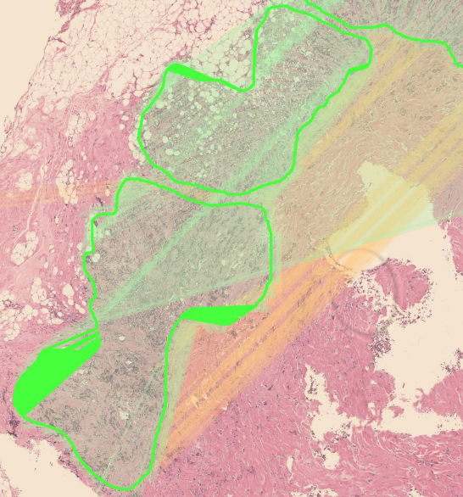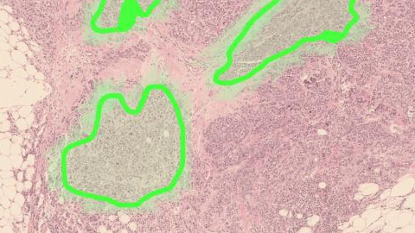
Fig. 40: Annotations generated from model predictions.
We successfully generated images and their corresponding labeled regions from model predictions (Fig. 40).

Whole-Slide Image Classification
Whole-slide image classification was implemented. However, the functionality was not integrated into the graphical user interface. The additional time required to integrate WSI classification with the GUI would not be substantial, as the GUI already displays the confusion metrics and confidence scores of individual classes (see following section).

Graphical User Interface (GUI)
We created a graphical user interface to view and browse slide images and their respective predictions. The GUI is used to view the different biopsy slides in our database, predicted regions and annotated regions for a specific slide image.
There are three pages: About, Viewer, and Data Types. An example of the main window’s Viewer page of the GUI is shown below in Fig. 41. Within this page, through a scrollable list of image names, an image can be selected to view on the display panel. The display panel will show the original biopsy slide of the selected item in the list as a preview. In the model results panel, the performance of each model used for the selected item is shown, such as the labels seen by the model, the labels’ specificity, the overall image confidence, and the accuracy of the model using a histogram.
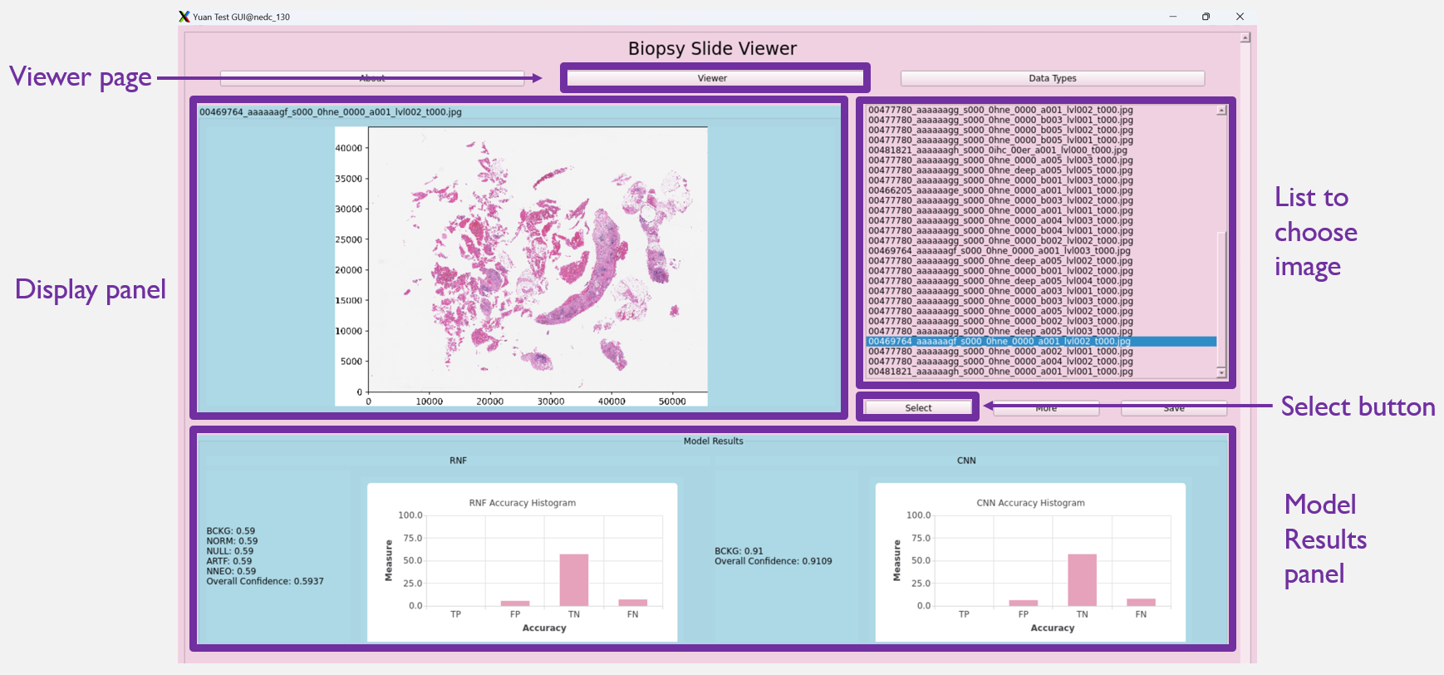
Fig. 41: GUI 'Viewer' page with descriptions of different areas/functions.
Another important function that this GUI has is the ability to view the pathologist annotations compared to the predictions made by a specific model. When the more button (to the right of the select button) is clicked, a new window pops up as shown in Figure 42. This window also has a display panel that displays the selected image. By toggling the Previous and Next buttons, you can swap between viewing the original image, the image with pathologist annotations, and the image with annotations and model predictions. Specifically in this figure, the RNF Predictions image is toggled. Using the legend below, the pathologist annotations and RNF predictions can be compared throughout the image. This display panel has zoom and drag functions enabled to view the image at a larger scale.
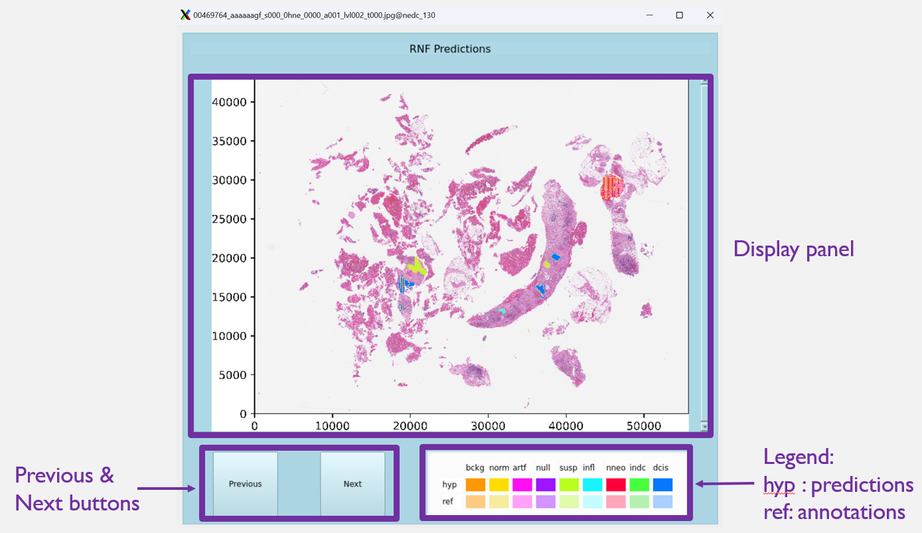
Figure 42: 'More' window that shows the RNF predictions of the selected image.
All functional requirements related to the graphical user interface (segmentation, confidence scoring and displaying annotations) were satisfied.

Time to Train
We used the Python ray multiprocessing framework to reduce training time to 1-2 days. Therefore, our target metric (<3 days) was satisfied.

Unsupervised Learning
Unsupervised learning was not implemented. The reason for this is that the research team ran out of time when training the model.

Standards & Specifications

Coding Standards
Our code was successfully written in Python’s PEP8 standard while maintaining ISIP standards. PEP8 has relatively loose rules about naming conventions and line length, so we came up with a naming convention where we are typically utilizing snake case for variable names and camelCase for function naming. We wrote object-oriented, modular, and highly parallelizable code that allowed for us to scale up to multiple GPUs independent of node specifications.

Cost
We require no purchases for our project. Due to our project being primarily based on Python, a free and open-source software (FOSS), an existing dataset (Temple University Health Digital Pathology), compute server (Neuronix High Performance Cluster), and team of researchers to support us, there isn’t a need to purchase anything. We evaluated contributing to the existing compute server via hardware purchases, but after touching base with our advisor, Dr. Picone, he seconded that there is no need to purchase anything and that it would not significantly impact our productivity, or final result
It is possible for us to purchase an enterprise version of our version control software (GitHub) which is not FOSS, but the benefit for large file support, workflow automation, and proprietary Continuous Integration/Continuous Delivery (CI/CD) pipeline weren’t significantly beneficial to our project due to having access to a large amount of reliable storage offered by the existing infrastructure.

Summary & Conclusion

Successes
From a programming infrastructure point of view, our system was a success. We implemented multiple end-to-end machine learning pipelines to incorporate not only machine learning but also deep learning into the ISIP environment. This allows us to quickly and efficiently manipulate high resolution biopsied tissue through various stages including preprocessing, prediction generation, postprocessing, and evaluation.
Furthermore, we implemented a secondary route to have deep learning networks perform feature extraction and identification based directly on RGB values. This is typically seen as the industry standard for image recognition and by creating the image queuing system and feature caching system we open the possibility to Residual Neural Networks to increase performance.
Our GUI was also clean, concise, and digestible. People in our live demonstration were able to nvigate easily and identify critical information quickly. This demo GUI could easily be ported to a production identification software.

Failures
The main downfall of our project was a lack of time for testing. We needed more time to bounce the model between the training and development set. Without adjusting hyperparameters and proper training time, our model underperformed. We lost a few weeks of testing that would have significantly improved our results if we were able to fix a bug earlier. Unfortunately, we were only able to identify and squash the bug after presenting our findings. This error possibly came from a lack of unit testing. If we had tested smaller modular parts of the code, it’s possible we would have been able to nip this in the bud and save weeks of training by investing a few hours into developing effective testing methodology.

Suggestions
A few minor improvements could be made to the model or pipeline that would improve results.
We discarded PCA when experimenting with convolutional neural networks (CNNs). We applied CNNs directly to RGB matrices because we discovered that using row vectors as input to CNNs did not produce accurate results. However, if we applied PCA across RGB values (that is, collapsing the 3-dimensional matrix into a 2-dimensional matrix), we could reduce the size of input matrices but retain much of the variance.
We did not normalize for image scale as discussed in §5.1. If windows were normalized for magnification depth, then input to the CNN would be much more consistent in shape, size and structure.
In addition to raw RGB data, we recommend further research into contourlet transforms for convolutional neural network input.

References

[1] | N. Harbeck, F. Penault-Llorca, J. Cortes, M. Gnant, N. Houssami, P. Poortmans, K. Ruddy, J. Tsang and F. Cardoso, "Breast cancer," Nature Reviews Disease Primers, vol. 5, no. 1, September 2019.
[2] | A. Khalid, A. Mehmood, A. Alabrah, B. F. Alkhamees, F. Amin, H. Al Salman and G. S. Choi, "Breast Cancer Detection and Prevention Using Machine Learning," Advances in Breast Cancer Imaging and Treatment, vol. 13, no. 19, p. 3113, January 2023.
[3] | "Magnetic Resonance Imaging (MRI)," [Online]. Available: https://www.nibib.nih.gov/science-education/science-topics/magnetic-resonance-imaging-mri.
[4] | P. M. N. H. L. Irwig, "Evidence relevant to the investigation of breast symptoms: the triple test," The Breast, vol. 11, no. 3, pp. 215-220, June 2002.
[5] | C. H. Weaver, "What Should I Know About a Breast Biopsy?," [Online]. Available: https://news.cancerconnect.com/breast-cancer/ask-the-doctor-what-i-should-know-about-a-breast-biopsy. [Accessed 30 August 2024].
[6] | T. Islam, M. A. Sheakh, M. S. Tahosin, M. H. Hena, S. Akash, Y. A. Bin Jardan, G. Fentahun Wondmie, H.-A. Nafidi and M. Bourhia, "Predictive modeling for breast cancer classification in the context of Bangladeshi patients by use of machine learning approach with explainable AI," Scientific Reports, vol. 14, no. 1, April 2024.
[7] | U. Nations, "The 17 Sustainable Development Goals," 2015. [Online]. Available: https://sdgs.un.org/goals.
[8] | S. C. Wetstein, V. M. T. de Jong, N. Stathonikos, M. Opdam, G. M. H. E. Dackus, J. P. W. Pluim, P. J. van Diest and M. Veta, "Deep learning-based breast cancer grading and survival analysis on whole-slide histopathology images," Scientific Reports, vol. 12, no. 1, September 2022.
[9] | J. Zhu, M. Liu and X. Li, "Progress on deep learning in digital pathology of breast cancer: a narrative review," Gland Surgery, vol. 11, no. 4, pp. 751-766, April 2022.
[10] | M. Khened, A. Kori, H. Rajkumar, G. Krishnamurthi and B. Srinivasan, "A generalized deep learning framework for whole-slide image segmentation and analysis," Scientific Reports, vol. 11, no. 1, June 2021.
[11] | M. C. Comes, L. Fucci, F. Mele, S. Bove, C. Cristofaro, I. De Risi, A. Fanizzi, M. Milella, S. Strippoli, A. Zito, M. Guida and R. Massafra, "A deep learning model based on whole slide images to predict disease-free survival in cutaneous melanoma," Scientific Reports, vol. 12, no. 1, November 2022.
[12] | C.-L. Chen, C.-C. Chen, W.-H. Yu, S.-H. Chen, Y.-C. Chang, T.-I. Hsu, M. Hsiao, C.-Y. Yeh and C.-Y. Chen, "An annotation-free whole-slide training approach to pathological classification of lung cancer types using deep learning," Nature Communications, vol. 12, no. 1, February 2021.
[13] | H. Azary and M. Abdoos, "A Semi-Supervised Method for Tumor Segmentation in Mammogram Images," Journal of Medical Signals & Sensors, vol. 10, no. 1, p. 12, 2020.
[14] | "Multi-Level Batch Normalization In Deep Networks For Invasive Ductal Carcinoma Cell Discrimination In Histopathology Images," arxiv, 11 January 2019 . [Online]. Available: https://arxiv.org/abs/1901.03684. [Accessed 20 October 2024].
[15] | "Automatic Speech Recognition: Internet Accessible Speech Technology," 2024. [Online]. Available: https://isip.piconepress.com/projects/speech/software/tutorials/general/. [Accessed 5 September 2024].
[16] | B. W. <. a. p. A. C. <. a. g. Guido van Rossum <guido at python.org>, "PEP 8 – Style Guide for Python Code," python.org, 01 August 2013. [Online]. Available: https://peps.python.org/pep-0008/. [Accessed 10 October 2024].
[17] | "The ABC of Machine Learning," aiplanet.com, [Online]. Available: https://aiplanet.com/learn/5-week_Data_Science_Bootcamp/week-2/162/the-abc-of-machine-learning. [Accessed 1 October 2024].
[18] | Y. K. Abdullah-Al Nahid, "Histopathological Breast-Image Classification Using Local and Frequency Domains by Convolutional Neural Network," Information-Centered Healthcare, 2017.
[19] | R. W. S. Alan V. Oppenheim, "The Discrete Cosine Transform," in Discrete-Time Signal Processing, Pearson, 2010, pp. 680-681.
[20] | Yumi, "Yumi's Blog," 19 July 2019. [Online]. Available: https://fairyonice.github.io/1D-DCT-vs-2D-DCT.html. [Accessed 4 October 2024].
[21] | N. Matloff, The Art of Machine Learning: A Hands-On Guide to Machine Learning with R, No Starch Press, 2024.
[22] | N. W. F. L. T. B. S. Andreas Lindholm, Machine Learning A First Course for Engineers and Scientists, Cambridge University Press, 2022.
[23] | R. Yehoshua, "Random Forests," 24 March 2023. [Online]. Available: https://medium.com/@roiyeho/random-forests-98892261dc49.
[24] | J. Frost, "Introduction to Bootstrapping in Statistics with an Example," [Online]. Available: https://statisticsbyjim.com/hypothesis-testing/bootstrapping/.
[25] | P. Galdi and R. Tagliaferri, "Data Mining: Accuracy and Error Measures for Classification and Prediction," in Reference Module in Life Sciences, Elsevier, 2018.
[26] | M. Chaudhary, "Random Forest Algorithm - How It Works & Why It’s So Effective," [Online]. Available: https://www.turing.com/kb/random-forest-algorithm.
[27] | IBM, "What is random forest?," [Online]. Available: https://www.ibm.com/topics/random-forest.
[28] | Raycad, "Convolutional Neural Network (CNN)," 14 November 2017. [Online]. Available: https://medium.com/@raycad.seedotech/convolutional-neural-network-cnn-8d1908c010ab.
[29] | L. Craig, "convolutional neural network (CNN)," [Online]. Available: https://www.techtarget.com/searchenterpriseai/definition/convolutional-neural-network.
[30] | A. Rosebrock, "Convolutional Neural Networks (CNNs) and Layer Types," 14 May 2021. [Online]. Available: https://pyimagesearch.com/2021/05/14/convolutional-neural-networks-cnns-and-layer-types/.
[31] | Y. Gavrilova, "Convolutional Neural Networks for Beginners," 2 August 2021. [Online]. Available: https://serokell.io/blog/introduction-to-convolutional-neural-networks.
[32] | GeeksforGeeks, "Convolutional Neural Network (CNN) in Machine Learning," 13 March 2024. [Online]. Available: https://www.geeksforgeeks.org/convolutional-neural-network-cnn-in-machine-learning/#.
[33] | B. D. N. J. I. A. I. O. J. P. Z. Wevodaur, "The Temple University Digital Pathology Corpus: The Breast Tissue Subset," 2021. [Online]. Available: extension://bfdogplmndidlpjfhoijckpakkdjkkil/pdf/viewer.html?file=https%3A%2F%2Fisip.piconepress.com%2Fpublications%2Fconference_presentations%2F2021%2Fieee_spmb%2Fdpath%2Fabstract_v22_with_poster_v12.pdf. [Accessed 1 October 2024].
[34] | "What is the resolution of my microscope in microns and image scale in microns per pixel?," Celestron, 18 December 2013. [Online]. Available: https://www.celestron.com/blogs/knowledgebase/what-is-the-resolution-of-my-microscope-in-microns-and-image-scale-in-microns-per-pixel?srsltid=AfmBOopJrlmOj7PSmBwnIdOcZRctqUWSlYcwjVt8ulMmY_XIcZSkZnAs. [Accessed 1 October 2024].
[35] | A. Corning, "Honey, I Shrunk the Display: Measuring Small LEDs, Pixels, and Subpixels," RADIANT Vision Systems, 22 July 2019. [Online]. Available: https://www.radiantvisionsystems.com/blog/honey-i-shrunk-display-measuring-small-leds-pixels-and-subpixels. [Accessed 1 October 2024].
[36] | Z. W. B. D. I. O. J. P. J. Simons, "The Temple University Hospital DPATH Corpus:," Temple University Hospital DPATH Corpus, 15 January 2021. [Online]. Available: https://view.officeapps.live.com/op/view.aspx?src=https%3A%2F%2Fisip.piconepress.com%2Fpublications%2Freports%2F2021%2Ftuh_dpath%2Fannotations%2Fannotation_guidelines_v10.docx&wdOrigin=BROWSELINK. [Accessed 1 October 2024].
[37] | T. Shah, "About Train, Validation and Test Sets in Machine Learning," Medium, 6 December 2017. [Online]. Available: https://towardsdatascience.com/train-validation-and-test-sets-72cb40cba9e7. [Accessed 1 October 2024].
[38] | baeldung, "https://www.baeldung.com/cs/multi-class-f1-score," F-1 Score for Multi-Class Classification, 18 March 2024. [Online]. Available: https://www.baeldung.com/cs/multi-class-f1-score. [Accessed 20 October 2024].
[39] | "NSF PFI-TT: REAL-TIME ANALYSIS OF ELECTROENCEPHALOGRAMS IN AN INTENSIVE CARE ENVIRONMENT," ISIP, [Online]. Available: https://isip.piconepress.com/projects/nsf_pfi_tt/. [Accessed 20 October2 2024].
[40] | Slurm Workload Manager, 6 August 2021. [Online]. Available: https://slurm.schedmd.com/overview.html . [Accessed 20 October 2024].
[41] | "Understanding FFT Overlap Processing Fundamentals," Tektronix, [Online]. Available: https://www.tek.com/en/documents/primer/understanding-fft-overlap-processing-fundamentals-0. [Accessed 1 October 2024].
[42] | S. Kahn, "Smoothing a Noisy Signal with a Savitsky-Golay Filter," Maplesoft, 17 December 2019. [Online]. Available: https://www.maplesoft.com/Applications/Detail.aspx?id=154593. [Accessed 1 October 2024].
[43] | "Introduction to Parallelism," 2018. [Online]. Available: https://cwant.github.io/hpc-beyond/21-introduction-to-parallelism/index.html. [Accessed 20 October 2024].

