COLLEGE OF ENGINEERING
Preliminary Exam Report:
Deep Learning Time Series Classification and Clustering
Vahid Khalkhali
Email: vahid@temple.edu
Department of Electrical and Computer Engineering
College of Engineering, Temple University
1947 North 12th Street, Philadelphia, Pennsylvania 19122

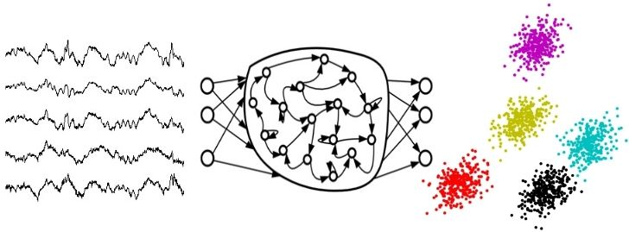
February 23, 2021
Examining Committee:
Dr. Joseph Picone, Committee Chair, Department of Electrical and Computer Engineering, College of Engineering, Temple University
Dr. Iyad Obeid, Committee Member, Department of Electrical and Computer Engineering, College of Engineering, Temple University
Dr. Albert Kim, Committee Member, Department of Electrical and Computer Engineering, College of Engineering, Temple University
Dr. Pallavi Chitturi, Committee Member, Fox School of Business, Temple University
Dr. Georgios Lazarou, Committee Member, Department of Electrical and Computer Engineering, College of Engineering, University of South Alabama

Executive Summary
The main goal of this document is to review deep learning methods involving clustering of time series. Time series applications are pervasive and impact a diverse range of disciplines including human speech recognition, natural language processing, acoustic scene classification, and stock market prediction. In this document, we review three papers that study and propose several unsupervised deep learning methods to cluster and classify large amounts of data without needing manual annotation of the data.
The first paper, titled Deep Learning for Time Series Classification: A Review, discusses the most recent advances in deep learning methods for time series classification (TSC). The authors evaluated eight deep learning architectures on the University of California, Riverside/University of East Angola (UCR/UEA) Time Series Classification Repository (http://www.timeseriesclassification.com) and demonstrated that the best two architectures were: (1) a residual deep neural network (ResNet), and (2) a fully convolutional neural network (FCN). A statistical analysis using the Wilcoxon signed rank test with Holm’s alpha (5%) correction demonstrated that there was no statistically significant difference between ResNet and the best-known classifier on this data – a collective of transformation-based ensembles with a hierarchical vote system (HIVE-COTE). The deep learning methods were shown to be much less computationally demanding. The computational complexity of ResNet was $O\left(nL^{4}\right)$ where $n$ is the number of neurons and $L$ is the number of layers versus $O\left(N^{2}T^{4}\right)$ for HIVE-COTE where $N$ is the number of time series and $T$ is the number of samples in time series. Moreover, using a Class Activation Map visualization method, they demonstrated that ResNet can successfully find the regions where two time series are visually different.
The second paper, titled Learning Representations for Time Series Clustering, discusses a new way of performing unsupervised deep learning for time series clustering. When a time series has multiple events occurring within a segment, it can be treated as a sequence to sequence decoding (seq2seq) problem. The most common clustering approach is to use a similarity measurement based on sliding windows of the waveform. Defining similarity in the time domain is not efficient because it is very time-consuming to find the best alignment. Also, a time domain comparison usually requires some form of dynamic time warping to account for the fact that similar events can have different durations. Therefore, it becomes advantageous to work in the frequency domain using mathematical transformations such as the Fourier transform or wavelets. Finding the best feature set is highly dependent on matching domain knowledge with the mathematical transformation. This paper introduces a novel unsupervised temporal representation learning model called a Deep Temporal Clustering Representation (DTCR), which integrates temporal reconstruction with K-MEANS clustering. They also increased the encoder’s accuracy by introducing noisy or fake training data. DTCR achieved the highest average rank on a variety of classification tasks.
The third paper, titled Unsupervised EEG Feature Extraction Based on Echo State Network, proposes a new method to find an efficient representation of a multichannel EEG signal by applying recurrent autoencoders. Most contemporary EEG classification approaches use hand-designed feature sets that integrate domain knowledge. Recent research shows that a linear autoregressive (AR) model for an EEG signal can extract very efficient feature sets. However, when the signal is highly nonstationary, linear regressive models have trouble following the dynamic nature of the EEG signal. Instead, nonlinear feature extraction models using deep neural networks, known as an Echo State Network (ESN) is proposed. ESN achieved a classification accuracy of 98.33% compared to 93.67% for traditional AR features.
Unsupervised time series classification and clustering are very efficient for processing nonstationary signals such as an EEG. Manual annotation of overlaid nonstationary signals is usually an errorful process. To decrease annotation error rates, annotation of the same data by multiple experts is needed, and that further drives up the cost of producing large amounts of data. Deep learning neural networks need a huge amount of data to be well trained (e.g., thousands of hours). Unsupervised deep learning can help achieve high performance without the need for an extensive amount of manually annotated data.
Table of Contents
1. Introduction 1
2. Generative or discriminative approaches 3
3. Classification with Deep Neural Network (DNN) 4
3.1. Multi-Layer Perceptron (MLP) 6
3.2. Time Convolutional Neural Network (TCNN) 7
3.3. Fully Convolutional Neural Network (FCN) 8
3.4. Residual Network (ResNet) 8
3.5. Multi-scale Convolutional Neural Network (MCNN) 9
3.6. Multi-Channel Deep Convolutional Neural Network 9
3.7. Time Le-Net 9
3.8. Echo State Networks (ESN) 10
3.9. Encoder 11
4. Datasets 12
5. Classification Experiment and Results 12
6. Unsupervised Clustering 20
6.1. Deep Temporal Clustering Representation (DTCR) 21
6.2. Unsupervised EEG Feature Extraction Based on Echo State Network 26
7. Conclusion 43
8. References 44

Introduction
Time series classification (TSC) and unsupervised clustering date back to the earliest developments in statistics (Ismail Fawaz et al., 2019). Historically, time series have been used in several disciplines such as medicine, economy, and astronomy. For example, in medicine, analyzing the effect of medication or disease on a patient need serial observations and measurements through time. In another case, the astronomical observations through time contribute to the invention of the calendar (Nielsen, A., 2019). Time series applications are pervasive and impact a diverse range of disciplines including human speech recognition, natural language processing, acoustic scene classification, and stock market prediction. For example, in the stock market, it is very common to use regressive estimations with the previous variation of time series data to forecast the value of stock in the future.
A “time series” is a term that can be used for every sequence of numbers or values changing through time or any other units rather than time. It means the independent variable, time, depicts the sequential order of the data. For example, sales of a product during several months is a time series, while a stream of characters or words in a sentence is also a time series. In the former case the time is exclusively implied, while in the latter case, the order inclusively shows the variation during the time.
One of the very well-known time series, especially in electrical engineering and related fields is called “signal”. A signal can be defined as an observable or measurable function that conveys information. The number of independent variables that are used to define the output function implies the number of dimensions of the signal. Accordingly, a signal can have a single temporal dimension like audio signals or more than one spatial dimension, such as images which usually have two dimensions. Therefore, the independent variables, aka dimensions, can be any physical measurable quantity such as time or space or even the combination of them like video which is a temporal-spatial signal.
Another practical difference is between the duration of a signal and the duration of a time series. Usually, the duration of a signal is longer than a time series. In this aspect, if the signal divides into several parts, then each part can be seen as a time series. A time series usually contain some events in a formal order and almost in the fixed places, while events in a signal may appear in every place without any order. Therefore, matching time series even directly makes sense, but matching signals as a whole are meaningless. EEG is a very well-known signal that its events do not appear in any specific order. It is impossible to match two separate EEG signals sample by sample to find its similarity.
One of the very well-known datasets for time series belongs to the University of California, Riverside/University of East Angola (UCR/UEA) (Dau et al., 2019; Bagnall et al., 2018). This dataset is separated into univariate (single channel) and multivariate (multi-channel). The univariate version contains 128 problems from different fields, such as physiology, biology, economy, etc. Each problem has is divided into training and test samples. In both cases, the duration of the time series is usually fixed, or it just contains one event. The number of classes in each problem is different. The largest number of samples per time series belongs to DucksAndGeese with a duration of 236,784 samples per time series. The highest number of classes is 60 and belongs to the ShapesAll problem. This dataset is used to make comparisons and development of several statistical and machine learning algorithms; from simple classifications to hybrid complex unsupervised clustering.
The supervised classification is defined as making a system that can recognize the category of every time series. To attain this objective, the learner system will be forced to discover common patterns of time series in every class and the discriminative patterns between classes from the training dataset. Then its ability will be tested by detecting or predicting the class label for each time series on an unseen test dataset. On the other hand, unsupervised classification or clustering is defined as making a system that finds the ‘similar’ time series and assigns a unique label to each group of them. The most important difference between supervised and unsupervised classification is the availability of class labels where are known in supervised learning and unknown in unsupervised learning. The testing or evaluation of success for both methods is usually similar.
Besides the traditional machine learning methods for time series classification and clustering, recent advancements in deep neural networks suggest their usage in this area too. Special kinds of neural networks have been created to cover ordered data such as images or signals. Two very well-known of these networks are a convolutional neural network (CNN), which can extract patterns with multiresolution convolutional transformations (LeCun, Y., 2015), and a recurrent neural network, which can find sequential relationships (Hochreiter, 1997). For example, a convolutional neural network has been successfully used to extract patterns in an electroencephalogram (EEG) signal as a two-dimensional temporal and spatial signal (Golmohammadi, M., 2020).
The current document focuses on recent methods that are used for supervised and unsupervised classification of time series. There are several methods for unsupervised classification; here the focus is on clustering because of its high efficiency and generality. Clustering is an unsupervised classification of signals based on some similarity measurements, such as Euclidean distance. Most of the time series are nonstationary, therefore they need to be split into smaller stationary ranges. The equality in the duration of these short-length time series is a good chance to use many traditional and modern similarity metrics on them. Hence, a longer nonstationary signal can be broken down into several parts, preferably equal size, and by time series classification methods, each part can be classified. Deep learning methods for both classification and clustering tasks will be discussed. Since classification and clustering have different goals, we will discuss these as two separate topics.
In this report, we review three papers that address various aspects of the TSC problem:
- Ismail Fawaz, H., Forestier, G., Weber, J., Idoumghar, L., & Muller, P. A. (2019). Deep learning for time series classification: a review. Data Mining and Knowledge Discovery, 33(4), 917–963. https://doi.org/10.1007/s10618-019-00619-1.
- Ma, Q., Zheng, J., Li, S., & Cottrell, G. W. (2019). Learning representations for time series clustering. Advances in Neural Information Processing Systems, 32(NeurIPS). https://papers.nips.cc/paper/8634-learning-representations-for-time-series-clustering.
- Sun, L., Jin, B., Yang, H., Tong, J., Liu, C., & Xiong, H. (2019). Unsupervised EEG feature extraction based on echo state network. Information Sciences, 475, 1–17. https://doi.org/10.1016/j.ins.2018.09.057.
The first paper discusses the most recent advances in deep learning methods for time series classification. The authors evaluated several learning architectures and demonstrated that two architectures, the CNN, and a fully convolutional neural network (FCN), are the winners. An FCN is a multilayer convolutional neural network without any pooling layers.
The second paper discusses a new way of performing unsupervised deep learning for time series clustering using a combination of deep neural networks with the traditional clustering method. This approach trains the neural network with an unsupervised clustering method. Moreover, they increase the limited number of samples by augmenting the data, a technique that uses mathematical transformations to reshape the existing data and add them to the training dataset. This simple technique improves their end-to-end classifier accuracy.
The third paper proposes a new method to find an efficient representation of a multichannel EEG signal by applying recurrent autoencoders (Schmidhuber, 2015). The representative of a class is a sample or model that can describe the class very well. For example, the average of a class can be the representative of a class. The authors have used an echo state network (ESN) (Ma, Q., 2016) as a simplified recurrent neural network to find the best representation of a signal. The comparison between their method and autoregressive (AR) models shows their method’s superiority; ESN achieved a classification accuracy of 98.33% compared to 93.67% for traditional AR features.
These papers’ discussions, from convolutional neural networks to the unsupervised clustering of time series with representational learning methods, help to understand how to cluster the EEG signals as a nonstationary time series into human interpretable categories.

Generative or discriminative approaches
A generative or model-based approach which is used also in unsupervised learning too is a method that assumes the system is similar to a model. Then it tries to determine the values of parameters in the model to make it as much as possible similar to the actual system. Then this model with known parameters can be used to detect, predict, or produce the output of the actual system based on the inputs. Some non-deep learning generative methods are auto-regressive models, hidden Markov models, and kernel models.
Autoencoders, generative CNNs, and Deep Belief Networks (DBN) are examples of generative models in deep neural networks (DNN). In this paradigm, the DNN approach is using generative models not just for classification but also for making a representation of the input signal in lower dimensions. This approach will be discussed in the unsupervised section of this review.
On the other hand, discriminative approaches are systems that directly make a map between input data and output probabilities. Like before, there are two ways to do the classification. The first method is to extract engineered features and the second method is to design the system to work end-to-end.
Since many time series can be interpreted by humans with plots, it is expected that image representation of time series can play as the feature extraction step. The transformation of the signal into an image helps to use the most knowledge that has been successfully implemented on image datasets.
Contrary to feature extraction methods, since learning good features need a good amount of domain knowledge and also making a good mathematical interpretation of this knowledge, then it is more preferable to have general methods to learn features without having domain-specific knowledge. This domain agnostic approach has been successfully implemented in many DNN applications.
The MLP can be used to learn temporal information but as discussed before, the features are not time-invariant. Instead, CNN can learn time-invariant features from raw input time series. Also, because of its quick training process, it is a very favorable architecture in time series analysis. The modified versions of CNN make a significant difference in learning rate and learning speed therefore there are variants of CNN that have their specific names, such as Residual Networks (ResNet) or Inception. Some variants of CNNs can also be used as Autoencoders, therefore, in this case, they will extract features and make a new compressed representation of the time series.
In this review document, we will talk about discriminative approaches in the classification part while the generative approaches will be discussed in the unsupervised section. This selection is planned because, in practice, discriminative approaches usually have better classification or discriminative abilities while they cannot be useful when interacting with unsupervised learning since they are highly dependent on training data. Some DNNs such as CNNs can be used in both discriminative and generative formats as they can be seen in Figure 1.
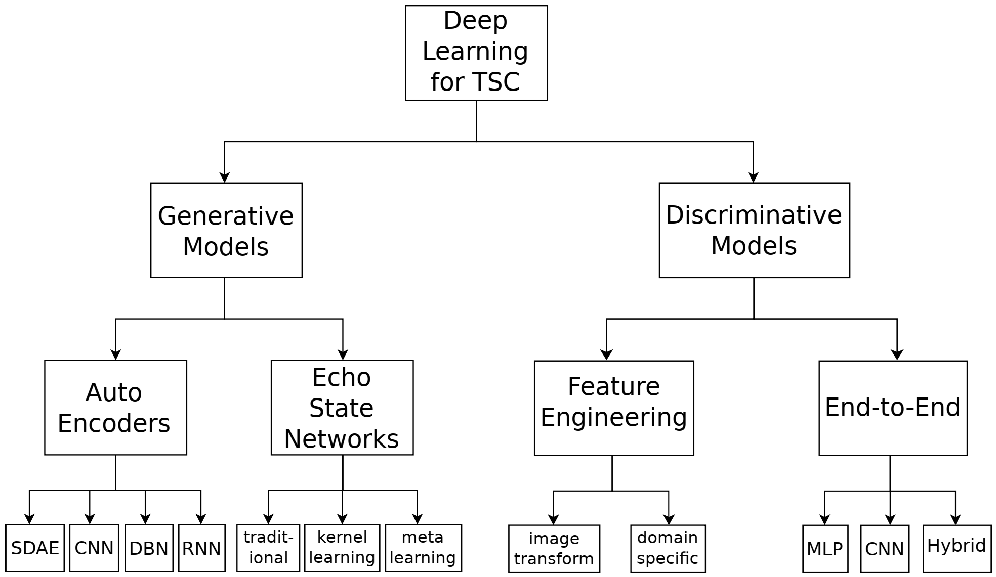
Figure 1 Deep Neural Network Approaches

Classification with Deep Neural Network (DNN)
Definition 1 A univariate time series with length T can be represented by $X=\left[x_{1},x_{2},⋯,x_{T}\right]$.
Definition 2 An M-dimensional time series can be represented by $X=\left[X^{1},X^{2},⋯,X^{M}\right]$ where $X^{i}ϵR^{T}$.
Definition 3 A dataset can be constructed by a collection of pairs $D=\left\{\left(X_{1},Y_{1}\right),\left(X_{2},Y_{2}\right),⋯,\left(X_{N},Y_{N}\right)\right\}$ where $X_{i}$ could either be a univariate or multivariate time series with $Y_{i}$ as its corresponding one-hot label vector. For a dataset containing K classes, the one-hot label vector $Y_{i}$ is a vector of length K where each element $j∈\left[1,K\right]$ is equal to 1 if the class of $X_{i}$ is j and 0 otherwise.
The task of classification is to find a map from the space of possible inputs to a probability distribution over the class variable values or labels.
A neural network or their children’s deep neural network are mathematical graphs that try to estimate a highly non-linear function (LeCun et al., 2015). Before the deep neural network, the common way of using neural networks was like other machine learning or classification algorithms; features were extracted from the samples and were used for classification. But after understanding the capability of deep neural networks to find very complex patterns in a multi-resolution hierarchy of samples, the feature learning and extraction level were also assigned to them. Nowadays, most deep learning systems work end-to-end. It means raw data inserted into the system and probabilities are received.
An end-to-end deep learning time series classifier is shown in Figure 2. The non-linear transformations box in Figure 2 can be replaced by any type of deep neural networks, such as a convolutional neural network or recurrent neural network.

Mathematically, a deep neural network can be viewed as L non-linear parametric functions which every function can be assumed as a layer. Each layer l_{i} contains neurons, which are small units that compute one element of the layer’s output. Every layer takes the output of the previous layer, implements some nonlinear operations on them, and then sends them to its output. To keep the design modular, it is common to keep the non-linear function fixed and change the parameters in every layer. Therefore, since the nonlinear functions are kept fixed, then the output of each layer is just dependent on its inputs and the parameters. Therefore, the deep neural network response can be written as follow.
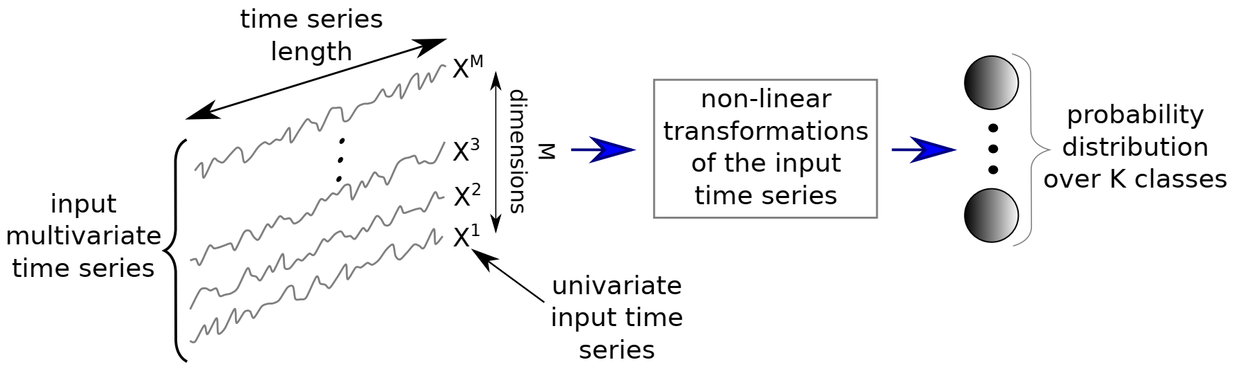
Figure 2. A unified end-to-end deep learning classifier

$f_{L}\left(θ_{L},x\right)=f_{L-1}\left(θ_{L-1},f_{L-2}\left(θ_{L-2},f_{L-3}\left(θ_{L-3},⋯,f_{1}\left(θ_{1},x\right)\right)\right)\right)$ (1)
It is rare to select different non-linear functions for f, therefore, optimization includes finding appropriate $θ_{i}$ to make the final layer output close to what is expected. It should be mentioned that $θ_{i}$s are vectors and not scalers. This type of data propagation from input x to the output layer is called feed-forward propagation.
Through training, random values will be assigned to $θ_{i}$s as the initial state. Then some portions of input data will be fed to the network and with the feed-forward propagation, some output will be received. This output will be compared to the desired output which in the classification process is called labels. The difference between the received and desired output is measured by some metric and it is called cost. There are some cost functions, but two important ones are mean square error and cross-entropy. The cross-entropy is defined as follows.
$L\left(X\right)=-\sum_{j=1}^{K}{Y_{j}log{\hat{Y}}_{j}}$ (2)
with L denoting the loss or cost when classifying the input time series X. Similarly, the average loss when classifying the whole training set of D can be defined using the following equations:
$J\left(Ω\right)=\frac{1}{N}\sum_{n=1}^{N}{L(X_{n})}$ (3)
These metrics help to measure the difference between detected and actual outputs and the differences are used in another algorithm that is called gradient descent to update the $θ_{i}$s. Again, several modified versions of original gradient descent algorithms are available. Adam is one of the well-known gradient descent algorithms which tries to choose proportional adaptive step size. The gradient plays a very important rule to update $θ_{i}$s. The last layer gradient is computed from the difference between desired and detected output.
The loss function is minimized to learn the weights in Ω using a gradient descent method which is defined by the following equation:
$ω=ω-α\frac{∂J}{∂ω} | ∀ω∈Ω$ (4)
with α denoting the learning rate of the optimization algorithm. The gradient of the layer before the last layer is computed from the differential chain rule. Therefore, beside $θ_{i}$s parameters, there are always another set of parameters that are stored the gradients for each layer and update in each iteration through the training process (LeCun et al., 2015).
It is highly desirable that the last layer gives the probability distribution function (pdf) of each class. Therefore, in many cases, the designers use some non-linear functions at the output layer to produce values for each class that can be used as probabilities. The softmax function is very common as the activation function in the output layer. In this function, the sum of outputs is equal to one like what is expected in the probability distribution function. Furthermore, it is differentiable. The softmax is defined as follows:
${\hat{Y}}_{j}(X)=\frac{e^{A_{L-1}*ω_{j}+b_{j}}}{\sum_{k=1}^{K}{e^{A_{L-1}*ω_{k}+b_{k}}}}$ (5)
with ${\hat{Y}}_{j}$ denoting the probability of X having the class Y equal to class j out of K classes in the dataset. The set of weights $ω_{j}$ (and the corresponding bias $b_{j}$) for each class j are linked to each previous activation in layer l_{L-1}.
After training, the process of testing will be started. Unseen data is used for the testing. The input samples are given to the network and the output probabilities are compared with desired outcomes. Through testing, no gradients will be calculated, and weights are kept fixed.
Many modifications are built to eliminate some problems in DNNs. Regularization such as l2-norm weight decay (Schmidhuber, J., 2015) and Dropout (Srivastava, N., 2014) are used to reducing overfitting by limiting the number of free parameters. Data augmentation is used to increase the number of training samples and help the network learn the desired patterns instead of artifacts. All these methods can increase the learning quality impactfully.
Most neural networks are designed modular and their building blocks are neurons or cells. A neuron is usually a nonlinear function on the weighted sum of its inputs. A cell may have more elements such as a very limited amount of memory. The architecture of the neural network can be defined as the way that these building blocks are connected. The ability of a neural network, as a nonlinear function, to make the desired input-output relationship is determined by its architecture. Moreover, the neural network architecture has a great impact on its trainability. In this section, nine architectures of neural networks with their capabilities for time series analysis will be discussed.

Multi-Layer Perceptron (MLP)
MLP is one of the oldest and most simple architectures proposed for neural networks. MLP is fully-connected (FC) which means that every neuron’s input in each layer comes from all the neurons of the previous layer. The links between neurons carry weights and non-linearity achieved by trigger functions at each neuron by the following equation.
$A_{l_{i}}=f\left(ω_{l_{i}}*X+b\right)$ (6)
where $ω_{l_{i}}$ is a vector of weights with the length equal to the length of time series X and b is the bias vector. This nonlinearity broadcasts to higher levels and the number of neurons in every layer is a hyperparameter that is determined beforehand.
MLP is the baseline of neural networks and it is usually selected because it helps to have a benchmark for comparison. In some applications, its variant can give an acceptable result. Here a 4 layer fully connected MLP with 500 neurons in each layer, ReLU activation function, and the softmax output layer has been used. The layers are followed by a dropout operation with rates equal to 0.1, 0.2, and 0.3, respectively. Dropouts help overfitting prevention (Srivastava, N. et al., 2014). The dropout rate indicates the percentage of neurons that are deactivated (set to zero) in a feed-forward pass during training.
The input dimensions in MLP are very important and it is not time/spatial invariant. In other words, each timestamp has its weight and the temporal information is lost. Hence, the MLP transferability is not trivial; the number of parameters (weights) of the network depends directly on the length of the input time series and the length of time series must be kept fixed.

Time Convolutional Neural Network (TCNN)
Applying sliding window filtering on a time series help to analyze it in multiresolution. Therefore, like what human use to interpret an image or signal, not only the local variations will be considered, but also global trends will be extracted. This kind of view brought many successful results to the visual field and in some cases, it passes the human ability, such as AlexNet which won the ImageNet competition in 2012 (Krizhevsky et al., 2017).
The layer t response in this network can be seen as the following equation.
$C_{t}=f\left(ω*X_{t-\frac{l}{2}:t+\frac{l}{2}}+b\right) | ∀ t ∈[1, T]$ (7)
where C denotes the result of a convolution (dot product *) applied on a univariate time series X of length T with a filter $ω$ of length l, a bias parameter b, and a final non-linear function f such as Rectified Linear Unit (ReLU).
Unlike MLPs, the same weights for convolution will be used to produce the output of a layer. This enables CNNs to learn weights which are invariant across time dimension.
After each layer convolution, in some cases, some midlevel decisions need to be made based on the outcome of convolutions. This is done by pooling operations. The pooling can be local or global and usually implements as computing average or maximum. Each pooling operation is done on a window, therefore instead of all samples on that window, a single sample that is the convolved window’s average or maximum will be kept. This significantly reduces the number of data points and just keep the indicator. If instead of a single indicator per window, a single indicator per several windows is being kept, then it is called global pooling. Global pooling is useful to avoid overfitting by reducing the number of parameters needed.
Normalization is another approach that helps to keep generalization by preventing the network from quick convergence.
The final layer of CNN is usually a fully connected (FC) network. This network is used to make the final decision of all later convolutional layers output. Therefore, the convolutional layers can be viewed as feature learners and extractors, and the FC network can be viewed as a classifier (Figure 3).
Since the convolution is a linear operation in the differentiation manner, the gradient descent algorithm can be used for training CNN the same way as before.
Time-CNN has three main differences compared to traditional CNN; first, for training, instead of the cross-entropy loss function, the mean square error (MSE) has been used. This change lets the output layer be a sigmoid function instead of softmax. Second, max pooling is replaced by average pooling. Finally, the fully-connected (FC) layer at the output was removed completely. It means the output of convolutional layers is directly connected to the output sigmoid functions. The Time-CNN has two consecutive convolutional layers with 6 and 12 filters respectively and a local average pooling operation with a length of 3.
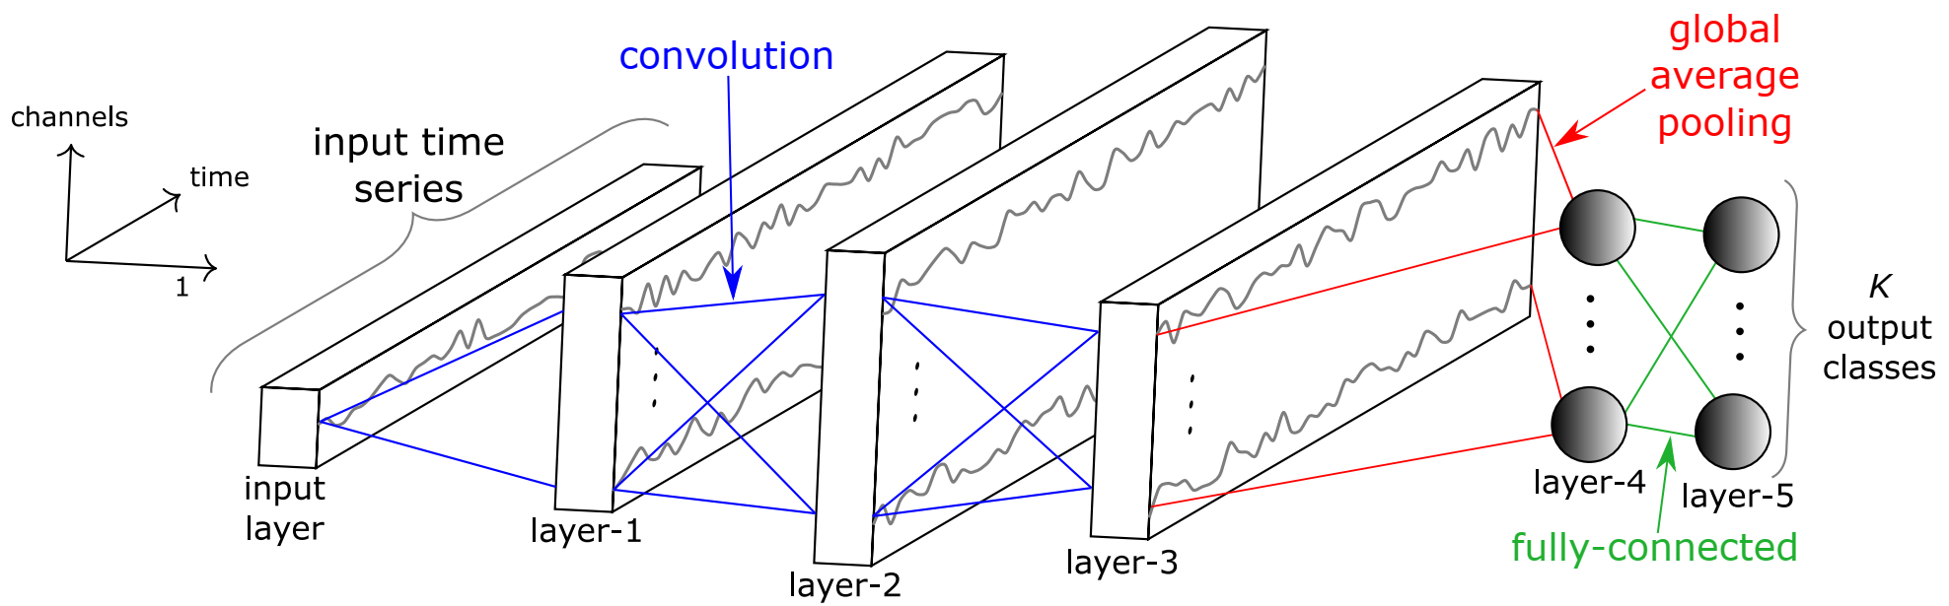
Figure 3. Convolutional Neural Network (CNN)

Fully Convolutional Neural Network (FCN)
Fully Convolutional Neural Networks (Z. Wang et al., 2017) are mainly convolutional networks that do not contain any local pooling layers which means that the length of a time series is kept unchanged throughout the convolutions. Another important difference between this network and the traditional ones is the replacement of the FC final layer with a Global Averaging Pooling (GAP) layer which is resulted in a drastic reduction of the number of parameters of the network.
The Wang et al. architecture has three convolutional layers with ReLU activation followed by batch normalization. The final layer is a GAP with the softmax activation function. In all convolutional layers, the stride has been chosen to be equal to one to preserve the length of the time series. The number and length of filters for the layers are 128 with 8, 256 with 5, and 128 with 3, respectively. The proposed FCN architecture has one important advantage; time-invariancy. By time-invariant property, the time series can have any length.

Residual Network (ResNet)
The ResNet (Figure 4) has given a very good response in image processing and other fields. Therefore, in many applications, one of the competitors can be ResNet. The proposed ResNet that has been used here has 11 layers which the beginning 9 of which are convolutional. The final layer is just a softmax activation and the layer before it is a GAP. Besides the deeper architecture of ResNet in comparison to FCN, there are residual connections between consecutive convolutional layers. This helps gradients to flow directly through the network and reduce the vanishing gradient effect (He et al., 2016). The number of filters is kept fixed to 64 which everyone is followed by batch normalization operation. The durations of residual blocks’ filters are 8, 5, and 3.
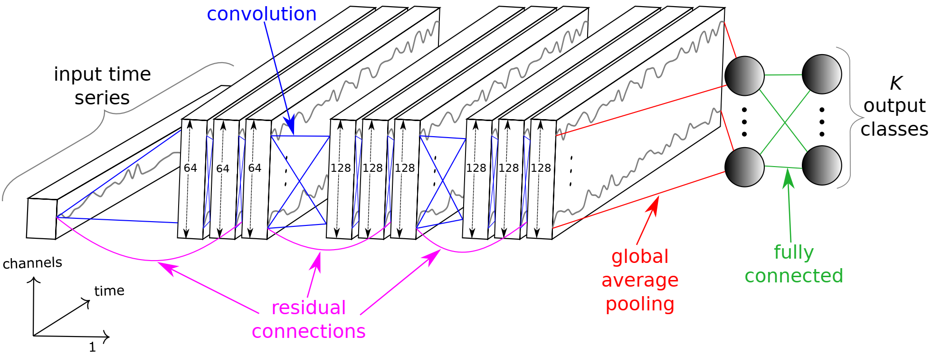
Figure 4 The residual Network's architecture for time series classification.

The ResNet is time-invariant and it enables the usage of transfer learning. It means that the network can be trained in several datasets without the need to change the number of neurons or architecture of networks.

Multi-scale Convolutional Neural Network (MCNN)
A Multi-scale Convolutional Network (MCNN) is a traditional CNN model with two convolutions (and max pooling) followed by an FC layer and softmax. Zhao et al. (2017) introduced this network and they used window slicing (WS) for data augmentation. They have done identity mapping, downsampling, and smoothing on these WS, and then trained the network. By these three transformations, univariate WS will convert to multivariate input. This heavy preprocessing makes questions if it can be assumed as an end-to-end approach. There are 4 layers in the network, each layer has 256 filters with sigmoid activation and max pooling. The first two layers of the network are designed to be time-invariant. The majority votes over all WSs in a time series are used for final detection.

Multi-Channel Deep Convolutional Neural Network
MCDCNN is a CNN that has been modified to work with multivariate time series (MTS). The solution was simple: using separate CNNs for separate channels. Hence, each channel of MTS goes through two convolutional stages with 8 filters of length 5 with ReLU activation and max-pooling with length 2. All channels’ second layer output goes to an FC layer with 732 neurons and ReLU activation. The softmax layer is used as an output. The FC layer limits the transferability of the network to the first and second convolutional layers.

Time Le-Net
Le-Net (t-LeNet) was proposed by (Guennec et al., 2016) based on the success of LeNet in image processing. The t-LeNet is a CNN with 2 convolutional layers followed by an FC layer and softmax. The differences from FCNs are fully connected layer and local max pooling. Unlike GAP, local pooling can introduce invariance to small perturbations in the output of convolutions. Also, by pool size such as 2, the length of time series decreases by half. First, the convolutional layer has 5 filters with a length of 5 and max-pooling with a length of 2. The second convolution layer has 20 filters with a length of 5 and max-pooling with a length of 4. Therefore, the time series length will decrease with the ratio 4*2=8 times. The FC layer after two convolutional layers has 500 neurons with ReLU activation function. Output layer softmax functions are equal to the number of classes. Since the convolutional layers are limited and there is an FC layer instead of GAP, the transferability of the network is not possible. It means that if the duration of input increases, the network needs to be retrained.
t-LeNet uses data augmentation to prevent overfitting. In their work, they have used WS and Window Warping (WW) for data augmentation. Similar to MCNN, since they use WS, voting for final detection is necessary.

Echo State Networks (ESN)
Recurrent Neural Network (RNN) is one of the old versions of neural networks that have been specifically designed for time-series regression and classification. When it was first introduced, it was similar to linear regression, but with the advancement of computation abilities, the nonlinearities were added to it by nonlinear functions. Unfortunately, RNNs suffer from vanishing gradients during the training process, therefore it is very hard to train them properly and many researchers avoid using them. But it should be mentioned that in theory, these networks should work fine if the weights can be found properly.
Several branches were produced from RNNs. Echo State Networks (ESN) is one of them which are designed to mitigate the vanishing gradient problem in RNN by eliminating the need to compute the gradient for the hidden layers. These hidden layers are initialized randomly and constitute the reservoir. The reservoir, a sparsely connected random RNN, is the core of an ESN. Neurons in the reservoir have their nonlinear activation and the inter-connected weights inside the reservoir and the input weights are not learned via gradient descent. The only weights which will be optimized are output weights with a learning algorithm (Figure 5).
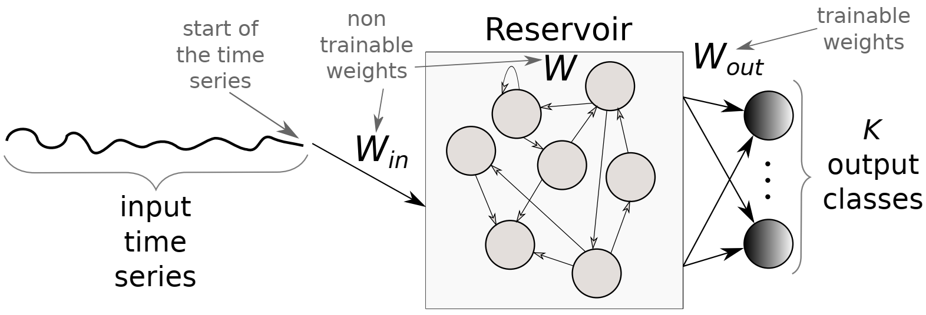
Figure 5. Echo State Network (ESN)

Figure 5 shows the diagram of an ESN. The common important parameters are the input dimension M, neurons in the reservoir N_{r}, and output dimension K which is equal to the number of classes. If $X(t)∈R^{M}$, $I(t)∈R^{N_{r}}$, and $\hat{Y}(t)∈R^{K}$ denote the vectors of the M-dimensional input, the internal (or hidden) state, and the output unit activity for time t, respectively, then $W_{in}∈R^{N_{r}×M}$, $W∈R^{N_{r}×N_{r}}$, and $W_{out}∈R^{C×N_{r}}$ respectively denote the weight matrices for input, internal connections, and output. The internal unit activity I(t) can be updated by using the internal states at time t-1 and input at time t with the following equation.
$I\left(t\right)=f\left(W_{in}X\left(t\right)+WI\left(t-1\right)\right) | ∀ t ∈[1, T]$ (8)
In this equation, I(t) is the internal unit activity at time t which is recursively updated from I(t-1) and current input by a nonlinear operation f. Input weights W_{in} is equal to the size of the input time series. W size is proportional to the number of neurons in the reservoir. Finally, the output of the ESN will be determined as follows.
$\hat{Y}\left(t\right)=W_{out}I(t)$ (9)
The initial values of neurons in the reservoir are important and usually restricted by a pre-determined hyperparameter that is called the spectral radius. This parameter will be discussed in more detail in the next sections of this review.
Time Warping Invariant Echo State Network (TWIESN) is a non-convolutional recurrent network that has been used in this study. Tanisaro et al. (2017) extent the usage of ESNs which were originally used for time-series forecasting to directly accept time series and output a probability distribution over the classes.
The reservoir in ESN is used to project the elements of time series to a higher dimension space. Thus, the elements of the univariate time-series will be combined in a complete nonlinear manner to a higher dimension because of the reservoir. Then these highly nonlinear features are fed to a Ridge classifier to predict the class of each time-series.
In ESNs, as we will talk about it more in the unsupervised section, three parameters need to be optimized; the reservoir’s size, sparsity, and spectral radius. For comparison purposes, these parameters are optimized on the dataset, and then ESN has been put in competition with other classifiers.

Encoder
If the last layer of FCN which is a GAP layer is replaced with an attention layer, then Encoder will be made (Serrà et al., 2018). Two variants of encoder proposed by Serra et al.; the first one was an end-to-end approach while the second one is pre-train the same architecture on a source dataset and then fine-tune it on the target dataset. The second approach reached better accuracy because of transfer learning.
In general, all approaches that can work with variable time series lengths can benefit from transfer learning. Since using transfer learning needs very large datasets and it is not available yet, then here just the first approach will be used and transfer learning can be remained for researchers to better tune their networks.
In addition to replacing the GAP layer with attention layer, three more consideration exists from FCN; (1) The PReLU activation has been used instead of ReLU. This facilitates the learning of the slope of the function. (2) The dropout regularization has been used to avoid vanishing gradients. (3) Max-pooling operations for overfitting prevention.
This network, similar to FCN is time-invariant and it can work with time-series with the variable-length duration.
These 9 classifiers’ architectures and hyperparameters are shown in Table 1 and Table 2.
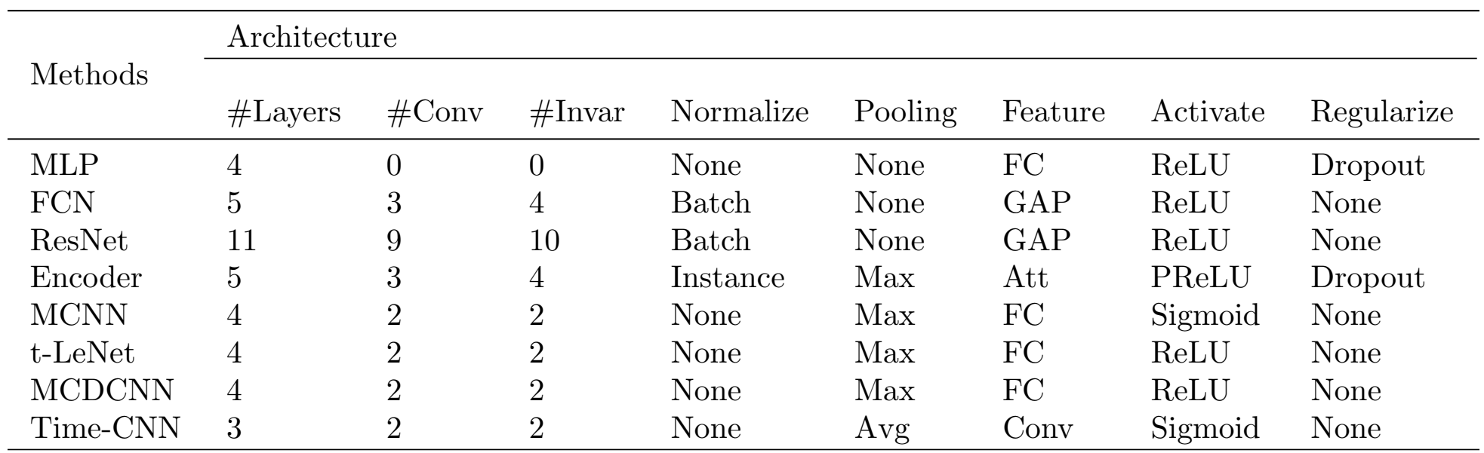
Table 1. Architecture’s hyperparameters for the deep learning approaches
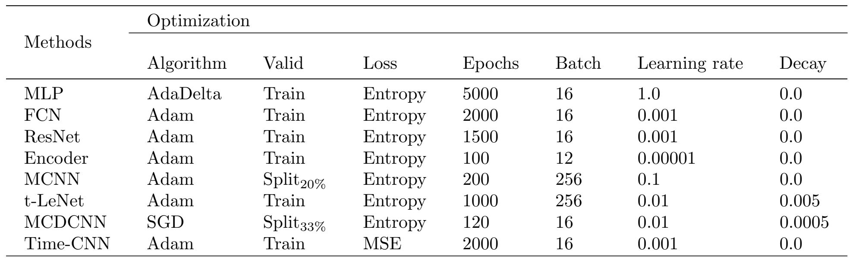
Table 2. Optimization’s hyperparameters for the deep learning approaches

Datasets
Two datasets have been used in this evaluation; UCR/UEA (Dau et al., 2019) is univariate and Baydogan (Baydogan, 2015) is multivariate.
The UCR/UEA archive contains 85 univariate time series. The durations of time series are very different from 24 to 2709. Also, the sizes of the training datasets vary from 16 to 8926. Some classes’ samples in the training set are too few (less than 50) which is not good for training deep networks. The number of classes varies from 2 to 60. All the time series in this archive are z-normalized. The advantage of using this dataset is the ability to compare the results with other systems. There are too many publications on this archive and it is a good resource to work with.
The Baydogan’s archive contains 13 MTS that is used in multivariate part. A common way to compensate for the inequality of lengths of time series is interpolation. For the multivariate dataset, this method has been used for having equal size multivariate time series. Since this preprocess has been done for all classifiers, it can be said that the evaluation remains fair.

Classification Experiment and Results
There are 97 datasets in total in both datasets. Nine deep learning models, described beforehand, have been trained. Since there are random parameters, each model will be trained and evaluated 10 times and the mean of results will be selected as the model’s result. The cluster that runs all the experiment has four types of GPUs; GTX 1080 Ti, Tesla K20, K40, K80. The summation of sequential running days was 100 days. Keras (Chollet & Others, 2015) and TensorFlow (Abadi et al., 2016) have been used as backend. After implementing experiments on UCR/UEA univariate archive, the critical difference diagram is shown in Figure 6.
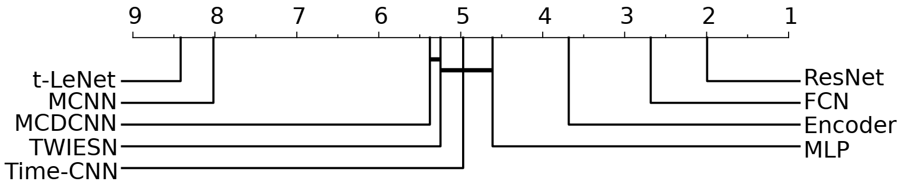
Figure 6 Critical difference diagram showing pairwise statistical difference comparison of state-ofthe-art classifiers on the univariate UCR/UEA time series classification archive.
Between deep learning methods, ResNet has significantly the best average rank which is 2. ResNet won 50 problems out of 85 problems and outperforms FCN. The authors (Ismail Fawaz et al., 2019) believe that the success of ResNet is because of its flexible deep architecture. In the field of neural networks, there is a general belief that deeper networks have better efficiency because they can learn more complicated patterns with a smaller number of neurons. But the deeper networks need more training data to avoid overfitting. The power of ResNet is that with some modification in pure CNN, such as max-pooling and residual broadcast, it generalizes better on unseen data than pure CNN. Another advantage of ResNet is its convolutional layers; The convolutional layers can learn sequential patterns very well. These sequential patterns may be spatial like images or temporal like signals.
On the other hand, MCNN and t-LeNet architectures yielded very low performance with only one win. The main idea behind both these networks is to use subsequences to augment the training data. These methods learn subsequences and then try to use voting to decide about the whole time series. The poor performance of these models indicates that learning the overall patterns of a time series just by using small slices of them is not possible. Therefore, Window Slicing is not a successful approach.
The Encoder’s result was mediocre. This indicates that for time series, the final GAP layer gives better discriminative performance compared to the final attention mechanism layer.
In (Bagnall et al., 2017) 18 traditional classifiers were evaluated. Four of them plus one from another source, which most of them are ensemble algorithms, selected as follows to compare them with current deep learning algorithms.
- Elastic Ensemble (EE) firstly proposed by (Lines & Bagnall, 2015) is an ensemble of nearest neighbor classifiers with 11 different time series similarity measures.
- Bag-of-SFA-Symbols (BOSS) was proposed by Schäfer (2015) and it is a discriminative bag of words that uses Discrete Fourier Transform as features and the nearest neighbor classifier with a bespoke distance measure.
- Shapelet Transform (ST) developed by Hills et al. (Hills et al., 2014) extracts discriminative subsequences (shapelets) and builds a new representation of time series that consists of 8 classifiers.
- Collective of Transformation-based Ensembles (COTE) proposed by Bagnall et al. (Bagnall et al., 2017) is a weighted ensemble of 35 TSC (time series clustering) algorithms including EE and ST.
- Hierarchical Vote Collective of Transformation-Based Ensembles (HIVE-COTE) proposed by Lines et al. (Lines et al., 2017) improves COTE’s performance significantly by using a hierarchical voting system as well as adding two new classifiers and two additional transformation domains.
Besides these five algorithms, Nearest Neighbor Dynamic Time Warping (DTW) with Warping Window (NN-DTW-WW) has been evaluated because it is yet popular in publications (Bagnall et al., 2017). Furthermore, a new approach which is called Proximity Forest (PF) has been added to the list (Lucas et al., 2019). It is similar to Random Forest which used a random similarity measure chosen out of EE’s elastic distances. The non-deep TSC algorithms were not implemented in current research, but their results from the Bagnall et al. (Bagnal et al., 2017) and other corresponding papers have been used for comparison. The critical difference diagram has been shown in Figure 7.
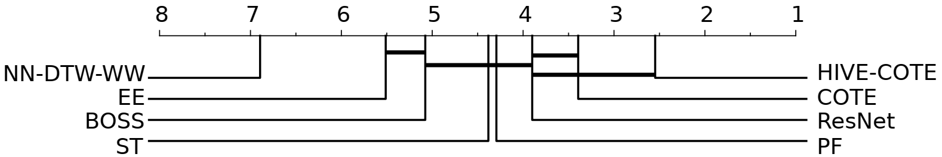
Figure 7 Critical difference diagram showing pairwise statistical difference comparison of state-ofthe-art classifiers on the univariate UCR/UEA time series classification archive.
The median accuracy of ResNet has been compared to state-of-the-art classifiers. The statistical test failed to find any significant difference between COTE/HIVE-COTE and ResNet. ResNet is the only deep learning algorithm that can reach the COTE performance. NN-DTW-WW and EE showed the lowest performance that indicates these algorithms cannot compete with state-of-the-art algorithms anymore.
Also, HIVE-COTE is still the most accurate classifier on UCR/UEA, its training time complexity makes it infeasible in many applications. Its time complexity is O(N².T⁴) which is proportional to the training time of ST (Shapelet) which is too slow. In some research, there were efforts to decrease the training time of ST that were successful, but again NN classifier is another obstacle for large datasets.
Moreover, the parameters of ResNet were not tuned for UCR/UEA dataset to keep the generality. For example, in HIVE-COTE, the DTW warping area or the number of k in kNN have been tuned to this dataset. Thus, the performance of ResNet may increase by this tuning.
For multivariate cases, a little different result was derived as it is shown in Figure 8. Although Time-CNN and MCDCNN were originally proposed for MTS, three deep CNNs (ResNet, FCN, and Encoder) outperformed them.
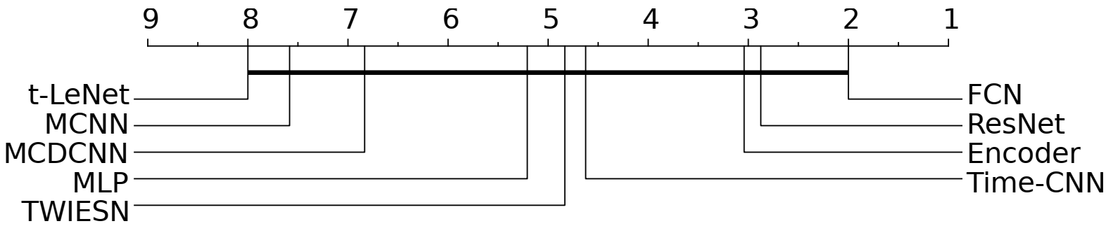
Figure 8 Critical difference diagram showing pairwise statistical difference comparison of nine deep learning classifiers on the multivariate time series classification archive.
As Figure 8 indicates, the statistical test failed to find any significant differences between nine classifiers which is because of the small number of samples in the dataset. Therefore, the results of both datasets were used and the critical difference diagram of both datasets is shown in Figure 9. Again, since there are 85 datasets in UCR/UEA in comparison to 12 MTS datasets in Baydogan, a significant difference between Figure 9 and Figure 8 cannot be observed.
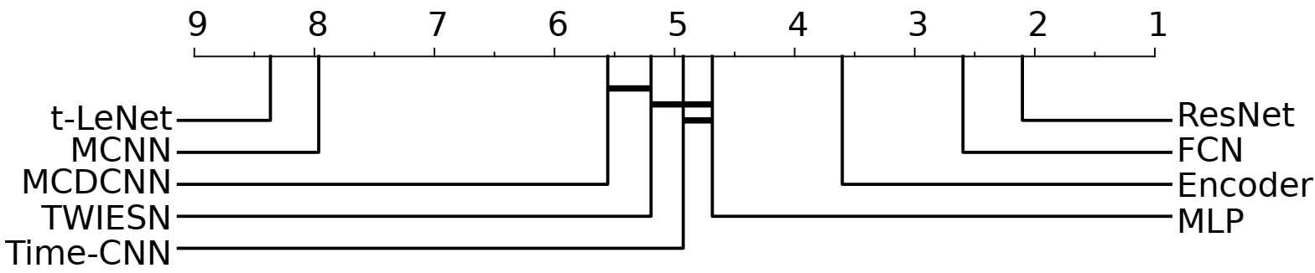
Figure 9 Critical difference diagram showing pairwise statistical difference comparison of nine deep learning classifiers on both univariate and multivariate time series classification archives.
Another interesting observation in this experiment was that ResNet did very well on several unrelated themes. For example, in Table 3, it can be seen that there is a low relationship between these themes from device malfunction to electrocardiogram or spectrometer, but in all cases, ResNet works fine.

The response of every classifier to different durations of time series is shown in Table 4. The similarity of classifiers’ ranks in Table 4 and Figure 9 depicts that DNNs are almost insensitive to the duration of time series. The concerns about the duration of time series become important when the time series gets very long. Some classifiers have vanishing gradient problem in the training step. The ESN is one of the classifiers which can handle very long time series without vanishing gradient problems.
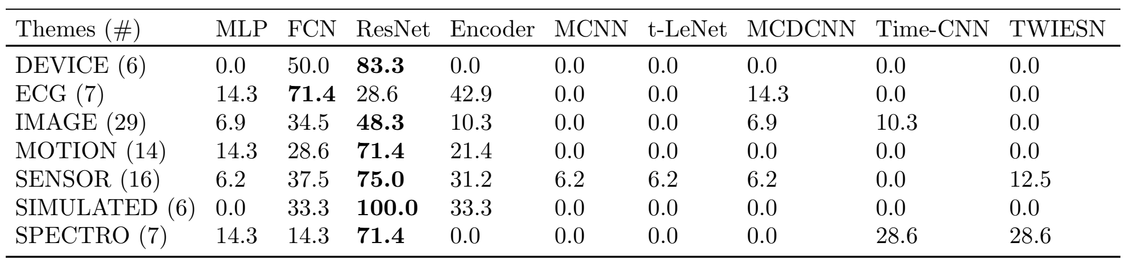
Table 3 Deep learning algorithms’ performance grouped by themes. Each entry is the percentage of dataset themes an algorithm is most accurate for. Bold indicates the best model.
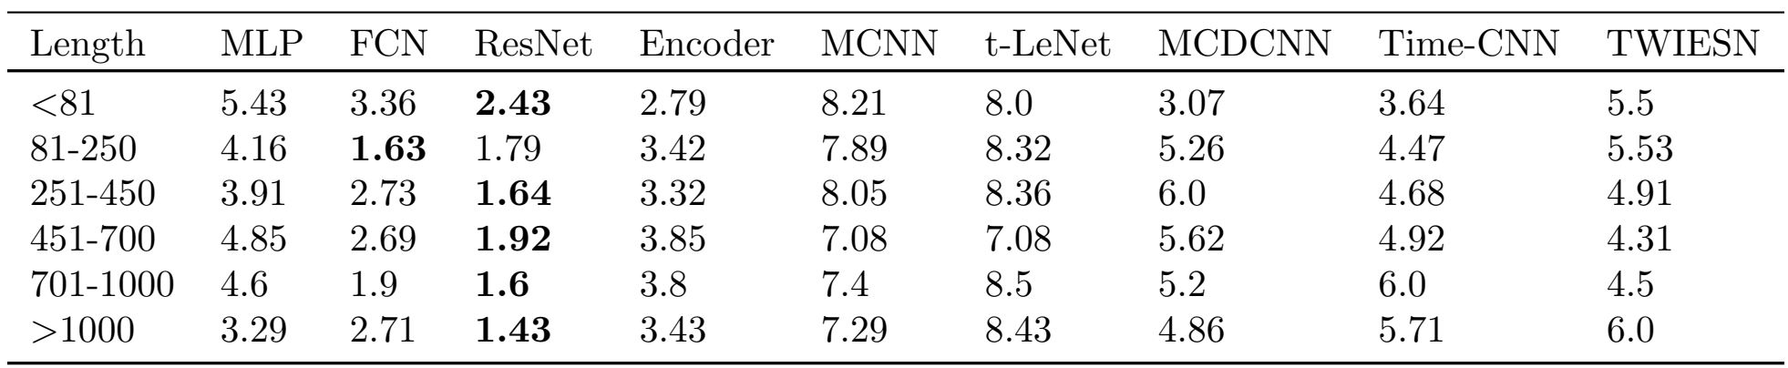
Table 4 Deep learning algorithms’ average ranks grouped by the datasets’ length. Bold indicates the best model.
The number of samples in the train set was another parameter that was investigated. Again, ResNet and FCN achieved the best response. But in practice, it was observed that on very small size datasets, the performance of ResNet and FCN becomes very poor in comparison with competitors because of overfitting. This fact can be seen in Figure 10 that when the number of instances in the training set decreases, the performance of ResNet drops down quickly. The performances of other DNNs to the training sets size are shown in Table 5.
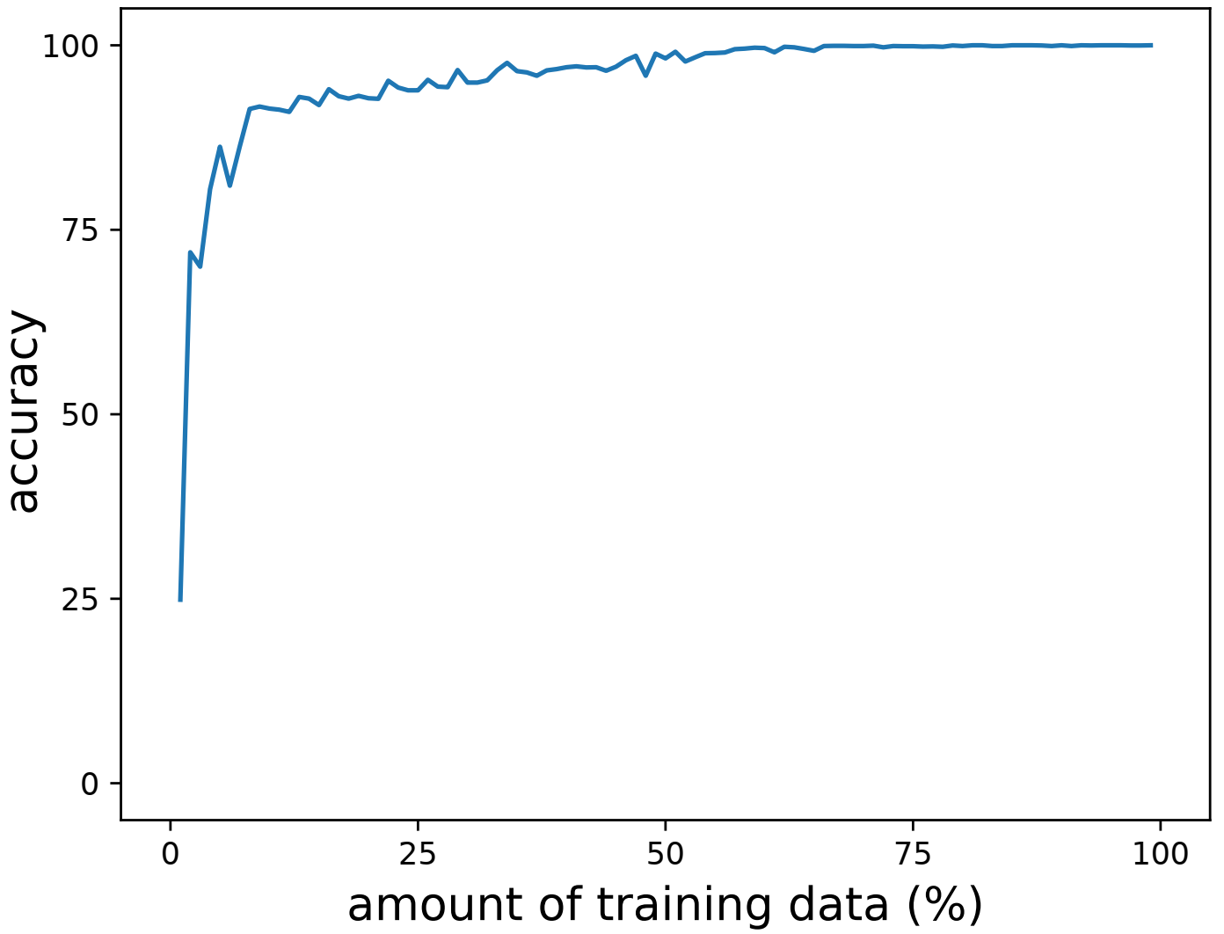
Figure 10 ResNet’s accuracy variation with respect to the amount of training instances in the TwoPatterns dataset.
For evaluation of random initialization, every network’s performance with several random initializations computed. The output variance of accuracy for ResNet was 1.48 and for FCN was 1.70 which shows less sensitivity of ResNet with respect to the random initialization.
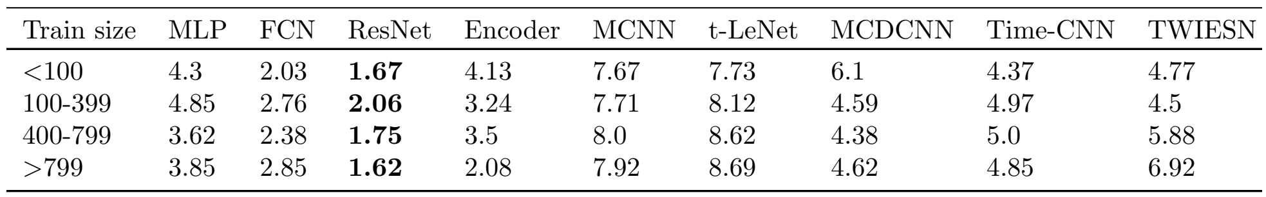
Table 5 Deep learning algorithms’ average ranks grouped by the training sizes. Bold indicates the best model.
Finally, it can be said that ResNet has the best performance in DNNs while FCN and Encoder follow it.
The Class Activation Map (CAM) helps an interpretable visualization method to find out how a classifier works. The CAM highlights the parts of an image that contributes the most to a given class. The original CAM was introduced for images, but it extended for 1D patterns like the time series, later. This approach can only be applied to DNNs which have probabilities output, such as softmax. If A_{m}(t) be the result of the last convolutional layer with M variables and $m∈\left[1,m\right]$ and $w_{m}^{c}$ be the weight between the m^{th} filter and the output neuron of class c, then input to the neuron of class c can be computed as z_{c}:
$z_{c}=\sum_{m}{ω_{m}^{c}\sum_{t}{A_{m}(t)}}$ (10)
If the z_{c} is rewritten as following, then CAM can be defined.
$z_{c}=\sum_{t}{\sum_{m}{ω_{m}^{c}A_{m}(t)}}$ (11)
${CAM}_{c}(t)=\sum_{m}{ω_{m}^{c}A_{m}(t)}$ (12)
Figure 11 shows the CAM for the GunPoint dataset. This dataset has been selected because
- It is easy to visualize, unlike other noisy datasets.
- Both FCN and ResNet models achieved almost 100% accuracy.
- There are just two classes which makes the visual comparison easy.
It is obvious that both classifiers neglecting the plateau non-discriminative regions. Also, both classifiers find out the most critical points. Moreover, the CNN works as it was expected, e.g. they found local discriminative areas regardless of where they appeared in time series; which shows CNN is a time-invariant classifier. The critical points can be discovered by shapelet-based classifiers too, but since shapelet classifiers are an ensemble of classifiers, it is unclear how the final decision is affected by individual classifiers, while DNNs are end-to-end classifiers and CAM can give a good explanation.
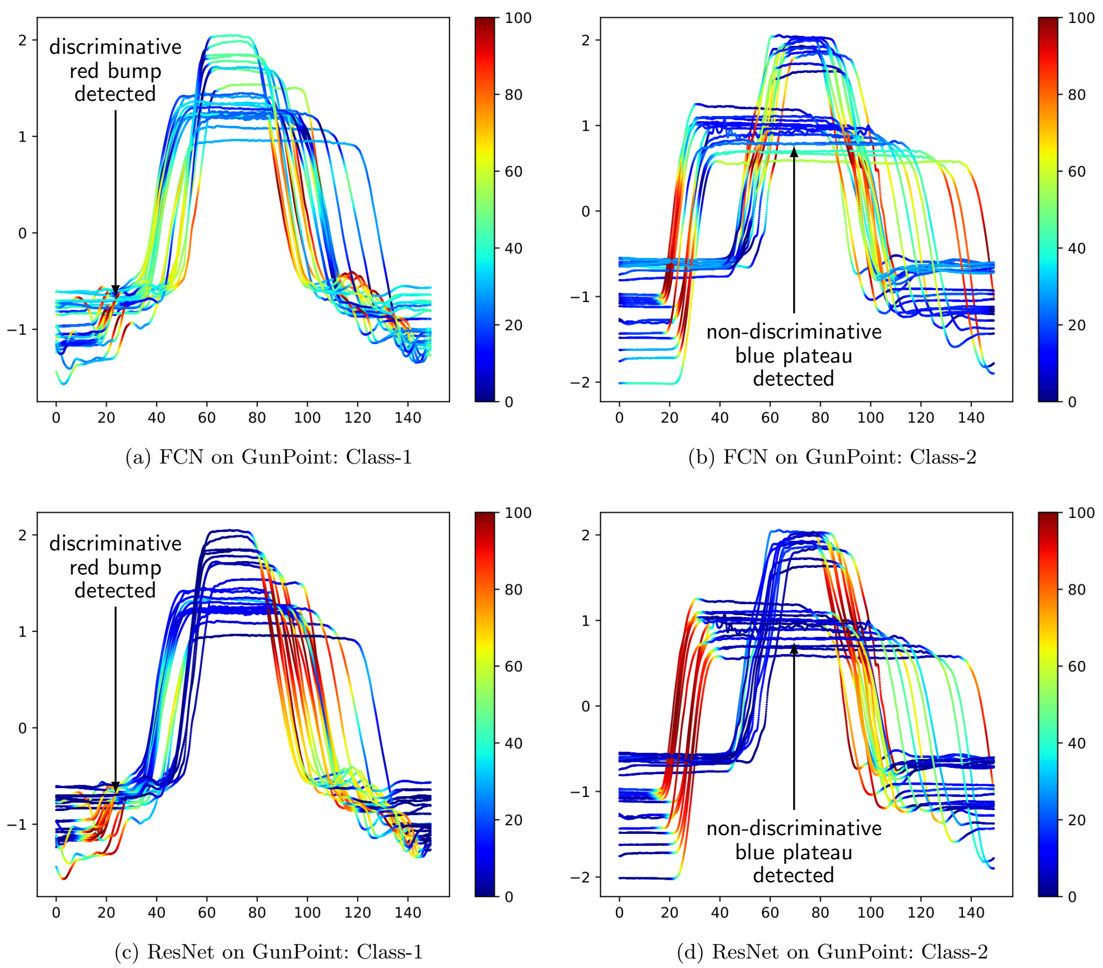
Figure 11 Highlighting with the Class Activation Map the contribution of each time series region for both classes in GunPoint when using the FCN and ResNet classifiers. Red corresponds to high contribution and blue to almost no contribution to the correct class identification (smoothed for visual clarity and best viewed in color).
Figure 12 shows another example from the Meat dataset. This dataset has three classes and ResNet and FCN accuracy were different with 97% and 83% respectively. The darker colors of ResNet show more certainty about the decisions while the light color of FCN shows it could not find complete distinctive areas. This observation is very strong for class 2 where ResNet completely rejects the discriminative capability of some areas while FCN thinks they are discriminative yet. This ability can be attributed to the main characteristic of ResNet which is composed of the residual connections between the convolutional blocks that enable the model to learn to skip unnecessary convolutions by dint of its shortcut links (He et al., 2016).
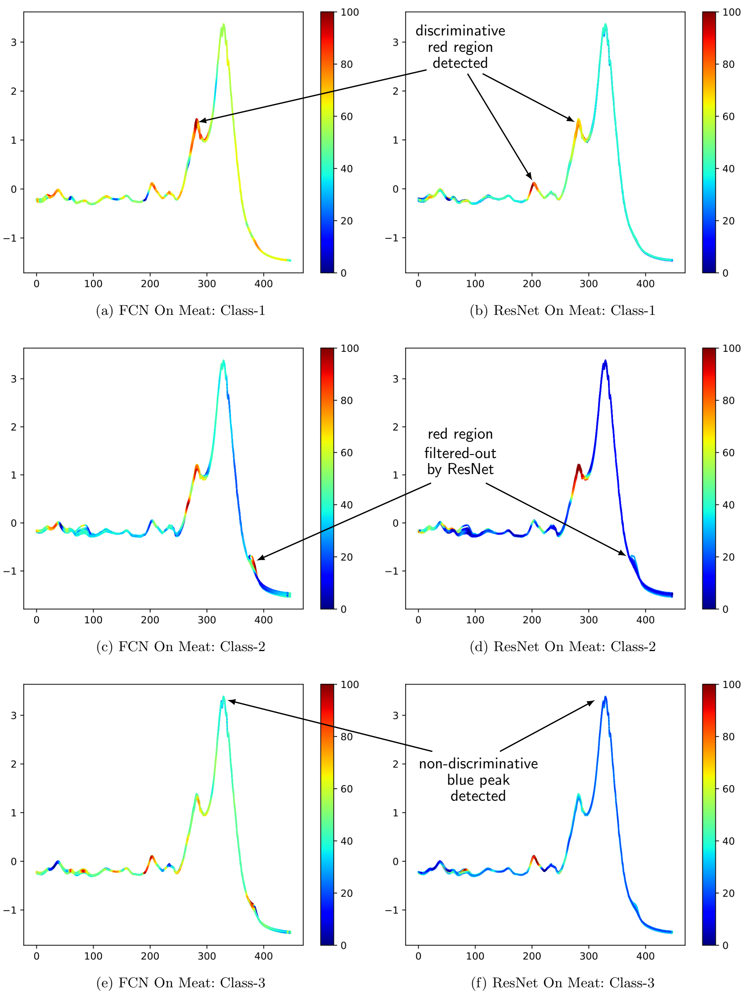
Figure 12 Highlighting with the Class Activation Map the contribution of each time series region for the three classes in Meat when using the FCN and ResNet classifiers. Red corresponds to high contribution and blue to almost no contribution to the correct class identification (smoothed for visual clarity and best viewed in color)
Another good method for visualization of individual samples spatially is Multi-Dimensional Scaling (MDS) which uses a pairwise distance matrix as input and aims at placing each object in an N-dimensional space such as the between-object distances are preserved as well as possible. It started with Euclidean Distance (ED) and then by distance matrix finds the appropriate spatial position of each sample. With this plot, it is possible to find out the separability capacity of a specific classifier in comparison to its competitors. Again, like before, the MDS has been implemented for ResNet and FCN because they have the highest rank on UCR/UEA and both have the GAP layer with softmax which makes the number of latent features invariant to the time series length.
The process of finding the MDS is as follows. First, the EDs of the 128-dimensional output vector of the last convolutional layer is calculated. Then the procedure tries to minimize a cost function which is called Stress.
${Stress}_{D}\left(X_{1},⋯,X_{N}\right)={\left(\frac{\sum_{i,j}{{\left(d_{ij}-\left\|x_{i}-x_{j}\right\|\right)}^{2}}}{\sum_{i,j}{d_{ij}^{2}}}\right)}^{1/2}$ (13)
where $d_{ij}$ is the ED between the GAP vectors of time series $X_{i}$ and $X_{j}$.
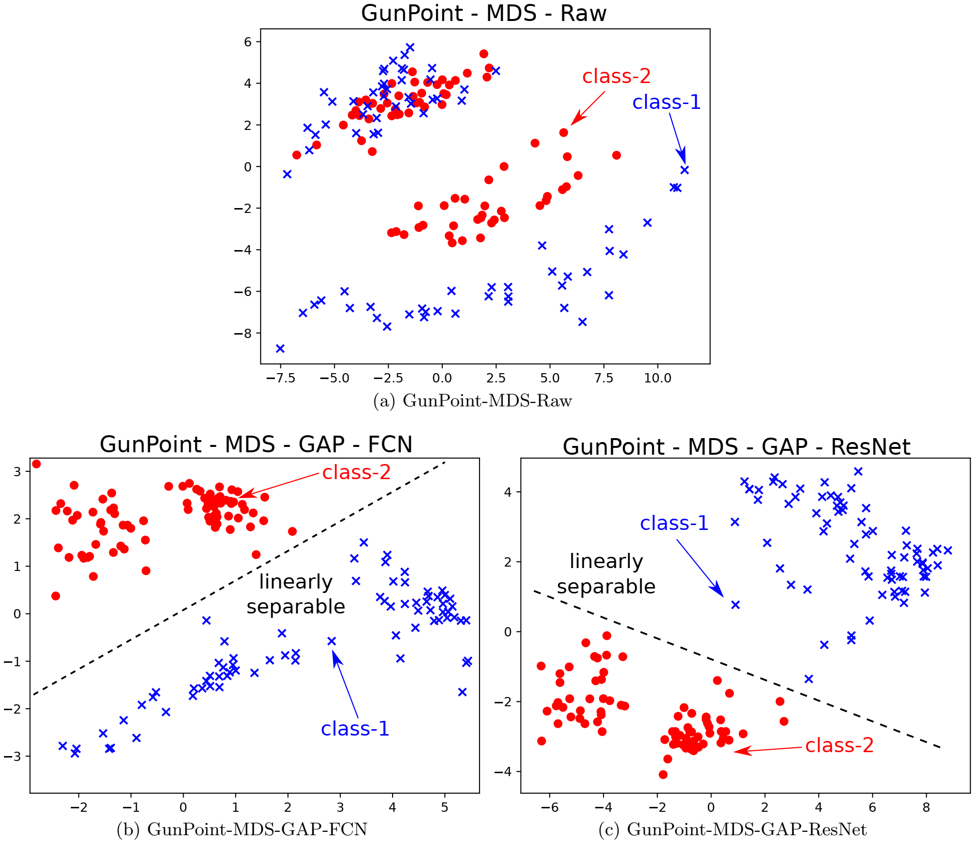
Figure 13 Multi-Dimensional Scaling (MDS) applied on GunPoint for: (top) the raw input time series; (bottom) the learned features from the Global Average Pooling (GAP) layer for FCN (left) and ResNet (right) - (best viewed in color). This figure shows how the ResNet and FCN are projecting the time series from a non-linearly separable 2D space (when using the raw input), into a linearly separable 2D space (when using the latent representation)
Figure 13 shows three MDS plots for the GunPoint dataset in three formats; the raw input time series, the learned latent features from the GAP layer for FCN and ResNet. The overlap in Figure 13a shows that the two classes cannot completely be separated. On the other hand, by the nonlinear transformations that FCN and ResNet bring, the two classes are linearly separable in Figure 13b and Figure 13c. This linear separable space proves again the accuracy of these two models on the GunPoint dataset which is 100%.
Although the MDS visualization on GunPoint datasets gives the reason for 100% accuracy for both classifiers, it does not show the difference between classifiers. Therefore, the MDS was implemented on the Wine dataset too. Figure 14 shows the MDS visualization on the classification result of FCN and ResNet. In Figure 14a, the raw data has been plotted. With FCN transformation, as it can be seen in Figure 14b, the separator surface is complex and hard to extract. While in Figure 14c it is obvious that ResNet transformation makes it possible to have a very smooth separator surface. This smooth separator surface can be a good reason that why the ResNet gives better results compared to FCN.
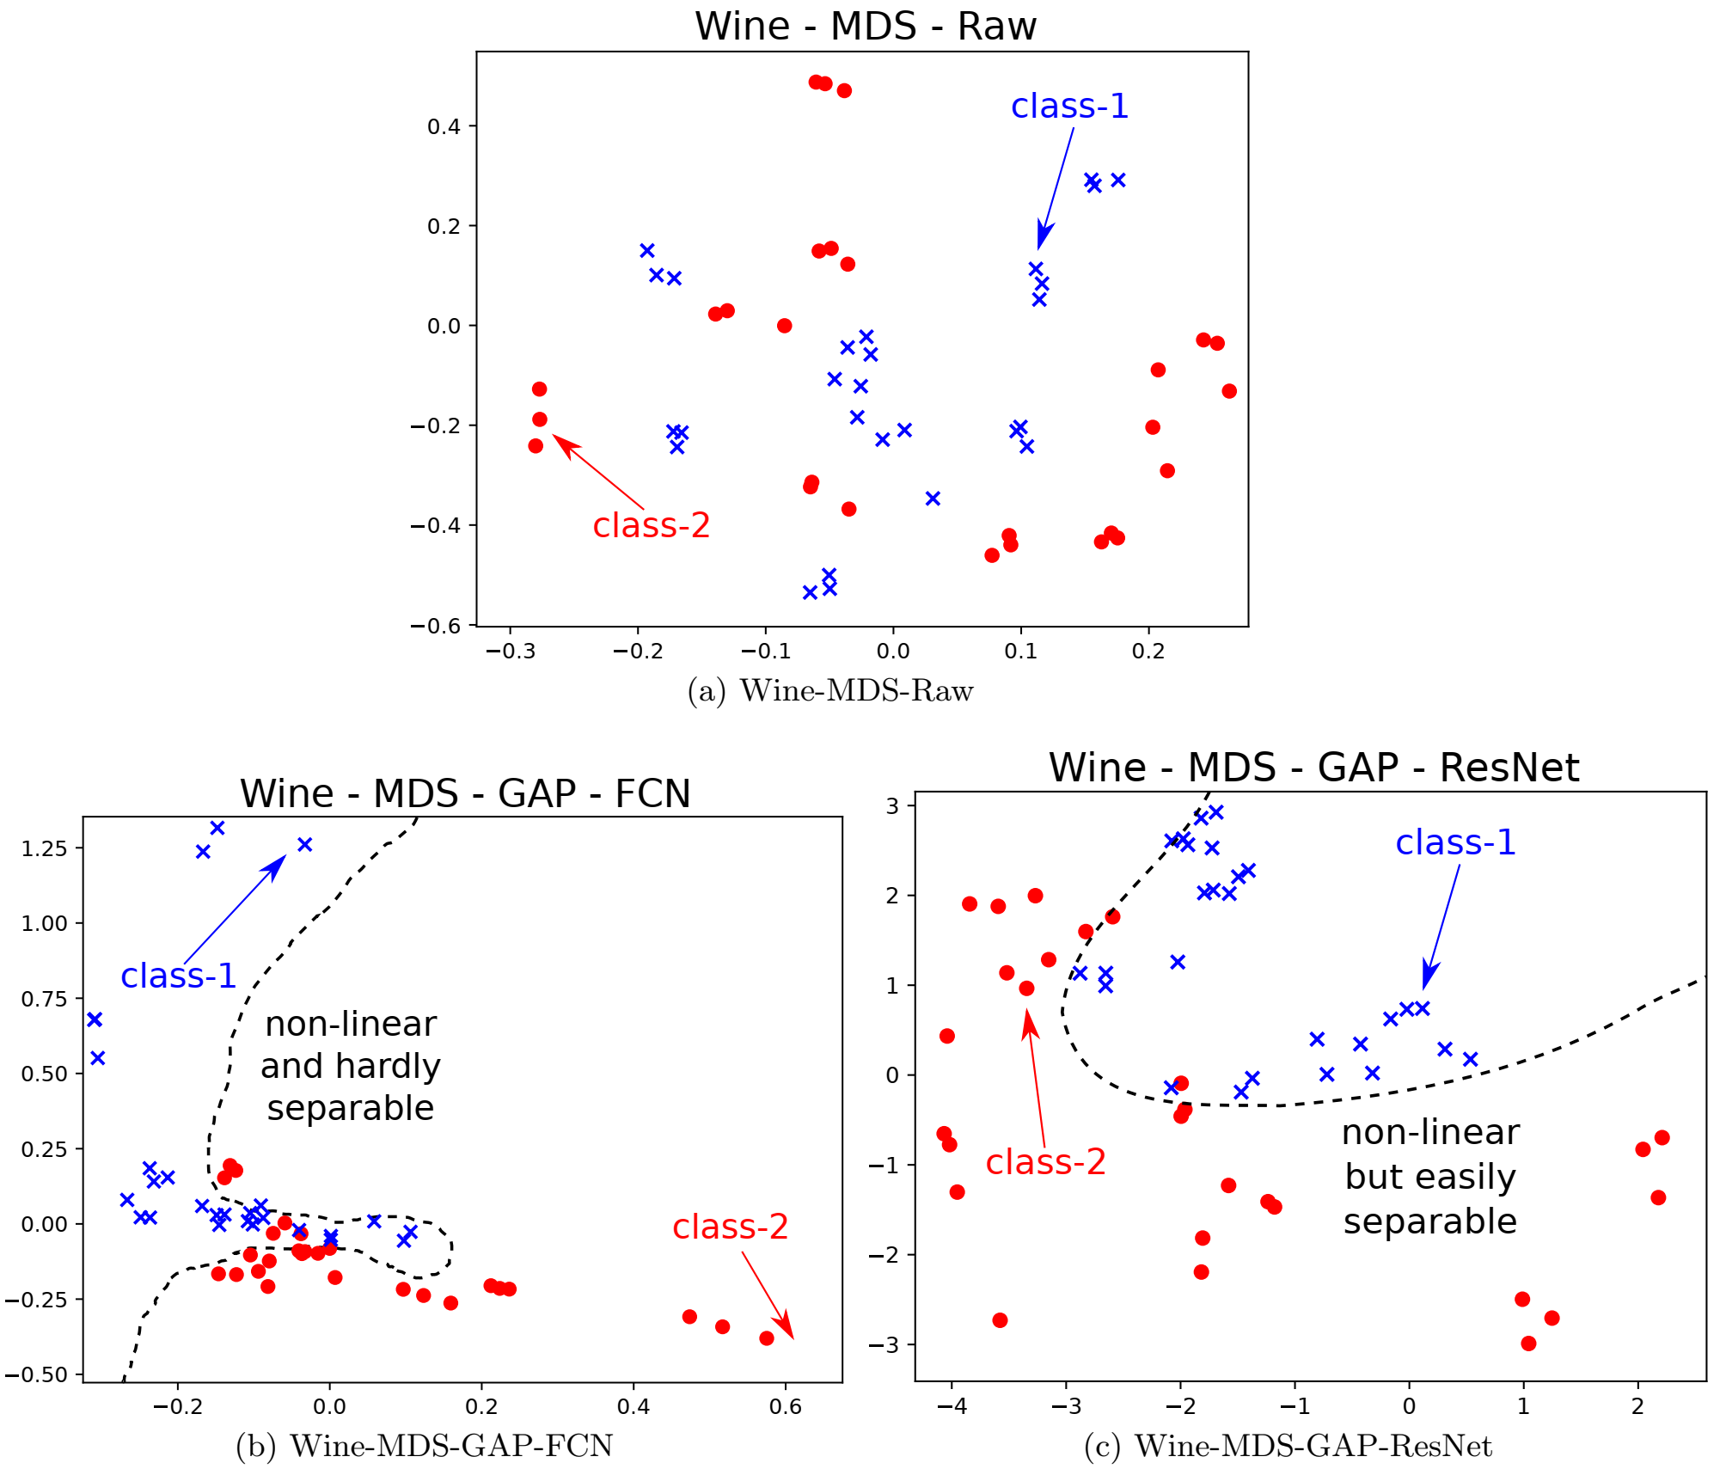
Figure 14 Multi-Dimensional Scaling (MDS) applied on Wine for: (top) the raw input time series; (bottom) the learned features from the Global Average Pooling (GAP) layer for FCN (left) and ResNet (right) - (best viewed in color). This figure shows how ResNet, unlike FCN, is able to project the data into an easily separable space when using the learned features from the GAP layer

Unsupervised Clustering
In many practical cases, the category information of time series is not available or it is not totally reliable. Moreover, when the signal is long and non-stationary behavior is observed on that, using sequence-to-sequence (seq2seq) processing would be necessary. In the next two sections, we specifically talk about two approaches for unsupervised learning of time series. The first one tries to use a model-based approach which is called Deep Temporal Clustering Representation (DTCR) and the second one uses Echo State Networks on Electroencephalogram signals.

Deep Temporal Clustering Representation (DTCR)
DTCR aims to learn a nonlinear temporal representation for time series clustering using the seq2seq model. The seq2seq approach helps to find the dynamics and multi-scale characteristics of time series. DTCR adapts bidirectional dilated recurrent neural networks as the encoder. This representation forms a cluster structure with the guidance of the K-MEANS objective. A fake-sample generation strategy has been used to enhance the ability of the encoder.
The general architecture of DTCR is shown in Figure 15. As it can be seen, the encoder maps the original time series into a latent space of representations. The representations are used to reconstruct the input data with the decoder. Simultaneously, a K-MEANS objective guides the representation learning.
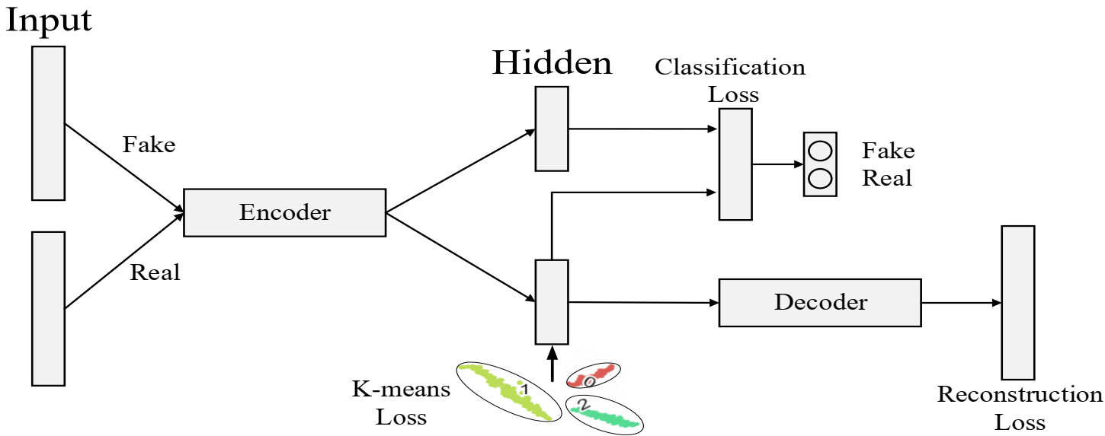
Figure 15 The general architecture of the Deep Temporal Clustering Representation (DTCR).
Given a set of n times series $D=\left\{x_{1},x_{2},⋯,x_{n}\right\}$, each time series $x_{n}$ contains T ordered real values samples denoted as $x_{i}=\left(x_{i,1},x_{i,2},⋯,x_{i,T}\right)$. Two nonlinear mappings $f_{enc}:x_{i}→h_{i}$ for encoding and $f_{dec}:h_{i}→{\hat{x}}_{i}$ for decoding will be defined for $h_{i}∈R^{m}$ which is the m-dimensional latent representation of time series $x_{i}$, defined by $h_{i}=f_{enc}(x_{i})$.
The goal is to train a good $f_{enc}$ to facilitate the clustering task. The dilated RNN (Chang et al., 2017) is used to implement this nonlinear encoder. Decoding is defined to produce ${\hat{x}}_{i}$, where ${\hat{x}}_{i}∈R^{m}$ by ${\hat{x}}_{i}=f_{enc}(h_{i})$. And Mean Square Error (MSE) is used for reconstruction loss as follows:
$L_{reconstruction}=\frac{1}{n}\sum_{i=1}^{n}{{\left\|x_{i}{-\hat{x}}_{i}\right\|}_{2}^{2}}$ (14)
The features learned from optimizing the reconstruction loss are not necessarily suitable for clustering tasks. To have a better cluster-specific representation, the network learning will be guided further through K-MEANS.
With a static data matrix $H∈R^{m×N}$, it has been shown that the minimization of K-MEANS could be reformulated as a trace maximization problem with the Gram matrix $H^{T}H$ which produces optimal global solutions without local minima. Spectral relaxation converts the K-MEANS objective into the following problem:
$L_{reconstruction}=Tr\left(H^{T}H\right)-Tr(F^{T}H^{T}HF)$ (15)
where Tr denotes the matrix trace and $F∈R^{N×k}$ is the cluster indicator matrix. The last equation can be further relaxed to a trace maximization problem by setting F to be an arbitrary orthogonal matrix:
$\max_{F}{Tr\left(F^{T}H^{T}HF\right)}, s.t. F^{T}F=I$ (16)
The closed-form solution of F is obtained by composing the first k singular vectors of H according to the Ky Fan theorem (Fan, K., 1972). However, in this case, H is learned by the network instead of being static. This change the equation as a regularization term for learning H. Thus, the target is to minimize the objective below (λ is a scaler):
$\min_{H, F}{J\left(H\right)+\frac{λ}{2}\left[Tr\left(H^{T}H\right)-Tr\left(F^{T}H^{T}HF\right)\right]}, s.t. F^{T}F=I$ (17)
where $J\left(H\right)$ is the sum of the reconstruction loss and the classification loss. The whole training process of DTRC consists of iteratively updating F and H. Fixing F, updating H can follow the standard stochastic gradient descent (SGD), with the gradient given as $J\left(H\right)+λH\left(I-FF^{T}\right)$. Fixing H, F will be updated using the closed-form solution to the equation by computing the k-truncated singular value decomposition (SVD) of H. To avoid instability, F should not be updated at each iteration. In practice, F has been updated once after every 10 iterations.
The seq2seq model relies on the capabilities of the encoder. Thus, it is expected that a better-trained encoder would give a better result. The augmented samples can improve the encoder quality. Given a time series $x_{i}∈R^{T}$, its fakes version by randomly shuffling some time steps will be generated. The number of selected time steps is $\left\lfloor α×T\right\rfloor$ where $α∈\left(0,1\right]$ is a hyper-parameter that is set to 0.2. For each raw time series, the fake samples will be generated. The auxiliary classification task is defined to train the encoder to detect whether a given time series is real or fake. The encoder is trained by minimizing the following loss function:
${\hat{Y}}_{i}=W_{fc2}\left(W_{fc1}h_{i}\right)$ (18)
$L_{classification}=-\frac{1}{2N}\sum_{i=1}^{2N}{\sum_{j=1}^{2}{1\left\{Y_{i,j}=1\right\}\log{\frac{\exp{{\hat{Y}}_{i,j}}}{\sum_{j=1}^{2}{\exp\left({\hat{Y}}_{i,j}\right)}}}}}$ (19)
Where $Y_{i}$ is a 2D one-hot vector indicating real or fake, and ${\hat{Y}}_{i}$ is the classification result. For simplicity, we ignore the bias term. $W_{fc1}∈R^{m×d}$, $W_{fc2}∈R^{d×2}$ are parameters of the fully connected layers and d is set to 128. This procedure helps to improve the performance of the encoder for giving a better representation of the time series. Finally, the overall training loss $L_{DTCR}$ of DTCR is defined by:
$L_{DTCR}=L_{reconstruction}+L_{classification}+λL_{K-means}$ (20)
where λ is the regularization coefficient. This equation is minimized to learn the cluster-specific representations:
- $L_{reconstruction}$ makes the representations reconstruct the input
- $L_{classification}$ enhances the ability of the encoder
- $L_{K-means}$ encourages the representations to form cluster structures.
Algorithm 1 DTCR Training Method
Input: Data set: D; Number of clusters: K; Alternate update: T; Maximum iterations: MaxIter
Output: Cluster result s
1: For each time series in D, generate the corresponding fake samples.
2: for iter = 1 to MaxIter do
3: Update latent representation ${\left\{h_{i}=f_{enc}\left(x_{i}\right)\right\}}_{i=1}^{n}$ using SGD based on Equation 20.
4: if iter % T = 0 then
5: Update F using the closed-form solution of Equation 16.
6: end if
7: end for
8: Apply K-MEANS to the learned representation and get the cluster result s.

The detailed training method of DTCR is presented in Algorithm 1. The algorithm was implemented on 36 time-series datasets of UCR (Dau et al., 2019) to evaluate performance. The statistics of the 36 datasets that have been used are shown in Table 6. Each dataset has a default train and test split. The training has been done on the default train set and the testing has been done on the default test set for comparison. The bidirectional multi-layer Dilated RNN is employed for encoding to capture the dynamics and multi-scale characteristics of the time series. The number of layers and dilation per layer are fixed to 3 and 1, 4, and 16, respectively. The observations show that DTCR performs well in this setting. The decoder is a single layer RNN with Gated Recurrent Units (GRU). The number of units per layer of the encoder is $\left[m_{1}, m_{2},m_{3}\right]⊂\{\left[100, 50, 50\right], \left[50, 30, 30\right]\}$. The number of hidden units in the decoder is $(m_{1}+m_{2}+m_{3})×2$. The encoder takes the final hidden state of the encoder as its initial state and performs iterative prediction, i.e., the output at time t-1 is fed as the input at time t. The λ parameter of the total lost equation is selected as $\left\{1, 0.1, 0.01, 0.001\right\}$. The batch size is 2N. By running each experiment 5 times, the impact of random initialization has been decreased, and the mean and standard deviation of results are reported.
The Rand Index (RI) and Normalized Mutual Information (NMI) are the common parameters for performance evaluation.
$RI=\frac{TP+TN}{{n\left(n-1\right)}/2}$ (21)
TP is the true positive, TN is the true negative and n is the number of samples in the dataset.
$NMI=\frac{\sum_{i=1}^{M}{\sum_{j=1}^{M}{N_{ij}\log\left(\frac{N.N_{ij}}{\left|G_{i}\right|\left|A_{j}\right|}\right)}}}{\sqrt{\left(\sum_{i=1}^{M}{\left|G_{i}\right|\log{\frac{\left|G_{i}\right|}{N}}}\right)\left(\sum_{j=1}^{M}{\left|A_{j}\right|}\log{\frac{A_{j}}{N}}\right)}}$ (22)
In this equation, N is the total number of time series. $\left|G_{i}\right|$, $\left|A_{j}\right|$ are the number of time series in the cluster $G_{i}$ and $A_{j}$. $N_{ij}=\left|G_{i}∩A_{j}\right|$ denotes the number of time series belonging to the intersection of sets $G_{i}$ and $A_{j}$. NMI close to one indicates a high-quality clustering.
The DTCR has been compared with 11 recently representative time series clustering methods. Also, it has been compared with 2 state-of-the-art non-time-series deep clustering methods, DEC (Xie et al., 2016) and IDEC (Guo et al., 2017). The results of these methods which are indicated in Table 6 are extracted from their publications.
As it can be seen from Table 6, DTCR gives the best performance in terms of the lowest average rank of 3.0694, the highest average RI of 0.7714, and the number of best results 17. A pairwise comparison for each method against DTCR has been performed to better analyze the performance. The Wilcoxon signed-rank test shows that DTCR is better than all of the other methods at p < 0.05 level, except USSL (Zhang et al., 2019). It should be mentioned that USSL depends on pseudo-labels to guide the learning, while there is no mechanism to reduce the negative impact when mistakes occur in the pseudo-labels. In contrast, DTCR is capable of correcting mistakes with the help of temporal reconstruction.
To show how $L_{K-means}$ and $L_{classification}$ can contribute to clustering, a comparison between the full DTCR model and its two ablation models, i.e. DTCR without K-MEANS loss and DTCR without the auxiliary classification loss have been evaluated and shown in Table 7. As it can be seen, the full DTCR is always superior to all of its ablations and demonstrate the effectiveness of the $L_{K-means}$ and $L_{classification}$.
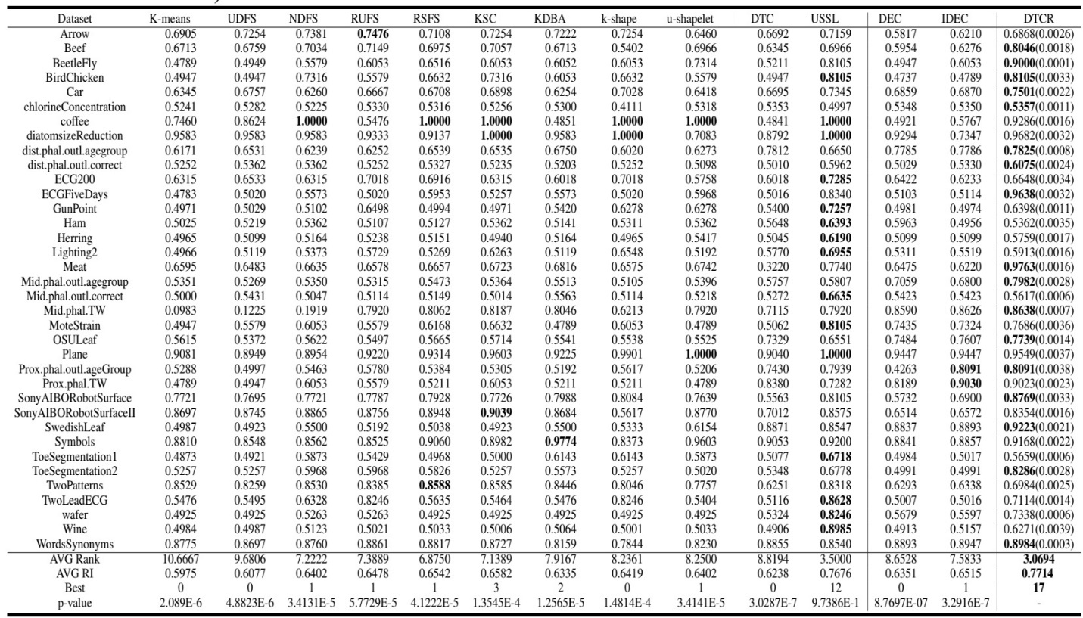
Table 6 Rand Index (RI) comparisons on 36 time series datasets (the values in parentheses present standard deviations)
The t-SNE method has been used for 2D visualization (Laurens, 2008). This visualization shows the effectiveness of cluster-specific representations even if K-MEANS makes mistake. The visualization has been produced on two datasets, ECGFiveDays and SonyAIBORobotSurface. Figure 16 shows the representation learned by DTCR has formed two clusters despite a small amount of mixing. In contrast, DTCR without K-MEANS loss presents no cluster shape, and contain a small amount of mixing as well. Even the representations produced by DTCR without classification loss are also mixed, which implies the importance of the encoder.
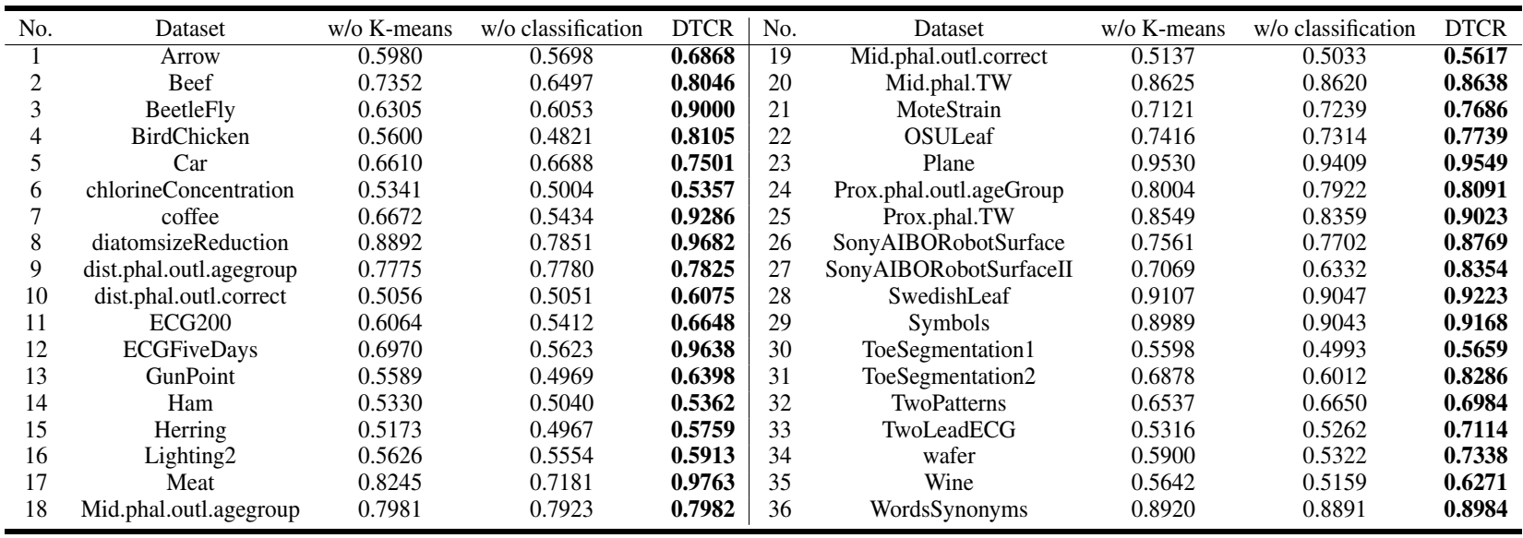
Table 7 Rand Index (RI) ablation study results of DTCR
Figure 17 shows the learning process of cluster-specific representations of DTCR. In the beginning, the data is scattered and chaotic. At epoch 30, two clusters are almost formed. At epoch 50, a well-learned cluster-specific representation is established with respect to the small distance of intra-class and the large inter-class distance. This process was implemented on all datasets and the same results were almost observed.
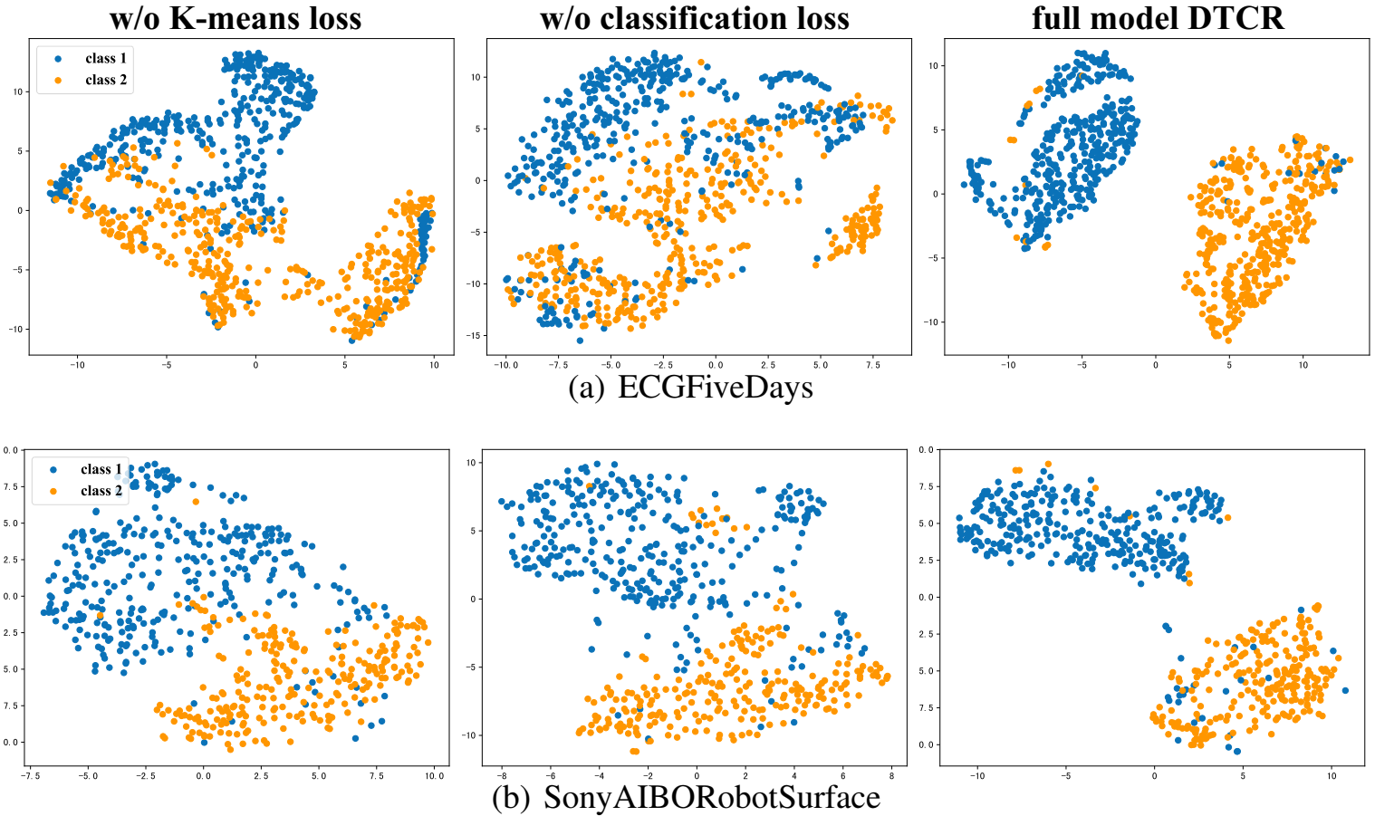
Figure 16 The visualizations with t-SNE on the datasets (a) ECGFiveDays and (b) SonyAIBORobotSurface. The colors of the points indicate the actual labels.
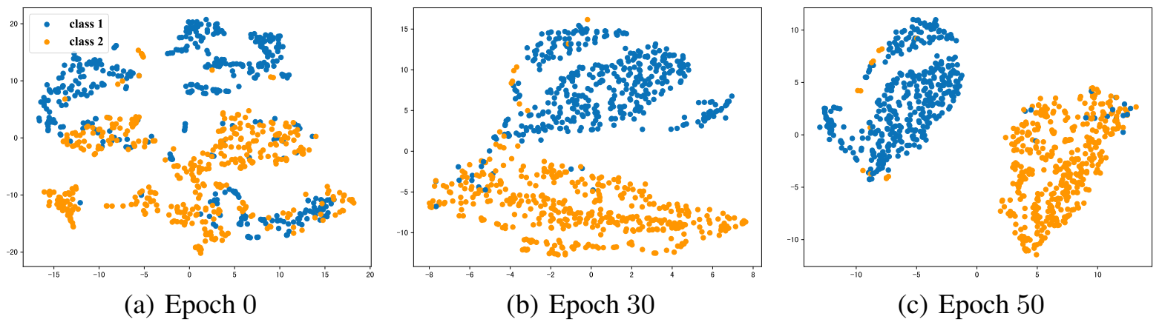
Figure 17 The learned representations on data set ECGFiveDays during the training process. From left to the right, the subfigure is obtained at Epoch 0, 30 and 50, respectively.
This model uses K-MEANS for producing initial clustering conditions. Here, it will be investigated if K-MEANS makes mistake. Figure 18 shows the ability of the model to correct mistakes of K-MEANS with the help of $L_{reconstruction}$. As it can be found from Figure 18 when the $L_{reconstruction}$ term is added to loss function, the RI improved which shows the correction ability of the method.
The proposed method, Deep Temporal Clustering Representation (DTCR) can effectively generate cluster-specific representations. Using the K-MEANS objective, the seq2seq model and temporal reconstruction significantly improve the clustering effectiveness. Also, fake-sample generation strategy and auxiliary classification task enhance the ability of the encoder.
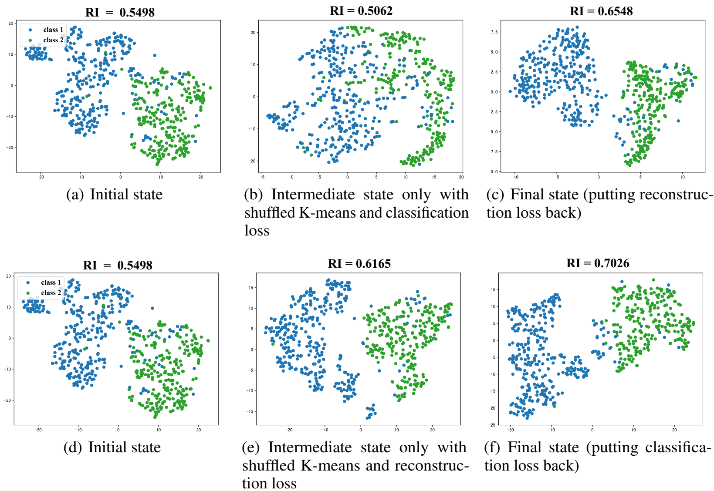
Figure 18 Robustness Analysis of DTCR on SonyAIBORobotSurface. Note that the (d) is the same as (a), replicated here for better illustration; hence the first and second rows start with the same state.

Unsupervised EEG Feature Extraction Based on Echo State Network
Most event detection, pattern recognition, clustering, and classification methods on electroencephalogram (EEG) rely on hand-crafted features. With unsupervised feature extraction methods, it would be possible to extract the best and most effective features. Furthermore, recurrent autoencoders and their children such as Echo State Network (ESN), have shown their abilities to learn effective features.
Two important abnormal activities needed to be found for seizure detection in EEG signals are ictal (during an epileptic seizure) and interictal (between seizures). Visual analysis of a long-term seizure is time-consuming and needs high expertise in the field. These two factors mean it needs a high amount of investment. The high amount of unannotated data in hospitals make the unsupervised labeling attractive.
Several classification methods, such as multilayer perceptron, support vector machines, and extreme learning machine, with hand-engineered features have been tried before. But it has been observed that the results are highly dependent on the quality of features, rather than classifiers.
It is proven that experts can classify EEG waveforms based on their visual identities. To have a better representation of visual features, several feature sets have been proposed, such as parametric models, wavelet transforms, and spectral band power methods. Most of these feature sets are based on linear models, therefore, they may not fully capture the complex nonlinear dynamics in human brain activities. The nonlinear dynamics theory and chaos theory, such as correlation dimension, largest Lyapunov exponent, and sample entropy, have been exploited to analyze EEG signals, too.
Several engineered feature sets from multiple fields have been proposed to numerically describe the EEG signals. The visual features (or waveform morphology features) include first half-wave amplitude (FHWA), first half-wave duration (FHWD), first half-wave slope (FHWS), second half-wave amplitude (SHWA), second half-wave duration (SHWD), and so on. Besides, statistical feature sets also help to describe the morphology features, such as mean absolute value (MAV), simple square integral (SSI), variance (VAR), root mean square (RMS), waveform length (WL), average amplitude change (AAC), etc.
The model-based EEG feature sets mainly use Fourier spectral analysis and transforms and regularly include short-time Fourier transform (STFT), discrete wavelet transform (DWT), and autoregressive (AR) model. The effectiveness of AR models has been observed in different physiological states (Han & Sun, 2010). However, most of these methods are based on linear models, Wang et al. (2017) argued that linear feature sets cannot completely identify different brain activities without considering the highly complex and nonlinear nature of EEG signals.
The nonlinear indicators also have been used to recognize ictal EEG signals from normal ones, such as the approximate entropy (ApEn), the Lyapunov exponents (LyEx), the correlation dimension (CorDim), and sample entropy.
Figure 19 shows some feature sets from three aspects.
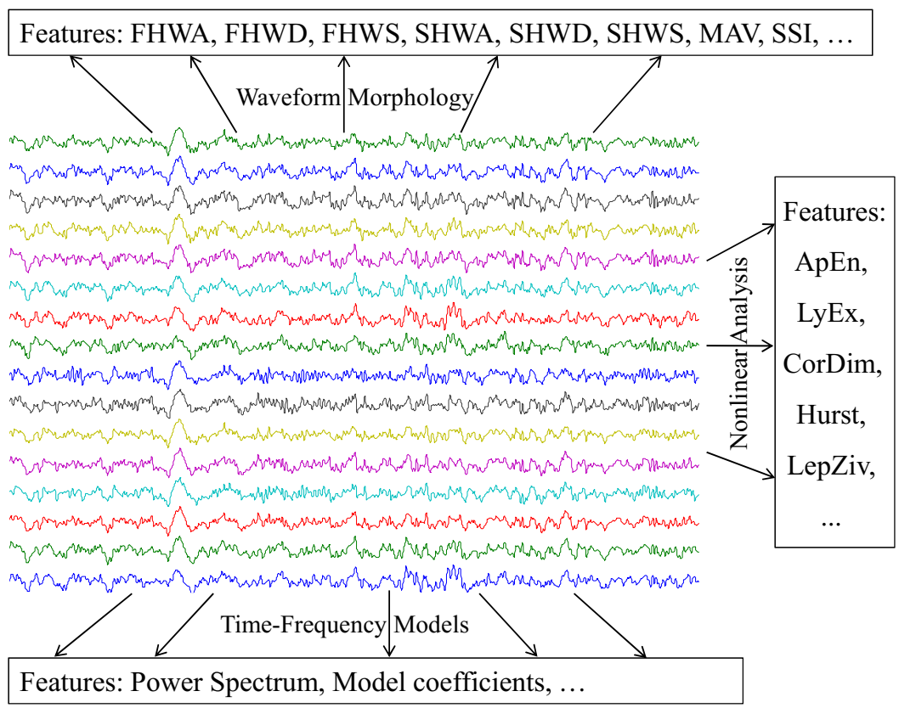
Figure 19 EEG features extracted from three different perspectives.
Hand-designed features are based on experts’ knowledge transfer or trial-and-error. Hence, too many features have been proposed but selecting the best set of them is usually done with feature reduction methods. The needs for feature processing and inefficiency of most engineered features are because each feature is extracted from a one-sided viewpoint, large redundancy may exist between features extracted from different viewpoints, and also the original data objects cannot be recreated by extracted features, which means that the obtained feature set is incomplete as well as that considerable information is lost during the feature extraction, as shown in Figure 20.
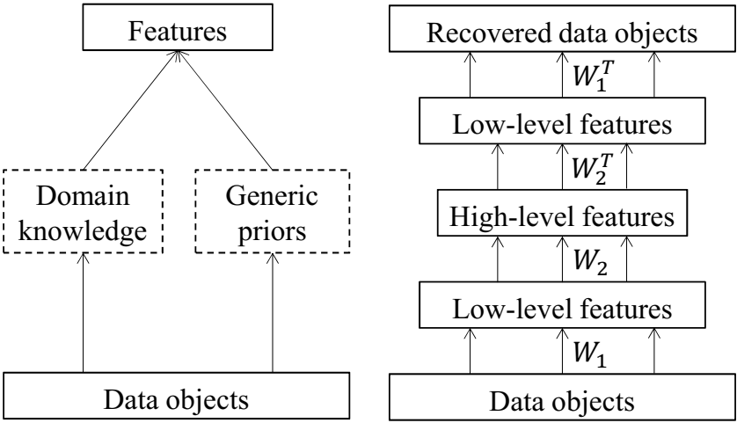
Figure 20 Comparison of hand-designed feature extraction with deep representation learning in an autoencoder
It has been observed that for simple tasks finding a good feature set is easy while for complex classification tasks, such as EEG signal case, a great deal of time and effort need to find an acceptable set of features.
With the strong ability of deep neural networks to capture the nonlinear behavior of nonstationary systems, they were used to extract features from unstructured data without hand-designed models relying on expert knowledge or prior assumptions. The main idea was to convert data records into low-dimensional vectors using deep autoencoders, then reconstructing the original data from these low-dimensional vectors. More close reconstructed data to the original unstructured data while preserving the few numbers of dimensions means more effectiveness of feature set. This kind of deep neural network is called autoencoder.
In recent years, CNN has been extensively used to extract features from images and it was successful in many applications. For temporal data such as time series, feed-forward neural networks, or even CNN cannot find temporal patterns successfully outside their views or windows. Instead, RNN has been proved to be able to extract temporal patterns from sequential data like time series.
The autoencoders have been used successfully in many applications but using them in EEG is very limited. The EEG signals are chaotic time series; hence, feed-forward neural networks which have been widely used for images or graphs cannot be used efficiently for EEG data. Recurrent neural networks (RNNs), on the other hand, have shown their capabilities to process time series if their persistent problem, e.g. vanishing gradients, can be handled. To overcome the problem of vanishing gradients, the echo state networks (ESNs) was proposed. Here, the feature extraction echo state networks (FE-ESN) will be implemented on EEG signals.
RNNs has been developed in the 1980s (Schmidhuber, 2015), different from neural networks, specifically to work with time series. RNNs have memory and their ability to predict the next-period values is of interest.
The RNN can be described as follow:
$x_{t}=f\left(W_{in}u_{t}+Wx_{t-1}\right),$ (23)
$y_{t}=g\left(W_{out}x_{t}\right)$
where $\left\{u_{t}\right\}, t=1, 2, …, T$ are the data collected in a sequence, x_{t} is the hidden state underlying timestamp t, which updates itself according to previous-period hidden states x_{t-1} and the current input u_{t}. Using the hidden state xt, an RNN can preserve all the historical inputs from u₁ to u_{t} in x_{t} and hence it has “memory” when it makes the next-period prediction. W_{in} and W are the input weights that connect input neurons with internal neurons and internal weights that connect internal neurons to themselves. At each time step t, the desired outputs are learned from $x_{t}$ with output weights W_{out} and mapping g(.).
The key challenge of the RNNs is how to train them. The long dependency of hidden states causes gradients to vanish quickly. To overcome this problem, Hochreiter proposed long short-term memory (LSTM) in 1997 (Hochreiter et al., 1997), and Cho et al. (Cho et al., 2014) proposed gated recurrent units (GRUs) in 2014. Different from these approaches, it is possible to keep the RNN’s internal weights fixed and only trained output weights. This idea produced ESNs (Jaeger et al., 2004) and liquid state machines (LSMs) (Maass et al., 2004).
Jaeger and Haas (Jaeger et al., 2004) tested ESNs on the benchmark task of predicting Mackey-Glass chaotic time series. The accuracy was improved by a factor of 2400 over previous techniques. Unlike traditional RNNs, ESNs are only trained on the output weights and output weights are computed to solve the protuberant optimal problem and efficiently avoids suboptimal solutions.
The key idea of the ESN is to drive a large random fixed recurrent neural network, which is called a reservoir, with the input signal, thereby inducing each neuron within the reservoir a nonlinear response signal, and then combine the desired output signal by a trainable linear combination of all of these response signals (Jaeger et al., 2004). The core component of ESN is the reservoir network, Figure 21, where input connections W_{in} (input-to-reservoir), internal connections W (neurons-to-neurons), and feedback connections W_{fb} (output-to-reservoir) are all randomly generated according to the specified parameters and fixed after being generated. Through the training process, only the output connections W_{out} are modified. ESNs and LSTM training concepts are similar.
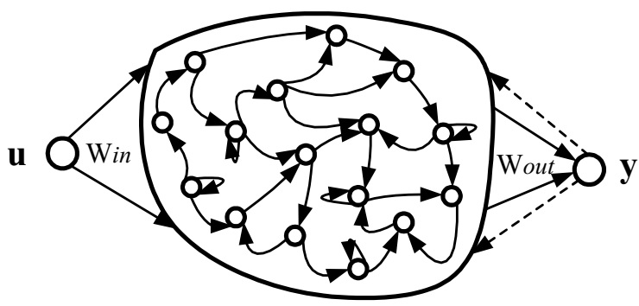
Figure 21 Reservoir network
The hidden state of the ESN is updated as follows:
$x_{t}=f\left(W_{in}u_{t}+Wx_{t-1}+W_{fb}y_{t-1}\right)$ (24)
where $x_{t}={\left[x_{1,t} x_{2,t} … x_{N,t}\right]}^{T}$is the N-dimensional hidden state vector of the reservoir at time t. u_{t} represents the L-dimensional inputs, while y_{t} denotes the K-dimensional outputs. In the task of chaotic time series prediction, ESN works without any output feedback, as a purely input-driven dynamical model; hence, W_{fb} = 0. If tanh(.) is adopted as the activation function of ESN, Equation 24 can be written as
$x_{t}=tanh\left(W_{in}u_{t}+Wx_{t-1}\right)$ (25)
The outputs of ESN at time t are computed according to the hidden state of the reservoir:
$y_{t}=g\left(W_{out}x_{t}\right)$ (26)
where $g(.)$ is an output activation function (typically an identity or a sigmoid function). Using the identity function helps to obtain the output weight matrix by pseudo-inverse (denoted by 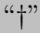) of the state matrix M as follows:
$W_{out}=YM^{†}$ (27)
where $M=\left[x_{t_{0}+1}…x_{T}\right]$ are the hidden states of the reservoir from time step t₀+1 to T, and $Y=\left[y_{t_{0}+1}…y_{T}\right]$ are the corresponding teacher signals in this period. $\left[x_{0} x_{1}…x_{t_{0}}\right]$ and $\left[y_{0} y_{1}…y_{t_{0}}\right]$ are deleted initial reservoir states and outputs separately, and they are not used in the computation of the output weight matrix because these hidden states may be impacted by the initial set states.
Based on Equation 24 to Equation 27, the algorithm of chaotic time series modeling and prediction based on ESNs can be summarized as follows:
Algorithm 2 ESN predictor
Input: $U=\left[u_{1}, u_{2}, …, u_{T}\right], { W}_{in}, W;$
Output: $y_{T+1}$
1: create a dynamical reservoir network according to $W_{in}$ and $W$.
2: drive the dynamical reservoir by the input $U=\left[u_{1}, u_{2}, …\right]$ sequentially according to Equation 25, which results in the responses of all internal neurons indicated by $X=\left[x_{1}, x_{2}, …\right]=\left\{x_{i,t}\right\},$ where $x_{i,t}$ represents the response of the i-th internal neuron at time t.
3: compute output weights $W_{out}$ according to Equation 27, where M is the stable part of $X=\left[M_{0} M\right]$.
4: when a new input $u_{T+1}$ is observed, feed it to the current reservoir network and combine the driven echo response signals by $W_{out}$ to obtain the prediction $y_{t+1}$.
Here, $z^{i}=\left\{z_{t}^{i}\right\}, t=1, 2, …, T$ represents single-channel EEG signals and the studied EEG dataset is $Z=\left\{z^{1}, z^{2}, …, z^{m}\right\}$. The EEG feature extraction is defined as transferring each EEG segments z_{i} into a vector $f^{i}=\left(f_{1}^{i}, f_{2}^{i}, …, f_{d}^{i}\right)$, where d is the number of features. Then $F=\{f_{j}^{i}\}$, where $f_{j}^{i}$ denotes the j-th feature of the i-th EEG signal, can be used for classification or clustering to identify different brain states.
By using Algorithm 2, it is possible to construct an autoencoder for EEG signals as a self-prediction learning task. The hidden states x_{t} are used as dynamic features of the observed time series at time step t in previous RNN autoencoders. Then classification or clustering of the hidden states at different time steps detects abnormal events or divides time series into subsegments in an EEG sequence.

This part just focuses on extracting the features of a given EEG segment; therefore, dividing the EEG signals into subsegments are not necessary. The proposed frameworks are illustrated in Figure 23 and Figure 22. Since W_{in} and W are both kept fixed in ESN during the training process, the W_{out} of the time series reflects the intrinsic differences of the studied time series in terms of inner dynamics. Figure 22 and Algorithm 3 presents the proposed single-channel EEG feature extraction method.
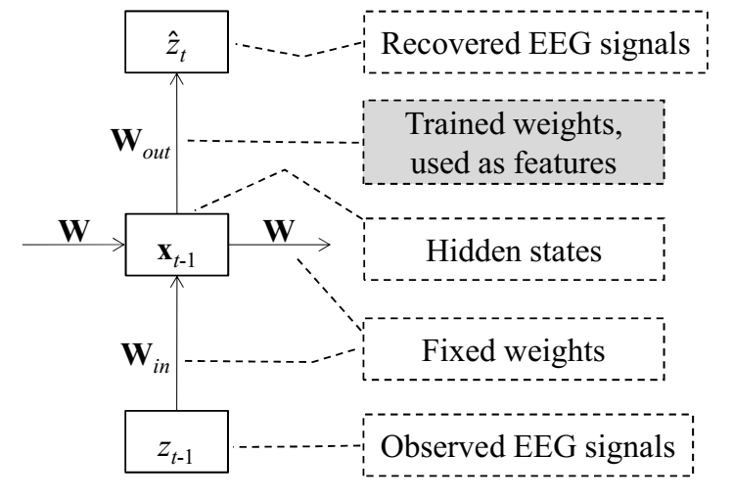
Figure 22 EEG feature extraction based on ESN
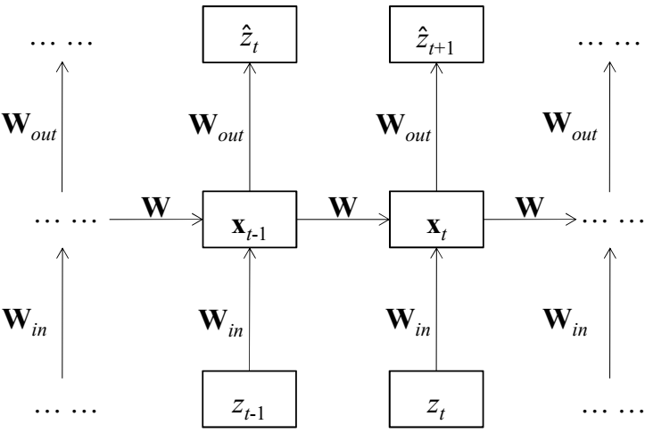
Figure 23 An unfolded echo state network

Algorithm 3 FE-ESN-Single
Input: $Z=\left[z^{1}, z^{2}, …, z^{m}\right], { W}_{in}, W;$
Output: $F=\left[f^{1}, f^{2}, …, f^{m}\right]$
1: create a dynamical reservoir network according to $W_{in}$ and $W$.
2: for the i-th EEG segment $z^{i}$, drive the reservoir network sequentially by $\left(z_{1}^{i}, z_{2}^{i}, …, z_{T-1}^{i}\right)$ and set the outputs as $Y_{1}^{i}=z_{2}^{i}, Y_{2}^{i}=z_{3}^{i}, …, Y_{T-1}^{i}=z_{T}^{i}$ separately, train ESN by the EEG signal and achieve the output weights as EEG features $f^{i}=W_{out}^{i}$.
3: repeat step 2 till the features of all the EEG signals are extracted.
To find the abnormality or functional zones in the brain, EEG signals are usually recorded using multielectrode and they are shown as $\left[z^{1}, z^{2}, …, z^{m}\right]$ where m is the number of channels. The $Z^{i}=\left\{z_{t}^{il}\right\}$ is a single channel and $z_{t}^{il}$ denotes the EEG value of the l-channel electrode or the individual i at a timestamp t. Extending the single-channel feature extraction methods to multichannel is not easy, but the proposed ESN autoencoder can naturally handle it, as is shown in Figure 24. In this figure, the values are set as $u^{l}=z^{l}=\left\{z_{t}^{l}\right\}, t=1, 2,…, T-1$ and $y^{l}={\overline{z}}^{l}=\left\{z_{t}^{l}\right\}$, and with one-step time delay, that is, $t=2, 3, …, T$ where l is the number of electrodes. $w_{out}^{l}$ is trained to combine the activated time series of internal neurons to recover $y^{l}$, and the overall output weights are $W_{out}=\left[w_{out}^{1};w_{out}^{2};…;w_{out}^{L}\right]$.
If the same input weights W_{in} and internal weights W are used to model different EEG signals separately as $\left\{Z^{1}, Z^{2}, …, Z^{m}\right\}$ , the overall output weights $f^{i}=\left[w_{out}^{1} w_{out}^{2}…w_{out}^{L}\right]$ can be employed as EEG features.
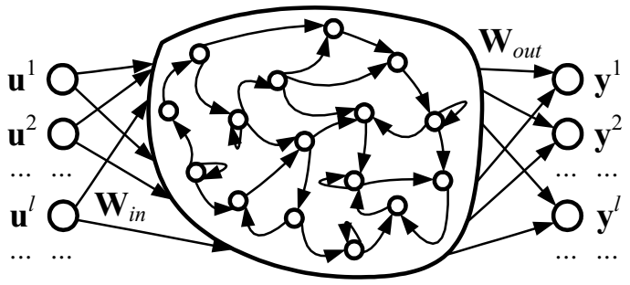
Figure 24 Reservoir network
The effectiveness of autoregressive (AR) coefficients in EEG signal classification has been reported. Though both ESN and AR models can be used in time series prediction, the relationship of the ESN with the AR model has not been discussed ever before. Here, the effectiveness of AR coefficients to present EEG signals in both metrics of classification accuracy and versatility will be investigated. The classical AR model with order p can be written as
$z_{t}=a_{1}z_{t-1}+a_{2}z_{t-2}+…+a_{p}z_{t-p}+ε_{t}$ (28)
where z_{t} represents the observed time series at timestamp $t, a_{i}, i=1, 2, ..., p$, is the i-th autoregression coefficient. If f(.) is set as an identity function in Equation 24 and setting other parameters as follows
$W_{in}=\left[\begin{matrix}1 \\ 0 \\ 0 \\ 0 \\ ⋮ \\ 0\end{matrix}\right], W=\left[\begin{matrix}0 & 0 & 0 & ⋯ & 0 & 0 \\ 1 & 0 & 0 & ⋯ & 0 & 0 \\ 0 & 1 & 0 & ⋯ & 0 & 0 \\ 0 & 0 & 1 & ⋯ & 0 & 0 \\ ⋮ & ⋮ & ⋮ & ⋱ & ⋮ & ⋮ \\ 0 & 0 & 0 & ⋯ & 1 & 0\end{matrix}\right], W_{fb}=\left[\begin{matrix}0 \\ 0 \\ 0 \\ 0 \\ ⋮ \\ 0\end{matrix}\right]$ (29)
which maintains a reservoir state $x_{t}=\left[z_{t} z_{t-1}… z_{t-p+1}\right]$ at time t. In Equation 26 g(.) adopts an identity function and $W_{out}=\left[a_{1} a_{2}…a_{p}\right]$. Then, Equation 28 can be obtained by combining Equation 24 and Equation 26. That is to say, the classical AR model can be seen as a simplified echo state network. Figure 25 presents the diagram of the classical AR model and an ESN.
This comparison shows that feature extraction based on the autoregression model (FEAR) is in fact an autoencoder-based EEG feature extraction method, which may be one of the reasons for FEAR’s superiority over other EEG feature extraction methods. But there is a debate that how effective a linear regression model such as AR can capture the nonlinear dynamics in EEG signals. The advantages of the proposed FE-ESN over other methods such as FEAR are as follows:
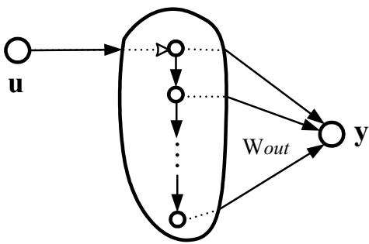
Figure 25 Classical AR model can be seen as a simplified ESN
- The information lost in the feature extraction process is limited. Since FE-ESN is designed based on an autoencoder, the original signal can be approximately reconstructed with the produced feature sets.
- The FE-ESN is unsupervised. It helps to use this method in most EEG analysis applications.
- The FE-ESN is expected to be able to model nonlinear dynamics of EEG.
- Training and decoding of FE-ESN are simple and efficient. The time and space complexity of FE-ESN depends on finding the pseudo-inverse of $N×N$ matrix, where N is the number of neurons.
The Bonn University epileptic seizure dataset (Andrzejak et al., 2001) and Kaggle EEG datasets are used for evaluation. The Bonn University consists of five subsets (denoted A-E), each containing 100 single-channel EEG signals of 23.6 seconds duration (4097 samples). These EEG signals are sampled at 173.61 Hz and Band-pass filtered at 0.53-40 Hz (12 dB/oct).
Defining the reservoir parameters is the first step of making FE-ESN. Three parameters are required to be specified in FE-ESN, namely, reservoir size N, connectivity c, and spectral radius r. Reservoir size N (the number of internal neurons) determines the modeling complexity of ESN. Meanwhile, N is the dimension of feature space. A small N results in underfitting, in which the ESN cannot well capture the underlying dynamics of EEG signals, and a large N may result in overfitting, especially in cases where the number of given samples are not enough to determine the parameters. Here, N is set to 20. The connectivity coefficient of the reservoir is set $c=0.1, 0.2, …, 1.0$ separately to observe the impact of connectivity on the performance of FE-ESN. It is recommended to choose a spectral radius less than unity (Jaeger et al., 2004) and here it is chosen as $r=0.98$.
The reservoirs are created randomly. To consider the effect of randomness in the reservoir, 20 of them are produced with similar parameters (N, c, r) and denoted as Net_{ij} where i shows the index of reservoir connectivity $c_{i}=0.1×i, i=1, 2, …, 10$, and j is the index of network $j=1, 2, …, 20$. Finally, 200 reservoir networks were created and Algorithm 3 (FE-ESN-Single) is employed to extract EEG features. Each network is evaluated separately.
To evaluate the classification ability of extracted features extreme learning machine (ELM) is used as the classifier. The reason for selecting ELM is that its generalization performance and learning speed have been proven to be acceptable with the least human intervention (Huang et al., 2011). Results show that ELM needs training time on an order of magnitude less compared with SVM and two orders of magnitude less compared with backpropagation neural network (BPNN) while the classification accuracy of ELM is comparable to that of SVM and BPNN.
The combination of FE-ESN and ELM is tested on three EEG sets from the Bonn University EEG dataset: set A (normal EEG signals), set D (interictal EEG signals), and set E (ictal EEG signals). As it was mentioned before, 200 reservoir networks have been created to better investigate the sparseness and randomness of reservoirs on the classification accuracy. Since when the reservoir is too sparse (c=0.1), the eigenvalue spread of the correlation matrix will be very large, this condition is removed. Additionally, each of five sets (A-E) contain 100 samples; therefore, linear discriminant analysis (LDA) is employed to reduce the dimensionality of the feature space (it is generally accepted that at least ten times as many as training samples per class as the number of features should be used). The dimensionality of the EEG feature space is set as five after dimensionality reduction by LDA.
In ELM, two parameters are required to be specified: the activation function of neurons and the number of hidden neurons (NHN). The sigmoid function is selected for activation function and NHN is varied from 10 to 100 with the step size 10. The performance of ELM is also affected by randomness; therefore, the classifier trained 20 times and the mean accuracy of classifiers will be assumed as final accuracy.
Finally, $9×20×10×2$0 classification results were produced via 10-fold cross-validation. By taking the mean of the accuracy of 20 classifiers, $9×20×10$ results are achieved. Some of them are shown in Figure 26 and Figure 27.
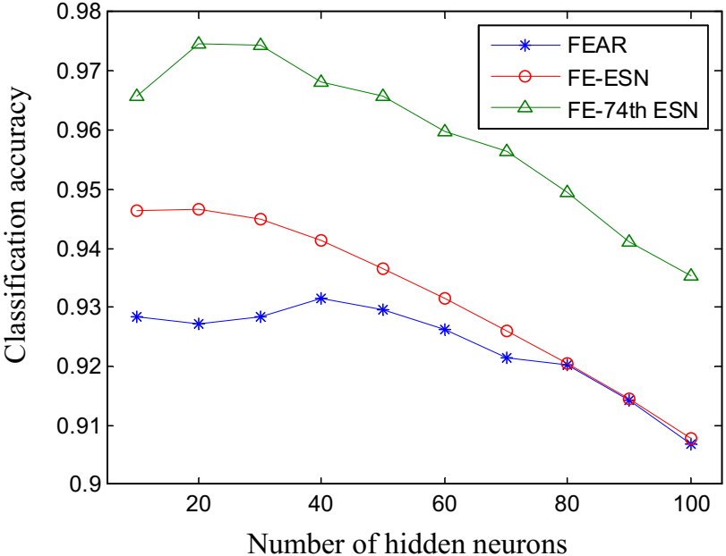
Figure 26 Comparison of EEG signal classification based on FEAR, FE-ESN, and FE-74th ESN
The bottom line in Figure 26 shows how the classification accuracy of FEAR+ELM varies with the NHN in ELM, the top line shows that of FE-74th ESN+ELM (FE-ESN is implemented based on the 74th reservoir network, the classification accuracy of which is the highest among the 180 reservoir networks, and the mean of 180 classification accuracies is used). It can be seen that FE-ESN has a higher classification accuracy than FEAR in most cases and EEG signal classification system based on FE-ESN has great potential to achieve even higher accuracy if the reservoir network is well designed. The decrease of accuracy while NHN increases suggest that ELM with 10 or 20 hidden neurons is suitable for this classification problem.

The accuracy variation of the FE-ESN+ELM system with changing the connectivity c is shown in Figure 27. The length of vertical lines shows the variance of 20 reservoirs’ accuracy which is the effect of the reservoir’s randomness on the FE-ESN performance.
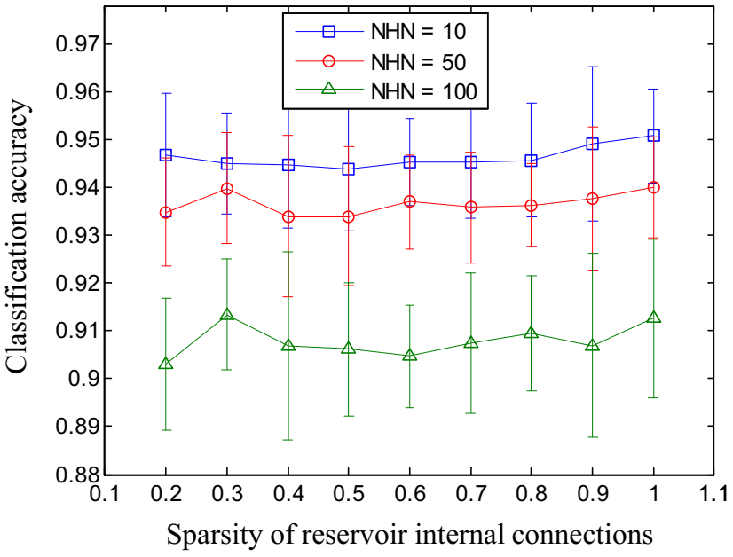
Figure 27 Impact of internal connectivity and randomness on FE-ESN
In Figure 27, it can be seen that as long as the connectivity c is large enough (larger than 0.1), the difference in accuracy caused by the reservoir’s connectivity c is very limited (less than 1.0%). Also, the variance of accuracy due to randomness is approximately 2.0%. The overall accuracy is almost 93% which indicates FE-ESN + ELM EEG signal classification system is robust against the reservoir’s internal connectivity and its randomness.
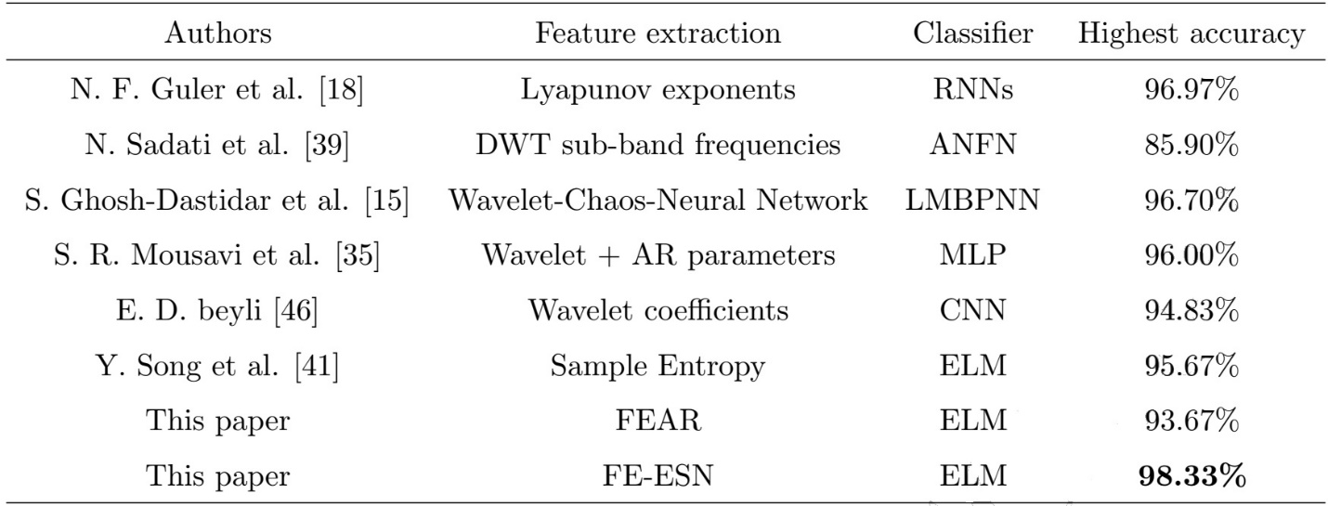
Table 8 Comparison of FE-ESN+ELM with previous methods
The highest achieved accuracy of FE-ESN+ELM is compared with the highest accuracy of other methods; it is shown in Table 8. As it can be seen, FE-ESN + ELM has achieved the best results. The accuracy has been increased from 93.67% to 98.33% by replacing FEAR with FE-ESN.
One of the advantages of autoencoders is their ability to reconstruct the original signal, while engineered features, in most cases, cannot recover the original signal; therefore, computing the lost information after feature extraction would not be possible. Since the FE-ESN has recovery capability, the recovery error of a feature set is compared with its impact on classification accuracy. Figure 28 shows the outcome of this comparison. As it can be seen, the reservoirs with lower recovery errors are more likely to achieve higher classification accuracies.
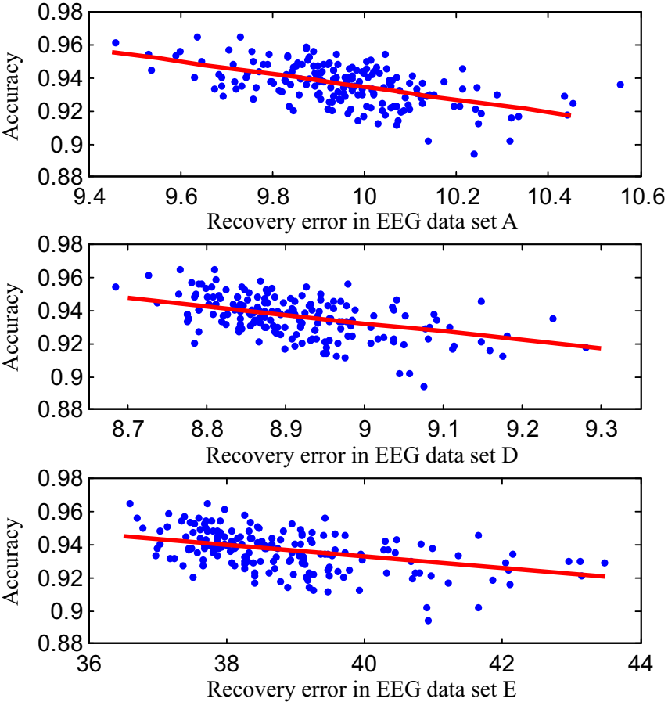
Figure 28 The relationship between modeling capacity of reservoir network and classification accuracy based on FE- ESN
The Bonn University database is single-channel. So, the Kaggle dataset is selected as a multichannel dataset for the seizure prediction task. EEG signals in the Kaggle dataset are labeled for four stages: interictal (between seizures), preictal (before seizure), ictal (seizure), and post-ictal (after seizure). Seizure forecasting needs the preictal EEG signals to be detected to avoid additional injuries for patients. The Kaggle Seizure Prediction Competition (KSPC) has been designed to identify preictal EEG signals from interictal ones (Kaggle, 2015).
KSPC consists of seven EEG datasets which five of them are from dogs and the remaining two are from patients with epilepsy. The sample rate of EEG signals for dogs is 400 Hz and for patients is 5000 Hz. Each of the seven datasets consists of three kinds of EEG signals. The dataset of the first patient, for example, contains 50 interictal EEG clips, 18 preictal EEG clips, and 195 unlabeled ones. Only labeled EEG clips were used for evaluation. Before feature extraction, EEG clips were processed as follows:
- Step 1: Cut each 10-min EEG clips into 1-min EEG clips.
- Step 2: Resample the EEG signals to 30 Hz
- Step 3: Normalize the EEG signals at the channel level.
While Step1 increases the number of samples, Step 2 reduces the length of EEG signals input to reservoirs. After performing these steps, the EEG dataset of the first patient had 500 interictal EEG clips and 180 preictal EEG clips, each clip containing $15×1800$ data points, where 15 is the number of channels. The other six datasets were also preprocessed in the same manner.
The FEAR, DWT, FFT, and LyExp have been used as EEG feature extraction baselines. They were extended to handle multichannel signals by extracting EEG features $f_{i}^{l}$ from each channel, where l is the channel pointer and i is the indicator of the data object. Then single-channel features combined to create i-th EEG clip as $\left[f_{i}^{1} f_{i}^{2}… f_{i}^{L}\right]$ , where L is the number of channels.
The parameters in FE-ESN reservoirs are set as follows:
- The connectivity of reservoirs c is set 0.3, which gave the higher average accuracy in the former experiment.
- NHN in reservoir N is set 20, again like the former experiment.
- The spectral radius r is set to 0.98.
The dimensionality for both FEAR and FE-ESN is L in N which is relatively large with respect to the number of objects. For instance, the first patient’s EEG dataset contains 500+180 samples, while each sample is represented by a 300-dimensional vector. Therefore, LDA is implemented to reduce the dimensionality of the feature space from 300 to 5. The wavelet coefficients in DWT were computed by Daubechies wavelet of order two and by using the mean and standard deviation of the wavelet coefficients in each sub-band, the feature vectors dimensionality was reduced. The mean, std, kurtosis, and skew value of EEG signals were used for the statistics method.
SVM is used as the classifier. Since EEG datasets are unbalanced, e. g. interictal clips are much more than preictal clips, the area under the curve (AUC) of the receiver operating characteristic (ROC) and precision-recall (PR) curve were employed as evaluation metrics. Besides AUC, accuracy is also computed to compare FE-ESN and FEAR. The ratio of interictal and preictal is the same in the train and test datasets. 5-fold cross-validation on all the seven EEG dataset is implemented. The average results are reported in Table 9 and Table 10.
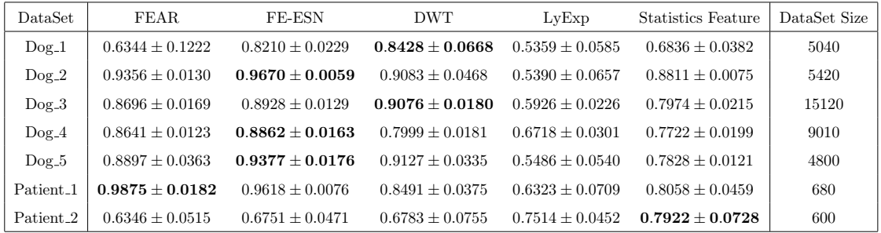
Table 9 Kaggle Experiment Result ROC-AUC
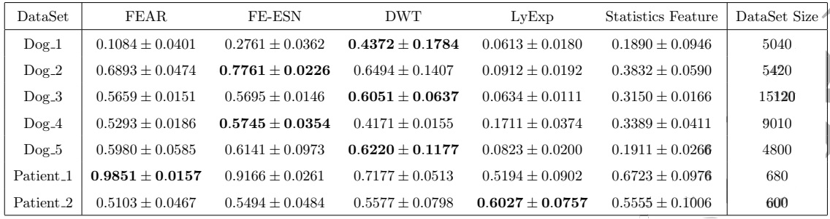
Table 10 Kaggle Experiment Result PR-AUC
It can be seen from Table 9 that FE-ESN is able to achieve 3-5% higher ROC-AUC over FEAR on most of the datasets. The performance gap of FEAR and FE-ESN on Patient_1 is limited, while there is almost a significant gap of 18.66% on Dog_1. The large ROC-AUC gap in Dog_1 and the small gap in Dog_4 are the consequence of similarity between preictal and interictal EEG clips in these two cases, as shown in Figure 29. It can be seen the strong consistency of Dog_4 in Figure 29 (b) and Figure 29 (d) in comparison of considerable difference in Figure 29 (a) and Figure 29 (c). One reason can be that FEAR extract features from each channel independently, while FE-ESN was trained by combining different channels and it is able to capture the dynamics discriminative features of different channels. This illustrates the effectiveness of FE-ESN in the feature extraction of multichannel EEG signals. Statistical test results in Table 11 show that FE-ESN outperforms other algorithms significantly on the Dog dataset. This test cannot be performed on patients in KSPC, because it just contains two patients.
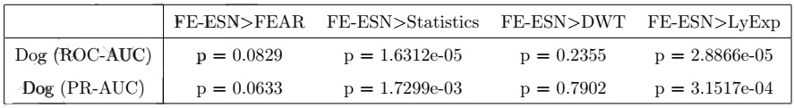
Table 11 Statistical test on Kaggle dataset
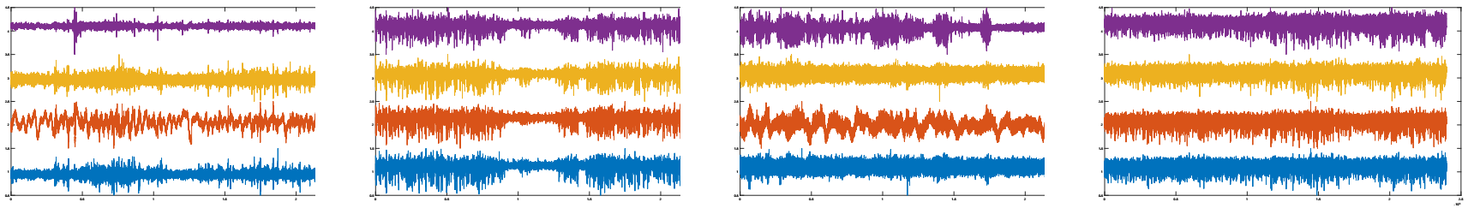
(a) Dog 1 Interictal Clips | (b) Dog 4 Interictal Clips | (c) Dog 1 Preictal Clips | (d) Dog 4 Preictal Clips
Figure 29 Comparison of EEG Clips From Different Datasets
To investigate the performance of FE-ESN, a clustering experiment was conducted on the Freiburg seizure EEG dataset (The Freiburg EEG Database, 2020). The aim is to divide the EEG signals into segments for detection and recognition. The dataset consists of 21 patients’ EEG signals with an actual seizure recorder in each EEG clip. Here, only one patient’s EEG signal was used. Figure 30 shows six-channel EEG signals from time stamp 700,001 to 899,680. This signal contained an ictal from 819,373 to 857,094, which was annotated by a neurologist.
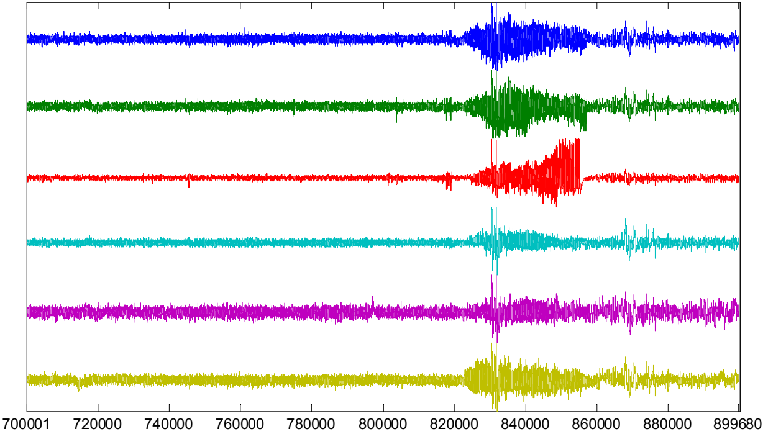
Figure 30 The studied Freiborg EEG signals
The studied EEG signals are divided into small clips by a sliding window of 2 seconds. 390 clips, each clip contained 3072 ($6×2×256)$ samples distributed into 6 channels obtained. The sample rate is 256 Hz. Each clip is viewed as a separate data object and clustering is implemented to split 390 clips into two clusters, representing ictal and normal EEG signals. This shows if the extracted features are effective enough to do the clustering successfully.
Two processes need for this experiment: feature extraction and clustering. Both FEAR and FE-ESN will be used for the first task which is feature extraction. The number of features was varied from 5 to 20 to evaluate better. The connectivity coefficient c and spectral radius r of FE-ESN are set to 1 and 0.98, respectively. Since the randomness of the reservoir has effects on the performance, 20 reservoirs were produced for each group of parameters. For the second task, classical clustering algorithms such as K-MEANS(KM) and K-centers (KC), and state-of-art algorithms like affinity propagation (AP) (Frey et al., 2007) and density peaks clustering (DPC) (Rodriguez et al., 2014) were employed. The similarity between the EEG clips was computed by the negative Euclidean distance of the extracted feature vectors.
Both single-channel and multichannel experiments were conducted. For single-channel case, both FEAR and FE-ESN works similarly. But for the multichannel case, while the FE-ESN can process it directly, FEAR needs to process each channel independently and then combine the features extracted from channels. The other baselines, DWT, LyExp, and Statistics were used to extract both single-channel and multichannel EEG features.
The normalized mutual information (NMI) and Accuracy are computed to compare the clustering results. While NMI is an entropy-based evaluation criterion that reflects the consistency of clustering results with real category labels, the accuracy is a more intuitive clustering performance criterion.
Table 12 contains single-channel results. The FE-ESN has better clustering performance in terms of both Accuracy and NMI on all six channels. The better results of both FEAR and FE-ESN on Channel_1, Channel_2, and Channel_6 compared to Channel_3, Channel_4, and Channel 5 indicate that the first channel set has a more clear ictal lesion.
Table 13 shows that FE-ESN is significantly better than other algorithms using KM, AP, and DPC clustering methods. The average performance of FE-ESN on all six channels is higher than other methods using KC, however, it is not significant.

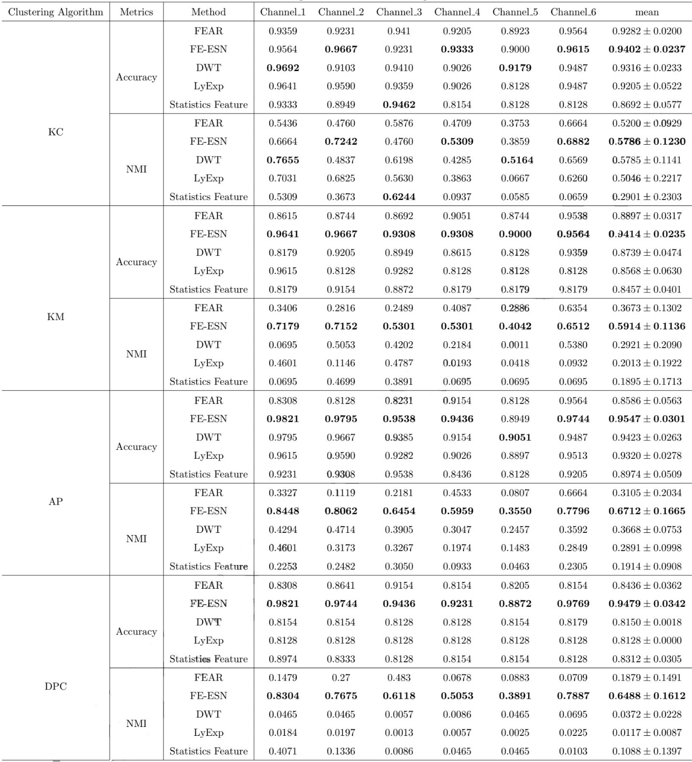
Table 12 Single-channel Learning Result
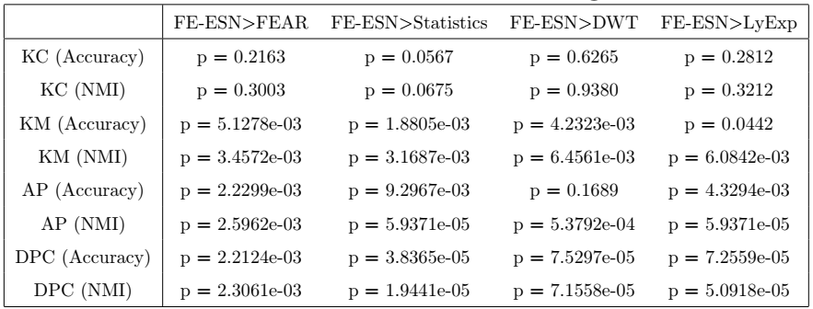
Table 13 Statistical test on Freiborg dataset
Visual comparison of the performance of the five feature extraction methods (FEAR, FE-ESN, DWT, LyExp, and Statistics) is presented in Figure 31, where Figure 31(a) is the ground truth partition. As it can be seen, no method can detect the seizure event through all its duration and every method has some gaps. Overall, FE-ESN detects most ictal EEG clips correctly, whereas the other methods missed more ictal EEG signals.
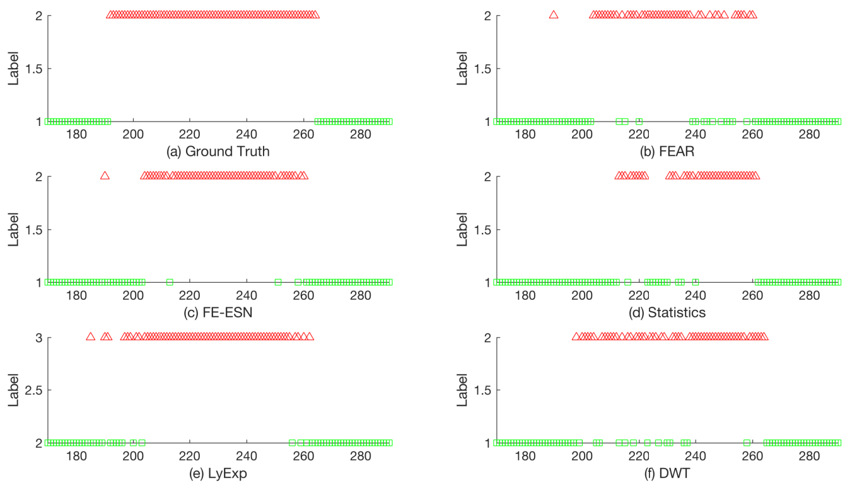
Figure 31 Comparison of the best clustering results in single-channel experiments
For multichannel results, since the AP clustering method has the best results for every feature extraction method, it has been used as the standard clustering algorithm, which is an exemplar-based clustering algorithm. The clustering result is shown in Figure 32. As it can be seen, the FE-ESN is very close to the ground-truth partition and it only misses a few ictal EEG clips. Other methods cannot detect the beginning and end of the seizure. FEAR missed many ictal EEG signals during the seizure, and the Statistics method had many wrong divisions at the end of the EEG signals.
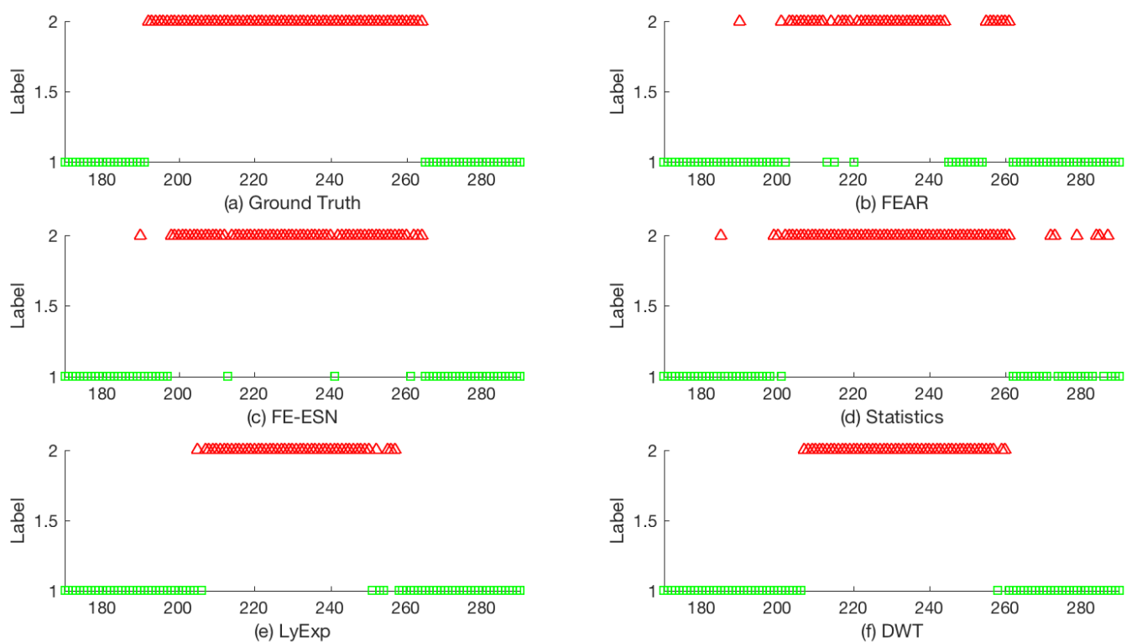
Figure 32 Comparison of the best clustering results in multichannel experiments
A quantitative comparison of NMI and Accuracy for the multichannel experiment is shown in Figure 33. The FE-ESN+AP achieved the highest clustering NMI and accuracy of 96.42% and 0.7031, respectively.
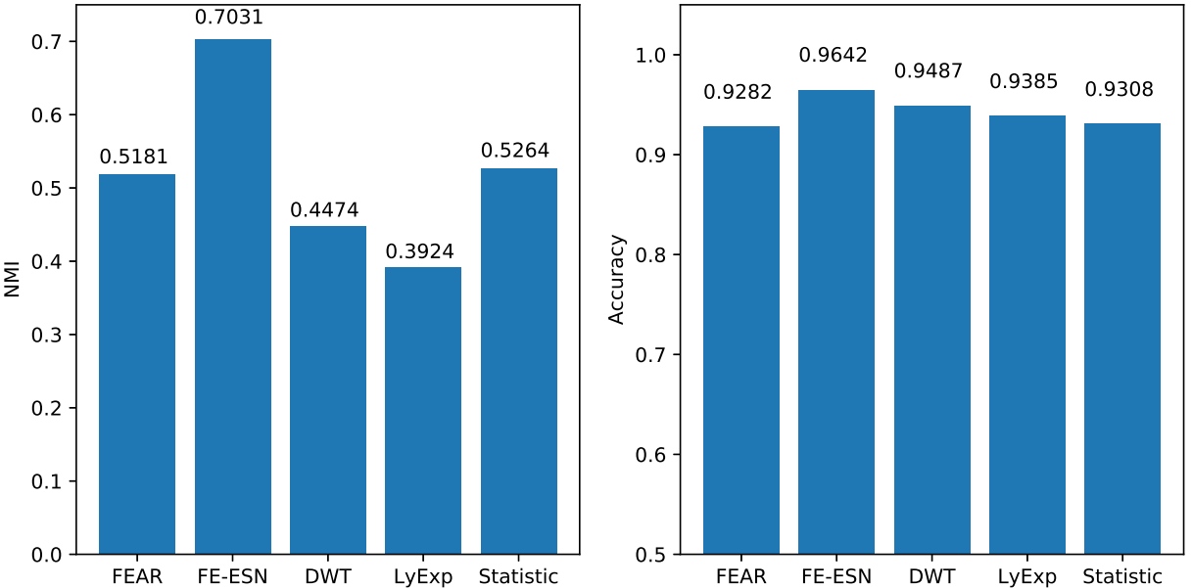
Figure 33 Evaluation of multichannel experiment results in terms of Accuracy
Finally, it can be said that feature extraction with Echo-State neural networks (FE-ESN) has many superiorities against engineered features in finding the best feasible feature vector to represent the signal in a much smaller dimension of original signal space with computable information lost based on reconstruction ability. This new representation method can be used in both classification and clustering applications. The capabilities of FE-ESN on EEG signal classification and clustering were compared with other state-of-art methods and its superiority in both single-channel and multichannel cases was observed.

Conclusion
In recent years, with the advancements in deep learning, time series processing and analysis have been extensively changed. In this literature review, we have reviewed the main topics in time series classification and clustering based on deep learning methods.
In the beginning, we reviewed several deep learning architectures, such as multilayer perceptron (MLP), fully convolutional neural network (FCN), residual neural network, multiscale convolutional neural network, and their advantages and drawbacks in time series analysis. Then these architectures were used for classification tasks. The final results in the classification section show that ResNet which came from the image processing field can achieve as good results as state-of-the-art ensemble methods with much less computational complexity.
Next, unsupervised clustering with deep learning methods was discussed. We saw that a combination of CNN and some clustering algorithms such as K-MEANS can result in a powerful unsupervised classifier. Also, data augmentation increases the clustering efficiency. Data augmentation is necessary for many time series applications because of a little amount of training data.
Finally, with the focus on the EEG signal processing, a new signal representation method was introduced to extract efficient features from a single-channel or multi-channel signal. The proposed method uses Echo State Networks, a type of RNN, to extract information from input signals with reconstruction capabilities. The efficiency of extracted features compared with the top engineered feature extraction methods based on the classification accuracy metric and the overall superiority of deep learning echo state autoencoder was observed.
By the methods and algorithms discussed here, their combination, and fine tunning, it will be possible to achieve better results in seizure detection EEG processing systems.

References
Abadi, M., Agarwal, A., Barham, P., Brevdo, E., Chen, Z., Citro, C., Corrado, G. S., Davis, A., Dean, J., Devin, M., Ghemawat, S., Goodfellow, I., Harp, A., Irving, G., Isard, M., Jia, Y., Jozefowicz, R., Kaiser, L., Kudlur, M., … Zheng, X. (2016). TensorFlow: Large-Scale Machine Learning on Heterogeneous Distributed Systems. https://arxiv.org/abs/1603.04467.
Andrzejak, R. G., Lehnertz, K., Mormann, F., Rieke, C., David, P., & Elger, C. E. (2001). Indications of nonlinear deterministic and finite-dimensional structures in time series of brain electrical activity: Dependence on recording region and brain state. Physical Review E - Statistical Physics, Plasmas, Fluids, and Related Interdisciplinary Topics, 64(6), 8. https://doi.org/10.1103/PhysRevE.64.061907.
Bagnall, A., Dau, H. A., Lines, J., Flynn, M., Large, J., Bostrom, A., Southam, P., & Keogh, E. (2018). The UEA multivariate time series classification archive, 2018. 1–36. http://arxiv.org/abs/1811.00075.
Bagnall, A., Lines, J., Bostrom, A., Large, J., & Keogh, E. (2017). The great time series classification bake off: a review and experimental evaluation of recent algorithmic advances. Data Mining and Knowledge Discovery, 31(3), 606–660. https://doi.org/10.1007/s10618-016-0483-9.
Baydogan, M. G. (2015). Multivariate time series classification datasets. http://www.mustafabaydogan.com/
Chang, S., Zhang, Y., Han, W., Yu, M., Guo, X., Tan, W., Cui, X., Witbrock, M., Hasegawa-Johnson, M., & Huang, T. S. (2017). Dilated recurrent neural networks. Advances in Neural Information Processing Systems, 2017-Decem(Nips), 77–87. https://arxiv.org/abs/1710.02224.
Cho, K., Van Merriënboer, B., Gulcehre, C., Bahdanau, D., Bougares, F., Schwenk, H., & Bengio, Y. (2014). Learning phrase representations using RNN encoder-decoder for statistical machine translation. EMNLP 2014 - 2014 Conference on Empirical Methods in Natural Language Processing, Proceedings of the Conference, 1724–1734. https://doi.org/10.3115/v1/d14-1179.
Chollet, F., & Others. (2015). Keras. https://keras.io.
Dau, H. A., Bagnall, A., Kamgar, K., Yeh, C. C. M., Zhu, Y., Gharghabi, S., Ratanamahatana, C. A., & Keogh, E. (2019). The UCR time series archive. IEEE/CAA Journal of Automatica Sinica, 6(6), 1293–1305. https://doi.org/10.1109/JAS.2019.1911747.
Fan, K., A Minimax Inequality and Applications, O. Shisha, Ed., Inequalities III, Academic Press, San Diego, 1972, pp. 103-113.
Frey, B. J., & Dueck, D. (2007). Clustering by passing messages between data points. Science, 315(5814), 972–976. https://doi.org/10.1126/science.1136800.
Guennec, A. Le, Malinowski, S., & Tavenard, R. (2016). Data Augmentation for Time Series Classification using Convolutional Neural Networks. ECML/PKDD Workshop on Advanced Analytics and Learning on Temporal Data. https://halshs.archives-ouvertes.fr/halshs-01357973/document.
Guo, X., Gao, L., Liu, X., & Yin, J. (2017). Improved deep embedded clustering with local structure preservation. IJCAI International Joint Conference on Artificial Intelligence, 0, 1753–1759. https://doi.org/10.24963/ijcai.2017/243.
Golmohammadi, M., Shah, V., Obeid, I., & Picone, J. (2020). Deep Learning Approaches for Automated Seizure Detection from Scalp Electroencephalograms. In Signal Processing in Medicine and Biology (pp. 235–276). Springer International Publishing. https://doi.org/10.1007/978-3-030-36844-9_8
Han, M., & Sun, L. (2010). EEG signal classification for epilepsy diagnosis based on AR model and RVM. 2010 International Conference on Intelligent Control and Information Processing, 134–139. https://doi.org/10.1109/ICICIP.2010.5565239.
He, K., Zhang, X., Ren, S., & Sun, J. (2016). Deep residual learning for image recognition. Proceedings of the IEEE Computer Society Conference on Computer Vision and Pattern Recognition, 2016-Decem, 770–778. https://doi.org/10.1109/CVPR.2016.90.
Hills, J., Lines, J., Baranauskas, E., Mapp, J., & Bagnall, A. (2014). Classification of Time Series by Shapelet Transformation. Data Min. Knowl. Discov., 28(4), 851–881. https://doi.org/10.1007/s10618-013-0322-1.
Hochreiter, S., & Schmidhuber, J. (1997). Long Short-Term Memory. Neural Computation, 9(8), 1735–1780. https://doi.org/10.1162/neco.1997.9.8.1735.
Huang, G. Bin, Wang, D. H., & Lan, Y. (2011). Extreme learning machines: A survey. International Journal of Machine Learning and Cybernetics, 2(2), 107–122. https://doi.org/10.1007/s13042-011-0019-y.
Ismail Fawaz, H., Forestier, G., Weber, J., Idoumghar, L., & Muller, P. A. (2019). Deep learning for time series classification: a review. Data Mining and Knowledge Discovery, 33(4), 917–963. https://doi.org/10.1007/s10618-019-00619-1.
Jaeger, H., & Haas, H. (2004). Harnessing Nonlinearity: Predicting Chaotic Systems and Saving Energy in Wireless Communication. Science, 304(5667), 78–80. https://doi.org/10.1126/science.1091277.
Kaggle. (n.d.). American epilepsy society seizure prediction challenge. https://www.kaggle.com/c/seizure-prediction/data.
Krizhevsky, A., Sutskever, I., & Hinton, G. E. (2017). ImageNet classification with deep convolutional neural networks. Communications of the ACM, 60(6), 84–90. https://doi.org/10.1145/3065386.
Laurens van der Maaten, G. H. (2008). Visualizing Data using t-SNE. Journal of Machine Learning Research, 9(86), 2579–2605. http://jmlr.org/papers/v9/vandermaaten08a.html
LeCun, Y., Bengio, Y., & Hinton, G. (2015). Deep learning. Nature, 521(7553), 436–444. https://doi.org/10.1038/nature14539.
Lines, J., & Bagnall, A. (2015). Time series classification with ensembles of elastic distance measures. Data Mining and Knowledge Discovery, 29(3), 565–592. https://doi.org/10.1007/s10618-014-0361-2.
Lines, J., Taylor, S., & Bagnall, A. (2017). HIVE-COTE: The hierarchical vote collective of transformation-based ensembles for time series classification. Proceedings - IEEE International Conference on Data Mining, ICDM, 1041–1046. https://doi.org/10.1109/ICDM.2016.74.
Lucas, B., Shifaz, A., Pelletier, C., O’Neill, L., Zaidi, N., Goethals, B., Petitjean, F., & Webb, G. I. (2019). Proximity Forest: an effective and scalable distance-based classifier for time series. Data Mining and Knowledge Discovery, 33(3), 607–635. https://doi.org/10.1007/s10618-019-00617-3
Ma, Q., Zheng, J., Li, S., & Cottrell, G. W. (2019). Learning Representations for Time Series Clustering. NeurIPS 2019, NeurIPS. https://papers.nips.cc/paper/8634-learning-representations-for-time-series-clustering.
Ma, Q., Shen, L., Chen, W., Wang, J., Wei, J., & Yu, Z. (2016). Functional echo state network for time series classification. Information Sciences, 373, 1–20. https://doi.org/10.1016/j.ins.2016.08.081
Maass, W., & Markram, H. (2004). On the computational power of circuits of spiking neurons. Journal of Computer and System Sciences, 69(4), 593–616. https://doi.org/10.1016/j.jcss.2004.04.001.
Nielsen, A. (2019). Practical Time Series Analysis. O’Reilly Media, Inc. https://www.oreilly.com/library/view/practical-time-series/9781492041641/
Nitish Srivastava , Geoffrey Hinton , Alex Krizhevsky , Ilya Sutskever , Ruslan Salakhutdinov, Y. B. (2014). Dropout: A Simple Way to Prevent Neural Networks from Overfitting. Journal of Machine Learning Research, 15. https://doi.org/10.5555/2627435.2670313.
Rodriguez, A., & Laio, A. (2014). Clustering by fast search and find of density peaks Alex Rodriguez and Alessandro Laio. 1492. https://doi.org/10.1126/science.1242072.
Schäfer, P. (2015). The BOSS is concerned with time series classification in the presence of noise. Data Mining and Knowledge Discovery, 29(6), 1505–1530. https://doi.org/10.1007/s10618-014-0377-7.
Serrà, J., Pascual, S., & Karatzoglou, A. (2018). Towards a Universal Neural Network Encoder for Time Series. Frontiers in Artificial Intelligence and Applications, 308, 120–129. https://doi.org/10.3233/978-1-61499-918-8-120.
Schmidhuber, J. (2015). Deep learning in neural networks: An overview. Neural Networks, 61, 85–117. https://doi.org/10.1016/j.neunet.2014.09.003
Sun, L., Jin, B., Yang, H., Tong, J., Liu, C., & Xiong, H. (2019). Unsupervised EEG feature extraction based on echo state network. Information Sciences, 475, 1–17. https://doi.org/10.1016/j.ins.2018.09.057.
Tanisaro, P., & Heidemann, G. (2017). Time series classification using time warping invariant Echo State Networks. Proceedings - 2016 15th IEEE International Conference on Machine Learning and Applications, ICMLA 2016, 831–836. https://doi.org/10.1109/ICMLA.2016.166.
The freiburg EEG database. (2020), http://epilepsy.uni-freiburg.de/%0Afreiburg-seizure-prediction-project/eeg-database.
Wang, L., Xue, W., Li, Y., Luo, M., Huang, J., Cui, W., & Huang, C. (2017). Automatic epileptic seizure detection in EEG signals using multi-domain feature extraction and nonlinear analysis. Entropy, 19(6), 1–17. https://doi.org/10.3390/e19060222.
Wang, Z., Yan, W., & Oates, T. (2017). Time series classification from scratch with deep neural networks: A strong baseline. Proceedings of the International Joint Conference on Neural Networks, 2017-May, 1578–1585. https://doi.org/10.1109/IJCNN.2017.7966039.
Xie, J., Girshick, R., & Farhadi, A. (2016). Unsupervised deep embedding for clustering analysis. 33rd International Conference on Machine Learning, ICML 2016, 1, 740–749. https://arxiv.org/abs/1511.06335.
Zhang, Q., Wu, J., Zhang, P., Long, G., & Zhang, C. (2019). Salient Subsequence Learning for Time Series Clustering. IEEE Transactions on Pattern Analysis and Machine Intelligence, 41(9), 2193–2207. https://doi.org/10.1109/TPAMI.2018.2847699.
Zhao, B., Lu, H., Chen, S., Liu, J., & Wu, D. (2017). Convolutional neural networks for time series classification. Journal of Systems Engineering and Electronics, 28(1), 162–169. https://doi.org/10.21629/JSEE.2017.01.18.

