Estimating Parameters of a Multi-Class Izhikevich Neuron Model to Investigate the Mechanisms of Deep Brain Stimulation
A Thesis Proposal
Submitted to
Temple University Graduate Board

In Partial Fulfillment
Of the Requirements for the Degree
MASTER OF SCIENCE
In ELECTRICAL ENGINEERING

Christopher Tufts
November 27 2012

Thesis Approval(s):
Iyad Obeid, PhD., Thesis Adviser, Electrical and Computer Engineering
Joseph Picone, PhD., Electrical and Computer Engineering
Li Bai, PhD., Electrical and Computer Engineering
Abstract
The aim of the proposed research is to provide a computationally efficient neural network model for the study of deep brain stimulation efficacy in the treatment of Parkinson’s disease. An Izhikevich neuron model will be used to accomplish this task and four classes of neurons will be modeled. The parameters of each class will be estimated using a genetic algorithm based on a phase plane trajectory density fitness function. After computing the optimal parameters the neurons will be interconnected to form the network model. The network will be simulated under normal conditions, Parkinsonian conditions, and Parkinsonian conditions under DBS treatment.

Table of Contents
1. Introduction 4
1.1. Motivation 4
1.2. Research Objectives 5
1.3. Organization of Thesis Proposal 5
2. Background 6
2.1. Deep Brain Stimulation 6
2.2. Neural Models 8
2.2.1. Hodgkin Huxley Model 8
2.2.2. Izhikevich Model 10
3. Methods 14
3.1. Phase Plane Analysis 14
3.2. Parameter Estimation 16
3.2.1. Error Function 16
3.2.2. Parameter Search Algorithm 18
4. Simulation 20
4.1. Preliminary Work 20
4.1.1. Multi-Class Neuron Model 20
4.1.2. Izhikevich Model 22
4.1.3. Parameter Estimation 22
4.2. Proposed Work 25
5. Research Plan 27
6. References 28
7. APPENDIX 31
7.1. GPi (GPe) Neuron 31
7.2. STN 33
7.3. TC 33

Introduction

Motivation
The goal of the proposed research is to provide a computationally efficient model to allow for the study of deep brain stimulation (DBS) for the treatment of Parkinson’s disease (PD). PD affects tens of millions of people worldwide and the frequency and economic burden of the condition are set to increase as the elderly population grows. PD is a neurodegenerative disorder characterized by tremors of the limbs and impaired muscular movements. [1]
DBS is a therapeutic strategy used to reduce symptoms associated with PD such as tremors and decreased locomotion. [2] However, the mechanisms behind DBS remain unclear and a topic of debate. [3] One method of investigation is to use computational models comprising several areas of the brain close to the stimulation site.
Modeling the stimulation site requires simulating multiple classes of neurons. DBS not only affects the neurons at the stimulation site, but also all the neurons in the surrounding network connected to the stimulation site. To study the dynamics of the network, a biologically plausible model must be used to simulate each neuron. However one tradeoff of in implementing biological plausible neural models such as the Hodgkin Huxley model is high computational complexity for high accuracy. The complexity severely limits the size of the networks and the length of the simulations, which in turn limits their predictive or explanatory power. There are other models, such as the Integrate and Fire model, which offer a low level of computational complexity, but lack biophysically realistic results.
The Izhikevich neuronal model is capable of offering biologically plausible results with low computational complexity. Creating a large-scale multi-class network using Izhikevich neurons would allow the long and short-term effects of DBS to be studied. This could provide great insight to some of the underlying mechanisms of DBS.

Research Objectives
The primary objective of the proposed research is to develop a computationally efficient and scalable neural network to study the effects of DBS using the Izhikevich class of modeled neurons. The neural network will consist of four different types of neurons: sub-thalamic nucleus (STN) neurons, thalamic cortical relay (TC) neurons, globus pallidus interna (GPi) neurons, and globus pallidus externa (GPe) neurons. Each neuron will be modeled using the Izhikevich neuron model. A principal objective of this work will be to find the parameters of each neuron using a phase plane trajectory density (PPTD) error function and a genetic algorithm to search the solution space. The test data for the parameter estimation is derived from biologically plausible Hodgkin Huxley (HH) neuron models of each individual class of neuron. After the parameters have been estimated for each neuron, the network of Izhikevich neurons will be connected in a network. The final outcome of the project will be a network of Izhikevich neurons capable of mimicking a network of HH neurons. The model will be designed to replicate the HH neural network published by Rubin and Terman in 2004. [4] Finally, the computational savings of the Izhikevich model over the HH model will be calculated for comparison.

Organization of Thesis Proposal
The thesis proposal is organized in the following manner. A comprehensive background is provided covering all aspects of the research. The background begins with an overview of the motivation for the research: DBS. The next background component will cover two types of neuron models: the HH model and the Izhikevich model. The next component is the methods section that will provide information on the PPTD error function and the genetic algorithm used for parameter estimations. Following the methods section, the preliminary and proposed work will be presented. The thesis proposal will conclude with the research plan.

Background
The overall goal of this research is to provide a simulation tool to study the mechanisms behind DBS efficacy. The mechanisms behind DBS remain unclear and the benefits of the treatment have primarily been established more or less empirically. [5] In previous studies, local field potentials (LFP) have been recorded during deep brain stimulation as a measure of synchronized neuronal activity. However no direct causal link between LFPs recorded during DBS and corresponding motor symptoms has been demonstrated. [6][7]
Ideally the optimal method for studying DBS would be to make electrical recordings from neurons throughout the brain in response to DBS stimuli. Since this is practically impossible, simulation is the next best tool to study DBS. [8] Numerical simulation is currently the only valid option to offer insight into the activity in the neuronal areas affected during treatment. The use of simulation may help uncover the network dynamics occurring as a result of DBS. If the network interactions during treatment are known, optimal DBS parameters could be calculated empirically instead of being determined ad hoc. A valid measure of DBS efficacy could allow for closed loop tuning of DBS allowing patients with PD a higher level of care.

Deep Brain Stimulation
DBS is therapeutic treatment for a variety of neurological issues including Parkinson’s disease and Dystonia. PD and Dystonia are motor control disorders characterized by uncontrolled muscle tremors or spasms. They are known to be caused by disease in one of the several structures of the deep brain responsible for feed-forward motor control. For example, PD is caused by death of dopaminergic neurons in the substantia nigra, which is part of the deep brain feedback loop that modulates motor control. [1][9] DBS electrodes may be placed bilaterally or a single electrode may be implanted unilaterally depending on the treatment selected. [10] Each implanted stimulation electrode has a single stimulation site. A pulse generator implanted subcutaneously in the subclavicular area drives the electrode. [11] Figure 1 shows a typical DBS implantation. [12] The stimulating electrode can be implanted in the STN, the GPi, or the ventral intermediate (VIM) nucleus. The frequency of stimulation ranges from 130 Hz to 185 Hz and is manually adjusted during the implantation procedure. [13]
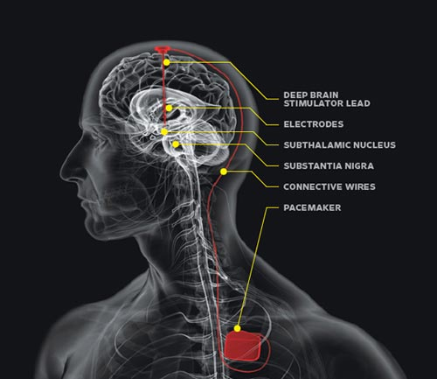
The mechanisms behind DBS’s efficacy are largely unknown. For example, it is not known whether DBS acts to enhance or suppress neuronal activity within a given brain structure, which areas and which neurons within these areas are acted upon by DBS, or how the geometry and orientation of the neurons modulate the effect of the electric field generated by DBS. [4] Increased neuronal activity in the GPi and STN is thought to account for the motor dysfunction in PD.[11] One possible mechanism underlying DBS is that it suppresses neuronal activity. This belief is held because DBS has a similar outcome to ablative surgeries. [14] Another possible mechanism for the efficacy of DBS is the increase in activity in the GPi causing downstream effects in other neurons. [4]
Figure 1 - DBS Implant Hardware

Neural Models

Hodgkin Huxley Model
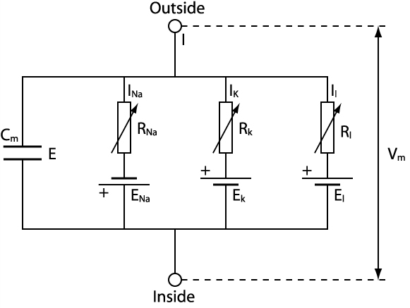
The Hodgkin Huxley model simulates the membrane voltage of an electrically active neuron using a network of capacitors and resistors. Current can move across the membrane by charging the membrane (C_{m}) or by movement of ions through resistances in parallel with the capacitance. The ionic channels present in this model are the Potassium (I_{k}) channel, the Sodium (I_{Na}) channel, and the leakage channel (I_{L}). The leakage channel represents the channel that chloride and other ions may travel across. [15]. The membrane channel impedances are voltage dependent and are modeled using first-order dynamics. Each Hodgkin-Huxley neuron requires four simultaneous differential equations to solve. Although accurate, HH models are not computationally efficient, especially when models scale to hundreds or thousands of interconnected neurons. Although HH was originally created to model membrane dynamics of squid axons, the general model style has since been used to model dozens of cell types. The term “HH model” refers to a membrane model with parallel capacitive and resistive elements. Each resistive element models one type of voltage gated ion channel, and includes a series constant “activation” voltage that models the Nernst potential. Each ion channel is controlled by voltage-dependent “gating variables” which are modeled with first-order dynamics. Gating variable parameters must be carefully matched to biological measurements in order for the model to produce biophysically relevant simulations. Depending on the sophistication of the cell type being modeled, the number of parallel differential equations per neuron could be as many as six.
Figure 2 - Hodgkin-Huxley Circuit Representation
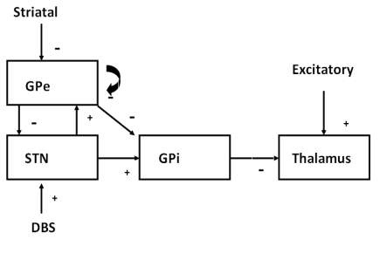
The goal of the proposed research is to build Izhikevich neuron models that accurately mimic the corresponding HH models. The Izhikevich model has eight parameters, which must be optimized to match the HH models. A genetic algorithm with a PPTD fitness function will be used to determine the optimum parameters. The neural network architecture for the proposed work can be seen in Figure 3. The HH mathematical descriptions of each of the four classes of neurons are outlined in the Appendix. The network has been modeled previously using HH neurons in research by Rubin and Terman. [4], [16] The Izhikevich network model will allow future work in which network models can be simulated that are an order of magnitude larger.
Figure 3 - Network Architecture
The network architecture outlined in Figure 3 shows the basic structures affected by DBS when applied at the STN. The “+” signs represent excitatory input currents and the “-“ signs represent inhibitory input currents. Each TC neuron receives excitatory input from the sensory motor cortex and inhibitory input from eight GPi neurons. Each GPi neuron receives inhibitory input from two GPe neurons and excitatory input from one STN neuron. Each STN neuron receives inhibitory input from two GPe neurons. The STN neurons also receive a DBS input current. The GPe neurons receive excitatory input from three STN neurons and inhibitory input from two other GPe neurons.
Although increased activity in the GPi is associated with PD, the model sets out to show that high frequency DBS will further increase GPi activity resulting in restoration of thalamic relay capabilities. The signals from the STN and GPe interact with the GPi currents to generate patterns of GPi activity consistent with experimental data. The TC cell acts a relay for signals from the sensory motor cortex. In the case of Parkinson’s disease, these signals are not relayed correctly or at all. However if DBS is applied at the STN, the STN becomes increasingly active. The increased activity in the STN results in increased activity in the GPi, inducing the neurons in the GPi to fire tonically at high frequency. This tonic high frequency firing results in restoration of the relay capability of the TC neurons. [4]

Izhikevich Model
The HH model is capable of producing all the firing patterns exhibited by real biological neurons. The primary issue with the HH model is the model’s computational complexity and extreme sensitivity to time step size during simulation. The HH sensitivity to time step was uncovered during preliminary work while replicating Rubin and Terman’s network model. Time steps as small as 1e-6 milliseconds with a fourth order Runge Kutta method were needed to ensure the model’s operation. Therefore the HH model is not well suited to large-scale neural model simulations.
A computationally simple model, known as the Izhikevich model, is capable of producing rich firing patterns exhibited in biological neurons. The Izhikevich model offers an alternative to the HH model and allows large-scale models to be simulated. [17] Whereas HH strives to create a biologically plausible model of each substructure in the neuron membrane, the Izhikevich model strives to create a simplified model in which many details are compressed into just two equations; with proper parameterization, the end result can be a biologically plausible cell model. In addition to the lower computational complexity, a lower order solution method can be used for simulations with an Izhikevich model. A simple first order forward Euler method with a time step of 0.01ms can be used to solve the Izhikevich equations.

The Izhikevich model has just two differential equations governing the membrane potential. These are membrane voltage v, and the recovery current, u as seen in Equation 16, Equation 17, and Equation 18. The variable C represents the membrane capacitance, vr is the resting potential, k describes the upstroke shape of an action potential, and vt is the instantaneous threshold potential. The recovery time constant is a.
$$C\frac{dv}{dt}=k\left(v-v_{r}\right)\left(v-v_{t}\right)-u+I$$
Equation 1
$$\frac{du}{dt}=a\left\{b\left(v-v_{r}\right)-u\right\}$$
Equation 2
$$if v≥ v_{peak}, then v←c, u←u+d$$
Equation 3

The variable b determines whether the recovery variable, u, is a resonant or an amplifying current. If b is greater than zero the recovery current will be a resonant current, if b is greater than zero the recovery current will be an amplifying current. Resonant currents cause the neuron membrane voltage to sag in response to hyperpolarized pulses of current, peak in response to depolarized subthreshold pulses, and produce rebound, or post-inhibitory, spikes. Amplifying currents allow the neuron to act as a quadratic integrate and fire neuron. The quadratic integrate and fire neuron is not capable of bursting or postinhibitory spikes. However the model is capable of exhibiting class one excitability, or the ability to encode the input current to the neuron.
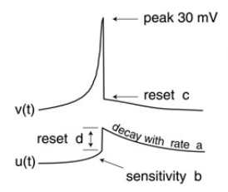
If a spike is detected the membrane potential is reset to c and the recovery current is altered. The variable d represents the total amount of outward minus inward currents activated during the spike and affecting the after-spike behavior. [18]
Figure 4 - Izhikevich spike with primary parameters
The Izhikevich model is capable of a variety of biologically realistic neuron spiking patterns. A summary of the patterns can be seen in Figure 5. Class two excitability differs from class one excitability in that it does not encode the input to the neuron. Regardless of excitatory input amplitude a class two neuron will maintain a constant spiking frequency. We can also see a variety of responses to depolarization and hyperpolarization. Many neurons exhibit a combination of the behaviors shown in Figure 5. Different firing patterns may require alterations to parameters in the model. It is not unusual to have several vectors of parameters for different conditions based on membrane potential and input current for a single neuron model.
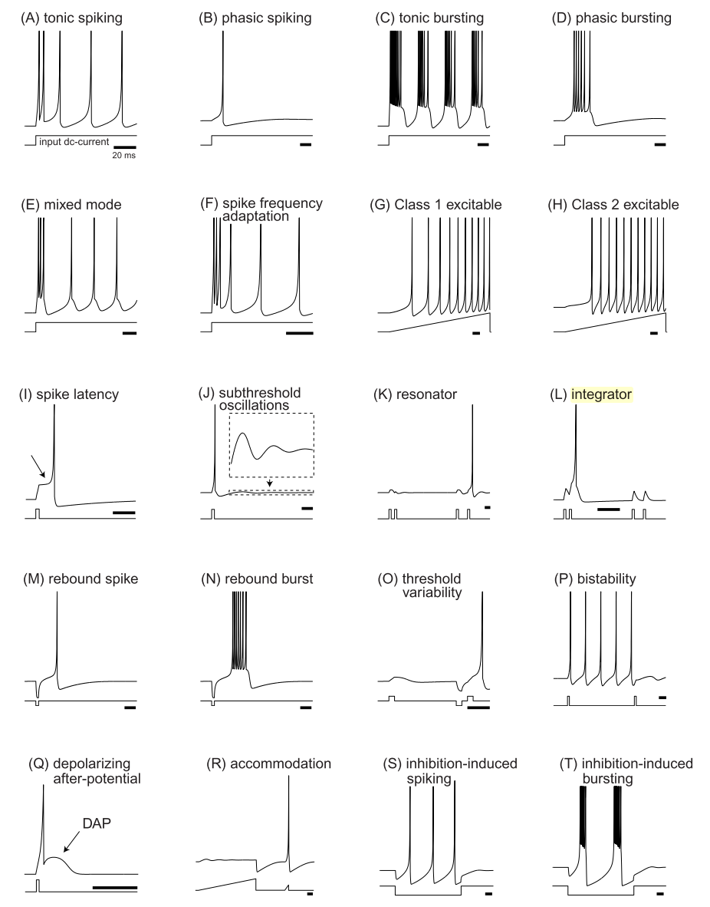
Figure 5 - Summary of neurocomputational properties for the Izhikevich neuron

Methods

Phase Plane Analysis
Phase plane analysis of a system is the geometrical representation of system dynamics. The analysis is carried out using phase portraits, which depict the equilibria and trajectories of the system’s state/phase space. In the case of a one-dimensional system, the phase portrait consists of a phase line, trajectories, and equilibria as seen in Figure 6. [19] The phase line is based on a state variable, x, and its derivative represented by f(x). The trajectories are represented by the arrows on the x-axis and the equilibria are represented by the circles.
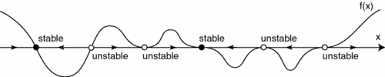
The black circles represent stable equilibria and the white circles are unstable equilibria. Equilibria occur where f(x) is equal to zero. In Figure 6 we can see that unstable equilibria have trajectories which point away from the equilibrium at all times. The stable equilibrium act as attractors and have trajectories pointing into the equilibrium. Using the trajectories and equilibria we can easily determine the dynamics of a system with the initial value of the state variable x.
Figure 6 - Phase Line

The Izhikevich neuron is often analyzed using a two-dimensional phase portrait. The dynamics of the Izhikevich neuron can be described using the state variables v and u. In Figure 7 below we can see an example of a phase portrait for an Izhikevich neuron. [18]
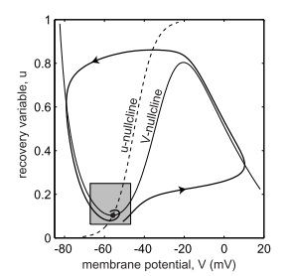
In Figure 7, the trajectory of the system is shown by the directional line. The u nullcline is represented by the dashed line and is defined as all points where the derivative of u with respect to time is equal to zero. Similarly, the v nullcline is defined by all points in the system where the derivative of v with respect to time is equal to zero. The nullclines of each state variable are important because each intersection of the nullclines represents an equilibrium point.
Figure 7 - Izhikevich Neuron Phase Portrait

The trajectory shown in Figure 7 is calculated based on a set of initial conditions (v(0),u(0)). The trajectory line is the value of (dv(t)/dt, du(t)/dt) for t=0 to a preset stopping time. Therefore we can tell the trajectory of the membrane potential and recovery variable if we have the initial conditions.

Parameter Estimation
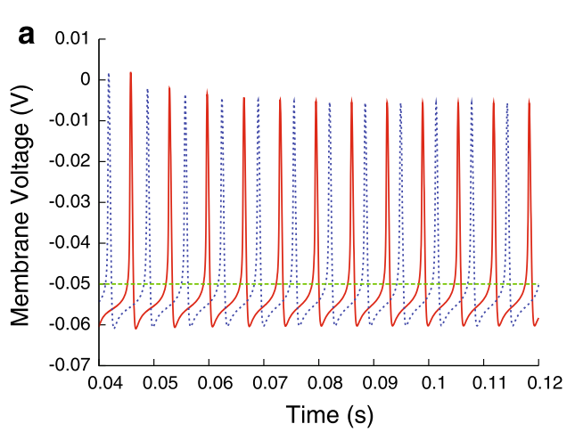
The parameter estimation method for the proposed research will be a genetic algorithm using phase plane trajectory density (PPTD) as a fitness function. The parameter estimation will begin with an initial guess at the parameters to be used in the Izhikevich model. The phase plane of the Izhikevich model using the initial parameters will be compared with the phase plane of the training data provided by an HH model used in the previous works of Rubin and Terman. [4] The difference between the two data sets will be found using the PPTD method. This value will be used by the genetic algorithm to “guess” the next set of parameters to test.
Figure 8

Error Function
Phase-plane trajectory density (PPTD) method will be used as the error function. The training data available will be the membrane potential and the input current. Therefore a point-to-point comparison of the voltage trace is the best option for the error function of the optimization algorithm. The easiest method for a point-to-point comparison is to calculate the root mean square of the difference between the training data and the model voltage traces as seen in Equation 5.
Equation 4 - PPTD Algorithm
$$rms= \sqrt{\frac{1}{N}{\sum_{i=0}^{N}{(v_{data}\left[i\right]-v_{model}[i])}}^{2}}$$

$$E= \sqrt{{\sum_{i=1}^{N_{x}}{\sum_{j=1}^{N_{y}}{(\frac{{data}_{ij}}{N_{data}}}}-\frac{{model}_{ij}}{N_{model}})}^{2}}$$

However the root mean square error of the voltage traces is susceptible to time shifts in the voltage traces of the training data as seen in Figure 8. The PPTD method was selected because it is less sensitive to phase shifts than other point-to-point methods while still allowing for the same degree of accuracy. [20], [21] The PPTD error function is displayed in Equation 4. The basic premise behind the PPTD method is to plot the phase plane of the model and to compare it to the phase plane of the training data. To obtain the phase plane, the voltage is plotted against the change in voltage over time. Next the phase plane is divided into a grid with each square of the grid representing a value of i and a value of j from Equation 4. The number of data points in each square of the phase plane plot are summed. Essentially a 2-D histogram of the phase plane is calculated. The values of the histograms make up the data_{ij} and the model_{ij} terms. N represents the total number of points and is used to normalize the values.
Equation 5 - RMS Algorithm
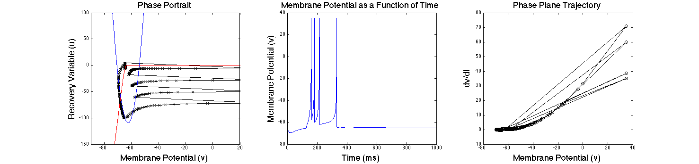
As previously mentioned, the phase portrait for the Izhikevich neuron based on two state variables: the recovery variable, u and the membrane potential, v. In Figure 9, the two-dimensional phase portrait, the membrane potential as a function of time, and the one-dimensional phase portrait are displayed. On the left a phase portrait is displayed with the v nullcline represented by the blue line, the u-nullcline represented by the red line, and the trajectory of the neuron shown in black.
Figure 9 - From left to right: Phase portrait, membrane potential as a function of time, phase plane trajectory

In the middle graph we see the neuron is firing a burst of rebound spikes. The neuron used in this simulation was given an inhibitory input for the first 125ms of the simulation, and then the input current was removed. The neuron fires multiple post-inhibitory spikes. The one-dimensional phase portrait, to the right, shows the derivative of the membrane potential plotted against the membrane potential at each point of the simulation.
In both the left and right graphs we can see the trajectory is repetitive. The graph in the middle confirms the repetitive trajectory as can be seen by the multiple spikes. Each time a spike occurs the neuron is reset to its resting potential. We can see on the far left the value of u is driven to a large negative value due to the inhibitory current and a positive b value. Once the inhibition is removed the neuron fires spikes at a decreasing frequency until the recovery variable becomes zero and the neuron returns to an equilibrium state. On the far left we see the derivative of the voltage is very large for the first spike, then decreases along the trajectory of each spike that follows.
PPTD will utilize the one-dimensional phase portrait for comparison between training data and model data. Although the two-dimensional phase portrait provides more information, it is incapable of being used because our training data strictly contains membrane potential. The two-dimensional phase portrait can be utilized when validating the parameters in the model to ensure the model displays the same dynamics as the original Rubin and Terman model.

Parameter Search Algorithm
The parameter space for each neuron class will be searched using a genetic algorithm (GA). The purpose of GA is to search the solution space to identify the best hypothesis.[22] The best hypothesis is defined as the hypothesis that optimizes the predefined fitness function. In the case of the proposed work the fitness function is PPTD.
The algorithm creates an initial population at random. Each member of the population is a vector containing an estimated value for each of the parameters to be optimized. At each iteration of the algorithm, the current population is used to create the next population. The creation of the new population is accomplished by first computing the current population’s fitness function. Based on the results of each member of the populations fitness score, several members will be selected to become parents. The members selected will have the best fitness score. There will also be a few members of the population with lower fitness scores selected and labeled as elite. The elite members of the population pass on to the next generation without modification. However the parents will produce children by one of two methods, mutation or crossover. The current population is then replaced with the elite members and the children produced by the parents. The algorithm stops once the stopping criteria is met.
The primary stopping criteria will be a function tolerance of 1e-12. The function tolerance is essentially the change in the average value of the fitness function for the population between the current generation and the previous generation. A fitness limit will also be implemented. If the best value in the population is less than or equal to the fitness limit, the algorithm will stop. A limit on the maximum number of generations will also be imposed. If the function tolerance or fitness limit has not been reached prior to 100 generations, the algorithm will be stopped.
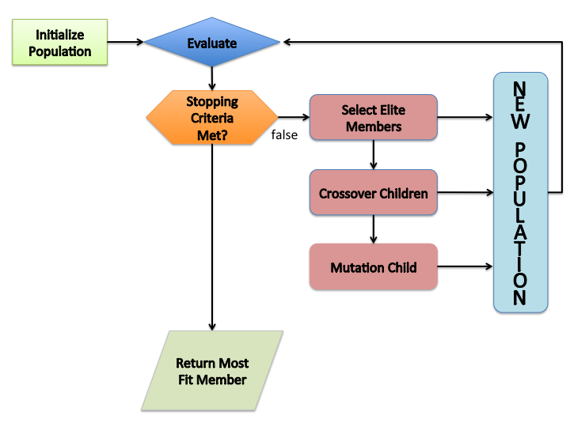
Figure 10 - Genetic Algorithm Flow Chart
Mutation and crossover are the two methods of creating children for the next generation. Mutation adds a random vector from a Gaussian distribution to the parent to create the mutated child. Crossover children are created by combining pairs of parents in the population. At each coordinate of the child vector, one gene, or entry, is selected at the same coordinate from one of the two parents and passed on to the child. [23], [24]

Simulation

Preliminary Work

Multi-Class Neuron Model
The primary focus of the proposed research is to develop a multi-class neuron model using Izhikevich neurons. The multi-class neuron model was originally developed by Rubin and Terman [4], and has neurons from the STN, GPi, GPe, and TC. The model is capable of replicating a network of Parkinsonian neurons under the effects of DBS.
The model created in Rubin & Terman 2004 was originally written in XPP-aut. XPP-aut, X-window phase plane plus auto, is a powerful tool for solving differential equations, boundary value problems, as well as other mathematical equations. The first step of the preliminary work was to convert the model into C++. Four separate class files were created; one for each class of neuron. Sixteen STN, sixteen GPi, sixteen GPe, and two TC neurons were instantiated and interconnected. The interconnection between neurons was specified as follows: each STN neuron received inhibitory input from two GPe neurons, each GPe neuron received excitatory input from three STN neurons and inhibitory input from two other GPe neurons, each GPi neuron received excitatory input from one STN neuron, and each thalamic neuron received inhibitory input from eight GPi neurons.
$$I_{α→β}= g_{α→β}[v_{α}- E_{α→β}]\sum_{j}{s_{α}^{j}}$$
Equation 6
$$s_{α}^{'}= A_{α}\left[1-s_{α}\right]H_{∞}\left(v_{α}-θ_{α}\right)- B_{α}s_{α}$$
Equation 7

Each neuron receives synaptic input based on Equation 6 and Equation 7. The synaptic input current, $I_{α→β}$, represents the input current from neuron α onto neuron β. The maximal synaptic conductance is represented by $g_{α→β}$ and the synaptic reversal potential is represented as $E_{α→β}$. The synaptic strength is represented as $s_{α}$ and is defined by Equation 7. The Heaviside step function is denoted as $H_{∞}$, and $A_{α}$ and $B_{α}$ control the synaptic time courses.
All calculations were carried out using an adaptive step Runge Kutta algorithm from the GNU scientific library. [25] All results of the C++ model were validated against the XPPaut model.

Izhikevich Model

The next step in preliminary work was to convert the C++ network model from HH neurons to Izhikevich neurons. Each class of neuron was converted to an Izhikevich neuron and different parameter settings were tested in MATLAB. Each class of neuron was manually tuned to match the characteristics defined by Rubin and Terman.[4]
Once the parameters were verified, a C++ model was implemented with four classes of Izhikevich neurons representing the STN, GPi, GPe, and TC cells. The program was compiled, executed, and the results were compared to the original Rubin and Terman results. The results from the new model using the Izhikevich model did not match the HH model.
The Izhikevich network was tested using a healthy (non-Parkinsonian) network for comparison with the HH model. The TC model was incapable of relaying the sensory motor signals. The STN, GPe, and GPi spike waveforms were disfigured and the spiking frequency of each class were drastically different from the values specified in Rubin and Terman’s model.

Parameter Estimation
After verifying the manual tuning of the neuron models would not provide reliable results, the next step was to select and validate a parameter estimation algorithm. The genetic algorithm was selected to search the parameter space and select the optimal set of parameters using PPTD as the fitness function. The genetic algorithm was chosen because it is a global search method. In the case of the proposed work, there may be several local minima available, so a simple gradient search method may not provide the optimal results.
A simple Izhikevich neuron model was created in MATLAB to generate test data. A PPTD function was written in MATLAB and implemented using the genetic algorithm provided in the global optimization toolbox. The parameters used to create the test data, the initial guess for each parameter used as an input to the algorithm, and the values the algorithm returned after 86 generations are displayed in Table 2. The genetic algorithm was run with a population of 20, the upper and lower bounds shown in Table 1, no inequality rules, and a function tolerance of 1e-16. The PPTD function used a 2D histogram with the dimension of 300 x 300.

Parameter | a | b | v_{r} | v_{t} | I_{app} | d | k | c
Lower Bound | 0 | -30 | -70 | -60 | 0 | 0 | 1e-3 | -80
Upper Bound | 0.1 | 30 | -45 | -30 | 400 | 200 | 2 | -5
Table 1 - Upper and Lower Boundaries for GA preliminary trial
Parameter | a | b | v_{r} | v_{t} | I_{app} | d | k | c
Value | 0.03 | -2.00 | -60.00 | -40.00 | 0 | 100.00 | 0.7 | -50.00
Initial Guess | 0.01 | -1 | -65.00 | -45.00 | 0 | 85.00 | 0.60 | -60.00
GA | 0.03 | 0.35 | -64.99 | -44.98 | 0.01 | 85.04 | 0.6 | -59.97
Table 2 - Parameter Optimization Results

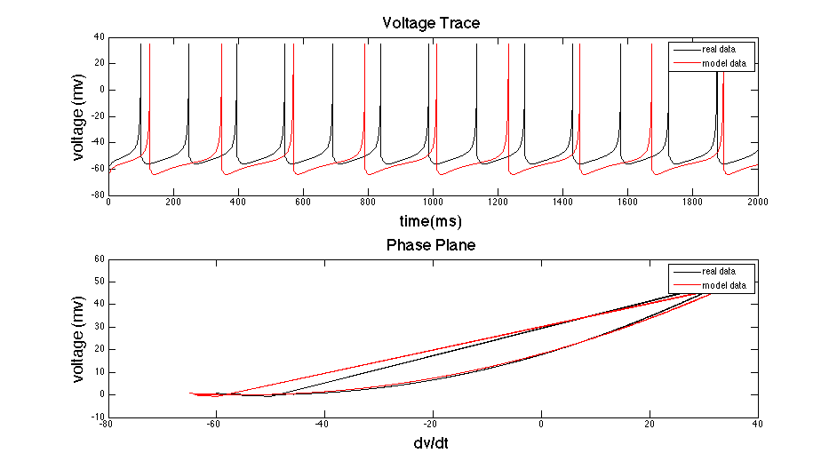
Figure 11 - Genetic Algorithm Preliminary Results
The results from the simulation are displayed in Figure 11. The top graph shows the membrane potential as a function of time for the training data (black) and the model data using the estimated parameters (red). The spikes are occurring at a slightly lower frequency, however the spike shape is consistent with the test data. The lower graph displays the phase plane trajectory of the training data (black) and the model data (red). There is slight variation but the same trajectory shape is seen. The model parameters must be able to accomplish the same firing dynamics and spike waveform shape. However the actually spike timing is not a high priority, so long as the spike frequency is preserved. PPTD ensures the parameters with the best fit will mimic firing characteristics and waveform shape optimally and is robust against time shift.
The preliminary results validate PPTD and genetic algorithm as a viable parameter estimation method for the proposed work. The error in the preliminary results can be minimized several ways:
- The dimensions of the histogram used in PPTD can be modified.
- The population of the genetic algorithm can be enlarged to allow for a farther-reaching exploration of the solution space.
- Inequality rules can be implemented to allow for better estimations. An example an inequality to be implemented: $v_{t}-v_{r}>15$. The instantaneous membrane potential cannot be within 15 mV of the resting membrane potential. This inequality will help decrease the available solution space allowing for a more optimal search.
- The function tolerance can be decreased.
- The number of generations can be increased.

Proposed Work
The proposed work will center on determining the optimal parameters for an Izhikevich version of each neuron class (STN, GPi, GPe, and TC). The optimal parameters will be determined using a genetic algorithm to search the solution space. PPTD will be used as the fitness function for the genetic algorithm.
The following parameters from the Izhikevich neuron model must be determined: a, b, v_{r}, v_{t}, I_{app}, d, k, and c. The applied current, I_{app}, will be included for each neuron to allow intrinsically spiking neurons. The Izhikevich neuron does not allow for spiking without an input current, therefore the applied current is necessary to replicate certain neuron characteristics.
Depending on the individual electro physical characteristics of each neuron, several vectors of parameters will be created. In Figure 12 a typical TC neuron is displayed. When receiving excitatory input current (top) the neuron fires at a frequency that is correlated with the amplitude of input current. TC neurons also fire bursts in response to hyperpolarization as can be seen in the lower graph of Figure 12. These two different electrophysiological properties can only represented using different values of b when using the Izhikevich neuron. In this particular case, the value of b is set to zero if the membrane potential is above the resting potential. The value of b is changed to 20 when the membrane potential falls below the resting potential.
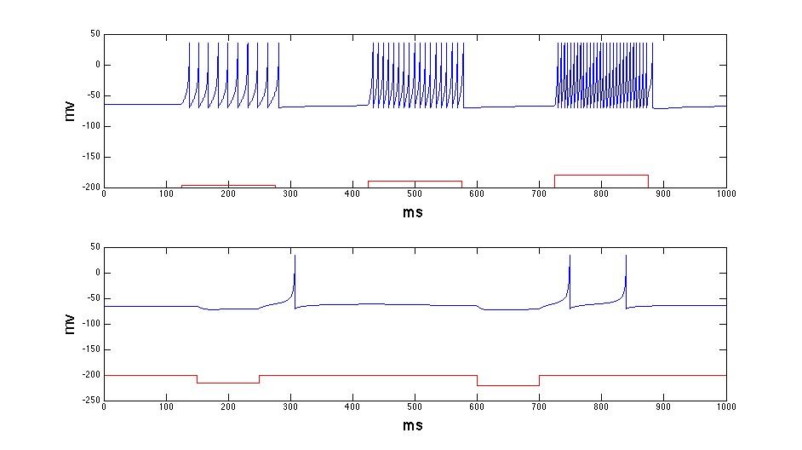
Figure 12 - TC Neuron Characteristics: (top) Excitatory Input (2,5,10 pA), (bottom) Inhibitory Input (-0.5, -1 pA) [Current traces in red, voltage traces in blue]

Research Plan
The goal of the proposed work is to replicate the activity of a multi-class biologically plausible model of HH neurons using the Izhikevich neuron. The genetic algorithm using a PPTD fitness function will allow the optimal model parameters to be estimated for each class of Izhikevich neuron. The neurons will be tested individually then interconnected to replicate the HH model designed by Rubin and Terman. [4] The completed network will then be analyzed to assess the validity of the Izhikevich model.
- Use MATLAB Global Optimization toolbox to determine parameters for each class of Izhikevich neuron. The estimated parameters will be validated by comparison of spike frequency, waveform shape, and PPTD of the network model using Izhikevich neurons versus the HH network model.
- Using the parameters determined in step one, each class of Izhikevich neuron will be written in C++. Each individual class of neuron will be tested against the original HH versions prior to connection with other neurons.
- Interconnect all Izhikevich neurons as previously outlined. Test network under normal, Parkinsonian, and Parkinsonian with DBS conditions. Quantify speed improvements.

References
[1] C. Hammond, H. Bergman, and P. Brown, “Pathological synchronization in Parkinson’s disease: networks, models and treatments.,” Trends in neurosciences, vol. 30, no. 7, pp. 357–64, Jul. 2007.
[2] A. Beuter and J. Modolo, “Delayed and lasting effects of deep brain stimulation on locomotion in Parkinson’s disease.,” Chaos (Woodbury, N.Y.), vol. 19, no. 2, p. 026114, Jun. 2009.
[3] Y. Guo, J. E. Rubin, C. C. McIntyre, J. L. Vitek, and D. Terman, “Thalamocortical relay fidelity varies across subthalamic nucleus deep brain stimulation protocols in a data-driven computational model.,” Journal of neurophysiology, vol. 99, no. 3, pp. 1477–92, Mar. 2008.
[4] J. E. Rubin and D. Terman, “High frequency stimulation of the subthalamic nucleus eliminates pathological thalamic rhythmicity in a computational model.,” Journal of computational neuroscience, vol. 16, no. 3, pp. 211–35, 2004.
[5] M. S. Okun, “Deep-brain stimulation for Parkinson’s disease.,” The New England journal of medicine, vol. 367, no. 16, pp. 1529–38, Oct. 2012.
[6] P. Brown and D. Williams, “Basal ganglia local field potential activity: character and functional significance in the human.,” Clinical neurophysiology : official journal of the International Federation of Clinical Neurophysiology, vol. 116, no. 11, pp. 2510–9, Nov. 2005.
[7] A. Kent and W. Grill, “Instrumentation to record evoked potentials for closed-loop control of deep brain stimulation,” … in Medicine and Biology Society, EMBC, …, 2011.
[8] A. Pascual, J. Modolo, and A. Beuter, “Is a computational model useful to understand the effect of deep brain stimulation in Parkinson’s disease?,” Journal of integrative neuroscience, vol. 5, no. 4, pp. 541–59, Dec. 2006.
[9] C. a Davie, “A review of Parkinson’s disease.,” British medical bulletin, vol. 86, pp. 109–27, Jan. 2008.
[10] P. Pollak, P. Krack, E. Moro, A. Mendes, S. Chabardes, and A. Koudsie, “Treatment Results : Parkinson ’ s Disease,” vol. 17, 2002.
[11] J. Obeso, C. Olanow, and M. Rodriguez-Oroz, “Deep-brain stimulation of the subthalamic nucleus or the pars interna of the globus pallidus in Parkinson’s disease,” N Engl J Med, vol. 345, no. 13, pp. 956–63, Sep. 2001.
[12] “Parkinson’s Disease.” [Online]. Available: http://biomed.brown.edu/Courses/BI108/BI108_2008_Groups/group07/Parkinsons.html.
[13] A. L. Benabid, A. Koudsié, A. Benazzouz, L. Vercueil, V. Fraix, S. Chabardes, J. F. LeBas, and P. Pollak, “Deep brain stimulation of the corpus luysi (subthalamic nucleus) and other targets in Parkinson’s disease. Extension to new indications such as dystonia and epilepsy,” Journal of Neurology, vol. 248, no. S3, pp. 37–47, Sep. 2001.
[14] C. W. Olanow, M. F. Brin, and J. A. Obeso, “The role of deep brain stimulation as a surgical treatment for Parkinson’s disease.,” Neurology, vol. 55, no. 12 Suppl 6, pp. S60–6, Jan. 2000.
[15] A. Hodgkin and A. Huxley, “A Quantitive Description of Membrane Current and Its Application to Conduction and Excitation in Nerve,” The Journal of physiology, pp. 500–544, 1952.
[16] D. Terman, J. E. Rubin, a C. Yew, and C. J. Wilson, “Activity patterns in a model for the subthalamopallidal network of the basal ganglia.,” The Journal of neuroscience : the official journal of the Society for Neuroscience, vol. 22, no. 7, pp. 2963–76, Apr. 2002.
[17] E. M. Izhikevich, “Simple model of spiking neurons.,” IEEE transactions on neural networks / a publication of the IEEE Neural Networks Council, vol. 14, no. 6, pp. 1569–72, Jan. 2003.
[18] E. M. Izhikevich, Dynamical Systems in Neuroscience: The Geometry of Excitability and Bursting, vol. First. MIT Press, 2007, p. 441.
[19] D. Terman and E. Izhikevich, “State space,” Scholarpedia, vol. 3, no. 3, p. 1924, 2008.
[20] P. Achard and E. De Schutter, “Complex parameter landscape for a complex neuron model.,” PLoS computational biology, vol. 2, no. 7, p. e94, Jul. 2006.
[21] W. Van Geit, E. De Schutter, and P. Achard, “Automated neuron model optimization techniques: a review.,” Biological cybernetics, vol. 99, no. 4–5, pp. 241–51, Nov. 2008.
[22] T. M. Mitchell, Machine Learning, Internatio. Singapore: McGraw-Hill Book Co., 1997, p. 414.
[23] “Global Optimization Toolbox User ’s Guide.” Natick, MA, p. 581, 2012.
[24] T. M. Mitchell, Machine Learning, Internatio. Singapore: McGraw-Hill Book Co., 1997, p. 414.
[25] M. Galassi, J. Davies, J. Theiler, and B. Gough, GNU scientific library : Reference Manual, 1.15 ed., no. April. 2002, p. 523.

APPENDIX

GPi (GPe) Neuron
The GPi and GPe neurons will be modeled in a nearly identical manner with the exception of their synaptic input currents. The equations describing GPi and GPe functionality are listed below in Equations 8 - 13.
$$C_{m}\frac{dv}{dt}= -I_{L}-I_{k}-I_{Na}-I_{T}-I_{Ca}-I_{Sn→Ge}-I_{Ge→Ge}+I_{app}$$
Equation 8 - Membrane Voltage Equation for GPe/GPi
In addition to the potassium, sodium, and leakage currents, the model takes into account low-threshold T-type calcium current (I_{t}), calcium current (I_{Ca}), synaptic input from the STN ($I_{Sn→Ge}$), and an input from other GPi (GPe) neurons ($I_{Ge→Ge})$. There is also an applied voltage (I_{app}), which represents a constant input from the striatum. The conductance values for each ion channel are represented by the g_{x} variables in each current equation. The slowly operating gating variables n, h, and r are a function of both time and voltage and are governed by Equations 14 and 15 (X = n, h, r).

The steady state voltage dependence for each gating variable (X = n, m, h, a, r, or s) is determined by Equation 16.
$$I_{L}= g_{L}(v-v_{L})$$
Equation 9
$$I_{k}=g_{k}n^{4}(v-v_{k})$$
Equation 10
$$I_{Na}=g_{Na}{m_{∞}}^{3}\left(v\right)h(v-v_{Na})$$
Equation 11
$$I_{Ca}=g_{Ca}{s_{∞}}^{2}(v)(v-v_{ca})$$
Equation 12
$$I_{T}=g_{T}{a_{∞}}^{3}(v){b_{∞}}^{2}(r)(v-v_{Na})$$
Equation 13

$$\frac{dX}{dt}= ∅_{X}[X_{∞}\left(v\right)-X/τ_{X}(v)]$$
Equation 14 - Gating variable (function of voltage)
$$τ_{X}\left(v\right)= τ_{X}^{0}+τ_{X}^{1}/[1+\exp\left[-\frac{v-θ_{X}^{τ}}{σ_{X}^{τ}}\right]]$$
Equation 15 - Time constant for gating variable
$$X_{∞}\left(v\right)= 1/[1+\exp\left[-\frac{v-θ_{X}}{σ_{X}}\right]]$$
Equation 16 - Steady State Voltage Dependence for Gating Variables

STN
The membrane potential for the STN neuron is defined in Equation 16. The STN neuron has the same currents with the exception of synaptic input, applied current, and the DBS input. The synaptic input to the STN neurons comes from the GPe ($I_{Ge→Sn})$. The DBS input will be discussed later sections. When the model is running without DBS, this current can be ignored.
$$C_{m}\frac{dv}{dt}= -I_{L}-I_{k}-I_{Na}-I_{T}-I_{Ca}-I_{Ge→Sn}+I_{DBS}+I_{app}$$
Equation 16 - STN Membrane Potential
The equations governing the voltage gating variables are defined in Equations 14, 15, and 16.

TC
The TC relay cell membrane potential is defined in Equation 18. The leakage and sodium currents are defined identically to the GPe/GPi/STN neurons. The gating variables for the TC neuron have been consolidated and therefore the potassium and slow calcium current have a different representation as seen in Equation 10 and Equation 13. The n gating variable has been consolidated and only the r and h gating variables will be used. The equations for the gating variables are listed in Equations 21 and 22.
$$C_{m}\frac{dv}{dt}= -I_{L}-I_{k}-I_{Na}-I_{T}-I_{Ca}-I_{Gi→Th}+I_{SM}$$
Equation 18 - TC Membrane Potential
$$I_{k}=g_{k}{[0.75\left(1-h_{Th}\right)]}^{4}(v-v_{k})$$
Equation 19
$$I_{T}=g_{T}p_{∞}^{2}(v)r_{Th}(v-v_{T})$$
Equation 20

$$\frac{dh}{dt}=(h_{∞}(v_{Th})-h_{Th})/τ_{Th}$$
Equation 21
$$\frac{dr}{dt}=(r_{∞}(v_{Th})-r_{Th})/τ_{r}(V_{Th})$$
Equation 22

