A Machine Learning Enabled Wireless Intracranial Brain Deformation Sensing System
S. Islam, S.T.R. Gidde, P. Hutapea, S. H. Song, J. Picone, and A. Kim, Member, IEEE
Abstract— A leading cause of traumatic brain injury (TBI) is intracranial brain deformation due to mechanical impact. This deformation is viscoelastic and differs from a traditional rigid transformation. In this paper, we describe a machine learning enabled wireless sensing system that predicts the trajectory of intracranial brain deformation. The sensing system consists of an implantable soft magnet and an external magnetic sensor array with a significantly improved sensing volume of 12 × 12 × 4 mm³. Machine learning predicts brain deformation by interpreting the magnetic sensor outputs created by the change in position of the implanted soft magnet. Three different machine learning models were trained on calibration data: (1) random forests, (2) k-nearest neighbors, and (3) a multi-layer perceptron-based neural network. These models were validated using both in vitro (a needle inserted into PVC gel) and in vivo (blast wave exposure to live and dead rat brains) experiments. The in vitro gel deformation predicted by these machine learning models showed excellent agreement with camera measurements. The in vitro deformation predicted by these models had a coefficient of determination (R²) scores of 96.75%, 98.16%, and 98.62%, respectively, with corresponding absolute errors of 137.4 µm, 128.9 µm, and 90 µm. The in vivo brain deformation predicted by these models for a live rat had R² scores of 86.22%, 78.47%, and 87.02% with corresponding absolute errors of 82 µm, 124.5 µm, and 98 µm. These results suggest that the proposed machine learning enabled sensor system is an effective tool for measuring in situ brain deformation.
Index Terms— Traumatic brain injury, brain deformation measurement, magnetic field measurement, magnetic sensors, machine learning.
A

INTRODUCTION
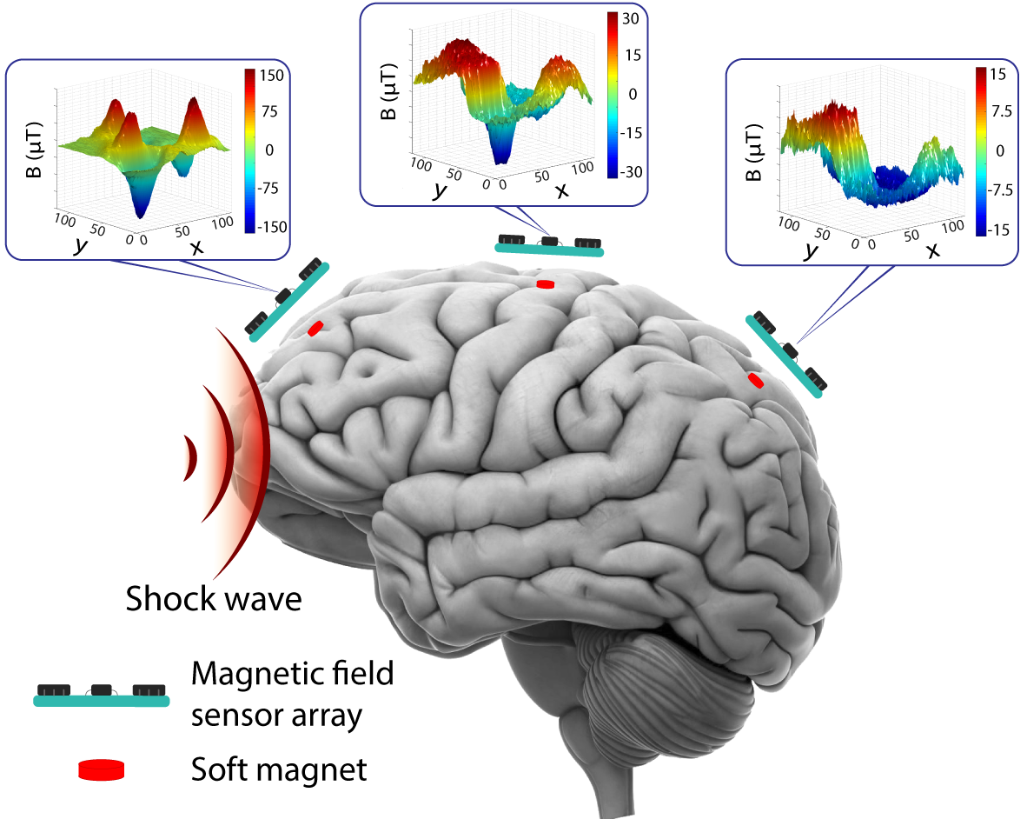
Fig. 1. The wireless intracranial brain deformation sensing system consists of an implantable soft magnet and an external head-mounted magnetic sensor.

pproximately three million individuals in the United States suffer from some degree of traumatic brain injuries (TBI) with both short- and long-term adverse clinical outcomes [1]–[3]. Leading causes of TBI include unintentional falls (47.9%), struck by/against an object (17.1%), automobile accidents (13.2%), and blast injuries [3]. For example, blast injuries are found in over 50% of combat injury cases of military personnel [4]–[6]. Symptoms of a TBI range from mild headaches to severe neuropsychiatric alterations such as depression, anxiety, and more. These risks are a substantial public health burden as the conditions are generally chronic and involve costly long-term treatment that negatively impacts the quality of life. During these TBI events, the brain is inflicted by external forces and undergoes a deformation. The mechanical deformation is viscoelastic by nature and does not transform rigidly. Depending on the location, the acceleration and direction of deformation may also vary [7]. Recent studies have suggested that such brain deformations, even in cases involving a few tens of micrometers, have direct neuropsychiatric (e.g., depression and anxiety) and neurodegenerative consequences (e.g., chronic traumatic encephalopathy) [5], [8]–[10].
Prevention, diagnosis, and treatment of TBI requires a better understanding of brain biomechanics. This has been a major research focus in the last few decades [11]–[14]. These efforts include several computational approaches such as analyzing wearable accelerometer/gyroscope data to find a relationship between external stimuli and the resulting TBI [15]. In parallel, direct measurements of intracranial brain biomechanics were also attempted. For example, M. Chavko et al. [16] measured the intracranial pressure using an implantable fiber optic sensor in a rat head. An alternate approach for measuring direct intracranial brain deformation has been to use a wireless sensing system that employs an implantable soft magnet and paired magnetic sensor array [17]. Although our first reported direct in situ and in vivo monitoring of localized brain deformation was a significant step forward [17], many technical challenges remain including: (1) a limited brain deformation detection range (<500 µm) due to the weak magnetic strength of the soft magnet and (2) a poorly estimated calibration map that was modeled using a sum of two 3-variable Gaussians.
In this paper, we present an improved wireless intracranial brain deformation sensing system that is calibrated using a machine learning (ML) model trained on experimental data (Fig. 1). We address two major shortcomings of our previous work by using (1) a magnetic tunnel junction (MTJ) sensor that offers higher sensitivity and longer operation range (improved sensing volume by three orders of magnitude), and (2) a machine learning model that predicts brain deformation with better accuracy than previously reported measurements using a standard Gaussian model [17]. The ML enabled sensing model was evaluated against experimentally measured calibration data, empirically built calibration map, in vitro needle insertion into a PVC gel data, and in vivo blast-induced brain deformation data using dead and live rats. Overall, the ML-enabled model exhibited excellent agreement with the experimentally measured calibration data (R² > 92%) compared to an empirical model (R² < 85%).

Methods and Materials

Wireless Brain Deformation Sensing System
In Fig. 2, we illustrate our wireless intracranial brain deformation sensing approach. A soft magnet that is implanted in the brain closely follows brain deformation when an external mechanical force is applied (e.g., needle insertion, blast wave, or concussion) (Fig. 2(a)). The change in magnetic field strength is proportional to the position and orientation of the soft magnet during the deformation (Fig. 2(b)). The sensor output is then converted into a position using a nonlinear mapping that is derived from calibration data.
The implantable soft magnet was fabricated by the same process as described in [17] (Fig. 2(c)). Iron (III) oxide (Fe₂O₃) nanoparticles (Sigma Aldrich) were mixed with a pre-gel silicone elastomer (EcoflexTM, 00-10) (40 wt%) and magnetized during curing. It was coated with a thin layer of Ecoflex to prevent mechanical degradation. The soft magnet had a dimension of 3 mm in diameter and 2 mm in height. The average magnetic strength was measured to be 127.5 µT.
Three magnetic tunnel junction (MTJ) sensors (Micro Magnetics STJ-240) were used in the external readout system (Fig. 2(d)). An MTJ sensor provides a sensitivity that is ten times greater than that provided by the giant magnetoresistive (GMR) sensors which were used in our previous study [17]–[19]. Two sensors were aligned laterally. A third sensor was placed perpendicular to a line connecting these two sensors at the midpoint of this line (Fig. 2(d)). This configuration resulted in an overall sensing volume of 12 × 12 × 4 mm³ with a sensitivity of 0.12 Ω/µT. Note that the sensing volume of our previous study was 1 × 1 × 0.5 mm³. The sensor array was connected to a data acquisition system (National Instruments PCI-6040E) for real-time data processing.
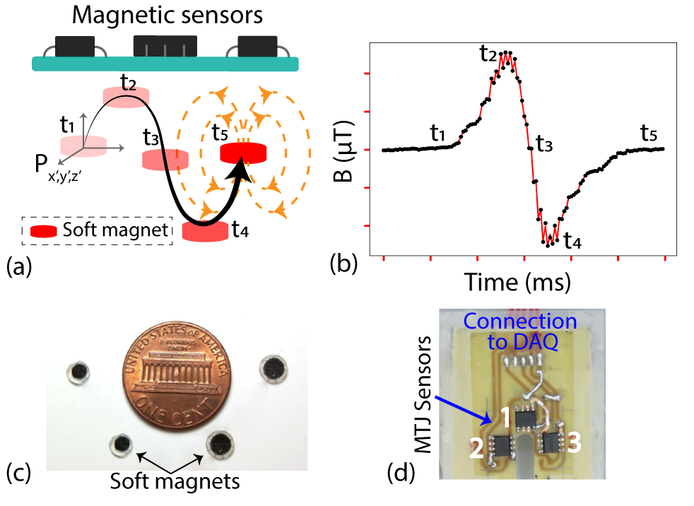
Fig. 2. An overview of the sensing approach: (a) soft magnet displacement is proportional to brain deformation, (b) the change in magnetic field strength is proportional to displacement and is detected with a magnetic sensor array, (c) the fabricated soft magnets, and (d) the magnetic sensor array consisting three MTJ sensors.

Fig. 3 shows a high-level block diagram of the ML process. Calibration data consisting of the magnetic field strength was measured by scanning the surrounding space of a soft magnet using the MTJ sensor array (see Section C below for details). Next, the ML models were trained using position and magnetic field strength data. After training, the ML-enabled models were able to predict brain deformation from magnetic field strength data. Three different machine learning algorithms were evaluated in this application: random forests (RF), k-nearest neighbors (KNN), and a multilayer perceptron neural network (MLP-NN).
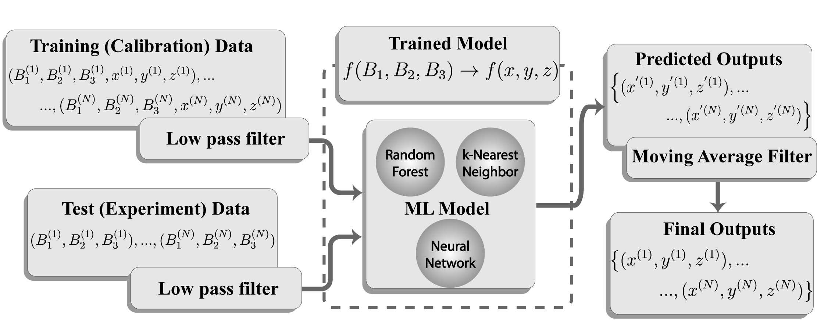
Fig. 3. Application of machine learning algorithm to measure the brain deformation through the prediction of the position of a soft magnet.

Description of the Data
The MTJ sensor reads the magnetic strength in units of resistance. The sensor outputs were converted to magnetic field strength using the following equation:
$B_{n}=\frac{{ΔR}_{n}}{S_{ n, sensitivity}}, n=1, 2, 3 \left(1\right)$
where n is the assigned sensor id (1 to 3), B_{n} (µT) is the magnetic strength, ΔR_{n} (Ω) is the difference between the measured resistance and the baseline resistance (R_{n,final} - R_{n,initial}), and S_{n,sensitivity} (Ω/µT) is the sensitivity given by the sensor manufacturer (average sensitivity was 0.12 Ω/µT). The output magnetic strength data was then processed using a moving average filter to reduce random noise which may have been introduced through several mechanisms [20], [21] (the electronics in the vicinity of the sensors, the measurement device itself, or natural geomagnetic variations). We informally optimized the averaging frame length, which serves as a low-pass filter [22], to be 5.
The input to the ML system consisted of three variables: the MTJ sensor measurements (B₁, B₂, and B₃). The outputs are the corresponding Cartesian coordinates ($x$, $y$, and $z$).

Calibration (Training Data)
After a soft magnet was mounted on a motor-controlled manipulator (provided by Makeblock Co., Ltd), the magnetic strength in a sensing volume (12 ×12 × 4 mm³) was measured with a 100 µm step-size in x and y direction and 1 mm step-size in the z-direction by the MTJ sensor array. This process is summarized in Fig. 4. For each point on the y-axis, the magnetic field was measured along the x-axis (Fig. 4(a)). For example, there were 120 data points from each sensor when the soft magnet was fixed at y = 0 mm and traveled along the x-axis (from 0 to 12 mm). This process was repeated along the y-axis every 100 µm, creating a xy plane. The scans were repeated at z = 0, 1, 2, 3, and 4 mm. Therefore, the overall calibration data incorporated five slices of xy planes (each plan had 120 × 120 data points) (Fig. 4(b)). All xy slices were overlaid to construct a three-dimensional calibration map from the MTJ sensor array (Fig. 5). Implementation of an MTJ sensor array improved the sensing range by an order of magnitude (from < 500 µm to 4 mm), especially in the z-direction (the major deformation direction) [17].
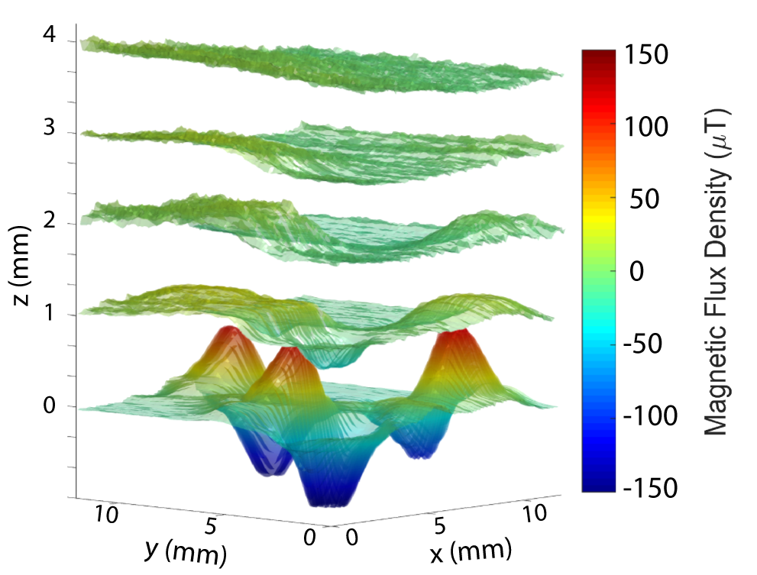
Fig. 5. Complete calibration map: five horizontal slices of measured magnetic strength as a relative position of a soft magnet.

Brain Deformation Experiments
To understand the accuracy of the ML models for predicting brain deformation, an in vitro model was used to validate z-axis deformation and an in vivo model was used to validate the three-dimensional trajectory of brain deformation.

D.1. In vitro needle insertion model

The first validation was focused on deformation along the z-axis, which is the primary deformation direction. To achieve z-axis deformation, needle insertion into soft tissue-mimicking PVC gel (Soft Plastic, M-F Manufacturing Co., TX, USA) was performed. The PVC gel had a dimension of 150 × 150 × 65 mm³, Young’s modulus of 1.2 kPa, and a density of 1,040 kg/m³, which mimics brain tissue [23], [24]. The soft magnet was inserted slightly below the top surface of the gel. The initial vertical distance between the soft magnet and the sensor array was 2 mm. A needle-like applicator (diameter = 3 mm) was slowly inserted next to the soft magnet at a velocity of 0.3 mm/s to create z-direction deformations. The MTJ sensor array was placed on top of the soft magnet to measure the deviation in magnetic field strength. The physical deformation (i.e., reference data) was also simultaneously measured using a video camera (60fps, EOS 60D, Canon).

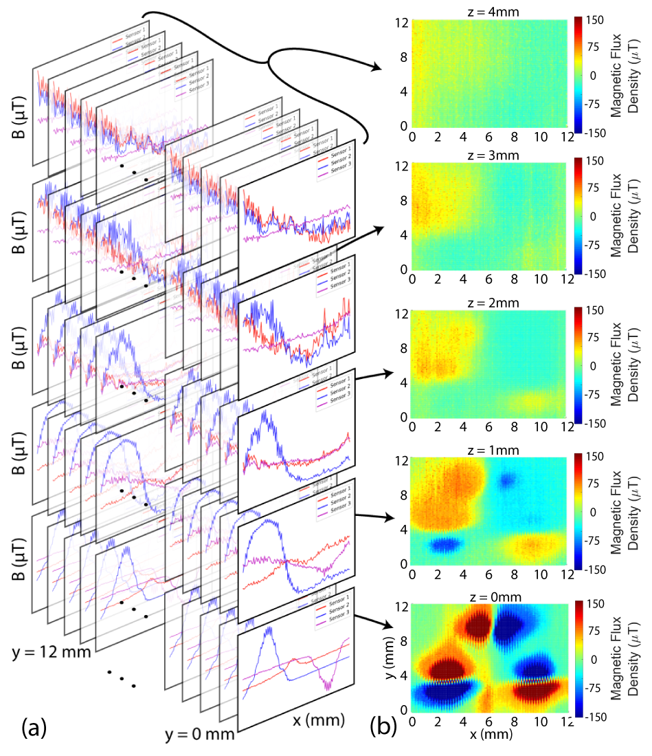
Fig. 4. Calibration process: (a) a series of one-dimensional scans along the x-axis when y is at 0 to 12 mm with 100 µm resolution, (b) reconstructed two-dimensional calibration maps at z = 0, 1, 2, 3, and 4 mm from the surface.

D.2. In vivo blast wave brain deformation model
Previously measured in vivo brain deformation data from dead and live rats were also used to validate the ML enabled model. Two test specimens (dead and live rats) were exposed to a positive peak overpressure blast wave that had a measured magnitude of 150 kPa for a 1.5 ms duration using an open-ended shock tube [25], [26]. The magnetic field changes were captured using a head-mounted magnetic sensor array placed on top of the rat skull aligned with an implanted soft magnet. The reference data were interpolated from an empirical model (i.e., a sum of two 3-variable double Gaussian distributions) [17].

Machine Learning Algorithms
We used Google’s cloud-based multicore computing resources (Intel® Xeon® CPU @ 2.20GHz with 12 GB RAM and NVIDIA® Tesla T4 GPU), the Python programming language and the scikit-learn machine learning library [27], [28] to model the data using three ML approaches. Our approaches are summarized in Fig. 6.

E.1. Random Forest (RF)
This is a popular machine learning algorithm due to its simplicity and versatility [29]. It is a supervised learning algorithm consisting of a set of decision trees (Fig. 6(a)). The trees are constructed based on minimizing the training error for regression models which serve as a surrogate for classification models [30]. A voting process is used on the observations to determine the final prediction (also known as the mode or mean prediction (regression) of the individual trees). We employed RF as the first ML algorithm because our calibration data had strong regression characteristics, especially in the xy plane.
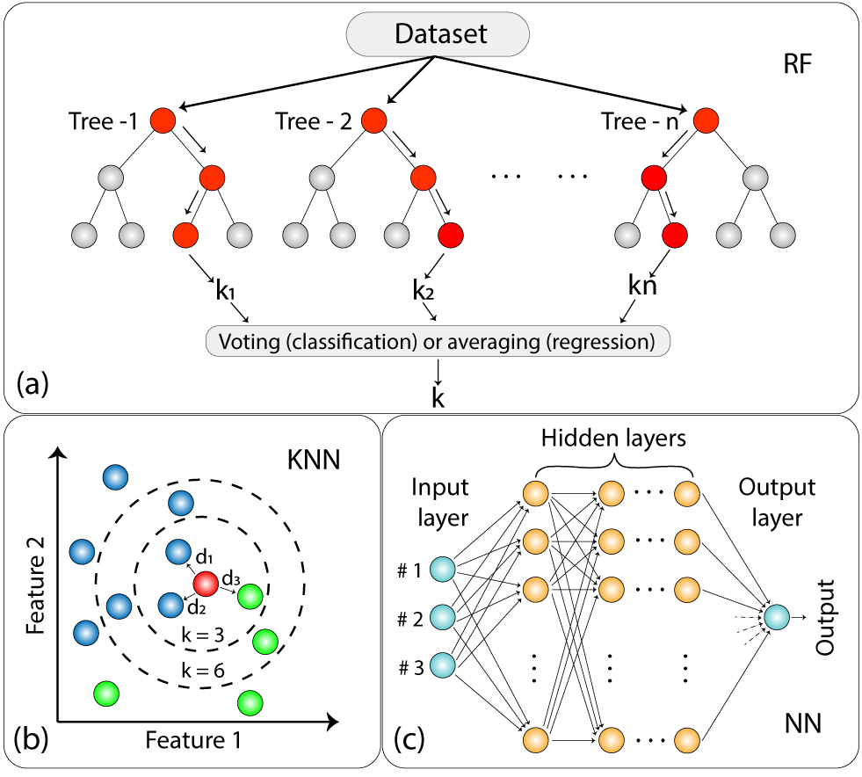
Fig. 6. Simplified representation of (a) Random Forest, (b) k-Nearest Neighbor and (c) multilayer perceptron neural network
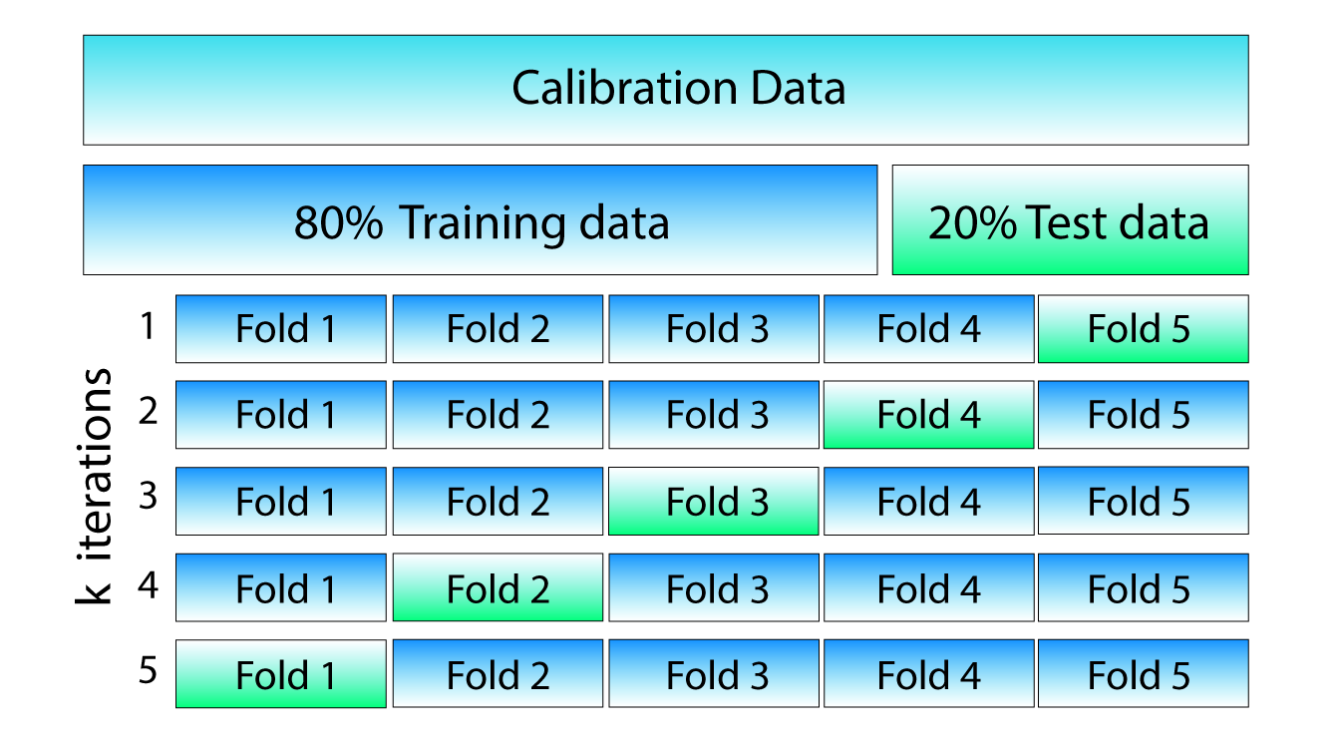
Fig. 7. A five-fold cross-validation process was used to evaluate performance.

E.2. k-Nearest Neighbor (KNN)
KNN is one of the least complicated non-parametric methods for pattern classification (Fig. 6(b)). It predicts the label for a data point based on the number of nearest neighbors, k, and their distances from these neighbors, $d_{ab}$ [31]. To define the distance between data points, there are several metrics available such as the Euclidean, Chebyshev, Mahalanobis, and Minkowski metrics [32]. The performance of various distance metrics (along with the type of datasets) were evaluated by Chomboon et al. [32]. We used the Mahalanobis distance metric in our work since this is a fairly standard approach. The Mahalanobis distance metric is defined as a measurement between a point and a distribution of data [33] and can be expressed as:

$$d_{ab}=\sqrt{{(x_{a}-y_{b})}^{T}C^{-1}(x_{a}-y_{b})} \left(2\right)$$

Where x (x₁, x₂, x₃) and y (y₁, y₂, y₃) are points in n-dimensional space (n = 3) and C is the covariance matrix. The number of neighbors, k, was set carefully to reduce misclassification error by monitoring the performance indicators (e.g., RMS error and R² value). In our case, a value of k = 9 minimized the error rate during the cross-validation process.

E.3. Multilayer Perceptron Neural Network
MLP-NN [34] was also used to train the brain deformation sensing system. MLP-NN mimics the basic learning framework of a biological neural network. It consists of artificial neurons (nodes) designated as the input layer, single or multiple hidden layers, and the output layer (Fig. 6(c)). Each layer contains multiple nodes with multiple inputs and output connections. In this study, our MLP-NN network consisted of five layers including an input layer, three hidden layers, and an output layer. The input layer comprises 6 input nodes (B₁, B₂, B₃, x, y, z), the hidden layers are sequentially cascaded with 1024, 512 and 256 nodes respectively. The output layer has 3 nodes which produce the predicted coordinate (x, y, z).
As data are fed and propagate through each node, a linear activation function (Rectified linear unit, ReLU) is combined with the weighted sum of the inputs during the process. The connection weights of the whole network are computed during the training process which involves back propagation technique, in which the weights of the network are fine-tuned based on the error rate calculated from the previous iteration (epoch = 3000).

ML Optimization and Performance Indicators
The parameters of the ML algorithms were optimized using a k-fold cross-validation method (Fig. 7). The data were randomly sorted and split into k subsets of mutually exclusive datasets (we chose k = 5 or a 20% split). Randomly selected k - 1 datasets were used for training the model, and one remaining dataset was used for validating the model (open-loop evaluation). This optimization process was iterated k times by changing the held-out dataset. We also conducted closed-loop tests using all the calibration data.
The overall performance of the trained model for the specific training parameters was evaluated using various performance indicators: absolute error, root mean square error (RMSE), coefficient of determination (R²), and Pearson correlation coefficient (Pearson's R). The absolute error is the distance between each predicted value and corresponding reference value in three-dimensional space (i.e., camera measurements for in vitro and empirical model for in vivo). The RMSE was calculated in terms of the standard deviation of the absolute errors. The RMSE value is a measurement of the spread or variance of the predicted values.
The R² value defines the ratio of the variance explained by the ML model and the total variance of the data, which indicates how well the data samples are likely to be predicted by the trained model. For example, a high R² value indicates a good amount of agreement between the predicted values and the reference values.
Similarly, the Pearson correlation coefficient (Pearson's R) describes the linear relationship of two datasets (e.g., predicted value vs. reference value) (equ. (3)) and varies between -1 to 1. A value close to ‘1’ or ‘-1’ implies a positive or negative linear relationship, a ‘0’ indicates that there is no relationship between the datasets. Pearson’s R is defined as:

$R_{xy}=\frac{\sum_{i=1}^{k}{\left(x_{i}-\overline{x}\right)\left(y_{i}-\overline{y}\right)}}{\sqrt{\sum_{i=1}^{k}{{\left(x_{i}-\overline{x}\right)}^{2}}} \sqrt{\sum_{i=1}^{k}{{\left(y_{i}-\overline{y}\right)}^{2}}}} \left(3\right)$

where x is the first dataset with a mean $\overline{x}$ and y is the second dataset with a mean $\overline{y},$ and k is the sample size.

Results and Discussion

ML Optimization
Table I summarizes the optimized machine learning parameters, the normalized RMSE (NRMSE) and R² scores for both open-loop and closed-loop tests acquired from the k-fold cross-validation process. As expected, the closed-loop test showed better prediction accuracy (average R² of 94.67% vs. 90.33%). The acquired datasets (in vitro and in vivo) were fed to the trained ML models with these training parameters.
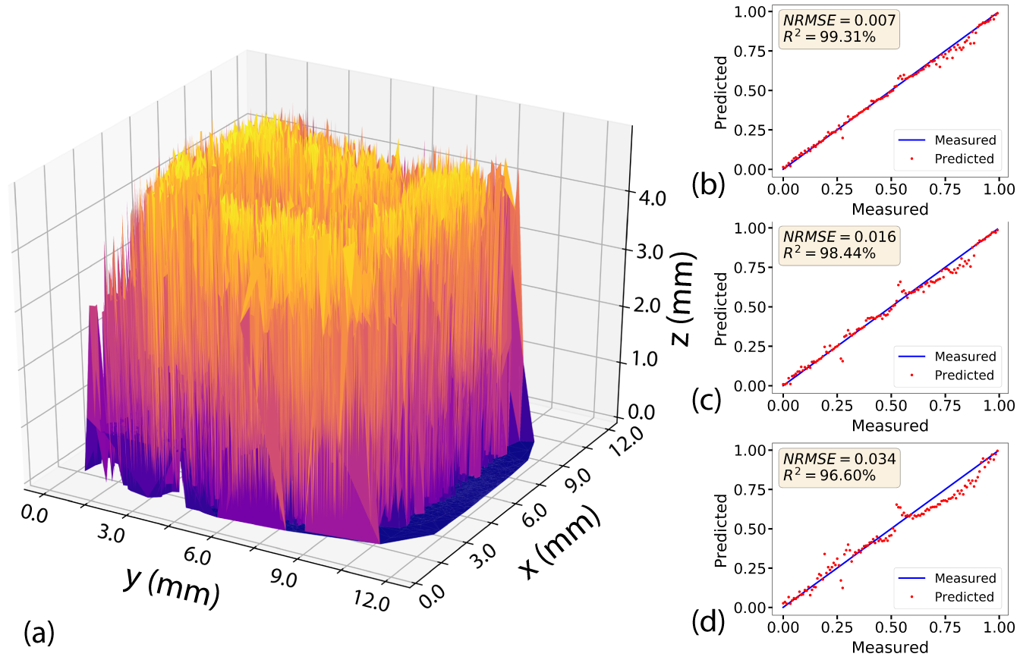
Fig. 8. (a) Reconstructed calibration map using RF-trained model, (b) one-dimensional calibration data as compared to predicted data by RF, (c) KNN, and (d) NN.

Machine Learning Enabled Calibration Map
The ML enabled reconstruction of the calibration map (Fig. 8) addresses one of the two major shortcomings of our previous work [17]. The empirical model, although reasonably accurate, was entirely replaced by machine learning that provided superior accuracy. As summarized in Table II, ML enabled models showed excellent agreement compared to the measured calibration data. All three ML models resulted in R² scores over 92% with average absolute values less than 500 µm. Note that the RMSE was normalized to compare the predictions in different experiments. The results also indicate that the reconstructed calibration data using ML models outperformed that of empirically built using 3-variable Gaussians by a good margin (~92% vs. 84.89% in R²).
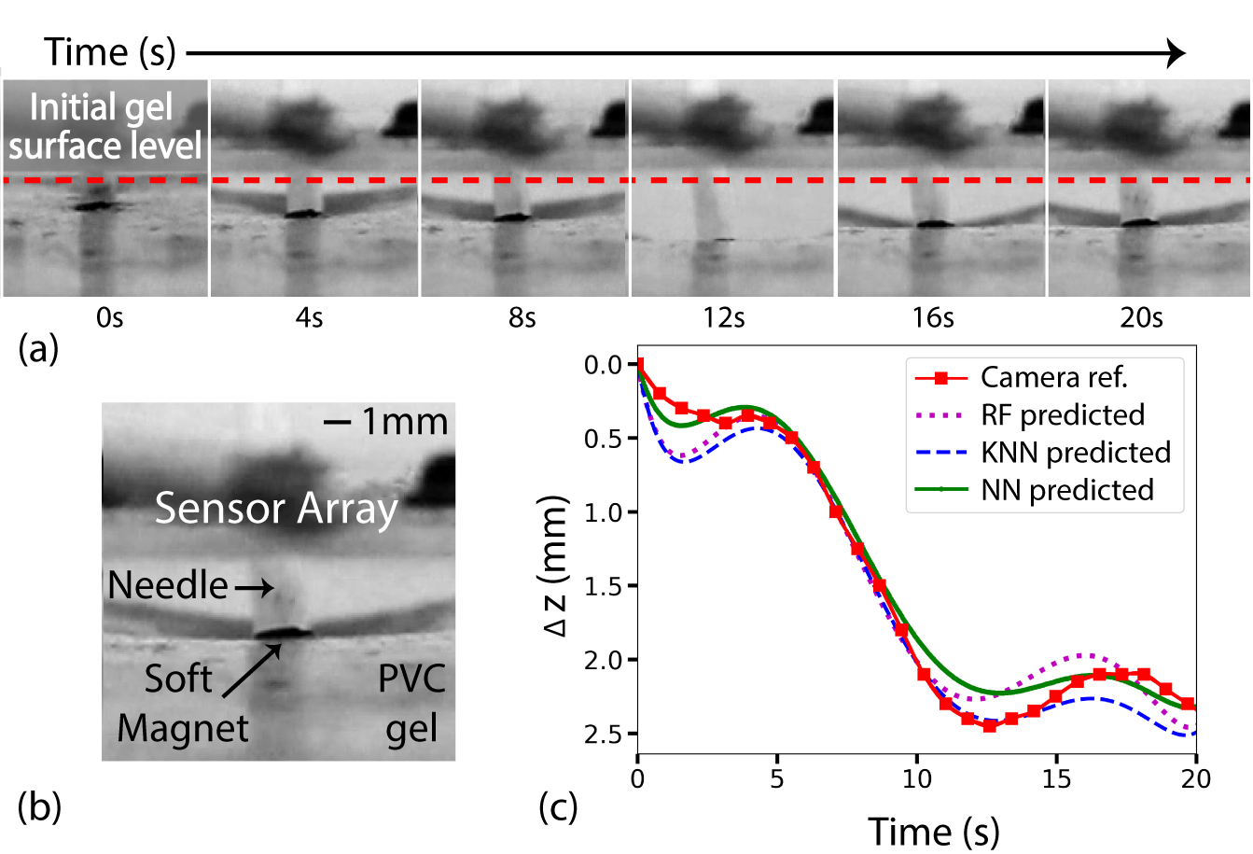
Fig. 9. (a) Soft magnet displacement along z-axis in PVC gel during direct mechanical stimulation; solid line with dot drawn as reference; maximum deformation of 2.45 mm was observed at 12.5 sec using the camera, (b) soft magnet and sensor array location with scale bar, (c) relative comparison of deformation captured by camera with ML predicted results along z-axis.

TABLE I
Machine Learning Model Performance and Prediction Scores
ML algorithm | Training parameters | Close loop |  |  |  | Open loop
 |  | Training time (sec) | Prediction time (sec) | NRMSE | R² (%) | Training time (sec) | Prediction time (sec) | NRSME | R² (%)
RF | Depth = 28  Estimator = 116 | 18.467 | 0.306 | 0.024 | 96.91 | 14.873 | 0.304 | 0.088 | 91.3
KNN | k = 9 | 0.050 | 0.107 | 0.042 | 94.69 | 0.037 | 0.097 | 0.097 | 90.4
NN | 3 hidden layers  Epoch = 3000 | 412.78 | 0.425 | 0.059 | 92.41 | 313.69 | 0.391 | 0.107 | 89.3

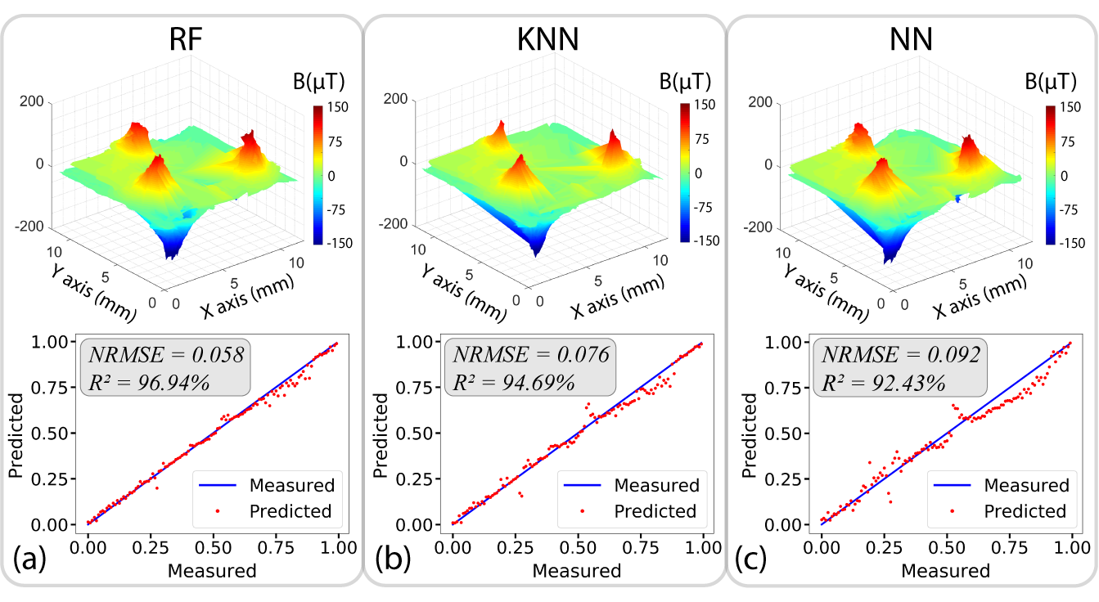
Fig. 8. Reconstructed calibration maps paired with one-dimensional validation of calibration data and predicted data using (a) RF, (b) KNN and (c) MLP-NN respectively.

TABLE II.
Calibration Comparison
Comparison | ML  Algorithm | Avg. Abs. Err. (µm) | NRMSE | Pearson Corr., R | R² (%)
Cal. (measured) vs. ML | RF | 250.2 | 0.058 | 0.985 | 96.94
 | KNN | 343.6 | 0.076 | 0.973 | 94.69
 | NN | 456.8 | 0.092 | 0.961 | 92.43
Cal. vs. Gaussian | - | 383.3 | 0.055 | 0.921 | 84.89

Validation – In vitro Needle Insertion
After reconstructing the calibration map with ML, the trained models were evaluated using a needle insertion into a PVC gel (see Section II.D.1 for details). The predicted deformation and optically measured deformation (using a camera) were compared in Fig. 9. Fig. 9(a) shows a time-lapse picture of the deformation along z-axis during the insertion. Fig. 9(b) illustrates the experimental setup. The MTJ sensor array was placed on the surface of PVC gel and aligned with the soft magnet with an initial z-directional distance of around 2 mm.
The predicted deformations using RF, KNN, and MLP-NN agreed closely with the camera measurements (Fig. 9(c)). The R² values also demonstrated excellent agreements: 96.75%, 98.16%, and 98.62% for RF, KNN, and MLP-NN, respectively. The Pearson correlation coefficients were +0.984, +0.991 and +0.993 which showed a strong positive correlation between the prediction and camera analyzed data. The absolute errors were 137.4 µm, 128.9 µm, and 90.0 µm and the NRMSE was 0.069, 0.069, and 0.046 for RF, KNN, and MLP-NN, respectively. The maximum deformation along the z-axis observed using the camera was 2.45 mm, the predicted values with RF, KNN and MLP-NN were 2.24 mm ± 0.168 mm, 2.41 mm ± 0.168 mm, and 2.23 mm ± 0.114 mm, respectively. The results are summarized in Table III.
The results from the z-direction validation confirmed that the predictions by the ML model correlate with the camera measurements. Although we observed a slightly larger error when z displacement was greater than 2 mm due to the sensing distance limitation (distance between the soft magnet and the MTJ sensor array neared the sensing limit of 4 mm), the results indicated that the sensing system could accurately track the vertical displacement of a soft magnet. Moreover, the sensing volume of the improved system should be sufficient for studies using rodent models whose skull thickness is less than 1 mm.

Validation – In Vivo Blast Wave Brain Deformation
The ML models were also evaluated by measuring the intracranial brain deformation due to blast waves. The sensor data were processed using both the 3-variable Gaussian [17] and the ML models. The results are shown in Fig. 10(a) and (b) for a dead and live animal, respectively. Fig. 10(c) and (d) are reconstructed three-dimensional deformation that represents the corresponding deformation trajectory with temporal information (color bars indicate time).
Table III summarizes the agreement between the predicted brain deformation trajectories using ML models and the calculated deformations using the Gaussian model. The average absolute errors were 41.11 µm, 37.02 µm, and 50.01 µm for the dead rat, and, 82.05 µm, 124.48 µm, and 97.90 µm for live rat using RF, KNN, and MLP-NN, respectively. The R² values calculated for the dead rat were 68.20%, 79.32%, 78.75%, and the live rat were 86.22%, 78.47% and 87.02% for RF, KNN, and MLP-NN, respectively. These results show that the predictions using MLP-NN resulted in the highest correlation. This is because the brain has a nonlinear viscoelastic deformation characteristic, which is difficult to model using simple linear regression models such as RF and KNN.
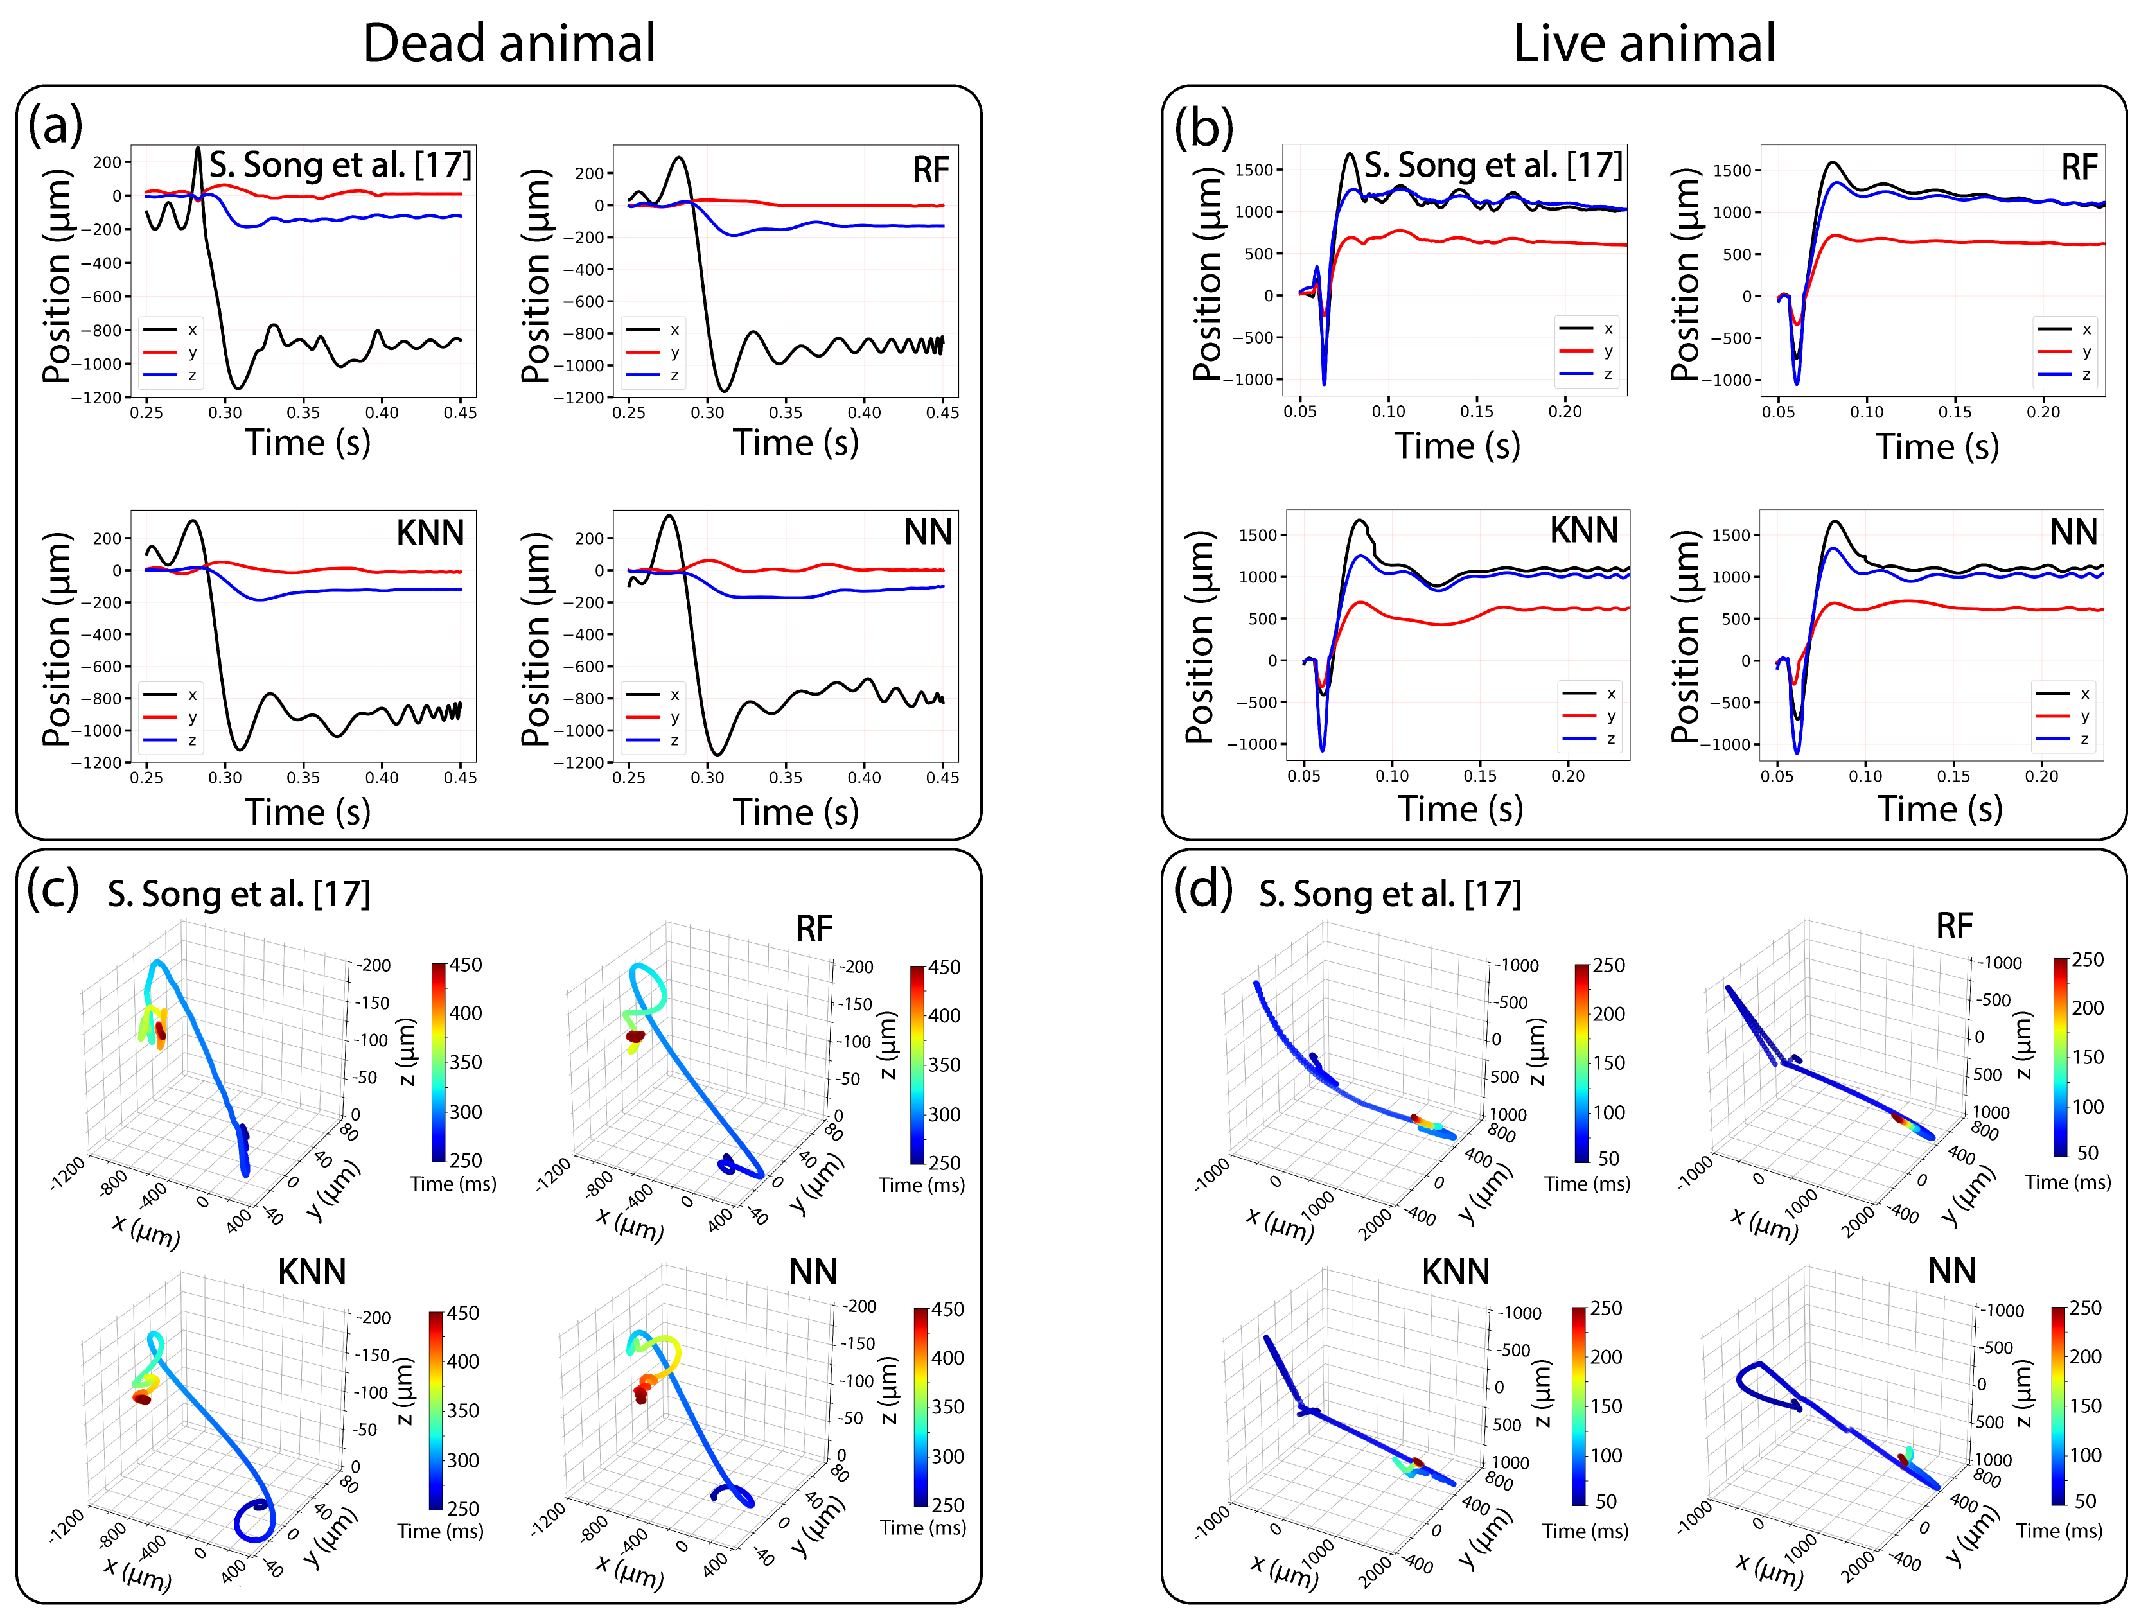
Fig. 10. Calculated and predicted in vivo brain deformation due to blast wave using (a) dead animal and (b) live animal targets. The reconstructed 3D brain deformation trajectory is shown for (c) dead animal and (d) live animal.
Note that there is no evidence to show which approach is more accurate due to the lack of validation method (imaging cannot sufficiently capture deformation with high temporal resolution in real-time). However, our experimental results support the hypothesis that the ML models represented the brain deformation more faithfully than the Gaussian model. Overall agreements between the ML models and measurements (i.e., calibration and camera measurement) showed over 90% agreement in terms of R². The agreement with the Gaussian model was moderate (R² < 90%).
TABLE III.
COMPARISON OF BRAIN DEFORMATION MEASUREMENT ACCURACY
Comparison | ML  Algorithm | Avg. Abs. Err (µm) | NRMSE | Pearson Corr., R | R² (%)
PVC gel  (Camera  vs. ML) | RF | 137.4 | 0.069 | 0.984 | 96.75
 | KNN | 128.9 | 0.069 | 0.991 | 98.16
 | NN | 90.0 | 0.046 | 0.993 | 98.62
Dead rat  (Gaussian  vs. ML) | RF | 41.1 | 0.126 | 0.777 | 68.20
 | KNN | 37.0 | 0.120 | 0.880 | 79.32
 | NN | 50.0 | 0.117 | 0.883 | 78.75
Live rat  (Gaussian  vs. ML) | RF | 82.1 | 0.078 | 0.928 | 86.22
 | KNN | 124.5 | 0.102 | 0.885 | 78.47
 | NN | 97.9 | 0.074 | 0.933 | 87.02
Calibration  (Gaussian  vs. ML) | RF | 576.6 | 0.085 | 0.902 | 81.42
 | KNN | 713.9 | 0.105 | 0.893 | 79.65
 | NN | 752.5 | 0.114 | 0.818 | 66.94

Conclusion
We have demonstrated a machine learning enabled wireless intracranial brain deformation sensing system. This system represents significant improvements in both the hardware and software components compared to our previous work. The system combines a novel magnetic sensing mechanism with robust machine learning algorithms. The sensing system is capable of measuring brain deformation in real-time over a large range of sensing distance (up to 4 mm). Our ML enabled sensing system is also versatile and can be used to provide information regarding the brain deformation in the study of various types of TBI injuries (e.g., needle insertion, concussion, blast wave).
It is also worth mentioning that the ML model can be further validated by linking the trajectory of brain deformation with histological analysis of brain tissue damage. This is the subject of ongoing research. We believe that this sensing system will enable testing hypotheses about pathogenesis post-TBI neuropathology in small animal models. This should aid in the development of new methods for injury prevention, diagnosis, and treatment.

Acknowledgment
The authors would like to thank Moonchul Park from Temple University for his help with the experimental setup, Vinit Shah from Temple University and Dr. Byoung-Gook Loh from Hansung University, South Korea for their valuable guidance with the machine learning aspects of this project.

References
[1] “Report to Congress on mild traumatic brain injury in the United States: steps to prevent a serious public health problem.,” Atlanta (GA), 2003.
[2] C. A. Taylor, J. M. Bell, M. J. Breiding, and L. Xu, “Traumatic Brain Injury–Related Emergency Department Visits, Hospitalizations, and Deaths — United States, 2007 and 2013,” MMWR. Surveill. Summ., vol. 66, no. 9, pp. 1–16, 2017.
[3] “Centers for Disease Control and Prevention (2019). Surveillance Report of Traumatic Brain Injury-related Emergency Department Visits, Hospitalizations, and Deaths—United States, 2014.”
[4] T. C. Holdeman, “Invisible Wounds of War: Psychological and Cognitive Injuries, Their Consequences, and Services to Assist Recovery,” Psychiatr. Serv., 2009.
[5] I. Cernak and L. J. Noble-Haeusslein, “Traumatic brain injury: An overview of pathobiology with emphasis on military populations,” Journal of Cerebral Blood Flow and Metabolism. 2010.
[6] M. R. Galarneau, S. I. Woodruff, J. L. Dye, C. R. Mohrle, and A. L. Wade, “Traumatic brain injury during Operation Iraqi Freedom: findings from the United States Navy–Marine Corps Combat Trauma Registry,” J. Neurosurg., 2008.
[7] K. Miller and K. Chinzei, “Constitutive modelling of brain tissue: Experiment and theory,” J. Biomech., vol. 30, no. 11–12, pp. 1115–1121, 1997.
[8] J. B. Long, T. L. Bentley, K. A. Wessner, C. Cerone, S. Sweeney, and R. A. Bauman, “Blast Overpressure in Rats: Recreating a Battlefield Injury in the Laboratory,” J. Neurotrauma, 2009.
[9] G. A. Elder et al., “Blast Exposure Induces Post-Traumatic Stress Disorder-Related Traits in a Rat Model of Mild Traumatic Brain Injury,” J. Neurotrauma, 2012.
[10] H. Ling, J. Hardy, and H. Zetterberg, “Neurological consequences of traumatic brain injuries in sports,” Mol. Cell. Neurosci., vol. 66, no. PB, pp. 114–122, 2015.
[11] L. Voo, S. Kumaresan, F. A. Pintar, N. Yoganandan, and A. Sances, “Finite-element models of the human head,” Medical and Biological Engineering and Computing. 1996.
[12] D. Rueckert, A. F. Frangi, and J. A. Schnabel, “Automatic construction of 3-D statistical deformation models of the brain using nonrigid registration,” IEEE Trans. Med. Imaging, 2003.
[13] L. M. Vigneron, R. C. Boman, J. P. Ponthot, P. A. Robe, S. K. Warfield, and J. G. Verly, “Enhanced FEM-based modeling of brain shift deformation in image-guided neurosurgery,” J. Comput. Appl. Math., vol. 234, no. 7, pp. 2046–2053, 2010.
[14] L. Zhang et al., “Recent Advances in Brain Injury Research: A New Human Head Model Development and Validation,” in SAE Technical Paper Series, 2018.
[15] F. Hernandez et al., “Six Degree-of-Freedom Measurements of Human Mild Traumatic Brain Injury,” Ann. Biomed. Eng., vol. 43, no. 8, pp. 1918–1934, 2015.
[16] M. Chavko, W. A. Koller, W. K. Prusaczyk, and R. M. McCarron, “Measurement of blast wave by a miniature fiber optic pressure transducer in the rat brain,” J. Neurosci. Methods, vol. 159, no. 2, pp. 277–281, 2007.
[17] S. Song, N. S. Race, A. Kim, T. Zhang, R. Shi, and B. Ziaie, “A Wireless Intracranial Brain Deformation Sensing System for Blast-Induced Traumatic Brain Injury.,” Sci. Rep., vol. 18, pp. 141–145, 2015.
[18] S. Cardoso et al., “Magnetic tunnel junction sensors with pTesla sensitivity,” in Microsystem Technologies, 2014, vol. 20, no. 4–5, pp. 793–802.
[19] Micro Magnetics, “Magnetic tunnel junction sensor development for industrial applications,” 2006.
[20] N. A. Stutzke, S. E. Russek, D. P. Pappas, and M. Tondra, “Low-frequency noise measurements on commercial magnetoresistive magnetic field sensors,” J. Appl. Phys., vol. 97, no. 10, pp. 1–4, 2005.
[21] S. Y. Khomutov, O. V. Mandrikova, E. A. Budilova, K. Arora, and L. Manjula, “Noise in raw data from magnetic observatories,” Geosci. Instrumentation, Methods Data Syst., vol. 6, no. 2, pp. 329–343, 2017.
[22] S. W. Smith, “Moving Average Filters,” in Digital Signal Processing, 2003.
[23] W. Li, B. Belmont, and A. Shih, “Design and Manufacture of Polyvinyl Chloride (PVC) Tissue Mimicking Material for Needle Insertion,” in Procedia Manufacturing, 2015.
[24] S. Budday et al., “Mechanical properties of gray and white matter brain tissue by indentation,” J. Mech Behav Biomed Mater, vol. 176, pp. 139–148, 2015.
[25] M. Skotak et al., “Rat injury model under controlled field-relevant primary blast conditions: Acute response to a wide range of peak overpressures,” J. Neurotrauma, vol. 30, no. 13, pp. 1147–1160, 2013.
[26] M. D. Alley, B. R. Schimizze, and S. F. Son, “Experimental modeling of explosive blast-related traumatic brain injuries,” Neuroimage, vol. 54, no. SUPPL. 1, pp. S45–S54, 2011.
[27] G. van Rossum, “Python Reference Manual,” CWI Rep. CS-R9524, 1995.
[28] F. Pedregosa et al., “Scikit-learn: Machine Learning in Python,” J. Mach. Learn. Res., vol. 12, pp. 2825–2830, 2011.
[29] M. H. Roy and D. Larocque, “Robustness of random forests for regression,” J. Nonparametr. Stat., vol. 24, no. 4, pp. 993–1006, 2012.
[30] G. Biau, “Complete Analysis of a Random Forest Model,” J. Mach. Learn. Res., vol. 13, pp. 1063–1095.
[31] S. Sun and R. Huang, “An adaptive k-nearest neighbor algorithm,” Proc. - 2010 7th Int. Conf. Fuzzy Syst. Knowl. Discov. FSKD 2010, vol. 1, no. Fskd, pp. 91–94, 2010.
[32] K. Chomboon, P. Chujai, P. Teerarassammee, K. Kerdprasop, and N. Kerdprasop, “An Empirical Study of Distance Metrics for k-Nearest Neighbor Algorithm,” in Proceedings of the 3rd International Conference on Industrial Application Engineering, 2015, no. December, pp. 280–285.
[33] P. C. Mahalanobis, “On the generilised distance in statistics,” Proc. Natl. Inst. Sci. India, vol. 2, no. 1, pp. 49–55, 1936.
[34] S. Lek and Y. S. Park, “Artificial Neural Networks,” pp. 139–194, 2013.

Manuscript received Month DD, YYYY; revised Month DD, YYYY; accepted Month DD, YYYY. Date of publication Month DD, YYYY; date of current version Month DD, YYYY. Asterisk indicates corresponding author. S. Islam is a graduate student in the Department of Electrical and Computer Engineering, S.T.R. Gidde is a graduate student in the Department of Mechanical Engineering at Temple University, Philadelphia, PA, USA. P. Hutapea is a Professor in the Department of Mechanical Engineering, Temple University. S. H. Song is an Assistant Professor in the Department of Electronics Engineering, Sookmyung Women’s University, Seoul, Korea. J. Picone is a Professor in the Department of Electrical and Computer Engineering, Temple University, and *A. Kim is an Assistant Professor in the Department of Electrical and Computer Engineering, Temple University, Philadelphia, PA. (e-mail: albertkim@temple.edu).

