# LIST OF FIGURES

Figure 1. The internal states and observations are shown for an LDM.

Figure 2. State predictions for an LDM model using a Kalman filter are shown.Figure 6. In our approach to predicting search term reliability, we decompose terms into features, such as N‑grams of phonemes and the number of phonemes, and apply these features to a variety of machine-learning algorithms.

Figure 3. A Kalman filter with RTS smoothing produces smoother state trajectories.Figure 8. Feature importance based on the RF algorithm is shown. The feature ”count,” which represents the frequency of occurrence of a word, is by far the singlemost valuable feature since it is not correlated with any of the other features.

Figure 4. The EM evolution as a function of iteration is shown for a variety of state dimensions. EM training procedure converges quickly, requiring no more than 10 iterations.

Figure 5. A hybrid HMM/LDM architecture is shown in which LDM is used to postprocess phone hypotheses using HMM segmentations.

# Figures

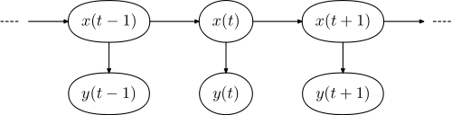

Figure 1. The internal states and observations are shown for an LDM. Every observable has a corresponding hidden internal state.

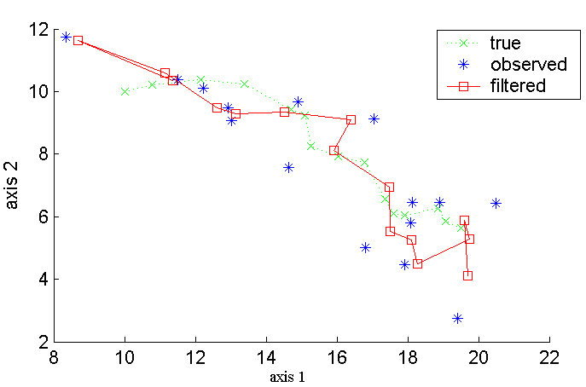

Figure 2. State predictions for an LDM model using a Kalman filter are shown.

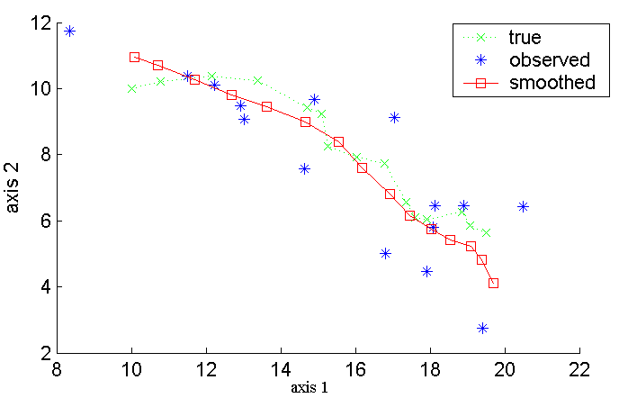

Figure 3. A Kalman filter with RTS smoothing produces smoother state trajectories.

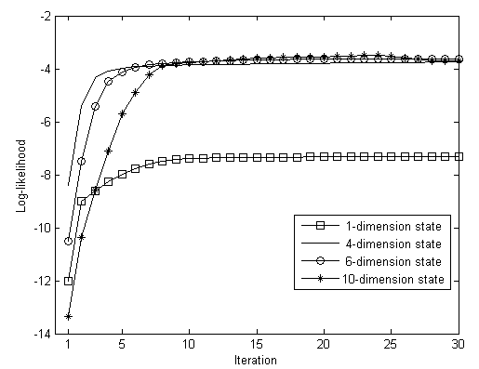

Figure 4. The EM evolution as a function of iteration is shown for a variety of state dimensions. EM training procedure converges quickly, requiring no more than 10 iterations.



Figure 5. A hybrid HMM/LDM architecture is shown in which LDM is used to postprocess phone hypotheses using HMM segmentations.