**LIST OF FIGURES**

Figure 3. A Kalman filter with RTS smoothing produces smoother state trajectories.

Figure 4. The EM evolution as a function of iteration is shown for a variety of state dimensions. EM training procedure converges quickly, requiring no more than 10 iterations.

Figure 5. A hybrid HMM/LDM architecture is shown in which LDM is used to postprocess phone hypotheses using HMM segmentations.

# Figures

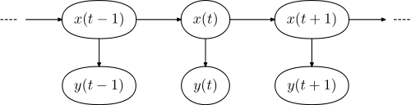

Figure 1. The internal states and observations are shown for an LDM. Every observable has a corresponding hidden internal state.

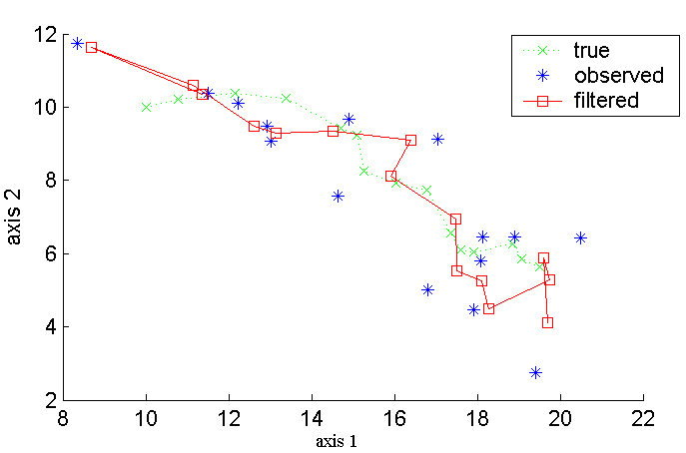

Figure 2. State predictions for an LDM model using a Kalman filter are shown.

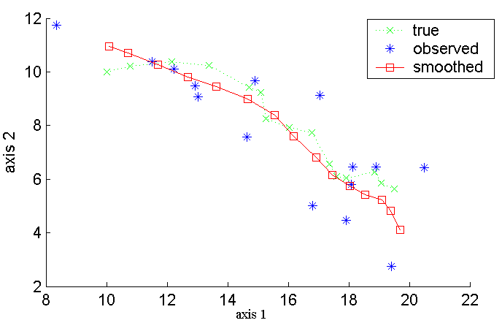

Figure 3. A Kalman filter with RTS smoothing produces smoother state trajectories.

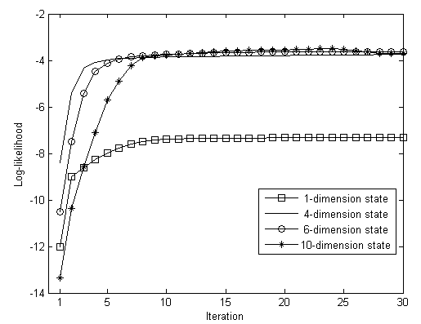

Figure 4. The EM evolution as a function of iteration is shown for a variety of state dimensions. EM training procedure converges quickly, requiring no more than 10 iterations.



Figure 5. A hybrid HMM/LDM architecture is shown in which LDM is used to postprocess phone hypotheses using HMM segmentations.