Engineers have played a central role in the advancement of civilization for thousands of years. In the past 200 years, the field has evolved dramatically and new specializations such as electrical, computer and biomedical engineering have emerged. This evolution will continue as electrical engineers face critical new challenges such as sustainable energy and transhumanism. Engineers are known for solving real world problems in real time and are often unsung heroes in the advancement of science. Therefore, even though the engineering profession is many centuries old, engineering remains vital to the science and technology interests of society.
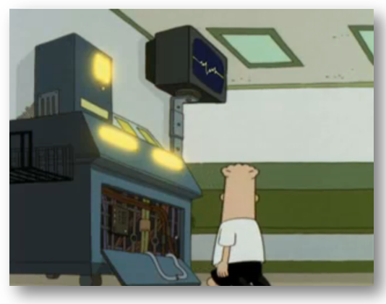
(Click on the picture
to learn more.)

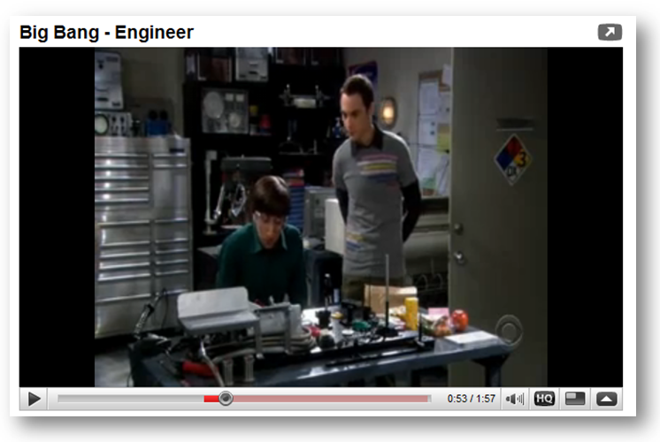
(Click on the picture
to learn more.)
How do you know an engineering career is right for you? One of my favorite stories came from the parent of a former student. When this student was 10 years old he nearly burned down his house attempting to build a large capacitor out of aluminum foil. The only thing that will motivate you to persevere through the math, physics and electronics is your love of designing and building “cool stuff.”
An engineering education at Temple is not just about coursework or research, but all about rewarding job opportunities, lifelong learning and professional development. Our students receive personal attention from our faculty and develop lifelong relationships in what we refer to as the engineering education lifecycle. There is always a shortage of good, creative engineers who can make a difference.

(Click on the picture
to learn more.)

Our undergraduate program offers degree options in electrical, computer and bioengineering. Our graduate program emphasizes three areas: signal and image processing, controls, and hardware. Our faculty are also active in related areas such as communications, energy systems, intelligent systems, microelectronics and robotics.
If you want to learn more about the innovative program we are building at Temple, visit ECE@Temple or follow us on Facebook. I would like to extend a personal invitation to you to visit our department and give us a chance to convince you that Temple is the right university for you.
Joseph Picone, Ph.D.
Chair and Professor, Department of Electrical and Computer Engineering
Tel: 215-204-4841
Email: picone@temple.edu

