A MACHINE LEARNING APPROACH TO AUTOMATED IDENTIFICATION OF ABNORMAL EEGS
S. López, G. Suarez, D. Jungreis, I.Obeid and J. Picone
Neural Engineering Data Consortium
Temple University
Philadelphia, Pennsylvania, USA
{silvia.lopez, gabriella.suarez, david.jungreis, obeid, picone}@temple.edu

Abstract—The interpretation of Electroencephalograms (EEGs) is a process that is still dependent on the subjective analysis of the examiners. The high interrater agreement for the results of this test is extremely important for its validity in diagnosis. In the present study, a state of the art machine learning approach based in the random forest ensemble learning method is proposed for the automated classification of normal and abnormal EEGs. This process could potentially reduce the visual bias inherent to the EEG interpretation and save time for the physicians. The computation of the residuals obtained from the principle components of the concatenated MFCC, differential energy and delta feature vectors allowed to reduce the dimensionality of the input vectors, allowing to establish a less computationally expensive system. The study showed that the performance of the system increased as the Principal Components Analysis (PCA) increased, with the best recorded performance being 64.86% correct classification. This performance was then compared to the method of guessing based on priors, which yielded a performance of 50.25%.

I. Introduction

Electroencephalography (EEG), or the recording of the electrical activity of the brain, has become a relatively inexpensive and practical way to demonstrate the physiological manifestations related to conditions such as epilepsy, seizures, sleep disorders and several types of mental status alterations [1]. The interpretation of EEGs, however, depends heavily on the subjective judgement of the examiner, situation that could lead to misdiagnosis or missed events in the record [9].
Maintaining a certain level of interrater agreement for the EEG interpretation plays a key role in the assessment of the validity of this diagnostics technique [9]. This affirmation is reinforced by the sensitivity levels of the EEG for the diagnosis of conditions such as epilepsy. Essentially, only 50% of the patients with epilepsy show interictal epileptiform discharges (IED) in their first EEG, number that is reduced in significance by the fact that at least 30% of non-epileptic patients with other conditions or injuries show this behavior in their recordings [10]. Hence, majority of the patients that present symptoms that could be related to an epileptic disorder must be subjects to more than one EEG prior to a diagnosis.
In this sense, the automated classification of EEGs as normal or abnormal records represents a significant step for the reduction of the visual bias intrinsic to the subjectivity of the record’s interpretation. Additionally, the assisted interpretation of the background patterns existing in the signal could help the specialized neurologists save time in their daily EEG interpretation routine, easing some of the service pressures that arise from the increasing demand of EEGs [10].
The classification of an EEG record as normal or abnormal is an assessment that is made through the observation and examination of certain characteristics, or lack thereof that contribute to the normality of the record. The main characteristics of an adult normal EEG are [11]:
- Reactivity: Response to certain physiological changes or provocations.
- Alpha Rhythm: Waves originated in the occipital lobe (predominantly), which should be between 8-13 Hz and 15 to 45 μV.
- Mu Rhythm: Central rhythm of alpha activity commonly between 8-10 Hz visible in 17% to 19% of adults.
- Beta Activity: Activities in the frequency bands of 18-25 Hz, 14-16 Hz and 35-40 Hz
- Theta Activity: Traces of 6-7 Hz activity present in the frontal or frontocentral regions of the brain.
The visual analysis of EEGs starts with the observation of the occipital alpha rhythm. A decision about the normality of the record heavily depends on the frequency, presence or distortion of this feature [11]. In this sense, the posterior dominant rhythm (PDR) or alpha rhythm, is taken in this study as the main decisive feature for the establishment of a normal/abnormal classification baseline, mainly because of its distinctive and prevalent characteristics in the normal EEG. Additionally, the fact that this feature appears mostly occipitally provides a logical advantage for the purpose of the formation of an experimental paradigm, because it allows to select one occipital channel from each recording to make a classification (see methodology).

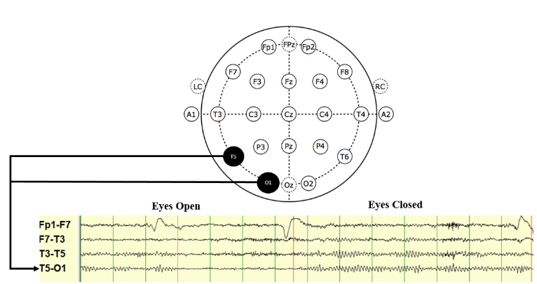

Figure 1. Emergence of the Posterior Dominant Rhythm (PDR) when the subjects eyes are closed. The channel that was used for classification and their spacial ubication are highlighted in the diagram.
The present study focuses on the setup of an experimental paradigm for the automated normal/abnormal classification of EEGs through state of the art machine learning techniques. For this purpose, a baseline is established and compared with the classification performance that would result from the guessing based on priors.

II. Methodology
The data that was utilized for the establishment of the first baseline for the normal/abnormal classification of EEGs, consists of a subset of the publicly available TUH EEG Corpus. This database is completely comprised of clinically recorded EEGs, which provides a statistically representative set for the purposes of the experiment [2]. The records were randomly selected from the normal and abnormal subsets of the database, which resulted in the selection of 200 abnormal and 202 normal EEGs. The distribution of the data for the establishment of the baseline can be seen in Table 1.
Table 1. Distribution of the data for the Baseline
Set | Normal | Abnormal
Training | 102 files | 100 files
Development | 50 files | 50 files
Evaluation | 50 files | 50 files

It can be seen from Table 1 that for the normal category 102 EDF files were used for training, 50 for development and 50 were held out for evaluation. In a similar way, 100 EDF files were used for the training of the abnormal category, while 50 files were used for development and evaluation. It is important to point out that the data was selected to be representative of the entire TUH EEG Corpus and, therefore, the selected recordings are uniformly distributed throughout the years 2003 and 2013.
To set an appropriate experimental paradigm in place, only one EEG channel was selected to be taken into consideration. After the research discussed in the previous section and the examination of EEG interpretation techniques practiced by licensed neurologists, it was agreed that an important channel to take into consideration would be T5-O1. This channel represents the difference between two electrodes located in the left temporal and occipital lobes. The spatial representation of this channel for a TCP montage is highlighted in Figure 1.
The first 60 seconds of each recording were used to extract signal features. The features were extracted through a standard cepstral coefficient-based approach that resembles the Mel Frequency Cepstral Coefficients (MFCCs) utilized in speech recognition [3], [4], [5]. However, differing from the approach utilized in speech recognition, for EEGs a linear frequency scale was implemented. To be more specific, 8 cepstral features (the zeroth-order coefficient was replaced with a temporal energy term) were extracted and augmented with a differential energy term to model the long-term changes in the energy of the signal.
$E_{d}=\max_{m}\left(E_{f}\left(m\right)\right)-\min_{m}\left(E_{f}\left(m\right)\right)$ (1)
The differential energy feature shown in Equation (1) examines the energy of the signal over a range of M frames centered in the current frame. The feature value computed for each frame would be given by the difference between the maximum and minimum energy terms in that particular frame. This last described feature augmented the previously described 8 cepstral coefficient vector to a 9-element feature vector. This features were further expanded through the computation of the 9-element feature vector’s first and second derivative terms through the approach described in [5]. As a result of this post-processing techniques, a 27-dimension feature vector was obtained.
The time and space complexity inherent to the dimensionality of the computed feature vectors was reduced through the representation of the data in a lower dimensional space. This was achieved through the computation of the residuals obtained from the retention of the principal components of the concatenated matrix comprised by the feature vectors [6].

III. Random Forest
The baseline for the normal/abnormal classification of EEGs was computed through a random forest approach, mainly because of the ease for tuning and training and the close performance that the technique has shown in comparison to boosting [12]. The algorithms described in [12] are used for the formation of an ensemble of trees${ \left\{T_{b}\right\}}_{1}^{B}$, which produce an output classification given by Equation (2).
${\hat{C}}_{rf}^{B} \left(x\right)=majority vote {\left\{{\hat{C}}_{b}\left(x\right)\right\}}_{1}^{B}$ (2)
In essence, a class prediction ${\hat{C}}_{b}\left(x\right)$ for the bth tree is produced, and the final classification decision ${\hat{C}}_{rf}^{B} \left(x\right)$is made in accordance to the majority of the classification results yielded by the ensemble of trees. For the purposes of the present experiments, the size of the forest utilized was of 50 trees.

IV. Experimental Results
In order to assess the impact of the dimensions of the input feature vectors to the system performance, the classification results were generated for several PCA dimensions. The performance of the system was then compared to the results that could be obtained through the guessing based on prior probabilities. Figure 2 shows the classification error as a function of the PCA dimensions.
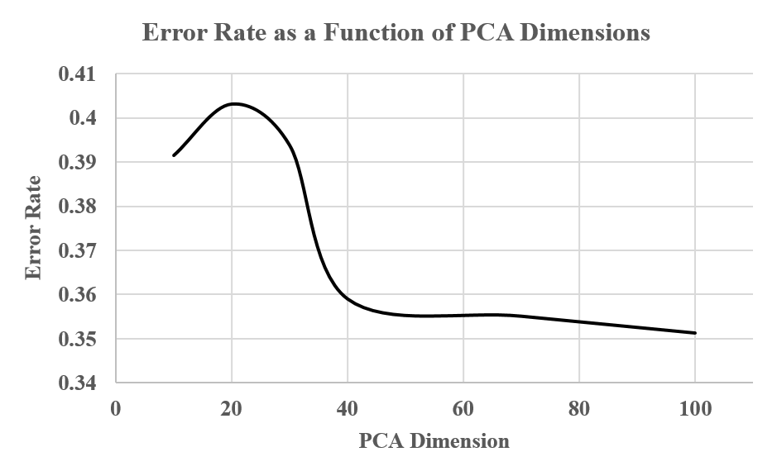Figure 2. The Error rate of the system decreases as the PCA dimensions for the input feature vectors increase. The best performance shown by the graph is obtained when the PCA dimensions are 100 and the error rate is 35.14%.
The performance of the random forest method was then compared to the performance that was obtained through the classification through guessing based on prior probabilities. Figure 3 shows the result of this comparison.
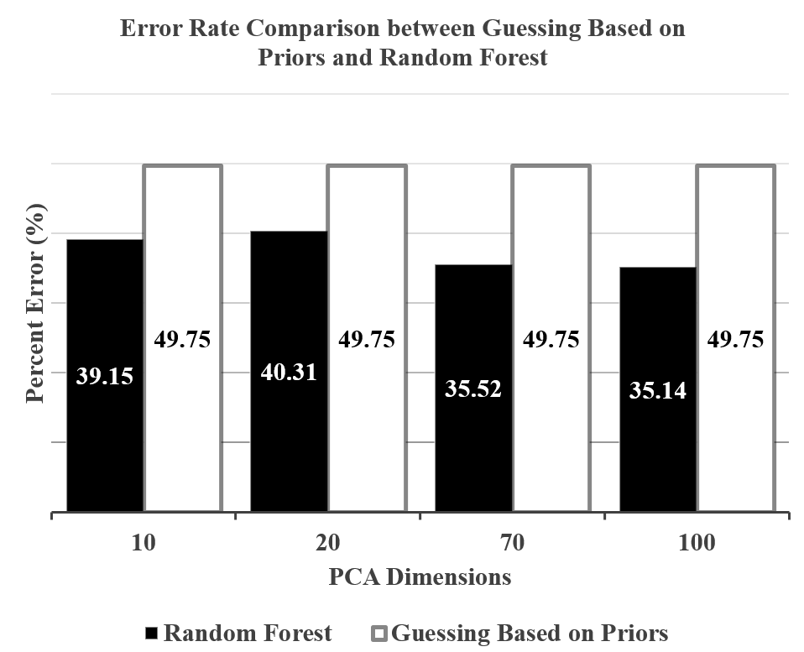
Figure 3. Classification comparison between the random forest approach and guessing based on priors. Some of the significant PCA dimensions were selected for the comparison.
Figure 3 shows the classification percent errors from the two different classification methods for different PCA dimensions.

V. Discussion
The conducted experiments showed important information about the performance of the system. In the first place, it can be observed that the performance of the classification is strongly affected by the PCA dimensions that are used to reduce the input vectors. In essence, Figure 2 shows that the error rate of the system decreases significantly as the PCA dimensions are increased. The best performance recorded by the experiment was 64.86% observed when the PCA was 100.
When the error rate of the random forest approach was compared to the error of the guessing based on priors, it was observed that even the worst performance for the random forest approach resulted in a better classification error than the guessing based on priors. Different performances from different PCA dimensions were chosen in order to make a complete comparison. The performances at 10 (initial), 20 (worst), 70, and 100 (best) were the ones selected, and the ones represented in Figure 3.

VI. Validation

VII. Future Work
Future work for the improvement of the system will include the addition of several events of interest that will potentially add important information for the classification process. The events of interest that will be labeled and used for the final classification decision were decided through the study of [11], which presented the following as important variants for the classification of normal/abnormal EEGs:
- Spike and Wave
- Focal Slowing
- Triphasic Wave
- PLED
- GPED
- Positive Occipital sharp Transients of sleep
With standard machine learning approaches, the labels proposed above will be recognized by the system and utilized as valuable information of the final classification of the EEG. The techniques used for the system’s improvement will be based in the incorporation of more sophisticated temporal modeling (i.e. Hidden Markov Models) in an approach similar to the one followed by [2].

VIII. Summary
The present study has focused in the establishment of a proper experimental paradigm for the automated classification of normal/abnormal EEGs. A baseline experiment has been set for reference of future studies in the issue. The classification decisions were made through the random forest ensemble learning method and the results were later compared to the performance obtained from the guessing based on prior information. The experiments conducted have shown that the random forest approach is better than the guessing based on priors even for the worst performance obtained through different PCA dimensions.
EEG interpretation knowledge presented in [8], [9], [10] and [11] has been used in order to establish a system that resembles the common methods and techniques implemented by the specialized neurologists but increases the interrater agreement through the introduction of this automated classification method. Essentially, the knowledge about the posterior dominant rhythm and its particular characteristics was used for the selection of a significant EEG channel for this particular study.
As it was established, state of the art machine learning techniques will be applied for the improvement of the system through the introduction of new labels that will augment the amount of information that is used in order to make a classification decision and more sophisticated temporal modeling techniques, such as Hidden Markov Models.

Acknowledgements
The primary funder of this research was the QED Proof of Concept program of the University City Science Center, Research reported in this publication was also supported by the National Human Genome Research Institute of the National Institutes of Health under Award Number U01HG008468 and the National Science Foundation through Major Research Instrumentation Grant No. CNS-09-58854. The TUH EEG database work was funded by the Defense Advanced Research Projects Agency (DARPA) MTO under the auspices of Dr. Doug Weber through the Contract No. D13AP00065, Temple University’s College of Engineering and Temple University’s Office of the Senior Vice-Provost for Research. Finally, we are also grateful to Dr. Mercedes Jacobson, Dr. Steven Tobochnik and David Jungries of the Temple University School of Medicine for their assistance in developing the classification paradigm used in this study and for preparing the manually annotated data

References
[1] Fahoum F, Lopes R, Pittau F, Dubeau F, Gotman J. Widespread epileptic networks in focal epilepsies: EEG-fMRI study. Epilepsia. 2012 Sep. 53(9):1618-27
[2] A. Harati, S. Lopez, I. Obeid, M. Jacobson, S. Tobochnik, and J. Picone, “THE TUH EEG CORPUS: A Big Data Resource for Automated EEG Interpretation,” in Proceedings of the IEEE Signal Processing in Medicine and Biology Symposium, 2014, pp. 1–5.
[3] J. Picone, “Continuous Speech Recognition Using Hidden Markov Models,” IEEE ASSP Mag., vol. 7, no. 3, pp. 26–41, Jul. 1990.
[4] J. Lyons, “Mel Frequency Cepstral Coefficient (MFCC) tutorial,” Practical Cryptography, 2015. [Online]. Available: http://practicalcryptography.com/miscellaneous/machine-learning/guide-mel-frequency-cepstral-coefficients-mfccs/. [Accessed: 10-Oct-2015].
[5] S. Davis and P. Mermelstein, “Comparison of Parametric Representations for Monosyllabic Word Recognition in Continuously Spoken Sentences,” IEEE Trans. Acoust., vol. 28, no. 4, pp. 357–366, 1980.
[6] Jolliffe, I. T., Principal Component Analysis, 2nd Edition, Springer, 2002.
[7] Breiman, L. "Random Forests." Machine Learning. Vol. 4, 2001, pp. 5–32.
[8] Lodder SS, Askamp J, van Putten MJAM (2014) Computer-Assisted Interpretation of the EEG Background Pattern: A Clinical Evaluation. PLoS ONE 9(1):e85966. doi: 10.1371/journal.pone.0085966
[9] Azuma H, Hori S, Nakanishi M, Fujimoto S, Ichikawa N, et al. (2003) An intervention to improve the interrater reliability of clinical EEG interpretations. Psychiatr Clin Neurosci 57: 485–9. doi: 10.1046/j.1440-1819.2003.01152.x
[10] Smith,S J M. EEG in the diagnosis, classification, and management of patients with epilepsy. Journal of Neurology, Neurosurgery & Psychiatry, 2005, 76, suppl 2, ii2-ii7
[11] Ebersole, J. S., & Pedley, T. A. (2003). Current practice of clinical electroencephalography. Philadelphia: Lippincott Williams & Wilkins.
[13] Hastie, T., Tibshirani, R., & Friedman, J. H. (2009). The elements of statistical learning: Data mining, inference, and prediction. New York: Springer.

