Automated Interpretation and Visualization
in Digital Pathology
M.A. Al Mamun, S. Purba, I. Obeid and J. Picone
Neural Engineering Data Consortium, Temple University
1947 N 12th Street
Philadelphia, PA 19122

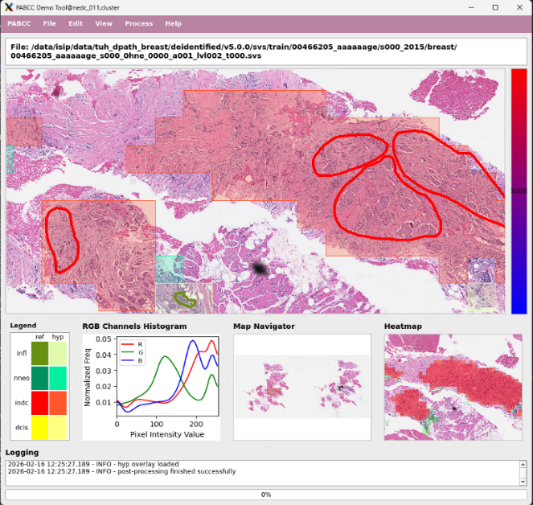
Figure 1. An interactive visualization of an annotated pathology image that includes a heatmap and confidence metrics

Abstract— There is a critical need for AI tools that support early screening and efficient tissue analysis in pathology. Despite tremendous advances recently in artificial intelligence, high performance segmentation of high-resolution pathology images remains an elusive goal. This paper introduces a deep learning based system that automatically interprets and visualizes digital pathology images. The proposed open source system utilizes a modular architecture that includes four major steps: preprocessing, decoding, post-processing, and visualization. Unlike generic off-the-shelf solutions, the inference engine is powered by deep learning models — specifically EfficientNet, ResNet, and Vision Transformers (ViT). These models have been trained on two recently released corpora: the Temple University Hospital Breast Cancer Corpus (TUBR) and the Fox Chase Cancer Center Breast Cancer Corpus (FCBR). The baseline system uses an optimized EfficientNet B0 model which balances computational efficiency with high-fidelity microsegmentation. An interactive graphical user interface facilitates direct comparison of an AI-generated hypothesis with expert ground-truth annotations via heatmaps and clinically weighted confidence metrics. On a standard image segmentation and classification task, a weighted error of 25.5% was achieved on TUBR using EfficientNet B7, while a weighted error of 25.0% was achieved on FCBR.
- INTRODUCTION
Breast cancer remains the most diagnosed cancer and the leading cause of cancer death among women globally. While the demand for cancer treatment continues to rise, diagnostic technology and the available workforce have lagged [1], leading to longer diagnosis times and delayed treatment. With any form of cancer, early detection and treatment is crucial. Pathology teams currently face growing pressure to review increasing caseloads with limited time and resources. Historically, pathologists have had to manually review every slide in a workflow, which is labor-intensive and quite fatiguing. Artificial Intelligence (AI) tools can ease this burden by prioritizing high-risk cases, and analyzing tissue more efficiently. However, these tools must be reliable (e.g., low false alarm rate) and clinically relevant.
In this work, we present an open source software platform designed to automatically interpret and visualize digital pathology images [1]. Unlike "black box" end-to-end pipelines, this tool was intentionally scoped to support interactive exploration and annotation review. It prioritizes high-risk images and enables pathologists to analyze predictions, compare expert annotations, and explore tissue structures to improve patient care. It was designed to support integration of new tools and algorithms, and leverages state of the art in deep learning-based image classification.
- DATASETS
A key differentiator of our system is the use of two robust open source digital pathology datasets [2] to train the inference models. These datasets are among the largest annotated collections of pathology slides in the world. To ensure clinical relevance and computational efficiency, we leverage these extensive data resources alongside optimized deep learning architectures. The models were trained using two open source resources: (1) the Temple University Hospital Digital Pathology Breast Tissue Subset (TUBR) and (2) the Fox Chase Cancer Center Digital Pathology Breast Tissue Subset (FCBR). TUBR consists of 3,505 high-resolution images from 296 patients, representing a diverse range of tissue types including normal, benign, and pre-cancerous lesions. FCBR consists of 1,463 oncology-focused slides from 1,397 patients, providing a rich source of invasive ductal carcinoma examples.
- MODEL ARCHITECTURES
To ensure the software is adaptable to different computational constraints, we trained and evaluated our system on multiple popular image processing architectures: ResNet-18 [3], EfficientNet (B0-B7) [4], and Vision Trans-formers (ViT-16/32) [5].
Extensive experiments [1] demonstrated that while the transformer-based architecture (ViT) and larger CNNs (EB7) offer strong theoretical performance, they incur significant computational costs. For the interactive system, we selected EB0 as the default engine. Complexity analysis shows that EB0, with approximately 5.3M parameters, provides a decoding time 1.7x faster than ResNet-18 while maintaining competitive accuracy. However, the software’s modular design allows researchers to easily swap in our trained ResNet and ViT models. We also explored the use of a SWIN model [6], but results were inconclusive.
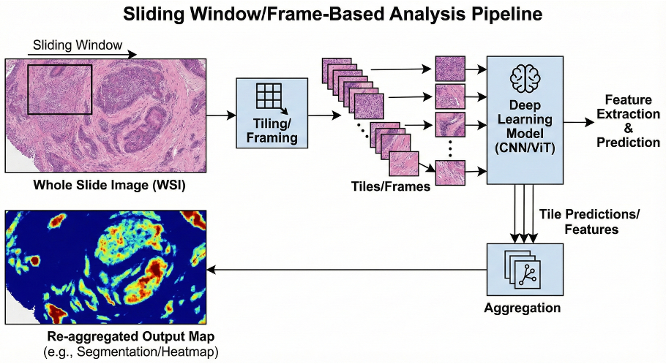
Figure 2. An overview of the digital pathology system workflow

- SYSTEM WORKFLOW
The automated interpretation system follows a sequential four-module workflow: preprocessing, decoding, post-processing, and visualization. An overview of the system is given in Figure 2:
Preprocessing: Before generating predictions, each whole slide image (WSI) begins with a preprocessing stage. Because WSIs are gigapixels in scale, the system splits the whole image into smaller $1024×1024$ image patches. This module includes an option to automatically normalize tissue regions by removing the white background, allowing the analysis to focus strictly on the tissue region.
Decoding: We refer to the core inference engine as a decoder. Instead of processing the entire slide simultaneously, the system uses a sliding window approach. The AI model analyzes normalized patches using an EB0 model. This model was trained to recognize specific histological features [1], including normal ducts (NORM), ductal carcinoma in situ (DCIS), invasive ductal carcinoma (INDC), non-neoplastic (NNEO) lesions and background. The frame-level predictions are generated using a specific window size (e.g., $1024×1024$) that was empirically determined to provide an optimal balance of spatial context and localization accuracy.
Post-processing: The AI model generates predictions at the frame level, which often appear as scattered, independent predictions that lack spatial continuity. In the post-processing phase, these raw frame outputs are mapped back to the original slide coordinates. We implemented and compared several algorithms to aggregate these frames, including Label Priority, Confidence Priority, and k-Nearest Neighbors (kNN) smoothing. Our internal benchmarks indicated that kNN Smoothing achieved the highest performance (MDICE scores of 25.5% on TUBR), effectively refining local inconsistencies and producing coherent polygonal regions for visualization. This algorithm updates a label based on the consensus of the most similar neighbors within a local window, ensuring smoother, more accurate boundaries.
Visualization: The final component, and perhaps the most interesting, is the visualization module, which provides an intuitive GUI for reviewing the AI's “thought process.” To efficiently handle large image files, which are in an SVS format, the viewer loads a low-resolution thumbnail initially and dynamically streams high-resolution tiles as users zoom and pan. The decoder output includes a heat map that is displayed in the lower right of Figure 1. The system also provides a confidence bar on the right-hand side of the interface that quantifies prediction confidence. This confidence logic has been optimized to be clinically relevant. For instance, DCIS receives the highest weight due to clinical risk, while non-neoplastic tissue receives the lowest.
The tool is specifically designed for hypothesis validation. Users can view the AI predictions (displayed as non-linear shapes) overlaid directly with ground-truth reference annotations (displayed as pen-shaped drawings). This layered view allows researchers to visually assess how well the model delineates complex histological boundaries.
- CONCLUSIONS
This automatic interpretation system, which we refer to as the NEDC Digital Pathology (DPATH) Demo, combines high-resolution imaging with robust deep learning models trained on large-scale, diverse corpora. The system leverages well-known deep learning models such as EB0, ResNet and ViT, and delivers high fidelity microsegmentations. Localization of information allows clinicians to spend less time searching and more time interpreting images and diagnosing diseases. Manual interpretation of such images is a time consuming and exhausting process. Using a modified MDICE score described in [1], we have achieved a weighted error of 25.5% on TUBR and 25.0% on FCBR using an EB7 model. These are the first published results on these tasks.
This system is open source and available at the URL: www.nedcdata.org. To learn more about our resources, follow the subscription instructions at this URL.
ACKNOWLEDGMENTS

The authors would like to thank C. Dumitrescu and D. Heathcote for their significant contributions to this system. We also would like to acknowledge M. Bagritsevich and D. Hackel for their work on the development of the annotated corpora. This material is based on work supported by several organizations over the years including the National Science Foundation (grants nos. 2211841, 1726188, and 1925494), the Temple University Catalytic Collaborative Funding Initiative, and most recently by the Pennsylvania Breast Cancer Coalition Breast and Cervical Cancer Research Initiative.
REFERENCES

- D. Hackel, M. Bagritsevich, C. Dumitrescu, Md. A. Al Mamun, S. A. Purba, D. Heathcote, I. Obeid, and J. Picone, “Enabling Microsegmentation: Digital Pathology Corpora for Advanced Model Development,” in Signal Processing in Medicine and Biology: Applications of Artificial Intelligence in Medicine and Biology, New York City, New York, USA: Springer, 2026, p. 50. [Online]. Available: https://isip.piconepress.com/publications/book_sections/2026/springer/dpath/.
- S. S. Shalamzari, M. Bagritsevich, Melles, Anne-Mai, I. Obeid, J. Picone, D. Connolly, C. Wu, B. Brown, J. James, Y. Gong, and H. Wu, “Big Data Resources for Digital Pathology,” in Proceedings of the IEEE Signal Processing in Medicine and Biology Symposium, Philadelphia, Pennsylvania, USA: IEEE, 2023, pp. 1–19. doi: 10.1109/SPMB59478. 2023.10372721.
- K. He, X. Zhang, S. Ren, and J. Sun, “Deep Residual Learning for Image Recognition,” in Proceedings of the IEEE/CVF Conference on Computer Vision and Pattern Recognition (CVPR), Las Vegas, Nevada, USA, 2016, pp. 770–778. doi: 10.1109/CVPR.2016.90.
- M. Tan and Q. V. Le, “EfficientNet: Rethinking Model Scaling for Convolutional Neural Networks,” in Proceedings of the International Conference on Machine Learning (ICML), K. Chaudhuri and R. Salakhutdinov, Eds., in Proceedings of Machine Learning Research, vol. 97. Long Beach, California, USA: PMLR, May 2019, pp. 6105–6114. doi: http://proceedings.mlr.press/v97/tan19a.html.
- A. Dosovitskiy, L. Beyer, A. Kolesnikov, D. Weissenborn, X. Zhai, T. Unterthiner, M. Dehghani, M. Minderer, G. Heigold, S. Gelly, J. Uszkoreit, and N. Houlsby, “An Image is Worth 16x16 Words: Transformers for Image Recognition at Scale,” in Proceedings of the International Conference on Learning Representations (ICLR), Vienna, Austria: OpenReview.net, 2021, pp. 1–21. doi: https://iclr.cc/virtual/ 2021/oral/3458.
- Z. Liu, H. Hu, Y. Lin, Z. Yao, Z. Xie, Y. Wei, J. Ning, Y. Cao, Z. Zhang, L. Dong, F. Wei, and B. Guo, “Swin Transformer V2: Scaling Up Capacity and Resolution,” in 2022 IEEE/CVF Conference on Computer Vision and Pattern Recognition (CVPR), 2022, pp. 11999–12009. doi: 10.1109/CVPR52688.2022.01170.

