Fluency in Imagined Speech Decoding Using Non-Invasive Techniques: A Review
S. Shrividya^{1,2}, S. Thundiyil¹ and J. Picone³
1. CNER Lab, BMS Institute of Technology & Management, Bengaluru, India
2. College of Engineering, Northeastern University, Boston, USA
3. Neural Engineering Data Consortium, Temple University, Philadelphia, Pennsylvania, USA
shrividya.shashidhara@gmail.com, saneesh@bmsit.in, picone@temple.edu
Imagined speech is defined as the internal simulation of speaking without producing audible sound [1]. Brain–computer interfaces (BCIs) that decode imagined speech into text promise a communication channel for individuals with severe speech impairments. While most efforts have targeted word or phoneme level classification using electroencephalography (EEG), magnetoencephalography (MEG) and functional near infrared spectroscopy (fNIRS) as modalities, the capacity to decode continuous, coherent, and contextually relevant imagined speech remains as an active area of research. This review examines literatures that focuses on neuro-cognitive basis of imagined speech, non-invasive neural acquisition modalities, surveys signal processing and decoding methodologies, and scrutinize fluency-specific challenges and metrics, outlining benchmarks, current limitations. While prior reviews have addressed word-level and phoneme-level classification [3, 4], in this review we focus on fluency-specific challenges.
This review synthesizes research on non-invasive imagined speech decoding with emphasis on fluency. The search terms such as "imagined speech," "imagined speech BCI," "EEG/MEG/fNIRS decoding," and "continuous speech decoding” were used to gather the literature. Papers emphasizing recent advances in deep learning architectures, transfer learning, and language model integration were commonly used in this process [3, 4]. Current findings are drawn from 109 papers, organized into five thematic sections. The number of papers reviewed, and their corresponding focus areas are presented in Figure 1.
Analysis of the neurocognitive foundations literature reveals that imagined speech is a motor-grounded, hierarchically organized cognitive process. The phenomenon represents a truncated form of overt speech, sharing similar neural pathways while lacking the final articulatory execution phase. The interdependence of motor/articulatory and auditory-perceptual components demonstrate that imagined speech is not merely "silent speech" but a distinct phenomenon whose multidimensional variability, temporal processing constraints, and individual differences in strategy have critical implications for imagined speech BCI development. Functional neuroimaging and neurolinguistics research highlight a core network for imagined speech involving the inferior frontal gyrus (Broca’s area), supplementary motor area, and superior temporal gyrus, interacting via the phonological loop to support lexical access and syntax generation. Fluent imagined speech requires rapid lexical retrieval, seamless syntax assembly, and dynamic working memory updates to manage serial order and semantic coherence. Break-downs in any component can manifest as hesitations or incoherent output [2].
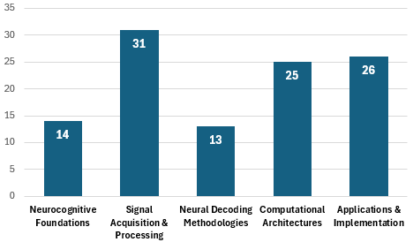
Figure 1. Overview of the literature based on focus area

We reviewed 13 research articles on non-invasive neural decoding. These studies predominantly EEG or MEG often in combination with fNIRS, to classify imagined phonemic or word level speech commands. The superior temporal resolution of an EEG makes it the predominant modality for imagined speech BCIs. Reviews report classification accuracies for small vocabularies (3–5 words) between 60–95% using feature extraction and deep learning [3]. However, EEG suffers from low spatial resolution and high susceptibility to noise and artifacts, impairing continuous decoding of fluent speech. MEG captures brain activity with millisecond temporal precision comparable to EEG, while providing better spatial resolution for localizing neural sources. However, MEG systems require magnetically shielded rooms and expensive sensor arrays, limiting accessibility compared to EEG, and generate large data volumes that complicate real-time processing [4]. Despite these constraints, subject-independent MEG decoding (where models generalize to new users without retraining) has achieved accuracies approaching those of subject-dependent systems through domain adaptation and curriculum learning [5], demonstrating MEG's potential for practical, fluent BCIs for speech decoding. fNIRS offers greater spatial resolution in comparison with EEG but limited by latency that constrains real-time fluency [6].
Across 31 studies in Signal Acquisition and Processing, it is noted that the focus is clearly on improving the quality of the data in non-invasive methods. The typical steps followed are signal collection, preprocessing, and artifact reduction. Independent component analysis and related techniques are commonly used for artifact removal. This is supported by regression and adaptive filters when reference signals are available. Building on these preprocessing techniques, recent work emphasizes the design of effective feature representations for fluent decoding. Traditional approaches segment signals into fixed windows, extracting spectral features such as power spectral density, band power. Sliding windows combined with deep learning methods such as Convolutional Neural Networks and Bidirectional Long Short-Term Memory networks are used in the recent approaches to capture temporal dependencies [7]. Transfer learning strategies, further refine feature extraction by leveraging simpler binary tasks (imagined speech vs. rest) to improve multi-class decoding performance [8].
Most of the papers that discuss computational architectures are focused on deep learning for EEG-based BCIs. CNNs and RNNs outperform traditional methods but face challenges in data scale and interpretability. In imagined-speech decoding, CNN variants and transformer-based models such as EEGformer [9] achieve strong multiclass performance by modeling temporal and frequency dependencies. Hybrid architectures like CTNet enhance generalization and efficiency, while transfer learning and cross-subject adaptation address data scarcity.
Integrating pre-trained NLP models and RNN-based models, enables contextual smoothing in EEG-to-text decoding. Techniques like beam search and probabilistic decoding can re-rank output hypotheses, while GPT-style autocorrection adjusts word sequences for coherence. Post processing pipelines leveraging these models typically include constrained re-ranking, confidence threshold calibration, and strategies to ground outputs and mitigate hallucinations. Such hybrid approaches can transform word-level predictions into coherent sentence strings. A summary of these post-processing techniques is shown in Figure 2.
Lexical continuity and syntactic coherence define fluency in BCI outputs. Key matrices that are used to measure fluency are Words per Minute (WPM), Sentence Coherence Score, Latency and Perplexity. While these matrices provide quantitative measures of fluency, subjective assessments such as user satisfaction, perceived naturalness etc., complement objective metrics but lack standardization. Developing benchmark tasks and combined fluency indices is critical for rigorous evaluation. Public EEG datasets such as the Chinese Imagined Speech Corpus (Chisco) with more than 20,000 sentences of high-density EEG recordings of imagined speech from healthy adults facilitate large-scale model training [10].
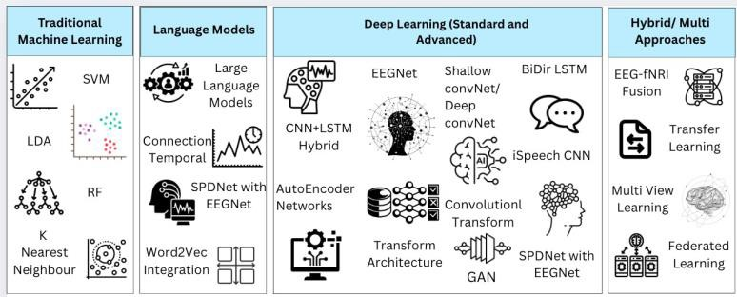
Figure 2. Machine learning and Deep Learning Approaches.

Decoding of imagined speech using non-invasive BCIs remains a challenge. Progress from word-level classification to continuous text generation requires high quality neural recording, advanced decoding architectures, and powerful language models, supported by standardized datasets and fluency-focused evaluation frameworks. Authors are creating a standard dataset while reviewing the state of the art and updates to this review, will be available at https://github.com/cnerlab/brain-to-text/. We acknowledge the Vision Group of Science and Technology, Karnataka, India, for supporting this review by providing facilities under GRD1116.
References
- Kraemer, David JM, C. Neil Macrae, Adam E. Green, and William M. Kelley. "Sound of silence activates auditory cortex." Nature 434, no. 7030 (2005): 158-158.
- Cooney, Ciaran, Raffaella Folli, and Damien Coyle. "Neurolinguistics research advancing devel- opment of a direct-speech brain-computer interface." IScience 8 (2018): 103-125.
- L. Zhang, Y. Zhou, P. Gong, and D. Zhang, “Speech imagery decoding using eeg signals and deep learning: A survey,” IEEE Transactions on Cognitive and Developmental Systems, vol. 17, no. 1,
pp. 22–39, 2025.
- D. Dash, P. Ferrari, A. Babajani-Feremi, D. Harwath, A. Borna, and J. Wang, “Subject generaliza- tion in classifying imagined and spoken speech with meg,” in 2023 11th International IEEE/EMBS Conference on Neural Engineering (NER), 2023, pp. 1–4.
- A. R. Sereshkeh, R. Yousefi, A. T. Wong, and T. Chau, “Online classification of imagined speech using functional near-infrared spectroscopy signals,” Journal of neural engineering, vol. 16, no. 1, p. 016005, 2018.
- A. Kamble, P. H. Ghare, and V. Kumar, “Deep-learning-based bci for automatic imagined speech recognition using spwvd,” IEEE Transactions on Instrumentation and Measurement, vol. 72, pp. 1–10, 2023.
- M. Bisla and R. S. Anand, “Optimized cnn-bi-lstm–based bci system for imagined speech recog- nition using foa-dwt,” Advances in Human-Computer Interaction, vol. 2024, no. 1, p. 8742261, 2024.
- A. Li, Z. Wang, X. Zhao, T. Xu, T. Zhou, and H. Hu, “Enhancing word-level imagined speech bci through heterogeneous transfer learning,” in 2024 46th Annual International Conference of the IEEE Engineering in Medicine and Biology Society (EMBC), 2024, pp. 1–4.
- Wan Z, Li M, Liu S, Huang J, Tan H and Duan W (2023) EEGformer: A transformer–based brain activity classification method using EEG signal. Front. Neurosci. 17:1148855. doi: 10.3389/fnins.2023.1148855
- D.-H. Lee, S.-J. Kim, and K.-W. Lee, “Decoding high–level imagined speech using attention– based deep neural networks,” in 2022 10th International Winter Conference on Brain-Computer Interface (BCI). IEEE, 2022, pp. 1–4.

