Towards a More Extensible Machine Learning Demonstration Tool
B. Thai, S. McNicholas, S.S. Shalamzari, P. Meng and J. Picone
The Neural Engineering Data Consortium, Temple University, Philadelphia, Pennsylvania, USA
{brianh.thai, shane.mcnicholas, somayeh.seifi.shalamzari, phuykong.meng, picone}@temple.edu
The Institute of Signal and Information Processing (ISIP) Machine Learning Demo (IMLD) is an educational tool designed to introduce the basics of machine learning through an easy-to-use graphical user interface (GUI) [1]. IMLD was first developed as part of a suite of Java applets in the late-1990’s when Java applets were envisioned as the future of interactive computing [2]-[4]. IMLD visualizes the performance and results of various machine learning algorithms and techniques in a simple, intuitive GUI. A typical IMLD screen is shown in Figure 1. This paper introduces the recent enhancements to IMLD, which now hosts many new customizations, where its adaptability allows users to access more complex machine learning algorithms and the ability to implement their own algorithms as needed. IMLD provides benefits to the realm of medical signal processing as users are exposed to machine learning and the benefits that it provides in classifying data through various algorithms.
In recent years, IMLD has been converted to Python, where most machine learning research is now done [1]. The Java version of IMLD predated the development of packages such as Sklearn [5] and JMP [6] and contained its own implementations of many popular algorithms. Since then, as machine learning and artificial intelligence have become highly visible disciplines, the terminology has shifted, and the implementation of many standard algorithms has become more nuanced. Hence, there is a need to update IMLD to leverage the wide range of machine learning algorithms publicly available and to support parameter configurations that mirror the interfaces to sophisticated packages such as JMP. Hence, in this abstract, we introduce IMLD v2.0.0, which has a clearly defined interface to machine learning algorithms in Python and makes it easy to integrate new Python-based algorithms. It also supports a wider range of parameter settings that allow results to match popular packages such as Sklearn and JMP.
IMLD has a range of tools dedicated to teaching the basics of machine learning. Users can create two-dimensional data sets from either predefined or personal data. From here, a collection of standard machine learning approaches is available, such as both parametric and nonparametric algorithms. Data sets to be analyzed and other vital parameters are user-defined. Step-by-step algorithm computations are performed in a dialog box for the user to follow. IMLD produces rendered decision surfaces and error rates. This user interface structure has proved effective in teaching machine learning principles and remains largely unchanged over the years.
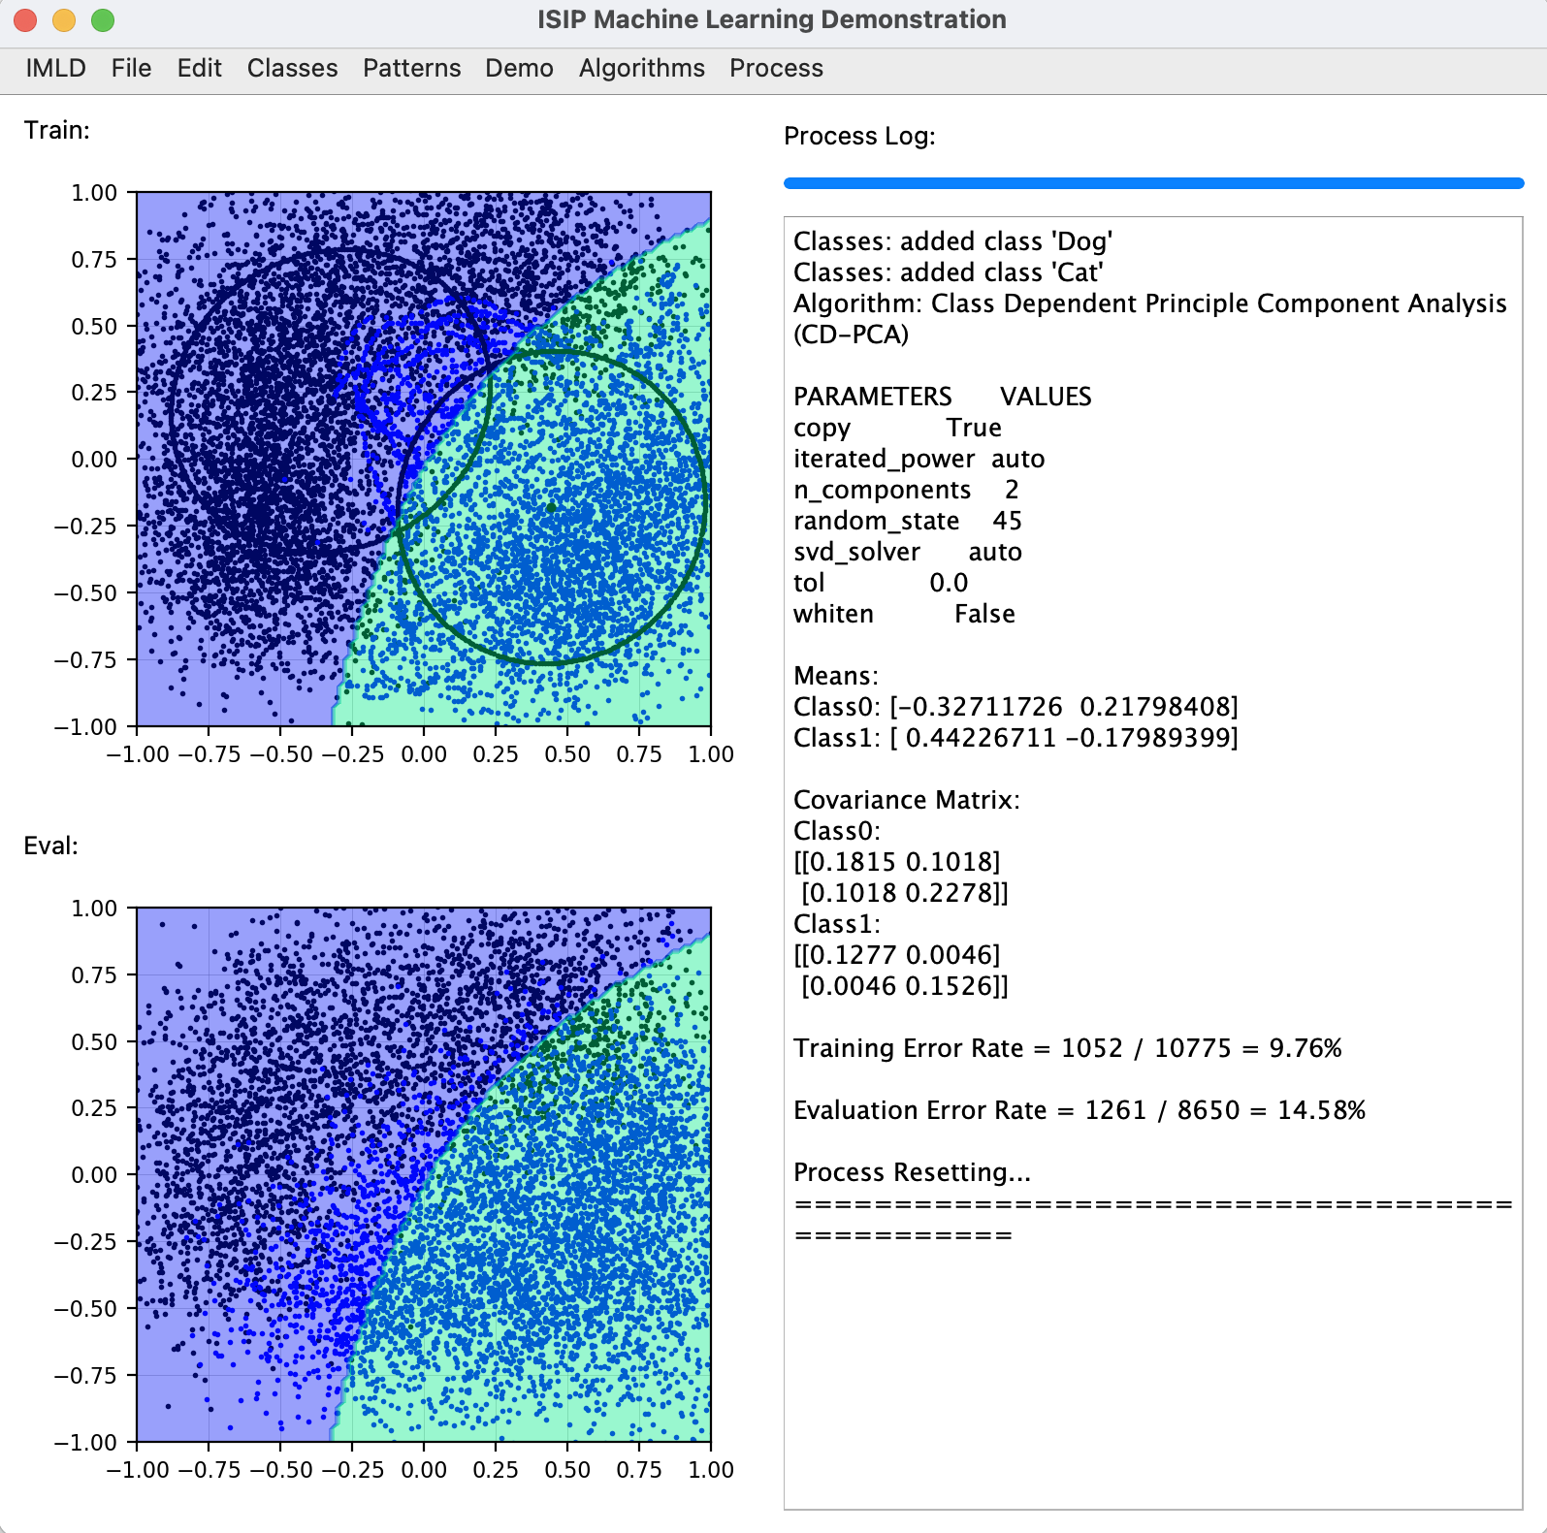
Figure 1. The IMLD v1.8.1 user interface
Aside from the user interface, another essential aspect of IMLD is data generation and handling. IMLD allows users to generate data using a variety of prestored models and drawing tools. Standard data sets can be generated and customized through its drawing tools. Training and evaluation data are generated separately. Created data is exported to CSV files using a simple format that makes it easy to integrate IMLD into other data processing pipelines.
IMLD v2.0.0’s software architecture has been redesigned so that the user interface and the algorithm classes are now completely separated. IMLD is still dependent on a variety of third-party libraries. IMLD continues to utilize PyQT5 [7] for its user interface, NumPy [8] for numerical computations, Sklearn/Scipy for implementing machine learning algorithms [5], and Matplotlib [9] for the visualization of data.
The new architecture, which is shown in Figure 2, has three major components: the graphical user interface, the library containing the algorithms (ml_tools), and the data handler. Most of IMLD's features and configurations are in a drop-down menu at the top of the user interface. These menus contain the elements for configuring classes and data, processing, and selecting algorithms. The algorithm implementations share a common interface through a library called as ml_tools. Previous computational algorithms for IMLD had been using non-conventional formatting and processing of the data. However, with ml_tools, the methods by which the data is being read and interpreted use a well-defined API. This library can be easily extended to include new algorithms by creating a script for the desired algorithm(s) along with the corresponding parameters through Python. A file template is provided as a guide for how implementing the necessary functions, parameters, etc. Through the API, users will have their functions linked into the application.
Due to this centralization of the algorithm code, we have expanded the algorithm selection and adapted terminology to use more modern names. This process presents complexities because there is a significant difference in the way packages like Sklearn and JMP refer to and implement standard algorithms such as Principal Components Analysis (PCA). For example, what was formerly called class-dependent PCA is now referred to as Quadratic Components Analysis algorithm (QDA). There is direct support for the following algorithms:
• Principal Components Analysis (PCA) • K-Means
• Linear Discriminant Analysis (LDA) • Naive Bayes (NB)
• K-Nearest Neighbor (KNN) • Support Vector Machine (SVM)
• Quadratic Components Analysis (QDA) • Multilayer Perceptron (MLP)
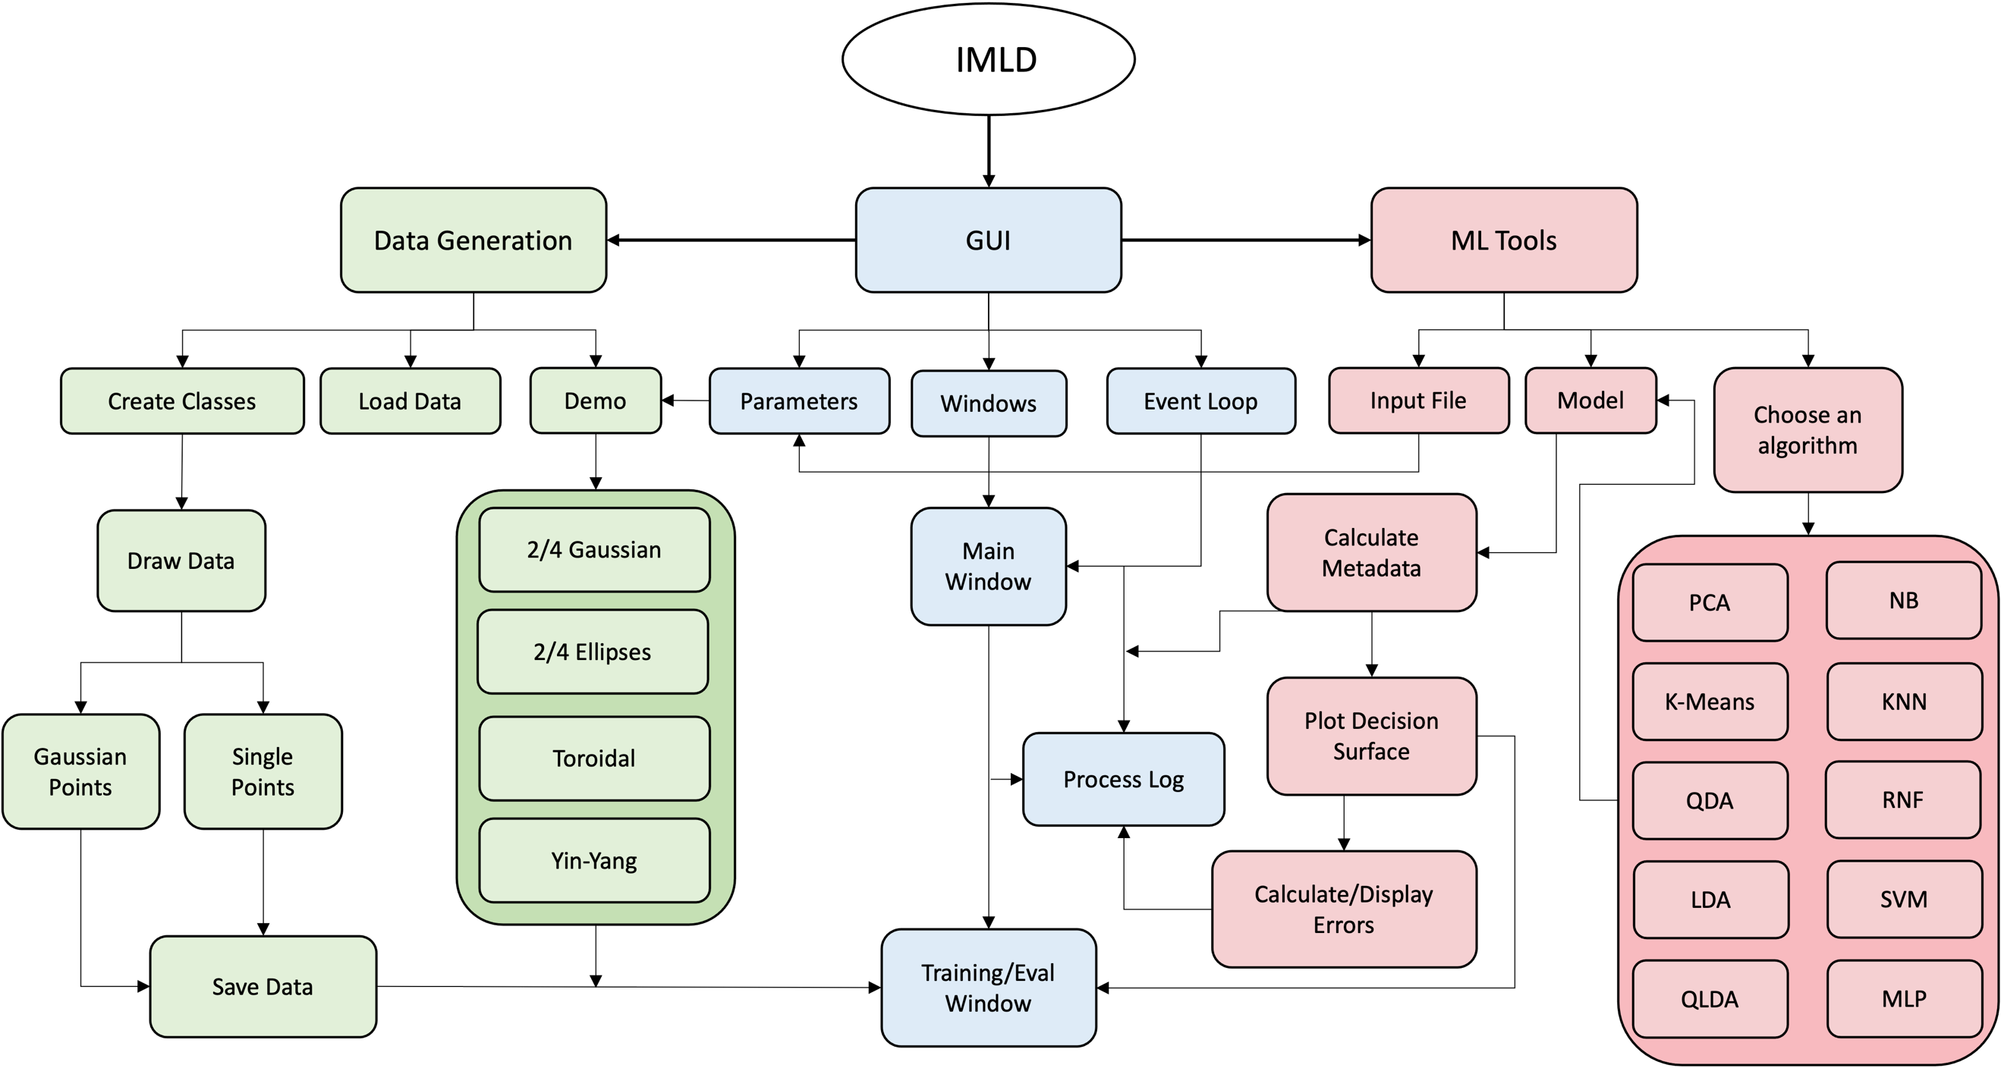
Figure 2. The IMLD software architecture

• Quadratic Linear Discriminant Analysis (QLDA) • Random Forests (RNF)
Since there are significant differences in the way Sklearn and JMP implement many of the same algorithms, the ml_tools library supports a wide range of parameter settings. This allows users to match results in either of these methods. For example, users can create a data set in IMLD, export it to JMP, and produce the exact same results on that data set using appropriate parameter settings. This was not possible in previous versions of IMLD, and matching results between Sklearn and JMP presents challenges. We have also expanded IMLD to support prior probabilities (probabilities that are assigned to incorporate initial beliefs about the outcome) and unbiased covariances (an estimate that asymptotically converges to the true value as the size of the data set grows) – two examples of parameter settings needed to match packages like JMP.

In the previous version of IMLD, values like parameters and settings were hardcoded directly into the program. For example, the drop-down menus and parameters were embedded within the user interface code, making it difficult for users to add their own choices. By exploiting Python’s excellent data-driven programming support, algorithms can be added without modifying the code. Menu choices are driven from descriptions in external parameter files that are loaded at run-time. This makes it much easier for users to customize the tool.
IMLD is a tool that allows users to easily explore machine learning algorithms on predefined and user-defined data sets. Its unique visualization of the machine learning process makes it an ideal teaching tool. It has been used by a machine learning class we have been teaching since the late 1990s (https://www.isip.piconepress.com/courses/temple/ece_8527/). The source code is available from the course website at: https://www.isip.piconepress.com/courses/temple/ece_8527/resources/imld/. A detailed user manual demonstrating the use of the tool and instructional videos are also available. A demonstration will be provided at the symposium.

Acknowledgements
The development of IMLD has been supported by many grants over the past three decades, including grants from the National Science Foundation, the National Institutes of Health, and the Temple University Office of Research. The material presented in this abstract was supported by the Temple University College of Engineering’s Summer Research Experience for Undergraduates program. Any opinions, findings, conclusions, or recommendations expressed in this material are those of the author(s) and do not necessarily reflect the views of these sponsors.
References
- T. Cap, A. Kreitzer, M. Miranda, D. Vadimsky, and J. Picone, “IMLD: A Python-Based Interactive Machine Learning Demonstration,” in Proceedings of the IEEE Signal Processing in Medicine and Biology Symposium (SPMB), I. Obeid, I. Selesnick, and J. Picone, Eds., Philadelphia, Pennsylvania, USA, 2021, pp. 1–4. doi: 10.1109/SPMB52430.2021.9672265.
- J. Shaffer, J. Hamaker, and J. Picone, “Visualization of signal processing concepts,” in Proceedings of the IEEE International Conference on Acoustics, Speech and Signal Processing, Seattle, Washington, USA, May 1998, pp. 1853–1856. doi: 10.1109/ICASSP.1998.681824.
- D. May and J. Picone, “The ISIP Pattern Recognition Applet,” Institute for Signal and Information Processing, College of Engineering, Mississippi State University, 2002. [Online]. Available: https://www.isip.piconepress.com/projects/speech/software/demonstrations/applets/util/pattern_recognition/current/. [Accessed: 05-Jul-2021].
- J. Picone, R. Duncan, and J. Hamaker, “Internet-Accessible Speech Recognition Technology,” in O’Reilly Open Source Convention, 2001. url: ﻿http://www.isip.piconepress.com/publications/ conference_presentations/2001/oscon/software/.
- F. Pedregosa et al., “Scikit-learn: Machine Learning in Python,” Journal of Machine Learning Research, vol. 12, pp. 2825–2830, 2011, doi: 10.5555/1953048.2078195.
- JMP®, SAS Institute Inc., Cary, North Carolina, USA, 1989 – 2023. Available: jmp.com.
- PyQT, “PyQt Reference Guide,” 2023, [Online]. Available: http://www.riverbankcomputing.com/static/Docs/PyQt5/html/index.html.
- Harris, C.R., Millman, K.J., van der Walt, S.J. et al. Array programming with NumPy. Nature 585, 357–362 (2020). doi: 10.1038/s41586-020-2649-2.
- J. D. Hunter, “Matplotlib: A 2D graphics environment,” Computing in Science & Engineering, vol. 9, no. 3, pp. 90–95, 2007, doi: 10.1109/MCSE.2007.55.

