Recent Advances in the TUH EEG Corpus:
Improving the Interrater Agreement for Artifacts and Epileptiform Events
G. Buckwalter, S. Chhin, S. Rahman, I. Obeid and J. Picone
The Neural Engineering Data Consortium, Temple University, Philadelphia, Pennsylvania, USA
{grace.buckwalter, sidney.chhin, rahman, iobeid, picone}@temple.edu
The Temple University Hospital EEG Corpus (TUEG) [1] is the largest publicly available EEG corpus of its type and currently has over 5,000 subscribers (we currently average 35 new subscribers a week). Several valuable subsets of this corpus have been developed including the Temple University Hospital EEG Seizure Corpus (TUSZ) [2] and the Temple University Hospital EEG Artifact Corpus (TUAR) [3]. TUSZ contains manually annotated seizure events and has been widely used to develop seizure detection and prediction technology [4]. TUAR contains manually annotated artifacts and has been used to improve machine learning performance on seizure detection tasks [5]. In this poster, we will discuss recent improvements made to both corpora that are creating opportunities to improve machine learning performance.
Two major concerns that were raised when v1.5.2 of TUSZ was released for the Neureka 2020 Epilepsy Challenge were: (1) the subjects contained in the training, development (validation) and blind evaluation sets were not mutually exclusive, and (2) high frequency seizures were not accurately annotated in all files. Regarding (1), there were 50 subjects in dev, 50 subjects in eval, and 592 subjects in train. There was one subject common to dev and eval, five subjects common to dev and train, and 13 subjects common between eval and train. Though this does not substantially influence performance for the current generation of technology, it could be a problem down the line as technology improves. Therefore, we have rebuilt the partitions of the data so that this overlap was removed. This required augmenting the evaluation and development data sets with new subjects that had not been previously annotated so that the size of these subsets remained approximately the same. Since these annotations were done by a new group of annotators, special care was taken to make sure the new annotators followed the same practices as the previous generations of annotators. Part of our quality control process was to have the new annotators review all previous annotations. This rigorous training coupled with a strict quality control process where annotators review a significant amount of each other’s work ensured that there is high interrater agreement between the two groups (kappa statistic greater than 0.8) [6].
In the process of reviewing this data, we also decided to split long files into a series of smaller segments to facilitate processing of the data. Some subscribers found it difficult to process long files using Python code, which tends to be very memory intensive. We also found it inefficient to manipulate these long files in our annotation tool. In this release, the maximum duration of any single file is limited to 60 mins. This increased the number of edf files in the dev set from 1012 to 1832.
Regarding (2), as part of discussions of several issues raised by a few subscribers, we discovered some files only had low frequency epileptiform events annotated (defined as events that ranged in frequency from 2.5 Hz to 3 Hz), while others had events annotated that contained significant frequency content above 3 Hz. Though there were not many files that had this type of activity, it was enough of a concern to necessitate reviewing the entire corpus. An example of an epileptiform seizure event with frequency content higher than 3 Hz is shown in Figure 1. Annotating these additional events slightly increased the number of seizure events. In v1.5.2, there were 673 seizures, while in v1.5.3 there are 1239 events.
One of the fertile areas for technology improvements is artifact reduction. Artifacts and slowing constitute the two major error modalities in seizure detection [3]. This was a major reason we developed TUAR. It can be used to evaluate artifact detection and suppression technology as well as multimodal background models that explicitly model artifacts. An issue with TUAR was the practicality of the annotation tags used when there are multiple simultaneous events. An example of such an event is shown in Figure 2. In this section of the file, there is an overlap of eye movement, electrode artifact, and muscle artifact events. We previously annotated such events using a convention that included annotating background along with any artifact that is present. The artifacts present would either be annotated with a single tag (e.g., MUSC) or a coupled artifact tag (e.g., MUSC+ELEC). When multiple channels have background, the tags become crowded and difficult to identify. This is one reason we now support a hierarchical annotation format using XML – annotations can be arbitrarily complex and support overlaps in time.
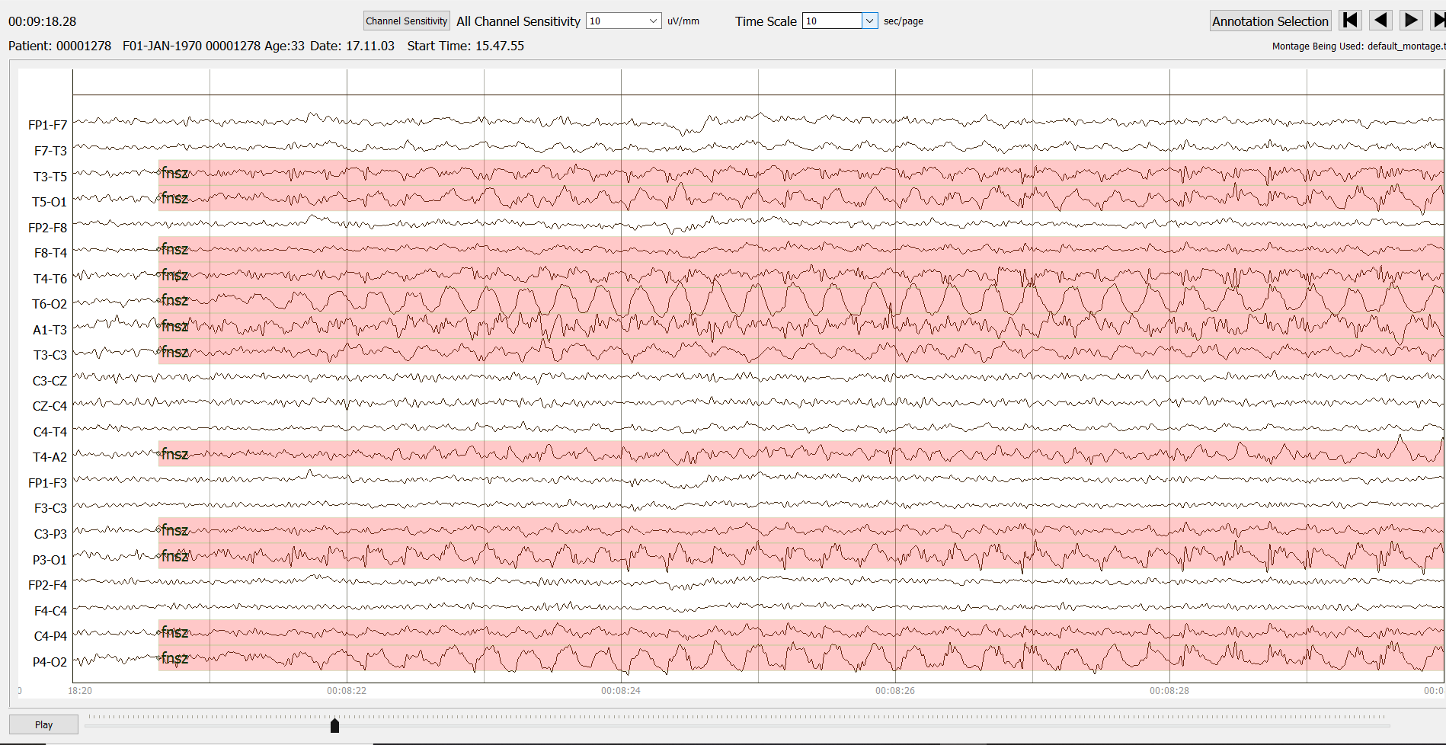
Figure 1. An example of an epileptiform seizure event with frequency content greater than 3 Hz

Our annotators also reviewed specific eye movement artifacts (e.g., eye flutter, eyeblinks). Eye movements are often mistaken as seizures due to their similar morphology [7][8]. We have improved our understanding of ocular events and it has allowed us to annotate artifacts in the corpus more carefully.
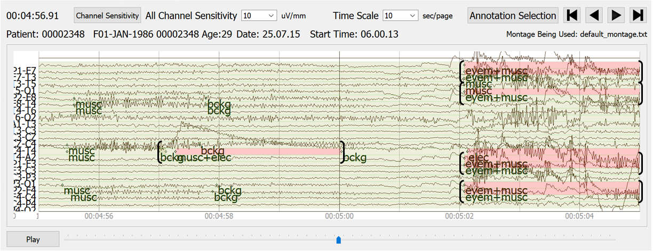
Figure 2. An example of an EEG file with multiple events occurring simultaneously

In this poster, we will present statistics on the newest releases of these corpora and discuss the impact these improvements have had on machine learning research. We will compare TUSZ v1.5.3 and TUAR v2.0.0 with previous versions of these corpora. We will release v1.5.3 of TUSZ and v2.0.0 of TUAR in Fall 2021 prior to the symposium.
Acknowledgments
Research reported in this publication was most recently supported by the National Science Foundation’s Industrial Innovation and Partnerships (IIP) Research Experience for Undergraduates award number 1827565. Any opinions, findings, and conclusions or recommendations expressed in this material are those of the author(s) and do not necessarily reflect the official views of any of these organizations.
References
- I. Obeid and J. Picone, “The Temple University Hospital EEG Data Corpus,” in Augmentation of Brain Function: Facts, Fiction and Controversy. Volume I: Brain-Machine Interfaces, 1st ed., vol. 10, M. A. Lebedev, Ed. Lausanne, Switzerland: Frontiers Media S.A., 2016, pp. 394-398. https://doi.org/10.3389/fnins.2016.00196.
- V. Shah et al., “The Temple University Hospital Seizure Detection Corpus,” Frontiers in Neuroinformatics, vol. 12, pp. 1–6, 2018. ﻿ https://doi.org/10.3389/fninf.2018.00083.
- A. Hamid et, al., “The Temple University Artifact Corpus: An Annotated Corpus of EEG Artifacts.” in Proceedings of the IEEE Signal Processing in Medicine and Biology Symposium (SPMB), 2020, pp. 1-3. ﻿https://ieeexplore.ieee.org/document/9353647.
- Y. Roy, R. Iskander, and J. Picone, “The NeurekaTM 2020 Epilepsy Challenge,” NeuroTechX, 2020. [Online]. Available: https://neureka-challenge.com/. [Accessed: 01-Dec-2021].
- S. Rahman, A. Hamid, D. Ochal, I. Obeid, and J. Picone, “Improving the Quality of the TUSZ Corpus,” in Proceedings of the IEEE Signal Processing in Medicine and Biology Symposium (SPMB), 2020, pp. 1–5. ﻿https://ieeexplore.ieee.org/document/9353635.
- V. Shah, E. von Weltin, T. Ahsan, I. Obeid, and J. Picone, “On the Use of Non-Experts for Generation of High-Quality Annotations of Seizure Events,” Available: https://www.isip.picone press.com/publications/unpublished/journals/2019/elsevier_cn/ira. [Accessed: 01-Dec-2021].
- D. Ochal, S. Rahman, S. Ferrell, T. Elseify, I. Obeid, and J. Picone, “The Temple University Hospital EEG Corpus: Annotation Guidelines,” Philadelphia, Pennsylvania, USA, 2020. https://www.isip.piconepress.com/publications/reports/2020/tuh_eeg/annotations/.
- D. Strayhorn, “The Atlas of Adult Electroencephalography,” EEG Atlas Online, 2014. [Online]. Available: http://eegatlas-online.com. [Accessed: 01-Aug-2021].

