Enabling Microsegmentation: Digital Pathology Corpora for Advanced Model Development
Dmitry Hackel, Maria Bagritsevich, Claudia Dumitrescu, Md. Abdullah Al Mamun,
Sadia Purba, Dylan Heathcote, Iyad Obeid and Joseph Picone
The Neural Engineering Data Consortium, Temple University, Philadelphia, Pennsylvania, USA
{dmitry.hackel, maria.bagritsevich, claudia-anca.dumitrescu, abdullah18,
sadia.afrin.purba, dylan.heathcote, iobeid, picone}@temple.edu

Abstract
Pathology remains a foundational discipline in modern medicine, yet traditional microscopy workflows are constrained by manual slide preparation, subjective interpretation, and limited scalability. The advent of digital whole slide imaging has enabled seamless digitization of histological sections, though challenges such as inter‑observer variability and workforce shortages persist. Recently, artificial intelligence based decision‑support tools – powered by deep‑learning algorithms and high‑performance computing – have demonstrated remarkable performance in pre‑screening, case triage, and morphology segmentation.
Artificial intelligence in diagnostic histopathology hinges on the availability of extensive, richly annotated image repositories. Therefore, in this chapter we introduce two important open source digital pathology corpora: the Temple University Hospital Digital Pathology Breast Tissue Subset (TUBR) and the Fox Chase Cancer Center Digital Pathology Breast Tissue Subset (FCBR). TUBR comprises 3,505 images from 296 subjects (1.2 TB of data). FCDP contributes 1,463 oncology‑focused slides from 1,397 subjects (336 GB of data). Both corpora have been manually annotated and cover a spectrum of tissue states from normal and benign through premalignant intraepithelial lesions and invasive carcinomas.
We also explore baseline performance of some well-established deep learning algorithms on an image classification task based on these corpora. A weighted error of 25.5% was achieved on TUBR using EfficientNet B7, while a weighted error of 25.0% was achieved on FCBR. We also examine the challenges involved in training across both datasets to enhance overall system performance and assess the role accurate microsegmentations play in achieving clinically acceptable performance.
Keywords: histopathology, whole slide imaging, artificial intelligence, deep learning
- Introduction
Pathology constitutes a cornerstone of modern medicine, providing essential support for accurate diagnosis, prognostication, and therapeutic planning across a wide range of tissue-based diseases. Traditionally, examination required a tedious workflow of preparing thin tissue sections on glass slides, followed by manual interpretation of stained tissue morphology under a microscope – an effort heavily reliant on the pathologist’s expertise to discern subtle architectural, spatial, and cellular features. In support of enhancing this process, digital whole slide imaging (WSI), which emerged in the mid-1990’s [1], enabled entire histological slides to be digitized into multi-resolution image pyramids. This allowed seamless, lossless zoom at arbitrary magnifications – unlike optical microscopes, which are limited to discrete objective lenses. This ensured consistent calibration, precise quantitative measurements, and preservation of subcellular detail across the specimen.
Corresponding Author: Joseph Picone, Room 718, College of Engineering, Temple University, 1947 North 12th Street, Philadelphia, Pennsylvania, 19122. Tel: 708-848-2846; Fax: 215-204-5280; Email: picone@temple.edu.
However, despite its potential, WSI did not mitigate inter‑observer variability, a challenge that spans virtually all pathological subspecialties. A recent systematic review of 12 validation studies [2] reported that digital vs. light microscopy inter‑observer κ values ranged from 0.45 (“moderate” agreement) to 0.75 (“substantial” agreement) across human pathology cases. More concerning was the fact that only 52% of pathologists report being satisfied with their career choice [3], and the U.S. pathology workforce declined by 17.5 % between 2007 and 2017 [4]. This decrease further worsens job satisfaction as remaining pathologists are being forced to increase workload, a difficult task to implement on a job requiring such precise analysis for each sample. To decrease the negative impacts of the dwindling workforce, in this chapter, we examine strategies for streamlining sample evaluation by equipping pathologists with advanced slide‐analysis platforms.
Among the lack of job satisfaction trends, it is worth mentioning that the declining headcounts, an aging workforce, and growing case complexity [5][6], as well as insufficient exposure to pathology during undergraduate medical education, have been shown to deter up to 40 % of students from considering the specialty [7]. In response, artificial intelligence (AI) based decision‑support tools have begun to fill critical gaps. In 2021, the FDA granted de novo authorization to Paige Prostate, the first AI‑based in vitro diagnostic device for prostate cancer detection on digitized slides [8]. By leveraging advances in high‑performance computing, gigapixel image storage, and deep‑learning algorithms, such systems can pre‑screen WSI, triage cases by risk, and highlight regions of interest – thereby reducing pathologist workload and enhancing diagnostic consistency beyond what WSI alone could achieve [9].
Conventional microscopy is a current standard within pathology, with a majority of 65% of pathologists reluctant to the digital alternative, considering it unsuitable for routine diagnostic practice [10]. Analog microscopy has a low to medium processing speed due to the need for manual transition of samples, which can lead to increased processing times that vary from a few minutes to hours [11]. In addition to eye strain, the need to be in a laboratory setting and manual labor has fueled the push toward digitizing pathology, which continues to grow in popularity given the assistive AI tools. Digitized slides can be accessed and analyzed beyond the confines of the laboratory, offering significant advantages for pathologists on call, particularly in time-sensitive scenarios such as organ transplantation, where rapid remote assessment is critical.
The greater acceptance of digital pathology within the field has provided a wealth of data that can be reviewed and utilized to further research into machine learning (ML) and deep learning (DL) technology that has the potential to aid pathologists’ workflow. Such assistive resources enable automated slide triage (ordering cases by suspected severity), generation of annotated heatmaps highlighting regions of interest, and quantitative extraction of morphological features. Indeed, many studies report “near‑perfect” performance: a recent meta‐analysis of 48 AI algorithms across diverse disease types found a pooled sensitivity of 96.3 % (CI 94.1–97.7) and specificity of 93.3 % (CI 90.5–95.4) [12]. While the application of deep learning in digital pathology has demonstrated remarkable performance – achieving mean sensitivities of 95% and specificity of 92% for multiclass tasks and 91%, 88% respectively, for binary ones.
However, the high rate of accuracy often stems from evaluation on highly curated datasets with limited diversity, typically from one or two institutions, which raises concerns about bias, lack of generalizability, and reproducibility. As the same review reports, 99% of included studies had at least one domain at high or unclear risk of bias, often due to non-random sampling, inadequate reporting, and domain shifts across institutions or scanners. This makes it difficult to translate AI models into robust clinical tools across different healthcare settings. Hance, in this chapter, we focus on establishing a performance baseline using our recently released datasets from two distinct medical centers, explicitly addressing these limitations through cross-institutional evaluation and transparent reporting practices.
- Digital Pathology Resources for Machine Learning
To develop robust deep learning models for digital pathology, a well-curated dataset encompassing a variety of normal, non-neoplastic, and cancerous tissue architectures is essential. At Temple University’s Neural Engineering Data Consortium (NEDC), two major open-source digital pathology corpora have been established: the Temple University Digital Pathology Corpus (TUDP) [13][14][15] and the Fox Chase Cancer Center Digital Pathology Corpus (FCDP) [16]. TUDP contains over 100,000 high-resolution images, representing a diverse range of tissue types, including both normal and abnormal specimens, supporting a broad spectrum of research applications. In contrast, FCDP, with 14,276 images, is more specifically focused on oncological studies. These corpora have been further refined through extensive evaluation and annotation, particularly in the breast pathology subsets, ensuring precise classification of cancerous, non-cancerous, and pre-cancerous structures. A comparison of these datasets to other publicly available datasets is given in Table 1. These enhanced datasets provide a critical foundation for training advanced AI models in digital pathology, facilitating improved diagnostic accuracy and research in cancer detection.
  - Slide Preparation
Traditional histological slide preparation [17] requires tissue sections to be thin enough to be mounted while maintaining the structural relationship between cells and extracellular components. This necessitates careful handling to ensure accurate cancer diagnosis. To support tissue integrity during sectioning, specimens are either frozen and cut using a cryostat microtome for rapid diagnosis without chemical interference or infiltrated with a liquid agent such as epoxy resin or histological wax, which solidifies to encase the sample, a routinely used method. Before mounting, tissue specimens must be preserved using a fixative, commonly a formaldehyde suspension for 6-12 hours, to prevent decomposition and eliminate microorganisms. Specimens are then dissected into 4 mm regions and processed with a hardening agent. Once prepared, paraffin sections of 3-5 µm thickness are cut to ensure only a single layer of cells is captured on a glass slide. These sections are then placed in a warm water bath for flattening and ease of handling before being mounted onto individual glass slides.
  - Immunostaining
Staining is essential for visibility during imaging [18]. Cells, apart from a few natural pigments like melanin, are mostly colorless. The routine hematoxylin and eosin (H&E) stain is used to provide general cellular structure information, staining nuclei blue and other cellular components in shades of pink. If further diagnostic information is required, special stains targeting specific cellular components are applied. For example, immunohistochemical (IHC) stains utilize antibodies to mark diagnostically relevant proteins, offering deeper insights into cellular processes. Once stained, the slides are covered with glass. Most slides can be achieved for years without damage or discoloration.
Immunostaining plays a critical role in the annotation of digital pathology datasets for machine learning applications, as it is capable of shifting data distribution very easily and making the model miserably fail the generalization test. This is because different staining protocols highlight different cellular and molecular features while failing to reveal others, making cross-dataset transferability challenging. As a result, switching between datasets becomes more complicated due to variation in immunochemistry. In digital pathology, immunohistochemical (IHC) stains utilize antibodies to detect specific cellular markers, such as estrogen receptor (ER), progesterone receptor (PR), and human epidermal growth factor receptor 2 (HER2), which are essential in breast cancer classification [19]. These stains provide a detailed molecular profile of tissues, aiding in the differentiation of neoplastic from non-neoplastic regions, which is crucial for training deep learning models to recognize cancerous patterns with high specificity.
In contrast, Hematoxylin and Eosin (H&E) staining remains the gold standard for histological examination, offering a broad visualization of cellular and tissue structures. Hematoxylin stains cell nuclei blue-purple, while eosin highlights cytoplasm and extracellular matrix in pink, allowing machine learning models to extract key morphological features that distinguish normal, pre-cancerous, and malignant cells [20]. The integration of both staining techniques enhances model performance by expanding the diversity of input data, enabling algorithms to learn from both molecular and structural tissue characteristics. Moreover, computational pathology tools leveraging deep learning can process large-scale immunostained datasets efficiently, reducing interobserver variability and improving diagnostic consistency [20]. By incorporating a variety of immunostains, machine learning models gain a deeper contextual understanding of tissue pathology, facilitating advancements in automated cancer detection, classification, and prognostic assessment.
  - Digitization
Digital pathology involves converting physical glass slide samples into digital files via WSI. This is achieved using a laser scanner that captures images at a resolution of 0.2 mm/pixel. Similar to a glass slide, a WSI contains one or more specimens along with the background space surrounding the histological sample. The scanning process in all cases utilizes a Leica Biosystems Aperio AT2 high-volume scanner. The scanning process is described in detail in [13]. The scanner captures a low-resolution image and assigns multiple focus points on the tissue. A green rectangular box marks the scanning frame, and technicians can manually adjust the focus points and frame as needed. This manual review step is crucial in preventing scanning failures caused by inaccurate automatic focus placement.
There are some cases where the scanner makes errors in its placement of the focus points and in determining the area of the scanning region. Both cases will cause a failure in the image processing of the specimen, thus causing a failure in scanning. Another error modality occurs when the scanning region is too large, which can cause unnecessary white space to be included in the WSI. In this case, the scanner might produce an image that is larger than necessary. Similarly, there is a risk of producing invalid images if the scanning region only partially encloses the specimen of interest. These events tend to occur with slides that are lightly stained or slides with a significant amount of white space between tissue samples. In such cases, the focus points must be manually placed.
Error caused by image blur is often seen to create resolution issues within some pathology slides. Image blur is a result of the attenuation of high spatial frequencies which occur when the image is compressed or filtered. Blur can also be a result of image acquisition [21]. This makes the pre-scan snapshot phase of the scanning procedure labor-intensive. We find about 2% of the slides scanned are likely to experience a scanning failure. However, this number varies according to the quality of the stain applied to the slides. These failed slides were reviewed, readjusted, and rescanned. To date, we have scanned approximately 120,000 slides using these tools.
The scanned image produced from the Aperio AT2 is stored in a file format known as ScanScope Virtual Slides (SVS) [22]. An SVS file is layered image representation that includes several thumbnails and the original source image. The source image is stored using JPEG compression with a quality factor of 70. (The specific image type in the Aperio ImageScope software is “SVS/JPEG 2”. The parameter “Image Depth” is set to 1 and “Image Channels” is set to 3.) These parameters result in roughly an order of magnitude of compression over lossless compression with minimal image degradation.
A full resolution image is stored as the baseline image using a tile size of 240 x 240 pixels (an image is represented as a series of adjacent tiles, or blocks). The following three layers contain downsampled version of the image at resolutions of 4:1, 16:1 and 32:1. The final layer is a low-resolution thumbnail. Each of these layers is an image encoded using lossy JPEG encoding. An SVS file also contains a low-resolution picture of the slide’s label as metadata and stores other information such as the downsample and offset information. The number of layers generated depends on the size of the original image. Smaller images (e.g., the maximum dimension is less than 50K pixels) will generally have only two layers.
Our primary software for viewing SVS files is Aperio ImageScope [23]. This software features a wide variety of tools for image editing, adjusting, and annotation. The image adjustment tools include brightness and contrast controls, color balance, and color curve adjustment. These can be applied to all channels or for individual red, green, or blue (RGB) channels. These adjustments only apply to the viewed image and do not modify or overwrite the stored image. The settings applied to the current session can be saved and applied to other scanned images. The default presets for ImageScope are always applied to the scanned images. Then, the image adjustment tools can be utilized to calibrate the image features according to the pathologist’s preferences. The stains applied on specimen images cause a specific structure to adopt a distinct color, and this color can be enhanced by adjusting the brightness, contrast, and the color channels of the image via the image adjustment tools. This is a beneficial tool for pathology diagnosis as it can be used to allow specific areas of investigation (such as cancerous tissue) to be more focused or to enhance quality of lightly stained specimens.
As mentioned earlier, the Aperio AT2 scanner features a z-stacking option. The scanner can produce multiple images of a slide tissue that were scanned at different focal depths. This generates a 3D image that allows navigation of the image through different focal depths, which is analogous to the process pathologists use with an analog microscope. ImageScope features a tool that can adjust the focal depth that is similar to using the objective fine and coarse adjustments of a focus slider in a microscope (Leica Biosystems). This feature has yet to be explored in the Department of Pathology at the Temple University Hospital but is being used by other hospitals. The z-stacked images are very large in size, often several gigabytes, which poses additional challenges for machine learning research [13].
  - Data Organization and Anonymization
A detailed description of the filenaming conventions and organization of the data can be found in [15]. The file naming convention is designed so that every file in the corpus has a unique filename, and simple UNIX commands can be used to locate data.
To ensure compliance with the Health Insurance Portability and Accountability Act (HIPAA), strict protocols are in place to maintain subject anonymity. Protocol No. 24943, approved by TU’s Institutional Review Board, governs the handling of all data to prevent any exposure of subject-identifiable information. The deidentification process follows a methodology similar to the one used in the Temple University Hospital EEG Seizure Corpus [24]. Each subject is assigned a unique, randomized 8-character letter sequence.
SVS files initially contain low-resolution tiled images of slide labels, which may include subject initials and specimen IDs. These labels are manually removed before data release. Together, these measures ensure that all released data is completely anonymized while maintaining the integrity required for research.
  - Annotation Guidelines
Pathology is the primary method for the confirmation of breast cancer, assessing tumor margins, and evaluating cancer proliferation. Assessing these metrics can be challenging due to the diverse nature of pathology. The vast amounts of different tissue architectures a pathologist needs to assess which in turn needs to be determined by a machine learning model is vast, which makes our dataset extremely valuable among the existing alternatives, as shown in Table 1. Our annotation guidelines document can be found in [25] and are discussed in [16]. When we discuss how we annotate the data, it is important to understand the basis of the anatomical and physiological components of breast tissue and how cancerous cells develop [26][27].

The mammary gland parenchyma is composed of primarily adipose stroma embedded in a connective‐tissue matrix rich in interstitial fluid, lobular alveoli, which synthetize milk, carried by lactiferous ducts that terminate at the nipple. The terminal ductal lobular units (TDLUs) are a primary interest for pathologists as most primary breast cancers proliferate here. Lobules make up these units which are hormonally responsive structures that originate from the TDLUs and are composed of glandular epithelial cells surrounding myoepithelial cells, a basement membrane, and fibro collagenous storm. These lobules are organized in clusters and play a crucial role in milk secretion. The epithelial-stromal junctions within the lobules consist of an epithelial-myoepithelial layer supporting by elastic fibers, fibroblasts, and capillaries with variability fiber deposition based on hormonal influence and age, adding a layer of complexity to the nature of this data. The hormonal impacts on the ductal units due to menopause, adolescence, or pregnancy means a far greater variability in lobular appearance. Standard acini and ducts are made up of three-layer layers: the basement membrane, myoepithelial layer, and epithelial lining. These ducts carry milk and are found throughout the TDLUs. The epithelial layer is usually only one thick cell which lines the ducts; however, multiple layers of cells, hyperplasia, is a common occurrence. To the degree at which these epithelial cells grow, it can determine if a patient has atypical ductal hyperplasia or ductal carcinoma in situ.
Ductal carcinoma in situ (DCIS) is defined by abnormal growth of epithelial cells throughout the duct. DCIS presents itself in a multitude of ways. Cribriform formations look like sponges as microcysts from within the tumor inside the duct. Micropapillary DCIS is defined by its microcalcification on mammograms and range in sizes. Other common formations of DCIS include Apocrine, comedo, with comedonecrosis, or papillary DCIS. All defined by the abnormal cells being contained within the ductal units of the breast because cancer prefers to proliferate in a path of least resistance. DCIS is usually graded from 1-3 or in some cases 1-5 to determine by mitotic rate.
Once the DCIS breaches the basement membrane of the ductal epithelium and invades the surrounding stromal tissue, it is classified as invasive ductal carcinoma. Invasive ductal carcinoma makes up 70%-80% of breast cancer cases [28]. The various presentations of invasive ductal carcinoma patterns include nests, cords, or sheets of small squamous cells. The tumor cells often exhibit moderate to marked nuclear pleomorphism and increased mitotic activity [29]. Tubule formation is a key histological feature assessed during grading. Tumors with more than 75% tubule formation receive a lower grade, indicating better differentiation and prognosis. However, many INDCs’ display less tubule formation, correlating with higher grades and more aggressive behavior. The heterogeneity in INDC's histological presentation poses challenges for AI models in accurately classifying and predicting outcomes, especially when rare subtypes or poorly differentiated forms are underrepresented in training datasets.
Non-neoplastic (NNEO) structures is a broad term that, in a broader medical context, lacks the specificity required for clinical decision-making and includes a wide variety of structural types. In the case of the TUH and FCCC breast corpora, NNEO structures refer to a range of structures that may either present themselves as a benign formation, pre-cancerous, or associated with cancer. Non-neoplastic can also define a possible precancerous like atypical ductal hyperplasia. Cysts are another one.
A NNEO structure is the formation of calcium deposits that are often visualized in mammograms and result due to cancer proliferation producing more calcium output which can accumulate and form solid formations [30]. These calcium microcalcification are likely a byproduct of dysregulated intracellular calcium transport channels due to oncological transformations. The regulatory imbalance, induced by oncological cells, causes an overexpression of calcium pumps such as SPCA2 and PMCA2 creating an environment that allows calcium to react with bone matrix proteins and phosphate transporters to develop a microenvironment conducive to mineralization, resulting in microcalcification [31]. The loss of calcium homeostasis and resulting structures could be leveraged to improve model training.
One thing that significantly increases the complexity of breast tissue analysis, particularly in pathological interpretation, is a dynamic and differing morphological variability of terminal ductal units driven by hormonal influences. Unlike other tissue architecture which may remain uniform, the breast undergoes structural changes depending on factors such as adolescence, menstrual cycling, pregnancy, lactation, and menopause. These states change the proliferative activity and differentiation status of epithelial and stromal components within the terminal duct units. For example, during pregnancy and lactation, lobules become hypertrophic, and exhibit increased acinar formation with prominent secretory activity. This makes the ducts look atypical and could be mistaken as non-neoplastic. Women who are going through menopause have reduced lobular units, atrophic epithelial lining, and increased stromal fibrosis or adipose replacement. These changes could pose a challenge for the development of models that can accurately analyze images for women of all ages and hormone levels.
This can be further complicated by the different morphological pathology which is genetically, or racially, specific and the impact breast cancer has on specific racial subgroups. It has been well established that the mutations in BRCA1/BRCA2 genes significantly elevate the risk of developing ductal and invasive carcinoma. People of African American descent have higher-grade tumors, more basal-like or triple-negative subtypes, and at a younger age. Race can also play a role in the tissue architecture of the terminal ductal units, meaning that the structure and image analysis of breast tissue specimens can have the same diagnosis, but may look different depending on a multitude of factors. This highlights the importance of data curation and diversity of data when developing such models and continues to become more and more apparent. It is therefore an ethical concern to design models that uphold fairness, transparency, robustness, and ensure a high degree of explainability and privacy.
To develop deep learning models capable of analyzing pathological features and decern differences between tissue architectures, data from TUDP and FCD must be meticulously annotated. Annotation refers to the manual delineation of both biological and non-biological structures by an annotator-in the case of TUH and FCCC breast corpus, an undergraduate bioengineering or pre-health student- who labels the structures. Annotation labels need to ensure precise margins to minimize extraneous structures such as background fibrous or adipose tissue. Proper margins or delineation between what is considered the structure or not is important for models that apply segmentation image analysis. The ability to delineate differences on a cellular level is incredibly important in pathology. Accurate delineation ensures that the model learns to distinguish the true boundaries of pathological structures, which is critical for reliable feature extraction, tissue classification and overall model performance in clinical applications.
Annotation of the entire slides would take far too long and be prohibitively expensive. Therefore, images are partially annotated, focusing on significant structures. These structures are either delineated based on patient reports which identify regions of diagnostic interest or based on an annotator’s decision. Selective annotation ensures efficient use of time and resources while still capturing clinically relevant tissue architecture and allowing for better label distribution.
Areas of interest in pathological slides vary. Although it would be simple to label tissue as either normal or cancerous, the vast array of different structures poses a real issue for models. In addition, there are many non-cancerous or pre-cancerous structures that would inform a pathologist about making medical determinations. The full list of labels can be found in [15] and is repeated here in Table 2. Normal ductal terminal units and lobules are labeled with the symbol (NORM), which is crucial for training models to allow for the differentiation between normal ducts and pathological ones.
The two primary labels utilized for cancerous structures are INDC and DCIS. These labels differentiate between ductal carcinoma in situ and invasive ductal carcinoma, allowing a model to distinguish between different stages of breast cancer. Although there is some differentiation between what constitutes ductal carcinoma among pathologists, cross-referencing with patient reports and metadata files ensures consistency and accuracy in labeling.
Artifact (ARTF) refers to the identification of grease-labels or other non-biological artifact found within slides and serves to prevent misclassification. These artifacts, if not properly labeled, could be misinterpreted by the model as meaningful biological signals, potentially leading to false positives.
NULL labels are given to areas that are considered undistinguishable tissue, either due to a blurry image or poor stain techniques. These regions are intentionally excluded from training to prevent introducing uncertainty or noise to the model.
Non-neoplastic (NNEO) labels include benign proliferative or reactive changes that could mimic cancers, improving model specificity. Inflammation labels (INFL) are given to areas of lymphocyte reactions to either non-neoplastic or cancerous structures. The distinction between these two labels allows for the distinction between an immune response and possible malignant progression.
The suspicious (SUSP) label is given to tissues that are suspected to be precancerous or are incredibly ambiguous. Background labels (BCKG) serve to prevent models from learning patterns in irrelevant regions. Background labels are given to any structure that does not follow in the prior labeling selection and primarily is made up of adipose and fibrous tissue.
Maintaining balanced label distributions is essential to mitigate bias and improve model robustness. Although randomization and weighted labels can be utilized to mitigate label biases, the importance of ensuring a good label distribution is vital. Class imbalance poses a significant challenge in medical datasets. In digital pathology databases, the abundance of normal and background tissue is significantly more common than carcinogenic or non-neoplastic structures. If the annotation process is not meticulous, a model would be disproportionately accurate on normal tissue architecture while severely underperform on cancerous structures. This overfitting of dominant labels can lead to models effectively ignoring minority classes. To address this issue, curating these datasets with sufficient representation of all relevant classes has been an important annotation objective, in addition to adding weighted loss functions and randomization during training.
  - Typical Examples of Annotated Slides
In Figure 1, we show normal duct and normal lobules, components of a terminal duct lobular unit, surrounded by stromal background tissue. The stroma is the pink-stained tissue found throughout the slides, which functions as supportive tissue around the ducts and lobules. Figure 1 is an example of fibrous stroma surrounding the regions of interest, with the inclusion of a few fat cells which appear as white round shapes. The NORM label is applied to regions where lobules remain circular with no instances of hyperplasia and where the ducts are clearly defined with both layers of the lining intact. The lobules around the duct are composed of small glands that are called acini, which are formed during puberty and represent secretory units of the breast. The acini and the ducts are lined by two different cell layers. The outer layer is made up of myoepithelial cells that are mostly just clear cytoplasm and function to contract and push milk through the breasts. The inner layer is made up of epithelial cells that produce breast milk and are usually where abnormal cell growth develops. The stroma consists of connective tissue, blood vessels and fat cells. The difference between fatty stroma and fibrous stroma can be seen in Figure 2.
Non-neoplastic annotations (NNEO) encompass a range of structures that aid in contextualizing the interpretation of specific tissue architecture. The NNEO label typically includes entities such as atypical hyperplasia, intraductal papilloma, calcifications, benign structures, and adenosis. Figure 3 highlights one of the most common NNEO structures: cysts, which present as pale, round spaces lined by a single layer of cuboidal epithelium and typically contain proteinaceous fluid. Cysts and cancer often coexist, as tumor growth can obstructer normal ductal drainage pathways and is frequently influenced by hormonal activity. The presence of cysts and other non-neoplastic features provides additional diagnostic clarity, supporting annotation of malignant or benign conditions. It is important to note that NNEO structures are not cancer, but rather benign or pre-malignant findings that assist in accurate classification.
Figure 4 represents an atypical case of ductal carcinoma in situ (DCIS), annotated due to its unique spherical nature resulting from its confinement within the breast ducts. Although DCIS may present itself with multiple structures within the same area, they are often annotated independently from one another. Identified by malignant epithelial cells that have not invaded into the basement membrane. Immunochemistry often stains these cells differently compared to the normal tissue. Calcifications are frequently present and may be visible present within the ducts. In annotation, ductal carcinoma regions were labeled based on nuclear atypia, preservation of the basement membrane, and architectural patters (e.g., cribriform or calcification).
In Figure 5, we see a Terminal Duct Lobular Unit undergoing non-neoplastic changes. The annotation of this structure may include either the entire TDLU, encompassing multiple non-neoplastic ducts simultaneously (as shown in Figure 5), or a single duct. This annotation approach is consistent across many labels, contributing to a more diverse and representative dataset for model training. Gynecomastoid hyperplasia or gynecomastia is characterized by two cell layer linings instead of one within the epithelial cell wall of the lobule or duct. Those formations are harder to detect since they require high magnification down to the cell layer of the lobule The cell can appear mushroom-like if the bi-layer juts into the lumen where it can become narrower toward the center of the lumen. Hyperplastic changes occur when the cell wall lining grows and takes up the lumen, so that there is little or no white space within. An additional feature of hyperplasia is represented by mushroom-like, irregular expansions of the cell. It can be classified with elongated, ovoid-shaped nuclei (dot-like particles) within the cell wall lining. Lymphocytes appearing as small dark dots can be seen, pointing to inflammation of the lobule. These visual markers guided annotators in consistently labeling regions exhibiting hyperplasia and inflammation.
In Figure 6, we see Intraductal papilloma, another nonneoplastic growth. Papillary lesions are known to be a heterogenous group histologically and clinically, which provides a significant challenge in accurate diagnosis (Kulka et al, 2021). These lesions are annotated with the NNEO label usually encompassing the entire papilloma or, at a minimum, ensuring that key architectural features are encompassed This group includes both benign and cancerous formations, as well as lobular neoplasia. Intraductal papillomas are made up of well-kept, vein-like structures that are contained with little to no inflammation surrounding the region. Their inner epithelial walls and surrounding myoepithelial tissue are highly proliferated and unbroken. This region may include atypical benign tumors within. Due to its massive and weblike appearance, this region can be mistaken for ductal carcinoma in situ. It is important for annotators to pay attention to the classic signs of dcis when annotating similar regions, such as unbroken border and nuclear abnormalities. Lack of those in a visually similar structure is characteristic of intraductal papilloma and other benign papillary lesions.
  - Annotation Challenges
Producing high-quality digital pathology data for breast cancer is challenging, particularly in distinguishing non-neoplastic structures from early-stage carcinogenic lesions and ensuring consistency in pathology diagnoses. One of the most complex distinctions is between atypical ductal hyperplasia (ADH) and ductal carcinoma in situ (DCIS), as these lesions share overlapping morphological features, leading to high interobserver variability even among expert pathologists [32]. Studies have shown that agreement rates in diagnosing ADH versus DCIS can be as low as 48%, highlighting the subjective nature of classification [33]. This inconsistency extends to broader breast cancer research, where pathologists often disagree on borderline or pre-malignant conditions, complicating the creation of reliable training datasets for machine learning. Deep learning models require consistent ground truth labels, and if expert pathologists struggle with diagnostic uniformity, AI systems risk learning from misclassified images, reducing their accuracy and real-world applicability [34].
Rare biological structures are underrepresented and pose a significant challenge for models. The lack of sufficient examples of uncommon cases makes it difficult to train models. Both metaplastic breast carcinoma and tubular carcinoma are invasive ductal carcinomas that are representative of less than 2% of all breast cancers. For example, tubular carcinoma can be mistaken by models as normal ductal formation because they are defined by small, angulated tubules with minimal atypia. Metaplastic breast carcinoma is poorly differentiated. It exhibits highly variable morphology, often including spindle cells, squamous components or even bone or cartilage like tissue. The lack of frequency in these presentations of INDC can lead to significant misclassification of models. This variability in morphological presentation of carcinoma further complicates the task of accurately classifying these structures.
Another issue with large datasets like this is the possibility of annotator bias. Due to the partially annotated nature of the data, annotation bias could pose a real issue and be translated into model. This was mitigated by multiple cross-reviews.
Furthermore, not all breast cancer diagnoses can be determined solely through digital pathology. While histological analysis of stained tissue samples is fundamental for diagnosing breast cancer, certain molecular and genetic subtypes require additional testing beyond digital imaging. For example, triple-negative breast cancer (TNBC), an aggressive subtype that lacks ER, PR, and HER2 expression, cannot be diagnosed based purely on histopathology [35]. Immunohistochemistry (IHC) and molecular profiling techniques such as fluorescence in situ hybridization (FISH) or next-generation sequencing (NGS) are necessary to determine receptor status and guide treatment decisions [36]. This limitation underscores the need for multimodal diagnostic approaches, where digital pathology is complemented by molecular testing to provide a comprehensive assessment of breast cancer cases.
- Database Analysis
Show and discuss summary statistics...
  - Patient Reports and CSVM files
Annotators are made of primarily undergraduate pre-health and bioengineering students. The NEDC research group does have access to pathologists at the Temple University Hospital. In addition, to aid in the annotation process patient reports and CSVM files are available for reference. Completely autonomized, these patient reports reveal significant structural aspects of the biopsy positively identified by a pathologist. CSVM files are much more limited in information and usually do not identify non-neoplastic or abnormal structure but do indicate the existence of ductal carcinoma or invasive ductal carcinoma.

  - The Breast Tissue Subsets
Recently, both corpora were enhanced by the release of detailed annotated slides for breast tissue subsets, ensuring precise classification of cancerous, non-cancerous, and pre-cancerous structures for annotation. The breast tissue subsets contain 4,968 WSI annotated with nine different labels (see Table 2). The breast subset within these corpora contains a larger number of WSI than most publicly available breast tissue datasets. The FCDP and TUDP datasets include more annotated instances than all other breast-focused datasets analyzed, with the exception of SPIDER subset from HistAI initiative. Many of the alternative datasets rely on binary classification (i.e cancer vs non-cancer), FCDP and TUDP adopt a more granular annotation framework. While binary classification may suffice for certain machine learning tasks, we argue that a more detailed annotation structure is essential to capture the complexities of tissue architecture and nuance morphological heterogeneity in breast tissue, enabling more robes and biologically informed model development.

These datasets are one-of-a kind, meticulously curated, and multi-reviewed data corpora, distinguished by their company unique annotations. Each annotation has undergone validation based on patient reports, and cross-review between annotators. This thorough review enhances their reliability for training deep models in digital pathology, particularly for breast tissue analysis. The combination of extensive image diversity and precise makes the corpora invaluable resources for advancing research in cancer detection and image analysis. Given that the dataset originates from two entirely different sources but share the same format, they offer two entirely different sources but shar the same format, offering a practical framework for evaluating a model’s capacity for generalization across separate data domains.
    - TUH Breast Subset

Temple University Hospital (TUH) data subset is borrowed from the Temple University Hospital biopsy archives, digitized, anonymized and annotated for further use by the Digital Pathology (DPATH) team. TUH Digital Pathology Corpus (TUDP) contains 3505 high resolution images with various degrees of carcinogenicity, ranging from samples with healthy background, ducts, and lobules to samples with definitive ductal and invasive carcinoma. This subset contains 8035 non-cancerous, 6222 carcinogenic, and 2714 cancerous identified structures (Figure 6). This totals 22,241 labels and an average of 6.3 annotations per slide (Table 3). The most common structures identified being non-neoplastic, background tissue, and normal ductal structures. Due to the general nature of issues TUH Pathology Department is tasked with imaging, a wide range of non-neoplastic changes and normal structures can be found in this subset. The dataset provides a unique archive of various benign non-cancerous structures such as papilloma, fibroadenoma, ductal and lobular hyperplasia, inflammatory lesions and others. The dataset is also rich in various samples of normal healthy ducts and lobules, with various degrees of branching and imaging clarity, which can be beneficial as a control for mistakenly marking healthy structures as non-neoplastic or carcinogenic. Each individual slide has at least one background label to equalize the difference in staining saturation and scanning discoloration.

    - FCCC Breast Subset

Fox Chase Cancer Center data set (FCCC) was borrowed from Fox Chase Cancer Hospital biopsy archives. Since Fox Chase specialized directly in imaging of cancerous structures, this data set provides a large sample size of images of the most common and most dangerous type of breast cancer – invasive ductal carcinoma. The FCCC subset contains 12164 non-cancerous, 1967 carcinogenic, and 5954 cancerous identified structures (Figure 7). This totals 20086 labels and an average of 13.7 annotations per slide and an average annotation area of approximately 23,000,000 pixels (Table 4). Each individual slide has at least one background label to equalize the difference in staining saturation and scanning discoloration. When compared to the TUH breast subset, the FCCC is more heavily weighted towards malignant pathology, offering a greater proportion of invasive ductal carcinoma. This makes it valuable for training models and validating models focused on identification of cancerous structures.

- Baseline Experiments

Though many current models have limited capabilities in terms of the type of diagnosis they can provide, these analysis techniques have grown significantly over the years. A generation of models debuted with only two prediction classes (cancerous and non-cancerous); however, they have since evolved to detect a broader range of pathologies, including multiple cancer types, precancerous lesions, and various non-cancerous conditions (Table 1). Advances in AI-driven digital pathology enable these models to identify complex biomarkers and subtle histopathological features, facilitating more precise and personalized treatment options. Furthermore, the AI systems can integrate molecular and genomic data, providing a deeper understanding of disease mechanisms, prognosis, and potential therapeutic responses, thus transforming the landscape of diagnostic pathology.

We evaluated multiple feature‐extraction modalities, classifier architectures, and end‐to‐end frameworks on our TUBR and FCDP cohorts. DCT central‑window and Resize methods revealed trade‑offs between local texture versus global context in Random Forests, with pronounced overfitting mitigated by cross‑validation. EfficientNet‑B0 (5.3 M parameters) outperformed B7 (66 M) in data‑limited regimes, highlighting the value of compound scaling for efficiency. We advocate for joint segmentation-classification to replace brittle preprocessors and note Swin v2 UNet hybrid alternative to capture long‑range dependencies, but requires sparse attention. Finally, SAM demonstrated variable segmentation performance, underscoring the need for domain‐specific fine‐tuning.

Applying a Discrete Cosine Transform (DCT) to localized patches concentrates energy in low‑frequency coefficients, effectively capturing micro‑architectural patterns, concentrating discriminative texture components, which will ultimately enhances specificity on benign-dominated datasets like TUDP. By windowing around annotations, spectral features suppress high‑frequency noise but risk discarding contextual cues beyond the patch bounds (Dang et al., 2024). In contrast, the Resize alternative maintains global tissue architecture by down sampling entire regions, supporting recognition of macro‑patterns at the expense of fine detail. Conversely, the results (Table 2) highlight that the Resize method preserves global tissue architecture via downsampling, improving sensitivity on cancer‑heavy datasets such as FCDP by capturing large‑scale histologic disruptions (Komura et al., 2025). These complementary strengths illustrate that feature granularity must align with dataset signal characteristics.

When faced with the results (Table 2) across the datasets, a particularly revealing case is the behavior of the Random Forest (RNF) classifier. Despite its theoretical robustness and ensemble nature, RNF exhibited frequent overfitting, particularly on training data. This phenomenon was observed more strongly on datasets with high-dimensional DCT-transformed features and where pathology-related complexity was most pronounced. This issue is rooted in both the nature of the datasets and the architecture of the Random Forest model. Firstly, the pathology domain inherently involves a high level of inter-class ambiguity, where tissue structures, especially in early or ambiguous stages of disease, share overlapping morphological features. This results in class overlap, where the statistical boundaries between categories are not well-separated, making classification more difficult for models that rely on binary splits at decision boundaries. This ambiguity is susceptible to Random Forests, as an ensemble models built from decision trees. Each on of theses trees in the forest partitions the feature space through axis-aligned splits based on maximizing impurity gain. In the presence of overlapping classes and noisy samples, this leads to highly fragmented and overfitted trees, which attempt to memorize localized patterns in the training set, creating over-specific decision rules that fail to generalize. As a result, the ensemble suffers from high training accuracy but drops significantly on validation and evaluation sets.
Table 2. Random Forest experimental results (seed = 42)
Dataset | Cross  Validation | Cropped  Dim | Window  Size | Feature  Size | Train  Sens | Train  Spec | Dev  Sens | Dev  Spec | Eval  Sens | Eval  Spec
TUDP v4.0.0 | No | 32 | 256 | 3072 | 100.000 | 100.000 | 25.570 | 91.891 | 26.925 | 91.963
TUDP v4.0.0 | Yes | 32 | 256 | 3072 | 97.994 | 99.687 | 26.290 | 92.230 | 27.072 | 92.245
TUDP v4.0.0 | No | - | 256 | 196608 | 100.000 | 100.000 | 30.270 | 92.766 | 29.148 | 92.556
TUDP v4.0.0 | Yes | - | 256 | 196608 | 98.383 | 99.855 | 30.609 | 92.880 | 29.511 | 92.622
TUDP v4.0.0 | No | 128 | 256 | 49152 | 100.000 | 100.000 | 29.764 | 92.704 | 29.541 | 92.674
TUDP v4.0.0 | Yes | 128 | 256 | 49152 | 100.000 | 100.000 | 29.967 | 92.810 | 29.732 | 92.674
FCDP v3.0.0 | No | 32 | 256 | 3072 | 100.000 | 100.000 | 27.387 | 93.775 | 27.057 | 94.039
FCDP v3.0.0 | Yes | 32 | 256 | 3072 | TBD | TBD | TBD | TBD | TBD | TBD
FCDP v3.0.0 | No | - | 256 | 196608 | 100.000 | 100.000 | 24.71 | 92.97 | 23.617 | 93.336
FCDP v3.0.0 | Yes | - | 256 | 196608 | TBD | TBD | TBD | TBD | TBD | TBD
FCDP v3.0.0 | No | 128 | 256 | 49152 | 99.98 | 99.996 | 27.664 | 93.96 | 28.287 | 94.279
FCDP v3.0.0 | Yes | 128 | 256 | 49152 | TBD | TBD | TBD | TBD | TBD | TBD

This tendency is compounded by the curse of dimensionality, especially in the context of DCT-transformed images. As the number of features grows, the volume of the feature space increases exponentially, making samples sparse. Sparse data limits the ability of decision trees to find statistically meaningful splits, which leads to over-partitioning. Each split attempts to fit noise rather than structure, reducing the generalization capacity of the forest. This is particularly problematic given that each sample may be represented by hundreds of coefficients, many of which carry redundant or marginally informative content.

Moreover, the overrepresentation of background regions, often lacking discriminative texture, can distort the learning process. These regions tend to dominate the decision surface, not due to clinical relevance, but because models, particularly tree-based ensembles, quickly overfit to these high-frequency, low-complexity patterns. While this boosts apparent training accuracy, it leads to poor generalization, especially for foreground pathologies in underrepresented classes.

To mitigate this, we applied k-fold cross-validation (cv = 5), which slightly improved generalization (~2%) by introducing structural regularization through varied split criteria and implicitly constrained tree depth. However, this was not sufficient to overcome the combined challenges of sparsity, label imbalance, and noisy, high-dimensional histopathological features.

These limitations motivated our exploration of convolutional neural networks better suited for such regimes. EfficientNet, in particular, offers a principled scaling of network depth, width, and resolution to balance representational power and computational demand. While larger variants like EfficientNet-B7 (≈66 M parameters) achieve high capacity, their memory and FLOPS requirements render them impractical for gigapixel whole slide images (WSIs) without hardware acceleration. In contrast, EfficientNet-B0 (≈5.3 M parameters) delivers competitive accuracy with significantly reduced overhead—an advantage confirmed in our TUH experiments (Table 3), where B0 outperformed B7 in evaluation sensitivity (43.0 % vs. 38.3%) for both bounding-box and center-of-mass configurations. These findings suggest that in data-scarce histopathology pipelines, smaller, well-scaled CNNs can generalize more reliably than their deeper, more resource-intensive counterparts.
Table 3. Error results for the TUDP dataset. (m = limit to the window extraction size; g = extra padding%)
Architecture | Dataset | Train Error | Dev Error | Eval Error
eb7 | bbox_m1024x1024_g00 | 3.21 | 22.56 | 26.38
eb7 | bbox_m1024x1024_g25 | 6.32 | 22.6 | 27.82
eb7 | bbox_m1024x1024_g50 | 8.32 | 26.99 | 31.77
eb7 | com_w0128x0128_g00 | 8.98 | 34.97 | 38.32
eb7 | com_w0128x0128_g25 | 13.4105 | 34.2 | 39.59
eb7 | com_w0128x0128_g50 | 11.42 | 31.48 | 36.46
eb7 | com_w0256x0256_g00 | 8.28 | 29.36 | 32.52
eb7 | com_w0256x0256_g25 | 8.57 | 25.24 | 30.03
eb7 | com_w0256x0256_g50 | 6.81 | 28.85 | 33.56
eb7 | com_w0512x0512_g00 | 8.44 | 22.06 | 27.77
eb7 | com_w0512x0512_g25 | 5.71 | 22.23 | 26.57
eb7 | com_w0512x0512_g50 | 9.03 | 21.82 | 29.15
eb7 | com_w1024x1024_g00 | 4.46 | 21.86 | 25.95
eb7 | com_w1024x1024_g25 | 3.63 | 23.66 | 27.36
eb7 | com_w1024x1024_g50 | 3.48 | 20.58 | 25.31
eb0 | bbox_m1024x1024_g00 | 14.67 | 29.98 | 35.09
eb0 | bbox_m1024x1024_g25 | 4.11 | 23.84 | 29.19
eb0 | bbox_m1024x1024_g50 | 7.29 | 24.62 | 29.07
eb0 | com_w0128x0128_g00 | 22.42 | 39.91 | 43.01
eb0 | com_w0128x0128_g25 | 13.89 | 35.42 | 39.87
eb0 | com_w0128x0128_g50 | 9.09 | 35.31 | 40.45
eb0 | com_w0256x0256_g00 | 4.13 | 30.45 | 34.56
eb0 | com_w0256x0256_g25 | 15.51 | 25.87 | 32.03
eb0 | com_w0256x0256_g50 | 8.16 | 28.69 | 35.02
eb0 | com_w0512x0512_g00 | 4.95 | 25.53 | 31.43
eb0 | com_w0512x0512_g25 | 15.77 | 28.22 | 33.94
eb0 | com_w0512x0512_g50 | 7.87 | 26.31 | 32.68
eb0 | com_w1024x1024_g00 | 8.12 | 22.43 | 28.21
eb0 | com_w1024x1024_g25 | 13.15 | 26.92 | 30.11
eb0 | com_w1024x1024_g50 | 13.03 | 25.33 | 32.56

Patch selection, bounding-box (bbox) versus center-of-mass (com), directly shapes the effective receptive field. Bbox patches include full lesion context (akin to large convolutional kernels) but introduce background noise, enhancing specificity while risking signal dilution. Com patches concentrate on lesion cores (similar to attention focusing), boosting sensitivity but omitting critical peripheral architecture. Our results show bbox favors specificity, while com increases sensitivity, underscoring the need for anatomically informed ROI strategies tailored to each dataset.

Excess background regions in WSIs often dominate training sets, causing models to over-predict the background class and inflate false-positive pathology calls. In TUDP, high non-cancerous prevalence exacerbates this bias, whereas FCDP’s cancer-heavy annotations naturally counteract it. Introducing an explicit background class, class-balanced sampling, and cost-sensitive loss functions teaches the model to distinguish true tissue-of-interest features from irrelevant regions, reducing background misclassification.

Whole-slide pathology images demand models that capture both fine-grained cell morphology and large-scale tissue architecture. Traditional convolutional networks excel at local texture patterns but rely on very deep stacks (or large filters) to gain wide receptive fields, which is inefficient for gigapixel histology. In contrast, vision transformers use self-attention to flexibly integrate information across the entire image, encoding long-range dependencies that CNNs inherently miss. Indeed, systematic comparisons report that transformer-based models often outperform CNNs in cancer segmentation tasks precisely because they encode global context (Atabansi et al., 2023). For example, Nguyen et al. found that almost all pure-transformer architectures exceeded CNN U-Nets and ResNets in histopathology segmentation, thanks to their image-wide attention (Nguyen et al., 2021). This ability to “see” the whole tissue at once is critical for breast cancer detection, where tumor regions may only be distinguishable by their relationship to distant anatomical landmarks or by subtle patterns that span many cells.

- Comparison to State of the Art

Joint segmentation–classification networks—analogous to HMMs in speech recognition that perform segmentation within decoding—share encoders for both localization and diagnostic labeling, facilitating shared feature learning, implicit attention, and reduced error propagation from separate preprocessors. Our planned Swin V2 UNet integration exemplifies this approach, promising improved robustness over sequential segmentation-then-classification pipelines.

Swin V2 is a hierarchical transformer designed for high-resolution vision tasks. It partitions the image into non-overlapping windows and performs self-attention within each window, then “shifts” windows between layers so that information propagates across the slide. This yields a multi-stage, multi-scale representation: early layers capture fine local detail (e.g. nuclei and cell boundaries) while deeper layers aggregate broader context (e.g. ductal structures or tumor margins). Crucially, Swin V2 introduces novel training techniques that address the challenges of scaling to gigapixel images. In particular, it uses a post-normalization + scaled cosine similarity scheme to stabilize very deep networks, and a log-spaced continuous relative position bias to bridge the resolution gap between pre-training and fine-tuning. In practice, this means a model pre-trained on low-resolution images can be transferred to WSIs with minimal fine-tuning of positional encoding (Liu et al., 2021). These advances allowed Swin V2 to scale up to billions of parameters and set new records on standard vision benchmarks. In breast histopathology Swin V2’s global attention can integrate scattered malignant indicators (e.g. cells with atypical nuclei) with surrounding tissue patterns, potentially improving tumor detection over a CNN that only sees local patches.

The U-shaped encoder–decoder (UNet) is a cornerstone for biomedical segmentation. Its contracting path captures context, while skip-connections pass fine details to the expanding path, yielding precise boundaries. However, a pure CNN UNet still has limited global view. To overcome this, many recent architectures incorporate transformers into the UNet framework. For example, Swin-Unet is an “all-transformer” UNet where both encoder and decoder are built from Swin Transformer blocks. In Swin-Unet, image patches are tokenized and fed through a symmetric transformer encoder–decoder with skip connections. The authors report that this model outperformed comparable fully-convolutional or hybrid models on multi-organ and cardiac segmentation tasks (Cao et al., 2021), highlighting the benefit of end-to-end self-attention for local-global feature learning. Other hybrids (e.g. TransUNet, DS-TransUNet, TransAttUnet) combine a CNN encoder with a transformer bottleneck, or vice versa, to balance local feature extraction and global reasoning. Surveys note that “vision transformer and CNN as encoders, both accept images and then combine features” yields better results (Atabansi et al., 2023). In practice, these hybrid UNets leverage convolutional layers (or CNN pre-trained backbones) to capture texture and edges, while transformer layers integrate information across tissue structures. This synergy is architecturally motivated: many studies found that while self-attention excels at modeling long-range dependencies, it can struggle with very fine details unless supplemented by convolutions (Atabansi et al., 2023). By stacking CNN and transformer modules, hybrid models get the best of both worlds – making them highly relevant for breast histology where both nuclear detail and tissue layout matter.

The Segment Anything Model (SAM) is a new zero-shot segmentation foundation model trained on millions of natural image masks. It can generate prompt-driven masks for arbitrary objects. One might hope to apply SAM directly to histopathology, but initial studies show limitations. In a zero-shot evaluation on WSIs, Deng et al. found SAM can indeed segment large connected regions (e.g. whole tumor areas) quite well. However, it fails to consistently segment dense or small instances such as individual nuclei or small carcinoma in situ foci, even when given many user prompts (Deng et al., 2023). The authors attribute this to several factors unique to pathology: WSIs are vastly higher resolution and have multi-scale structures that SAM wasn’t trained on, making prompt selection difficult (Deng et al., 2023). In effect, SAM’s coarse masks may capture a tumor outline but miss tiny malignant clusters (see Figure X). Thus, while SAM hints at the power of general attention models, its off-the-shelf application in pathology is limited. Without domain-specific fine-tuning or prompt engineering, SAM’s masks lack the precision needed for tasks like nuclear atypia detection or fine boundary segmentation (Deng et al., 2023).

The makeup of training data strongly shapes the model architecture and training strategy. Consider two example datasets: a large, heterogeneous collection like TUDP (100k+ images of diverse normal and pathological tissues) versus a focused set like FCDP (∼14k images emphasizing oncological cases, including a breast cancer subset with detailed annotations). These differences lead to very different learning problems. For instance, FCDP’s breast subset contains a high proportion of malignant tissue, whereas TUDP’s slides include many normal biopsies and benign findings. A model trained on TUDP would see many more normal patterns, risking that it learns to under-detect cancer (a majority-class bias). By contrast, training on FCDP might make the model sensitive to cancerous features but possibly prone to false positives when deployed on general data

The origin and diversity of images also influence generalization. Models trained on the narrow domain of FCDP’s cancer cases might perform very well on similar breast images but poorly on new hospitals or on other tissue types. In contrast, a model trained on TUDP’s wide-ranging tissues might be more robust across subtypes. Analogously, multi-center studies (e.g. separate lung or breast histology cohorts) often find that stain differences or scanner artifacts shift the distribution (Asadi-Aghbolaghi et al., 2024). For example, in a breast histology benchmark the target dataset (BreakHis) contained thousands of patches from one source and had a very different class balance than the small ICIAR source set (Asadi-Aghbolaghi et al., 2024). In practice, one must watch how differing dataset composition affects the model’s sensitivity and specificity. A model trained on high-prevalence cancer data might achieve high sensitivity but at the cost of specificity when applied to general screening images. Conversely, one trained mostly on normal tissue might under-predict disease and suffer low recall. Careful calibration, perhaps through threshold tuning or meta-learning of prevalence, is necessary to maintain an appropriate balance between false positives and false negatives given each dataset’s statistics.

- Cross-Modal Training Results
Discuss how performance varies when you train on one and evaluate on another

- Conclusion (needs to be expanded)
The integration of newly annotated breast tissue data from FCDP and TUDP strengthens the robustness and generalizability of machine learning models in digital pathology. These datasets enable training and validation on diverse tissue structures, disease stages, and pathological features. A dual-dataset approach fosters the development of resilient AI models capable of handling image variability, annotation styles, and disease presentations, ultimately enhancing diagnostic precision and adaptability in pathology.

Acknowledgements
This material is supported by the National Science Foundation under grants nos. CNS-1726188 and 1925494. Any opinions, findings, and conclusions or recommendations expressed in this material are those of the author(s) and do not necessarily reflect the views of the National Science Foundation.
Opensource libraries that were used to develop the deep learning model presented in this chapter are: Shapely v1.6.4, OpenSlide v1.1.1, Abstract Syntax Library, OpenCV-Python v3.4.1, NumPy v1.14.2, PIL v4.2.1, TensorFlow v1.9.0, and Keras v2.2.4.

References
- Bacus, J. V., & Bacus, J. W. (1995). Method and apparatus for automated assay of biological specimens (United States Patent US-5473706-A). url: https://patents.google.com/patent/US5473706A.
- Kusta, O., Rift, C. V., Risør, T., Santoni-Rugiu, E., & Brodersen, J. B. (2022). Lost in digitization – A systematic review about the diagnostic test accuracy of digital pathology solutions. Journal of Pathology Informatics, 13, 100136. doi: 10.1016/j.jpi.2022.100136.
- Xu, H., & Remick, D. G. (2016). Pathology: A Satisfying Medical Profession. Academic Pathology, 3, 2374289516661559. doi: 10.1177/2374289516661559.
- Metter, D. M., Colgan, T. J., Leung, S. T., Timmons, C. F., & Park, J. Y. (2019). Trends in the US and Canadian Pathologist Workforces From 2007 to 2017. JAMA Network Open, 2(5), Article 5. doi: 10.1001/jamanetworkopen.2019.4337.
- Walsh, E., & Orsi, N. M. (2024). The current troubled state of the global pathology workforce: A concise review. Diagnostic Pathology, 19(1), Article 1. doi: 10.1186/s13000-024-01590-2.
- Jhala, N. (2017). Digital Pathology: Advancing Frontiers. IEEE Signal Processing in Medicine and Biology Symposium (SPMB). https://doi.org/10.1109/SPMB.2017.8257013.
- Holloman, A. M., Berg, M. P., Bryant, B., Dixon, L. R., George, M. R., Karp, J. K., Knollmann-Ritschel, B. Ec., Prieto, V. G., Timmons, C. F., Childs, J. M., Lofgreen, A., Johnson, K., & McCloskey, C. B. (2023). Experiential exposure as the key to recruiting medical students into pathology. Academic Pathology, 10(2), Article 2. doi: 10.1016/j.acpath.2023.100074.
- The Paige Prostate Suite: Assistive Artificial Intelligence for Prostate Cancer Diagnosis: Emerging Health Technologies (EH0123; p. 23). (2024). Canadian Agency for Drugs and Technologies in Health. url: https://www.ncbi.nlm.nih.gov/books/NBK608438/.
- Matthews, G. A., McGenity, C., Bansal, D., & Treanor, D. (2024). Public evidence on AI products for digital pathology. Npj Digital Medicine, 7(1), Article 1. doi: 10.1038/s41746-024-01294-3.
- Bellis, M., Metias, S., Naugler, C., Pollett, A., Jothy, S., & Yousef, G. M. (2013). Digital Pathology: Attitudes and practices in the Canadian pathology community. Journal of Pathology Informatics, 4(1), Article 1. doi: 10.4103/2153-3539.108540.
- Clarke, E., Doherty, D., Randell, R., Grek, J., Thomas, R., Ruddle, R. A., & Treanor, D. (2023). Faster than light (microscopy): Superiority of digital pathology over microscopy for assessment of immunohistochemistry. Journal of Clinical Pathology, 76(5), 333. doi: 10.1136/jclinpath-2021-207961.
- McGenity, C., Clarke, E. L., Jennings, C., Matthews, G., Cartlidge, C., Freduah-Agyemang, H., Stocken, D. D., & Treanor, D. (2024). Artificial intelligence in digital pathology: A systematic review and meta-analysis of diagnostic test accuracy. Npj Digital Medicine, 7(1), Article 1. doi: https://doi.org/10.1038/s41746-024-01106-8.
- Shawki, N., Shadhin, M. G. M., Elseify, T., Jakielaszek, L., Farkas, T., Persidsky, Y., Jhala, N., Obeid, I., & Picone, J. (2020). The Temple University Digital Pathology Corpus. In I. Obeid, I. Selesnick, & J. Picone (Eds.), Signal Processing in Medicine and Biology: Emerging Trends in Research and Applications (1st ed., pp. 67–104). doi: 10.1007/978-3-030-36844-9.
- Doshna, B., Wevodau, Z., Jhala, N., Akhtar, I., Obeid, I., & Picone, J. (2021). The Temple University Digital Pathology Corpus: The Breast Tissue Subset. In I. Obeid, I. Selesnick, & J. Picone (Eds.), Proceedings of the IEEE Signal Processing in Medicine and Biology Symposium (SPMB) (pp. 1–3). IEEE. doi: https://doi.org/10.1109/SPMB52430.2021.9672275.
- Shalamzari, S. S., Bagritsevich, M., Melles, Anne-Mai, Obeid, I., Picone, J., Connolly, D., Wu, C., Brown, B., James, J., Gong, Y., & Wu, H. (2023). Big Data Resources for Digital Pathology. Proceedings of the IEEE Signal Processing in Medicine and Biology Symposium, 1–19. doi: 10.1109/SPMB59478.2023.10372721.
- Bagritsevich, M., Hackel, D., Obeid, I., & Picone, J. (2024). Annotation of the Fox Chase Cancer Center Digital Pathology Corpus. Proceedings of the IEEE Signal Processing in Medicine and Biology Symposium, 1–4. doi: 10.1109/SPMB62441.2024.10842255.
- Rolls, G. (2019). An Introduction to Specimen Preparation. In Leica Biosystems (p. 1). url: https://www.leicabiosystems.com/pathologyleaders/an-introduction-to-specimen-preparation.
- Anderson, J. (2019). An Introduction to Routine and Special Staining. In Leica Biosystems (p. 1). url: https://www.leicabiosystems.com/pathologyleaders/an-introduction-to-routine-and-special-staining.
- Niyas, S., Bygari, R., Naik, R., Viswanath, B., Ugwekar, D., Mathew, T., Kavya, J., Kini, J. R., & Rajan, J. (2023). Automated Molecular Subtyping of Breast Carcinoma Using Deep Learning Techniques. IEEE Journal of Translational Engineering in Health and Medicine, 11, 161–169. doi: 10.1109/JTEHM.2023.3241613.
- Madabhushi, A., & Lee, G. (2016). Image analysis and machine learning in digital pathology: Challenges and opportunities. Medical Image Analysis, 33, 170–175. doi: 10.1016/j.media.2016.06.037.
- Wu, H., Phan, J. H., Bhatia, A. K., Cundiff, C. A., Shehata, B. M., & Wang, M. D. (2015). Detection of blur artifacts in histopathological whole-slide images of endomyocardial biopsies. 2015 37th Annual International Conference of the IEEE Engineering in Medicine and Biology Society (EMBC), 727–730. doi: 10.1109/EMBC.2015.7318465.
- Leica Biosystems. (2008). ScanScope SVS file format specifications. url: https://www.leicabiosystems.com/products/whole-slide-imaging/scanscope-svs-file-format/.
- Goode, A., Gilbert, B., Harkes, J., Jukic, D., & Satyanarayanan, M. (2013). OpenSlide: A vendor-neutral software foundation for digital pathology. Journal of Pathology Informatics, 4(1), Article 1. doi: 10.4103/2153-3539.119005.
- Obeid, I., & Picone, J. (2016). The Temple University Hospital EEG Data Corpus. In M. A. Lebedev (Ed.), Augmentation of Brain Function: Facts, Fiction and Controversy. Volume I: Brain-Machine Interfaces (1st ed., Vol. 10, pp. 394–398). Frontiers Media S.A. doi: 10.3389/fnins.2016.00196.
- Simons, J., Wevodau, Z., Doshna, B., Obeid, I., & Picone, J. (2021). The Temple University Hospital DPATH Corpus: Annotation Guidelines (p. 18). Temple University. url: https://isip.piconepress.com/publications/reports/2021/tuh_dpath/annotations/.
- Hoda, S. A., Rosen, P. P., Brogi, E., & Koerner, F. C. (2020). Rosen’s Breast Pathology. Wolters Kluwer Health. url: https://shop.lww.com/Rosen-s-Breast-Pathology/p/9781496398918.
- Gurcan, M. N., Boucheron, L. E., Can, A., Madabhushi, A., Rajpoot, N. M., & Yener, B. (2009). Histopathological Image Analysis: A Review. IEEE Reviews in Biomedical Engineering, 2, 147–171. doi: 10.1109/RBME.2009.2034865.
- Raghavendra, A. S., Bassett, R., Damodaran, S., Barcenas, C. H., Mouabbi, J. A., Layman, R., & Tripathy, D. (2025). Clinical Characteristics and Survival Outcomes of Metastatic Invasive Lobular and Ductal Carcinoma. JAMA Network Open, 8(4), e251888. doi: 10.1001/jamanetworkopen.2025.1888.
- Cireşan, D. C., Giusti, A., Gambardella, L. M., & Schmidhuber, J. (2013). Mitosis detection in breast cancer histology images with deep neural networks. International Conference on Medical Image Computing and Computer-Assisted Intervention, 16(Pt 2), 411–418. doi: 10.1007/978-3-642-40763-5_51.
- Condrescu, M., Opuni, K., Hantash, B. M., & Reeves, J. P. (2002). Cellular regulation of sodium-calcium exchange. Annals of the New York Academy of Sciences, 976, 214–223. doi: 10.1111/J.1749-6632.2002.TB04744.X.
- Cross, B. M., Breitwieser, G. E., Reinhardt, T. A., & Rao, R. (2014). Cellular calcium dynamics in lactation and breast cancer: From physiology to pathology. American Journal of Physiology-Cell Physiology, 306(6), Article 6. doi: 10.1152/ajpcell.00330.2013.
- Tozbikian, G., Brogi, E., Vallejo, C. E., Giri, D., Murray, M., Catalano, J., Olcese, C., Van Zee, K. J., & Wen, H. Y. (2017). Atypical Ductal Hyperplasia Bordering on Ductal Carcinoma In Situ. International Journal of Surgical Pathology, 25(2), 100–107. doi: 10.1177/1066896916662154.
- Elmore, J. G., Longton, G. M., Carney, P. A., Geller, B. M., Onega, T., Tosteson, A. N. A., Nelson, H. D., Pepe, M. S., Allison, K. H., Schnitt, S. J., O’Malley, F. P., & Weaver, D. L. (2015). Diagnostic Concordance Among Pathologists Interpreting Breast Biopsy Specimens. Journal of the American Medical Association, 313(11), 1122–1132. doi: 10.1001/JAMA.2015.1405.
- Lambert, B., Forbes, F., Doyle, S., Dehaene, H., & Dojat, M. (2024). Trustworthy clinical AI solutions: A unified review of uncertainty quantification in Deep Learning models for medical image analysis. Artificial Intelligence in Medicine, 150, 102830. doi: 10.1016/j.artmed.2024.102830.
- Yin, L., Duan, J.-J., Bian, X.-W., & Yu, S. (2020). Triple-negative breast cancer molecular subtyping and treatment progress. Breast Cancer Research, 22(1), 61. doi: 10.1186/s13058-020-01296-5.
- Nong, L., Zhang, Z., Xiong, Y., Zheng, Y., Li, X., Li, D., He, Q., & Li, T. (2019). Comparison of next-generation sequencing and immunohistochemistry analysis for targeted therapy-related genomic status in lung cancer patients. Journal of Thoracic Disease, 11(12), 4992–5003. doi: 10.21037/jtd.2019.12.25.

List of Tables
Table 1. An overview of the publicly available breast histological H&E corpus (WSI = whole-slide images)
Dataset | Size (GB) | Subjects | Annotations | #Samples | Data Origin | Pixel size (μm/pixel)
ACROBAT | 1164 | 1152 | Invasive Cancer, Non-Malignant, Artefacts, Ductal Carcinoma, Lobular Carcinoma, Normal | 4212 WSIs | Karolinska Institutet (SE) | 0.91
BACH / ICIAR 2018 | 13 | - | Normal, Benign, InSitu, Invasive | 400 slides  30 WSIs | Ipatimup and INEB (PT) | 0.50
BCNB | 33 | 1058 | Coordinates of Tumor | 1058 WSIs | Beijing University of Posts and Telecommunications (CN) | -
BRACS | 1100 | 189 | Benign, Ductal Hyperplasia (2), Flat Epithelial Ductal Carcinoma, Invasive Carcinoma, Normal | 547 WSIs | Institute for High Performance Computing and Networking (IT) | 0.25
BreaKHist | 2 | 82 | 4 Benign, 4 Malignant subtypes | 7909 slides | P&D Lab, Federal University of Parana (Brazil) | multiple
CAMELYON16 | 1160 | 399 | Tumor, Normal | 400 WSI | Radboud University Medical Center, UMC Utrecht (NL) | 0.24
CAMELYON17 | 2950 | 200 | Negative, ITC, Micro-metastasis, Macro-metastasis | 1399 WSIs | Radboud University Medical Center, UMC Utrecht (NL) et. al. | 0.24
CPTAC-BRCA | 113 | 134 | Cancer, Normal | 642 WSIs | Clinical Proteomic Tumor Analysis Consortium (USA) | 0.25  0.50
GTEx-breast | 80 | 894 | Pathology (unlocated) | 894 WSIs | Broad Institute of MIT and Harvard (USA) | 0.5
HER2 / Warwick | 20 | 86 | HER2 Score | 172 WSIs | University of Warwick, University of Nottingham, and AIDPATH consortium (UK) | 0.23
HEROHE | 820 | 360 | Binary | 500 WSIs | Institute of Research and Innovation in Health from Porto (PT) | 0.24
SPIDER | 85 |  | 18 morphologies | 1925 slides | HistAI initiative | 0.40
TCGA-BRCA | 1640 | 1098 | Nuclei segmentations | 3111 WSIs | The Cancer Genome Atlas (USA) | 0.25
TIGER | 169 | 370 | Tumor, Stroma, Lymphocytes, Necrosis | 370 WSIs | Radboud University Medical Center of Nijmegen (NL), Jules Bordet Institut (BE) and TCGA-BRCA | 0.50
TUBR | 1226 | 296 | Artifact, Background, Ductal Carcinoma, Invasive Ductal Carcinoma, Inflammation, Nonneoplastic, Normal, Null, Suspicious | 3505 | Temple University Hospital (USA) | 0.20
FCBR | 336 | 1397 |  | 1463 | Fox Chase Cancer Center (USA) | 0.20

Table 2. Labels for the TUH and FCCC breast tissue corpora
Label | Description / Features
Normal (norm) | normal ducts and lobules
Background (bckg) | stroma, no ducts or lobules
Artifact (artf) | grease pen marks, stitches, foreign bodies, etc.
Non-Neoplastic (nneo) | fibrosis, hyperplasia, intraductal papilloma, adenosis, ectasia, etc.
Inflammation (infl) | areas of inflammation
Suspected (susp) | regions that are at risk of developing into cancerous regions
Ductal Carcinoma in Situ (dcis) | ductal carcinoma in situ, and lobular carcinoma in situ
Invasive Ductal Carcinoma (indc) | invasive ductal carcinoma, invasive lobular carcinoma, and invasive mammary carcinoma
Indistinguishable (null) | indistinguishable tissue, normally due to issues with the cut/stain

List of Figures
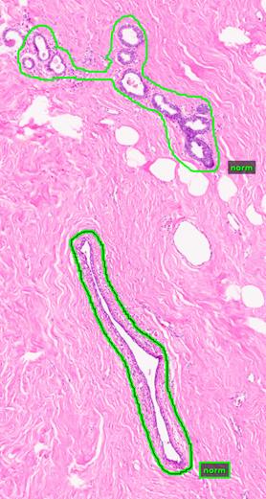
Figure 1. A normal terminal duct unit surrounded by healthy fibrous stroma

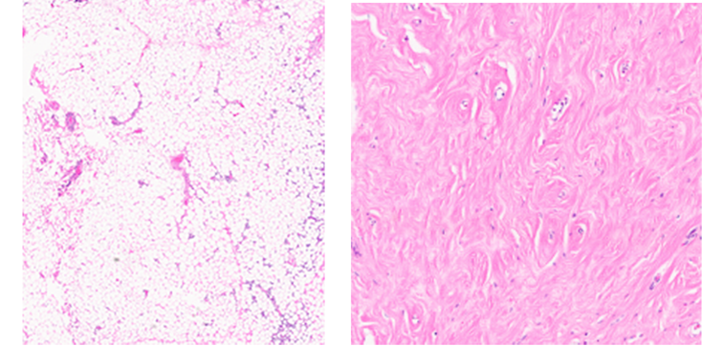
Figure 2. Examples of fatty stroma (left) and fibrous stroma (right)

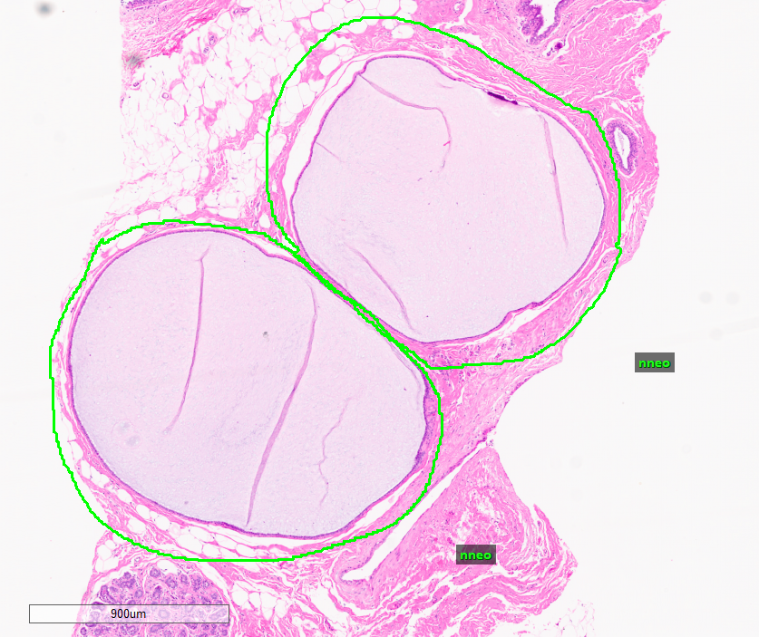
Figure 3. Microcysts annotated as NNEO
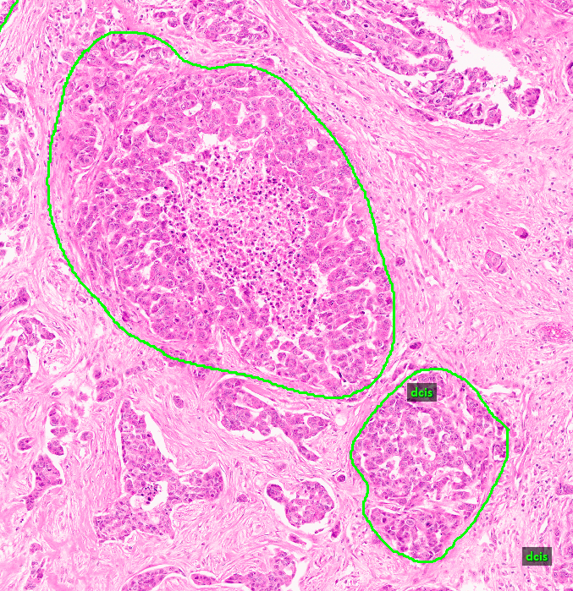
Figure 4. Typical DCIS (ductal carcinoma in situ) presentation of malignant epithelial cells confined to the ductal-lobular system
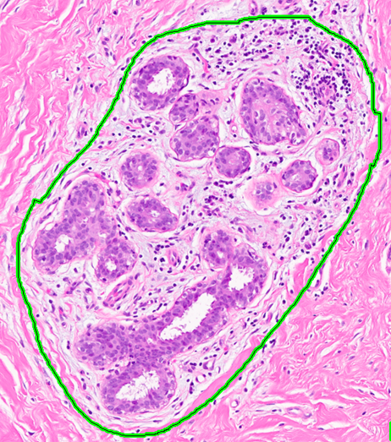
Figure 5. Gynecomastoid hyperplasia, benign proliferation

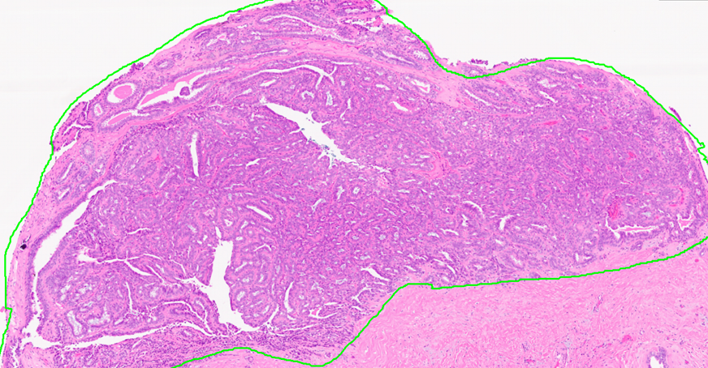
Figure 6. benign intraductal papilloma

Fig. 1 Segment Anything (SAM) results for different .svs resolutions: top side – level 2 (smallest), bottom left – section corresponding to level 1 segmentation, bottom right – section corresponding to level 0 (largest) resolution
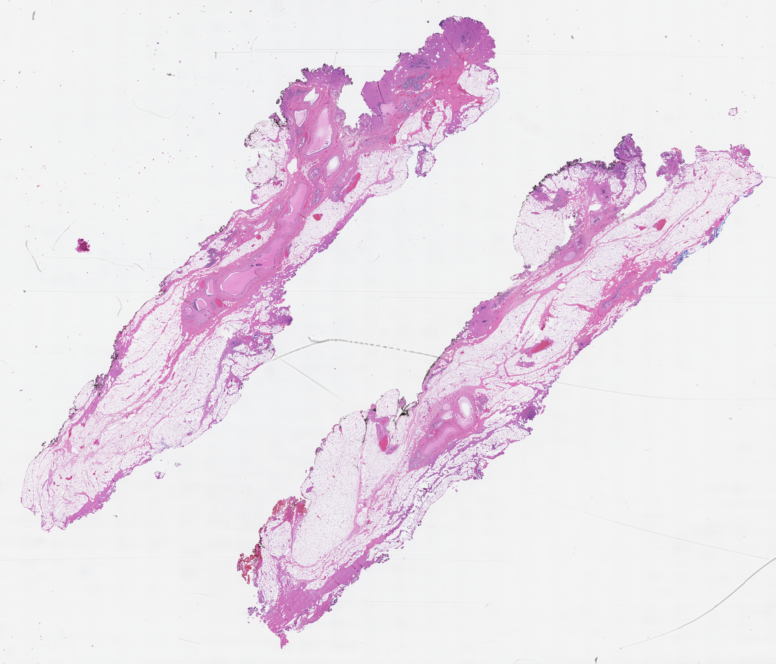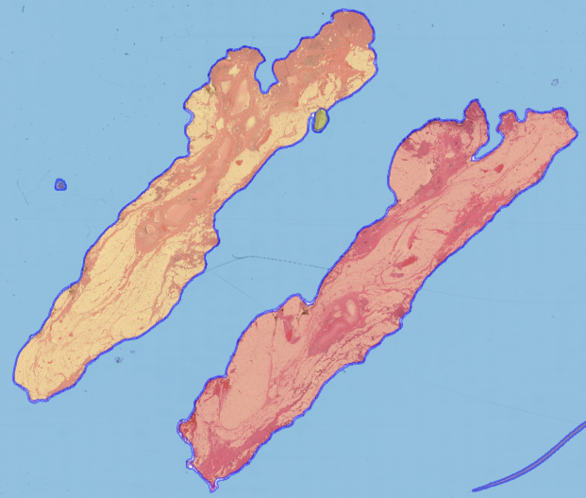
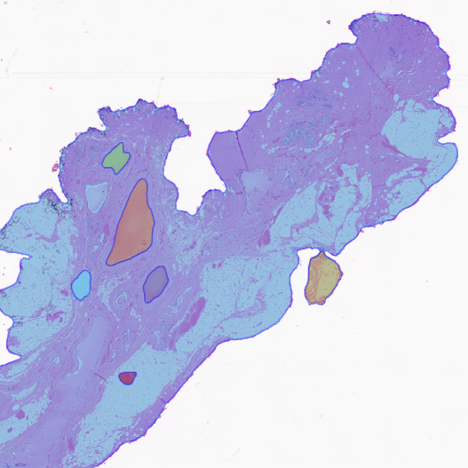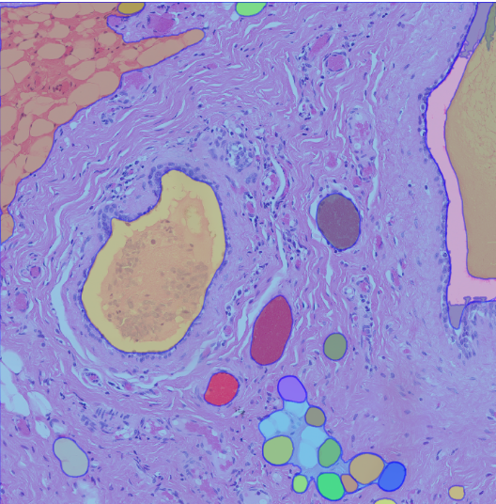

Temple University Digital Pathology
(TUDP)
no. xml files | 3505
no. total labels | 16971
average no. labels per slide
no. non-cancerous labels | 8895
no. carcinogenic signs | 5362
no. cancerous labels | 2714
Table 3. Label Breakdown for the TUDP Breast Subset

Fox Chase Cancer Center Digital Pathology Corpus
(FCDP)
no. xml files | 1463
no. total labels | 20085
average no. labels per slide | 13.7
no. non-cancerous labels | 7169
no. carcinogenic signs | 752
no. cancerous labels | 12164
Table 4. Label Breakdown for the FCCC Breast Subset

Figure 2. A typical WSI for a specimen from a breast case

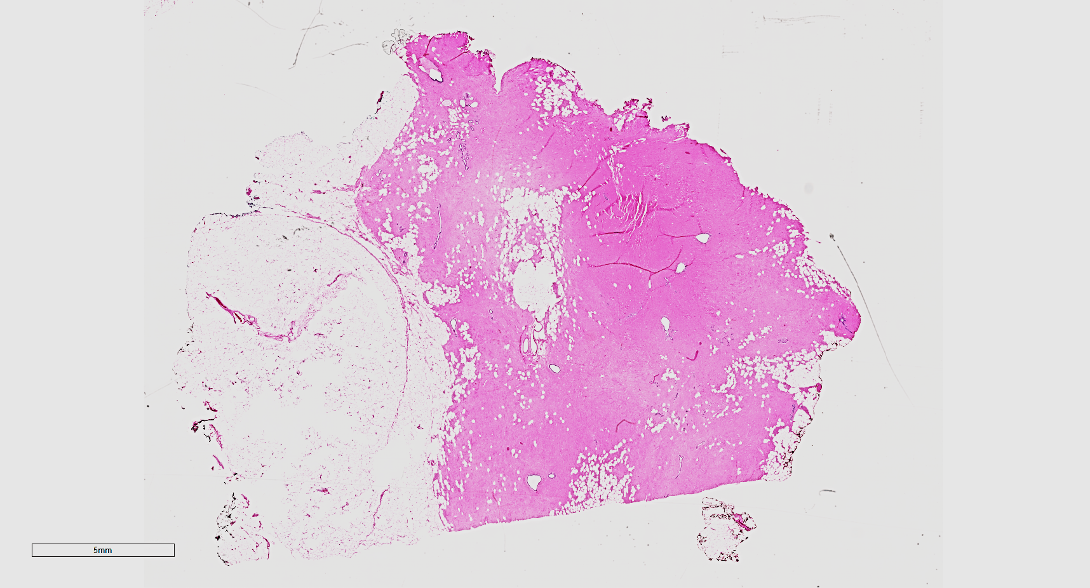
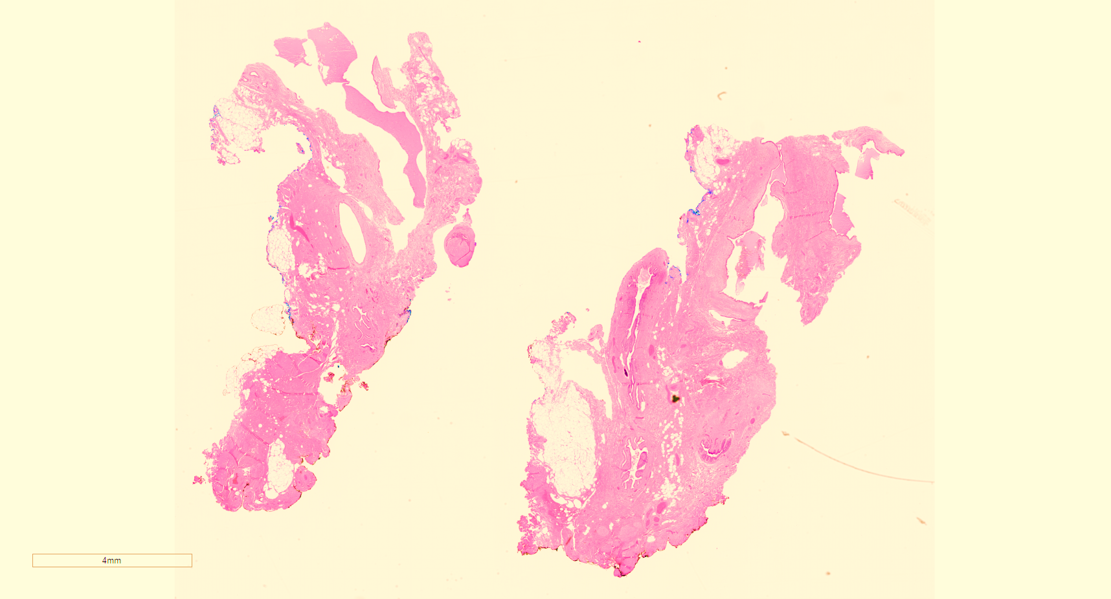
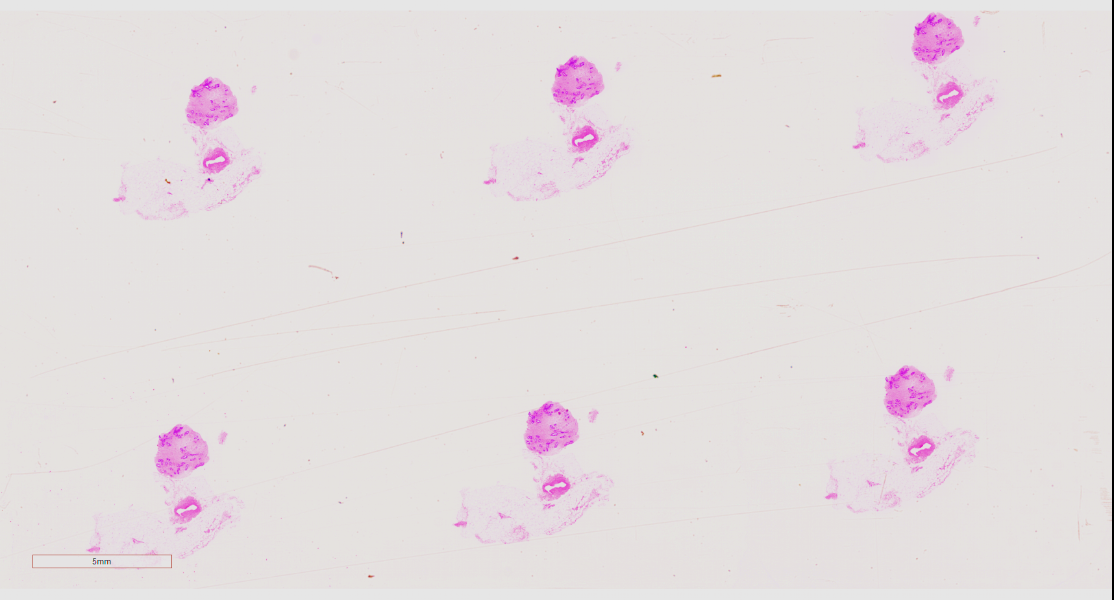
Figure 3. A range of WSIs of breast specimens

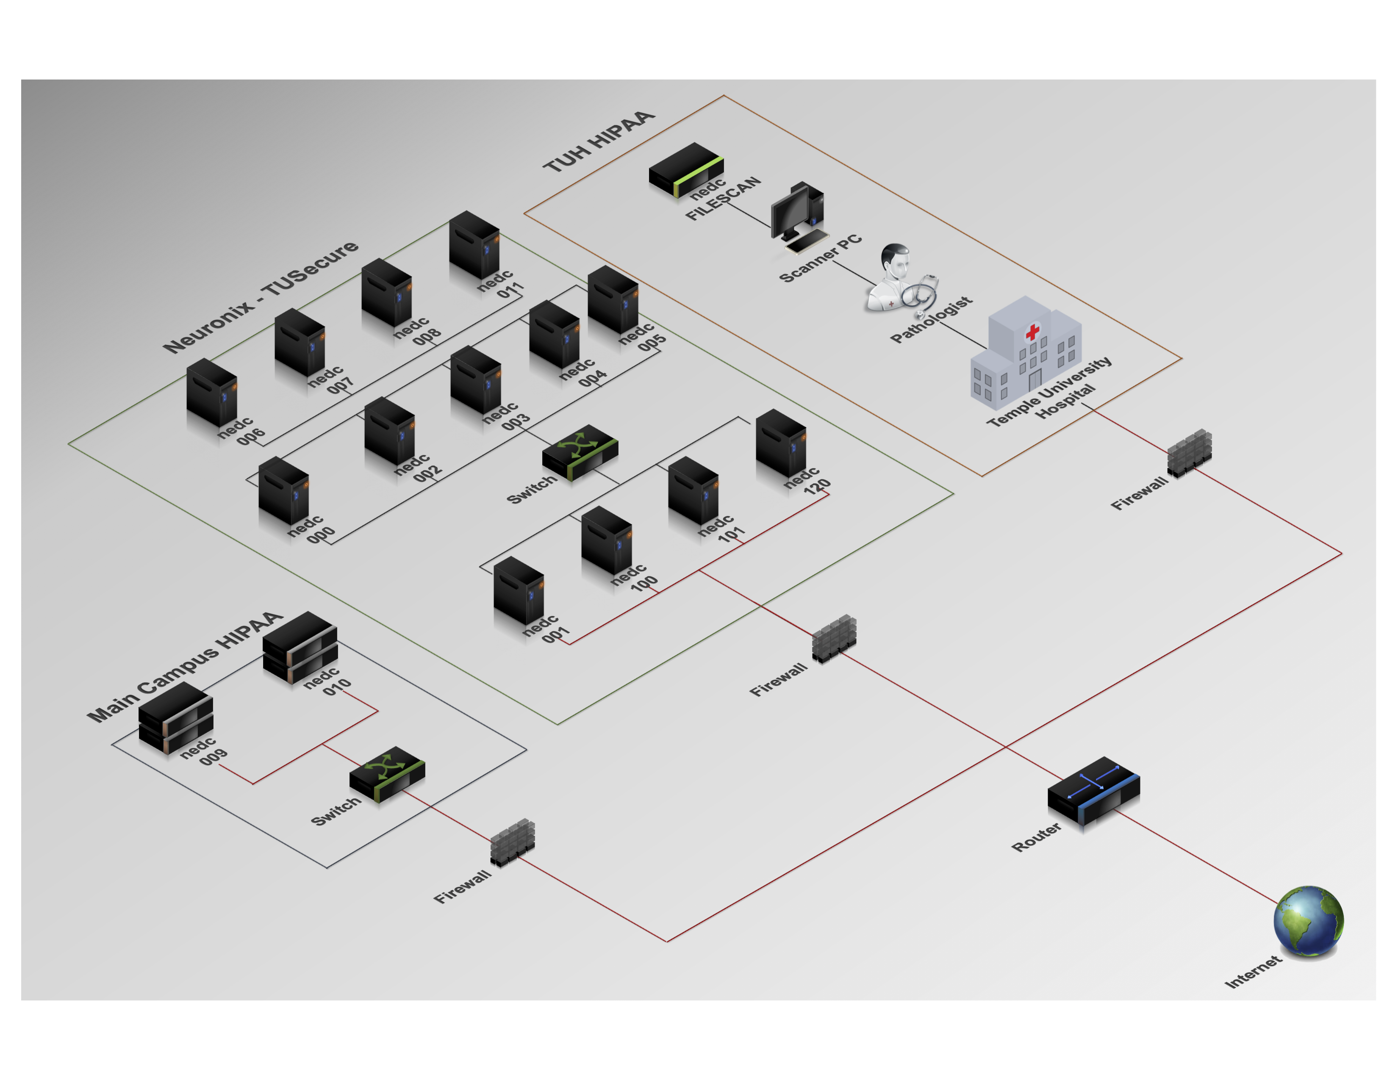
Figure 4. An overview of the HIPPA-compliant network architecture

Figure 5. A typical clinical case report

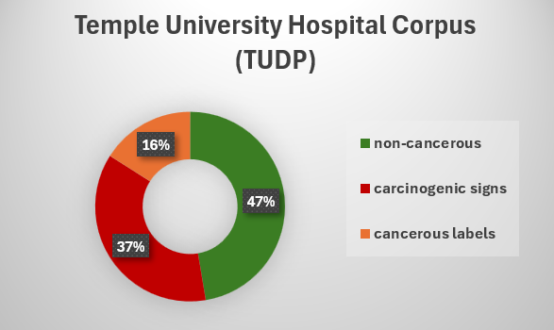
Figure 6. Breakdown of TUDP Labels

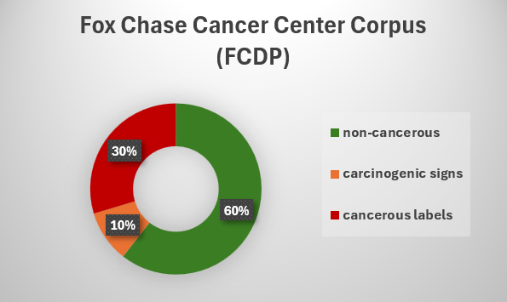

Figure 7. Breakdown of FCCC Labels

Figure 8. Breakdown of FCCC Labels

Don’t delete this line

