Title: Applications of Kernel Theory to Speech Recognition

Authors: Joseph Picone, Aravind Ganapathiraju and Jon Hamaker
Corresponding Author:
Joseph Picone
Room 2133
Center for Advanced Vehicular Systems
Mississippi State University
200 Research Blvd.
Starkville, Mississippi 39759
Tel: 662-325-5444
Fax: 662-325-5433
Email: picone@cavs.msstate.edu

Other Author Contact Information:
Jon Hamaker Aravind Ganapathiraju
12516 NE 168th Court 14211 NE 186th Pl.
Woodinville, WA 98072 Woodinville, WA 98072
Tel: 425- 482-1677 Tel: Tel: (425) 636-0705
Email: jonham@microsoft.com Email: AGanapat@conversay.com

Applications of Kernel Theory to Speech Recognition
Automated speech recognition is traditionally defined as the process of converting an audio signal into a sequence of words. Over the past thirty years, simplistic techniques based on the design of smart feature extraction algorithms and physiological models have given way to powerful statistical methods based on generative models. Such approaches suffer from three basic problems: discrimination, generalization, and sparsity.
In the last decade, the field of machine learning has grown tremendously, generating many promising new approaches to this problem based on principles of discrimination. These techniques, though powerful when given vast amounts of training data, often suffer from poor generalization. In this chapter, we present a unified framework in which both generative and discriminative models are motivated from an information theoretic perspective. We introduce the modern statistical approach to speech recognition and discuss how kernel-based methods are used to model knowledge at each level of the problem. Specific methods discussed include kernel PCA for feature extraction and support vector machines for discriminative modeling. We conclude with some emerging research on the use of kernels in language modeling.

Keywords: speech recognition, support vector machines, machine learning, discrimination
Table of Contents
Introduction 1
An Information Theoretic Basis for Speech Recognition 2
The Elements of a Speech Recognition System 4
Feature Extraction 5
Acoustic Modeling 10
SVM Design for Speech Recognition 12
Experiments on Conversational Speech 15
Impact on Language Modeling 18
Summary 20
References 22
Figures 28
Tables 34

Introduction
The goal of a speech recognition system is to provide an accurate and efficient means of converting an audio signal to text typically consisting of a string of words. The audio signal is often sampled at a rate between 8 and 16 kHz. The signal is converted to a sequence of vectors, known as features, at a rate of 100 times per second. These features, denoted 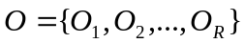, are referred to as observations. The observations are then ultimately mapped to a sequence of words, denoted 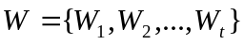, by integrating knowledge of human language into a statistical modeling framework. The dominant approach to achieving this signal to symbol conversion is based on hidden Markov models (Jelinek, 1998; Rabiner & Juang, 1993). A speech recognition system today is typically just one component in an information retrieval system that can perform a wide range of human computer interactions including voice mining, dialog, and question answering (Maybury, 2005). Historically, speech recognition has focused on maximizing the probability of a correct word sequence given the observations, denoted 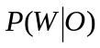, using generative models. However, in this chapter, we will explore a relatively new class of machines that attempt to directly minimize the error rate using principles of discrimination.
There are several subtle aspects of this problem that make it a challenging machine learning problem. First, our goal is to produce a machine that is independent of the identity of the speaker or the acoustic environment in which the system operates. This requires a learning machine to infer characteristics of the signal that are invariant to changes in the speaker or channel, a problem often described as robustness (O’Shaughnessy, et al., 2006). Second, the duration of a word can vary in length even for the same speaker, which requires a learning machine to be able to perform statistical comparisons of patterns of unequal length. Third, the pronunciation of a word, which often represented as a sequence of fundamental sound units referred to as phones, can vary significantly based on factors such as linguistic context, dialect, and speaking style (Jurafsky & Martin, 2000). Fourth, and perhaps most importantly, state of the art speech recognition systems must learn from errorful transcriptions of the words. Systems are typically trained from transcriptions that contain only the words spoken, rather than detailed phonetic transcriptions, and often these word transcriptions have error rates ranging from 1% to 10%. Practical considerations such as these often require careful engineering of any learning machine before state of the art performance can be achieved. Nevertheless, in this chapter, we will focus primarily on the core machine learning aspects of this problem.

An Information Theoretic Basis for Speech Recognition
Given an observation sequence, , a speech recognizer should choose a word sequence such that there is minimal uncertainty about the correct answer (Valtchev, 1995; Vertanen, 2004). This is equivalent to minimizing the conditional entropy:
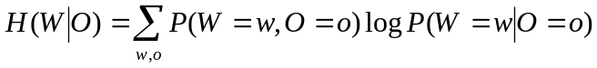 . ()
The mutual information, 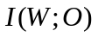between  and is equivalent to:
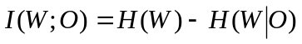 . ()
A simple rearrangement of terms results in:
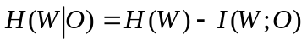 . ()
Therefore, if our goal is to minimize 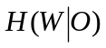, we can either minimize the entropy,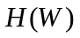, or maximize the mutual information, 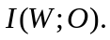 We refer to the former problem as language modeling since it involves developing machines that can predict word sequences given a history of previous words and knowledge about the domain. The latter problem is known as the acoustic modeling problem since it involves predicting words given observations, which represent information about the original audio, or acoustic, signal. Most of this chapter will be devoted to various forms of acoustic modeling, because this is where kernel machines have had the greatest impact. At the end of this chapter we will briefly discuss emerging research on applications of kernel machines to language modeling since this is a relatively new area in the field.
Brown (1980) demonstrated that maximizing the mutual information over a set of observations is equivalent to choosing a parameter set, , that maximizes the function:
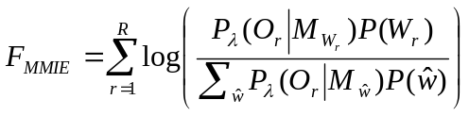 ()
where 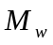 represents a statistical model corresponding to a candidate sequence of words, , describing the input signal, and 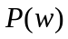 is the probability of this word sequence. is often computed using a language model, which is designed to minimize . The denominator term sums probabilities over all possible word sequences, , and involves contributions from both the acoustic and language models.
The decomposition in () can often be expanded to include a pronunciation model (Jurafsky & Martin, 2000):
()
The pronunciation model, 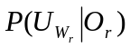, typically describes how words are mapped to phones. The simplest form of a pronunciation model is a lexicon, which lists the sequence of phones that are most commonly used to pronounce a given word. More complicated approaches to pronunciation modeling use learning machines such as decision trees (Odell, 1995). The same statistical methods that are popular for acoustic modeling, such as HMMs, can be applied to pronunciation modeling. The details of such approaches are beyond the scope of this chapter. Here, we will focus primarily on fundamental aspects of the statistical modeling problem.
One approach to maximization of ()()() is to increase the numerator term. The solution to this problem is well-known and typically involves using maximum likelihood estimation (MLE) of the parameters of the models representing the individual terms. A second approach to maximization of ()()() is to decrease the denominator term (Valtchev, 1997), a process known as Maximum Mutual Information Estimation (MMIE). This has been a popular approach to introducing notions of discrimination into the traditional hidden Markov model paradigm, and involves making incorrect hypotheses less probable, thereby minimizing the summation in the denominator of (). This process is also known as discriminative training and has produced significant improvements in performance in the last decade. It is a process that is typically introduced after MLE-based models have been estimated. Therefore, let us first focus on the components of a typical MLE-based speech recognition system.

The Elements of a Speech Recognition System
The MLE approach to speech recognition, which involves the maximization of the numerator term in (), can be viewed as a classic noisy communications channel problem (Rabiner, et al., 1993). This well-known formulation of the speech recognition problem concisely expresses the relationship between various sources of knowledge using Bayes Rule:
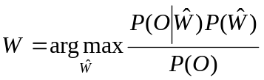 . ()
This formulation is important for two reasons. First, the term associated with the acoustic model, 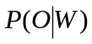, provides insight into a process whereby statistical models can be trained. Estimation of the probability of an observation sequence, , given a word sequence , can be accomplished by creating a database of speech labeled with the correct word sequences, and use of an expectation maximization (EM) process that guarantees convergence of model parameters to an MLE solution. Second, the denominator term, which represents the probability of the observation sequence, can be ignored during the maximization process.
Therefore, the MLE approach to the speech recognition problem often is simplified to:
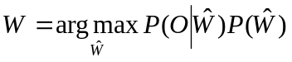 . ()
A conceptual block diagram of this approach is shown in . There are four major components to the system: feature extraction, acoustic modeling, language modeling, and search. Kernel methods have not been directly applied to the search problem and therefore search will not be discussed here. Comprehensive reviews of this topic are given in Mohri (1997), Zweig (2002), Deshmukh (1999). Applications of kernel methods in language modeling have only recently emerged and will be discussed at the end of this chapter. Acoustic modeling, the most straightforward application of kernel-based methods, is discussed in Section XX. Feature extraction (Picone, 1993) is the process by which the acoustic signal is converted to a sequence of vectors that captures important temporal and spectral information, and is discussed next. The use of kernels for feature extraction is also discussed extensively in Chapter 14.

Feature Extraction
The general goals of the feature extraction process are to produce features that model the perceptually-meaningful aspects of the signal and to ignore artifacts due to variations in channel, speaker, and other such operational impairments. Traditional speech recognition features often consist of measurements that are correlated and have unequal variances, and hence require some form of statistical normalization. Early attempts to transform features in a way that could improve discrimination focused on principal components analysis (Bocchieri, 1986) and linear discriminant analysis (Kumar, 1998) – techniques that operate primarily on the correlation properties of the features.
A typical speech recognition front end (Young, 2005), as shown in Figure 2, integrates absolute measures of the spectrum computed using a mel frequency-based cepstrum with energy (MFCC). Twelve spectral measurements are concatenated with an energy measurement to produce thirteen features. These features are then differentiated to measure the rate of change of the spectrum, and then differentiated once again to measure the acceleration. This particular approach produces a feature that contains 39 elements known as mel frequency scaled cepstral coefficients. Since the overall computation involves almost 100 msec of data, and is performed every 10 msec, there is significant overlap of information between two feature vectors that are adjacent in time.
Other approaches to feature extraction compute a much larger number of features, often the result of a fine grain analysis of the spectrum, and then reduce the dimensionality of the feature set through standard techniques such as linear discriminant analysis. More recently, multistream approaches have become popular as a way to integrate higher levels of knowledge and measurements of asynchronous events into a single feature vector. Since all of these techniques mix heterogeneous measurements, it is easy to see that normalization and decorrelation are essential components of any subsequent processing. The use of linear transformations to decorrelate features has been a part of the speech recognition systems for the past 30 years.
Kernel-based methods provide a principled way to move beyond simple linear transformations, and to transform the features to a new space in which discrimination is improved. It is important to understand that virtually any low-level measurement of the speech signal is highly ambiguous. This is demonstrated in Figure 3, in which we display the first two MFCC features measured for four vowels extracted from a conversational speech corpus. There are essentially two ways to disambiguate such classes – condition the measurements on more linguistic context or employ nonlinear feature transformations. Though the latter is the focus of a kernel-based approach, in practice it takes a combination of both approaches to achieve high performance speech recognition.
Kernel-based approaches represent a substantial improvement because the use of a nonlinear mapping allows the features to be transformed into high dimensional spaces which increase separability of the features. An overview of this approach is shown in Figure 4. These transformations can be computationally expensive. Therefore, any improvements in performance must be weighed against the cost. Feature extraction today typically consumes less than 1% of the overall processing time in a speech recognition system.
Principal components analysis (PCA) is a well-established technique for statistical normalization dimensionality reduction (Fukunaga, 1990). Here we will focus on the simplest form of PCA in which a single transformation is used to decorrelate all observations. This process is often referred to as class-independent PCA or the pooled covariance approach, since a single covariance method, which mixes measurements on speech and nonspeech (e.g., silence or background noise) is used to model the data. It is relatively straightforward to extend PCA to a class-dependent approach in which individual words, phonemes, or other elements of an acoustic model use a unique transformation. However, the essential advantages of a kernel-based approach can be demonstrated from the simplest form of PCA in which we apply a single linear transformation to the data.
Class-independent PCA on a set of feature vectors,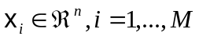, begins with computation of the covariance matrix. Without loss of generality, we will assume the features have a zero mean: 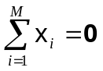. The covariance matrix is defined as:
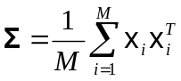 . ()
We seek a linear transformation of the input vectors that produces decorrelated features. The well-known solution to this problem is a linear transformation derived from an eigenvalue analysis of :
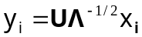 , ()
where  is a diagonal matrix consisting of the eigenvalues of and  represents a matrix of eigenvectors of . Dimensionality reduction has proven to be a useful way to enhance performance, and can be performed by eliminating the dimensions corresponding to the least significant eigenvalues (Bocchieri, 1986). Notions of discrimination where developed initially through the use of simultaneous diagonalization (Fukunaga, 2000), class-dependent transforms (Bocchieri, 1986) and eventually linear discriminant analysis (Kumar, 1998).
Kernel-based PCA (KPCA) (Schölkopf, 1999) is a technique that applies a kernel function to the PCA process in order to obtain decorrelated feature vectors in the higher dimensional space. The combination of a decorrelation transformation and a nonlinear mapping allows data not separable by a hyperplane decision surface to be more accurately classified. Since speech recognition features suffer from significant amounts of confusability in the feature space due to, among other things, strong coarticulation in casual speech, classification techniques that can model nonlinear decision surfaces are extremely important.
The nonlinear mapping in KPCA is implemented as a dot product of the mapped variables: 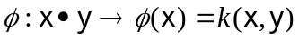. The kernel matrix, , is defined as 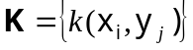. Let us define a matrix,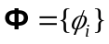, for 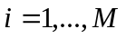, where 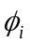 represents the mapping of  into a higher dimensional space,, and 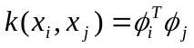. We can define a covariance matrix in the transformed feature space in terms of the mapped data:
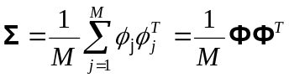 . ()
The KPCA representation of is given by the projection of 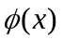 onto the eigenvectors of , which can be expressed as:
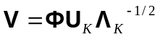 , ()
where  and 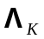 contain the eigenvectors and eigenvalues of the kernel matrix, . The process of transforming input data involves a similar transformation to PCA, but this transformation operates on the mapped data:
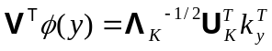 , ()
where 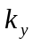 represents an  dimensional vector formed by 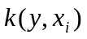 for .
Lima, et al. (2003) initially applied KPCA to a speaker independent isolated word recognition experiment consisting of 520 Japanese words spoken by 80 speakers. The experiment consisted of 10,400 training utterances and 31,200 evaluation utterances. A standard MFCC analysis was used for feature extraction. The baseline system achieved a word error rate of 8.6%. A polynomial kernel function was selected for these experiments.
Performance on speech recognition has not shown a strong dependence on the choice of a kernel. Polynomial and radial basis functions have been popular choices for kernels. First and second order polynomial kernels were evaluated in this study. The number of dimensions per kernel was varied from 8 to 256. A summary of the error rates is given in Table 1. A 22% relative reduction in WER was achieved using a second-order polynomial and 32 dimensions.
Though conceptually straightforward, KPCA has a significant drawback that all the training data is required to compute in (12). A variety of standard techniques in pattern recognition have been explored to deal with this problem including subsampling (Lima, et al., 2005) and clustering (Lu, et al., 2004).
There are many other variants of PCA that have proven successful in speech recognition. Independent Component Analysis (ICA) (Bell, 1995) is one of the more promising generalizations of PCA because of its effectiveness at separating speech from noise in applications where little prior information is available about either signal. ICA attempts to minimize the mutual information between its outputs instead of minimizing the correlation, as in PCA. Bach & Jordan (2003) showed that kernel-based ICA provided superior performance on several tasks involving separation of complex deterministic signals as well as speech signals. Boscolo, et al. (2001) showed that kernel-based ICA performed well on a wide variety of signal separation tasks in which the a priori statistics of the signals were unknown. Extensions of these approaches to classical problems such as blind deconvolution are an active area of research.

Acoustic Modeling
The acoustic modeling components of a speech recognizer are based on hidden Markov models (HMMs) (Rabiner & Juang, 1993). The power of an HMM representation lies in its ability to model the temporal evolution of a signal via an underlying Markov process. The ability of an HMM to statistically model the acoustic and temporal variability in speech has been integral to its success. The probability distribution associated with each state in an HMM models the variability which occurs in speech across speakers or phonetic context. This distribution is typically a Gaussian mixture model (GMM) since a GMM provides a sufficiently general parsimonious parametric model as well as an efficient and robust mathematical framework for estimation and analysis.
Widespread use of HMMs for modeling speech can be attributed to the availability of efficient parameter estimation procedures, such as MLE. One of the most compelling reasons for the success of ML and HMMs has been the existence of iterative methods to estimate the parameters that guarantee convergence. The expectation maximization (EM) algorithm provides an iterative framework for ML estimation with good convergence properties. The process of estimating parameters is conducted in a supervised learning paradigm in which the recognizer is given large numbers of example utterances along with their transcriptions. These transcriptions typically consist of a sequence of words. Note that segmentation information or speech/non-speech classification is not required – the supervised learning paradigm allows the statistical models to acquire this information automatically. Hence, a speech recognition system does a significant amount of self-organization during the training process, and has the flexibility to learn subtle distinctions in the training data.
There are, however, problems with an MLE formulation for applications such as speech recognition (Ganapathiraju, 2002). Many promising techniques (Vertanen, 2004) have been introduced for using discriminative techniques to improve the estimation of HMM parameters (Woodland & Povey, 2000; McDermott, 1997). Artificial neural networks (ANNs) represent an important class of discriminative techniques that have been successfully applied to speech recognitionError: Reference source not foundError: Reference source not found. Though ANNs attempt to overcome many of the problems previously described, their shortcomings with respect to applications such as speech recognition are well-documented (Bourlard & Morgan, 1994)Error: Reference source not foundError: Reference source not found. Some of the most notable deficiencies include design of optimal model topologies, slow convergence during training and a tendency to overfit the data. However, it is important to note that many of the fundamental ideas presented here (e.g., soft margin classifiers) have similar implementations within an ANN framework. In most classifiers, controlling a trade-off between overfitting and good classification performance is vital to the success of the approach.
Kernel-based methods, particularly SVMs, are extremely attractive as alternatives to the GMM. SVMs have demonstrated good performance on several classic pattern recognition problems (Schölkopf, 2005) and have become popular alternatives across a range of human language technology applications (Wan, 2005). The primary attraction of these techniques is the way in which they generalize the maximum likelihood and discriminative training paradigms using risk minimization.

SVM Design for Speech Recognition
Since speech recognition problems suffer from extreme amounts of overlap in the feature space, the use of a soft margin classifier is critical. One particular formulation of the SVM that has been effective in acoustic modeling for speech recognition poses the margin maximization problem as:
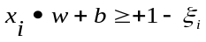, 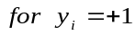 , ()
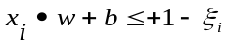, 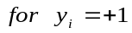 , ()
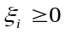, , ()
where 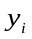are the class assignments, represents the weight vector defining the classifier, is a bias term, and the ’s are the slack variables. Derivation of an optimal classifier for this non-separable case exists and is described in detail in (Ganapathiraju, 2002).
Several approaches for controlling the quality and quantity of support vectors have been studied extensively in recent years (Schawe-Taylor and Cristianini, 2002). Perhaps the most important consideration in speech recognition is the need to be robust to outliers in the data that usually arise from mislabeled training data or anomalous speaker behavior. The linear cost function in (13) has proven to be effective in training speech recognition systems using large amounts of conversational speech recognition data (Ganathapiraju & Picone, 2000).
Hybrid approaches for speech recognition (Bourlard, 1994)Error: Reference source not found provide a flexible paradigm to evaluate new acoustic modeling techniques such as SVMs. These systems do not entirely eliminate the HMM framework because traditional classification models such as SVMs do not inherently model the temporal structure of speech. Sequence kernels, discussed extensively in Chapter 12, are an emerging technique that overcomes these types of limitations. The process by which we estimate parameters of the models and optimize the number of support vectors for large amounts of acoustic training data is described extensively in (Ganapathiraju, 2002). In integrating SVMs into more traditional hybrid system approaches, several issues arise: posterior estimation, classifier design, segmental modeling, and N-best rescoring.
The first major concern in using SVMs for speech recognition is the lack of a clear relationship between distance from the margin and the posterior class probability. While newer classifiers have been developed that are more suited to Bayesian classification (Hamaker, et al., 2002), for SVMs, unmoderated probability estimates based on ML fitting (Platt, 1999) represent an effective trade-off between computational complexity and error performance. A sigmoid distribution is used to map the output distances to posteriors:
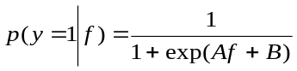. ()
Where the parameters and  can be estimated using a model-trust minimization algorithm (Platt, 1999). Error: Reference source not foundError: Reference source not foundIn order to avoid biased estimates, a cross-validation set must be used to estimate the parameters of the sigmoid (Ganapathiraju, 2002).
The second major issue relates to classifier design. Frame-level classification in speech recognition has not proven to be a promising approach. The baseline HMM system described here uses an inventory of 8,000 context-dependent phone models to describe the most likely sequences of three consecutive phones. Each phone model uses three states to represent its corresponding sound, arranged in a simple left-to-right topology. Hence, there are approximately 24,000 states in the acoustic models, and it is not practical to train discriminative classifiers for so many states. Instead, for computational efficiency, one-vs.-all classifiers are trained for each phone model, and these classifiers model posteriors for phones rather than states or frames.
A third major issue involves segmental modeling. The acoustic model needs to capture both the temporal and spectral structure of speech that is clearly missing in frame-level classification schemes. HMMs elegantly model such structure using a finite state machine. Phone durations vary, and learning such duration information is a critical part of the acoustic modeling problem. Segment durations are correlated with the word choice and speaking rate, but are difficult to exploit in an SVM-type framework. A simple but effective approach motivated by the 3-state HMMs used in most systems is to assume that the segments (phones in most cases) are composed of a fixed number of sections. The first and third sections model the transition into and out of the segment, while the second section models the stable portion of the segment. Segments composed of three sections are used in all experiments described below. The segment vector is then augmented with the logarithm of the duration of the phone to explicitly model the variability in duration. Figure 5 demonstrates the construction of a composite vector for a phone segment.
A fourth issue relates to the decoding paradigm used in the hybrid system. Though it is highly desirable to embed the SVM classifier within the supervised training process used in HMMs, computationally efficient means for doing this remain elusive. A more standard approach for integrating such classifiers is to use an N-best rescoring paradigm. A conventional HMM system is used to generate a list of sentence hypotheses that includes underlying phone alignments. Segment-level feature vectors are generated from these alignments. These segments are then classified using the SVMs. Posterior probabilities, computed using the sigmoid approximation previously discussed, are then used to compute the utterance likelihood of each hypothesis in the N-best list. The N-best list is reordered based on the likelihood and the top hypothesis is used to calibrate the performance of the system. An overview of the resulting hybrid system is shown in Figure 6.Error: Reference source not found

Experiments on Conversational Speech
The hybrid SVM/HMM architecture previously described has been extensively analyzed using two relatively simple baselines: the Deterding vowel recognition task (Deterding, 2000) and the OGI Alphadigit corpus (Cole, et al., 1997). On the first task, SVMs were shown to outperform many standard classifiers (Ganapathiraju, et al., 2002). On the second task, a radial basis function kernel was shown to provide slightly better performance than a polynomial kernel. An SVM/HMM hybrid system was also shown to provide approximately a 10% decrease in word error rate (WER) over a comparable HMM system. A summary of WERs by the class of sound is shown in Table 2. These word classes have been found to comprise the major error modalities for the dataset. These subsets are particularly challenging because they are phonetically very close and can only be disambiguated by the acoustic model since there are no higher-level language modeling constraints applied in this task.
SVMs have also shown encouraging results on a conversational speech task, SWITCHBOARD (SWB) (Godfrey, et al., 1992). The training set consists of 114,441 utterances while the development test set consists of 2,427 utterances. These utterances have an average length of six words and an average duration of two seconds. The test set vocabulary is approximately 22,000 words while the training set vocabulary has over 80,000 words. A 42-phone set was used for this task. The baseline HMM system was trained on 60 hours data from 2,998 conversation sides. The input features were MFCCs which had been normalized to have a zero-mean and unit variance. Twelve mixture components per state were used. This baseline system has a WER of 41.6% on the development test set.
The experiments on this task are summarized in Table 3. For this task, 10-best lists with a list error rate of 29.5% were used for all experiments. Segmentations derived from the corresponding HMM hypothesis were used to rescore the N-best list with the SVM classifier. This hybrid approach did improve performance over the baseline, albeit only marginally — WER of 40.6% compared to a baseline of 41.6%.
The use of oracle segmentations and transcriptions in the hybrid system was then explored to gain further insight into the drawbacks of the rescoring paradigm. On the Alphadigits task, using the reference segmentations improved performance of the hybrid system from 11.0% to 7.0% WER (compared to a baseline of 11.9% WER). On the SWB task, the reference segmentation improved the performance of the system from 40.6% to 36.1%. This demonstrates that the mismatch between the HMM segmentations, which are derived using ML training, and the SVM system, trained using a maximum margin classifier, is a source of degradation in performance.
Another set of experiments was conducted to determine the effect of the richness of N-best lists on the performance of the hybrid system. The N-best list error rate was artificially reduced to 0% by adding the reference to the original 10-best lists. Rescoring these new N-best lists using the corresponding segmentations resulted in error rates of 9.1% WER and 38.1% on Alphadigits and SWB respectively. This improvement corresponds to a 30% relative improvement in performance on the Alphadigits task. On this task, the HMM system did not improve performance over the baseline even when the reference (or correct) transcription is added to the N-best list.
This result indicated that SVMs are superior to HMMs when they are exposed to accurate segmentations. Unfortunately, the current hybrid approach does not allow the SVM to be trained in a way in which it is exposed to alternate segmentations. Hence, the SVM doesn’t learn to discriminate between alternate segmentations. We hypothesize that this is the reason that introduction of the correct segmentation has such a big impact on performance for the SVM.
Another set of experiments were run to quantify the absolute ceiling in performance improvements the SVM hybrid system can provide. This ceiling can be achieved when we use the hybrid system to rescore the N-best lists that include the reference transcription using the reference-based segmentation. Using this approach, the system gave a WER 3.3% on the Alphadigits task, and 5.8% on SWB. This huge improvement should not be mistaken for a real improvement for two reasons. First, we cannot guarantee that the reference segmentation is available at all times. Second, generating N-best lists with 0% WER is extremely difficult, if not impossible for conversational speech. This improvement should rather be viewed as a proof of concept that by using good segmentations to rescore good N-best lists, the hybrid system has a potential to improve performance significantly.

Impact on Language Modeling
Recall from () that the goal of a language model is to predict the probability of a word sequence, 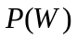. Methods for computing this quantity have been studied extensively over the years, and ranged from complex probabilistic finite state machines (Levinson, 1985) to N-gram analysis (Brown, et al., 1992). N-gram analysis has proven to be remarkably effective over the years because of its simple formulation and powerful computational properties. In an N-gram approach, the probability of a word is decomposed into a product of its predecessors:
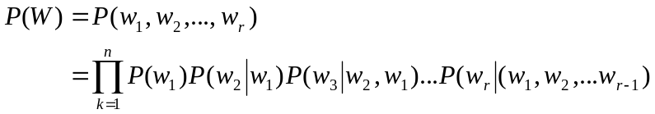 . ()
N-grams orders of three, referred to as a trigram, are commonly used in the first pass of a complex speech recognition system. Often longer span models are then applied selectively to improve performance on difficult phrases. Effective ways of encoding the word histories in () becomes a critical part of the language modeling problem since there are vast numbers of trigrams possible for a given language.
There are two main drawbacks to the N-gram approach. First, even when trained on large amounts of data, the trigram representation can be sparse and consist of many poorly approximated probabilities. Smoothing techniques based on information theory have been extensively explored to deal with this problem (Jelinek, 1997). Second, these N-grams can become very domain specific, and prove difficult to abstract. The ability to predict new phrases is limited when those phrases don’t appear in the training data. Many techniques have been explored to improve the generalization ability of the N-gram model (e.g., class-based N-grams). But the essential problem bears striking similarity to the other problems we have discussed – controlling generalization in a high dimensional space that is sparsely populated by training data. A computational model that allows mixtures of diverse types of information about word sequences (e.g., semantic tags) to be integrated into a single probabilistic framework and can produce plausible approximations for N-grams previously unseen in the training data is required.
In recent years, the classic probabilistic finite state machine has been replaced by a neural network-based language model. In such models, words are represented by points in a continuous multi-dimensional feature space and the probability of a sequence of words is computed by means of a neural network. The feature vectors of the preceding words make up the input to the neural network, which then will produce a probability distribution over a given vocabulary (Menchetti, et al., 2005).
The fundamental idea behind this model is to simplify the estimation task by mapping words from the high-dimensional discrete space to a low-dimensional continuous one where probability distributions are smooth functions. This is somewhat the reverse of the feature extraction problem, in which we mapped features from a low-dimensional space to a high-dimensional space. The network achieves generalization by assigning to an unseen word sequence a probability close to a word string seen in the training data. Of course, the main challenge here is whether the network can learn semantically-meaningful distances. An added benefit is that the neural network approach is computationally simple and fast, as well as being amenable to parallel processing.
Kernel methods offer similar advantages over neural networks for language modeling problems as they did for feature extraction and acoustic modeling. Kernel-based algorithms are easier to train because they minimize a convex functional, thus avoiding the difficult problem of dealing with local minima. However, a kernel function usually needs to be adapted to the problem at hand, and learning the kernel function is still an open problem. This is particularly true in the case of the discrete space encountered in the language modeling problem.
Application of such methods to the language modeling problem is still a relatively new area of research. Initial experiments with neural network approaches have shown promise. Emami, et. al. (2005) have shown modest decreases in language model perplexity and recognition error rates on tasks such as the Wall Street Journal corpus using a combination of a structured language model and neural network model for probability computation.

Summary
Kernel-based methods are having profound impact on speech processing in general as this research area increasingly embraces machine learning research. Applications of kernel methods are not strictly limited to speech. The use of kernel machines in computational biology was discussed extensively in Chapter 3. In Chapter 12, the use of these machines for other speech problems, specifically, speaker verification, is discussed. We did not elaborate on applications of these techniques to diverse problems such as language identification or speaker adaptation.
The speech problem poses some unique challenges for such techniques however. Though mature approaches such as SVMs have been shown to provide significant improvements in performance on a variety of tasks, there are two serious drawbacks that hamper their effectiveness in speech recognition. First, though sparse, the size of the SVM models (number of non-zero weights) tends to scale linearly with the quantity of training data. For a large speaker-independent corpus such as SWB this effect causes the model complexity to become prohibitive. Techniques have been developed to overcome these problems, but they typically involve approximations which can only attempt to insure that the location of the model on the error surface remains reasonably close to optimal. It is much more preferable to examine methods where this sparse optimization is explicit in the training of the model.
Second, SVMs are fundamentally binary classifiers which are only capable of producing a yes/no decision. In speech recognition this is an important disadvantage since there is significant overlap in the feature space which can not be modeled by a yes/no decision boundary. Further, the combination of disparate knowledge sources (such as linguistic models, pronunciation models, acoustic models, etc.) requires a method for combining the scores produced by each model so that alternate hypotheses can be compared. Thus, we require a probabilistic classification which reflects the amount of uncertainty in our predictions. Efforts have been made to build posterior probability estimates from the SVM models by mapping the SVM distances to a sigmoid function. While this does build a posterior estimate, Tipping (2001) argues quite effectively that the sigmoid estimate is unreliable and that it tends to overestimate the model’s confidence in its predictions.
A promising new area of research is a learning machine that introduces a Bayesian approach into the vector machine concept. MacKay (1995) incorporates an automatic relevance determination (ARD) prior over each model parameter. This tends to force most of the parameters to zero, leading to a sparse model representation. A kernel-based learning technique termed the Relevance Vector Machine (RVM) is an application of ARD methods. Hamaker, et al. (2002) have shown this is a prominsing technique that provides comparable performance to SVMs, but generates much fewer parameters. ARD techniques are recently being explored in conjunction with many of the learning machines previously introduced (Van Gestel, et al., 2001).
Finally, what tends to be lacking in all these approaches is a tightly integrated closed-loop paradigm for training the parameters of these kernel machines within the supervised learning framework of a speech recognition system. MLE methods excel in speech recognition because of the supervised learning paradigm. Despite the strong fundamental structure of the classifier, the data input into a speech recognition system is becoming increasingly imperfect as research systems strive to process tens of thousands of hours of speech data. The MLE process forces models to reorganize information as necessary to reach some sort of optimal state. This process is robust to imperfect data, model topologies, etc., and delivers surprisingly good performance on training data with high error rates (Sundaram, 2002). Techniques that combine the robustness and computational efficiency of MLE-based supervised learning with the ability to maintain good generalization will continue to be an active area of research over the next 10 years.
Note that many of the algorithms, software, and recognition systems described in this work are available at http://www.cavs.msstate.edu/hse/ies/projects/speech.

References
Bach, F. & Jordan, M. (2003). Kernel Independent Component Analysis. Journal of Machine Learning, 3, 1-48.
Bell A.J. and Sejnowski T.J. 1995. An information maximisation approach to blind separation and blind deconvolution, Neural Computation, 7(6), 1129-1159.
Bengio, Y., Ducharme, R. and Vincent, P. (2001). A neural probabilistic language model. Advances in Neural Information Processing Systems. 932-938.
Bocchieri, E & Doddington, G. (1986). Frame-specific statistical features for speaker independent speech recognition. IEEE Transactions on Acoustics, Speech, and Signal Processing, 34(4), 755-764.
Boscolo, R., Pan, H. & Roychowdhury, V. (2004). Independent Density Analysis Based on Nonparametric Density Estimation, 15(1), 55-65.
Bourlard, H.A. & Morgan, N. (1994). Connectionist Speech Recognition — A Hybrid Approach, Kluwer Academic Publishers, Boston, Massachusetts, USA.
Brown, P. (1987). The Acoustic Modeling Problem in Automatic Speech Recognition, Ph.D. Disseration, Carnegie Mellon University, Pittsburgh, Pennsylvania, USA.
Brown P.F., Della Pietra, V.J., deSouza, P.V. , Lai, J.C. & Mercer, R.L. (1992). Class-Based n-gram Models of Natural Language. Computational Linguistics, 18 (4), 467-479.
Cole, R., et. al. (1997). Alphadigit Corpus. Center for Spoken Language Understanding, Oregon Graduate Institute (available at http://.cse.ogi.edu/CSLU/corpora/alphadigit).
Deshmukh, N., Ganapathiraju, A. & Picone, J. (1999). Hierarchical Search for Large Vocabulary Conversational Speech Recognition. IEEE Signal Processing Magazine, 16(5), 84-107.
Deterding, D., et. al. (2000) Vowel Recognition. available at http://.ics.uci.edu/pub/machine-learning-databases/undocumented/connectionist-bench/vowel/.
Emami, A. & Jelinek, F. (2005). A Neural Syntactic Language Model. Journal of Machine Learning – Special Issue on Learning in Speech and Language Technologies (in press).
Fukunaga, K. (1990). Introduction to Statistical Pattern Recognition. New York, New York, USA: Academic Press.
Ganapathiraju, A. and Picone, J. (2000). Support Vector Machines for Automatic Data Cleanup. Proceedings of the International Conference of Spoken Language Processing, 210-213, Beijing, China.
Ganapathiraju, A. (2002). Support Vector Machines for Speech Recognition, Ph.D. Dissertation, Mississippi State University, Mississippi State, Mississippi, USA.
Ganapathiraju, A., Hamaker, J. & Picone, J. (2004). Applications of Support Vector Machines to Speech Recognition, IEEE Transactions on Signal Processing, 52 (8), 2348-2355.
Van Gestel, Suykens, A.K., De Moor, B. & Vandewalle, J. (2001). Automatic Relevance Determination for Least Squares Support Vector Machine Regression. International Joint Conference on Neural Networks. 2416-2421.
Godfrey, J., et al. (1992). SWITCHBOARD: Telephone Speech Corpus for Research and Development. International Conference on Acoustics, Speech and Signal Processing, San Francisco, California, USA, 1, 517-520.
Hamaker, J., Picone, J. & Ganapathiraju, A. (2002). A Sparse Modeling Approach to Speech Recognition Based on Relevance Vector Machines. International Conference of Spoken Language Processing, 1001-1004, Denver, Colorado, USA.
Jelinek, F. (1998). Statistical Methods for Speech Recognition, Boston, Massachusetts, USA: MIT Press.
Jurafsky, D. & Martin, J.H. (2000). Speech and Language Processing: An Introduction to Natural Language Processing, Computational Linguistics, and Speech Recognition, Englewood Cliffs, New Jersey, USA: Prentice-Hall.
Kumar, N. & Andreou, A. G. (1998). Heteroscedastic discriminant analysis and reduced rank HMMs for improved speech recognition. Speech Communication, 26, 283–97.
Levinson, S.E., (1985) Structural methods in automatic speech recognition, IEEE Proceedings, 73(11), 1625-1650.
Lima, A., Zen, H., Nankaku, Y., Miyajima, C., Tokuda, K. & Kitamura, T. (2003). On the Use of Kernel PCA for Feature Extraction in Speech Recognition. European Conference on Speech Communication and Technology. Geneva, Switzerland. 2625-2628.
Lima, A., Zen, H., Nankaku, C., Tokuda, K., Kitamura, T. & Resende, F.G. (2005). Sparse KPCA for Feature Extraction in Speech Recognition. International Conference on Acoustics, Speech and Signal Processing, Philadelphia, Pennsylvania, USA. I-353-356.
Lu, C., Zhang, T., Du, X., & Li, C. (2004). Robust Kernel PCA Algorithm. International Conference on Machine Learning and Cybernetics, Shanghai, China. 3084-3087.
MacKay, D.J.C. (1995). Probable Networks and Plausible Predictions -- A Review of Practical Bayesian Methods for Supervised Neural Networks. Network: Computation in Neural Systems, 6, 469-505.
Maybury, M. (ed.) (2005). New Directions in Question Answering, Menlo Park, California. USA: AAAI Press.
McDermott, E. (1997). Discriminative Training for Speech Recognition, Ph.D. Dissertation, Waseda University, Japan.
Menchetti, S., Costa, F., Frasconi, P. & Massimiliano, P. (2005). Wide coverage natural language processing using kernel methods and neural networks for structured data. to appear in Pattern Recognition Letters.
Mohri, M. (1997). Finite-State Transducers in Language and Speech Processing, Computational Linguistics, 23(2), 269-311.
Odell, J.J. (1995). The Use of Context in Large Vocabulary Speech Recognition. Ph.D. Dissertation, University of Cambridge, Cambridge, U.K.
O'Shaughnessy, D., et al. (Eds.). (2006). EURASIP Journal on Applied Signal Processing (special issue on robust speech recognition to be published in Fall’2006).
Picone, J. (1993). Signal Modeling Techniques in Speech Recognition. IEEE Proceedings, 81(9), 1215-1247.
Platt, J. (1999). Probabilistic Outputs for Support Vector Machines and Comparisons to Regularized Likelihood Methods. Advances in Large Margin Classifiers, MIT Press, Cambridge, Massachusetts, USA.
Rabiner, L.R. & Juang, B.H. (1993). Fundamentals of Speech Recognition, Englewood Cliffs, New Jersey, USA: Prentice Hall.
Schölkopf, B. & Smola, A.J. (2005). Support Vector Machines and Kernel Algorithms. Encyclopedia of Biostatistics. (Eds.) Armitage, P. and T. Colton, John Wiley & Sons.
Schölkopf, B., Mika, S., Burges, C., Knirsch, P., Müller, K.-R., Rätsch, G. & Smola, A. (1999). Input space vs. feature space in kernel-based methods. IEEE Transactions on Neural Networks. 10. 1000–1017.
Schawe-Taylor, J. & Cristianini, N. (2002) On the generalization of soft margin algorithms. IEEE Transactions on Information Theory, 48(10), 2721–2735.
Sundaram, R. (2003). Effects of Transcription Errors on Supervised Learning in Speech Recognition, M.S. Thesis, Mississippi State University. Mississippi State, Mississippi, USA.
Tipping, M. (2001). Sparse Bayesian Learning and the Relevance Vector Machine. Journal of Machine Learning, 1, 211-244.
Valtchev, V. (1995). Discriminative Methods in HMM-Based Speech Recognition, Ph.D. Dissertation, University of Cambridge, Cambridge, U.K.
Valtchev, V., Odell, J.J., Woodland, P.C., & Young, S.J. (1997). MMIE Training of Large Vocabulary Speech Recognition Systems. Speech Communication, 22, 303-314.
Vertanen, K. (2004). An Overview of Discriminative Training For Speech Recognition. University of Cambridge, Cambridge, U.K.
Wan, V. & Campbell, W.M. (2000). Support Vector Machines for Speaker Verification and Identification. IEEE International Workshop on Neural Networks for Signal Processing, Sydney, Australia.
Wan, V. & Renals, S. (2005). Speaker Verification using Sequence Discriminant Support Vector Machines. IEEE Transactions on Speech and Audio Processing, 13(2), 203-210.
Woodland, P. & Povey, D. (2000) Very Large Scale MMIE Training for Conversational Telephone Speech Recognition. NIST Speech Transcription Workshop, University of Maryland, College Park, Maryland, USA.
Young, S.J., et al. (2005): HTK: hidden markov model toolkit V3.3. Cambridge University, University of Cambridge, Cambridge, U.K.
Zweig, G., Saon, G. & Yvon, F. (2002). Arc minimization in finite state decoding graphs with cross-word acoustic context. International Conference on Spoken Language Processing, Denver, Colorado, USA, 389-392.

.

Figures
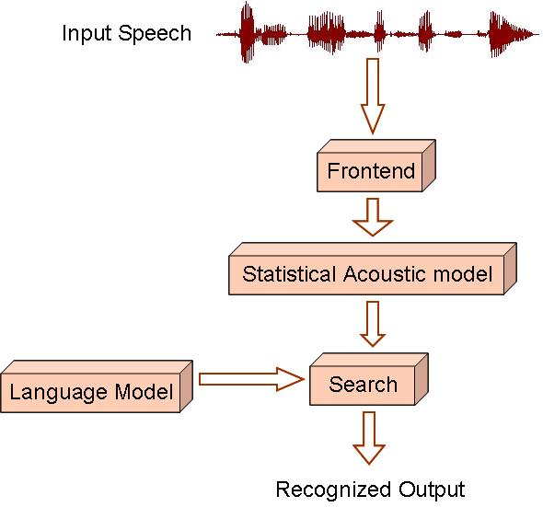
Figure 1. The four major components of a speech recognition system.

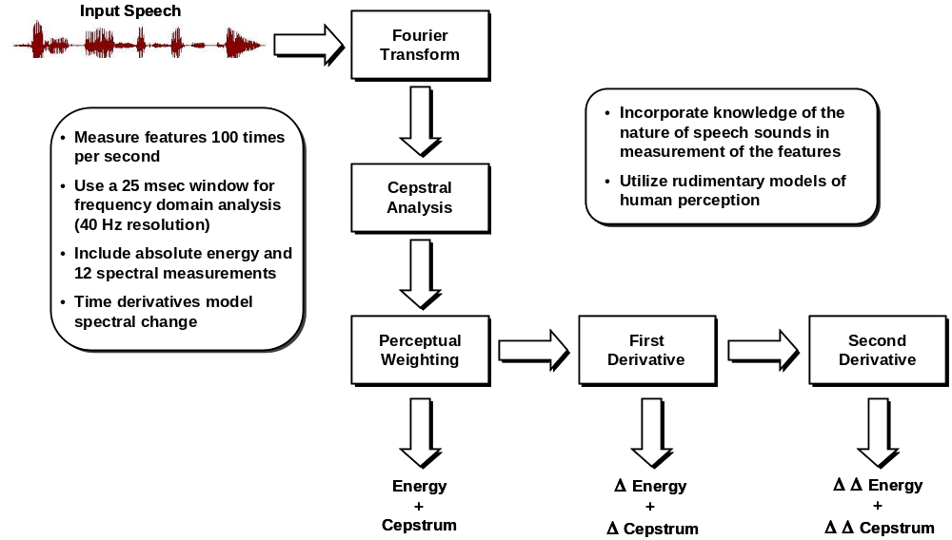
Figure 2. A standard speech recognition front end.

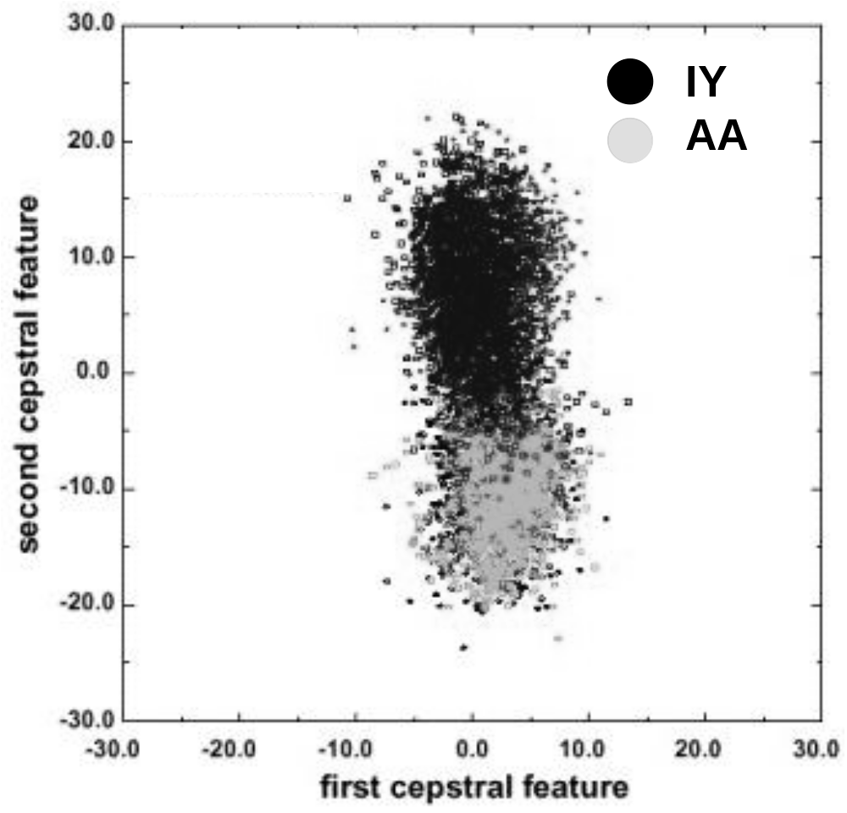
Figure 3. A scatter plot of the first two cepstral coefficients in an MFCC-based front end for two vowels.

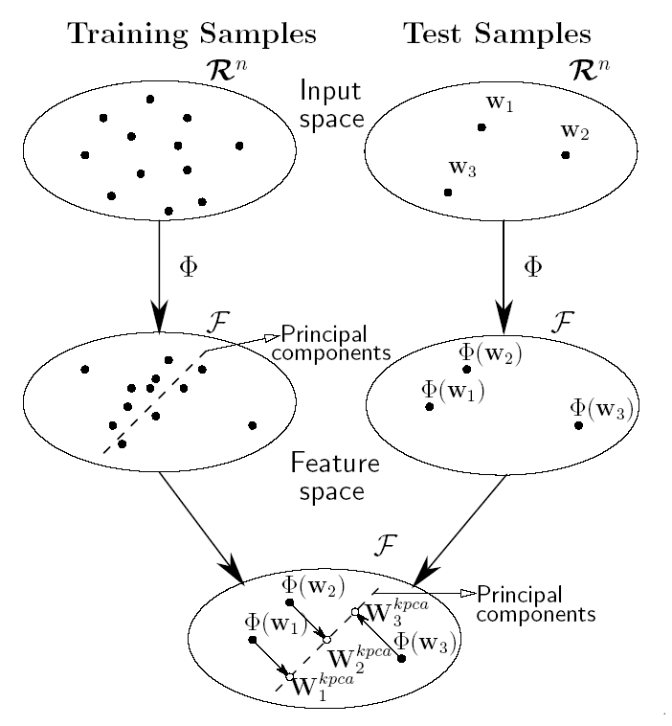
Figure 4. A simplified view of KPCA (Lima, et al., 2005).
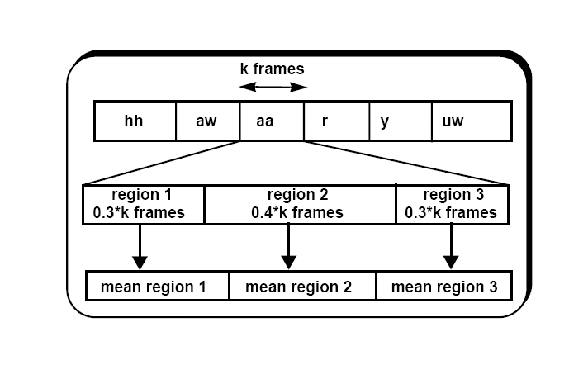
Figure 5. A composite feature vector for SVM-based speech recognition.

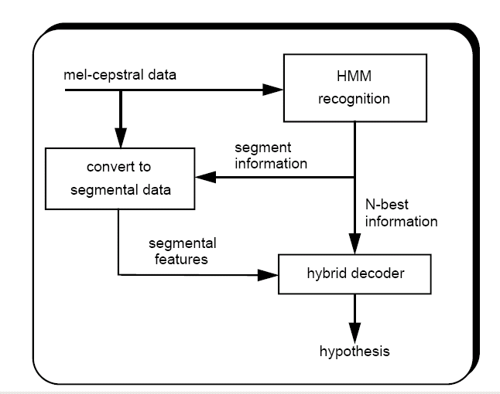
Figure 6. A hybrid SVM/HMM system based on a rescoring paradigm.

Tables

Dim/Kernel | P=1 | P=2
8 | 8.82 | 7.65
13 | 7.45 | 6.71
16 | 8.19 | 6.84
32 | 10.37 | 6.53
64 | N/A | 8.96
128 | N/A | 16.31
256 | N/A | 36.97
Table 1. Error rate for KPCA using a polynomial kernel.

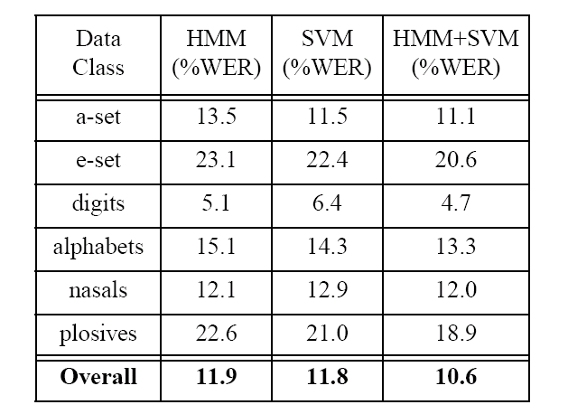
Table 2. Comparison of performance of the HMM and SVM systems as a function of word classes for the OGI Alphadigits task.

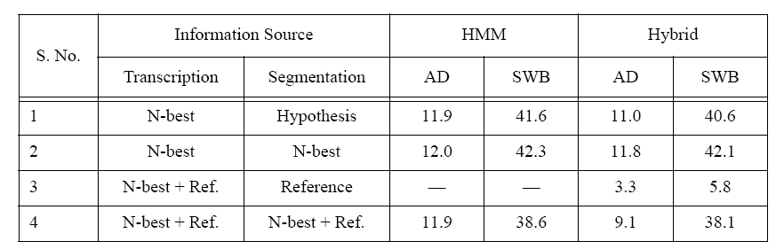
Table 3. Summary of recognition experiments using the baseline HMM system and the hybrid system on the Switchboard (SWB) and Alphadigits (AD) tasks.
[… end of document …]

. Note that traditional MFCC features were used for all experiments described in this section.

