Scalar Embedding:

The conventional reconstructed phase space is defined over a scalar time series. To analyze the nonlinear dynamics of the source which generated the observed time series, typically, a reconstructed phase space is used. Forming a reconstructed phase-space (trajectory) matrix involves sliding a window of length m through the data to form a series of vectors, stacked row-wise in the matrix. Each row of this matrix is a point in the reconstructed phase space.

Figure 1 illustrates the Lyapunov spectra computation using this concept in the presence and absence of noise. One variable from the Lorentz system (which is a system comprising 3 coupled differential equations in 3 independent variables) is used to compute the Lyapunov spectra using SVD-Embedding. The results obtained are similar to results documented in previous work. The negative exponent computation is not stable, which is again reported in previous studies. However, estimation of the positive and zero exponents is accurate given the right choice of SVD window size, Evolve step size and number of nearest neighbors.

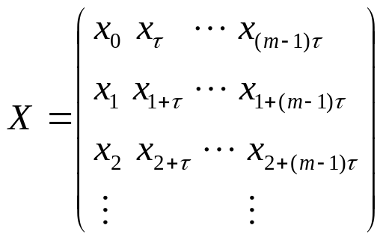

Vector Embedding:

Given a vector time series, a reconstructed phase space of the system’s attractor can be created by stacking time delayed versions of vectors from the data vector-stream.

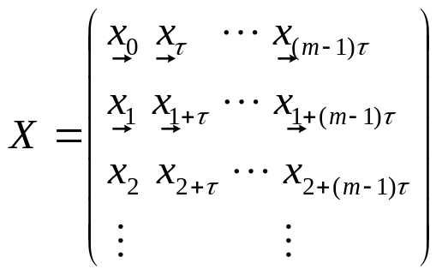

Parameters for Lyapunov spectra estimation:

SVD Window Size: Refers to the dimension of the initial RPS matrix constructed with a delay of one sample. This matrix is then reduced to a smaller dimension (embedding dimension) using singular vectors from the singular value decomposition.

Number of Neighbors: To find the trajectory matrix at a point in RPS, a neighborhood matrix consisting of points in RPS very close to the specified point, needs to be constructed first. Number of neighbors refers to the number of points in this neighborhood.

Evolve Step Size: Refers to the jump in the trajectory evolution for the finding tangent matrix.

In the following experiments, we vary these parameters and compare results of the estimated Lyapunov spectra with the theoretical values. All plots in the left column of each figure correspond to the 'clean' signal case, while figures on the right column of each figure correspond to plots for the 'noisy' signal case.

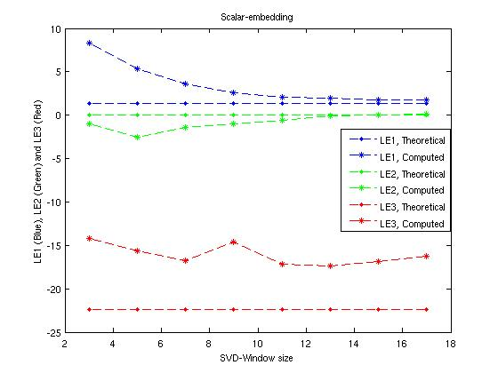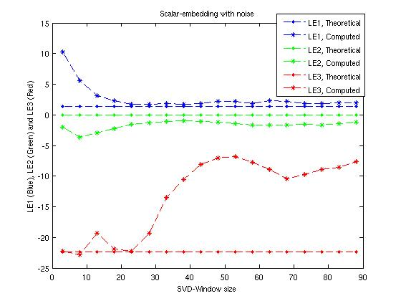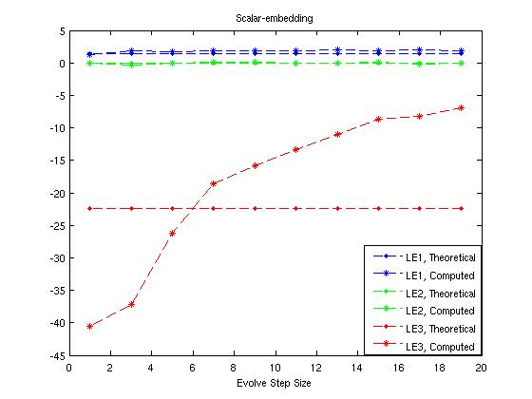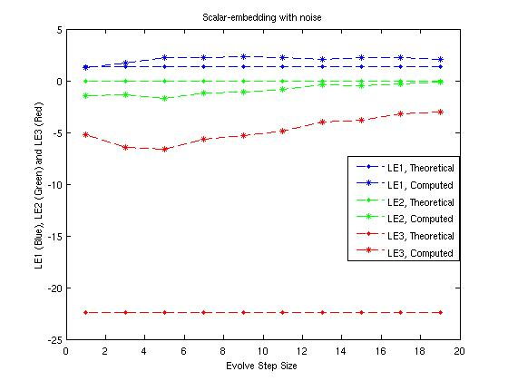
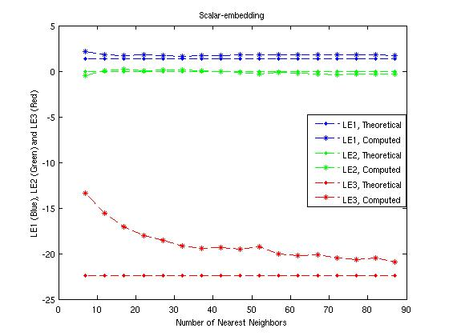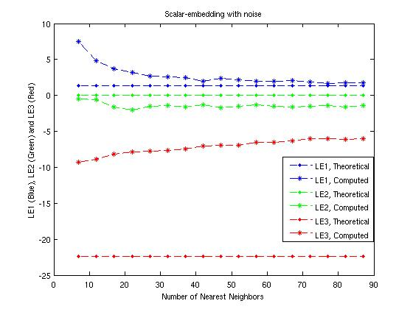
Figure 1: Illustrating Lyapunov spectra estimation in the presence and absence of noise using SVD-Embedding on a scalar time series (generated by data from one variable of the Lorentz system).

(with noise)
(with noise)

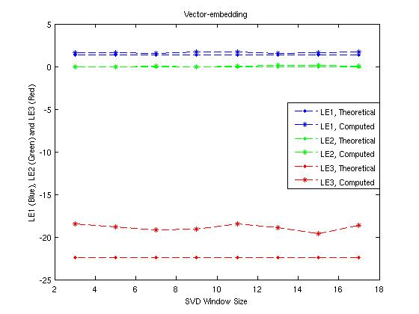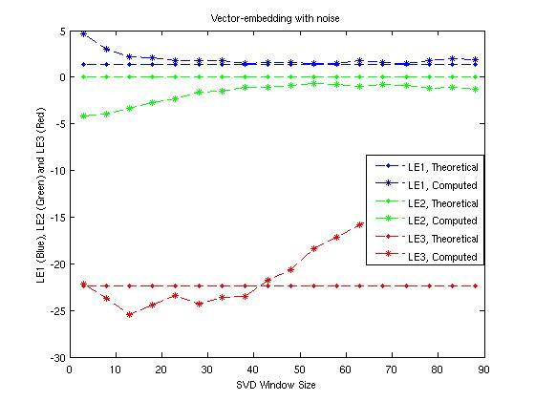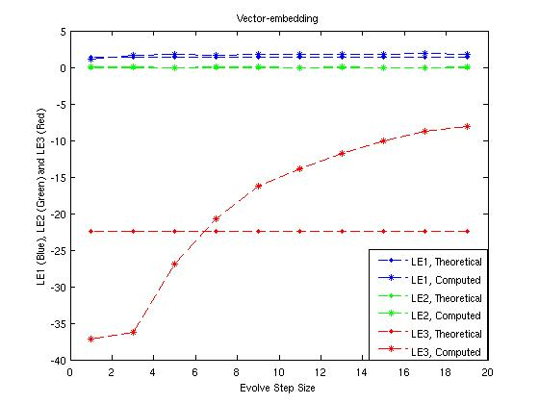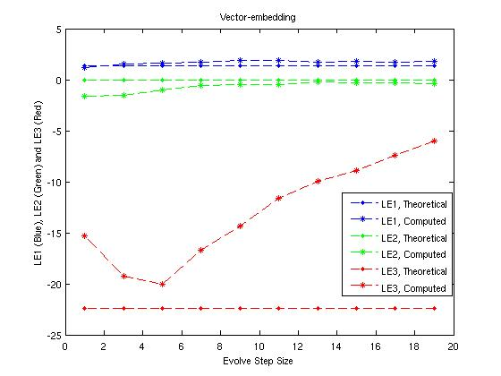
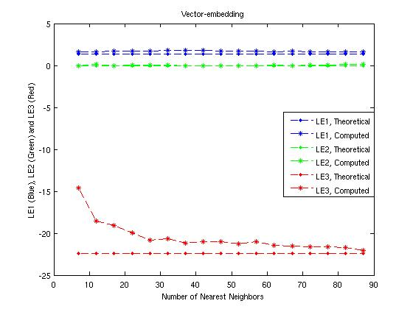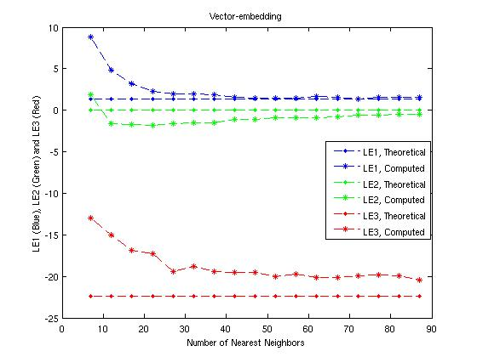
Figure 2: Illustrating Lyapunov spectra estimation in the presence and absence of noise using SVD-Embedding on a vector time series (generated by data from all three variables of the Lorentz system).

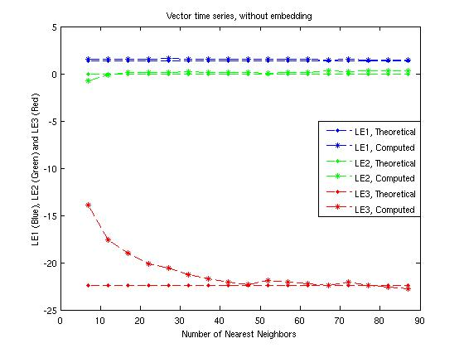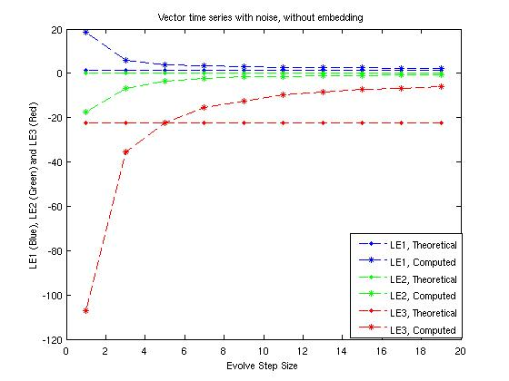
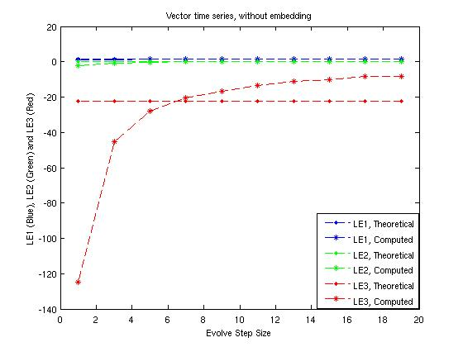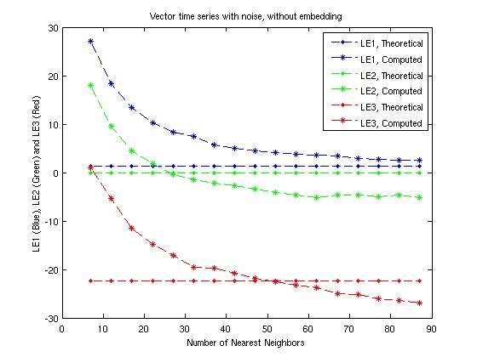

Figure 3: Illustrating Lyapunov spectra estimation in the presence and absence of noise without any embedding on a vector time series (generated by data from all three variables of the Lorentz system).

Figures 2 through 3 illustrate Lyapunov spectra estimation on a vector time series generated by data from all three variables of the Lorentz system. Figure 2 uses SVD embedding for the estimation, while figure 3 illustrates Lyapunov spectra computed using the three variables of the Lorentz system for constructing the RPS matrix (without embedding).

