Postdoctoral Position Announcement
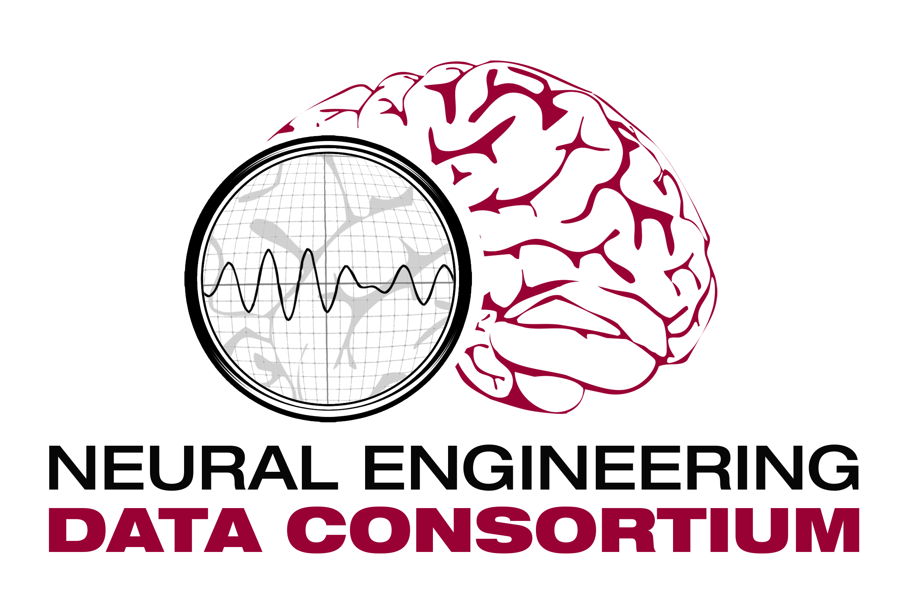
Temple University
ENGR Room 703A
1947 North 12th Street
Philadelphia, PA 19122
Tel: 215-204-4841 (office) / 662-312-4209 (cell)
Fax: 215-204-5960
Email: joseph.picone@gmail.com
URL: http://www.nedcdata.org
Postdoctoral Fellow
The Neural Engineering Data Consortium, Temple University
Philadelphia, Pennsylvania, 19122, USA
The Neural Engineering Data Consortium (NEDC) at Temple University invites applications for a Postdoctoral Fellow position in the area of automated EEG analysis. The Postdoctoral Fellow will contribute to a project that enables comparative research by automatically uncovering clinical knowledge from a vast BigData archive of clinical EEG signals and EEG reports collected over the past 14 years at Temple University Hospital (see www.isip.piconepress.com/projects/tuh_eeg for more information). We are developing a proof-of-concept based on the discovery of patient cohorts and provide an annotated BigData archive as well as the software that enabled the annotations and the generation of the patient cohort retrieval system. The candidate will be involved in overseeing the generation of labeled data for machine learning training, developing algorithms to automatically uncover and model structure based on deep learning principles, implementing an active learning approach that minimizes the amount of labeled data needed and supervising research to automatically extract medical concepts from EEG reports. A large portion of the project focuses in extraction of information from unstructured text, and hence, expertise in natural language processing is important.
Qualifications: Must have earned a Ph.D. degree in a relevant discipline such as computer science or electrical engineering. The candidate should be proficient in statistical methods in machine learning and natural language processing, including deep learning. This position requires experience in the complete software development life cycle from algorithm to application in a cross-platform environment:
- Machine learning of sequential data (e.g., biomedical or speech signals) using techniques such as hidden Markov models, autoencoders and deep learning;
- Windows-based programming environments (e.g., C++) and Windows-based client/sever applications;
- Scripting languages such as Python (e.g., GUI development using PyQt);
- Database development using Oracle, MySQL or MongoDB;
- Cross-platform development environments for portable applications (e.g., iPhones, Android);
- Configuration management (e.g., GitHub) and distribution tools (e.g., MSI);
- Requirements gathering, acceptance testing and clincal validation.
The candidate should have demonstrable interests in research related to human language technology and EEG signal processing.
Target start date: October 1, 2015, although the exact start date is negotiable.
Salary: $42K annually (follows the NIH payscale for postdocs)
Please submit a curriculum vita, statement of research interests, and contact information for three references to Dr. Joseph Picone (joseph.picone@gmail.com). Review of applicants begins September 1, 2015 until the position is filled. For information on current projects, see http://www.nedcdata.org and http://www.isip.piconepress.com/.

