Explore Engineering!
Ages 10 to 14
August 23-27, 2010 9 AM-12 PM
Temple University Fort Washington Campus

Dennis Silage, PhD
silage@temple.edu
Professor College of Engineering Temple University
What do Engineers do? They use technology and imagination to solve real-world problems right in our own communities and work to improve people’s lives. Learn about the field of Engineering and have the hands-on opportunity to invent, design and build creations while developing skills in teamwork and leadership.
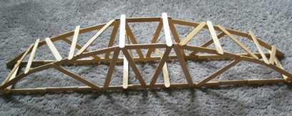
We’ll first look at Civil Engineering, the oldest Engineering profession. This experience is provided by the American Society of Civil Engineers. Civil Engineers implement the highways, sanitation, pollution control and earth resource conservation for our modern civilization. We’ll investigate the role of bridges with the Popsicle Bridge Challenge.
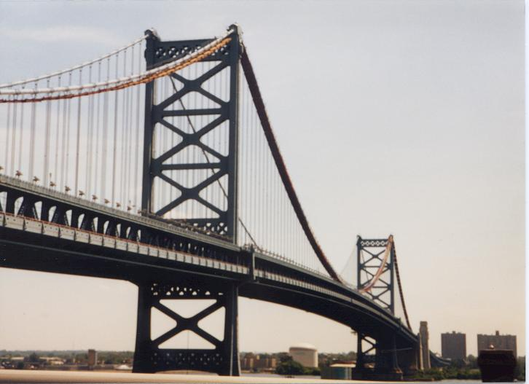
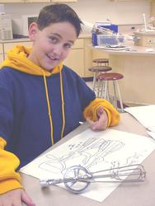

Next, we’ll look at Mechanical Engineering, the force behind the continuing industrial revolution. This experience is provided by the American Society of Mechanical Engineers. Mechanical Engineers use the force behind and the motion of the machines to give us a part of our modern civilization. We’ll investigate how simple mechanical machines work with Making It Easier.
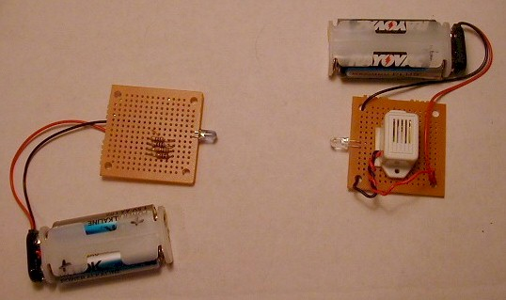
Finally, we’ll look at Electrical Engineering, the magic behind the electrical, electronic, and computer revolution. This experience is provided by the Institute of Electrical and Electronics Engineers. Beside many electrical inventions, Electrical Engineers have developed electronic communication and cellular technology. We’ll investigate how wireless communication works with the Marconi Challenge using infrared (IR) signals, the same technology as a remote control.

Explore Engineering! meets for half-a-day (9 AM – 12 PM) for one week, August 23-27, 2010 at the Fort Washington Campus of Temple University at 401 Commerce Drive, Fort Washington PA 19034 (215-468-8500).
To learn more about this course, email: silage@temple.edu. To register for this course, use the link: Register for this Course
(or: http://amb-hercules.ftwash.temple.edu/CourseStatus.awp?~~10C8749)

To learn more about the College of Engineering at Temple University, use this link below:
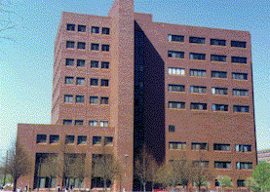
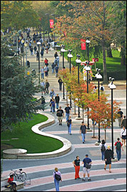
http://www.temple.edu/engineering/
