Physical Setup
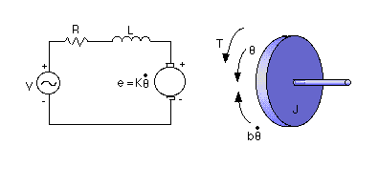
* moment of inertia of the rotor (J) = 0.01 kg.m^2/s^2
* damping ratio of the mechanical system (b) = 0.1 Nms
* electromotive force constant (K=Ke=Kt) = 0.01 Nm/Amp
* electric resistance (R) = 1 ohm
* electric inductance (L) = 0.5 H
* input (V): Source Voltage
* output (theta): position of shaft
* The rotor and shaft are assumed to be rigid
The motor torque, T, is related to the armature current, i, by a constant factor Kt. The back emf, e, is related to the rotational velocity by the following equations:
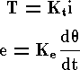

After writing Newton's law and Kirchoff's law:
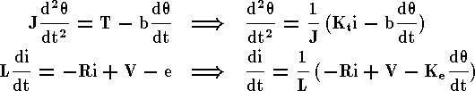

The angular acceleration is equal to 1/J multiplied by the sum of two terms (one pos., one neg.). Similarly, the derivative of current is equal to 1/L multiplied by the sum of three terms (one pos., two neg.).

J=0.01;
b=0.1;
K=0.01;
R=1;
L=0.5;

