**COLLEGE OF ENGINEERING**

design document for

**GADGET: A Really Cool Thingamabob**

submitted to:

Professor Joseph Picone

Senior Design Project I and II

Temple University

College of Engineering

1947 North 12th Street

Philadelphia, Pennsylvania 19122

February 5, 2010



prepared by:

J. Doe, J. Smith, M. Smith, and Y. Smith

Faculty Advisor(s): Professor John Smith

Industrial Advisor(s): James Smith, Corona Corporation

Team Name

Temple University

College of Engineering

1947 North 12th Street

Philadelphia, Pennsylvania 19122

For further information, please contact Dr. Joseph Picone (email: picone@temple.edu).



**Team No. 1: Urban Wind Engineering**

Title: Harnessing Wind Energy for the Integration of Sustainable Energy   
in Temple University’s Campus

Team:

|  |  |
| --- | --- |
| **Team Members** | **Faculty Advisor(s)** |
| Josef Argenio | Michel Boufadel |
| Jeremiah Gonzalo | Sandip Shah |
| Jesse Harper | Joseph Picone |
| Besik Mamistvolv |  |

Abstract:

This is your 150 to 200 word abstract….Wind energy is a renewable, alternative energy source that is in constant supply. Although initial capital costs are high, wind energy is one of the cheapest forms of electricity generation to maintain after the initial investment. UW engineering installed a wind turbine on top of the Engineering and Architecture (EA) Building, on Temple University’s Main Campus, in order to generate power harnessing the wind. There were many design constraints that governed the size and layout of the system. Computational Fluid Dynamics (CFD) software (Meteodyn Inc.) was utilized to analyze wind flow around the structures and the turbines installation site. Data for CFD modeling was obtained over a 500-meter radius area around the EA Building. Model results were used to determine size, type, and position of the system, such that power output and return on investment were optimized. Wind speed monitoring at the installation location was used to confirm the results of CFD modeling.  The installed turbine is currently producing power sufficient to reduce the building’s dependence on grid power by an average 10%.

**Executive Summary**

The executive summary must be exactly one page long – no more no less. It should be composed of four paragraphs. The first paragraph contains an overview of the problem (not the approach).

The second paragraph contains an overview of the design constraints. The goal of this paragraph is to make sure the reader understands the key technical challenges.

The third paragraph contains an overview of the approach you are taking to solve the problem. How do you plan to meet your key design constraints? The second and third paragraphs are the longest.

The last paragraph contains an overview of the novelty of your design. This is a fairly short paragraph that summarizes innovation in your project. What other things can be done to improve your design; what will be the impact of success, etc. This paragraph should be about four sentences.

**TABLE OF CONTENTS**

1. Problem 1

2. DESIGN REQUIREMENTS 1

2.1. Functional Design Constraints 1

2.2. Practical Design Constraints 1

3. APPROACH 2

3.1. DC Power Supplies 2

3.2. Hardware Design 3

3.3. Software Design 4

4. EVALUATION 4

4.1. Test Specification 4

4.2. Test Certification – Simulation 4

4.3. Test Certification – Hardware 4

4.4. Test Certification – Software 4

5. SUMMARY AND FUTURE WORK 4

6. ACKNOWLEDGEMENTS 4

7. REFERENCES 5

APPENDIX A: Product SPECIFICATION 6

APPENDIX B: SOME INTERESTING RELEVANT DERIVATION 7

# Problem

In this section, you will define the problem you are addressing, explain its significance, and discuss the impact of your solution (not how you are going to solve the problem, but what will happen if you solve the problem). Start with a general overview, background, etc., and then get progressively more detailed. This section must be at least two pages long.

# DESIGN REQUIREMENTS

Start with an introductory paragraph or two. Then you will list your specific design constraints, followed by an explanation. This section should be at least three pages long.

Design constraints must be quantitative and must be testable. The section on evaluation will describe the tests you use to verify your design constraints.

## Functional Design Constraints

|  |  |
| --- | --- |
| **Name** | **Description** |
| Signal to Noise Ratio | We will achieve a signal-to-noise ratio of 30 dB or greater, and demonstrate that this exceeds performance of existing technology. |
| Communications Protocol | We will use an RS-232C interface for communications between the module and the base station. |
| Accuracy | This system’s incorrect classification rate will not exceed 3.5% on data whose SNR exceeds 15 dB. |
| Robustness | The imposter acceptance rate will not exceed 3% on data whose SNR exceeds 10 dB. |
| Transmission Distance | Our base station will communicate with the server at a maximum distance of 100 feet with a bit error rate not to exceed 1e-05. |

Table 1. Functional design constraints for the GADGET system.

Our five functional design constraints are shown in Table 1. Each team must have five functional design constraints that adequately constrain the design of the physical system (including software). Functional design constraints typically relate to the performance of the system. Note the format of the table and the use of a cross-reference in the text above.

You will need several paragraphs explaining these design constraints. Typically these are explained in groups since design constraints are often interrelated. Use constraints that relate to well-known standards (such as UL or FCC specs), and be sure to explain these specifications.

## Non-Functional Design Constraints

In the ABET handbook on accrediting engineering programs, it states:

“Students must be prepared for engineering practice through the curriculum culminating in a major design experience based on the knowledge and skills acquired in earlier course work and incorporating engineering standards and realistic constraints that include most of the following considerations: economic; environmental; sustainability; manufacturability; ethical; health and safety; social; and political.”

|  |  |  |
| --- | --- | --- |
| **Type** | **Name** | **Description** |
| Economic | Cost | The expected retail for this price is $100 based on a parts cost of $25. |
| Environmental | Power | The main processor unit will dissipate no more than 3 Watts. |
| Sustainability | Reliability | This system will be designed to operate over a five year period without failure. The expected battery life is seven years and is the only part requiring regular maintenance. |
| Manufacturability | Size | The physical dimensions will be 3” high, 4” wide, and 6” deep. |
| Health and Safety | Safety | We will conform to UL Specification 631 which requires that this unit not deliver an electrical shock to the user under …, and UL Specification 837 which requires a …. |

Table 2. Non-functional design constraints for the GADGET system.

Every senior design project must include five design constraints that address some of these issues. See the lecture notes for some ideas on the types of non-functional design constraints that you can use. An example of these are shown in Table 2. These typically include things like size, power, weight, and cost. Every project need not address all of the factors specified by ABET. However, all projects must have five design constraints that relate to these issues.

After you provide these constraints, some explanation will be required.

# APPROACH

In this section, you explain your approach in great detail. This will be the single largest section in the document, often 20 or 30 pages long. It will contain a comprehensive explanation of your design, including theory and practice. It should be somewhat self-contained so that a student with a background similar to yours can understand it. It will most likely use two levels of subsections (e.g., 3.1 and 3.1.1). Only the first level of subsections (e.g., 3.1) needs to be included in the Table of Contents.

Figures should appear as shown below and be referenced in the text as Figure 1. Similarly, tables should be included in the text and be referenced as Table 1 (see the examples in the previous section). All text in figures and tables, including the captions, use a 9 pt. Times New Roman font (as does the text).

Equations in your document should appear as shown below with the equation number in parentheses to the right of the equation. Use a medium-sized font — one that matches the rest of the document:

We will follow APA format for citations. See References for more information on the format. References are cited in the text using an in-line style. For example, the best way of developing a DC power supply is to use a Duracell battery (Anderson, 2005). Many approaches exist for developing such things, but my favorite one is an approach which is really space efficient (Anderson, *et al.*, 2003). Note that APA style does not require the use of cross-references (Armony & Dolan, 2002).

## DC Power Supplies

You should probably start this section with a general overview of the primary technology you are developing. Then you can transition into the specifics of the hardware and software design.

[Some filler text here … Some filler text here … Some filler text here … Some filler text here … Some filler text here … Some filler text here … Some filler text here … Some filler text here … Some filler text here … Some filler text here … Some filler text here … Some filler text here … Some filler text here …]

[Some filler text here … Some filler text here … Some filler text here … Some filler text here … Some filler text here … Some filler text here … Some filler text here … Some filler text here … Some filler text here … Some filler text here … Some filler text here … Some filler text here … Some filler text here …]

[Some filler text here … Some filler text here … Some filler text here … Some filler text here … Some filler text here … Some filler text here … Some filler text here … Some filler text here … Some filler text here … Some filler text here … Some filler text here … Some filler text here … Some filler text here …]

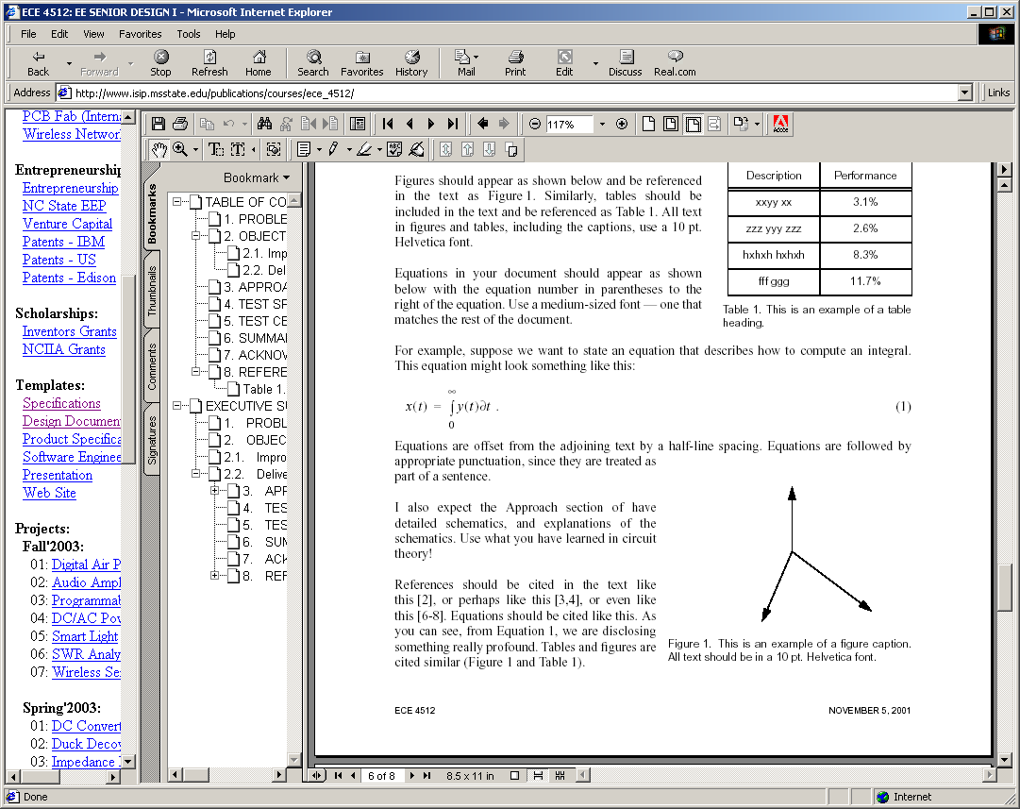

Figure 1. This is an example of a figure. Captions are justified when they are multiple lines, and centered if they are one line. Captions should be no more than about three lines.

For example, below, in Figure 1, we can see some interesting experimental results. This results are supported by the all important equation of life:

 ()

We can see in Equation (1) that the mystery of life is explained.

## Hardware Design

Each project will describe their hardware and software designs in major sections. Hardware design should begin by developing a block diagram of the overall system, and then expanding on the theory and design behind each one of these blocks.

Some interesting text goes here… Some interesting text goes here… Some interesting text goes here… Some interesting text goes here… Some interesting text goes here… Some interesting text goes here… Some interesting text goes here… Some interesting text goes here… Some interesting text goes here… Some interesting text goes here… Some interesting text goes here… Some interesting text goes here… Some interesting text goes here… Some interesting text goes here… Some interesting text goes here… Some interesting text goes here… Some interesting text goes here… Some interesting text goes here… Some interesting text goes here… Some interesting text goes here…

### Theory of DC Power Supplies

Some interesting text goes here… Some interesting text goes here… Some interesting text goes here… Some interesting text goes here… Some interesting text goes here… Some interesting text goes here… Some interesting text goes here… Some interesting text goes here… Some interesting text goes here… Some interesting text goes here… Some interesting text goes here… Some interesting text goes here… Some interesting text goes here… Some interesting text goes here… Some interesting text goes here… Some interesting text goes here… Some interesting text goes here… Some interesting text goes here… Some interesting text goes here… Some interesting text goes here…

### More Interesting Theory

Some interesting text goes here… Some interesting text goes here… Some interesting text goes here… Some interesting text goes here… Some interesting text goes here… Some interesting text goes here… Some interesting text goes here… Some interesting text goes here… Some interesting text goes here… Some interesting text goes here… Some interesting text goes here… Some interesting text goes here… Some interesting text goes here… Some interesting text goes here… Some interesting text goes here… Some interesting text goes here… Some interesting text goes here… Some interesting text goes here… Some interesting text goes here… Some interesting text goes here…

## Software Design

We will go through a formal software design process in class. You can use most of this material for your software design. More details will be given on this during classroom lectures.

Some interesting text goes here… Some interesting text goes here… Some interesting text goes here… Some interesting text goes here… Some interesting text goes here… Some interesting text goes here… Some interesting text goes here… Some interesting text goes here… Some interesting text goes here… Some interesting text goes here… Some interesting text goes here… Some interesting text goes here… Some interesting text goes here… Some interesting text goes here… Some interesting text goes here… Some interesting text goes here… Some interesting text goes here… Some interesting text goes here… Some interesting text goes here… Some interesting text goes here…

# EVALUATION

This section contains two major sections.

## Test Specification

Describe in detail what tests you will run to verify your design constraints. I expect three subsections for simulation, hardware, and software.

## Test Certification – Simulation

Describe how you used simulations to verify your design.

## Test Certification – Hardware

I expect two subsections here: one for the prototype and one for the packaged version.

## Test Certification – Software

Again, two subsections for the prototype and packaged system.

# SUMMARY AND FUTURE WORK

This section will be about one page long and review what was accomplished (what worked? what didn’t work?), and talk about future extensions of the project (what things could be done better? what things needed to be done differently to overcome problems).

# ACKNOWLEDGEMENTS

We wish to acknowledge John Doe of ABC Corporation, Dr. John Smith of the National Institute

for Cool Things, and Dr. I.M. Smart of XYZ for their continued support and feedback regarding this project. We also acknowledge the National Science Foundation for its funding of this project, which enables many useful on-line documents to be developed. Mr. Doe’s interactions have helped us add features to the system, some of which make this system very unique compared to other systems. Say a few more good things.

# REFERENCES

Anderson, A. K. (2005). Affective influences on the attentional dynamics supporting awareness. *Journal of Experimental Psychology: General*, *154*, 258–281.

Anderson, A. K., Christoff, K., Panitz, D., De Rosa, E., & Gabrieli, J. D. E. (2003). Neural correlates of the automatic processing of threat facial signals. *Journal of Neuroscience*, *23*, 5627–5633.

Armony, J. L., & Dolan, R. J. (2002). Modulation of spatial attention by fear-conditioned stimuli: An event-related fMRI study. *Neuropsychologia*, *40*, 817–826.

References must follow APA format. There are many good sites that describe these standards. Here are two that I find very useful:

<http://en.wikipedia.org/wiki/APA_style>

<http://flash1r.apa.org/apastyle/basics/index.htm>

Your overall reference list should be close to 50 items, with at least 25 of these coming from peer-reviewed journals and books.

1. Product SPECIFICATION

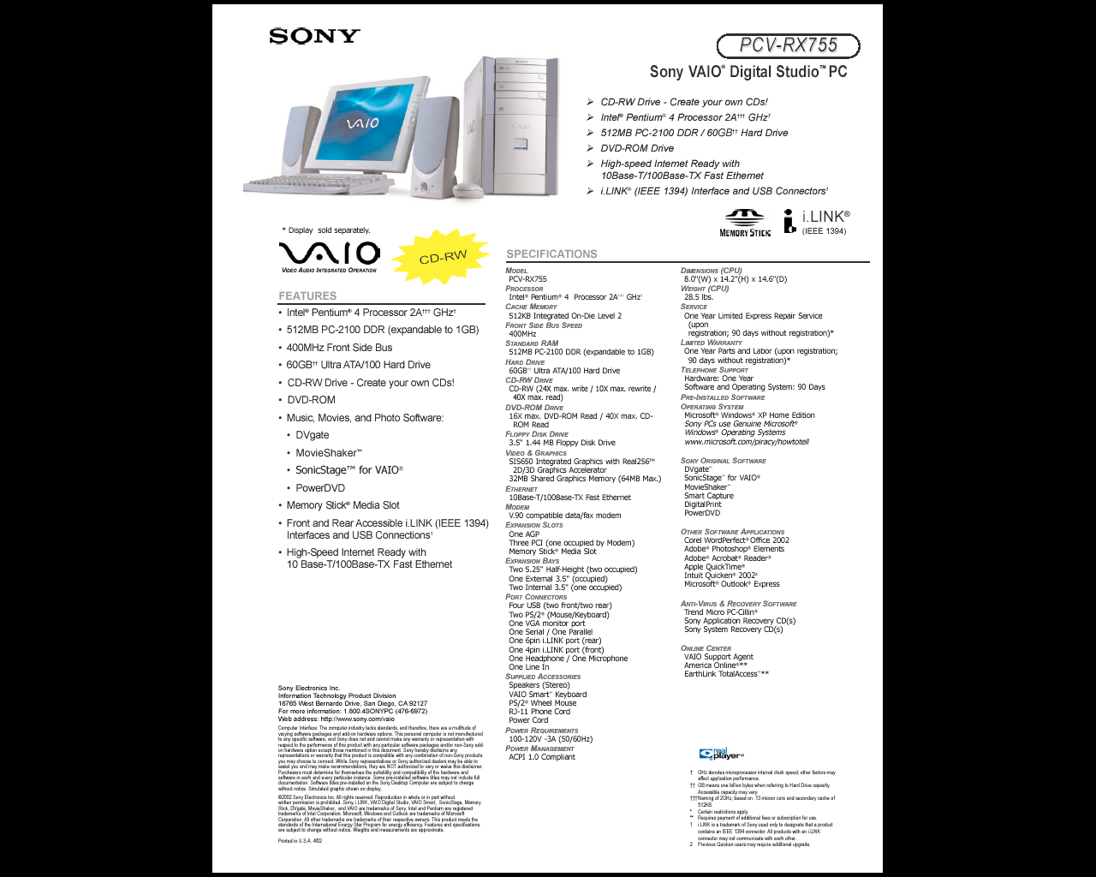

1. SOME INTERESTING RELEVANT DERIVATION

Software listings are generally NOT included in the document. These should be on the web site and referenced from the document using a URL.

It is common, however, to want to discuss a specific point or derive an important relationship. Such details, when not immediately relevant to the document, are best included as appendices.