design document for

PLCCS: A Power Line Carrier Communications System

submitted to:

Professor Joseph Picone

ECE 4522: Senior Design II
Department of Electrical and Computer Engineering
Mississippi State University
Mississippi State, Mississippi 39762

December 5, 2000

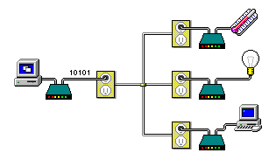

submitted by:

W. Kwan, W. Parker, B. Roberts, J. Tatum
Faculty Advisor: Dr. Nicholas Younan
Department of Electrical and Computer Engineering
Mississippi State University
Box 9571
Mississippi State, Mississippi 39762
Tel: 662-338-5361
email: wyk1@ece.msstate.edu, whp1@ra.msstate.edu, brobe100@aol.com, jat1@ece.msstate.edu

EXECUTIVE SUMMARY

Technology in today’s world is advancing at a very rapid rate. Once a rare commodity, computers can now be found in hundreds of millions of homes and businesses [1]. A growing trend involving computers is industrial control and home automation, a practice in which electrical devices are controlled with little or no human interaction [2]. Although this may sound like a noble concept, many of these control systems suffer from poor performance in terms of data communications capability [3]. They also require the user to configure them locally, which makes it difficult to check the status of the systems from afar. Also, many systems carry a steep price tag that many potential buyers find unappealing [4].

To remedy the first of these issues, a new data communications system will be developed. The system will consist of one or more host units and multiple target units. The host units will initiate all data communications processes to the target units, and a target unit may reply only to the host that hails it. Only one communications process may exist at any given time per host, preventing data communication collisions. Existing electrical wiring will serve as the communications medium, preventing the expense of installing additional wiring in the building.

The access issue will be remedied by designing a software package for a personal computer. The software will allow the host device to connect to a PC, as well as the Internet using TCP/IP. The user will therefore be able to access the host device through a standard Internet connection.

A third issue is the cost of comparable control systems. Presently-available systems that are used in industry cost thousands of dollars [4]. By programming a microcontroller to emulate traditional hardware, less electronic components will be required to build a working system. As a result, overall production costs will be substantially lower than comparable systems. The production cost of each host and target unit will not exceed $30 and $25, respectively. The expected market price of a host unit will be $149.95, and the expected market price for each target unit will be $39.95.

We will approach this project by dividing it into several key components. A modem will be designed that will allow the host and target units to communicate over the power line. Microcontroller firmware will be created to control the functionality of both host and target units. Circuitry and firmware will be implemented to interface the host unit to a PC. Software will be written to allow user-control over host and target units.

Our design will be superior to presently-available device control systems in that ours will reduce the number of control errors due to corrupted data transmissions, thereby enhancing the reliability of the system. It will also provide an easy-to-use interface that will allow users to render remote control over all host and target units and all of their associated peripherals.

Considering the ongoing growth in popularity of home and industrial control systems, this project has an abundant future [5]. Potential design enhancements include improving the data transfer rate of the modems and enhancing the remote web interface.

TABLE OF CONTENTS

ABSTRACT. . . . . . . . . . . . . . . . . . . . . . . . . . . . . . . . . . . . . . . . . . . . . . . . . . .  - INTRODUCTION. . . . . . . . . . . . . . . . . . . . . . . . . . . . . . . . . . . . . . . . . . . . . . .  - PROBLEM . . . . . . . . . . . . . . . . . . . . . . . . . . . . . . . . . . . . . . . . . . . . . . . . . . .  - OBJECTIVES . . . . . . . . . . . . . . . . . . . . . . . . . . . . . . . . . . . . . . . . . . . . . . . . .  - APPROACH . . . . . . . . . . . . . . . . . . . . . . . . . . . . . . . . . . . . . . . . . . . . . . . . . .  - Host Unit . . . . . . . . . . . . . . . . . . . . . . . . . . . . . . . . . . . . . . . . . . . . . . . . .  - Target Unit . . . . . . . . . . . . . . . . . . . . . . . . . . . . . . . . . . . . . . . . . . . . . . .  - Computer Software . . . . . . . . . . . . . . . . . . . . . . . . . . . . . . . . . . . . . . . . .  - Cost . . . . . . . . . . . . . . . . . . . . . . . . . . . . . . . . . . . . . . . . . . . . . . . . . . . .  - TEST SPECIFICATION. . . . . . . . . . . . . . . . . . . . . . . . . . . . . . . . . . . . . . . . . .  - TEST CERTIFICATION. . . . . . . . . . . . . . . . . . . . . . . . . . . . . . . . . . . . . . . . . .  - SUMMARY . . . . . . . . . . . . . . . . . . . . . . . . . . . . . . . . . . . . . . . . . . . . . . . . . . .  - FUTURE WORK . . . . . . . . . . . . . . . . . . . . . . . . . . . . . . . . . . . . . . . . . . . . . . .  - ACKNOWLEDGEMENTS . . . . . . . . . . . . . . . . . . . . . . . . . . . . . . . . . . . . . . .  - REFERENCES . . . . . . . . . . . . . . . . . . . . . . . . . . . . . . . . . . . . . . . . . . . . . . . | 1  1  2  2  5  6  22  36  40  41  44  61  61  61  61

ABSTRACT

As the need for control automation systems increases, the number of commercially available systems is broadening every day. Of these systems, the most reliable ones can cost thousands of dollars [4]. The inexpensive ones suffer from poor reliability [3] and must be controlled locally. To solve these issues, a system that is reliable, affordable, and easily accessible is needed. This system is the PLCCS. This automation system will improve the addressed issues by utilizing the capabilities of both customized hardware and software. The system will use communications chips that have costs comparable to inexpensive systems, but with reliability found in more robust systems. Users will also be able to access the system through a network, such as the Internet, thereby eliminating the constraint of requiring local control.

1. INTRODUCTION

The purpose of this project is to design and implement a device control system that utilizes a building’s existing electrical wiring as a communications medium. This design will give consumers a more cost-efficient device control solution. The design approach will consist of simulation, construction, and field testing of the system. The significance of the device is that all host and target units may be controlled by any computer connected to the network.

In the early 1970’s, Pico Electronics Ltd. was founded by a group of investors who wanted to develop integrated circuits for the handheld calculator market. Each time Pico Electronics started a new project, the project was given an experiment number. Their ninth experiment, “experiment #9”, was an integrated circuit for a programmable record changer for a phonograph. Shortly after this, Pico Electronics was asked to build a wireless remote control system for the record changer. This became “experiment #10” for Pico Electronics, or “X-10” for short. [6]

The X-10 systems were designed to use existing household wiring to control devices throughout the household. Pico engineers soon realized that this system had many other uses besides controlling record changers. In 1978, Pico Electronics signed contract with several large retail stores to sell the X-10 system. The system was soon being advertised in 1979, and now, 20 years later, it is still growing in popularity. [6]

In more recent years, several enhanced carrier-current networking solutions have been introduced. CEBus and LONWorks boast improved data transmission rates over X-10, as well as improved error detection [7], but they also “boast” much higher price tags. [8,9]

PLCCS will be able to combine the low cost of X-10 with the reliability and accessibility of CEBus and LONWorks into a single system.

In order to expedite the design of the PLCCS, a team of four members has been assembled. Will Parker is responsible for creating microcontroller firmware and its associated circuitry. Jason Tatum is responsible for writing and debugging the user interface software. Sammi Kwan is responsible for testing the hardware and for creating and maintaining the group’s web page. Finally, Brian Roberts for simulating and testing the hardware.

2. PROBLEM

Industrial control and home automation has rapidly been gaining popularity for the past decade. Although many automation and control products are available on the market, many of them employ a modulation technique that was developed twenty years ago. This technique utilizes simplex communications, which simply means that the modules that control electrical equipment are capable only of receiving data and not transmitting. As a result, the modules have no way of informing the host controller if they properly received a data transmission. Because of this, data from the host is often received as corrupted, and erratic equipment behavior may result.

A second issue encountered with these systems is that many of them utilize a host unit that is unable to interface with a computer network. In this technological era, it is almost a necessity to provide an interface between sophisticated electronic products and a PC. This certainly applies to controls - why even buy a control system unless you can access it while you are away?

To remedy the communications issue, our team will develop a more reliable method of data transmission. This will ensure that more data will successfully reach the target device while being transferred over a building’s noisy wiring, which will in turn lessen the number of inappropriate switchings by the secondary units. In effect, the system owner will no longer have to spend time attempting to fix an uncorrectable problem.

The accessibility issue will be resolved by designing a user-friendly computer interface for the system. With this interface, users will be able to remotely check the status of their systems, therefore eliminating the worry of discovering that their “controlled” devices are on the blink. Users will also be able to remotely make changes to the operation of their devices to comply with their schedules.

3. OBJECTIVES

- Data Transfer Rate: Most inexpensive automation systems have a data transmission rate of only approximately 100 bits-per-second (bps), whereas the more costly ones have a rate of several thousand bps [3,6]. Our system’s rate will be a compromise between the two, with a minimum rate of 600 bps and a desired rate of 1200 bps.

- Error Rate: Low-cost carrier-current data transmission systems can have a less-than-appealing rate of errors. Our system will have a maximum bit error rate of 0.01% [10].

- System Structure: The most common low-cost automation system can support a maximum of only 256 target units [6]. Using a 32-bit identification tag for each unit, our system will be able to support up to a total of 4.29 billion host and target units.

- Browser Compatibility: Since our system will be accessed remotely through a web browser, the web interface will be compatible with Netscape 3.01 and Microsoft Internet Explorer 4.0.

- Power Usage: In order to keep energy costs low, each host unit will draw no more than 1.5 watts, and each target unit will draw no more than 3 watts. This will result in an electricity cost of only 11 cents per month for each host unit and 22 cents per month for each target unit, assuming the electricity cost is ten cents per KWH.

- Memory Capabilities: Each host unit will be able to send scheduled commands to the target units, even if the host computer is turned off. A 32 kilobyte EEPROM will allow each host unit will be able to store command profiles for up to 500 target units, assuming that a 64-byte data block is used to represent the schedule profile of each target unit.

- Electromagnetic Emissions: In order to prevent harm to remote electrical devices, the system will conform to FCC rules and regulations §15.107 and §15.109 [12].

- Cost: In order to compete with the prices of other bi-directional automation systems, our system will carry a price tag comparable to or lower than that of other systems [8,9]. The production cost of each host unit will not exceed $35; the expected market price for the host unit is $149.95. The production cost of each target unit will not exceed $30; the expected market price for the target unit is $39.95.

3.1. Data Transfer Rate

Assuming that all 500 schedule profiles are occupied (see 3.6), and assuming that host unit requires the maximum allotted time to successfully transfer data to each target (see 3.2), a data rate of no less than 600 bits-per-second is required in order to send data to all 500 units within a ten-minute interval. Therefore, the minimum acceptable data transfer rate between host and target units is 600 bps. The desired rate is 1200 bps.

3.2. Error Rate

In order to outperform the data communication error rates of other low-cost automation systems, the system will have a worst-case bit error rate of 0.01%. This low error rate will be accomplished by appending each transmitted data packet with a 16-bit CRC. If the CRC for a received packet proves invalid, the host unit will transmit the packet up to four more times until it is received properly by the target unit. If the transmission is unsuccessful after a total of four retransmissions, the host unit will indicate that the target unit is not functioning properly.

3.3. System Structure

A host unit will connect to the building’s electrical wiring system via a 120V outlet. Target units will then plug into other outlets among the same wiring system. The host unit will send control commands to the target units via the wiring. The commands may be stored in the host’s EEPROM to be executed at a scheduled time, or commands may be issued to the host unit via an RS-232 line that links the host to a PC. The PC will be running server software that indirectly links the host to a network, allowing any computer on the network to control the host and target units.

Each host unit and target unit will be assigned a four-byte address when the unit is manufactured. The address will be used to identify the intended recipient when information is transferred over the carrier line, thereby preventing miscommunication between units. Since a four-byte address will be used, a total of over 4.29 billion host and target units may be used on the same line.

3.4. Browser Compatibility

To avoid requiring custom software from being installed on every computer that remotely accesses the host unit, the system’s server software will be compatible with Netscape Navigator 3.01, Microsoft Internet Explorer 4.0, and all subsequent releases of the browsers. A user will be able to access the system from anywhere as long as the host unit is connected to a computer that is connected to a network capable of transferring TCP/IP data.

3.5. Power Usage

The host unit will require no more that 1.5 watts. A transformer will be used in the host unit to lower the 120 volt supply to a level appropriate for the host’s circuitry. In order to maintain a steady supply voltage for the host’s digital circuitry, a five-volt voltage regulator will be used.

The target unit will require no more than 3 watts to operate. A zener diode, capacitor, and resistor will be used to lower the voltage to a usable level for the circuitry, eliminating the need for a transformer. The only additional power needed will be the power used by the device that the target unit is controlling.

3.6. Memory Capabilities

Each host unit will be able to store profiles for up to 500 target units. This will allow the host unit to control the target units independent of the server, even if the server is powered down. The host unit will use a 32 kilobyte EEPROM to store the operations, with each operation occupying 64 bytes.

3.7. Electromagnetic Emission

The system will conform to FCC rules and regulations §15.107 and §15.109. FCC regulation §15.107 states that there is no limit on conducted emissions of any signal placed on a power line below the frequency of 30 MHz, provided that the system induces no more than 1000 μV on the standard AM broadcast band. Carrier signals for two different modem chips will be evaluated. The following table displays the maximum field strengths allowed by §15.109:

Carrier Frequency (kHz) | Field Strength @ 300m
71.4 | 33.6 μV / m
72.6 | 33.1 μV / m
85.95 | 27.9 μV / m
87.15 | 27.5 μV / m
95.0 | 25.3 μV / m
132.5 | 18.1 μV / m
148.5 | 16.2 μV / m

Table 1. FCC field strength requirements.

3.8. Cost

The production cost of each host unit will not exceed $35. The primary electrical components will include a microcontroller, an RS-232 interface chip, a real-time clock chip, an EEPROM, a carrier-current modem chip, a power transformer, and various discrete components. The expected market price for the host unit is $149.95.

The production cost of each target unit will not exceed $30. The primary components will include a microcontroller, a carrier current modem chip, a relay, and various other components. The expected market price for the target unit $49.95.

- APPROACH

The overall system structure is shown in Figure 1. To build this system, the design of this project will be broken down into three phases. The first phase will consist of creating the host unit. The host unit will send instructions through the power line to the appropriate target unit at the designated time. The host unit will link to a LAN or the Internet by means of a host computer, therefore enabling anyone on the network to access the host unit. The second phase will consist of creating target units. The target units receive instructions from the host unit through the power line, and if appropriate the target units then perform the designated command. The third phase will consist of programming the host computer’s software. This software will be the gateway between the user and the host unit, thereby enabling the user to control and program the host unit from any computer connected to a LAN or the Internet.

Internet/LAN
Host Computer
Host Unit
Target Unit
Appliance
Power Line

Figure 1. Overall system structure.

  - Host Unit

The host unit is the heart of the control system. Instructions can be programmed into the host unit by the host computer. After being programmed, the host unit will be able to run independently. At the appropriate time, the host unit will send out commands via the power line to a target unit. In addition to independent operation, other computers may control the host unit via the Internet.

4.1.1. Host Unit Hardware

An overview of the hardware is shown in Figure 2. The hardware for the host unit will consist of an RS-232 interface, a COP8 microcontroller, a real time clock, an EEPROM, a power line modem, and a power supply.

Real-Time Clock Module

Power Line Modem
Power Line
To Target Units
Host PC
RS-232
Micro-controller

+5V +10V

EEPROM
Power Supply

Figure 2. Host unit hardware.

4.1.1.1. Host Unit Hardware: Microcontroller

The microcontroller is an essential part of the host unit. It helps to tie all the other components to one another. It is also responsible for all operations performed by the host unit.

National Semiconductor’s COP8SAC728N8 will be the microcontroller used in the host unit. The COP8 provides a variety of choices for its clock oscillator including R/C time constant, crystal, and external. Since the timing for serial data communications is critical (to achieve a stable bit rate), a piezoelectric crystal will be used as the oscillator.

The COP8SAC728 has 24 I/O pins. Many of these pins are versatile in that they may instantly be changed from input to output (and vice-versa) with one simple instruction – they are not “hard-wired” to serve solely as either input or output. The following table shows how the pins will be used:

# of Pins: | Connect to:
2 | EEPROM
4 | Modem chip
4 | RS-232 driver chip
4 | Clock module
1 | V_{CC}
1 | Ground
2 | Quartz crystal
1 | Reset pin (connects to Watchdog pin)
1 | Watchdog pin (connects to Reset pin)
8 | [Spare / future use]

Table 2: Host Unit COP8 pin usage.

The following schematic illustrates the wiring diagram of the COP8 in the host unit:

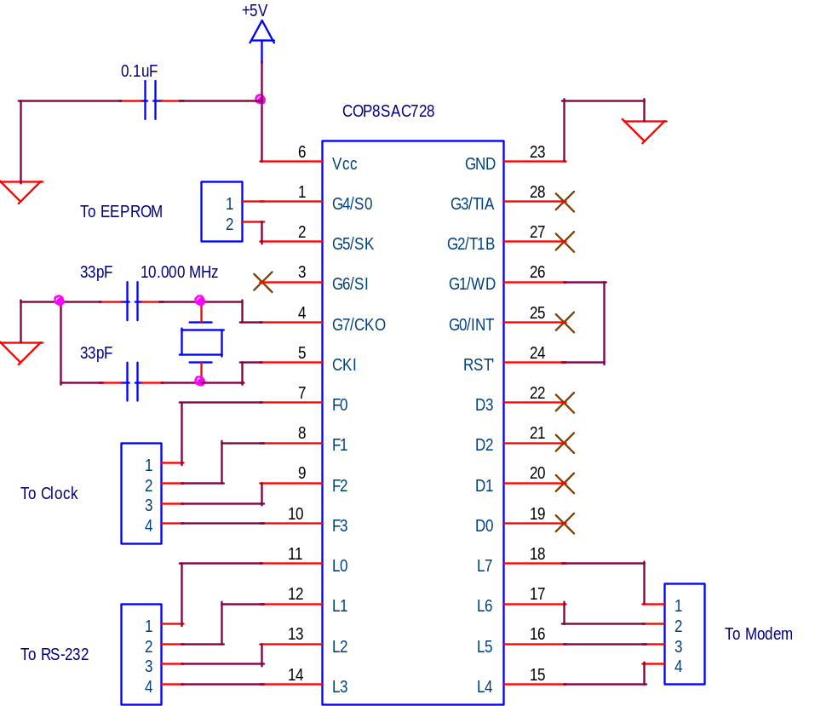

Figure 3: Microcontroller circuit of host unit.

A 10.000 MHz crystal will be used as the clock source for the COP8. Since ten clock cycles correspond to one instruction cycle in the COP8, this will provide a 1μs instruction cycle period. The COP8 has an on-chip bias resistor, eliminating the need for one to be placed in parallel with the crystal.

The COP8 will be configured via software so that it resets upon power-up, initializing the instruction counter to zero and the stack pointer to the default value of 6Fh. Also, the watchdog output pin will connect to the chip’s reset pin. This will reset the microcontroller if either (1) The clock oscillator malfunctions or (2) The value of the instruction pointer becomes corrupted and the program loses proper execution. The modem chip will be connected so that it resets each time the microcontroller resets.

4.1.1.2. Host Unit Hardware: Clock Chip

A real-time clock module will be present in the host system to keep track of time so that scheduled events may be executed at their proper times. The Epson RTC-4553 has been chosen because it provides all the necessary functions (year, month, day, hour, minute) while maintaining a low cost [29,30,31]. It also provides automatic leap year correction [29].

The 4553 uses a four-wire serial protocol for communications. Two of the pins are dedicated inputs (data synchronization tick and receive command) and two are outputs (clock tick and send time data). [29]

Several external components are needed to gain full functionality from the 4553. A 0.1μF capacitor is connected across the power terminals to provide immunity to noise spikes on the power bus. In order to preserve the clock during a power outage or other disruption, a large-value capacitor (0.1 farads) is connected in parallel with the clock. To prevent the capacitor from discharging on other parts of the circuit (such as the microcontroller and modem), a diode has been included in the circuit. Although this diode will reduce the voltage applied to the clock to about 4.3 volts, this does not present a problem because the clock may function from a voltage as low as 2 volts [29]. The circuit is shown below:
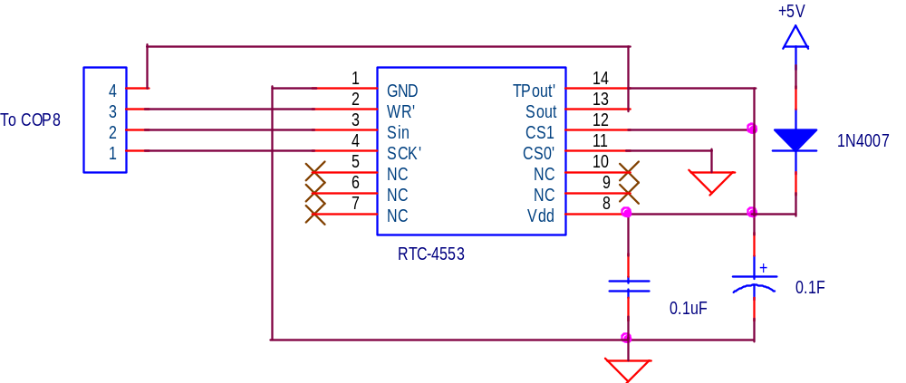

Figure 4: Real-time clock circuit.

4.1.1.3. Host Unit Hardware: EEPROM

In order for the host unit to execute events independent of the server computer, the schedules and actions of those events must be stored locally on the host unit. These events will be stored in the 24LC256 serial EEPROM chip. This chip was chosen for several reasons:

- It utilizes the I²C protocol, which requires only two of the COP8’s I/O pins. Other serial EEPROMS use different protocols, requiring up to five pins. [38,39,40]
- It can be reprogrammed in-circuit up to one million times, allowing scheduled operations to be changed frequently [38].
- If future revisions of the system require more EEPROM, up to eight 24LC256 units may be cascaded onto the same bus, providing up to 256 kB of memory for profiles [38].

The 24LC256 uses the I²C communications protocol, therefore requiring only two I/O pins. One pin receives the data synchronization pulses generated by the COP8, and the other pin transfers data to and from the COP8.

The 24LC256 requires only one external component for reliable operation. That component it the standard shunt capacitor found across a digital chip’s terminals. The circuit is shown below:

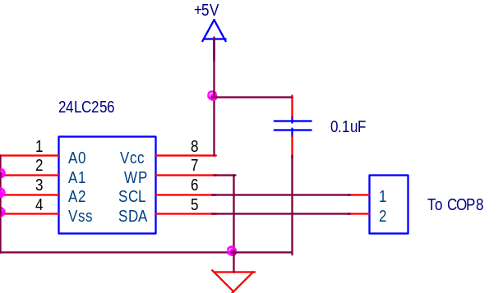

Figure 5: EEPROM Circuit.

4.1.1.4. Host Unit Hardware: RS-232 Interface

In order to interface the host unit’s microcontroller to the RS-232 port of a personal computer, a chip must be present to convert the RS-232 voltage levels to TTL and vice-versa. This is done using a garden-variety RS-232 converter chip. The MAX232CPE was chosen because it provides two RS-232 to TTL and two TTL to RS-232 conversions, the exact number needed for the host unit to communicate effectively with a personal computer. It also had the lowest price for chips that fit the conversion requirement [41].

Although RS-232 requires both a positive and negative voltage in order to communicate reliably, the MAX232 requires only a +5 volt power supply to provide full RS-232 compatibility. It does this by producing ±10V by means of an on-chip voltage converter. The converter portion requires four external capacitors. A general V_{CC}–to-ground shunt capacitor is also needed. The circuit is shown below:

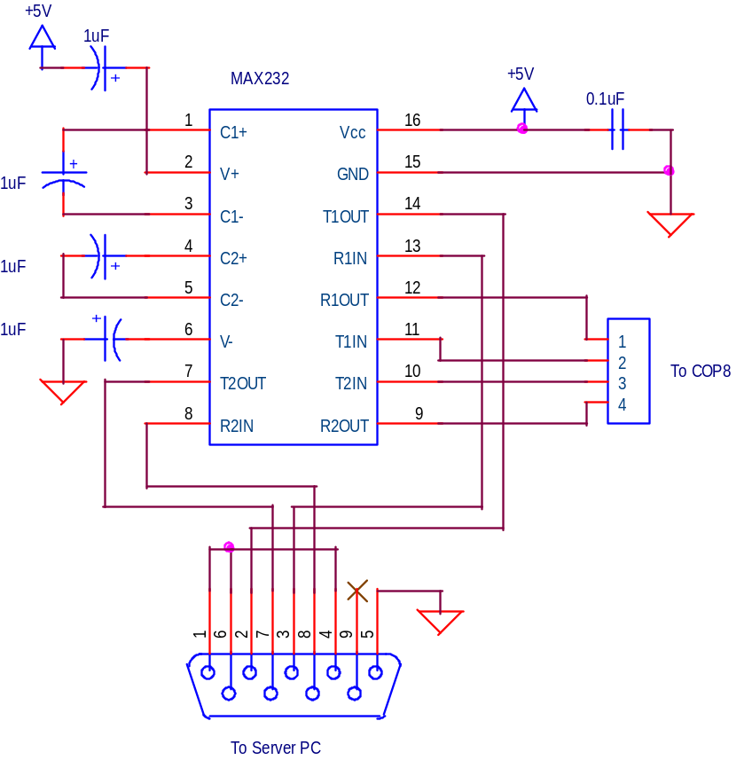

Figure 6: RS-232 interface.

4.1.1.5. Host Unit Hardware: Modem Chip

The modem chip is used to interface the host unit to the target units via the building’s AC wiring. Because the chip must interface a TTL-level signal to 120VAC, a fair amount of circuitry external to the chip is required to maintain a robust signal level while maintaining isolation from the high-voltage line. Isolation is a must because the RS-232 connection to the server computer provides a path to ground. If the hot wire of the 120V line managed to come in contact with the RS-232 connection, any electronic components in the current’s path will inevitably be destroyed.

In an effort to maximize data transfer rates compared to other low-cost systems [req. 1], three modem chips have been considered: National Semiconductor’s LM1893, Philips’ TDA5051, and ST Microelectronics’ ST7537. The present status of the LM1893 is “lifetime buy,” which implies that the chip’s production may cease at any moment. The remaining two chips are capable of at least a 600 bps data rate [10, 23], which is five times as fast as X-10 [6].

Simulations were run on the other two chips to determine which one will function more robustly under the noise conditions present on the communications medium (the power line). Since the TDA5051 utilizes two-state amplitude-shift keying (commonly known as on-off keying or OOK), it interprets many noise spikes as data bits [23]. However, the TDA5051 employs frequency-shift keying, where signal amplitude is not much of an issue as long as it exceeds the minimum level required for detection [10]. As a result, the TDA5051 will be the chip used in both the PLCCS host and target units.

The ST7537 is half-duplex and requires four pins to interface with the COP8: Rx Data, Tx Data, Clock Recovery, and a pin to select its mode (either Transmit or Receive). It requires two different power supplies: +5V and +10V. The circuit is shown below:

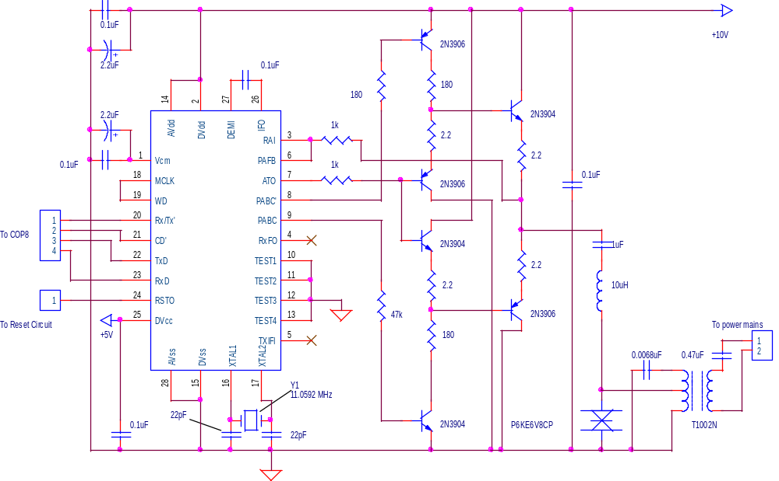

Figure 7: Host modem circuit.

In order to meet necessary FCC regulations [req. 7], a low-pass filter must be connected between the modem’s output and the power line in order to suppress harmonics that would otherwise risk violating FCC rules and regulations [12].

4.1.1.6. Host Unit Hardware: Power Supply

The power supply used in the host unit will depend primarily on what modem chip is used. Regardless, both modem chips require a +5V supply. One focus on power supply design is the amount of power that it draws. Since the host unit will be running 24 hours a day, 365 days a year, the electricity costs can add up if the unit draws excessive amounts of power. By drawing 1.5 watts, the host unit will require only eleven cents to power per month [req. 5], assuming that the energy rate is ten cents per kWh. A simulation has been run to determine an adequate +5V supply (one that draws less than 1.5 watts). It is shown below:

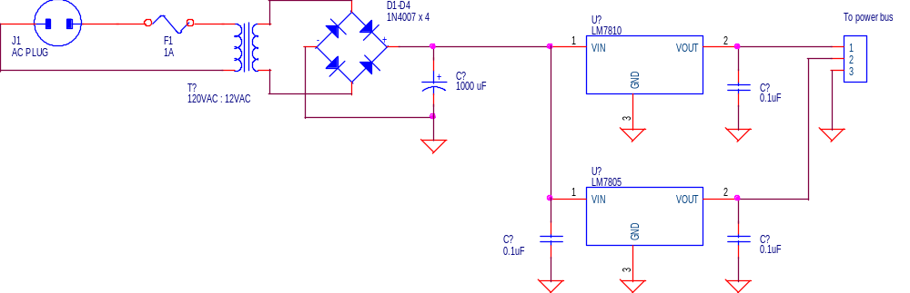

Figure 8: Host unit power supply.

Using the common 7805 regulator, a low-cost, steady-voltage source is obtained [21, 41]. This circuit provides power for the entire host unit.

4.1.1.8. Host Unit Hardware: Complete Host Unit

After piecing together all of the previous host unit sub-circuits, the following circuit is obtained as the overall host unit:
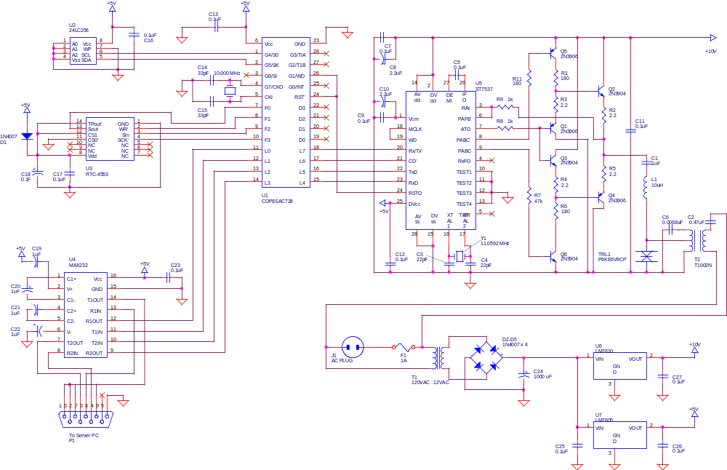

Figure 9: Overall host unit.

4.1.2. Host Unit Firmware

The firmware for the microcontroller will be responsible for interpreting all requests and executing all actions on the host unit. In an effort to suppress the cost of the system [req. 8], several hardware components have been omitted and replaced with software, such as the UART chip used for serial data transmission.

All firmware will be written in COP8 Assembly Language and compiled and linked using the freeware available from National Semiconductor’s web site [43]. The source code files will be written in plain ASCII text. The files will be named host_nnn.asm, where nnn is replaced with the firmware revision number.

Figure 10 shows a flow chart for the firmware that will be present in the microcontroller. The subsections following the chart contain data pertaining to the components of the chart.

Get Time

Change Time?
Reset Index
Yes
Count=0
Update Time
Read EEPROM
No
Finished Polling?
Yes
Program?
Yes
No
Computer Interrupt?
Program EEPROM
Yes
No
Increment Index
No
Direct Command?
Yes

Need to Send?
Send Command
No
No

+1 To Count
Yes

Random Delay
Send Command

Error Flag!
No
Check Status?
Count=5?
OK
Not OK

Yes

Figure 10. Host Unit Firmware flowchart.

4.1.2.1. Host Unit Firmware: Write EEPROM

Target unit profiles will be stored as a 64-byte block within the host’s EEPROM chip. The data for each profile will be partitioned as follows:

Target ID | Time | Command | T | C | T | C | T | C | T | C | T | C | T | C | T | C | T | C | T | C
4 Bytes | 4 Bytes | 2 Bytes | 4 | 2 | 4 | 2 | 4 | 2 | 4 | 2 | 4 | 2 | 4 | 2 | 4 | 2 | 4 | 2 | 4 | 2

As can be seen, up to ten different times and commands may be stored per profile. Using this method, over 500 target units may be automatically controlled using the 32kB EEPROM [req. 6].
Data will be written to the EEPROM as four blocks of 16 bytes each (64 bytes total) in the following manner:

- Send serial data indicating the address where the first byte will be written to the EEPROM.
- Dump the 16-byte data block at that address.
- Repeat step 2 three more times to fill the EEPROM’s data block with the target unit’s schedule profile.

This code is present in the WriteEprom procedure.

4.1.2.2. Host Unit Firmware: Read EEPROM

The host unit will continuously be polling the EEPROM to determine if a scheduled command needs to be sent to a target unit. This will be done as follows:

- Set the EEPROM index to zero.
- Read the first 16 bytes of the EEPROM’s present 64-byte data segment into the COP8’s data block (bDataBlock). Note: The first 4 bytes contain the target unit’s ID, and the remaining 12 contain two six-byte time/command blocks.
- Determine if either of the two times in the block is due for execution. If so, execute the command (see Execute Scheduled Command). If not, go to step 4.
- Read the next twelve bytes of the EEPROM, placing them in the upper 12 bytes of bDataBlock. This preserves the original target ID while gathering two new time / command blocks.
- Go to step 3 unless all 64 bytes have been read.
- If all 64 bytes have been read, increment the EEPROM index by one so that it points to the next 64-byte data block.
- If all profiles have been polled, go to step 1.
- Otherwise, go to step 2.

This code is present in the ReadEprom procedure. Note that if a request is made from the server PC to communicate with the host unit, all polling will cease, and control will jump to the GetPacket_from_DTE procedure.

4.1.2.3. Host Unit Firmware: Get Time

Before the host polls through the EEPROM to determine if a scheduled command is due to be executed, the host must fetch the time from the clock module. It does this in the following manner:

- Load an array pointer with the starting address of bDataBlock.
- Send a command to the clock to receive the year.
- Receive the year byte, place it at the array pointer’s location, and increment the pointer by one.
- Send a command to the clock to receive the month.
- Receive the month byte, place it according to the pointer, and increment the pointer.
- Send a command to receive the day.
- Receive the day byte, place it according to the pointer, and increment the pointer.
- Send a command to receive the hour.
- Receive the hour byte, place it according to the pointer, and increment the pointer.
- Send a command to receive the minute.
- Receive the minute byte, place it according to the pointer, and increment the pointer.

This code is found in the GetTime procedure.

4.1.2.4. Host Unit Firmware: Set Time

Occasionally the contents of the clock module become corrupted, making it necessary to set the time to the proper value. This is done through the SetTime procedure as follows:

- Clear the contents of bDataBlock, setting all bytes to zero.
- Place the time in BCD form into bDataBlock, with the year in index 0, month in 1, day in 2, hour in 3, and minute in 4.
- Send the “Set Time” command to the clock.
- Sequentially send the bytes in bDataBlock to the clock, starting with index 0 and stopping at index 5.

4.1.2.5. Host Unit Firmware: Receive Byte from Target

In order to receive data from target units, GetByte_from_Modem has been written. It operates as follows:

- Wait for modem’s carrier detect pin to go high [10].
- When modem’s clock recovery pin goes low [10], capture present bit from modem’s Rx_Data pin. Place the bit into the COP8’s carry bit.
- Rotate the carry bit right so that it goes into the most significant bit position of the accumulator.
- Jump to step 3 eight more times.
Note: after these eight iterations, the accumulator will contain the received byte.
- Copy the accumulator into the data transfer variable, bDataByte.

4.1.2.6. Host Unit Firmware: Receive Packet from Target

This procedure, known as GetPacket_from_Modem, ties in directly with GetByte_from_Modem. It functions as follows:

- Load the B pointer with the starting address of bDataPacket.
- Launch GetByte_from_Modem. Received byte will be in bDataByte.
- Copy bDataByte into the location referenced by the B pointer.
- Increment B.
- If B is less than the packet length, then more bytes are waiting to be received. Go to step 2.
- Otherwise, all bytes have been gathered. bDataPacket contains the complete 16-byte packet that was sent by the target unit.

4.1.2.7. Host Unit Firmware: Receive Byte from Server

This procedure, GetByte_from_DTE, is responsible for receiving data from the server computer’s serial port. Data will be transferred at a rate of 9600 bps. The procedure works as follows [16]:

1. Wait for RTS line from server to go high.
2. Receive current bit from server and place it in the carry bit.
3. Rotate the carry bit right so that it goes into the most significant bit position of the accumulator.
4. Jump to step 3 eight more times.
Note: after these eight iterations, the accumulator will contain the received byte.
- Copy the accumulator into the data transfer variable, bDataByte.

4.1.2.8. Host Unit Firmware: Receive Packet from Server

This procedure, GetPacket_from_DTE, places the bytes received by GetByte_from_DTE into bDataPacket as follows:

1. Load the B pointer with the starting address of bDataPacket.
2. Launch GetByte_from_DTE. Received byte will be in bDataByte.
3. Copy bDataByte into the location referenced by the B pointer.
4. Increment B.
5. If B is less than the packet length, then more bytes are waiting to be received. Go to step 2.
- Otherwise, all bytes have been gathered. bDataPacket contains the complete 16-byte packet that was sent by the server.

4.1.2.9. Host Unit Firmware: Send Byte to Target

In order to send data to target units via the power-line modem, SendByte_to_Modem has been written. It operates as follows:

- Place the byte to be transmitted into the accumulator.
- Set the carry bit high. (start bit)
- Set the modem’s carrier generate pin high so that a carrier is present on the line.
- If the carry bit is high, set the modem’s Tx_Data pin high. If it is low, set the Tx_Data pin low.
- Insert a time delay to set the modem’s data rate. (1/1200 of a second for 1200 bps)
- Rotate the accumulator left one bit so that its MSB is now in the carry bit.
- Repeat steps 4-6 eight more times so that entire data byte has been sent.
- Set the carrier generate pin low to remove the carrier signal from the line.

4.1.2.10. Host Unit Firmware: Send Packet to Target

This procedure, known as SendPacket_to_Modem, is used in conjunction with SendByte_to_Modem to transfer the contents of bDataPacket to a target unit. It is structured as follows:

1. Load the B pointer with the starting address of bDataPacket.
2. Launch SendByte_to_Modem. The byte pointed to by B has been sent.
3. Increment B.
4. If B is less than the packet length, then more bytes are waiting to be sent. Go to step 2.

Note that the contents of bDataPacket are identical to those used with GetPacket_from_Modem in section 4.1.2.6. The packet structure is shown below:

Target ID | Host ID | Command | Additional Data | CRC
4 bytes | 4 bytes | 1 byte | 5 bytes | 2 bytes

4.1.2.11. Host Unit Firmware: Send Byte to Server

This procedure, known as SendByte_to_DTE, allows the host unit to send data to the server computer. Data will be sent at the common rate of 9600 bps. The procedure has the following structure:

1. Place the byte to be sent into the accumulator.
2. Reset the carry bit (set it low). This will be the start bit.
3. If the carry bit is high, set the RS-232 output pin high. If the carry bit is low, set the RS-232 output pin low.
4. Insert a time delay to set the modem’s data rate. (1/9600 of a second for 9600 bps)
5. Rotate the accumulator right by one bit, placing the next bit to be sent into the carry bit.
6. Go to step 3 until all eight bits of the accumulator have been transmitted.
7. Set the RS-232 output high, and delay for one period. (This is the stop bit.)

4.1.2.12. Host Unit Firmware: Send Packet to Server

This procedure, known as SendPacket_to_DTE, is used in conjunction with SendByte_to_DTE to transfer the contents of bDataPacket to a target unit. It is structured as follows:

1. Load the B pointer with the starting address of bDataPacket.
2. Launch SendByte_to_DTE. The byte pointed to by B has been sent.
3. Increment B.
3. If B is less than the packet length, then more bytes are waiting to be sent. Go to step 2.

4.1.2.13. Host Unit Firmware: Gather Status of Target Unit

This procedure, known as GetRemoteStatus, enables the host unit to check the status of a target unit. The structure of the data packet transmitted to the target is as follows:

PACKET STRUCTURE

The procedure has the following structure:

1. Place the 4-byte address of the intended target unit in bDataPacket, followed by the 4-byte address of the host unit.
2. Place the command to retrieve remote status as the next two bytes. ($3000h)
3. Calculate the 16-bit CRC of the packet using Calculate_CRC and place it in the last two bytes of the packet.
4. Send the packet to the target using SendPacket_to_Modem.
5. Wait for the target to reply with its response.
6. Receive the target's response using GetPacket_from_Modem.
7. Verify that the received packet is uncorrupted using Calculate_CRC.

4.1.2.14. Host Unit Firmware: Execute Scheduled Command

This procedure, known as ExecuteTimedCommand, is solely called by ReadEprom. It reorganizes the data present in bDataPacket to where it can be transmitted to the target unit. It operates as follows:

Note: The target unit's address already occupies the first four bytes of bDataPacket, which is where it should be.

1. Place the 4-byte address of the host unit in bDataPacket such that it immediately follows the target unit's address.
2. Place the command that is to be executed in the next two bytes of bDataPacket.
3. Clear the next four bytes of bDataPacket. (They are used solely for data transmission between the host unit and server computer.)
4. Calculate the 16-bit CRC of the packet using Calculate_CRC and place it in the last two bytes of bDataPacket.
5. Send the packet to the target using SendPacket_to_Modem.

Note: The target unit will not automatically acknowledge if it received the packet properly. The only way to check the target unit's status is through GetRemoteStatus.

4.1.2.15. Host Unit Firmware: Execute Server Command

This procedure is called when the server executes an unscheduled command on one of the target units. Execute_DTE_Command operates as follows:

Note: bDataPacket already contains the host address and target address in the proper locations.

1. Place the command that is to be executed in bDataPacket immediately after the host unit's address.
2. Clear the next four bytes of bDataPacket. (They are used solely for data transmission between the host unit and server computer.)
3. Calculate the 16-bit CRC of the packet using Calculate_CRC and place it in the last two bytes of bDataPacket.
4. Send the packet to the target using SendPacket_to_Modem.

4.1.2.16. Host Unit Firmware: Get Host Version

Sometimes the server will request the host unit to provide its version information. VersionInfo handles this request as follows:

1. Place the host address in the first four bytes of bDataPacket.
2. Place the version information in the remaining twelve bytes of bDataPacket.
3. Send the packet to the server using SendPacket_to_Server.

4.1.2.17. Host Unit Firmware: Calculate CRC

In order to guarantee data integrity during data transmission over the building's wiring [req. 2], a 16-bit CRC algorithm will be applied. This means that 99.9985% of all data errors will be detected. The polynomial used is the standard "CRC-16" polynomial: 1+x^2+x^15. The technique used employs traditional bit shifts and compares. The procedure is titled Calculate_CRC; the structure is as follows [44]:

Note: bDataPacket should already contain the data for which the CRC is being calculated / verified.

1. If bDataPacket contains data that is about to be transmitted, set the last two bytes of the packet to zero. If the packet contains received data, do not modify the last two bytes.
2. Set the 16-bit CRC variable (wCRC) to zero.
3. Set the B pointer to the first bit of bDataPacket.
4. Read the bit referenced by B into the carry bit, and increment B to the next bit of bDataPacket.
5. Rotate wCRC left by one bit, placing the carry bit into wCRC's least-significant bit position, and placing the most-significant bit of wCRC into the carry bit.
6. If the carry bit is 1, then XOR wCRC with the polynomial. (For CRC-16 the polynomial is 10000000 00000101b or 85h.)
7. Loop to step 4 until all bits of bDataPacket have been analyzed.
8. Copy wCRC into the last two bytes of bDataPacket.

The last two bits of bDataPacket now contain the CRC of the packet. If the packet is about to be sent to an external unit, then the CRC is nonzero. However, if the packet analyzed is a received packet, then the CRC should equal zero. If it is nonzero, an error occurred during data transmission.

  - Target Unit

All target units will be constantly listening for a carrier signal on the power line. If a carrier signal is detected, the target units will receive the data packet from the host unit. If the address contained within the data packet matches the address of the target unit, then the target unit will execute the command contained within the data packet.

4.2.1. Target Unit Hardware

A block diagram of the overall target unit hardware is shown in Figure 11. The hardware for the target unit will consist of a COP8 microcontroller, a power line modem, a relay (or other control mechanism), and a power supply.

Relay / Control Device
Micro-controller
Power Line Modem
Appliance
Power Line
To Host Unit

Power Supply
+5V +10V

Figure 11. Target unit hardware.

4.2.1.1. Target Unit Hardware: Microcontroller

Just like the microcontroller is an integral part of the host unit, it is also a critical part of the target unit. Since fewer I/O operations will be performed in the target unit compared to the host, a microcontroller with fewer pins may be used. National’s COP8SAC720N is the microcontroller of choice. It has sixteen I/O pins, which is more than adequate for the target unit, it is very cost-efficient compared to other microcontrollers: only 80 cents each in quantity.

The following table shows how the microcontroller’s pins will be used:

# of Pins: | Connect to:
4 | Modem chip
1 | Relay driver
1 | V_{CC}
1 | Ground
2 | Quartz crystal
1 | Reset pin (connects to Watchdog pin)
1 | Watchdog pin (connects to Reset pin)
9 | [Spare / future use]

Table 3: Target Unit COP8 pin usage.

The following schematic illustrates the wiring diagram of the COP8 in the target unit:

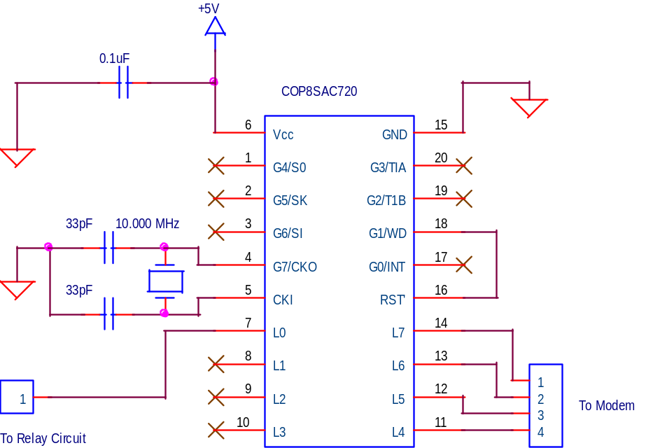

Figure 12: Microcontroller circuit of target unit.

Other than pin count and function, the COP8 in the target unit is identical to that of the host unit. It too will use a 10.000 MHz clock crystal, and it will have both power-on reset and watchdog enabled.

4.2.1.2. Target Unit Hardware: Modem Chip

The same three modem chips that are being considered for the host unit are being considered for the target unit. Refer to section 4.1.1.5 for a description of the chips. However, since the circuitry of the target unit requires no isolation from the AC mains, the circuitry needed to interface with the mains no longer requires an isolation transformer. The modem circuit for the target is shown below:

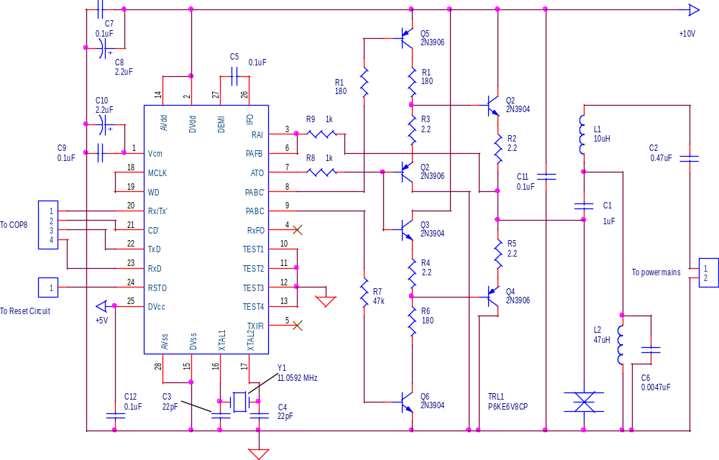

Figure 13: Target unit modem circuit.

4.2.1.3. Target Unit Hardware: Relay

A relay will be used to toggle the power to the electrical device connected to the target unit. The relay of choice for this system is the Aromat JS1-5V. It is capable of switching loads of up to ten amps, and it costs less than sixty cents in quantity [35].

The relay coil requires about 72 mA to function reliably [35]. Since few microcontrollers can directly provide this amount of current from their I/O pins, a driver transistor will be included that can adequately interface the relay to the microcontroller. A 2N3906 transistor will be used. It costs only four cents [41], and its current rating of 100mA exceeds the amount of current drawn by the relay [35,41].

A diode will be connected in parallel with the relay coil to prevent high-voltage spikes from occurring when the relay is switched on and off [16,20]. The 1N4007 will be used, which costs less than one cent in quantity [26].

The diagram for the Relay circuit is shown below:

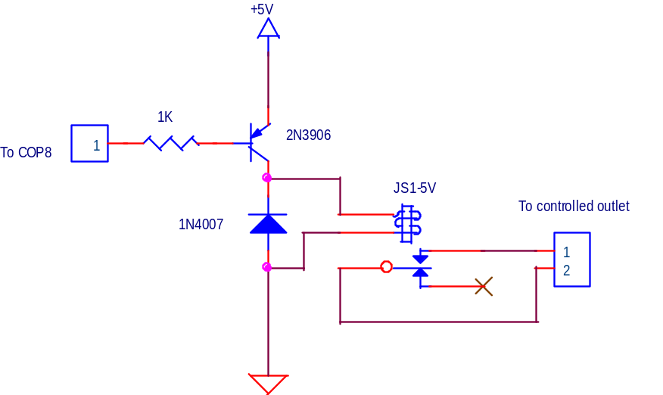

Figure 14: Relay circuit used in target unit.

4.2.1.4. Target Unit Hardware: Power Supply

Just as it does in the host unit, the power supply used in the target unit will depend on which modem chip is used. However, regardless of the voltages required, the power supply in the target unit will not require a transformer to step down the AC voltage. Instead, a simple circuit consisting of a zener diode, resistor, and capacitor will perform the duty of reducing the 120 VAC down to 5 VDC and 10 VDC [16, 18]. Although the circuitry will no longer be isolated from the AC’s “hot” line, this does not present a problem. The target unit requires no isolation because the only connectors accessible to the end user are the 120V plug and the 120V switched outlet, which are hot regardless of the isolation of the target unit’s internal circuitry.

Two circuits proved to be valid candidates for the power supply. The first is classified as a series regulator [18] and utilizes an emitter-follower to provide a constant voltage. The reference voltage (and therefore the output voltage) is equal to the voltage of the zener diode minus the bias voltage of the transistor’s base-emitter junction [16,17]. Below is a circuit for the power supply:

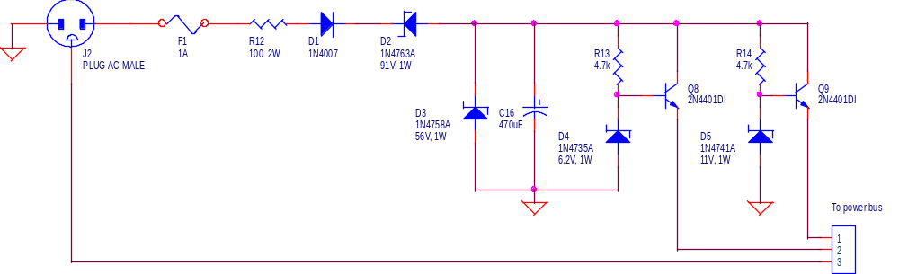

Figure 15: Target power supply #1.

One problem that was encountered while designing the circuit relates to the amount of current dissipated within the transistors. Initially, D2 and D3 were not present. Therefore, it was the sole duty of the regulator transistors to absorb all of the additional voltage and to dissipate it as heat. Under this scenario, each transistor was dissipating about eight watts, and the voltage present across the CE junction exceeded 120 volts, which far exceeded the rating of the transistors [28]. To combat this issue, a zener diode was placed in series with the incoming line voltage (D2). Note that the zener is reverse-biased, causing a voltage drop to occur equal to the zener’s reverse voltage. Since a 91-volt zener diode was used, the voltage applied to the transistor regulators is 91 volts less than it initially was. This greatly reduced the amount of power dissipated within the transistors and in the overall circuit. D3 was added as a safeguard so that the voltage never exceeds the transistors’ rated CE voltage breakpoint.

Another circuit was considered that used zener diodes as shunt regulators. It is shown below:

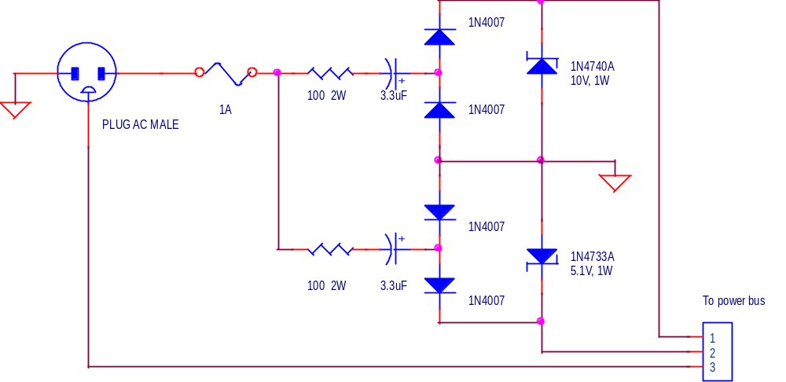

Figure 16: Target power supply #2.

In this circuit, the 3.3 μF capacitors block most of the 120VAC signal from reaching the zeners, thereby preventing the burden of dissipating the voltage as heat.

Simulation proves both circuits to be valid candidates for the design; neither of them exceeds the objective of drawing less then three watts [req. 5]. Actual hardware implementation will determine which circuit is more adequate.

4.2.1.5. Target Unit Hardware: Complete Target Unit

Since there are two potential power supplies for the target unit, there are two corresponding circuits. The one utilizing the series regulator circuit is shown in Figure 17. The second uses the shunt regulator and is shown in Figure 18.

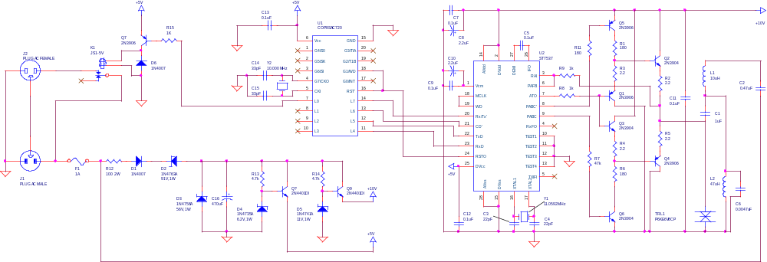

Figure 17: Complete target unit using series power supply.

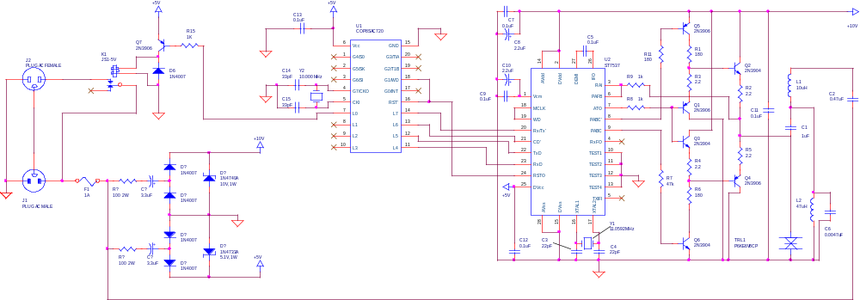

Figure 18: Complete target unit using shunt power supply.
4.2.2. Target Unit Firmware

Figure 19 shows a flow chart for the firmware that will be present in the target unit microcontroller. Firmware will be written in COP8 assembly language.

Check For Carrier

Carrier Detect Found?

No

Yes

Get Data Packet

CRC OK?
No

Yes
ID Match?
No

Yes
Toggle Relay?
Yes
Toggle Relay

No
Send Status?
Yes
Send Status

No

Figure 19. Target unit firmware.
The following subsections describe the operation of each portion of the flow chart. Note that some of the procedures have the same names as those used in the host unit. Although the procedures may be very similar, there is a possibility that they differ slightly.

4.2.2.1. Target Unit Firmware: Receive Data Packet

When the target unit is not transferring data to the host unit or toggling the appliance connected to its output, it continually listens for a data packet to be sent from the host unit. In procedure GetPacket_from_Modem, the target listens for a carrier signal. Once it detects the carrier, it gathers the data bytes to form bDataPacket.

- Is a carrier signal detected? If so, go to step 2. If not, continue listening for one. [10]
- Load the B pointer with the starting address of bDataPacket.
- Receive the current byte using GetByte_from_Modem. Received byte will be in bDataByte.
- Copy bDataByte into the location referenced by the B pointer, and increment B.
- If B is less than the packet length, then more bytes are waiting to be received. Go to step 3.

bDataPacket now contains the data block transmitted by the host unit.

4.2.2.2. Target Unit Firmware: Receive Byte from Host

In order to receive data from host units, GetByte_from_Modem has been written. It operates as follows:

- Wait for modem’s carrier detect pin to go high [10].
- When modem’s clock recovery pin goes low [10], capture present bit from modem’s Rx_Data pin. Place the bit into the COP8’s carry bit.
- Rotate the carry bit right so that it goes into the most significant bit position of the accumulator.
- Jump to step 3 eight more times.
Note: after these eight iterations, the accumulator will contain the received byte.
- Copy the accumulator into the data transfer variable, bDataByte.

4.2.2.3. Target Unit Firmware: Calculate CRC

In order to guarantee data integrity during data transmission over the building's wiring, a 16-bit CRC algorithm will be applied. The polynomial used is the standard "CRC-16" polynomial: 1+x^2+x^15. The technique used employs traditional bit shifts and compares. The procedure is titled Calculate_CRC; the structure is as follows [44]:

Note: bDataPacket should already contain the data for which the CRC is being calculated / verified.

1. If bDataPacket contains data that is about to be transmitted, set the last two bytes of the packet to zero. If the packet contains received data, do not modify the last two bytes.
2. Set the 16-bit CRC variable (wCRC) to zero.
3. Set the B pointer to the first bit of bDataPacket.
4. Read the bit referenced by B into the carry bit, and increment B to the next bit of bDataPacket.
5. Rotate wCRC left by one bit, placing the carry bit into wCRC's least-significant bit position, and placing the most-significant bit of wCRC into the carry bit.
6. If the carry bit is 1, then XOR wCRC with the polynomial. (For CRC-16 the polynomial is 10000000 00000101b or 85h.)
7. Loop to step 4 until all bits of bDataPacket have been analyzed.
8. Copy wCRC into the last two bytes of bDataPacket.

The last two bits of bDataPacket now contain the CRC of the packet. If the packet is about to be sent to an external unit, then the CRC is nonzero. However, if the packet analyzed is a received packet, then the CRC should equal zero. If it is nonzero, an error occurred during data transmission.

4.2.2.3. Target Unit Firmware: CRC Check

After receiving the data packet, it is necessary to determine if it contains any errors before executing the command within the packet. If the packet is corrupted, executing the command may prove risky. Therefore, the packet must be discarded. CRC_Check determines if the packet contains any errors, and if it does the command is ignored. The procedure is executed as follows:

- Calculate the CRC of the bDataPacket by calling Calculate_CRC.
- If the CRC is zero, then the data is uncorrupted. Continue to the next procedure (which is ID_Match).
- If the CRC is not zero, then the data is corrupted. Skip executing the action, and return to listening for another data packet.

4.2.2.4. Target Unit Firmware: ID Match

Most PLCCS systems will contain multiple target units on the same AC mains. In order to distinguish the units from one another, each unit has a unique 4-byte ID code. This allows up to 4.29 billion host and target units to theoretically be present on the same mains [req. 3]. Whenever the host unit sends data over the mains, all target units receive the data packet. A target unit determines if it is the intended recipient of the data packet by calling ID_Match. This is a procedure that compares the target’s ID code to the code received in the data packet. It is executed as follows:

- Read the target unit’s ID code from its ROM.
- Compare the ID from the ROM to the ID contained in bDataPacket.
- If the IDs match, then continue to the next procedure (which is Determine_Action).
- Otherwise, return to listening for another data packet.

4.2.2.5. Target Unit Firmware: Determine Action to Execute

Based on the command within bDataPacket, the target unit has three potential actions which may be executed. Determine_Action examines the two command bytes of bDataPacket and causes the target unit to take corresponding action.

- If the first command byte is 30h, then the host is requesting that the target unit send its status back to the host. In this case the second byte is irrelevant. SendStatus is executed.
- If the first command byte is 10h, then the host is requesting that the target unit toggle the relay on. Toggle_Relay_On is executed.
- If the first command byte is 17h, then the host is requesting that the target unit toggle the relay on. Toggle_Relay_On is executed.

4.2.2.6. Target Unit Firmware: Send Target Status

Send_Target_Status allows the target unit to send its status to the host. The data block (bDataPacket) sent to the host has the following structure:

Target ID | Host ID | Command | Unit Type | Status | Firmware version | CRC
4 bytes | 4 bytes | 81h | 01h | 00h=off 01h=on | 3 bytes | 2 bytes

The status is sent in the following manner:

- Place the command 81h into bDataPacket. This informs the host unit that the packet contains status information.
- Place 01h into bDataPacket. This states the type of target unit that is responding. Presently, only one type exists (toggle on/off devices), though this may change in the future.
- Check the status of the device connected to the target unit, and place the corresponding value into bDataPacket.
- Read the firmware version of the target from the ROM and place it in bDataPacket.
- Calculate the CRC of the packet.
- Send the packet to the host unit using SendPacket_to_Modem.

4.2.2.7. Target Unit Firmware: Toggle Relay On

Toggle_Relay_On simply turns the relay on, thereby applying power to the device under control. The procedure is almost trivial; it consists of only two statements:

- Apply ground to the base of the 2N3906, thereby saturating it and applying power to the relay.
- Return to listening for another data packet.

4.2.2.8. Target Unit Firmware: Toggle Relay Off

Toggle_Relay_Off turns the relay off, thereby powering down the device under control. The procedure is as follows:

- Apply +5V to the base of the 2N3906 (through a current-limiting resistor) to toggle the relay off.
- Return to listening for another data packet.

4.2.2.9. Target Unit Firmware: Send Packet to Host

This procedure, known as SendPacket_to_Modem, is used in conjunction with SendByte_to_Modem to transfer the contents of bDataPacket to the host unit. It is structured as follows:

1. Load the B pointer with the starting address of bDataPacket.
2. Launch SendByte_to_Modem. The byte pointed to by B has been sent.
3. Increment B.
4. If B is less than the packet length, then more bytes are waiting to be sent. Go to step 2.

4.2.2.10. Target Unit Firmware: Send Byte to Host

In order to send data to the host unit via the power-line modem, SendByte_to_Modem has been written. It operates as follows:

- Place the byte to be transmitted into the accumulator.
- Set the carry bit high. (start bit)
- Set the modem’s carrier generate pin high so that a carrier is present on the line.
- If the carry bit is high, set the modem’s Tx_Data pin high. If it is low, set the Tx_Data pin low.
- Insert a time delay to set the modem’s data rate. (1/1200 of a second for 1200 bps)
- Rotate the accumulator left one bit so that its MSB is now in the carry bit.
- Repeat steps 4-6 eight more times so that entire data byte has been sent.
- Set the carrier generate pin low to remove the carrier signal from the line.

  - Computer Software

The computer software will allow the user to control and program the host unit, which in turn controls the target units. It will also link the host computer to the Internet, allowing it to be controlled from anywhere in the world. This software will be written using Visual Basic and will be capable of executing the following actions:

- Viewing the status of the host and target units.
- Creating schedules for controlling target units.
- Modifying or deleting these schedules.
- Sending unscheduled commands directly to the target units.
- Setting the real-time clock on the host unit.

The user will be able to perform these actions from any computer connected to the network that is running a standard web browser.

    - Computer Software: Receive Packet from Host

In order to receive data packets from the host unit, the following procedure will be used:

- Wait for the RTS line to go high.
- Once the RTS line goes high, set the CTS line high.
- Serially receive 16 bytes from the host unit at a rate of 9600 bps.
- Reset the CTS line.

    - Computer Software: Send Packet to Host

The following procedure will be used for transferring data from the server computer to the host computer.

- Set the CTS line high and wait for a response from the host unit on the RTS line.
- Once the RTS line is high, the host unit is ready to receive the 16-byte data packet. Send the packet serially at a rate of 9600 bps.
- Reset the RTS line.

    - Computer Software: Sending Commands to Host Unit

When any command is sent to the host unit, the data will be placed in the data packet as follows:

Target ID | Host ID | Command | Additional Data
4 bytes | 4 bytes | 1 byte | 7 bytes

Note that some fields are not always required. If this is the case, then they will be filled with zeros. Once the data packet has been filled with the necessary bytes, it will be sent to the host unit using Send Packet to Host.

This technique applies to all commands that are sent to the host. The data in Table 4 contains values that will be present in the data packet to perform assorted functions.

Operation | Target ID  (4 Bytes) | Host ID  (4 Bytes) | Host Command  (1 Byte) | Additional Data  (7 bytes)
Get Status of Host | Empty | Empty | 01h | Empty
Get Status of Target | Target ID | Empty | 02h | Empty
Get Entire Schedule from Host | Empty | Empty | 10h | Empty
Send Backup Schedule to Host | Empty | Empty | 11h | Empty
Get Schedule for one Unit | Empty | Empty | 18h | Empty
Send Schedule for one Unit | Target ID | Time | 19h | Command
Send Command to Target | Target ID | Empty | 20h | Target Command
Get Clock Status of Host | Empty | Empty | 30h | Empty
Set Clock in Host Unit | Empty | Empty | 33h | Time & Date

Table 4: Host unit command summary.

    - Computer Software: User Interface

The user interface of the PC software allows the user to easily access the host unit and thereby control the target units. Several routines make up the user interface; their operation is outlined in the following 4.3.4.x sections.

4.3.4.1. Computer Software: Add Device

In order for the user to access a target unit through the PC software, the user must add the device and its properties to a database. This database contains information relevant to all target units, such as their ID numbers, descriptions, locations, etc. The “Add Device” routine is accessed and executed as follows:

- Select the command button labeled Edit Devices.
- Select the command button labeled Add Device.
- Enter the Target ID assigned to the device, as well as the device’s name, description, and location.
- To save the device in the database and return to the Edit Devices window, click OK.
- To cancel the action, select the CANCEL command button.

4.3.4.2. Computer Software: Delete Device

In some instances, the user may wish to delete a device from the database. The Delete Device routine must be accessed; it is structured as follows:

- Select the command button labeled Edit Devices.
- Select the command button labeled Delete Devices.
- Scroll to the desired target to delete.
- Once the desired device is located, select the command button labeled Delete.

The device has now been deleted from the database. To return to the main menu, the user will click the Close button.

4.3.4.3. Computer Software: View Device

In order for the user to view the devices present in the database, the “View Device” routine is accessed:

- Select the command button labeled View Devices.
- A form will load that will display the target unit device, as well as the location of the device.
- To view other devices in the list, the user will select the horizontal scroll bar to toggle between units in the database.

To return to the main menu, the user will click the Close button.

4.3.4.4. Computer Software: Edit Device

If the attributes of a device in the database need to be changed, such as the device’s location, the “Edit Device” routine is accessed:

- Select the command button labeled Edit Devices.
- Scroll to the device that is to be edited.
- Type the information to be edited directly into the text box corresponding to the correct data field.

To save the new data and return to the main program, click the Close button.

4.3.4.5. Computer Software: Turn Off Device

To toggle off the AC receptacle of a target unit, the “Send Command” routine is accessed, and the Off command is placed into the data packet as outlined in 4.3.3:

- Select the command button labeled Send Command from the main window.
- Scroll the slide bar until the device to be turned off is listed.
- Select the option labeled off.
- Click the command button labeled Send Command.

To return to the main menu, the user will click the Close button.

4.3.4.6. Computer Software: Turn On Device

To toggle on the AC receptacle of a target unit, the “Send Command” routine is accessed, and the On command is placed into the data packet as outlined in 4.3.3:

- Select the command button labeled Send Command from the main window.
- Scroll the slide bar until the device to be turned off is listed.
- Select the option labeled on.
- Click the command button labeled Send Command.

To return to the main menu, the user will click the Close button.

4.3.4.7. Computer Software: Check Target Status

In order to retrieve information about a target unit, such as its firmware version and its on/off status, the “Get Target Status” routine is accessed:

- Select the command button labeled Get Target Status from the main window.
- Scroll to the desired device.
- Select the command button labeled Get Status.

The current version of the firmware will be displayed in the text box labeled Firmware Version. The status of the device will be displayed as either on or off by highlighting the appropriate field.

4.3.4.8. Computer Software: Check Target Status

In order to retrieve information about a target unit, such as its firmware version and its on/off status, the “Get Target Status” routine is accessed:

- Select the command button labeled Get Target Status from the main window.
- Scroll to the desired device.
- Select the command button labeled Get Status.

The current version of the firmware will be displayed in the text box labeled Firmware Version. The status of the device will be displayed as either on or off by highlighting the appropriate field.

4.3.4.9. Computer Software: Get Host Information

In order to retrieve information about a target unit, such as its firmware version and its on/off status, the “Get Target Status” routine is accessed:

- Select the command button labeled Get Host Info from the main window.
- A new window will pop up. Once again, select the command button labeled Get Host Info.

The host information will be displayed in the Host Info textbox. This includes the firmware version and its revision date.
  - Cost

The material costs associated with the host and target units are shown below. Price quotes for the active and discrete components were gathered using PartMiner [41].

Part Number | Part Description | Vendor | Price
COP8SAC728N9 | COP8 Microcontroller | Avnet Marshall | $1.96
MAX232CPE | RS-232 Interface Chip | Avnet Marshall | $1.92
RTC-4553 | Clock Module | Digi-Key | $2.29
24LC256 | EEPROM | Digi-Key | $2.10
ST7537HS1 | Modem | Avnet Marshall | $7.09
XT49U-20 10.0000 | 10 MHz Quartz Crystal | Allied Electronics | $0.33
FOX115 | 11.0592 MHz Crystal | Mouser Electronics | $0.29
7805PI | +5V Regulator | Mouser Electronics | $0.13
41FG200 | 120V : 12.6V Xformer | Mouser Electronics | $2.10
221001-03 | AC Power Cord | Digi-Key | $0.71
Misc. components | Resistors, caps, etc. |  | $3.00
Enclosure |  |  | $2.50
Circuit Board |  |  | $2.50
 |  | Total: | $26.91

Table 5: Material cost of host unit.

Part Number | Part Description | Vendor | Price
COP8SAC720N9 | COP8 Microcontroller | Avnet Marshall | $1.78
ST7537HS1 | Modem | Avnet Marshall | $7.09
XT49U-20 10.0000 | 10 MHz Quartz Crystal | Allied Electronics | $0.33
FOX115 | 11.0592 MHz Crystal | Mouser Electronics | $0.29
311007-01 | 3-Conductor Pwr Cord | Digi-Key | $1.70
Misc. components | Resistors, caps, etc. |  | $3.50
Circuit Board |  |  | $2.50
Enclosure |  |  | $2.50
 |  | Total: | $19.69

Table 6: Material cost of each target unit.

5. TEST SPECIFICATION

Several tests will be performed to ensure the accuracy of the system. The preliminary tests will ensure that the system operates correctly within the predefined requirements. To perform these tests, several software programs will be utilized. After a prototype system has been built, tests will be performed on the physical system to ensure proper operation.

The following data in Table 1 illustrates the design requirements and the tests that will be used to simulate the system to insure that it will be compliant with these requirements. With these tests, we will be able to ensure that the design project will be a success.

Requirement | Power Line Testing | Circuit Modeling | Class B Emission | Software Testing and Debugging
Data Transfer Rate | • |  | • | •
Error Rate | • |  |  | •
System Structure |  |  |  | •
Browser Compatibility |  |  |  | •
Power Usage |  | • | •
Memory Capability |  |  |  | •
Electrical Emissions | • |  | •
Physical Packaging |  |  | •
Cost |  | •

Table 7. A summary of tests through which requirements will be certified.

5.1. Power Line Testing

The power line test will involve calculations and field testing. A power line model will be simulated using Electronics Workbench. A carrier signal identical to that produced by the modem chip will placed onto the input of the power line model. The signal at the output of the model will be measured and compared to the signal placed on the input. The applied signal will be a 1.13 V_{RMS} 71.5 kHz sine wave. The amplitude present on the remote end will need to be at least 3 mV_{RMS} in order to be reliably detected. For the field test, the prototype system will be tested at several locations, but with the same test and measurement criteria.

5.2. Circuit Modeling

This test will analyze the power supplies used in the host and target units. The power supply of host and target units must be capable of supplying two voltages. The first is 5 volts DC with a maximum ripple of 0.5 V_{PP} and the second is 10 volts DC with a maximum ripple of 0.5 V_{PP}. Both the host and target units will consume no more than 3 watts of power.

5.3. Class B Emission

This test will certify that the equipment complies with FCC Rule §15.109. This test will be conducted in the preliminary stage using MATLAB. A mathematical representation of the modem output will be coupled onto a representation of the power line. An equation representing the amplitude of the signal induced at a remote point will then be used to determine if the system is compliant. The maximum field strengths allowed by §15.109 for a 71.5 kHz signal is 33.6 μV/m when measured 300 meters away from the power line.

After the prototype has been built, the output of the modem will be interfaced to the power line. Emissions will be measured using the necessary test equipment.

5.4. Software Testing and Debugging

A test log will be created for purposes of testing and debugging both the microcontroller firmware and the Windows server software. A log of tests will be created for the main program body and each subroutine. The subroutines and main program will then be modified if any bugs are present. The Visual Basic development tools will be used to test the Windows server software. The Metalink COP8SIM emulator will be used for testing the firmware for both the host and target units [11].

6. RESOURCES

  - Power Line Testing

PSPICE 8.0 and Electronics Workbench 4.1 will be used in the preliminary development stages. PSPICE may be accessed from the computers in the Simrall PC Lab. A personal copy of Electronics Workbench will be used. For measurements, the digital storage oscilloscope in the Simrall Communications Lab will be used. In addition, MATLAB 5.3 will be used to do Fourier analysis. MATLAB is accessible in the Simrall PC lab

6.2. Circuit Modeling

PSPICE 8.0 and Electronics Workbench 4.1 will be used to simulate portions of the target and host units. PSPICE will be accessed from the computers in the Simrall PC Lab. A personal copy of Electronics Workbench will be used. For measurements, the digital storage oscilloscope will be used to record signals. In addition, a digital multimeter will be used to measure voltages and currents. MATLAB 5.3 will also be used to do Fourier analysis.

6.3. Class B Emission

MATLAB 5.3 will be used in the modeling of the power line emissions. For measurements, the biconnical antenna and the spectrum analyzer in the Simrall Communications Lab will be used.

6.4. Software Testing and Debugging

Visual Basic 6.0 will be used to create the user interface. The debugging software that is included in the Visual Basic suite will be used for testing and debugging purposes. A personal copy of Visual Basic 6.0 will be used. The firmware source code for the host and target units will be written using simple text editors such as MS-DOS EDIT, Unix PICO, and Windows Notepad. To compile and link the firmware code, ASMCOP8 v4.10 will be used. To simulate the code, the Metalink COP8SIM program will be used.

7. TEST CERTIFICATION

The results from the simulations and measurements show that the design meets all of the specified requirements.

7.1. Power Line Testing

This part of the simulation involved two parts. The first part involved using a transmission line model for the electrical wiring to study the behavior of the signal placed onto it. The second part involved measuring noise on common building electrical wiring in several different circumstances. The overall purpose of this test was to insure that the signal placed onto the electrical wiring by the host unit would properly reach the target unit.

7.1.1 Transmission Line Model

We used Electronics Workbench (EWB) to simulate the transmission line. EWB includes a T-line model in which you set various per-unit-length parameters of the line. The transmission line module included in Electronics Workbench was set to have the parameters of common 12-gauge copper wiring, which were calculated as follows:

Parameter | Formula | Variables | Param. Value | Parameter Value
Inductance | L = 4π × 10⁻⁷ ln(D/r′) | D = distance between wires  r′ = 0.7788 × radius of conductor | D = 0.25”  r′ = 0.0315” | L = 2.60 μH / m
Capacitance | C = πε / ln(D/r) | D = distance between wires  r = radius of conductor | D = 0.25”  r = 0.0404” | C = 45.8 pF /m
Resistance | R = ρ | ρ = Resistance per unit length | ρ = 5.21 mΩ / m | R = 5.21 mΩ / m

The per-unit conductance of the line’s insulation was in the microsiemen-per-meter range and was therefore ignored.

The 1.13V @ 71.5kHz sine wave generated by the power line modem was placed onto the line model. Then the signal strength at various transmission line lengths was recorded. Figure 20 shows the results of the simulation.

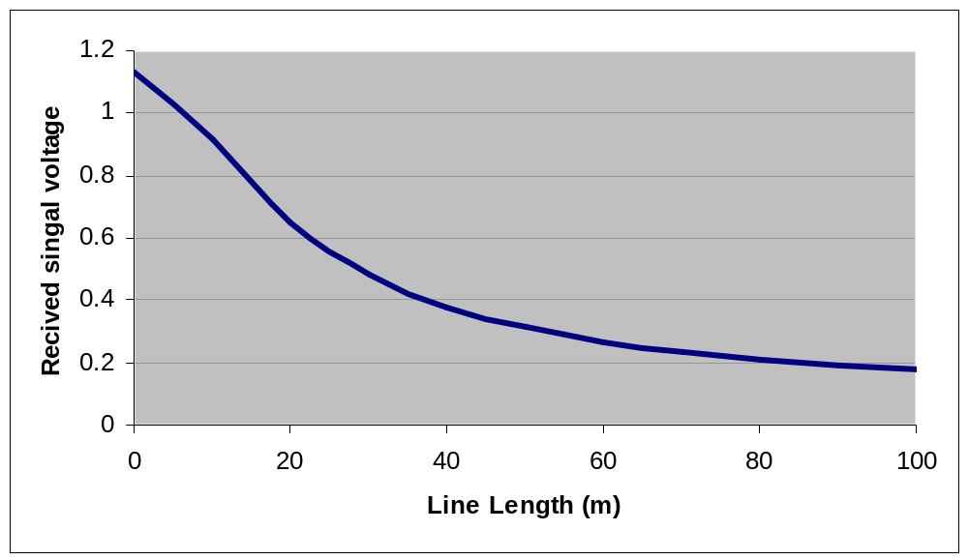
Figure 20: Simulated signal attenuation along power line.

The signal was found to be 200mV at 100m. This is much greater than the modem’s minimum signal detection level of 3mV.

For the field testing, the host unit was set up to continuously transmit. The host unit was connected to several electrical outlets different locations. Using a digital storage oscilloscope, the received signals at another electrical outlets was measured and stored. Then, using MATLAB, the signal strength was determined for each location. Since the length of electrical wiring between each outlet was unknown, the distance was approximated from the physical distance of the outlets. Several different capacitors were tested in the interfacing circuit to the power line until the strongest signal was obtained. The following is a comparison of the best-measured signal strength to the simulated signal strength.

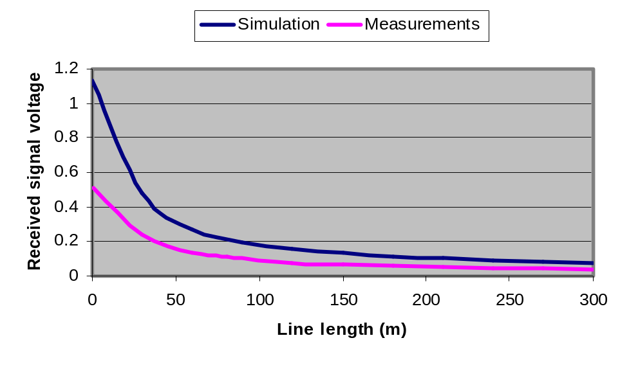
Figure 21: Signal attenuation along power line.

In addition, in order to further analyze the circuits, the target unit was set up to continuously transmit. The signal strength was then checked at several of the same outlets used before, and compared to the signal strength from the host unit. The signal strength was higher when transmitted from the target unit. Since the only difference between the host unit interface to the power line and the target unit interface to the power line is that the host unit interface contains an isolation transformer, it was concluded that the isolation transformer on the host unit was attenuating the signal.

7.1.2. Line Noise

Using a digital storage oscilloscope, signals at several electrical outlets in the Communications Lab (Simrall 436) on the fourth floor were measured and saved to a computer file. The frequencies concerned with were centered around 71.5kHz. When recording the data, the oscilloscope was set to store 5000 data points, with 1μs between each data point. For some of the data recordings, noise was intentionally placed onto the electrical wiring from other outlets. The intentional noise was created using several different items, including kitchen appliances and overhead fluorescent lights. The noise-generating items without motors were rapidly switched on and off to create the maximum amount of noise, and the devices with motors were allowed to run continuously. The following graphs show the amplitude and frequency components of the data collected.

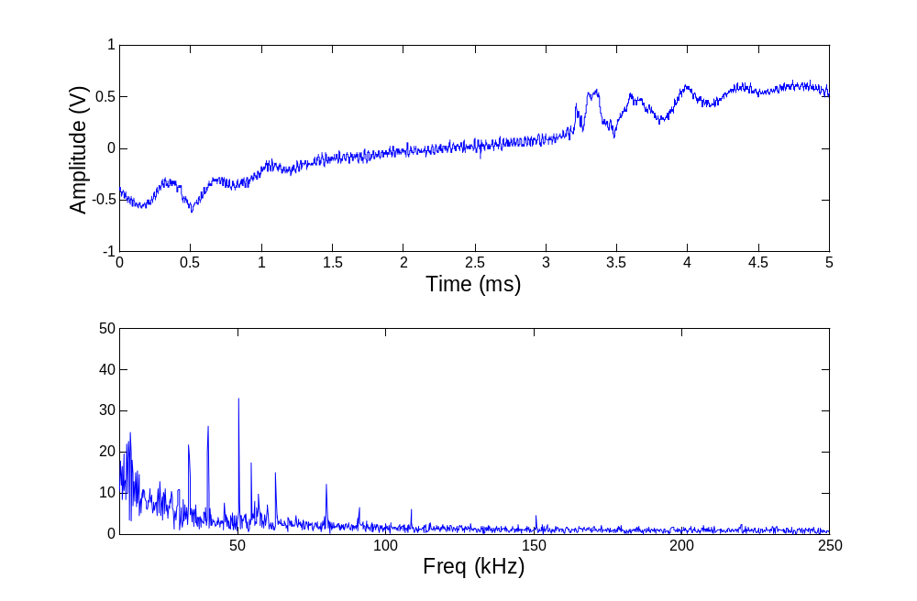
Figure 22: Analysis of random noise present on power line.

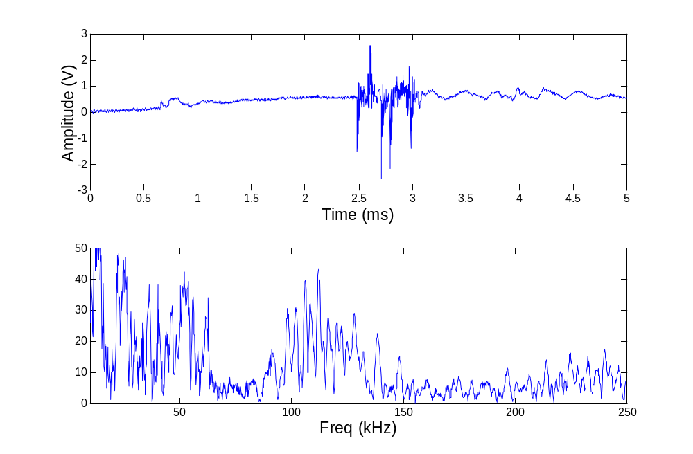
Figure 23: Analysis of toaster noise present on power line.

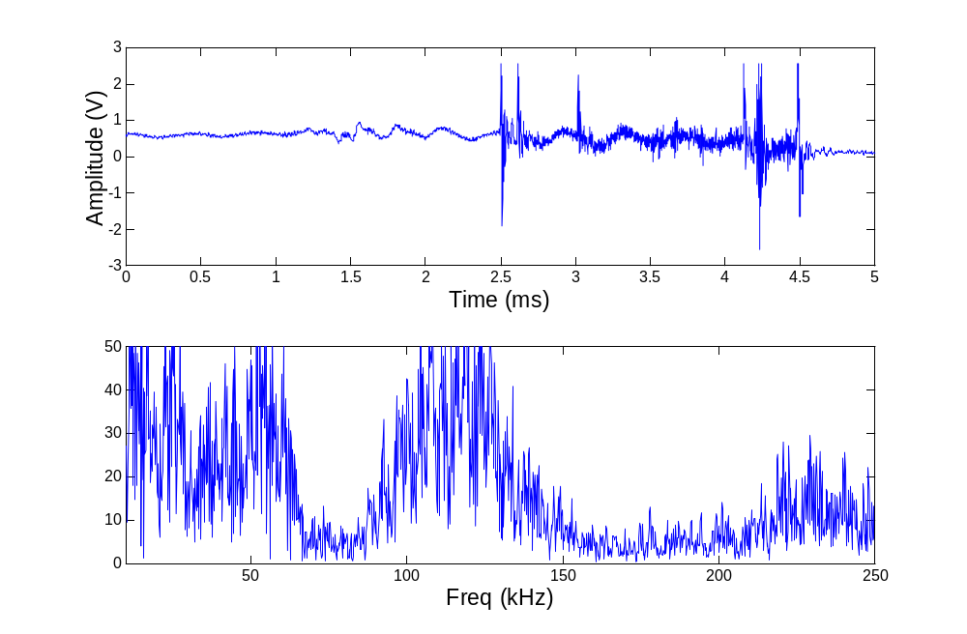
Figure 24: Analysis of hand mixer noise present on power line.

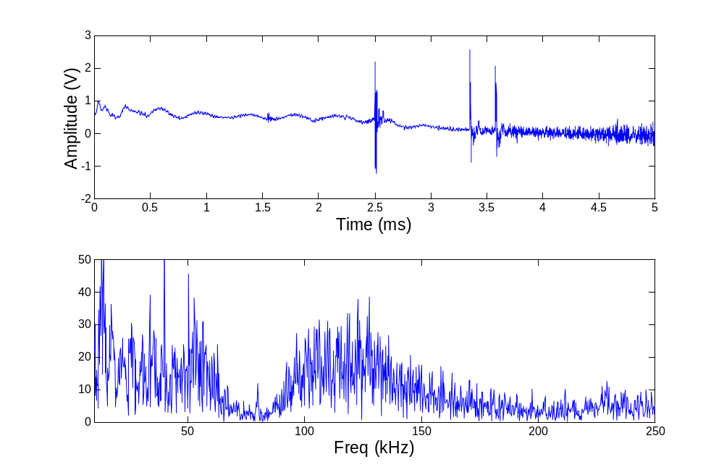
Figure 25: Analysis of electric drill noise present on power line.

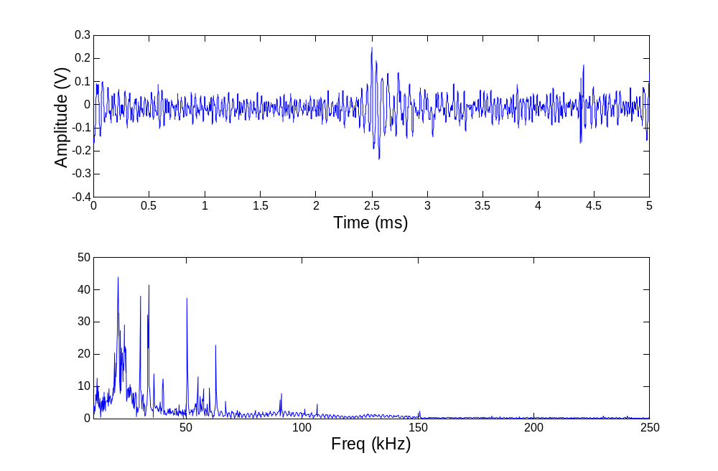
Figure 26: Analysis of blender noise present on power line.

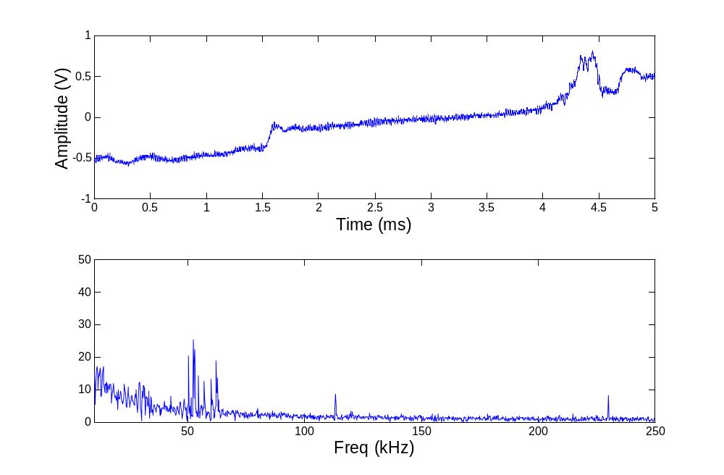
Figure 27: Analysis of random noise present on power line.

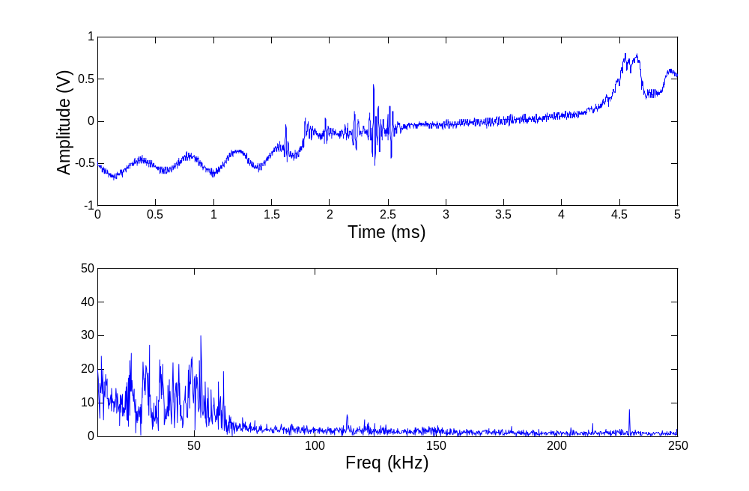
Figure 28: Analysis of random noise present on power line.

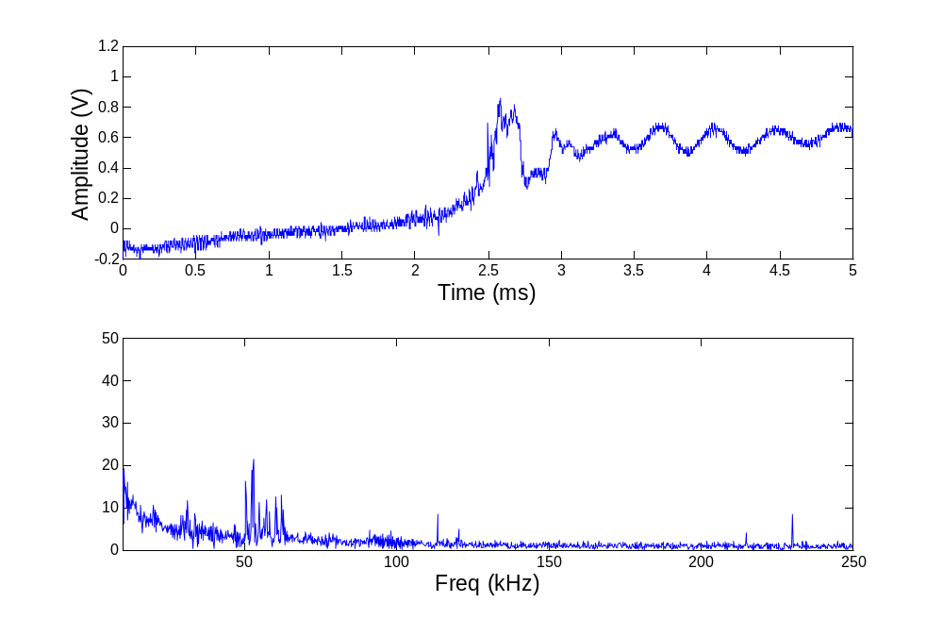
Figure 29: Analysis of random noise present on power line.
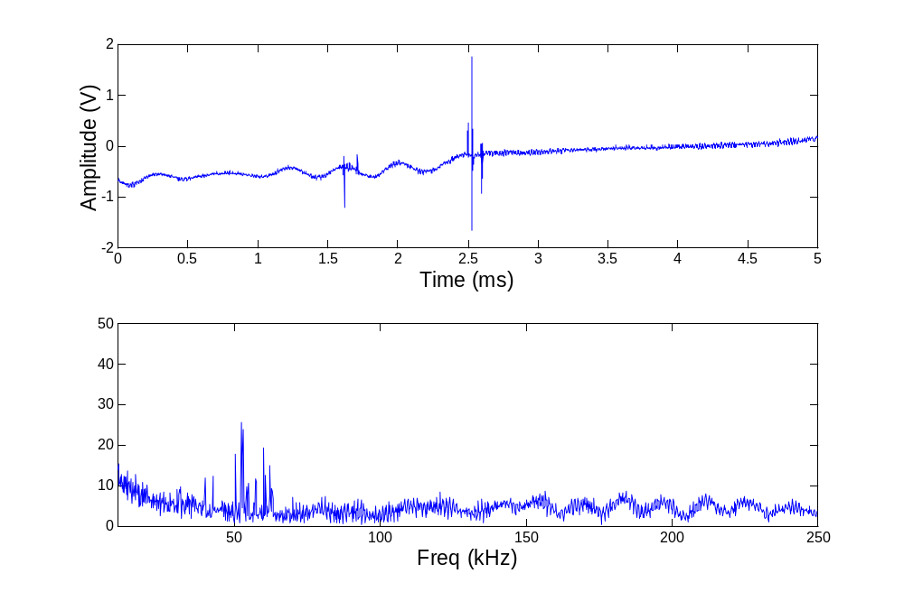
Figure 30: Analysis of fluorescent light noise present on power line.

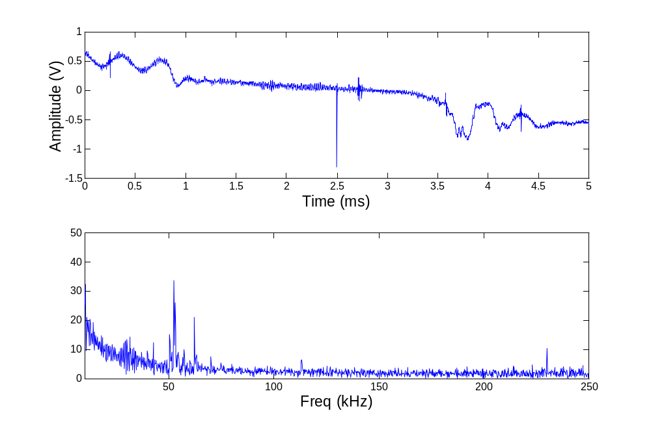

Figure 31: Analysis of fluorescent light noise present on power line.

Observation of the frequency domain graphs show that the noise present on the wiring is low around 70 kHz. Therefore, using a frequency of 71.5kHz for transmitting a signal is practical.

The power line modem has a bandpass filter to reduce the noise outside of the 71.5 kHz carrier frequency. To simulate this, the Butterworth filter function in MATLAB was used. First, each of the above noise signals was passed through the filter, and the peak noise voltage was measured. Next, a 7mV RMS 71.5kHz sine wave was imposed onto the noise data. This signal was then passed through the Butterworth filter, and the peak amplitude at 71.5 kHz was measured. The signal-to-noise ratio was then found by applying the following formula: SNR_{dB} = 20 log (Signal / Noise). After comparing the filtered signals in the frequency domain, the average signal-to-noise ratio was found to be 19.5dB. Since the modem requires a 15dB SNR in order to have a 0.001% bit error rate, we will generally experience less than one corrupted bit per every 100,000 bits transferred.

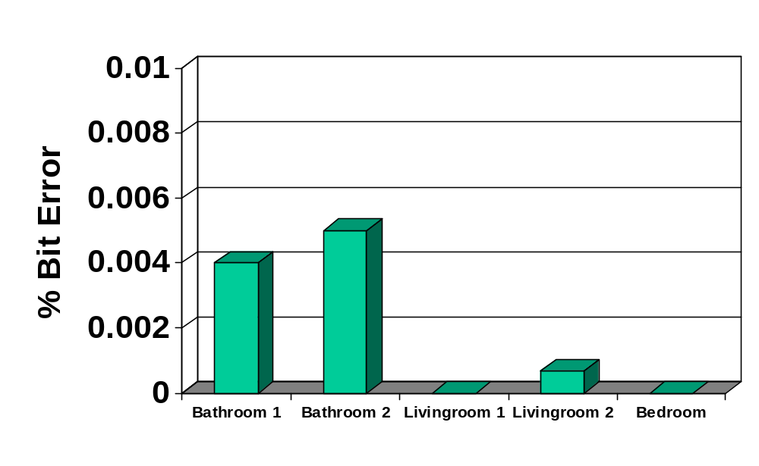In order to measure the actual bit rate that occurred, the host unit was set up to continuously transmit data. The target unit was set up to receive the data, and log it to a computer. The recorded data was then compared to what was transmitted using MATLAB, and the bit error rate was calculated from the differences between the transmitted data and the received data. The following shows the bit error rates that occurred for different locations within an apartment.
Figure 32: Measured bit error rate.

All bit error rates were below the required 0.01%. In addition to this test, several different capacitors were tested in the interfacing circuit to the power line until the lowest bit error rate was found. The capacitor values that obtained the lowest bit rate were the same as those that gave the strongest signal strength.

  - Circuit Modeling

Since the units will be running 24 hours a day, 7 days a week, having low power consumption is very important. The power supplies must be able to supply 5V and 10V ±10% and have no more than a 0.5V ripple. Therefore, two different power supplies were considered: a shunt regulator and a series regulator. Electronics Workbench was used to model the power supplies.

The following graph shows the results from the shunt regulator.

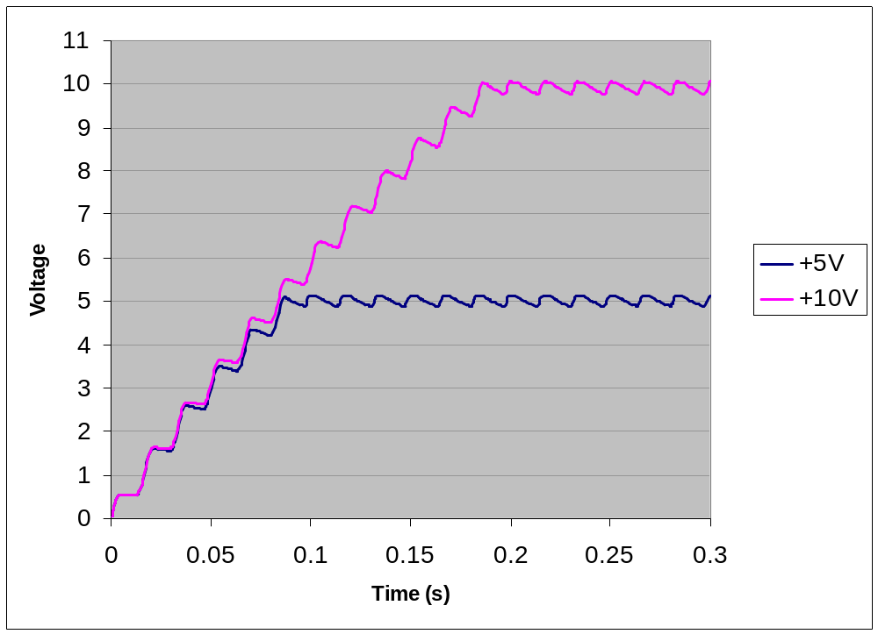Figure 33: Shunt voltage regulator simulation.

The shunt regulator provided voltages of 5.2V and 9.8V, which are both within the required 10% range. The ripple voltage was 200mV, which meets the 0.5V ripple requirement.

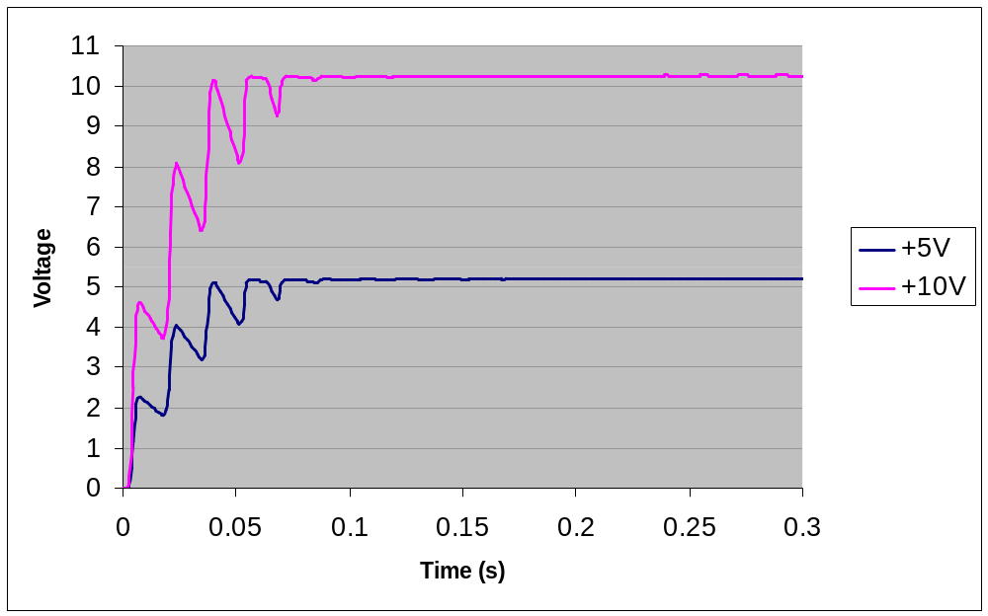The next graph shows the results from the series regulator.

Figure 34: Series voltage regulator simulation.

The series regulator provided voltages of 5.2V and 10.2V, which are within the required 10% range. The ripple of the series regulator is only 100mV, which meets the 0.5V ripple requirement.

Since both regulators meet the voltage requirements, the power consumption was used to determine which regulator would be used. The following shows the power consumption for both the shunt and series regulators.

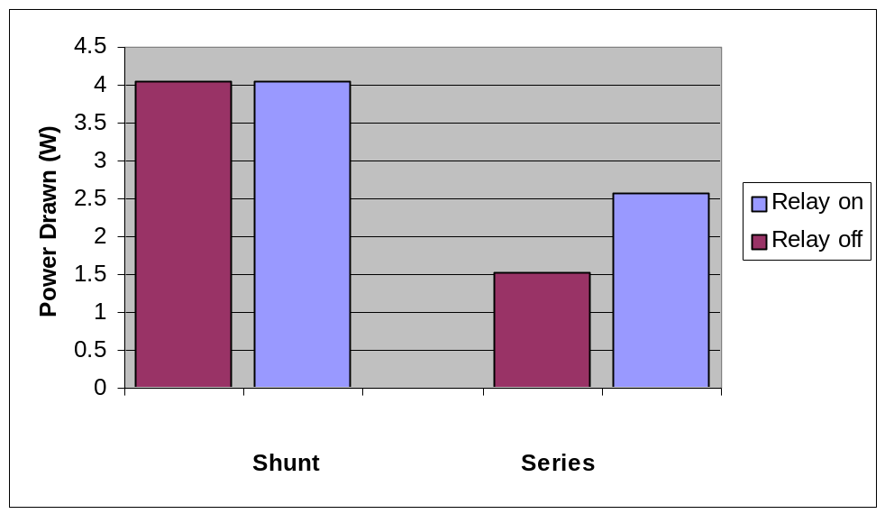

Figure 35: Series voltage regulator simulation.

This graph shows that the power consumption of the shunt regulator is 1.1 watts above the 3 watt allowance. The maximum power drawn by the series regulator is 2.6W, which meets the allowance. Since the series regulator is the only regulator that met the power requirement, it is the one that is used in the actual circuit.

To measure the +5V and +10V supplies and the ripple of the actual circuit, a digital storage oscilloscope was used to measure and record the values with the unit in operation. The following are the actually recorded +5V and +10V levels for both the host and target unit.

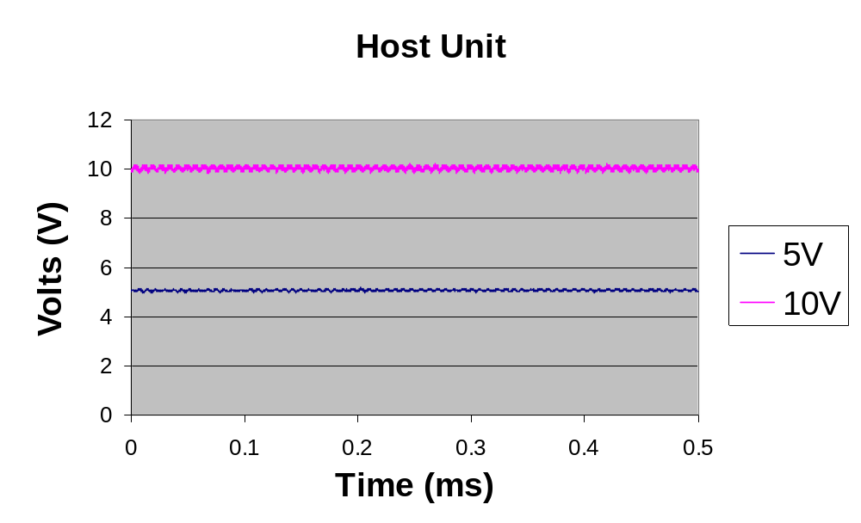Figure 36: Measured voltages for +5V and +10V supplies for host unit.

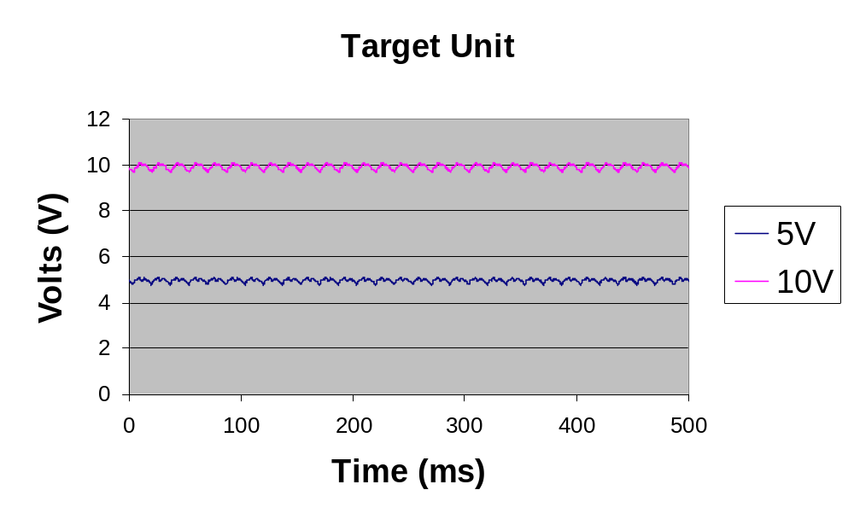
Figure 37: Measured voltages for +5V and +10V supplies for target unit.

For the host unit, the actual measured voltages were 5.05V and 10.05V. This was within the 10% requirement. Both of the measured voltages were 0.15V lower than the simulated voltages. The maximum measured ripple was 0.424V, which is within the 0.5V requirement. Although the 0.424V ripple was the maximum difference for the entire sample detected by the digital oscilloscope, from observation of the graphed data, the average ripple was around 0.2V.

For the target unit, the actual measured voltages were 5.05V and 9.91V. This was also within the 10% requirement. The 5.05V was 0.15V less than the simulated voltage, but the 9.91V supply was 0.29V less than the simulated voltage. The differences were probably due to variances between component tolerances in the simulation and the actually components tolerances.

In order the measure the actual power consumption, the current and voltage were measured with a digital multimeter, and the power consumption was calculation from this. The power was measured while the host unit was transmitting, while the host unit was receiving, while relay was on in the target unit, and while the relay was off in the target unit. In order to determine the power factor, the current and voltages were simultaneously displayed on a digital oscilloscope. From these observations, the current and voltage peaked almost approximately at the same time. Therefore, the power factor was approximated at 1.0.

The following graph shows the power consumption in each case. For the host unit, an average power consumption was approximated. This was based on the host unit sending to 500 target units 100 commands each over one day.

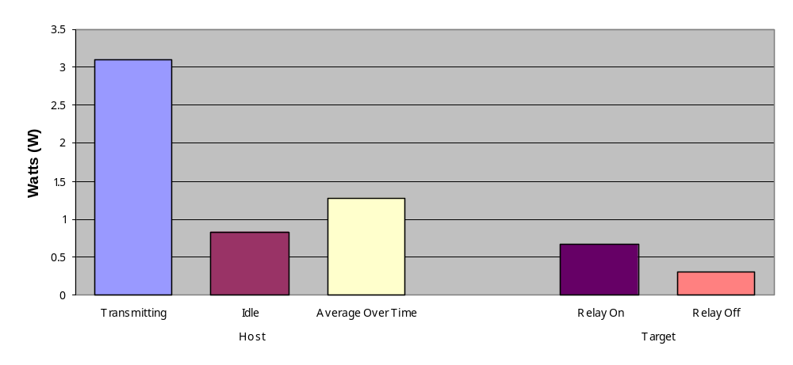 Figure 38: Measured power consumption.

For the host unit, the power consumption while transmitting was 3.1W, but only 0.83W while not transmitting. For the average power consumption approximation based on the host unit sending 500 units each 100 commands over a period of one day, 1.3W was consumed. For the target unit, 0.67W was consumed while the relay was on, and 0.30W was consumed while the relay was off.

  - Class C Emissions

In order on comply with FCC Rules and Regulations §15.109, MATLAB was used to simulate the emissions using standard field equations. FCC Regulation §15.109 states that for a carrier-current signal below 490 kHz, the maximum allowable field strength 300 meters away from the line is 2400/f , where f is the frequency of the signal in kilohertz. Therefore, for the 71.5 kHz signal placed onto the power line, a field strength of no more than 33.6μV/m may be present when measured 300 meters away from the line.

To simulate the power line, a 100-meter dipole antenna with constant current distribution was modeled. Since 300 meters is within the near field of the model, near field equations had to be used for the simulation. The simulated field strength at 300 meters was 13.90nV/m.

In order to measure the actually field strength, the host unit was connected to different outlets and set up transmit. The field strength was then measured using a biconical antenna and a spectrum analyzer, and the distance between the host unit and the biconical antenna was measured for each location. Because of noise emissions from other sources, the field strength at 300 meters was too small to measure. Therefore, measurements were taken at closer distances, and the field strength due to the host unit at 300 meters was extrapolated from this data. The measured field strength extrapolated was 0.1747nV/m. The following is a graph of the simulated and extrapolated field strengths.

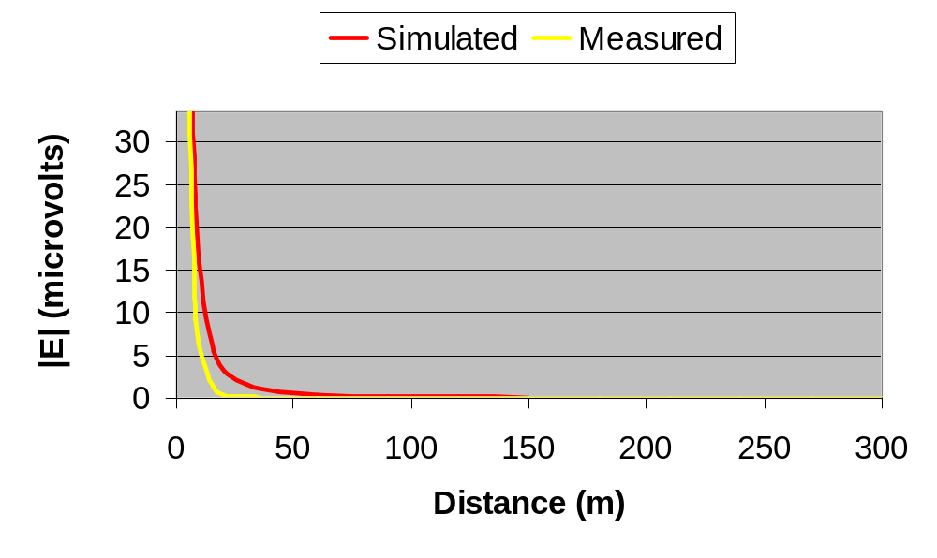Figure 39: Simulated and measured field strengths.

The differences between the simulated and measured results were due to several problems. First, the model used for the simulation approximated a power line. Second, the actual signal strength at 300 meter could not be measured, but instead was extrapolated. Third, the simulation did not take into account walls and other shielding that may have occurred. Finally, the antenna used was designed for measuring signals above 30MHz. Nevertheless, the simulation and measurements show that the fields at 300 meters are well below the required 33.6μV/m.

  - Cost

For the host unit, the cost could not exceed $35.00. After contacting several vendors for prices, the following cost summary was created. The quotes are for quantities of 10,000 or more.

Part Number | Part Description | Vendor | Price
COP8SAC728N9 | COP8 Microcontroller | Avnet Marshall | $1.96
MAX232CPE | RS-232 Interface Chip | Avnet Marshall | $1.92
RTC-4553 | Clock Module | Digi-Key | $2.29
24LC256 | EEPROM | Digi-Key | $2.10
ST7537HS1 | Modem | Avnet Marshall | $7.09
XT49U-20 10.0000 | 10 MHz Quartz Crystal | Allied Electronics | $0.33
FOX115 | 11.0592 MHz Crystal | Mouser Electronics | $0.29
7805PI | +5V Regulator | Mouser Electronics | $0.13
41FG200 | 120V : 12.6V Xformer | Mouser Electronics | $2.10
221001-03 | AC Power Cord | Digi-Key | $0.71
Misc. components | Resistors, caps, etc. |  | $3.00
Enclosure |  |  | $2.50
Circuit Board |  |  | $2.50
 |  | Total: | $26.91

Table 8: Host unit cost.

With a cost of only $26.91, the host unit cost is 23% less than its maximum allowed cost.

For the target unit, the cost could not exceed $30.00. After contacting several vendors for prices, the following cost summary was created.

Part Number | Part Description | Vendor | Price
COP8SAC720N9 | COP8 Microcontroller | Avnet Marshall | $1.78
ST7537HS1 | Modem | Avnet Marshall | $7.09
XT49U-20 10.0000 | 10 MHz Quartz Crystal | Allied Electronics | $0.33
FOX115 | 11.0592 MHz Crystal | Mouser Electronics | $0.29
311007-01 | 3-Conductor Pwr Cord | Digi-Key | $1.70
Misc. components | Resistors, caps, etc. |  | $3.50
Circuit Board |  |  | $2.50
Enclosure |  |  | $2.50
 |  | Total: | $19.69

Table 9: Host unit cost.

With a cost of only $19.69, the target unit cost is 34% less than its maximum allowed cost.

8. SUMMARY

Although a handful of home and industrial automation devices exist, many of them fail to be compatible with a user’s checkbook. The ones that are affordable are generally lacking in terms of reliability, and the ones that boast high speed and reliability tend to be expensive. Also, many of these systems may only be accessed locally. These issues may be solved by developing a system that incorporates the cost and speed of the low-end systems and the reliability and accessibility of the high-end systems.

9. FUTURE WORK

Although the design of the present system provides enough functionality to perform adequately, there is still room for enhancements.

- Target units will have the ability to control more devices such as thermostats and lamp dimmers.
- Functions will be added that allow target units to contain sensors such as thermometers and smoke detectors.
- Target units will be enhanced so they can interface to personal computers and their peripherals, allowing the power line to be used as a data network.
- The system will be compatible with existing automation standards such as X-10 and CEBus.

10. ACKNOWLEDGEMENTS

We wish to acknowledge Dr. Nicolas Younan of Mississippi State University for his assistance and feedback regarding this project. We also would like to acknowledge Dr. Joseph Picone and Dr. Follett for their support and input.

11. REFERENCES

- A. Cohen, “Computers in use by Country,” Sales and Marketing Management, Vol. 150, No. 3, p.14, March 1998.

- C. Brown, “Home Smart Home,” Black Enterprise, Vol. 27, No. 8, pp. 87-89, March 1997.

- M. Shwehdi, “A Power Line Data Communications Interface Using Spread Spectrum Technology In Home Automation,” IEEE Transactions on Power Delivery, Vol. 11, No. 3, pp. 1232-1237, July 1996.

- S. Butler, “Smart Toilets and Wired Refrigerators,” US News and World Report, Vol. 126, No. 22, p. 48, 7 June 1999.

- E. Razzi, “Get Smart,” Kiplinger’s Personal Finance, Vol. 54, No. 1, pp.118-123, January 2000.

- P. Kingery, “Digital X-10,” http://gardentoys.com/htinews/feb99/articles/kingery/kingery- 13.htm, Leviton TelCom, USA, 1999.

- X. Feng, “Home Networking,” ftp://ftp.netlab.ohio-state.edu/pub/jain/courses/cis788-99/home_nets/index.html, Ohio State University, USA, 1999.

- “Domosys Pricing,” http://216.208.231.80/pricing/, Domosys Corporation, Canada, 2000.

- “Echelon Open Systems 99 Special Offer,” http://www.echelon.com/tour99/Special.htm, Echelon Corporation, USA, 1999.

- ST7537 Home Automation Modem, http://us.st.com/stonline/books/pdf/docs/1787.pdf, STMicroelectronics, USA, 1995.

- COP8SAA7/COP8SAB7/COP8SAC7 8-Bit One-Time Programmable (OTP) Microcontroller, Literature # 102130-001, National Semiconductor Corporation, USA, August 1996.

- “Title 47, Part 15 – Radio Frequency Devices,” Code of Regulations, Federal Communications Commission, USA, 16 April 1999.

- “Understanding the FCC Regulations for Low-Power, Non-Licensed Transmitters,” OET Bulletin #63, Federal Communications Commission, USA, February 1996.

- COP8 Feature Family User’s Manual, Literature # 620897-003, National Semiconductor Corporation, USA, September 1996.

- J. Huloux and L. Hanus, Power Line Modem Application, http://us.st.com/stonline/books/pdf/docs/1124.pdf, STMicroelectronics, 1995.

- P. Horowitz and W. Hill, The Art of Electronics, Cambridge University Press, New York, New York, USA, 1989.

- Z. Lau and M. Gruber, The ARRL Handbook: Seventy-Fifth Edition, The American Radio Relay League, Newington, Connecticut, USA, 1998.

- E. Hnatek, Design of Solid-State Power Supplies, Van Nostrand Reinhold Company Inc., New York, New York, USA, 1981.

- F. Mims, The Forrest Mims Engineer’s Notebook, LLH Technology Publishing, Eagle Rock, Virginia, USA, 1993.

- R. Pease, Troubleshooting Analog Circuits, Butterworth-Heinemann, Newton, Massachusetts, USA, 1991.

- LM78XX Fixed Voltage Regulator, http://www.fairchildsemi.com/ds/LM/LM7805.pdf, Fairchild Semiconductor Corporation, USA, 1999.

- Z. Yamayee and J. Bala, Electromechanical Energy Devices and Power Systems, John Wiley & Sons, Inc., 1994.

- “TDA5051A Home Automation Modem,” http://www.semiconductors.com/acrobat/datasheets/TDA5051A_2.pdf, Philips Semiconductors, Eindhoven, the Netherlands, 31 May 1999.

- “LM1893 / LM2893 Carrier-Current Transceiver,” http://www.national.com/ds/LM/LM1893.pdf, National Semiconductor Corporation, USA, April 1995.

- “Products: SSC Power Line,” http://www.intellon.com/products/ssc/sscpower.html, Intellon Corporation, Ocala, Florida, USA, 2000.

- “1N4001 – 1N4007,” http://www.fairchildsemi.com/ds/1N/1N4007.pdf, Fairchild Semiconductor Corporation, South Portland, Maine, USA, 1998.

- “2N3904,” http://www.fairchildsemi.com/ds/2N/2N3904.pdf, Fairchild Semiconductor Corporation, South Portland, Maine, USA, 1997.

- “2N4401 NPN Small Signal Transistor,” http://www.vishay-liteon.com/datasheets/ds11103.pdf, Diodes Incorporated, Westlake Village, California, USA.

- “Serial-Interface Real Time Clock Module RTC-4553,” http://www.eea.epson.com/pdfs/rtc4553.pdf, Seiko Epson Corporation, Tokyo, Japan, 28 December 1998.

- “Serial-Interface Real Time Clock Module RTC-4543SA/SB,” http://www.eea.epson.com/pdfs/rtc4543.pdf, Seiko Epson Corporation, Tokyo, Japan, 28 December 1998.

- “I²C Bus Compatible Real Time Clock Module RTC-8583/8593 Series,” http://www.eea.epson.com/pdfs/rtc8583.pdf, Seiko Epson Corporation, Tokyo, Japan, 28 December 1998.

- “Application Manual: Real Time Clock Module RTC-4553,” http://www.eea.epson.com/pdfs/rtc4553am.pdf, Seiko Epson Corporation, Tokyo, Japan.

- J. Huloux and L. Hanus, “ST7537 Power Line Modem Application,” http://us.st.com/stonline/books/pdf/docs/1124.pdf, STMicroelectronics, USA, 1995.

- R. Ziemer, W. Tranter, and D. Fannnin, Signals and Systems: Continuous and Discrete, Fourth Edition, Prentice-Hall, Upper Saddle River, New Jersey, 1998.

- “JS Power Relays,” http://www.aromat.com/jsbroch.pdf, Matsushita Electric Works, Ltd., Osaka, Japan, 1997.

- “G2R Power PCB Relay,” http://oeiweb.omron.com/oei/PDF/G2R.pdf, Omron Electronics Inc., Schaumburg, Illinois, USA, 1997.

- “G2R Power G5C Relay,” http://oeiweb.omron.com/oei/PDF/G5C.pdf, Omron Electronics Inc., Schaumburg, Illinois, USA, 1997.

- “24AA256 / 24LC256 / 24FC256 256K Bit I²C CMOS Serial EEPROM,” http://www.microchip.com/Download/Lit/Memory/IC/64to128/21203f.pdf, Microchip Technology Incorporated, Chandler, Arizona, USA, 1999.

- “FM93C86A 16Kbit Serial CMOS EEPROM (Microwire Synchronous Bus),” http://www.fairchildsemi.com/ds/FM/FM93C86A.pdf, Fairchild Semiconductor Corporation, South Portland, Maine, USA, February 2000.

- “25AA640 / 25LC640 64K SPI Bus Serial EEPROM,” http://www.microchip.com/Download/Lit/Memory/SPI/21223d.pdf, Microchip Technology Incorporated, Chandler, Arizona, USA, 1999.

- “PartMiner Version 3.0,” http://www.partminer.com/, Partminer Inc., 1999.

- “+5V Powered, Multichannel RS-232 Drivers / Receivers,” http://pdfserv.maxim-ic.com/arpdf/1798.pdf, Maxim Integrated Products, Sunnyvale, California, USA, November 1999.

- COP8 Microcontroller Families, http://www.national.com/appinfo/mcu/index.html, National Semiconductor Corporation, Santa Clara, California, USA.

- T. Ramabadran and S. Gaitonde, "A Tutorial on CRC Computations", IEEE Micro, August 1988.

- D. Pozar, Microwave Engineering: Second Edition, John Wiley & Sons, Crawfordsville, Massachusetts, USA, 1998.

