ENGR 2013: Engineering Analysis and Applications
Laboratory No. 6: How Do I Analyze Circuits Using Linear Algebra?
Goal: The goal of this lab is to demonstrate how we can do simple DC circuit analysis using linear algebra. In this lab, you will model a DC circuit and optimize its components.
Preliminary Work: Replicate Example 1.5.1 in the textbook. Write a program that reads the coefficients of a system of linear equations from a plain text file into a matrix and a vector and solve for the associated variables. For example, for this circuit, we have the following equations:
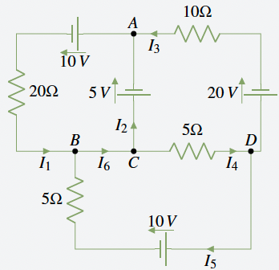
Figure 1. A typical DC circuit analysis problem

$$\left(1\right)I_{1}+\left(-1\right)I_{2}+\left(-1\right)I_{3}+\left(0\right)I_{4}+\left(0\right)I_{5}+\left(0\right)I_{6}=0 \\ \left(-1\right)I_{1}+\left(0\right)I_{2}+\left(0\right)I_{3}+\left(0\right)I_{4}+\left(-1\right)I_{5}+\left(1\right)I_{6}=0 \\ \left(0\right)I_{1}+\left(0\right)I_{2}+\left(1\right)I_{3}+\left(-1\right)I_{4}+\left(1\right)I_{5}+\left(0\right)I_{6}=0 \\ \left(20\right)I_{1}+\left(0\right)I_{2}+\left(0\right)I_{3}+\left(0\right)I_{4}+\left(0\right)I_{5}+\left(0\right)I_{6}=15 \\ \left(0\right)I_{1}+\left(0\right)I_{2}+\left(10\right)I_{3}+\left(5\right)I_{4}+\left(0\right)I_{5}+\left(0\right)I_{6}=15 \\ \left(0\right)I_{1}+\left(0\right)I_{2}+\left(0\right)I_{3}+\left(-5\right)I_{4}+\left(-5\right)I_{5}+\left(0\right)I_{6}=-10$$
You can write the coefficients into a text file as comma separated values and read them into a matrix. You can then strip the last column of the matrix and store it in a vector using the striding approach I introduced earlier. This allows you to set up a system of equations of the form $Ax+b$, which you can solve using matrix inversion.
Use this approach to replicate the values of $I_{1}$ to $I_{6}$ shown in Example 1.5.1.
Tasks:
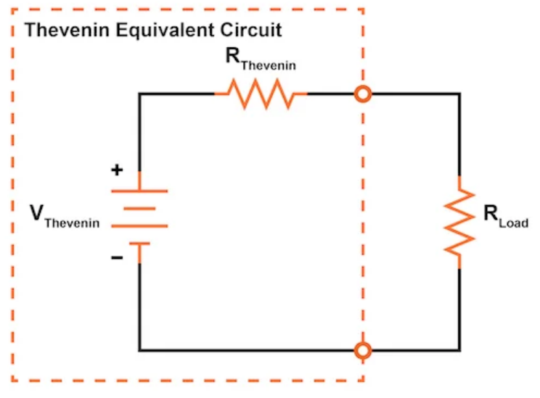Figure 2. A simple Thevenin equivalent circuit
- Let’s rediscover the Maximum Power Transfer Theorem. Set the value of the voltage source to $10V$. Set the value of $R_{Thevenin}$ to $1$. Using your code above, write a loop that steps through all possible values of $R_{Load}$ from [$-10$ to $10$] in steps of $0.1$. At what value does the power dissipated in the resistor (defined as the voltage across the resistor multiplied by the current in the resistor) peak? Justify your answer.
Note that you cannot simply solve the equation inside your code. You must represent the circuit as a matrix and use your equation solver.
- Repeat (1) for the circuit shown in Figure 3. Find the value of $R_{2}$ that maximizes the power dissipated in $R_{2}$.
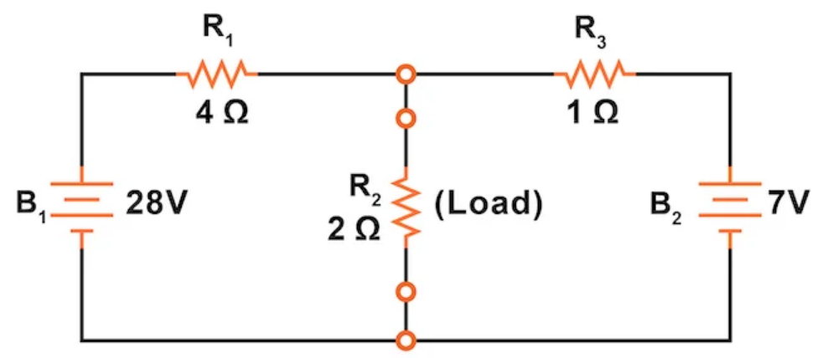
Figure 3. A more complex circuit
- Solve for the voltages and currents for the circuit shown in Figure 4 using your Python program. Verify your answer using Multisim.
- For the circuit shown in Figure 4, modify the matrix equations using a series of elementary row operations. Redraw the circuit. Solve it again using your software tools.
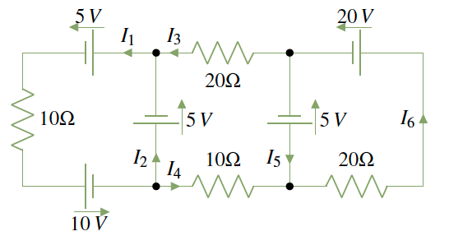
Figure 4. A three-mesh circuit
Did the solution change? If not, why not?
Summary:
The ability to manipulate circuits using mathematical abstractions and tools greatly increases our ability to design complex circuits and optimize their performance. Through the course of your undergraduate education, you will learn many techniques for designing and analyzing linear systems using linear algebra. Circuits are simply a special case of this.

