Name:

|  |  |  |
| --- | --- | --- |
| Problem | Points | Score |
| 1 | 20 |  |
| 2 | 20 |  |
| 3 | 20 |  |
| 4 | 20 |  |
| 5 | 20 |  |
| Total | 100 |  |

Notes: The exam is closed book and closed notes.

**(20 pts) Problem No. 1**:



(20 pts) Problem No. 2:



(20 pts) Problem No. 3:



(20 pts) Problem No. 4:

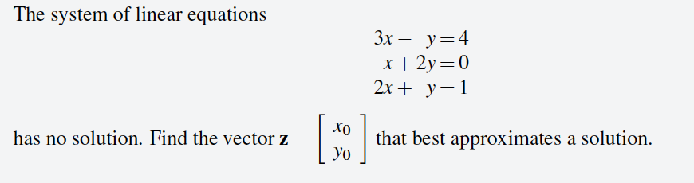

(20 pts) Problem No. 5:

