Name:

Problem | Points | Score
1 | 50
2 | 30
3 | 20
Total | 100

Notes: The exam is closed book and closed notes.
(50 pts) Problem No. 1:
A square box is defined by the vertices: [1,0], [2,0], [2,1], [1,1]. Find a transformation, $T(x)$, that transforms this box so that its vertices lie at: [0,0], [-1,0], [-1, -1], [0, -1]. Consider x as a 2x1 vector that represents each vertex. The transformation should map x to the corresponding point in the new object, y. Use the attached picture as a visualization of what your transformation should. Hint: Your transformation should include at least one matrix and one vector.
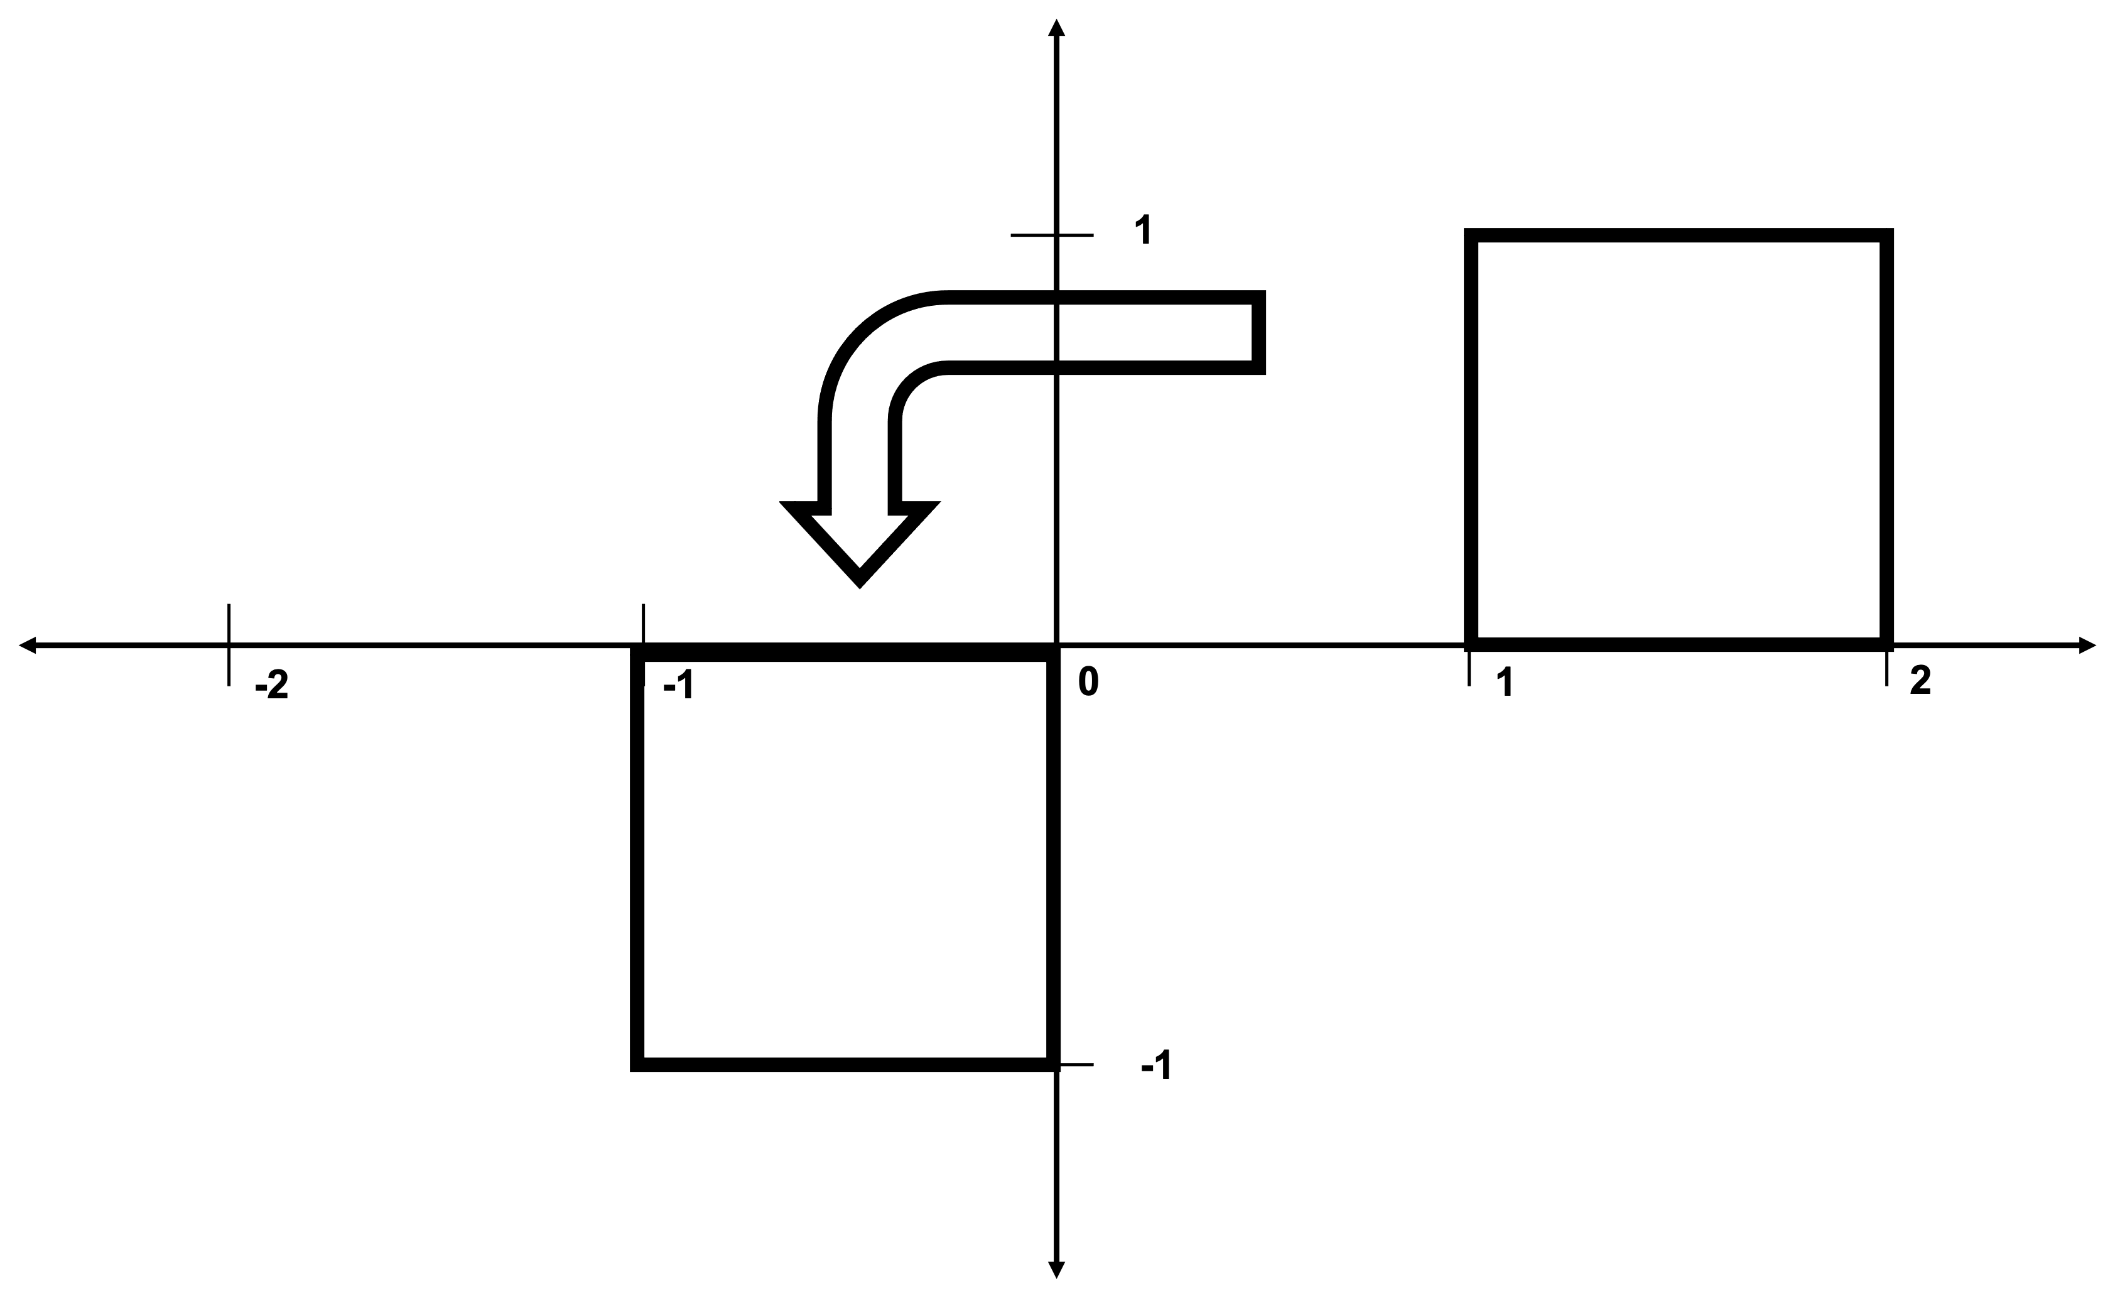
Note: You must derive the transformation using linear algebra – you cannot simply deduce it using divine inspiration ;) You will be graded on the thoroughness of your derivation.

(30 pts) Problem No. 2:
Solve for the matrix Y given the equation: $Y = AB + C^{T}D^{-1}$, where:
$A=\left[\begin{matrix}1 & 0 \\ 0 & 1\end{matrix}\right]$, $B=\left[\begin{matrix}1 & 1 \\ 1 & 1\end{matrix}\right]$, $C=\left[\begin{matrix}1 & 1 \\ 0 & 1\end{matrix}\right]$, $D=\left[\begin{matrix}1 & 1 \\ 0 & 2\end{matrix}\right]$
(20 pts) Problem No. 3:
Determine whether the matrix $A=\left[\begin{matrix}1 & 1 & 1 \\ 0 & 1 & 0 \\ 1 & 0 & 1\end{matrix}\right]$ is singular using only concepts covered in Chapters 1-2, Show your work and justify your answer.

