Mary Hassan
Dr. Joseph Picone
Honors Introduction to Engineering
10 May 2011

Growing up in Pittsburgh, I have always had a fascination with the study and operation of water travel and systems. Centered right in between three major rivers, including the great Ohio River, Pittsburgh has definitely enlightened me on the idea of shipping, whether it is for transportation, military, or industrial use. When I found out we were visiting the naval shipyards this semester, I was really excited to see the military vessels, engines, and control systems. Once we got to the NAVSEA building and started our tour, I was definitely impressed by the magnitude and size of the machines they use on a daily basis. I have been on boats before, but I have never been on a real, full-scale military ship. While we did not go on an actual ship, seeing the engines that power these great machines was an experience I think every engineer, especially students, should have. One topic our guides discussed that I found greatly interesting was the idea of using superconductivity in the setup of the ship’s engine.

Merriam-Webster Dictionary defines superconductivity as “a complete disappearance of electrical resistance in a substance especially at very low temperatures.” Likewise, The New Oxford American Dictionary defines a superconductor as “a substance capable of becoming superconducting at sufficiently low temperatures.” By these definitions, you can infer that engines and motors need to be stored at an extremely low temperature in order for the superconductive reaction to occur. In our NAVSEA tour, we got a chance to see one of these superconducting motors. The large-scale motor, taking up the majority of one of the wings of the warehouse-like space, was, to put it simply, fascinating. Although the NAVSEA website does not give very specific information on their operating systems, the one we viewed was extremely complex, made to power an entire navy ship.

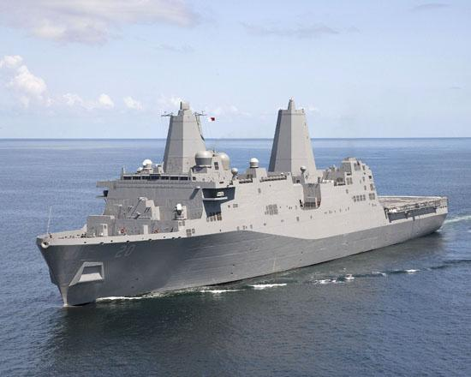
The USS Green Bay (one of the NAVSEA Naval/Air Force ships) sailing outside of Long Beach, California

While we toured, I was extremely impressed and interested in the work of NAVSEA. Working for a division of the U.S. Naval Department, our tour guides told us how they work both for the U.S. government, but also in the private sector because their work is to analyze, design, and create new, cheaper, and more effective equipment for the ships and all of their parts. According to the NAVSEA website, “[t]he Naval Sea Systems Command is comprised of command staff, headquarters directorates, affiliated Program Executive Offices (PEOs) and numerous field activities. Together, we engineer, build, buy and maintain ships, submarines and combat systems that meet the Fleet's current and future operational requirements.” The website goes on to discuss the budget, stating NAVSEA “ . . .is the largest of the Navy's five system commands. With a fiscal year 2008 budget of $24.8 billion, NAVSEA accounts for nearly one quarter of the Navy's entire budget.” With a budget that high, you can imagine the price tag on some of the ships’ parts. For example, parts making up the superconductor engine alone cost in the hundreds of millions. The engine itself is one of the most expensive pieces of the ship. Because of the cost and importance of a machine of this size, NAVSEA must closely watch and patrol the superconducting engine. At the end of the tour, I asked one of the engineers where exactly the parts come from to make the motor and if they are strictly U.S. made. He stated that while most of the materials used are made in the United States, anything that is assembled or manufactured elsewhere are closely watched in order to ensure 100% safety and efficiency with these expensive and potentially dangerous pieces of equipment.

Since this equipment is so very valuable, superconductivity in the engine itself must work properly and efficiently in order for the ship to run and not cost the company, or the U.S. government, any more money. Because of this, it is necessary to know what exactly superconductivity is and a little background information concerning its uses. Superconductivity, as stated previously, is a way in which you can eliminate electrical resistance by lowering temperatures. In the article, The History of Superconductors, the founding of this phenomenon is explained:
In 1911 superconductivity was first observed in mercury by Dutch physicist Heike Kamerlingh Onnes of Leiden University. When he cooled it to the temperature of liquid helium, 4 degrees Kelvin (-452F, -269C), its resistance suddenly disappeared. The Kelvin scale represents an "absolute" scale of temperature. Thus, it was necessary for Onnes to come within 4 degrees of the coldest temperature that is theoretically attainable to witness the phenomenon of superconductivity. Later, in 1913, he won a Nobel Prize in physics for his research in this area. (1)

By finding this vital information concerning superconductivity, Onnes paved the way for future scientists to continue research and further the benefits of lowering temperature in substances to decrease their electrical resistance. The above article goes on to discuss many other accomplishments until “ . . .in 1986, a truly breakthrough discovery was made in the field of superconductivity. Alex Müller and Georg Bednorz, researchers at the IBM Research Laboratory in Rüschlikon, Switzerland, created a brittle ceramic compound that superconducted at the highest temperature then known: 30 K. What made this discovery so remarkable was that ceramics are normally insulators” (7). By discovering a way to conduct electricity with an insulator instead of an inductor, Müller and Bednorz opened a whole new door in the study of electrics and superconductivity.

While we know what superconductivity is and how it was discovered, one question still remains—what good does it do? In a report done by Donald M. Rote and Larry R. Johnson at The Smithsonian/NASA Astrophysics Data System, they found many valuable attributes to the study and advancement of superconductivity in the U.S., especially for transportation:

Research in U.S. transportation applications of superconductors is strongly motivated by a number of potential national benefits. These include the reduction of dependence on petroleum- based fuels, energy savings, substantially reduced air and noise pollution, increased customer convenience, and reduced maintenance costs. Current transportation technology offers little flexibility to switch to alternative fuels, and efforts to achieve the other benefits are confounded by growing congestion at airports and on urban roadways. (1)

These benefits are an obvious plus for society at large, suggesting that superconductivity could greatly lower gas prices, which, given the hike in price at the pump within the past few weeks, would be great for all Americans. Likewise, by cutting down on pollution and maintenance costs, we could reduce both our carbon footprint and our budget for road repairs. All in all, superconductivity seems to be the next logical step for our country, especially with fuel and pollution crises growing every day. While the superconductor we saw will be used to power massive naval ships, this same technology can be applied to smaller, more compact modes of transportation, such as automobiles or trucks. I believe with the knowledge we have now concerning superconductivity that we can one day mass produce cars using this technology, thus solving many of the problems we currently face in a petroleum gas-dependant society.

As far as the technical advantages go for superconductors in naval ships, a recent report done by Swarn S. Kalsi, Nancy Henderson, and John Voccio shows that this technology will help advance the naval field in an extremely positive way. In their report they listed the various ways this method will be beneficial toward the management and operation of massive naval ships:

The HTS ship propulsion motors offer a range of benefits and advantages for both naval and commercial shipping applications, including the following: (1) Up to three-times higher torque density than alternative technologies, HTS machines are more compact and lighter in weight. The size and weight benefits make HTS machines less expensive and easier to transport and install, as well as allowing for arrangement flexibility in the ship, (2) Absence of iron stator teeth reduce the structureborne noise, (3) High efficiency from full-to-low speed, boosting fuel economy, sustained speed, and mission range, all key mission parameters for warships, and (4) Isothermal field winding is well suited for repeated load changes. (4)

The HTS ship propulsion motor they suggest in this article is a typical superconducting motor, much like the one we saw at the NAVSEA yard. With the benefits listed above, it is no wonder companies, shipyards, and governments all want a part in this revolutionary technology.

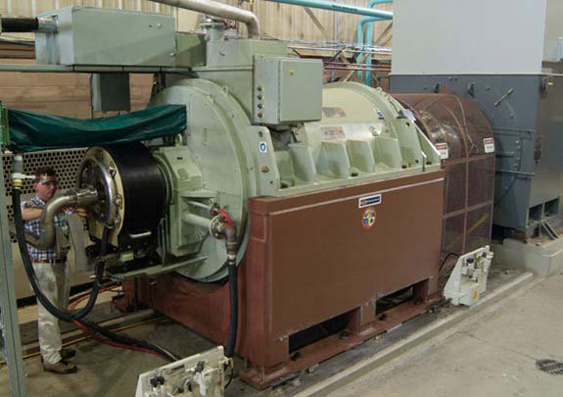
An HTS Ship Propulsion Motor used for large-scale naval ship

By using a superconducting motor, NAVSEA has incorporated three major forms of engineering disciplines: chemical, mechanical, and electrical. By using different substances and materials to determine the most efficient and cost-effective design, they have incorporated chemical engineering into the manufacturing of the motor. Similarly, by building a multi-functional motor with different moving parts, they have incorporated mechanical engineering. With every different reaction that takes place in the motor, mechanical engineering is being put into action. Finally, by using a superconductor to increase the electrical output of the motor, there is the obvious role that electrical engineering plays in the ship’s motor. By incorporating these three disciplines, the superconducting motor is a great engineering marvel and continues to shape the future of eco-friendly and cost-efficient transportation.

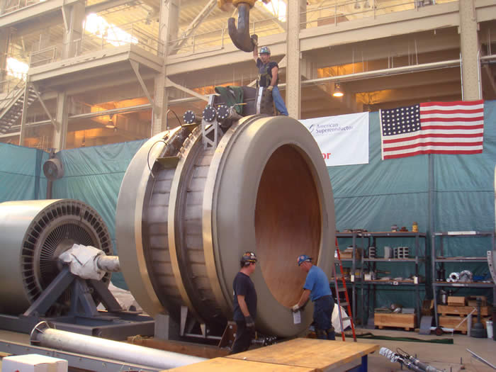
A superconducting motor used in ships

As an aspiring civil engineer, I definitely want to be involved in other projects outside of my specialty, especially ones such as the superconducting motor. This technology has the ability to alter the way current transportation operates and hopefully fight against the high costs of gasoline, road repairs, and driving hassles. As more research is put into large prototypes, there is a lot of hope for the future of superconducting motors, especially in the private sector.

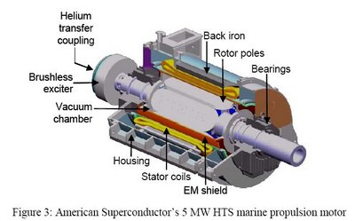
A labeled breakdown of a superconducting motor

Works Cited

"About NAVSEA." Naval Sea Home. NAVSEA. Web. 09 May 2011. <http://www.navsea.navy.mil/AboutNAVSEA.aspx>

Kalsi, Swarn S., Nancy Henderson, and John Voccio. "Superconductor Motors For High Speed Ship Propulsion." American Superconductor Corporation. Web. <http://www.amsc.com/products/motorsgenerators/documents/HTSMotorsforHighSpeedShipsAS NE.pdf>.

Rote, Donald M., and Larry R. Johnson. "Potential Benefits of Superconductivity to Transportation in the United States." The Smithsonian/NASA Astrophysics Data System. The Smithsonian/NASA Astrophysics Data System, 29 Aug. 1988. Web. 09 May 2011. <http://adsabs.harvard.edu/abs/1988suco.symp.....R>.

"The History of Superconductors." Superconductor History. Mar. 2011. Web. 09 May 2011. <http://www.superconductors.org/history.htm>.

