Matthew Rieger

Dr. Picone

Honors Into to Engineering

March 3, 2011

“Leonardo Da Vinci Flying Machines: The Glider”

Leonardo Da Vinci was one of the most prolific and influential inventors in history. His accomplishments are astounding and range tremendously. Da Vinci was a painter, a scientist and an engineer. He made discoveries and inventions well beyond his time that seem amazing even to this day.

He is primarily known as one of the best painters of all time, causing many of his other accomplishments to go unnoticed. Leonardo created many masterpieces in the field of engineering that often don’t get enough attention as they should. His inventions include practical things such as bridges, weapons to be used by military forces, geometrical structures used in mathematics, and a variation of flying machines. His flying machines are particularly impressive when observed closely. Although none of these flying machines worked fully, the designs for them were well beyond his time and extremely impressive. Da Vinci did not have anything machine related to work with and built his structures based on engineering principles and what he had studied on the flight of birds. Leonardo spent countless hours studying the flight of birds and the currents of the air. He based his designs off of these studies. Had he had what the Wright Brothers had to work with when they first successfully flew, he would have been much more successful. It is interesting to think that Da Vinci was so close to flying and he lived four centuries before the first successful flight. That notion is a true testament to his engineering prowess and knowledge beyond his time.

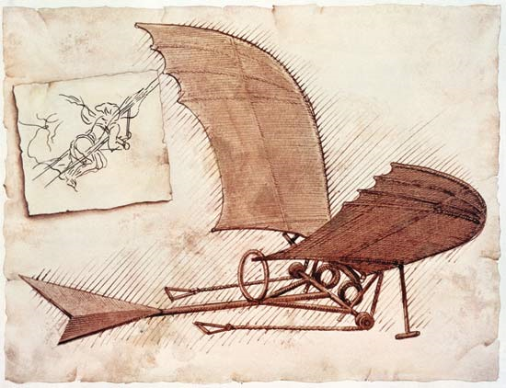 One of Leonardo’s more recognizable flying machines in the “Mechanical Bat” or better known as the “Glider”. The Glider takes into account many of the concepts of basic flight and is constructed to mock the flight of a bat. It is one of the most practically usable of his flying machines. The Glider was capable of flying but only for a very short period of time. It was composed of largely scaled wings, a cockpit for the person to control the wings, and a tail to keep the machine on track. Each part was specifically designed to do something different and promote flight.

“The "Glider"

The wings of the apparatus were designed in a specific way. They were made to model the wings of a bat or of any bird with a large wingspan. This is apparent because the wings of the machine are somewhat un-proportionally large compared to the rest of the machine. Using large wings makes more sense than using small wings. Using small wings may be easier to control, however they definitely would not be able to support the weight of a human and the rest of the machine in flight. The wings are subdivided into several sections. This makes it easier for the wings to be taut and makes them more structurally sound, being able to resist tearing. It also allows for a larger range of motion, with each subdivision moving at different angles. These subdivisions in the wings 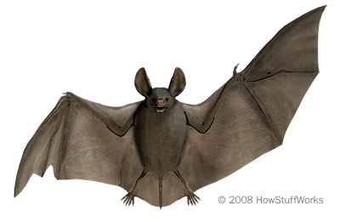closely represent the wings of a bat. A bat has bones in its wings that allow for more dexterity and flexibility in flight. He once wrote “Remember that your bird should have no other model than the bat” because he understood that a bat swoops like a glider and that its wing permits no air to pass through. Despite this, he based many of his observations on the flight of birds as well. Leonardo studied the flight of birds in very much depth. He observed that the inner part of their wings moves more slowly than the outer part of their wings. This is because the outer part of the wing has more distance to cover and therefore must move quicker. This generates forward thrust and Da Vinci attempted to copy this in his glider design. The curvature of the wings is also modeled after the wings of a bird and is intended for forward thrust. All of these engineering and flight principles were closely studied in the creation of the wings.

Bat's Wings

 The cockpit was designed for the pilot to lie down and control the motion of the wings with his or her arms. The person would lay down, with their midsection and arms through loops in order to keep themselves stable. They would grab handles on their right and left sides that are attached to the inner portion of the wings. Moving their arms up and down would move the inner portion of the wing slowly, in turn moving the outer portion of the wings more quickly. The person’s feet were also used to move the inner portion of the wing. The feet were placed on handles that if pushed against, pulled the inner wing. This cockpit design was very simple compared to some of Leonardo’s other flying machine’s cockpit designs. In his “Great Kite” the person sat down in the cockpit. Like the glider, hands and feet were used to control the wing movement. Additionally the person had to move their shoulders and torso in order to control the tail of the apparatus. This added dimension to the design makes the Great Kite a more complex machine than the glider, however even if the kite had been able to fly, it would have been very complicated and difficult to control. The design of the cockpit was critical to Da Vinci’s flying machines. It is the nucleus of the apparatus and every part of the machine can be controlled from there. One of the major flaws in Da Vinci’s design in his flying machines was that a man lacks the concentrated muscle power to imitate a bird. A man could not possibly move the wings fast enough to propel flight. Da Vinci’s cockpit design may not have been perfect, seeing that he was not able to achieve flight, but it was very well thought out and well engineered design.

Great Kite Cockpit

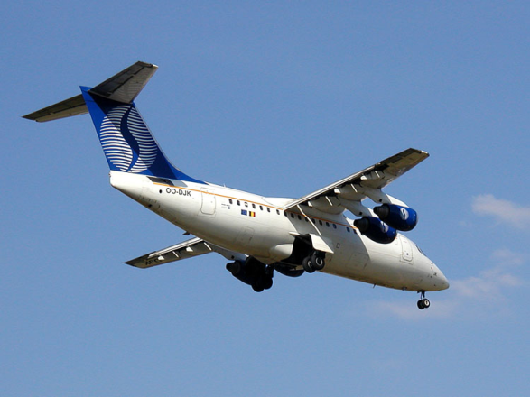 The tail of the glider was a vital part of the contraption. Leonardo invented it initially to keep the contraption balanced and on track in flight. The tail was somewhat effective in keeping the contraption balanced and not too top-heavy. Leonardo’s use of tails on his flying machines may have influenced the use of tails on planes today. Today tails on planes are used for balance and stability. Additionally, they are used to promote high performance aerodynamics and are especially effective for planes flying at slow speeds. They assist the wings of the plane and utilize the Bernoulli Effect much like the wings. On a typical plane, the tail is t-shaped. This shape promotes excellent glide ratio as the empennage is not affected by wing slipstream. The t-shape tail is often used on gliders, proving that Leonardo’s design has lasted through the years. This t-shape design differs slightly from Leonardo’s design because his initial design was more of an upside down t. Regardless, Da Vinci’s design for a tail on his glider has lasted through the years and has influenced certain dynamics of modern flight.

T-shaped tail

Although it has been assumed that Leonardo Da Vinci’s flying machines did not achieve flight, there is some evidence suggesting that he did achieve a certain degree of success. Several accounts state that in certain staged tests of several of his machines, he was successful in flying a distance of at least four hundred meters, which would merit a successful flight. Among these machines tested was the glider. It was said that the glider worked magnificently and flew for a good amount of time. While it is nice to think that these machines worked, these accounts seem to be more stories than reliable historical accounts. While the design for the glider was extraordinary, it is not conceivable to imagine one human controlling the whole apparatus and achieving flight. It is reasonable to assume that the machine could glide from a high point to a low point, much as gliders do today, but it is hard to imagine the contraption gaining height without a huge upward force of wind. Overall, it is somewhat safe to assume that the glider and Da Vinci’s other flying machines were not completely capable of flight and were at most able to glide along a certain distance.

Had Da Vinci found success in his flying machines, it would have been a tremendous deal at the time and would have started a revolution in flight. When the Wright Brother made the first fully functioning and successful flying machine, it was a huge deal and started a period of rapid evolution for flight. Had this flying revolution occurred centuries earlier, our modern knowledge of flying technology would be astounding. Leonardo’s creation of a successful flying machine would also have most likely made him the highest earning artist of all time, surpassing Michelangelo. It is interesting to think about how close Da Vinci came to success and how the world of flight would have changed had he been successful.

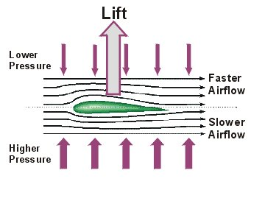 Despite the engineering prowess, Da Vinci lacked the technology needed to produce a successful flight and lacked one principle critical for flight. The Bernoulli principle is a scientific reasoning for why the wings of a plane help the plane lift into the air. Wings are designed with a flat bottom and a longer, curved top. The air travelling on the bottom part of the wing travels at a normal speed and the wind travelling on the top of the wing travels at a high speed. This high speed and separation of wind helps create lift under the wing. All that it needed is speed in order to create enough wind resistance. The Bernoulli principle is used in modern flight design and basically shapes the design of a wing. Leonardo was not familiar with the Bernoulli principle. Had he been, he may have been able to find a greater degree of success. His wing design was shaped after a bird’s wings and did not have the curved design necessary for the Bernoulli principle to work. Had he reshaped the wings of his glider and found a way to achieve a fast land speed before taking off, then he might have achieved flight. While Leonardo’s approach was different than modern planes and did not account for the Bernoulli principle, there is no doubt that his flying innovations influenced many aspect of modern flight and even engineering.

The Bernoulli principle

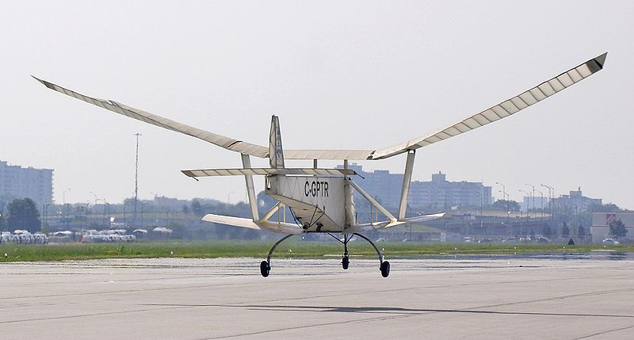 Despite all this, there is one design that very closely resembles Da Vinci’s glider. The “Ornithopter” is a flying device that mocks the flight of a bird, bat or insect. It achieves flight by using an engine or various other means to flap wings. The first semi-successful Ornithopters were built in the latter half of the nineteenth century in France. Gustave Trouve’s model flew a distance of seventy meters in a demonstration for the French Academy of Sciences. The wings were flapped by gunpowder charges activating a bourdon tube. Lawrence Hargrave was a revolutionary in Ornithopters. From 1884 on, he build Ornithopters powered by rubber bands, springs, steam and compressed air. He introduced the use of small flapping wings providing the thrust for larger fixed wings. The development of the Ornithopter carried on over the next century, with various methods being used to flap the wings. In 1995, Yves Rousseau made his first human muscle powered flight attempt. He made many attempts over the next decade and in 2006, on his 212th attempt, he achieved a distance of sixty three meters. This proves flight that is solely powered by man is impossible over long distances, and that Da Vinci was attempting something impossible when designing his flying machines. In 2006, a jet assisted Ornithopter named the “UTIAS Ornithopter No. 1” was designed. The design was successful and although the jet was necessary for flight, the wings were said to do most of the work. In 2010, Todd Reichert of the University of Toronto Institute for Aerospace Studies piloted a human-powered Ornithopter. The device had a one hundred and five foot wingspan and weighed only ninety-two pounds. The flight sustained for 19.3 seconds over a distance of 145 meters. It flew at an average speed close to sixteen miles per hour and is the most successful account of man –powered flight ever. Such recent experimentation with wing powered flight shows that humans are still looking to improve flying techniques and experiment with different forms of flight. All of this Ornithopter advancement can be traced back to the accomplishments of Da Vinci. His experimentation with man powered flight and the use of flapping wings has influenced so many attempts at flight and still remains an aspect of curiosity to this day.

Utias Ornithopter No. 1

Leonardo Da Vinci was a man with an engineering prowess and knowledge well beyond his time. His utilization of this prowess is clearly evident in the creation of his various flying machines. One of his machines in particular, the “Glider”, expresses many of his principles put to the test. He wanted to mock the flight of a bird so instead of making the wings stationary, he made them move up and down as a birds do. He made it so that the outside portion of the wing moves faster than the inside portion, in order to provide thrust. His cockpit was designed so that a human can fully control the movement of the wings. The tail was used for balance and stability of the device and could be controlled in certain other devices such as Da Vinci’s “Great Kite. Overall Da Vinci was not able to achieve flight, however he did achieve things of great importance. He revolutionized aspects of flight and influenced many aspects of flight that are taken into account today. His man powered machine was realistically impossible to fly and did not take into account certain principles such as the “Bernoulli principle which is widely used today. Despite this his designs were absolutely revolutionary for his time and have influenced human curiosity in regard to flight to this day. The Ornithopter is Da Vinci’s glider evolved over time. The base design for the Ornithopter is related quite closely to Da Vinci’s glider design and is a true testament to Da Vinci’s influence in flight. Leonardo Da Vinci’s accomplishments in flight have been tremendous to humanity and continue to influence us today.

Works Cited

Cooper, Margaret Rice. *The Inventions of Leonardo Da Vinci*. New York: Macmillan, 1965. Print.

"The Da Vinci Flying Machine - Glider! Flight of Genius!" *Leonardo Da Vinci Paintings, Inventions and His Complete Biography!* Web. 03 Mar. 2011. <http://www.leonardo-da-vinci-biography.com/da-vinci-flying-machine.html>.

"Da Vinci Glider." *ENLIGHTENMENT*. Web. 03 Mar. 2011. <http://sped2work.tripod.com/leoglider.html>.

"Did Leonardo Da Vinci Fly?" *ENLIGHTENMENT*. Web. 03 Mar. 2011. <http://sped2work.tripod.com/davinci.html>.

"Leonardo Da Vinci - Glider." *THE BRITISH LIBRARY - The World's Knowledge*. Web. 03 Mar. 2011. <http://www.bl.uk/onlinegallery/features/leonardo/glider.html>.

"Leonardo Da Vinci’s Workshop: Inventor, Artist, Dreamer at the Franklin Institute Philadelphia — Visitphilly.com." *Philadelphia - Official Visitor Site - Visitphilly.com*. Web. 03 Mar. 2011. <http://www.visitphilly.com/museums-attractions/philadelphia/leonardo-da-vinci-workshop-at-the-franklin-institute/>.

"Ornithipter." *Wikipedia*. Web. <Works Cited <http://en.wikipedia.org/wiki/Ornithopter>>.

"Page 2." *Andrea's Blog | Just Another WordPress.com Site*. Web. 03 Mar. 2011. <http://andreakb.wordpress.com/page/2/>.

"Tailplane." *Wikipedia, the Free Encyclopedia*. Web. 03 Mar. 2011. <http://en.wikipedia.org/wiki/Tailplane>.