Mary Hassan
Dr. Joseph Picone
Honors Introduction to Engineering
22 March 2011

Leonardo da Vinci: A Modern Mind in the Ancient World

Imagine for a moment, being an engineer without the full concept of gravity, the most fundamental principle in physics. Now imagine building a machine meant to fly with this limited knowledge. While this sounds impossible to do, especially from a modern-day perspective, Leonardo da Vinci, famed artist, inventor, and engineer, successfully designed and built a flying machine over 500 years ago. Modeled after the wings of a bat, da Vinci’s flying machine incorporates aspects of mathematics and physics unknown to most of the world during his time.

As I walked through the Leonardo da Vinci exhibit at the Franklin Institute, I was intrigued by so many of his designs. Looking through the collections of sketches on display, I noticed da Vinci was not only methodical in his design and planning but also very creative, doodling other designs in the margins of his sketchbook. While my experience with engineering thus far is very limited, I think that his approach to design had a lot to do with his success as an engineer. While it is important for an engineer to carefully plan and execute his or her designs, it is also necessary to keep one’s imagination open to new possibilities. Of all da Vinci’s mathematical, yet creative designs, I found the flying machine the most inventive and interesting.

As I looked at the flying machine display at the Franklin Institute, I noticed the similarities between it and a modern-day hang glider. With the pilot steering in the center of the machine, he or she controls the wings by pulling down on different pulleys in the makeshift cockpit. The pilot, therefore, controls the speed and direction of his or her motion, much like a bat flaps its wings to change flight patterns. While the flying machine is remarkable on its own, the era in which da Vinci designed this adds to its brilliance. Designed sometime in the late 15th century and early 16th century, da Vinci’s flying machine along with other inventions for flight explored the possibility of air travel before automobiles or trains were even created. While his inventions were not successfully executed, they were a marvel in the engineering world, even to this day. In his notebooks, da Vinci raises an important point regarding the design of the wings on his flying machine, stating “[r]emember that your flying machine must imitate no other than the bat, because the web is what by its union gives the armour, or strength to the wings” (da Vinci 333). While the machine did not work, this idea behind wing structure represents the brilliance behind da Vinci’s work. He notices while a bird has the ability to fly, its feathers cause issues because air passes through them, thus making them what he refers to as “pervious.” While the wings of a bird are extremely strong, their design lacks the overall sturdiness of a bat’s.

While I was extremely impressed with the flying machine in its mechanics, I was also intrigued by da Vinci’s ability to incorporate the anatomical makeup of a bat in the design. Known for works such as the Vitruvian Man, The Last Supper, and sketches of many body parts, da Vinci noticed more than just a body. He saw anatomy as a machine of its own, with joints and muscles acting as hinges and support for a system. In the flying machine, da Vinci points out the contours of a bat’s wings and the motion produced in the flapping during flight. By doing so, da Vinci provides an interesting background for one of the first forays into engineering a flying machine.

As stated before, the world was not extremely knowledgeable about gravity and flight at this time. Da Vinci, however, paved the way for future engineers and designers with his idea for the flying machine. While he was not successful overall, his designs represent the process in which all engineers create and test systems, pushing the limits of current mathematical and physical properties, thereby creating new theories. To say the flying machine was ahead of its time would even be an under-exaggeration. Influencing engineers centuries later, including the Wright brothers, Octave Chanute, and the Boeing Company, to name a few, da Vinci’s flying machine continues to fascinate and inspire people to this day. His idea behind wing design is noticeable in today’s modern aircrafts, seeing that they are solid wings, just as a bat’s wings are webbed, unlike the feathered and therefore spaced wings of a bird. Aerodynamically sound, da Vinci’s creation also introduced the concept of a pilot centered between the two wings, controlling the motion of flight and direction.

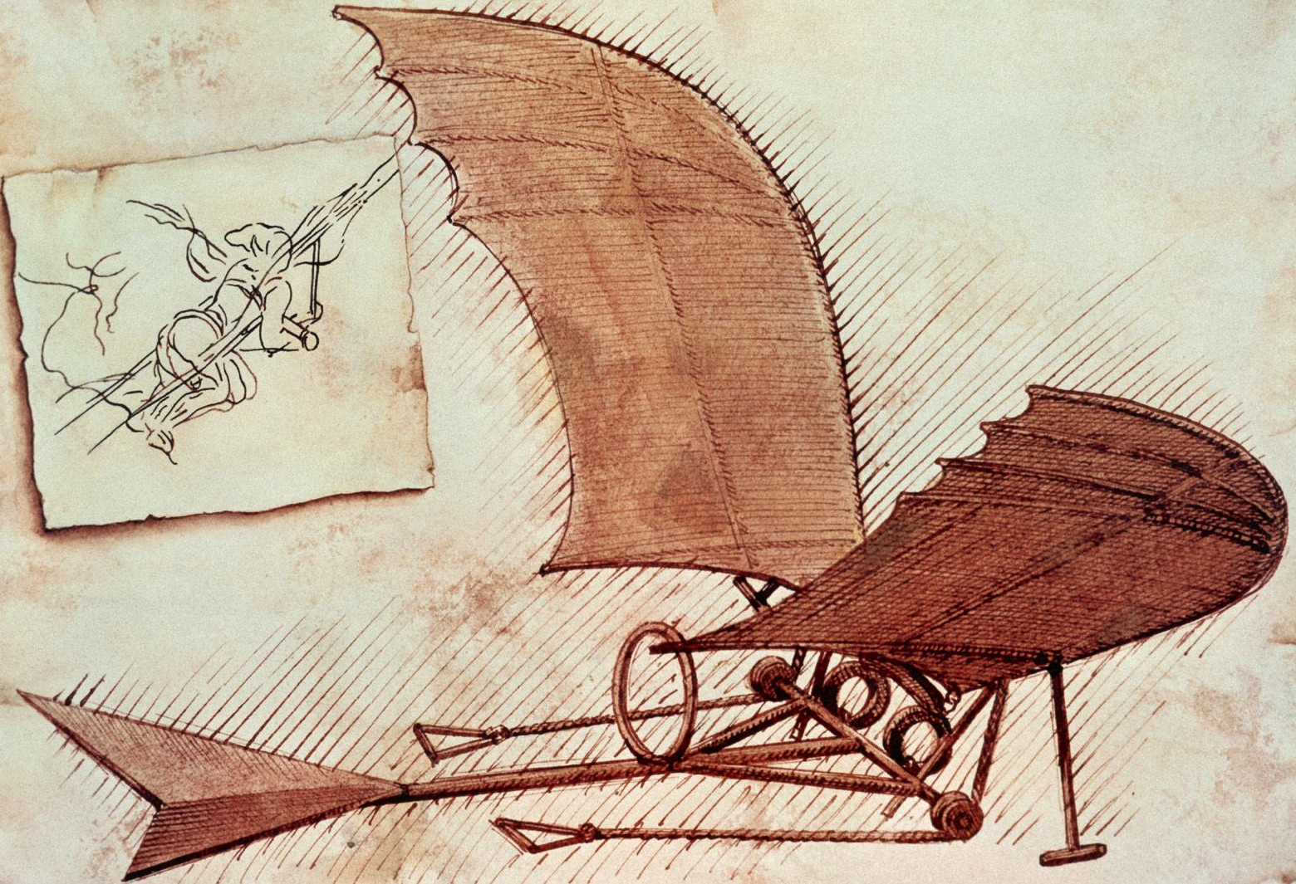

As seen in the picture above, the pilot controls the motion of flight with both hands and feet, lying on a panel between the wings. With a tail-like structure in the back, the flying machine increases its success in aerodynamic design because it evens out the weight from the pilot and the resistance from the air. This illustration also highlights the anatomical aspect of da Vinci’s design; the wings of the machine are almost identical to that of a bat, with curved cutouts along the back of the wing. Webbed and tightly bound with a cloth material, the wings of the flying machine perfectly reflect that of a bat’s.

Da Vinci, I have found, is most impressive because of the variety in his works. Ranging from the beautiful artistry of the Mona Lisa to the exact mathematics behind his cannon machine, he is one of the most influential designers in the world. His flying machine is no exception to this multi-disciplinary style: incorporating anatomy, physics, engineering, and mathematics in one design. With examples of biomechanical, mechanical, civil, and aerospace engineering in this design, da Vinci’s machine crosses many engineering disciplines. As a first year engineering student, I found this very inspiring; while I aspire to be a civil engineer, da Vinci proves that you are never regulated to one certain discipline. The wings of the machine show biomechanical engineering, the pulley system in the cockpit show mechanical engineering, the overall building of the machine incorporates civil engineering, and the idea of an aircraft itself shows aerospace engineering.

As I looked at the flying machine on display at the Franklin Institute, I was impressed with da Vinci’s attention to detail, especially with the limited tools he had at the time. While today it seems relatively easy to create a hang glider, da Vinci did not possess the materials and modern hardware tools we have; he relied entirely on his own studies and observations. His pages upon pages of sketches and notes are ultimately the ways in which he was able to make such an impressive design into an actual machine. While the machine did not completely work, he opened up new ideas behind the study of flight and how gravity and distribution of weight affect flight patterns. In his notebook, da Vinci explains his theories behind flight and how wing size directly affects the pilot’s accuracy in steering:
An object offers as much resistance to the air as the air does to the object. You may see that the beating of its wings against the air supports a heavy eagle in the highest and rarest atmosphere, close to the sphere of elemental fire. Again you may see the air in motion over the sea, fill the swelling sails and drive heavily laden ships. From these instances, and the reasons given, a man with wings large enough and duly connected might learn to overcome the resistance of the air, and by conquering it, succeed in subjugating it and rising above it. (Da Vinci 333)
Incorporating air resistance with the pilot’s weight and wing size, da Vinci proves that his design goes far beyond a simple sketch of a bat’s wings. He goes further in his study of flight to prove the importance of webbed wings and their ability to steadily control flight.

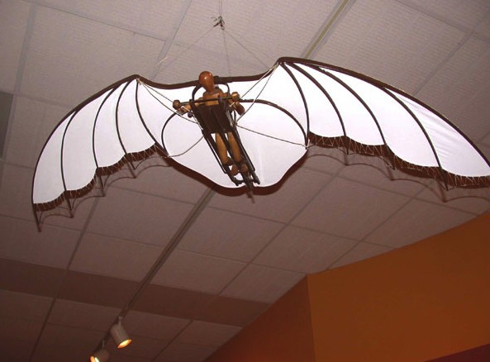

His incorporation of many types of engineering continues to amaze the world over, and as explained by Michael Gelb, author of How to Think Like Leonardo da Vinci, da Vinci pushed the limits on engineering during his time:
His inexhaustible quest for truth also inspired him to look at reality from unusual and extreme perspectives. It took him under the water (he designed a snorkel, diving equipment, and a submarine) and into the sky (he designed a helicopter, a parachute, and his famous flying machine). He plunged into unfathomed depths and sought previously unimaginable heights in his passion to understand. Leonardo’s fascination with flight—his studies of the atmosphere, wind, and especially the movements of birds—offers a compelling metaphor for his life and work. (Gelb)
It has often been said, “a scientist studies what is, while an engineer studies what never was,” and Leonardo da Vinci is no exception to this. A pioneer in the studies of physics, mathematics, and biology, da Vinci went above and beyond the expectations of an inventor during his time, creating machines only thought of in peoples’ imaginations. He incorporated everyday things to create fascinating designs, something that the world still marvels at today.

While the flying machine never worked as da Vinci had hoped, his study of flight directly influenced modern flight explorations. His designs show a heavy emphasis on how to control the machine when it is working against the drag of air resistance. Likewise, da Vinci’s drawings show how to stabilize the structure during flight with changing wind patterns. As the wind fluctuates, the pilot steers wings by using the pulley system at the front of the cockpit. By doing so, the pilot has the ability to use the wind as a force resisting other forces pulling the machine downward, namely gravity.

Albert Einstein once said that “[s]cientists investigate that which already is; engineers create that which has never been.” As a student majoring in engineering, this idea is particularly exciting for me. This quote, along with da Vinci’s amazing inventions, proves that there is no limit to what you are able to create. While da Vinci, as well as other countless other engineers, ran into some failure in design or execution of a machine, his unwillingness to ever give up on creating and inventing shows that you can do anything with a design as long as you keep improving with every step. Realizing mistakes and trying to fix them is all part of the intricate process that is engineering, whether it be building a bridge, completing an electric circuit board, or creating a new aircraft. No matter what you try to create, you will always run into speed bumps along the way. But, as I have learned from the works of Leonardo da Vinci, a great engineer takes those difficulties and turns them into possibilities. With da Vinci’s flying machine, the world was introduced to the possibility of aviation as a form of transportation.

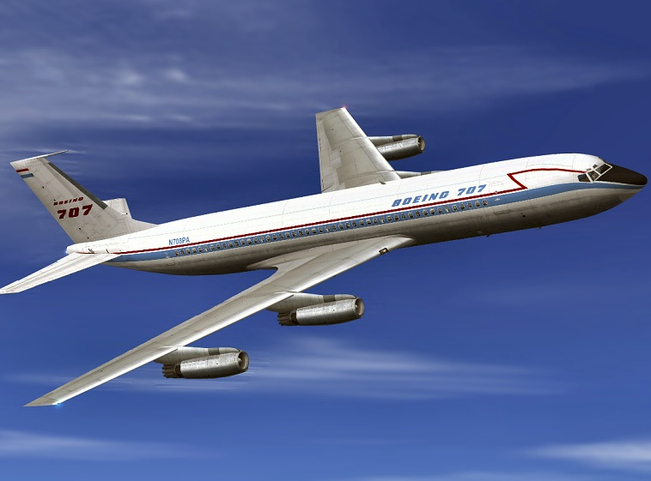
Bibliography

Distributed Proofreaders. "The Notebooks of Leonardo Da Vinci." The Notebooks of Leonardo Da Vinci. Ed. Charles Aldarondo. Project Gutenberg EBook, Jan. 2004. Web. 17 Mar. 2011.

Gelb, Michael. How to Think like Leonardo Da Vinci: Seven Steps to Genius Every Day. New York, NY: Delacorte, 1998. Print.

Pictures

http://www.oneartprints.com/wp-content/uploads/2011/03/Flying-Machine-by-Leonardo-da-Vinci.jpg

http://www3.hsc.edu/museum/exhibits/davinci/images/flyingmachine600.jpg

http://www.simviation.com/hjg/aircraft/boeing/b707-120/boeing_airplane_company_707-121_n708pa_1958.jpg

