A Study of Leonardo da Vinci’s Inventions: The Aerial Screw
Presented by Dylan Connelly
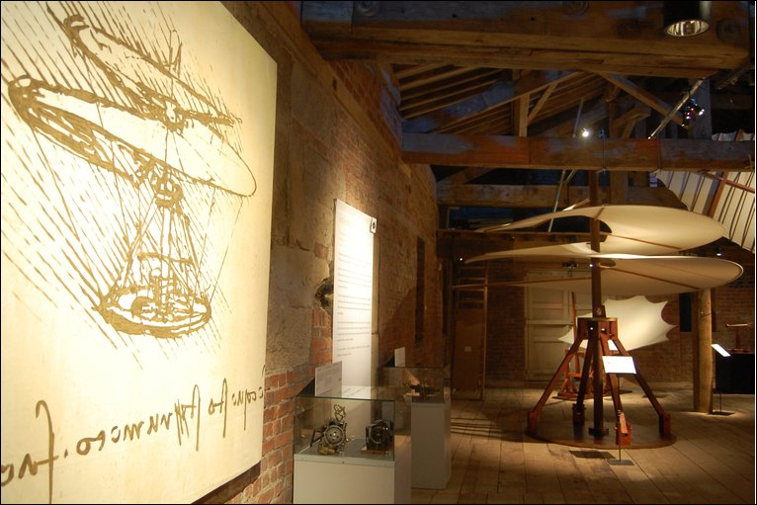

Google Images: http://www.google.com/imgres?imgurl=http://news.bbc.co.uk/media/images/46719000/jpg

Leonardo da Vinci is known to all as a master of painting, sculpture, architecture, engineering, anatomy and even music. It is not hard to see why he is called the “Renaissance Man,” since his vast knowledge of drafting and art seems as endless as that of math and science. What Leonardo may not have known is the effect on the world that has occurred in consequence to the mass amount of art and design that he produced. Now, roughly five centuries after Da Vinci lived, there is practically no one who cannot point out The Mona Lisa, The Last Supper or even The Vitruvian Man, all pieces of historically significant art. There has even been a book and a movie that centered about his pieces. The point is, while many have studied the art and sculpture that Leonardo produced in the fifteenth and sixteenth century, there is just as much importance to be found in his engineering designs and his extensive knowledge in physical mechanics and mathematics.
To put this into perspective, Leonardo’s gunship designs utilize traditional cannons that take a long time to reload into multi-cannoned vessels that had the capabilities to fire rapidly. His knowledge of mechanics helped him design a self moving cart with full braking and steering capabilities hundreds of years before even the first steam engine was produced, and his drafts of flying machines date back to before the idea of human flight seemed possible. Da Vinci constantly dreamed of expanding mankind’s reign into the air, and giving the gift of flight, a concept that struck all mankind, which could have been obtained by one of his several flying machine inventions. Take for consideration the “Aerial Screw,” an invention found in Manuscript B (folio 88v), that is now known as a helicopter and is also the first of this kind (Laurenza 47). The most intriguing thing about this invention is that no other serious design like it existed before the Industrial Revolution. The fact that Leonardo was centuries ahead of his time is simply mind boggling, considering the relative understanding of science and engineering during his day. He spent years dissecting and studying the human body, learning the biology that keeps us alive. These anatomical studies were crucial parts in letting Da Vinci understand the build and proportions of the human in a mechanical and physical sense. In one way these studies helped his paint to the proper proportions, while in another helped him understand the mechanical aspects of the body. Subsequently Leonardo realized that the human body is dynamic enough to perform as an engine, and designed ways to potentially put man in the air hundreds of years before the technology even existed. This line of thought led to the drafting of the Aerial Screw, a machine designed to lift the four men powering it into the air using a manually cranked rotor. Because the resources needed to build this machine were close to impossible to obtain, the Aerial Screw was never built until after the life of Da Vinci, but the drawings tell nearly everything about it.
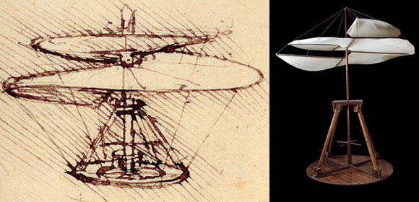
The design of the Aerial Screw dates back to 1480-1483, and its features are quite simple when looked at. The beauty and elegance in Da Vinci’s design comes from this simplicity, which is derived from his impressive knowledge of basic mechanics. Many of Da Vinci’s designs consist of wooden gears, pulleys and suspension which demonstrate that he understood the basic elements of movement. Leonardo recognized these elements of physics like motion, energy and fluidity and utilized them via levers, inclined planes and pulleys throughout his inventions. The Aerial Screw can be broken down into several components: the helical rotor, the drive train, the suspension and support components, and the operation platform where several men would tread to fly the machine. The design revolves around the rotor, which seems to be the core inspiration behind the possible construction of the invention. Da Vinci realized that unlike water, air can be compressed with force, and though the actual relationship between force and the compressibility of a gas would not be solidified in science for many years, Da Vinci’s scientific insight helped wrap his head around the concept. As we know now from modern technology, the shape of a wing on a plane or the rotor on a helicopter is everything when it comes to lift. In the case of the plane wing, because the top of the wing has a curve while the bottom is flat a pressure builds up from the uneven airspeeds above and below the wing surface. Consequently this pressure exerts an upward force that increases as the speed of the wing increases. Without these mechanics, Boeing 747s could never lift off the ground. This basic theory is what Leonardo deducted through clever experimentation (Laurenza 47).
www.google.com/imgres?imgurl=http://events.nationalgeographic.com/media/images/photos/da-vinci-exhibit
Taking a look at the wing in the picture above, when the inclined plane is spun in the right direction, air flow is directed downwards as the wing cuts through the air, creating an upward lift. This helix shaped wing is not far off from the design of a modern day rotor on a plane or helicopter, except for the fact that the propeller of Da Vinci’s design is continuous over a linen spiral, rather than angled blades which are commonly used today. Theoretically the design for this wing could lift the weight of the helicopter and four men once the rotational speed of the wing reached a certain threshold. Leonardo’s flaw occurs at this step. Taking into consideration the weight of the original helicopter design and the possible speed at which humans could spin the crank, it is evident that the machine could not have flown by Da Vinci’s specifications due to heavy weight and not enough lift. This flaw does not take away from the ingenuity of the design, but rather gives insight to Da Vinci’s understanding of aerodynamics. The reason he designed this machine in the first place was to test the possibility of human flight. The second most important component of the Aerial Screw design is the support lines of the propeller and of the helicopter body itself. Because the propeller would be made of linen over a thin frame, it is essential that the tension of the cloth be maintained tight enough to withstand air resistance, and that the base of the machine remain stable while the wing is in motion. These were two significant engineering constraints that Da Vinci had to overcome. Not only did the linen helical structure have to maintain a solid shape while forcing down air, the machine would have to remain relatively level while in the air. Any pitch in the machine while in flight could cause technical difficulties, and even lead the invention to plummet. Da Vinci’s solution to this is the use of stitching along the cloth to attach to the helix shaped frame, while supporting each level of the wing with reed poles to the next. Tension lines would then be attached from the edge of the wing to the stationary operating platform to maintain stability (Laurenza 50-51). The engine of this invention is human force, a characteristic shared by all of Leonardo’s flying machine designs. The four men needed to operate this machine hold onto the handles jutting out of the operating tiller and walk, but remain stationary while the propeller begins to spin. In essence, the men grab the frame and push the propeller with their feet as they step along the rotating platform. In a way the human engine is the critical component Da Vinci needed to draft his design.
It is easy to see that Leonardo da Vinci was ahead of his time in many ways, but the question remains, how far ahead? People still marvel over his artwork today all over the world, but what makes his inventions so significant? The more understanding we have about Da Vinci’s world the easier it becomes to realize how great he truly was. To measure the extent of the knowledge of science and physics in the fifteenth and sixteenth centuries seems to be the same as measuring the extent Da Vinci understood these topics; he was truly a pioneer in his fields. First know that Leonardo da Vinci drafted his idea for the Aerial Screw in roughly 1482. This was a period in Da Vinci’s life when he moved from Florence to Milan looking to work for the Francesco Sforza, the Duke, engineering new ideas of weaponry, architecture and more. At his studio in Milan, he would draft the first helix propelled helicopter the world would see (Nicholl 185-190). Historically speaking, about a decade before Columbus stumbled upon the Americas, over 400 years before the Wright brothers took the sky for the first time in Ohio, Da Vinci was inventing flying machines. It seems impossible that a man could vastly understand science this far ahead of his time. Before this, the only other concept of the rotating wing came from a Chinese toy invented to fly like a helicopter in about the fourth century A.D., and this idea is only seen in ancient literature (Kimmet, & Nash). That being said, the Da Vinci design is considered the first serious design of its kind. This information suggests the idea of air being compressible and usable to create energy is centuries old, as we can see even by the invention of the sails on a boat or the flight of a kite. While the more primitive toy design was most likely based off the floating-spinning motion of seeds falling off a tree, Da Vinci’s design is based off a more theoretical view of fluidity and mechanics. The obvious limitations he would find were energy conversion using air, and the basic elements of propulsion. Because the world knew so little about the idea of flight, Da Vinci felt it necessary to draft this machine if only to test and confirm the nature of his theories (Nicholl 185-190).
On paper the helicopter was a simple yet elegant way for Leonardo to achieve flight from mechanical motion but to fully understand the nature of its mechanics Da Vinci would need to build the machine. Unfortunately, in the 1480s it was nearly impossible to do so. This was an age before engineering feats like the engine, when most moving machines where totally mechanical and manually operated. Most of the parts that Da Vinci needed for his projects were made of wood, steel or cloth and were generally constructed by him. To answer the pending question, Leonardo Da Vinci was so advanced an engineer that he was in fact held back by the technological inabilities of his time. Without new discoveries in science and physics, or an efficient way to create the machine, the Aerial Screw would never exist out of the notebook of Da Vinci.
Though the production of Leonardo’s inventions was held back in one way or another, he still laid a foundation for human flight for centuries to come. Even though his calculations on weight to power ratios may have been off, he still discovered the essence of theory that is crucial to human flight; that a device could screw itself into the air by revolving at a rapid enough speed. The quest for human flight finally hit the ground running, or hit the sky flying at the turn of the twentieth century as an effect of Da Vinci’s explorations. His knowledge of how the world worked paved the way for the way of thinking that would become modern engineering, and his inquiries about fluid mechanics got to the bare essentials of flight. Understanding the concept of pitch and thrust was crucial in developing the first airplanes and helicopters in the modern world. Still today, one can find traces of da Vinci’s flying machine when looking at a propeller of a boat, plane or helicopter to see where his ideas came from.
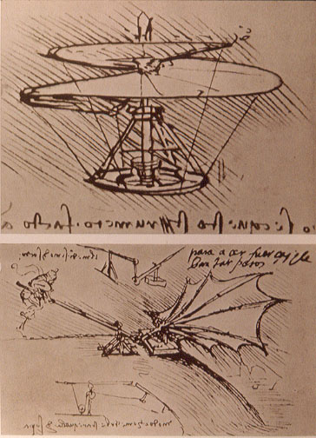
The reason Leonardo da Vinci was such a revolutionary engineer is because he was able to use theories he did know to question and find out theories that he did not know. At first this may seem the nature of an engineer’s existence, but think about the information Leonardo had to deal with. Before he took into consideration the compressibility of air, Da Vinci had to understand fluidity. The many plans for boats or gunships point to the fact that he had studies the effects of buoyancy and thrust in the water. There had to be a way to create a multi cannoned gunship loaded with ammunition that would not sink like a stone, and Leonardo had conquered this. Perhaps Da Vinci’s experience in architecture, such as his famous moving bridge design, gave him insight about suspension, tensional lines and support systems, all which are relevant to the production of the Aerial Screw and other flying machines as shown in the picture to the left. Da Vinci even created the first self propelled cart, essentially a car, using only the mechanical conversion of energy to create motion. This technology is so advanced people of Da Vinci’s era could not keep up with the science. Combining his findings from the array of his inventions, Leonardo was able to piece together theories of human flight years and years before the rest of the world. By testing the limits of the laws of physics, Da Vinci designed where no other man had the chance to until centuries later when the world would catch up with him. It is incredible to think how extensive his knowledge of science and technology is directly applicable to studies of engineering today.
http://www.google.com/imgres?imgurl=http://www.designpartners.co.uk/Images/leonardo_da_vinci_helicopter
Aside from the fact that Leonardo Da Vinci conquered nearly every field of creativity possible, he contributed a great deal of scientific discovery that proves to remain pertinent today. The basic elements of the Aerial Screw are still used to lift aircraft today all over the world, and elements of his designs can be seen everywhere. While held back by insufficient technology on the fifteenth and sixteenth centuries Da Vinci’s intellectual, artistic and especially technological studies make his name and his work timeless in the line of human discovery.
Work Cited
Kimmet, K., & Nash, A. (n.d.). History of the helicopter. Retrieved from http://asms.k12.ar.us/classes/humanities/amstud/97-98/helicptr/webpage.htm

Laurenza, D. (2006). Leonardo's machines: Da Vinci's inventions revealed. Cincinnati, OH: David & Charles Publishing Company.

Nicholl, C. (2004). Leonardo da Vinci: flights of the mind. New York, New York: Penguin Books Ltd.

The Da Vinci exhibit at the Franklin Institute

