**Gaussian Distributions and Maximum Likelihood Decoding**

Task 1:

Using the normrnd function from Matlab’s Statistics Toolbox, two set of Gaussian Random Numbers GRV were generated each consisting of 10,000 data points. Each GRV is described using its mean (μ) and its variance (δ); in Task 1, the GRVs are denoted as GRV1[μ1 ,δ1] and GRV2[μ2 ,δ2] where,

|  |  |
| --- | --- |
| GRV1 | |
| μ1 | δ12 |
| 1 | 1 |
| GRV2 | |
| μ2 | δ22 |
| -1 | 1 |

**Table 1.**

The data sets generated are classified using the Maximum Likehood Decoder with the assumption that the data is equally likely, in other words they have equal probability. Observing the means (μ) of the two GRVs, we apply a threshold at **0**, in other words, data above the threshold is classified in class 1 which belongs to GRV1 and obviously, any data below the threshold is will fall into class 2. This is then repeated for different thresholds, for each of the thresholds, the error is tabulated below:

|  |  |  |  |  |
| --- | --- | --- | --- | --- |
| Threshold | Theoretical error | | Simulated Error | |
| GRV1 | GRV2 | GRV1 | GRV2 |
| 0 | 0.1640 | 0.1483 | 0.1555 | 0.1547 |
| 0.5 | 0.3147 | 0.0651 | 0.3000 | 0.0663 |
| -0.5 | 0.0703 | 0.3151 | 0.0627 | 0.3040 |

**Table 2.** Theoretical and simulated error based on the given thresholds

The theoretical error of each GRVs is obtained by integrating the area under the Gaussian distributions and to right of the GRV­2 and to the left of the GRV1 starting from the decided threshold. As illustrated the simulated and the theoretical yield to the same values.

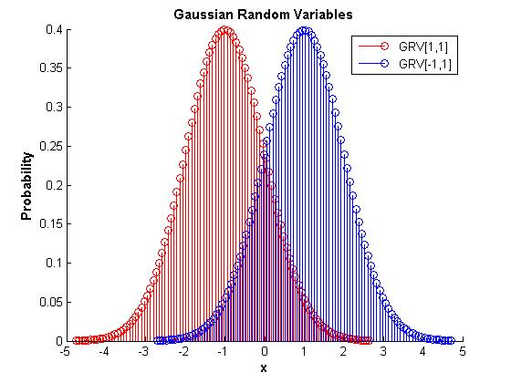

**Figure 1.** Gaussian Random Variables distribution

Task 2:

An important parameter to consider is the variance of the GRVs. In Task 2, the effects of varying the variance is illustrated using the error rates for each of the GRVs as the variance is altered in a certain interval [0.1, 2].

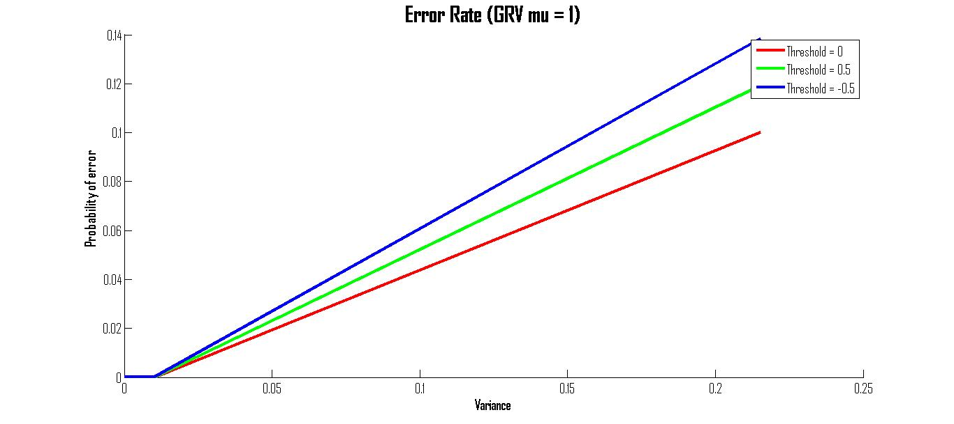

**Figure 2.** Calculated error rate in result to a change in variance

As the variance δ2 is changed, we expect a direct relationship between the probabilities of error and the variance. An increase of the variance signifies that the data is polluted with Gaussian noise with greater amplitudes. Figure 3 illustrates 3 GRVs with 3 values for the variance. As it can be observed, a high value for the variance results in samples that are more likely to go beyond the threshold, hence the increase of the error.

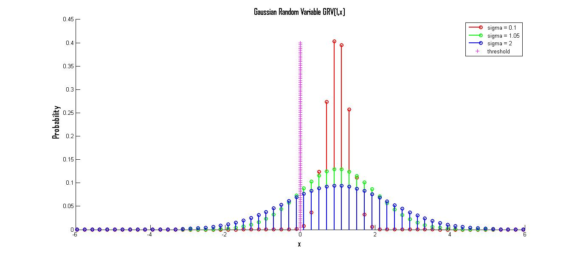

**Figure 3.** Gaussian Random Variable with varying variance from [0.1, 2]

Task 3:

In this task, the multivariate GRVs were experimented in a similar manner as the univariate GRVs in the first two cases. The 2 variables GRVs were simulated with means GRV1[-1,1], GRV2[1,1] and identity covariance matrices. The data generated from the GRVs is illustrated below:

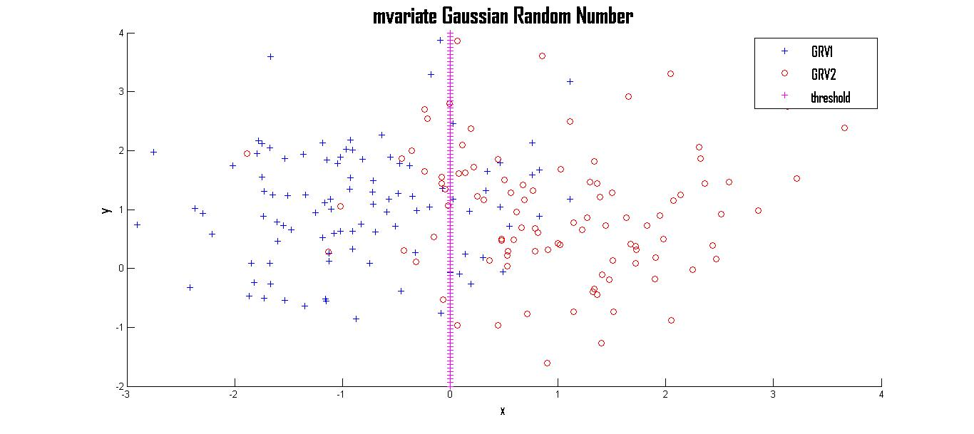

**Figure 4.** Data obtained from GRVs

Similarly, the error is found for the theoretical and the simulated data as illustrated in table 3.

|  |  |  |  |  |
| --- | --- | --- | --- | --- |
| Threshold | Theoretical error | | Simulated Error | |
| GRV1 | GRV2 | GRV1 | GRV2 |
| [ 0 , 1 ] | 0.1837 | 0.1837 | 0.200 | 0.1700 |

**Table 3.** Theoretical and simulated error based on the given threshold for the multivariate GVNs

The theoretical and simulated are fairly close, as we expected, even though it is 2 dimensional, the procedure remains the same for calculating the theoretical error. In this case, the theoretical error is defined by the volume enclosed by the two GVNs.

Task 4:

This last task, simulates the GVNs for four different covariance matrix, (∑). The covariance matrix is an important factor as it describes the GVN’s support region.

Plotting the contours of the GRVs allows us to observe the ellipses of the support regions.

∑1

|  |  |
| --- | --- |
| 1 | 0 |
| 0 | 1 |

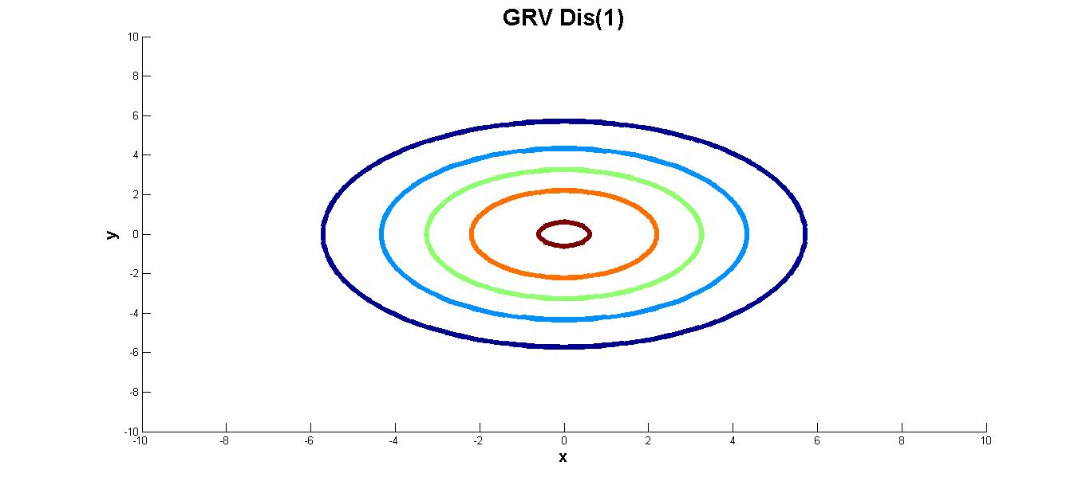

A covariance matrix with the identity matrix yields to a circular support region

∑2

|  |  |
| --- | --- |
| 1 | 0.1 |
| 0.1 | 1 |

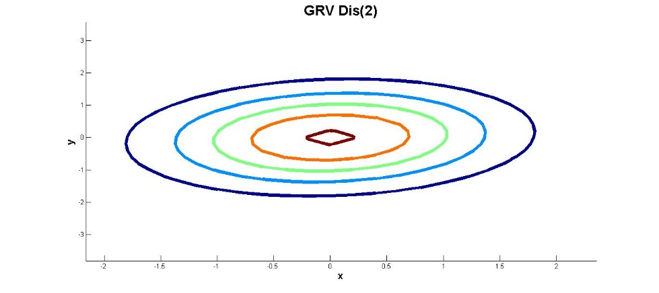

A covariance matrix with arbitrary values in the off diagonal elements matrix yields to an ellipsoidal support region

∑3

|  |  |
| --- | --- |
| 0.2 | -0.3 |
| -0.3 | 0.5 |

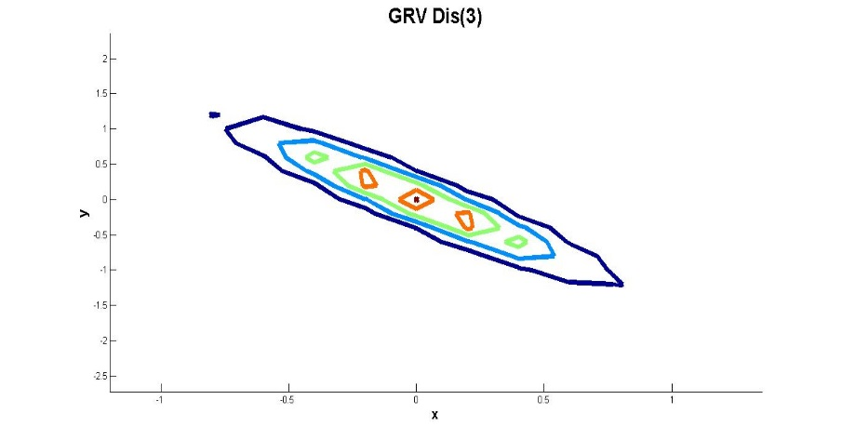

A covariance matrix with arbitrary values in the off diagonal elements matrix yields to an ellipsoidal support region

∑4

|  |  |
| --- | --- |
| 0.5 | 0.3 |
| 0.3 | 0.2 |

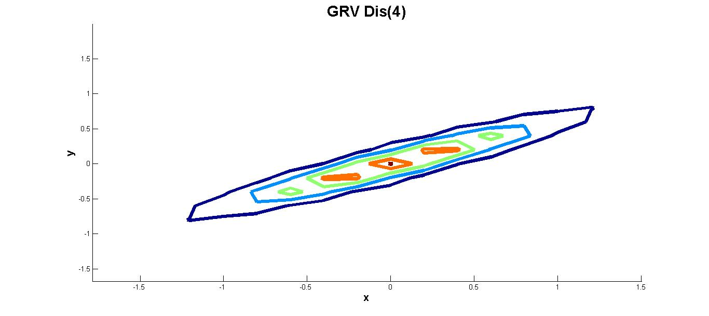

A covariance matrix with arbitrary values in the off diagonal elements matrix yields to an ellipsoidal support region